Supplementary Material (ESI) for Lab on a Chip
This journal is © The Royal Society of Chemistry 2006

Additional imaging of the NMuMG cells grown on rigid or flexible gelatin substrates was done to further investigate the three-dimensionality of the structures and the differences in intracellular organization between monolayer and three dimensional cultures. Also, longer term cultures were maintained in order to allow the cells to form more complex structures. The cells were fixed and stained after 3 days post seeding using the following protocol:

Cells were washed using PBS in the microchannels three times, fixed using a solution of 4% formaldehyde in PBS, and allowed to incubate at room temperature for 10 minutes. Cells were then washed again with PBS, and permeablized with a 0.2% Triton X-100 solution in PBS and allowed to incubate at room temperature for 10 minutes. Cells were then rinsed again three times with PBS, and a solution of 1 unit/mL PBS Alexa488-Phalloidin stain (Molecular Probes) was added to the channels, and allowed to incubate at room temperature for 10 minutes. Finally, a solution of 1:1,000 dilution DAPI (Molecular Probes) was added to the channels 5 minutes before visualization and allowed to remain at room temperature. Alexa488-Phalloidin stains F-actin (cytosolic), while DAPI stains double stranded DNA (nuclear).

Visualization was done using an inverted fluorescence microscope, obtaining a 8um total distance z-stack of images (for the 3-D cultures on gelatin substrates), using a 0.25um step size. Deconvolution software was used to improve the clarity of the images, and a single image of the stack from both the DAPI and Phalloidin staining were pseudocolored and overlayed.

Figure 5 shows 3 day cultures of NMuMGs on a glass coverslip (2-D rigid substrate, glass was used for imaging purposes) and on flexible gelatin gels (3-D flexible substrate) stained as described, while Figure 6 shows the same culture conditions, but in phase contrast images at 2 days.

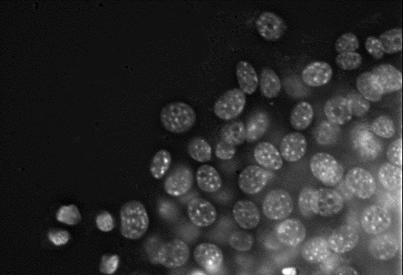  (a) | 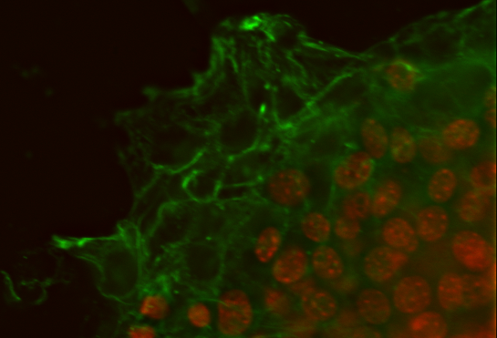  (b)
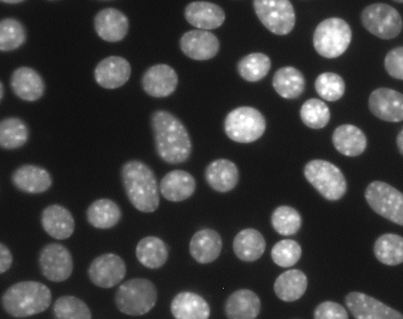  (c) | 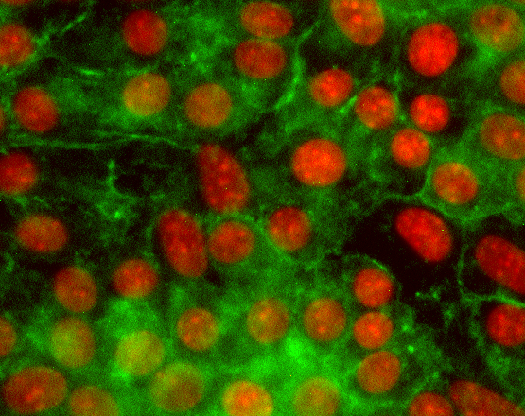  (d)
Figure 5: Fluorescence images of NMuMG cells at 3 days after seeding. Cells grown on flexible gelatin substrates showing just nuclear staining (a) and an overlay of both nuclear (red) and actin (green) staining (b) at 40x magnification. Nuclei can be seen in the focal plane, and behind it, along with overlapping nuclei, indicating a three dimensional structure. Cells grown on rigid glass substrates showing just nuclear staining (c) and a similar overlay of nuclear and actin staining (d) at 40x magnification. Nuclei are spaced much further apart, all are in the focal plane and show no overlapping, indicating that these cells are growing as a two dimensional monolayer. Also, differences in the localization of the actin staining between (b) and (d) can be seen, with more organization of the actin towards the edges of the cells in the 3-D cultures, rather than more homogeneous, unorganized staining in the 2-D cultures.

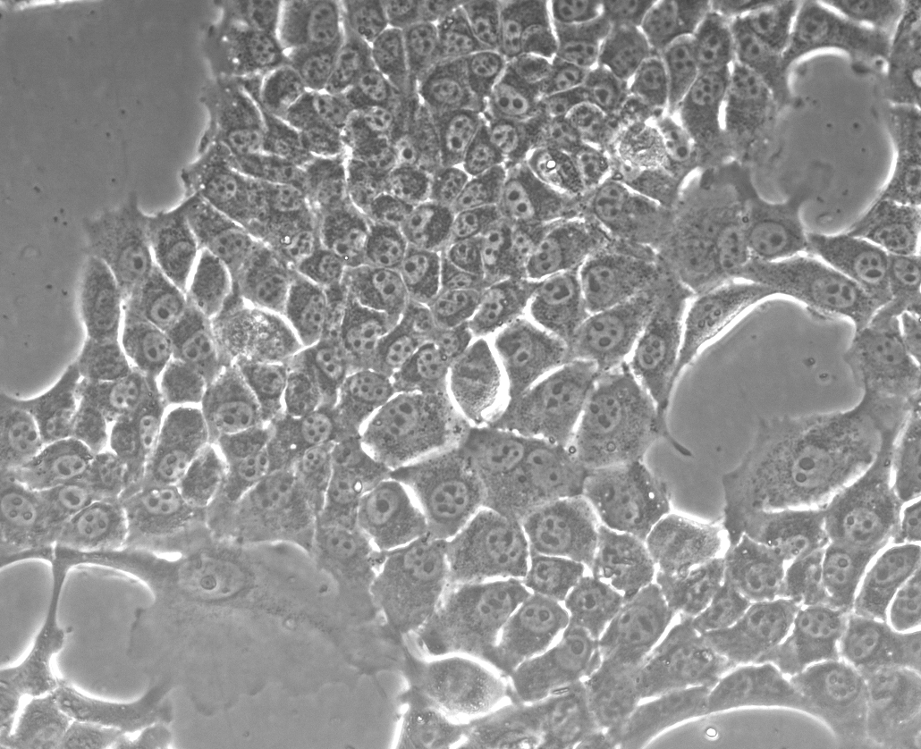  (a) | 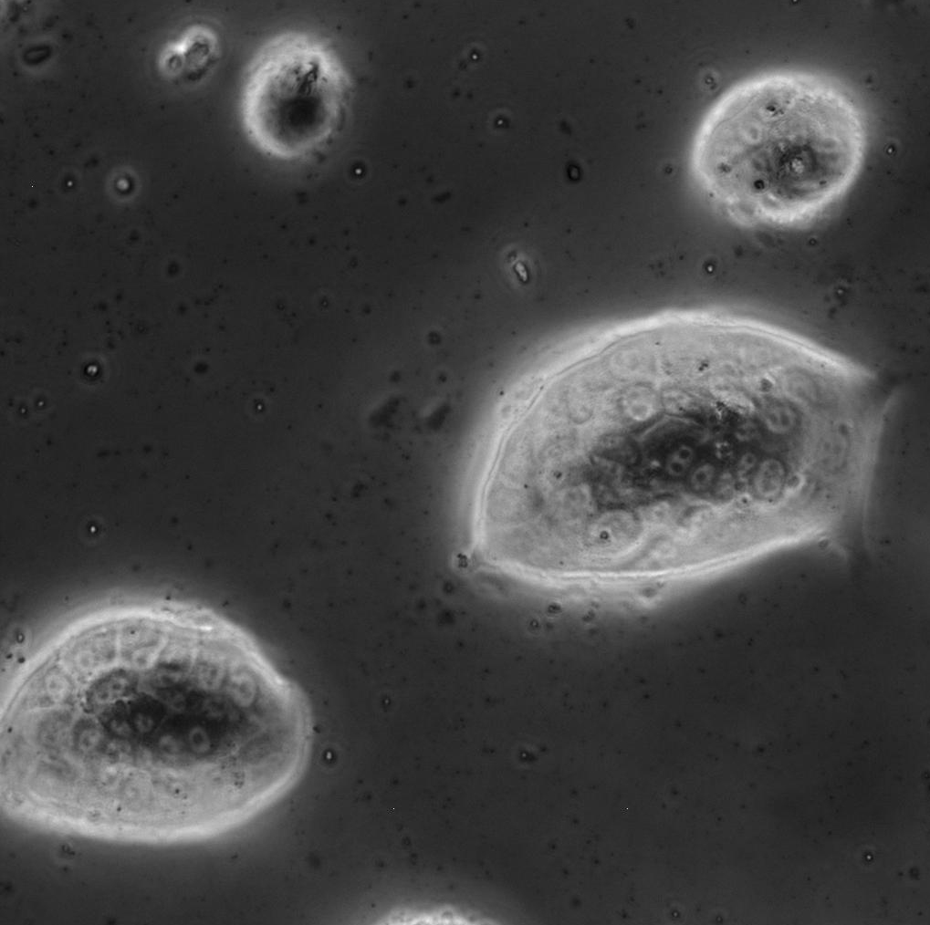  (b)
Figure 6: Phase contrast image of cell structures growing on a rigid substrate (a) as compared to those on the flexible gelatin substrates (b) after 2 days, 20x magnification. The cobblestone appearance of typical NMuMG cells can be seen on the surface of the three dimensional structures. Differences in morphology of the cells grown on flexible gelatin gels versus those on rigid substrates become more pronounced during longer culture periods, indicating that cells are surviving and organizing into 3-D structures.

