Supplementary Material (ESI) for Lab on a Chip
This journal is © The Royal Society of Chemistry 2006

Fig. 1 UV spectrums of GMA-modified polymers before (—) and after (…) benzylamine derivation. Sample (A) poly(AAM-co-GMA), (B) poly(DMA-co-GMA), (C) PVP-g-GMA and (D) PVA-g-GMA 0.5% in water.

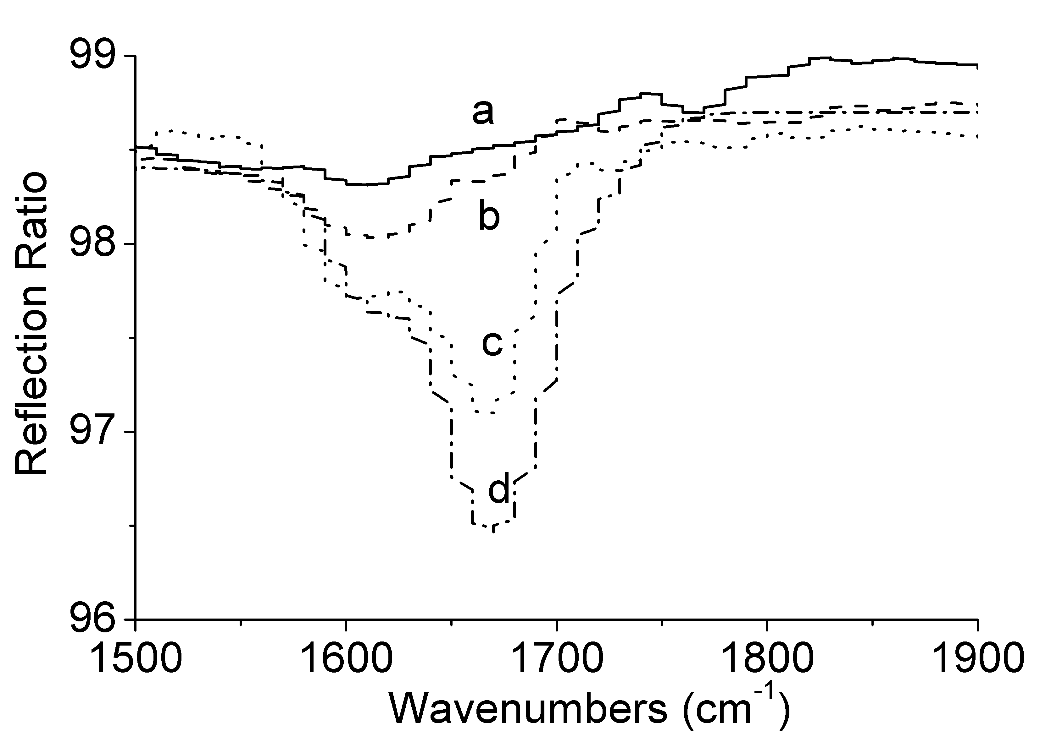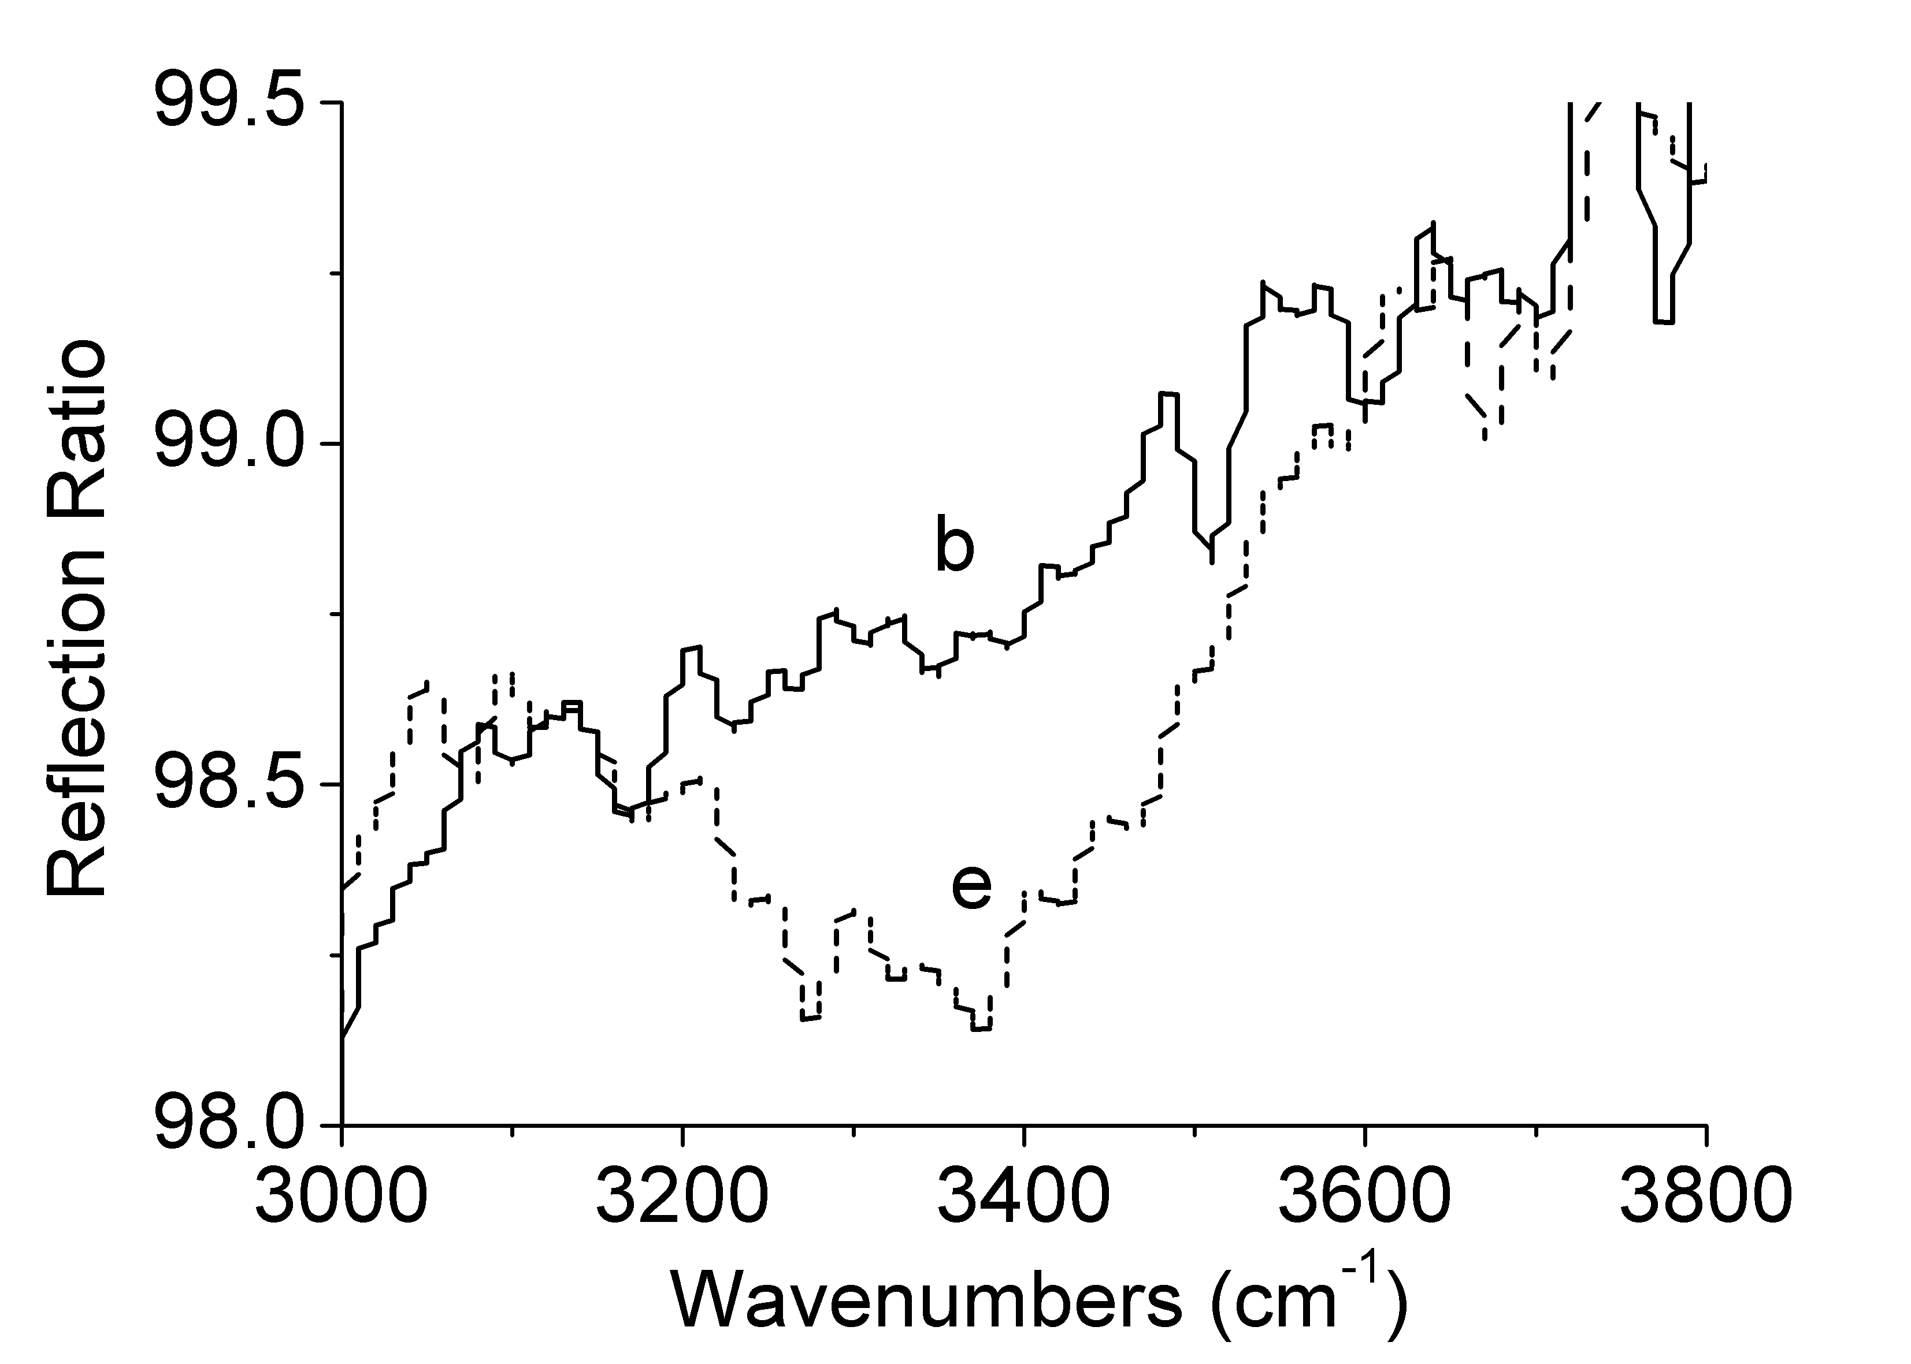
Fig. 2 RAIRS spectrums of (a) native PDMS, (b) plasma oxidized and APTES silanized PDMS, (c) PVP-g-GMA coated PDMS, (d) poly(DMA-co-GMA) coated PDMS, and (e) PVA-g-GMA coated PDMS.

