Supplementary Material (ESI) for Lab on a Chip
This journal is © The Royal Society of Chemistry 2007
High-throughput microfluidics: improved sample treatment and washing over standard wells – supplementary information

Jay Warrick, Ivar Meyvantsson, Jongil Ju, & David J. Beebe*

Introduction

The main article refers to Equation 1 as a method of approximating fluid replacement in a uniform channel when the fluid is Newtonian and flow is relatively steady, fully-developed, and laminar. Equation 1 is derived here along with numerical calculations of ζ for various geometries and other supplementary experimental data referenced in the article. $Φ=\text{100}\text{\%}×\left[\frac{C_{c,f}−C_{c,i}}{C_{t}−C_{c,i}}\right]=\text{100}\text{\%}×\left[α−ζ{\left[\frac{{\text{Vol}}_{\text{chan}}}{{\text{Vol}}_{t}}\right]}^{n}\right]$ (1)

Theoretical analysis of fluid-replacement

The simple case of flow in a cylindrical micro-channel will be used to illustrate the theoretical methods for obtaining ζ in Equation 1 and determining relevant ranges of Vol_{chan}/Vol_{t}.
Assuming a Newtonian fluid in a uniform channel with steady, fully developed, laminar flow, pressure and velocity are linearly related. What follows from this linear relationship is that from time zero to time t, the distance traveled for a particle on a streamline is linearly related to the total volume that has flowed through the channel, which will allow us to relate treatment volume to how much fluid is replaced in a micro-channel.
There exists a critical velocity in this simplified system that, when multiplied by the pumping time, t, equals the channel length. In other words, a particle traveling at this critical average velocity was able to make it completely through the channel from the entrance to the exit. This particle and the particles that follow completely replace the particles that existed in the channel on this streamline. For a cylindrical channel, this critical velocity corresponds to a channel radius inside which fluid from the droplet has completely replaced the fluid originally in that region of the channel. Outside this radius, the fluid is partially replaced. Fluid flow into the channel can be analyzed to determine how much channel fluid was replaced.
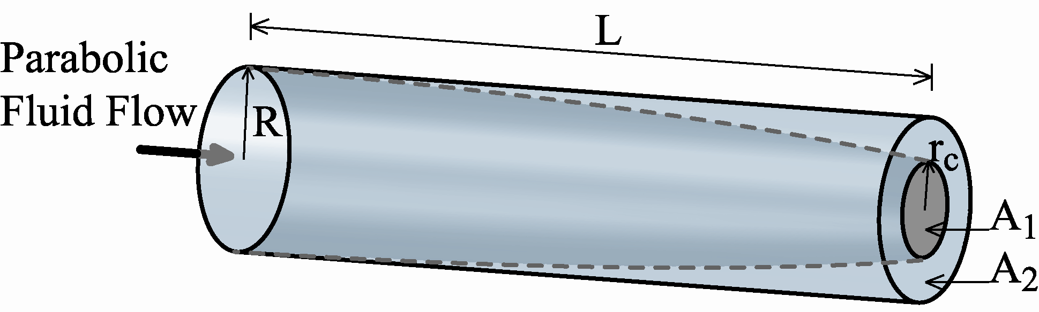
Figure 1 Fluid-Replacement in a Cylinder – The state of a cylindrical channel after flow has ceased. The region labeled ‘A₁’ represents the cross-sectional area where treatment fluid has completely replaced the fluid originally in the channel. The region labeled ‘A₂’ represents the cross-sectional area that is partially replaced by treatment fluid. A₁+A₂ = πR².
Analysis is continued in non-dimensional form. Velocity is normalized to the maximum velocity of the flow and radius is normalized to the radius of the channel. Equations 2 and 3 are general for Newtonian fluid in a uniform channel with steady, fully developed, laminar flow and relate the normalized critical velocity described above to the volume of the channel and the volume of the treatment.
$v_{\text{crit}}=δ\frac{{\text{Vol}}_{\text{chan}}}{{\text{Vol}}_{t}}$ (2)
$δ=\frac{1}{A_{\text{total}}v_{\text{max}}}\int_{A_{\text{Total}}}{\text{vdA}}$ (3)
The variable v is the normalized velocity profile of the flow. The constant δ is the volumetric flow rate of the channel divided by the flow rate of plug flow. Our assumptions allow us to calculate δ=1/2 for parabolic flow a cylinder. Equation 4 represents the normalized critical radius, r_{c}, of the cylindrical channel as described above.
$r_{c}=\sqrt{1−v_{\text{crit}}}$ (4)
Using the same assumptions as Equations 2 and 3, Equation 5 can be treated as general and is used to find П, the volume ratio of how much treatment fluid exists in the channel over the channel volume. If П = 1, then the channel volume has been completely replaced with fluid from the droplet.
$Π=\frac{1}{v_{\text{crit}}{\text{tA}}_{\text{Total}}}\left[\int_{A_{2}}{\text{vt}}\text{dA}+v_{\text{crit}}{\text{tA}}_{1}\right]$ (5)
The time t is a constant in Equation 5 and is the time for the pumping event to occur. The critical radius, r_{c}, is used to perform the integration in Equation 5 for a uniform cylindrical channel to obtain Equation 6.
$Π=1−{\text{mv}}_{\text{crit}}$ where $m=\left(1−δ\right)=1/2$ (6)
The constant m is defined here for later use and discussion. Upon substituting Equation 2 into Equation 6, and Equation similar to Equation 1 is derived where ζ = m δ = (1-δ) δ.
$Π=1−ζ\frac{{\text{Vol}}_{t}}{{\text{Vol}}_{\text{chan}}}$ (7)
Therefore, the volume ratio of how much droplet fluid exists in the channel over the channel volume asymptotically approaches 1 as more and more treatment volume is introduced into the channel. To speak in percentages, if П = 0.7, then 70% of the channel volume is made up of treatment fluid. Equation 7 is the basis for Equation 1. Equation 1 shows a few slight modifications to account for different situations. The variable α is inserted for the value 1 in Equation 7 to allow for outside effects that could alter channel concentrations like surface adsorption of solute to channel walls. The entire equation is multiplied by 100% to give results in terms of percent concentrations. The right-hand term in Equation 7 is raised to the power of n to allow for the possibility that multiple treatments might be needed. Motivation for this can be seen when performing an example calculation.
Assume the initial channel concentration is 0, the concentration of the treatment fluid is 1, and 1 treatment replaces 70% of the channel fluid (i.e. П = 0.7 and *Vol_{t}/Vol_{chan} = 0.3). If diffusion is allowed to redistribute the solute evenly throughout the channel, the end channel concentration after 1 treatment will be 0.7. If a second treatment is performed, the initial concentration of the channel is changed to 0.7. The second treatment will replace 70% of the volume with treatment fluid and the end concentration will be (0.7+Π*(1-0.7)) = 0.91 or (1 – 0.3^2). In this way, multiple treatments can be accounted for with the exponent, n. However, it is important to remember that values of n other than 1 can only be used if diffusion is allowed to redistribute solute evenly throughout the channel between treatments as Equation 1 and 7 assume that the channel fluid and treatment fluid each begin as homogenous solutions.
One very important note about Equation 1 and 7 is that it they are only valid for values of v_{crit}≤1. If v_{crit}>1, none of the droplet solution has flowed far enough to exit the channel and П would be given by Equation 8.
$Π=\frac{{\text{Vol}}_{\text{drop},c}}{{\text{Vol}}_{\text{chan}}}$ when $v_{\text{crit}}>1$ (8)
Another important point is that, immediately after treatment, the distribution of old and new solution in the channel is not uniform and depends upon the flow profile.
Since the number of treatments, channel volumes, and treatment volumes are all known variables of an experiment, if  can be determined for a given geometry, channel concentrations can be predicted using Equation 1. We have shown that δ = 1/2 for a cylinder, which corresponds to a value of ζ is 1/4. Interestingly, the same result holds for elliptical geometries as well. For other geometries, the integrals in Equation 3 and 5 often cannot be solved analytically. In these cases, various approximation methods, analytical and numerical, can be implored to perform the integration. Also, Equation 6 does not often simplify to linear form. Therefore, in future analysis, the constant m in Equation 6 will be found by applying linear fits to numerical simulation data and residuals will be reported to indicate the validity of the linear approximation.
Rectangular channels, which are typical of photolithography, are analyzed numerically to obtain approximations for  at various aspect ratios (i.e. height over width, h/w). The infinite series solution for the velocity profiles in a rectangular channel is given in Equation 9.
$$v=\left(\frac{−∂P}{∂x}\frac{4h^{2}}{{\text{μπ}}^{2}}\right)\sum_{ℓ=0}^{∞}{\frac{{\left(−1\right)}^{ℓ}}{{\left(2ℓ+1\right)}^{3}}}\left[1−\frac{\text{cosh}((2ℓ+1){πx}/h)}{\text{cosh}((2ℓ+1){πw}/h)}\right]\text{cos}((2ℓ+1){πy}/h)$$
(9)
When taking a finite number of terms, the approximation is more accurate when h is made smaller than w. The aspect ratio of the rectangular channels is defined as h/w. To ensure accurate calculations, 40 terms of Equation 8 were numerically integrated using Maple to solve for δ in Equation 3. The analytical approximations were compared to finite-element results obtained in MATLAB to ensure agreement within < 0.2%. MATLAB was then used to calculate Ф and plot it as a function of v_{crit}. The curves for Ф vs. v_{crit} were fitted with a line from v_{crit}=0 to 1 and forced to pass through 0 at v_{crit}=0. Values of m in Equation 6 correspond to the slope of the curve fits. Residuals are reported for each value of m.
Table 1 shows all the results for all the geometries analyzed here. The results for h/w=0 is found using the analytical solution for parallel plates, but is then fitted like all other simulation data with a line to find m and give a better approximation for the range of interest.
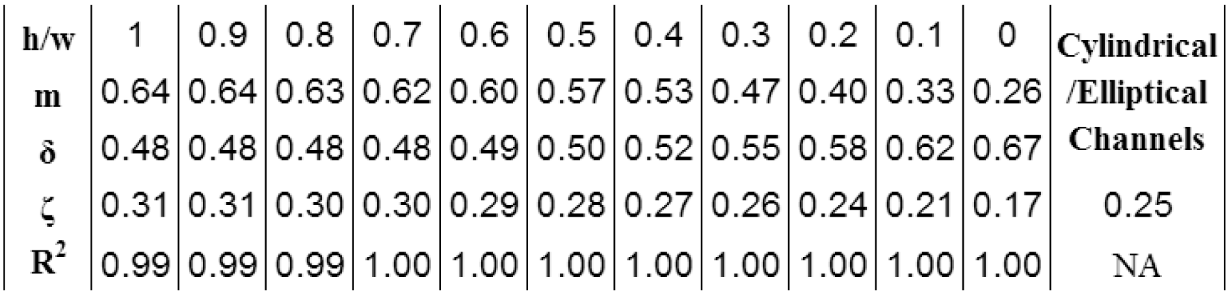
Table 1 Numerical Data – Table of calculated values for m, R², δ, and ζ, for various aspect ratios, h/w. The values for ζ and m are only applicable for values of v_{crit} = δ*(Vol_{chan}/Vol_{t}) ≤ 1.
The results for ζ are plotted in Figure 2 to aid in looking up values of ζ for various aspect ratios, h/w.
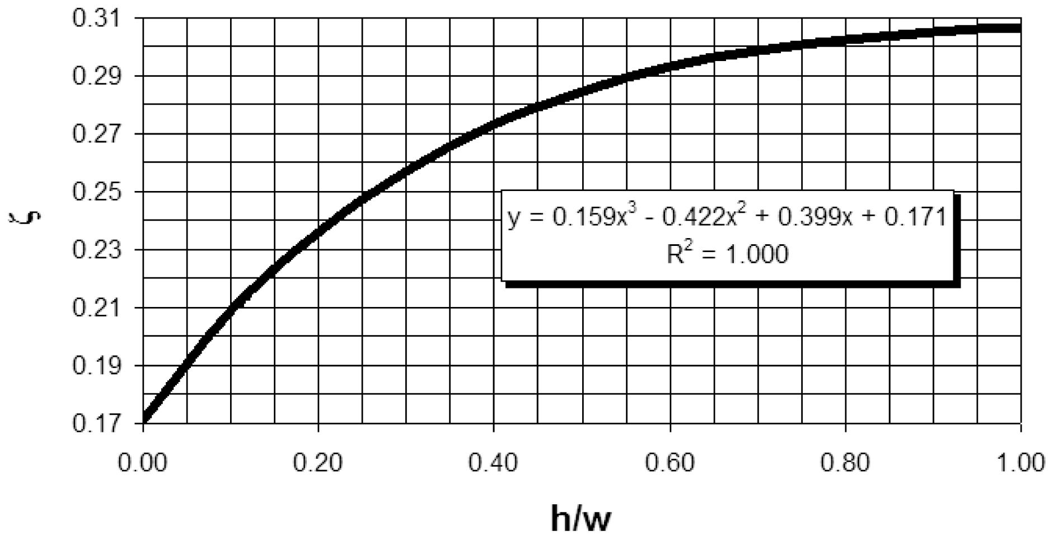
Figure 2 plots the approximation for ζ versus h/w for rectangular channels. The approximate values for ζ are only applicable for values of v_{crit} = δ*(Vol_{chan}/Vol_{t}) ≤ 1.

Experimental supplements

Calibration curves – Figure 3 plots normalized intensity difference versus normalized concentration for known dilutions of beads and McCormick blue food coloring. Figure 3a is for the beads while Figure 3b is for the McCormick blue food coloring. The curves were obtained over the experimental concentrations used in the main article. The polynomial fits were used to calculate concentrations from intensity data.
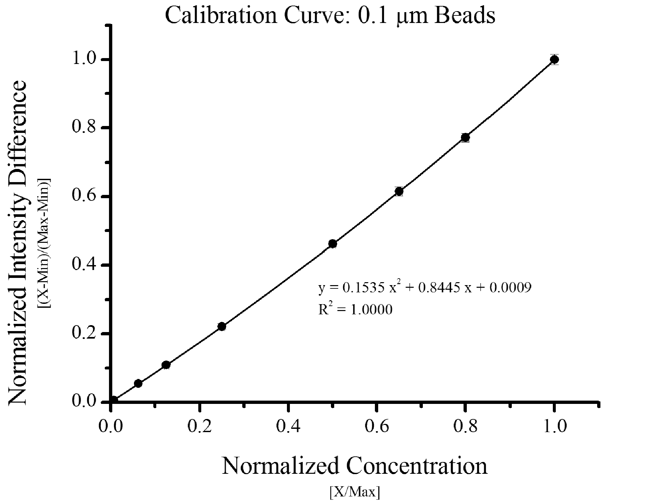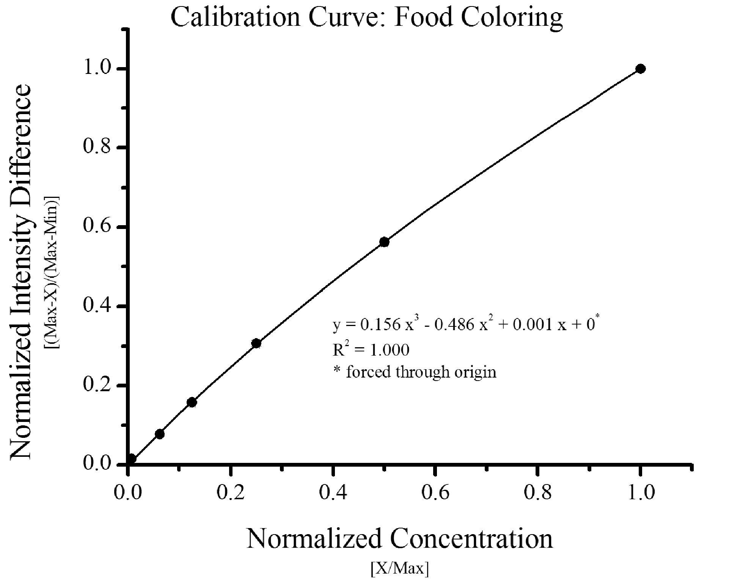
Figure 3 Calibration Curves – Plots of normalized intensity difference vs. normalized concentrations for the 0.1 μm beads and food coloring. a) 0.1 μm beads. b) Food coloring. The polynomial fits are used to calculate concentrations from intensity data for further experimentation. Error bars represent 99% confidence intervals using the student’s t-statistic and are obscured by the necessary size of the data point markers.
A plot of absorbance is provided in Figure 4 for the dye to illustrate that data follows normal absorption theory.
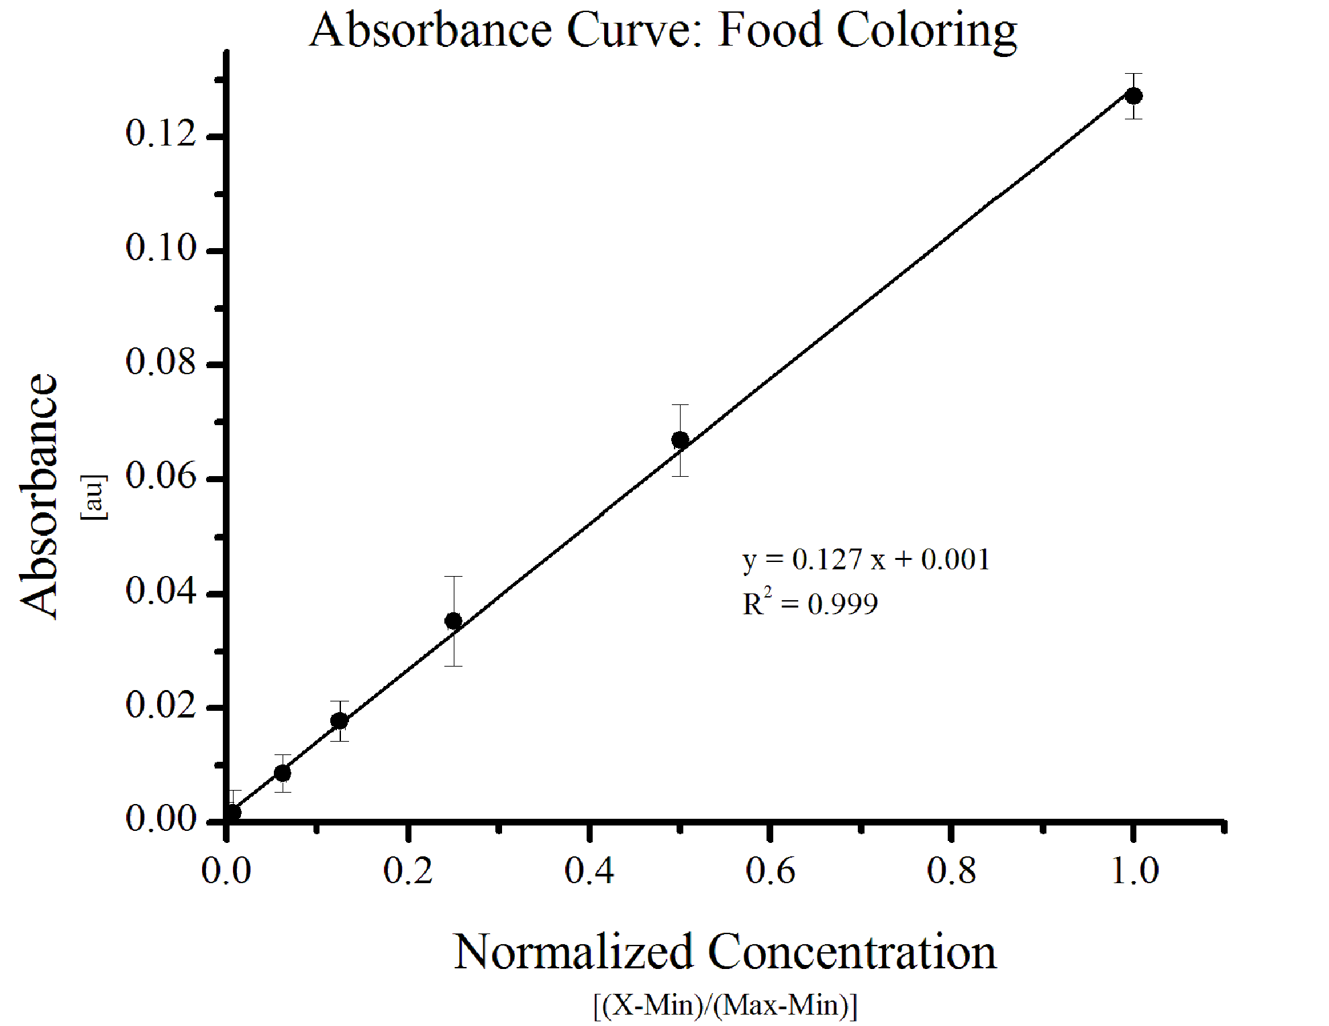
Figure 4 Dye Absorbance – Plot of absorbance vs. normalized concentration. Concentrations are the same as those used in the primary experiments. A linear curve represents compliance with absorption theory. Error bars represent 99% confidence intervals using the student’s t-statistic.

Wait time determination - Experimentally, Equation 1 is to be verified in the main article using the channel shown in Figure 3. The article also describes the methods used.

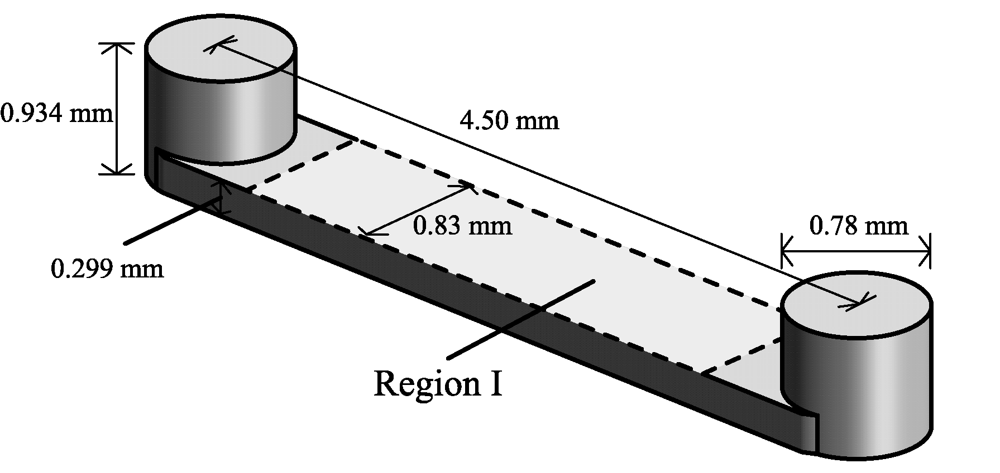
Figure 5 Microchannel Design - Diagram of the microchannel used in all experiments. The volume of the channel is 1.87 ± .05 μL. The channel is 0.299 ± .003 mm deep and 0.83 ± .01 mm wide, giving an aspect ratio of 0.36. The ports measured 0.78 ± .01 mm. Typical Reynolds and Womersley numbers for manual pipetting in this channel are <10 and <0.75, respectively, assuming the density and viscosity of water. Region I represents the region over which the channel was imaged.
Some of the experiments require a wait step. The appropriate amount of time to wait between steps depends upon diffusion and evaporation. Measurements are obtained for the food coloring using only 80% of the width of Region I. Thus, an even distribution of food coloring particles in the channel is necessary for an accurate measurement and time must be given for diffusion to redistribute the solute accordingly. Yet, if too much time is given to diffusion, significant evaporation can occur, skewing results. Diffusion between the treatment volume and the boundary layer would cause measurements to decrease while evaporation would cause measurements to increase. Therefore if measurements of the channel were taken over time it could be difficult to discern if the effects of boundary layer diffusion and evaporation were simply canceling each other out. However, concentrations will increase at the air-fluid interface and will tend to diffuse towards Region I and the air-fluid interface will move slightly towards the center of the channel. Therefore, if diffusion is not given enough time to bring solute into Region I, then evaporation will not affect measurements in Region I.
The equation [t = L²/(10D)] is sometimes used to estimate when diffusing particles will begin reach a point a distance L away in low concentrations. The air-fluid interface remains roughly 1 mm away from Region I over many minutes. The equation predicts it would take over 8 minutes for the food coloring to diffuse the 1 mm from the air-fluid interface to the edge of Region I. Thus, if a wait time of less than 8 minutes is chosen, evaporation should not have a significant effect on results.
If measurements of channel concentration are taken in the time leading up to 8 minutes, effects of boundary layer diffusion can be monitored independent of evaporation effects. Therefore, concentration was measured in Region I of Figure 2 at t = 2, 3, 4, and 5 min after a 2 μL treatment of food coloring to monitor changes due to boundary layer diffusion. All measurements were within 0.3 %. Thus, experimental and theoretical data suggest a 2.3 ± 0.3 min is an appropriate wait time to use in the experiments of the main article.

Implementation of results in microchannel and experimental design

Equation 1 can be implemented easily using algebra in many different situations to aid microchannel or experimental design. This will be illustrated in a short example.
The goal of the hypothetical experiment is to seed cells in a microchannel with standard media at time t = 0 hours, treat the cells with a growth factor at t = 24 hours, replace the media containing the growth factor with standard media at t = 48 hours, and examine the effects of the treatment at t = 72 hours.
In order to quantify the dose response of the cells to the growth factor, it is necessary to know the growth factor concentration over time in the microchannel. Equation 1 would then be used with information about the geometry of the channel (i.e. rectangular aspect ratio, etc.) to determine ζ and the volume of the channel (e.g. ζ = 0.3, and Vol_{chan} = 3 µL). Suppose we would like to bring the growth factor concentration in the channel to >95% of maximum given a 1 nM concentration contained in the treatment solution. Thus, 95% = 100% (1 - 0.3 (3 / Vol_{t} )^{n} ), which suggests that an 18 μL treatment volume is necessary to achieve the target concentration in a single treatment or 2 treatments of 7.4 µL using the treat-wait-treat method. Similarly, at t = 48 hours when the growth factor treatment is to cease, a single treatment of 18 µL or 2 treatments of 7.4 µL using the treat-wait-treat method would remove >95% of the growth factor media from the channel. Thus, concentrations of treatments are defined at the critical times of 24 and 48 hours. That is not to say however, that the concentration is constant over the critical time period. The subsequent concentrations within the channel can be a function of a multitude of factors including degradation, uptake, absorption, and adsorption. However, in differential equation terminology, the boundary conditions have been determined.
The percent fluid-replacement (i.e. 95%) can also be used to roughly estimate the boundary layer thickness of fluid without growth factor that still remains in the channel. Although the boundary layer increases in thickness from input port to output port, an average thickness can be estimated by volume. If 95% of the volume is replaced, and the remaining 5% is distributed on the boundary, the average thickness of the boundary layer can be calculated accordingly. In the case of a thin boundary layer, (i.e. boundary layer thickness, δ << width or height), the remaining percentage can be multiplied by the cross-sectional area and divided by the perimeter of the cross section (0.05(0.83mm*0.299mm) / (2*(0.83mm+0.299mm)) = .0055mm). This is not a rigorous calculation but can give insight into the remaining diffusion distance for the growth factor to reach the cells, or settling distances of particles contained within the treatment flow as well as possible gradients that would arise from settled particles or diffusing factors.
Also, using a simple control volume and mass balance, concentrations of the fluid that has exited the channel can also be inferred. This could be important in estimating concentrations of cell secreted factors. Adding fluid to the input would push a portion of the incubated media from the channel for subsequent analysis. However, Equation 1 was shown to be a conservative estimate of channel concentration and, thus, will most likely over estimate the amount of treatment fluid that has exited the channel and should be kept in mind during analysis. Additionally, when using a treat-wait-treat method, one might be able to consider the fluid that has exited the channel as separated from the channel contents due to the time necessary to diffuse back into the channel. Thus, it is possible that only the end state of the channel need be considered to estimate concentrations of cell secreted factors. Implementation of a control volume can work for a multitude of different treatment and aspiration scenarios.

