Supplementary Material (ESI) for Lab on a Chip
This journal is © The Royal Society of Chemistry 2007

Solvent Resistant Microfluidic DNA Synthesizer
Yanyi Huang,^{uv} Piero Castrataro,^{uv#} Cheng-Chung Lee,^{ut} and Stephen R. Quake*^{v}
Department of Bioengineering and Howard Hughes Medical Institute
Stanford University, California 94305

CRIM Laboratory, Scuola Superiore Sant’Anna, Viale R. Piaggio 34, 56025
Pontedera (PI), Italy

Department of Bioengineering, California Institute of Technology
Pasadena, California 91125

- Experimental
- Materials
Porous silica beads (5 μm in diameters, pore size 200 nm) were purchased from Sepax Technology (Newark, DE, USA). Fluorolink D4000 was purchased from Solvay Solexis (Thorofare, NJ, USA). Dichloropentafluoropropane was purchased from SynQuest Laboratories (Alachua, FL, USA). Isocyanatoethyl methacrylate (EIM, 95%) was purchase from Monomer-Polymer & Dajac Labs (Feasterville, PA, USA). 3-Aminopropyl-trimethoxysilane (APTMS), N,N-diisopropylethylamine (DIEA), (1S)-(+)-(10-camphorsulfonyl)oxaziridine (CSO), anhydrous toluene, 2,2-Dimethoxy-2-phenyl acetophenone (DMPA, 99%), and Dibutyltin diacetate (DBTDA, 99%) were purchased from Aldrich (Milwaukee, WI, USA). 5-Ethylthio-1H-tetrazole (activator, 0.25 mol/L solution in anhydrous acetonitrile), deblocking mix (3% dichloroacetic acid (DCA) in dichloromethane (DCM)), anhydrous acetonitrile (MeCN), 5’-dimethoxytrityl-N-phenoxyacetyl-2’-deoxyAdenosine-3’-[(2-cyanoethyl)-(n,N-diisopropyl)]-phosphoramidite (Pac-dA-CE phosphoramidite), 5’-dimethoxytrityl-N-acetyl-2’-deoxyCytidine-3’-[(2-cyanoethyl)-(N,N-diisopropyl)]-phosphoramidite (Ac-dC-CE phosphoramidite), 5’-dimethoxytrityl-N-p-isopropyl-phenoxyacetyl-deoxyGuanosine-3’-[(2-cyanoethyl)-(N,N-diisopropyl)]-phosphoramidite (iPr-Pac-dG-CE phosphoramidite), 5’-dimethoxytrityl-2’-deoxyThymidine-3’-[(2-cyanoethyl)-(N,N-diisopropyl)]-phosphoramidite (dT-CE phosphoramidite), 1-[3-(4-monomethoxytrityloxy)propyl]-1’-[3-[(2-cyanoethyl)-(N,N-diisopropyl)phosphoramidityl]propyl]-3,3,3’,3’-tetramethylindocarbocyanine chloride (Cy3-phosphoramidite) were purchased from Glen Research (Sterling, VA, USA). 5’-O-(4,4’-dimethoxytrityl)-thymidine-3’-O-succinic acid (5’O-DMT-2’-dT-3’-O-succinate) was purchased from Monomer Science, Inc. (New Market, AL). 2-(7-Aza-1H-benzotriazole-1-yl)-1,1,3,3-tetramethyluronium hexafluorophosphate (HATU) was purchased from Anaspec (San Jose, CA, USA). SYBR Gold nucleic acid gel stain, pre-cast 15% TBE-Urea denaturing polyacrylamide gels (1.0 mm, 10 well), and ultrapure water were purchased form Invitrogen (Carlsbad, CA, USA). Tris-EDTA (TE) buffer (pH 7.5) was purchased from Integrated DNA Technologies (IDT, Coralville, IA, USA). All the DNA oligonucleotides, except the ones we synthesized from the microfluidic chips, were ordered from IDT and HPLC purified.

- Synthesis of Perfluoropolyethers (PFPEs)
In a typical synthesis, Fluorolink D4000 (1000 g, 0.24 mol) was added to a dry 2 L round bottom flask and purged with argon for 15 minutes. EIM (67.56 mL, 0.48 mmol) was then added via syringe along with Dichloropentafluoropentane (319 mL), and DBTDA (8 mL). The solution was immersed in an oil bath and stirred at 50ºC for 24h. The solution was then passed through a chromatographic column (silica, Dichloropentafluoropentane, 5 × 5 cm). Evaporation of the solvent yielded clear, colorless, viscous oil (PFPE DMA) which was further purified by passage through a 0.22 μm polyethersulfone filter.
In a typical cure, 1 wt% or 0.1% wt of DMPA (0.5 g or 0.05 g, 20.0 mmol or 2 mmol) was added to PFPE DMA (50 g, 12.0 mmol) along with 20 mL Dichloropentafluoropentane until a clear solution was formed. After removal of solvent, the viscous oil was passed through a 0.22 μm polyethersulfone filter to remove any DMPA that did not disperse into the PFPE DMA. The filtered PFPE DMA was then irradiated with a UV source (Electrolite UV curing chamber model no. 81432-ELC-500, λ = 365nm, with only one of the four lamps operating to produce 7 mW/cm² power flux) while under an oxygen-free nitrogen purge. The fully cured PFPE has tensile modulus and oxygen permeability (3.9 MPa , 400 barrers) similar to that of PDMS (2.4 MPa, 550 barrers).

- Fabrication of the Microfluidic Chips
All the fabrication steps were conducted in a glove box purged with N₂. The PFPE DMA was prepared with 2 different concentrations of photoinitiator, 0.1% and 1.0%. Before use, the polymer was bubbled with N₂ for 30 min. A thick layer (2 mm) of PFPE DMA containing 0.1% of photoinitiator was poured onto the Si wafer having the desired flow pattern made of AZ50 (AZ Electronic materials) and SU-8 2025 features (only the reaction chamber for trapping beads). The thick layer was irradiated with a UV source (Electrolite UV curing chamber, ELC-500, λ = 365nm, 7 mW/cm²) for 12 sec. Then PFPE DMA with 1.0% of photoinitiator was spin coated to a thickness of 30 µm (800 rpm for 20 s) onto a Si wafer with the desired control pattern made of AZ50. This wafer was placed in the UV chamber and irradiated for 5 sec. The thick layer was removed, aligned to the thin layer and then irradiated for another 24 sec to bond them together. The chip was peeled off and took out of the glove box to punch inlet and outlet holes in the fluidic layer as well as the control layer; then it was placed back into the glove box. A 40 µm thick layer of PFPE DMA with 1.0% photoinitiator was spin coated (600 rpm 20 s) onto a glass slide and then irradiated for 4 sec. The chip was placed on top of the coated glass slide and then irradiated for 5 min.

- Operation of the Microfluidic Chips
All the inlets and outlets of the chips are inserted with steel tubes (New England Small Tube Co., Litchfield, NH) and connected with either microbore PTFE tubing (for chemical reagents) or Tygon tubing (for control valves). All the tubing are purchased from Cole-Parmer (Vernon Hills, IL). The valves are filled with Krytox oil. Both reagent delivery (10 psi) and valve actuation (30 – 40 psi) are pressured by argon. The pressure is switched on and off by computer-controlled solenoid valves (Pneumadyne, Plymouth, MN). Chips were operated on a single-use basis.

- Synthesis of the Oligonucleotides
The porous silica beads were modified with the first nucleotide (Thymidine in our experiments) attached. We added 0.5 g silica beads into 10 mL 8 mol/L HNO₃, and refluxed it for 4 hours. The beads were washed with water and then dried in an oven at 120 °C overnight. The dried beads were re-suspended into 10 mL anhydrous toluene and then 0.6 mL APTMS was added into the system. The mixture was refluxed for 24 hours and then filtered and washed with toluene and acetone. All beads were then transferred into a new vial with 75 mg 5’O-DMT-2’-dT-3’-O-succinate, 40 mg HATU, 100 μL DIEA, and 5 mL MeCN. The reaction vial was sealed and the mixture was stirred overnight at room temperature. Finally the beads were filtered, washed with MeCN, acetone and then dried under vacuum.
We suspended the beads in MeCN and then piped the solution of beads into the microfluidic chip while the “column valve” was actuated. The square profile fluidic channel necessary for the construction of “column valves” ensures that the thin membrane can not close fully. While liquid are able to flow through small openings at the two edges, solids objects remain trapped by the “column valve”. A column of porous beads was thus packed inside the reaction chamber. All the phosphoramidite compounds were dissolved into anhydrous MeCN to form 0.1 mol/L solutions. The CSO was dissolved in anhydrous MeCN (0.1 g/mL) and filtered through a 0.45 μm filter.
All the reagents were flushed through the microfluidic channels during setup to remove unwanted air bubbles. Each synthesis cycle contained 3 reaction steps and 3 washing steps. The step-sequence was: deblocking (2 min) → washing (1 min) → coupling (2 min) → washing (1 min) → oxidizing (2 min) → washing (1 min) (Scheme 1). During the coupling step, two coupling reagents (phosphoramidite and activator) were sent through the reaction column alternately (Figure S1): one reagent flowed continuously for 1.8 s then the other one flowed for 1.8 s at a flow rate of 500 nL/min. For the labeled oligonucleotides, we replaced one of the phosphoramidite solutions with Cy3-phosphoramidite and increased the coupling time to 5 min. Final “DMT-off” (“MMT-off” for Cy3-phosphoramidite) was done by flowing deblocking reagent into the column for 2 min. After MeCN wash, we released the “column valve” and flushed the beads out of the chip and into a micro-centrifuge tube. The MeCN was evaporated using centri-vap. We added 0.3 mL concentrated ammonium hydroxide into the tube and then incubated the tube at room temperature for 1 hour. The beads were spun down to the bottom of the tube by centrifuge and then the liquid phase was transferred into a new tube and kept at room temperature for 3 hours for removal of the side-protection groups on the oligonucleotides. Finally the tube was lyophilized to yield solid-form oligonucleotides (with salts).
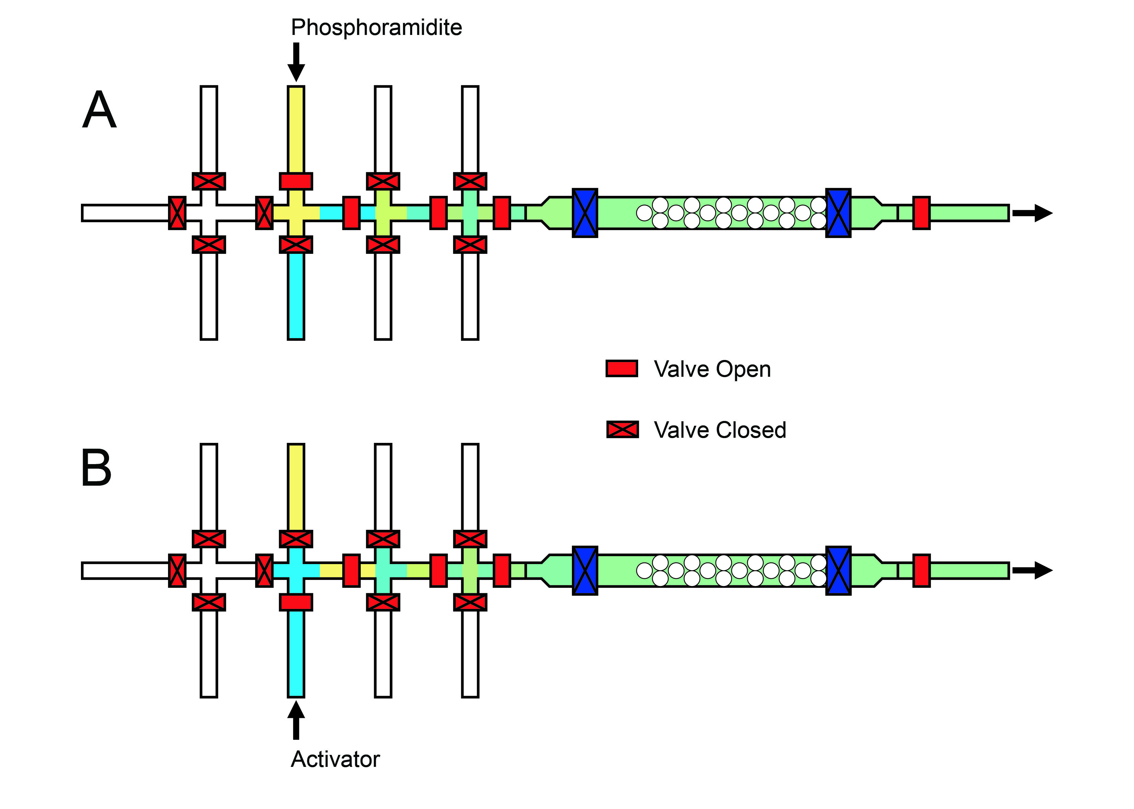
Figure S1. Schematic diagram of the coupling step. (A) Phosphoramidite is flowing through the column. (B) Activator is flowing through the column.

- Electrophoresis
The synthesized oligonucleotides were re-suspended into pH 7.5 TE buffer and mixed with TBE-Urea sample loading buffer (Invitrogen). The samples (typical volume is 20 μL) were loaded onto a TBE-Urea gel. 1X TBE running buffer (Invitrogen) was used. The temperature was set to ca. 60 ºC and the voltage was set to 175 V. Usually running time of 45 min to 1 hour was enough to achieve single-base resolution of the gel bands. For un-labeled samples, we used SYBR gold dye to stain the gels for 30 min. A Typhoon 9410 (GE Health) scanner was used to scan the gel images. The final images were processed using Matlab (Mathworks).

- Mass Spectrometry
The synthesized oligonucleotides were sent to Novatia, LLC (Monmouth Junction, NJ) for HPLC/MS characterization. The LC column was a 2 × 50 mm Clarity C18 3 μm from Phenomenex and the experimental temperature was 40 °C. The gradient was 5-25% B in 20 min at 200 μL/min. A = 0.075% hexafluoroisopropanol (HFIPA) / 0.0375% DIEA in water, B = 90% methanol with 0.075% HFIPA / 0.0375% DIEA. The MS data were acquired on an LTQ mass spectrometer from Thermo. The samples were analyzed by electrospray ionization (ESI) mass spectrometry. The detected signal was deconvoluted to generate the final mass spectra.
- Melting curve measurement
We used a commercial microfluidic digital isolation and detection (DID) chip (Fluidigm, South San Francisco, CA) to carry out melting curve measurements. 1 pmol of standard DNA sample or the DNA sample synthesized from the microfluidic chips (same sequence, with 5’-Cy3 labeled, 5’-Cy3-CCG ACC TGG ATA CTG GCA TT-3’) and 1 pmol of FAM-labeled complementary strand (5’-AAT GCC AGT ATC CAG GTC GGT TT-FAM-3’) or 1 pmol of FAM-labeled single nucleotide mismatched strand (5’-AAT GCC AGT AAC CAG GTC GGT TT-FAM-3’) were mixed with Taq PCR buffer (doped with VOX dye for internal reference) to form 10 μL solutions. The complementary and single nucleotide mismatched strands had 3 extra Thymidine bases at the 3’-end because the fluorescent quantum efficiency would decrease drastically if the FAM was directly coupled to Guanosine. Negative control experiments (solutions containing only FAM-labeled samples or only Cy3-labeled samples, or none of the labeled samples) were also carried out on the same chip simultaneously. We heated the samples to 95 ºC for 5 min and then placed the chips on a lab bench to cool to room temperature in order to hybridize the DNA strands in the solutions.
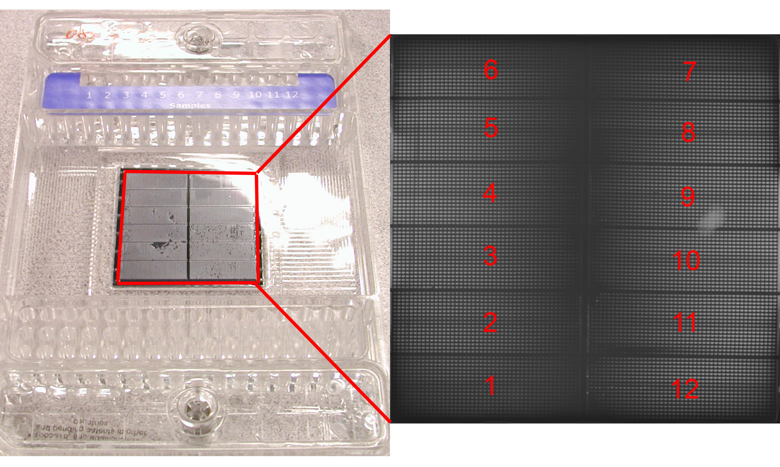
Figure S2. The DID chip and a sample fluorescent image of the chip. Each bright square section in the fluorescent image indicates an isolated reaction well.

We loaded the samples into the chip by following the manufacture’s instructions. Each sample was delivered into 1200 isolated identical reaction cells (Figure S2). The chip was placed on a computer-controlled thermo-cycler and was excited by a band-filtered mercury lamp. The fluorescent signal was captured by CCD camera and both FAM and VOX channels were recorded. We cooled down the chip to 15°C and then slowly increased the temperature from 15 ºC to 75 ºC. We captured the images while the chip is heated. The VOX image at each temperature was used to correct for in-homogeneity of the excitation intensity over the chip area (~ 4 cm × 4 cm). The fluorescent signal for each sample integrated over ~250 individual cells was used for the data processing. Each intensity point was calibrated with VOX channel signal, background-corrected with the negative control experiments, and then normalized as Figure 2 in the paper.
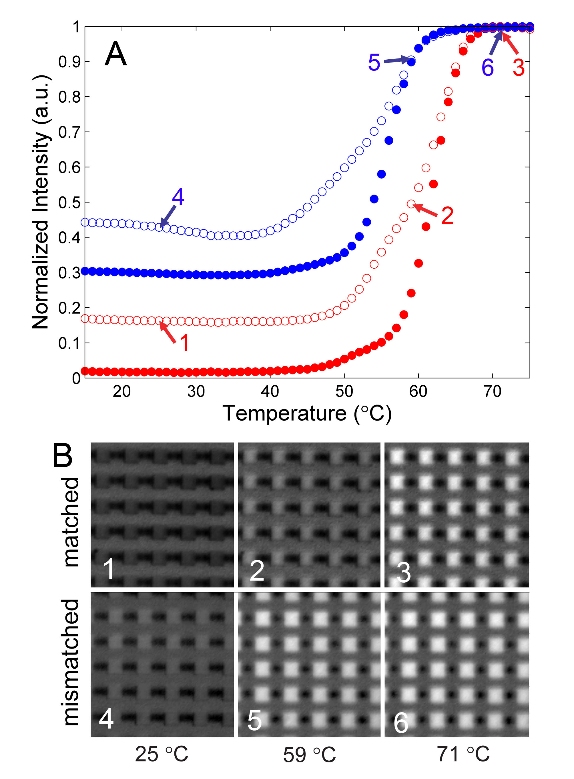
Figure S3. Fluorescent images of unpurified synthesized ss-DNA mixed with complementary and mismatched strands at different temperature on a PDMS chip with multiple reaction wells. Each bright square section in the image is an individual sample well.

- Additional Results
- TBE-Urea Gel electrophoresis.
- 5’-Cy3-TTT TTT TTT TTT TTT TTT TT-3’ (Poly-dT 20-mer, Cy3 labeled)
We also synthesized poly(dT) DNA oligonucleotides (20 mer, with Cy3 labeled at the 5’-end) and compared it to the standard sample purchased from IDT. The standard sample is a mixture of identical amounts of the HPLC purified poly(dT) 10mer, 15mer and 20mer. The gel image (Figure S4) indicates that the major product of our synthesis is the poly(dT) 20mer.
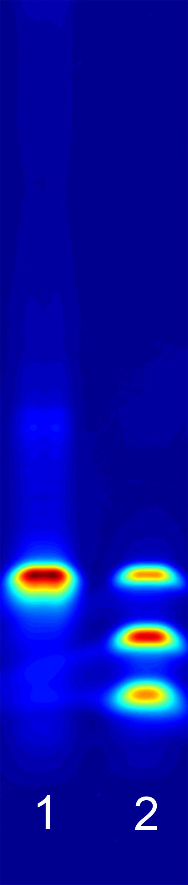
Figure S4. Lane 2 is the mixture of the HPLC purified Cy3-labelled poly-dT 10-mer, 15-mer and 20-mer (all ordered from IDT). Lane 1 is the 5’-Cy3-labeled poly-dT 20-mer sample we synthesized from the PFPE microfluidic chip, without purification.

- 5’-CCG ACC TGG ATA CTG GCA TT-3’ (DNA 20-mer)
We also synthesized the DNA 20-mer without fluorescent labels. We use both gel electrophoresis and LC/MS to test our product. Figure S5 is the gel image. Figure S6 and S7 are LC/MS data. The gel was stained with SYBR gold. Lane 2 contains 1 pmol of DNA molecules, while lane 1 contains 10% of the product from a single reaction on the microfluidic chip. By comparing the fluorescent intensity of the bands, we can estimate that the total amount of the DNA oligonucleotides produced by each run of the reaction is ca. 60 pmol. The reaction of the labeled DNA oligonucleotides has a similar yield.

Figure S5. Lane 2 is the HPLC purified unlabeled DNA 20-mer ordered from IDT. Lane 1 is our synthesized unlabeled DNA 20-mer without purification.

- HPLC/MS result.
Chromatogram Summary
Retention Time (min) | Base Peak Mass (Da) | Intensity | LC/MS Area Percent
14.13 | 5475.4 | 1.61E+004 | 7.57
14.53 | 5788.2 | 1.16E+005 | 24.64
14.74 | 5803.3 | 1.92E+005 | 25.55
14.96 | 6092.5 | 8.94E+005 | 42.24

From the deconvoluted mass spectrums of product from various retention time of HPLC, one can conclude that the major impurities are DNA sequences with deletion of single nucleotides. No obvious results were observed regarding material leached from fluoropolymers. However, due to the inert nature of the fluoropolymer as well as complete curing of the device, leached material should have minimal or no effect on solid-phase synthesis of DNA.

Figure S6. LC/UV chromatogram of the synthesized DNA 20-mer at 260 nm.
Figure S7. The deconvoluted mass spectrum of the synthetic DNA 20-mer at the retention time of 14.96 min. The calculated molecular weight of the DNA 20-mer is 6093 and the detected molecular weight from MS is 6092.5. The smaller peak with molecular weight of 5763.6 comes from a single deletion of nucleotide G in the expected sequence.
Figure S8. The deconvoluted mass spectrum of the synthetic DNA 20-mer at the retention time of 14.74 min. The two large peaks with molecular weight of 5779.0 and 5803.3 correspond to single deletions of nucleotide A or nucleotide C from the expected sequence, respectively.

Figure S9. The deconvoluted mass spectrum of the synthetic DNA 20-mer at the retention time of 14.53 min. The large peak with molecular weight of 5788.2 corresponds to a single deletion of nucleotide T in the expected sequence.

* Correspondence should be addressed to quake@stanford.edu. ^{u} These authors contribute equally to this work. ^{v} Stanford University. # CRIM Labortory. ^{t} California Institute of Technology.

