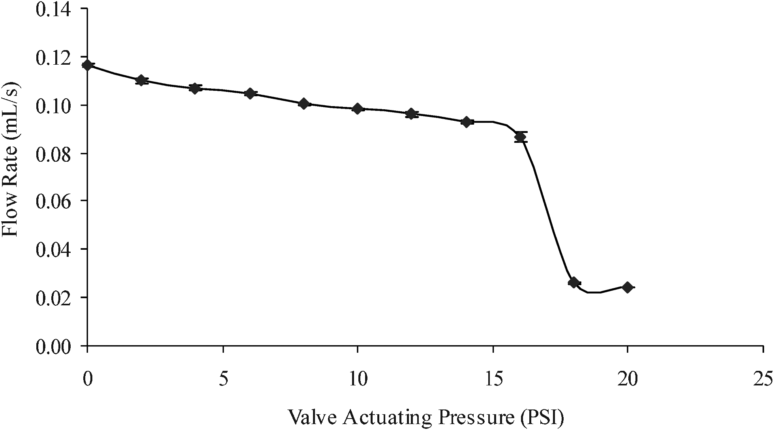

Supplementary Figure 1. Fluid flow (mL/s) versus valve actuating pressure (psi) study on a working Sifel valve.

