Electronic Supplementary Information

Ruthenium Complexes as Novel Inhibitors of Human Islet Amyloid Polypeptide Fibril Formation

Lei He,ª Xuesong Wang,ª Cong Zhao,ª Hongfei Wang, ^{b} Weihong Du*ª
ªDepartment of Chemistry, Renmin University of China, Beijing, 100872, China. Tel : 8610-62512660, Email : whdu@chem.ruc.edu.cn.
^{b}Institute of Opto-Electronics, Shanxi University, Taiyuan, Shanxi Province, 030006, China.
Materials and methods
Materials
Human islet amyloid polypeptide (hIAPP) was chemically synthesized by SBS Biotec company(Beijing, China) and further purified and identified by HPLC and MS. The sample purity was more than 95%. The metal complexes were prepared as described previously.^{[1-3]} All other reagents were of analytical grade. Lyophilized hIAPP was dissolved in HFIP for 1 h to obtain a 4 mg/mL stock solution. Aliquots of the peptide stock solution were lyophilized before use.
Synthesis of Ru complexes
Synthesis of NAMI-A ^{[1]}: 100 mg [(DMSO)₂H][Ru(DMSO)₂Cl₄] was dissolved in 2 mL of acetone and then stirred for 4h after the addition of 49 mg imidazole. The deposit turned into brick red from orange. After filtration, the product was washed with acetone and diethyl ether and vacuum-dried (yield 90%).
Synthesis of Ru(bpy)Cl₄ ^{[2]}: 86 mg RuCl₃·3H₂O, 60 mg KCl and 93.6 mg 2,2’-bipyridine were dissolved in 5 mL of 1 M HCl and stirred at 30 ºC for 72 h. The deposit was filtered and washed with acetone and diethyl ether and vacuum-dried. The product was suspended in 5 mL of 0.2 M HCl and bubbled with Cl₂ for 15 min, and then stirred for 1h. After filtration, the almost black solid was washed with ice-water and dried in a vaccum (yield 56%).
Synthesis of Ru(bpy)₂Cl₂ ^{[3]}: 78 mg RuCl₃·3H₂O, 93.6 mg 2,2’-bipyridine and 84 mg LiCl were heated together at reflux in 5 mL of DMF for 8h. After the reaction mixture was cooled to room temperature, 5 mL of acetone was added and the resultant solution was cooled at 0 ºC overnight. Filtering the yielded red to red-violet solution, a dark green-black microcrystalline was produced. The solid was washed three times with water followed by diethyl ether, and then it was dried a vaccum (yield 76%).
ThT assay
The metal compounds were added in equimolar amounts to hIAPP (5 μM) in a 10 mM phosphate buffer, pH 7.5. The samples were incubated with ThT (10 μM) and the fluorescence was monitored by using a F-4500 Fluorescence spectrometer (Hitachi) with a programmable temperature controller (PolyScience). The ThT signal was quantified by averaging the fluorescence emission at 500 nm over 10 s when the sample was excited at 432 nm. As for the study of aggregation kinetics, the lyophilized peptide was dissolved in sodium phosphate buffer (10 mM, pH 7.5) to a final concentration of 20 μM, and equimolar amounts of Ru compound was added to this solution. The emission intensity at 482 nm was measured over a time course of 0-10 h.
Equilibrium microdialysis
The dialysis tubing (MWCO 10,000), which is impermeable to particles larger than 10,000 Da was used in equilibrium microdialysis. Aging hIAPP (50 μM), which was dissolved in a 10 mM phosphate buffer, pH 7.5, in the absence and presence of equivalent amounts of Ru complexes was added into the dialysis tubing. ThT solution (in the same buffer as the fibrils placed in the dialysis tubing) with an initial concentration C₀ (100μM), was placed outside dialysis tubing (chamber 1). For performing equilibrium microdialysis, the samples were set on a rocking device for 28 hours. Afterwards, the absorption spectra of solutions from the dialysis tubing (chamber 2) and outside it were determined by a Cary 50 UV-vis spectrophotometer (Agilent, USA). A 1 mm quartz cell was used for all UV-vis spectra.
TEM experiments
For the inhibition study, samples were prepared by adding one or three equivalent amounts of metal complex to hIAPP solutions respectively, and then incubated at 37 °C for 4 days. For the disaggregation part, one or three equivalent amounts of metal complex was added to the aging hIAPP and then incubated at 37 °C for 3 days. The final peptide concentration of all samples was 0.1 mM with 1% DMSO. Each sample was spotted onto a carbon-coated 600-mesh copper grid and negatively stained by 2% phosphotungstic acid. Air-dried specimens were examined and photographed by a Hitachi H-800 electron microscope (Hitachi, Japan) operating at 200 kV.

AFM experiments
For the inhibition study, samples were prepared by adding three equivalent amounts of metal complex to hIAPP solutions respectively, and then incubated at 37 °C for 4 days. For the disaggregation part, three equivalent amounts of metal complex was added to the aging hIAPP and then incubated at 37 °C for 3 days. The final peptide concentration of all samples was 5 μM. Images were obtained in the tapping mode with a silicon tip under ambient conditions, a scanning rate of 1 Hz, and a scanning line of 512 using the Veeco D3100 instrument (Veeco Instruments 151 Inc., USA).

UV-vis spectrophotometer
UV absorption spectra were measured from 190-600 nm after serial additions of concentrated Ru compounds stock solution to 60 μM hIAPP solution on a Cary 50 UV-vis spectrophotometer (Agilent, USA). After each addition of metal complex, the solution was mixed by inversion and allowed to equilibrate for a minimum of 1 min before recording the spectrum. Each difference spectrum was obtained by subtracting the absorption of metal complex. A 1 cm quartz cell was used for all UV-vis spectra.
CD analysis
The spectra were measured on a Jasco J-810 spectropolarimeter (Japan Spectroscopy, Japan). The samples were prepared in 5 mM phosphate buffer at pH 7.5. The final peptide concentration was 60 μM. A 1 mm quartz cell was used for all CD spectra. The spectra were recorded between 190 and 250 nm with 0.5 nm spectral step and 2 nm bandwidth. A scan rate of 100 nm min⁻¹ with 1 s response time was employed. The background spectrum of corresponding Ru complex was removed using the same buffer. The final spectrum for each sample was the average of three repeated experiments.
MALDI-TOF MS
The peptide concentration used in MS determination was constant at 250 μM. Ten equivalent amounts of metal complex was added to the hIAPP solultion. All MS measurements were performed with a BIFLEX III MALDI-TOF mass spectrometer (Bruker Daltonics, Bremen, Germany) equipped with a nitrogen laser (λ=337 nm). Mass spectra (20 summed shots) were acquired in the reflector mode with a 19 kV accelerating voltage and a 20 kV reflector voltage. Prior to MS analysis, matrix solution and analyte solution were mixed at an equal volume, and 1 μL of the mixed solution was spotted on the MALDI target plate. After being dried in air, the samples were subjected to analysis.
NMR spectroscopy
NMR spectroscopy experiments were carried out on Bruker 400 MHz spectrometer. Suppression of the residual water signal was achieved using a watergate pulse program with gradients. 2D TOCSY experiments were acquired with a total spinlock time of 120 ms using a regular MLEV-17 mixing sequence. All samples were prepared at 10mM phosphate buffer, pH 5.5. Chemical shifts were referenced to the methyl resonance of 4,4-dimethyl-4-silapentane-1-sulfonic acid used as internal standard.
Cell culture and MTT assay
INS-1 rat insulinoma cell line was got from BIOK&KM company (Wuxi, China). Cells were grown in monolayer cultures in RPMI-1640 medium supplemented with 10% FBS, 2 mmol/L L-glutamine, 100 U/mL penicillin, and 100 U/mL streptomycin, at 37 ºC in a humidified (5% CO₂, 95% air) atmosphere. The cells seeded in 96-well microplate at a density of 1×10⁴ cells per well were cultured at 37 ºC in a humidified atmosphere for 24 h, and then they were exposed to different treatments. After 48 hours of reaction, cells were incubated with 10 μL MTT at 37 ºC. The absorbance of the final solution was recorded in a spectrophotometer at 570 nm. Each experiment was carried out in quadruplicate. The data were calculated as a percentage of untreated control values. Each sample repeated three times.

[1] A. Bergamo, R. Gagliardi, V. Scarcia, A. Furlani, E. Alessio, G. Mestroni, G. Sava, J. Pharmacol. Exp. Ther., 1999, 289, 559-564.
[2] F. Dwyer, H. Goodwin, E. Gyarfas, Aust. J. Chem., 1962, 16, 42-50.
[3] B. Sullivan, D. Salmon, T. Meyer, Inorg. Chem., 1978, 17, 3334-3341.

Fig. S1 Structures of metal complexes: (A) NAMI-A; (B) Ru(bipy)Cl₄; (C) Ru(bipy)₂Cl₂.

Fig. S2 Evaluation of the effects of Ru complexes on inhibition of hIAPP aggregation by ThT assay. (A) hIAPP was incubated with ThT in the absence (black) and presence of equivalent amounts of NAMI-A (red), Ru(bipy)Cl₄ (blue), and Ru(bipy)₂Cl₂ (green). (B) ThT fluorescence intensity in the absence (black) and presence of equivalent amounts of NAMI-A (red), Ru(bipy)Cl₄ (blue), and Ru(bipy)₂Cl₂ (green).

Fig. S3 Evaluation of the effects of Ru complexes on inhibition of hIAPP aggregation as measured by ThT fluorescence. (A) hIAPP was incubated with ThT in the absence (black) and presence of 1.0 equiv of NAMI-A (red), 2.0 equiv of NAMI-A (blue), 3.0 equiv of NAMI-A (green), 4.0 equiv of NAMI-A (magenta) and 5.0 equiv of NAMI-A (dark yellow). (B) hIAPP was incubated with ThT in the absence (black) and presence of 1.0 equiv of Ru(bipy)Cl₄ (red), 2.0 equiv of Ru(bipy)Cl₄ (blue), 3.0 equiv of Ru(bipy)Cl₄ (green), 4.0 equiv of Ru(bipy)Cl₄ (magenta) and 5.0 equiv of Ru(bipy)Cl₄ (dark yellow). (C) hIAPP was incubated with ThT in the absence (black) and presence of 1.0 equiv of Ru(bipy)₂Cl₂ (red), 2.0 equiv of Ru(bipy)₂Cl₂ (blue), 3.0 equiv of Ru(bipy)₂Cl₂ (green), 4.0 equiv of Ru(bipy)₂Cl₂ (magenta) and 5.0 equiv of Ru(bipy)₂Cl₂ (dark yellow). As shown at the right column, the effects of Ru complexes on ThT fluorescence intensity with corresponding concentration.

Fig. S4 The absorption spectrum of equilibrium microdialysis experiments. (A) Absorption spectra of ThT incorporated in the hIAPP fibrils in the absence of metal complexes. Black curve and purple curve represent absorption of ThT in chamber 1 (free ThT at concentration C_{f}) and in chamber 2 (superposition of the absorption spectra of free ThT at concentration C_{f}, ThT bound to frbrils at concentration C_{b}, and the apparent absorption caused by the light scattering) after the equilibrium attained. Gray curve represents optical density determined by the fibril light scattering as calculated by the equation D_{scat}=αλ^{-m}. Coefficients α and m were determined from the linear part of the purple curve. Green curve represents the total absorption of free and bound ThT after light scattering subtraction. The red curve is the absorption spectrum of ThT incorporated in the amyloid fibrils (the difference between the green curve and the blue one). (B) Absorption spectra of ThT incorporated in the hIAPP fibrils in the absence of NAMI-A. (C) Absorption spectra of ThT incorporated in the hIAPP fibrils in the absence of Ru(bipy)Cl₄. (D) Absorption spectra of ThT incorporated in the hIAPP fibrils in the absence of Ru(bipy)₂Cl₂.

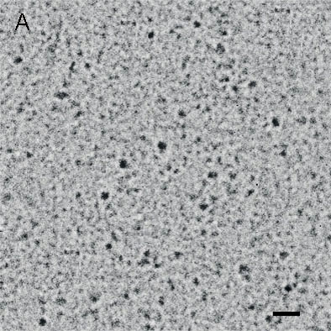
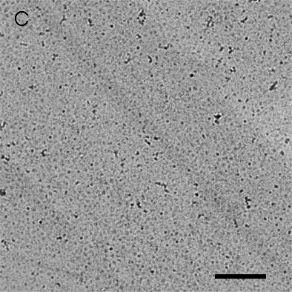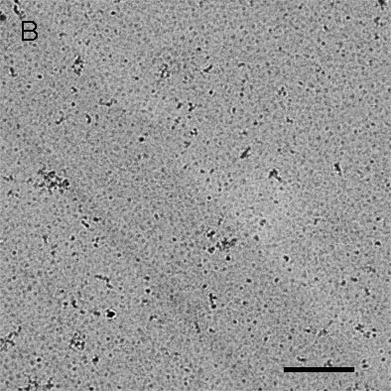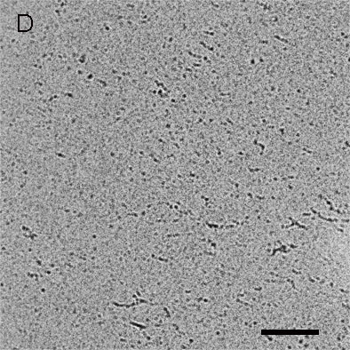
Fig. S5 (A) TEM image of the study on the formation of hIAPP fibrils at initial time. The scale bar is 100 nm. TEM image of different Ru complexes on the copper grid (B) NAMI-A, (C) Ru(bipy)Cl₄ and (D) Ru(bipy)₂Cl₂. The scale bar is 500 nm.

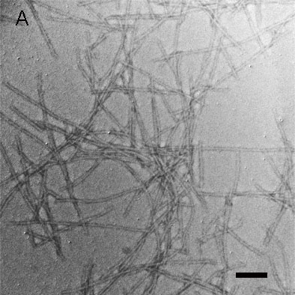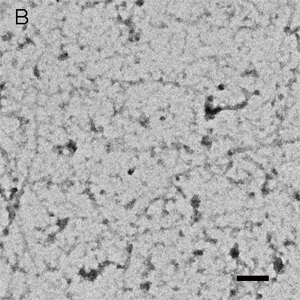
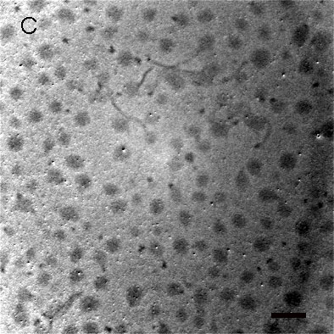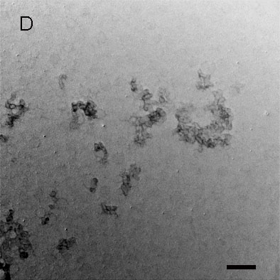
Fig. S6 TEM images of the comprehensive study of the inhibition effects of Ru complexes on hIAPP fibrils formation. (A) Incubation of hIAPP in the absence and the presence of equivalent amounts of (B) NAMI-A, (C) Ru(bipy)Cl₄, (D) Ru(bipy)₂Cl₂. The scale bar is 100 nm.

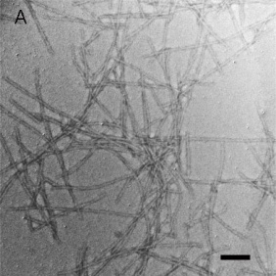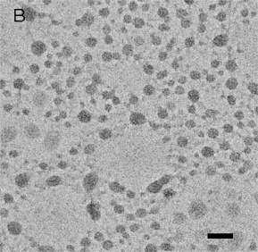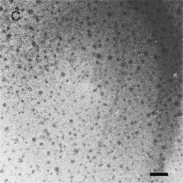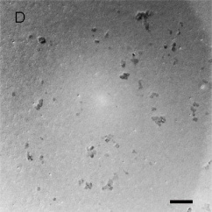
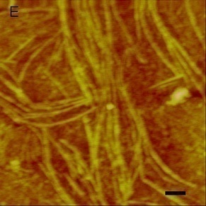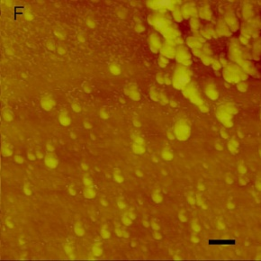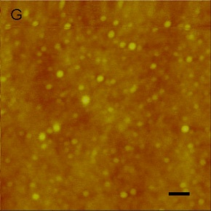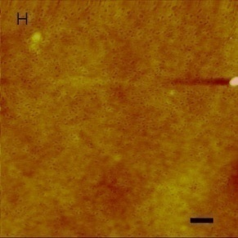
Fig. S7 TEM and AFM images of the comprehensive study of the inhibition effects of Ru complexes on hIAPP fibrils formation. (A and E) Incubation of hIAPP in the absence and the presence of 3 equivalent amounts of (B and F) NAMI-A, (C and G) Ru(bipy)Cl₄, (D and H) Ru(bipy)₂Cl₂. The scale bar is 100 nm.

Fig. S8 (A) Observed UV difference spectra of hIAPP measured from 190-450 nm in the absence (black) and presence of 1.0 equiv of NAMI-A (red), 2.0 equiv of NAMI-A (blue), 3.0 equiv of NAMI-A (green), 4.0 equiv of NAMI-A (magenta) and 5.0 equiv of NAMI-A (dark yellow). The absorption of metal complex was subtracted. (B) UV spectra of NAMI-A with different concentrations, 1.0 equiv of NAMI-A (red), 2.0 equiv of NAMI-A (blue), 3.0 equiv of NAMI-A (green), 4.0 equiv of NAMI-A (magenta), 5.0 equiv of NAMI-A (dark yellow).

Fig. S9 (A) Observed UV difference spectra of hIAPP measured from 190-450 nm in the absence (black) and presence of 1.0 equiv of Ru(bipy)Cl₄ (red), 2.0 equiv of Ru(bipy)Cl₄ (blue), 3.0 equiv of Ru(bipy)Cl₄ (green), 4.0 equiv of Ru(bipy)Cl₄ (magenta) and 5.0 equiv of Ru(bipy)Cl₄ (dark yellow). The absorption of metal complex was subtracted. (B) UV spectra of Ru(bipy)Cl₄ with different concentrations, 1.0 equiv of Ru(bipy)Cl₄ (red), 2.0 equiv of Ru(bipy)Cl₄ (blue), 3.0 equiv of Ru(bipy)Cl₄ (green), 4.0 equiv of Ru(bipy)Cl₄ (magenta), 5.0 equiv of Ru(bipy)Cl₄ (dark yellow).

Fig. S10 (A) Observed UV difference spectra of hIAPP measured from 190-450 nm in the absence (black) and presence of 1.0 equiv of Ru(bipy)₂Cl₂ (red), 2.0 equiv of Ru(bipy)₂Cl₂ (blue), 3.0 equiv of Ru(bipy)₂Cl₂ (green), 4.0 equiv of Ru(bipy)₂Cl₂ (magenta) and 5.0 equiv of Ru(bipy)₂Cl₂ (dark yellow). The absorption of metal complex was subtracted. (B) UV spectra of Ru(bipy)₂Cl₂ with different concentrations, 1.0 equiv of Ru(bipy)₂Cl₂ (red), 2.0 equiv of Ru(bipy)₂Cl₂ (blue), 3.0 equiv of Ru(bipy)₂Cl₂ (green), 4.0 equiv of Ru(bipy)₂Cl₂ (magenta), 5.0 equiv of Ru(bipy)₂Cl₂ (dark yellow).

Fig. S11 (A) Circular dichroism spectra of Ru complexes alone. NAMI-A (red), Ru(bipy)Cl₄ (blue), and Ru(bipy)₂Cl₂ (green). (B) Circular dichroism spectra of NAMI-A with different concentrations, 0.4 equiv of NAMI-A (red), 1.0 equiv of NAMI-A (blue), and 3.0 equiv of NAMI-A (green). (C) Circular dichroism spectra of Ru(bipy)Cl₄ with different concentrations, 0.4 equiv of Ru(bipy)Cl₄ (red), 1.0 equiv of Ru(bipy)Cl₄ (blue), and 3.0 equiv of Ru(bipy)Cl₄ (green). (D) Circular dichroism spectra of Ru(bipy)₂Cl₂ with different concentrations, 0.4 equiv of Ru(bipy)₂Cl₂ (red), 1.0 equiv of Ru(bipy)₂Cl₂ (blue), and 3.0 equiv of Ru(bipy)₂Cl₂ (green). These spectra were not smoothed.

Fig. S12 (A) Circular dichroism spectra of the hIAPP (black) and in the presence of 0.4 equiv of Ru(bipy)Cl₄ (red), 1.0 equiv of Ru(bipy)Cl₄ (blue), and 3.0 equiv of Ru(bipy)Cl₄ (green). (B) Circular dichroism spectra of the hIAPP (black) and in the presence of 0.4 equiv of Ru(bipy)₂Cl₂ (red), 1.0 equiv of Ru(bipy)₂Cl₂ (blue), and 3.0 equiv of Ru(bipy)₂Cl₂ (green). The spectras were smoothed by OriginPro software after subtracting the absorption of Ru complex.

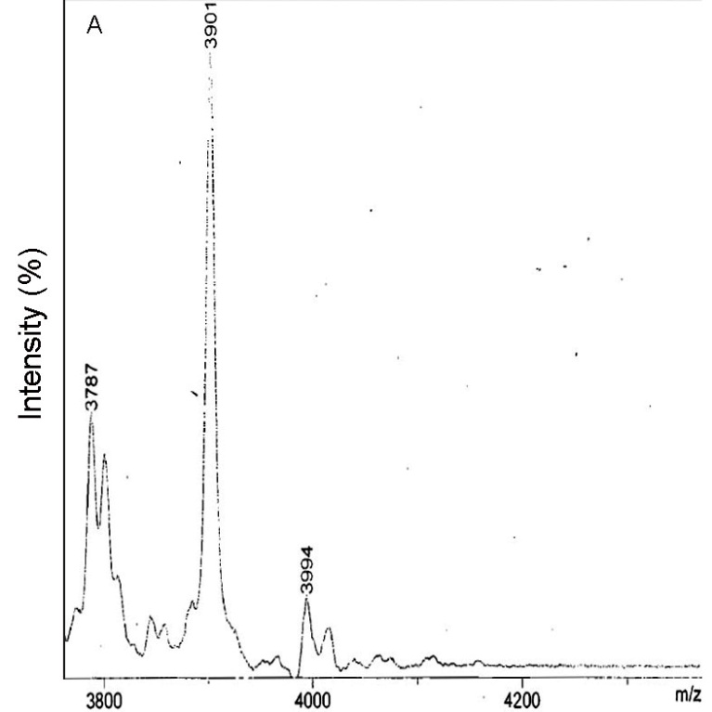

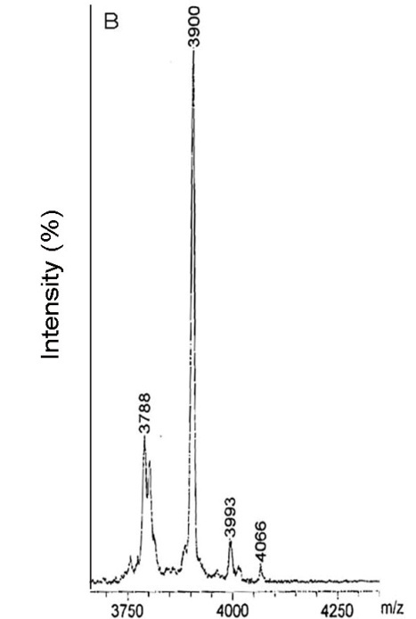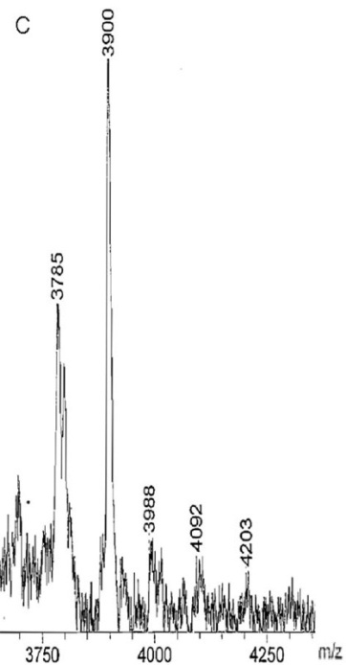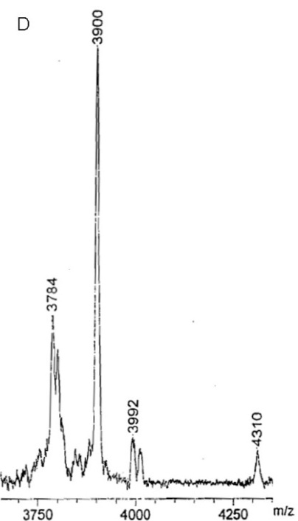

Fig. S13 (A) MALDI-TOF/MS results of hIAPP in the absence and presence of (B) NAMI-A, (C) Ru(bipy)Cl₄, and (D) Ru(bipy)₂Cl₂. The samples were prepared by adding ten equivalent amounts of Ru complexes to hIAPP (250 μM).

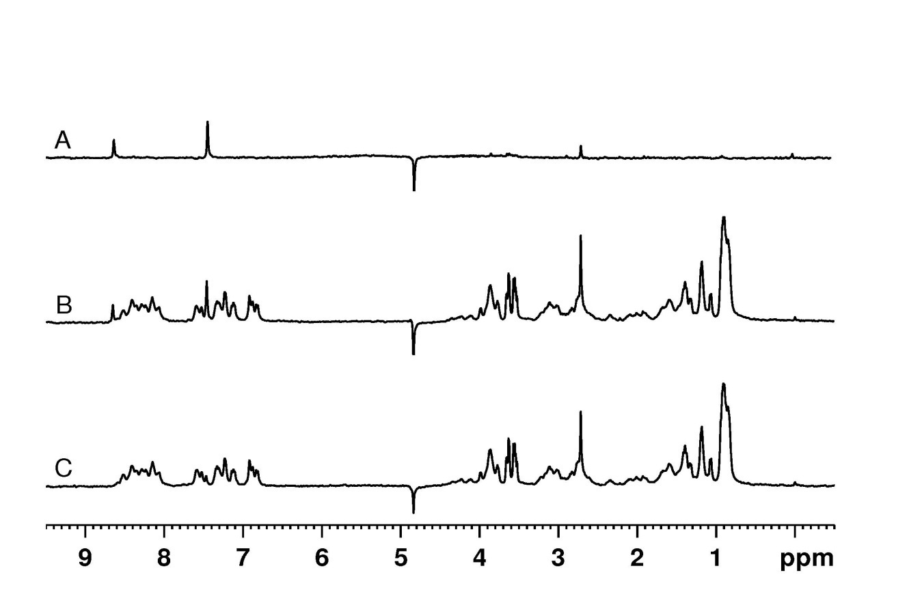
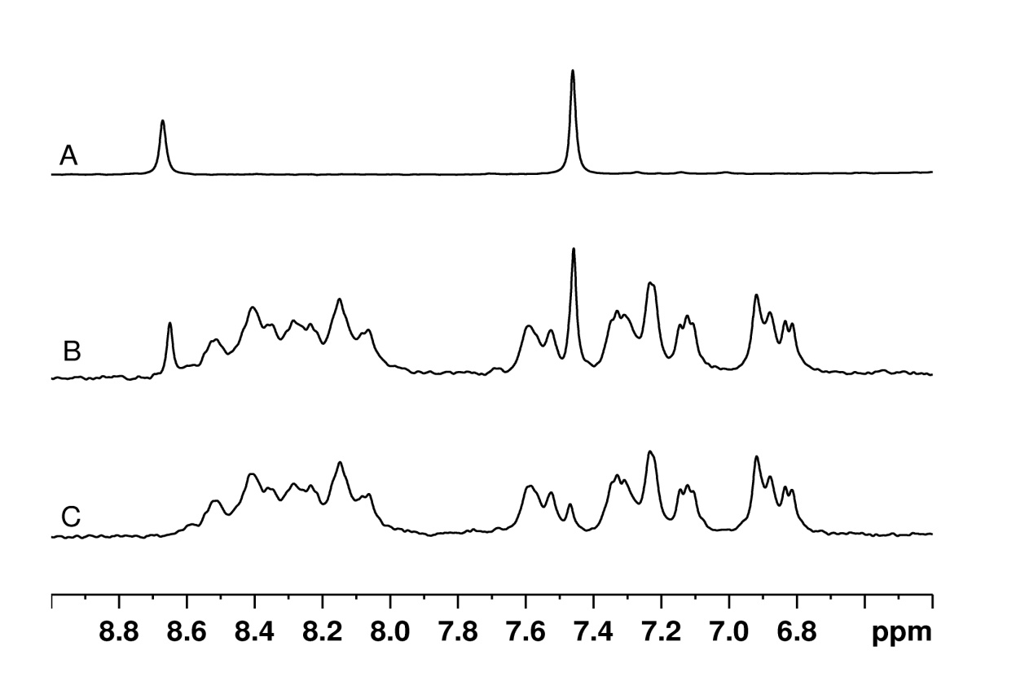
Fig. S14 Lower panel: ¹H NMR spectra of 0.12 mM hIAPP and 0.24 mM NAMI-A in H₂O/D₂O at pH 5.5, 298 K. (A) NAMI-A; (B) hIAPP in the presence of NAMI-A (2.0 equiv); (C) hIAPP. The signals at 8.66 ppm (green circle in A) and 7.45 ppm (purple circle in A) of NAMI-A was clearly perturbed by the interaction with hIAPP. Upper panel: The total spectra corresponding to lower panel.

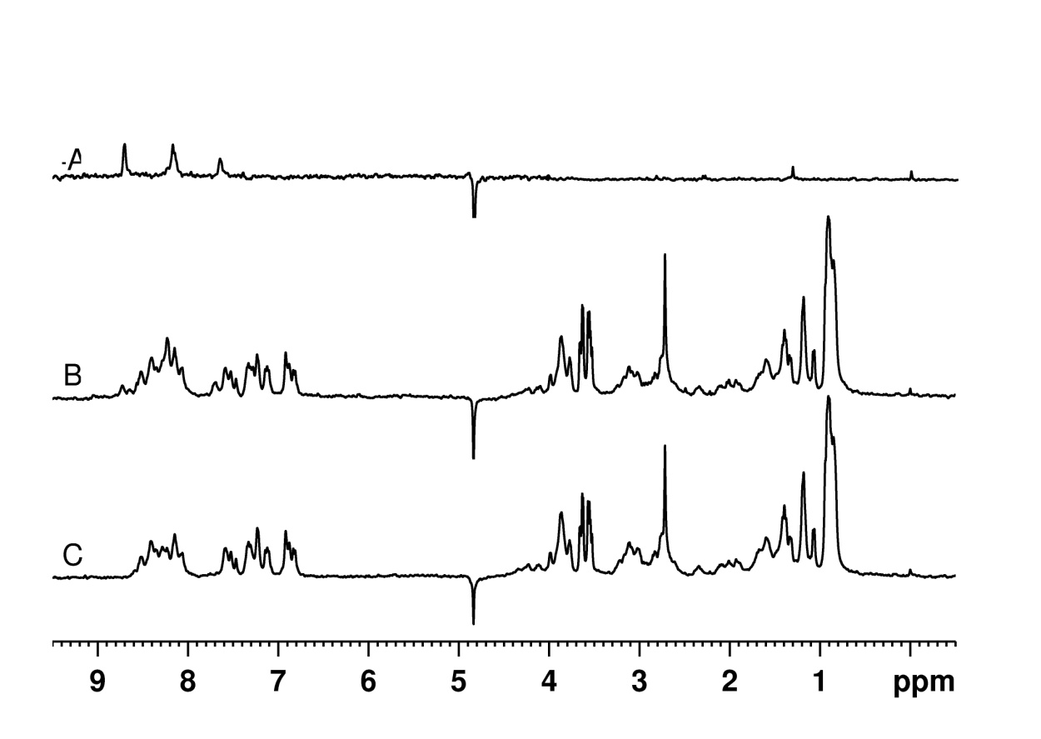
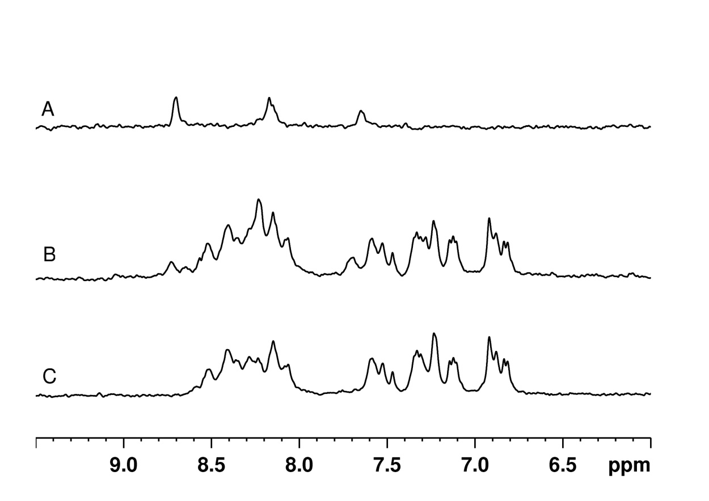
Fig. S15 Lower panel:¹H NMR spectra of 0.12 mM hIAPP and 0.24 mM Ru(bipy)Cl₄ in H₂O/D₂O at pH 5.5, 298 K. (A) Ru(bipy)Cl₄; (B) hIAPP in the presence of Ru(bipy)Cl₄ (2.0 equiv); (C) hIAPP. The signal at 8.75 ppm (green circle in A) of Ru(bipy)Cl₄ was clearly perturbed by the interaction with hIAPP. Upper panel: The total spectra corresponding to lower panel.

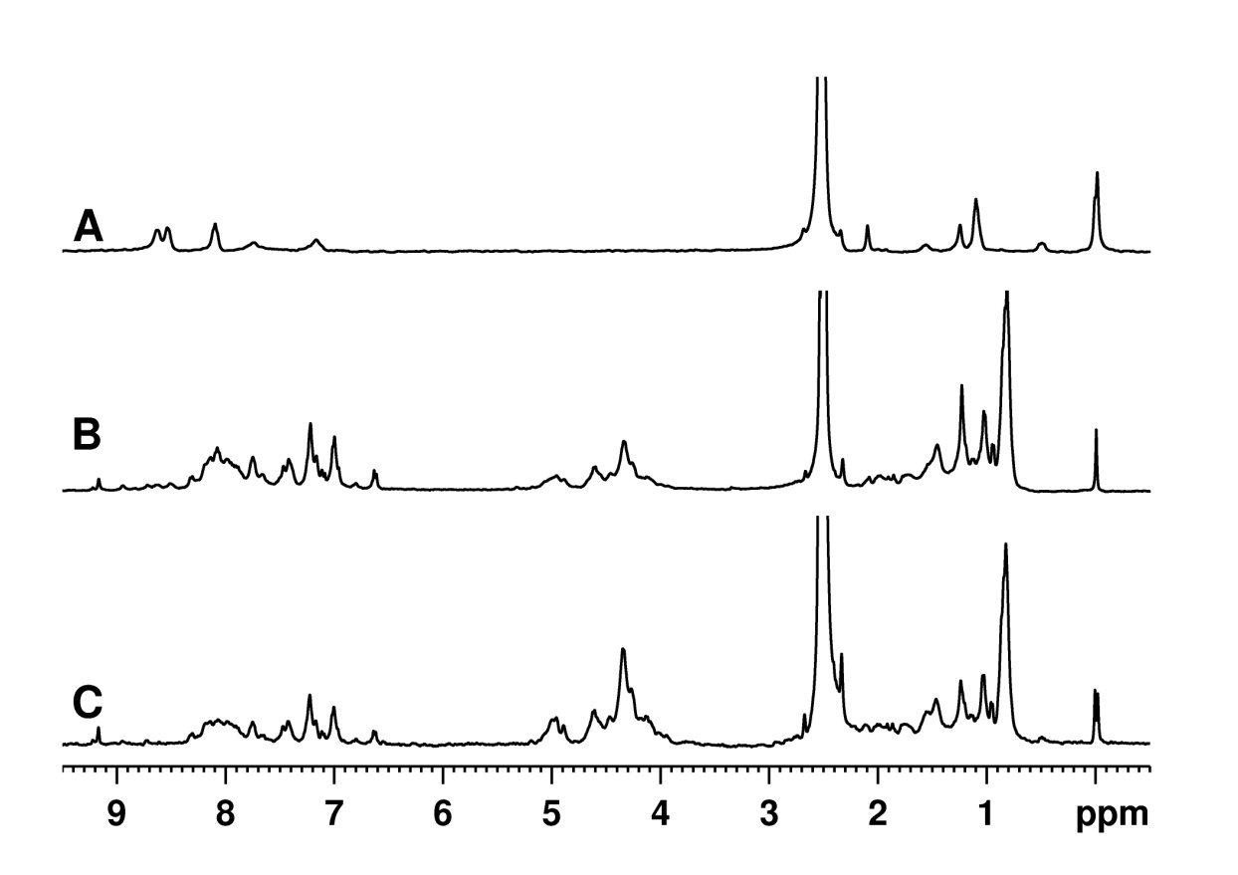
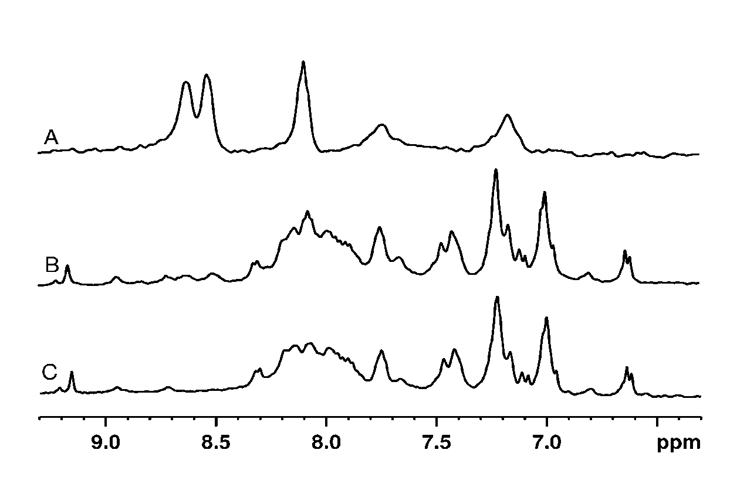
Fig. S16 Lower panel: ¹H NMR spectra of 0.12 mM hIAPP and 0.24 mM Ru(bipy)₂Cl₂ obtained in d6-DMSO, 298 K. (A) Ru(bipy)₂Cl₂; (B) hIAPP in the presence of Ru(bipy)₂Cl₂ (2.0 equiv); (C) hIAPP. The signal around 8.60 ppm (green circle in A) of Ru(bipy)₂Cl₂ was significantly relaxed. This implying that Ru(bipy)₂Cl₂ can interact with hIAPP. Upper panel: The total spectra corresponding to lower panel.

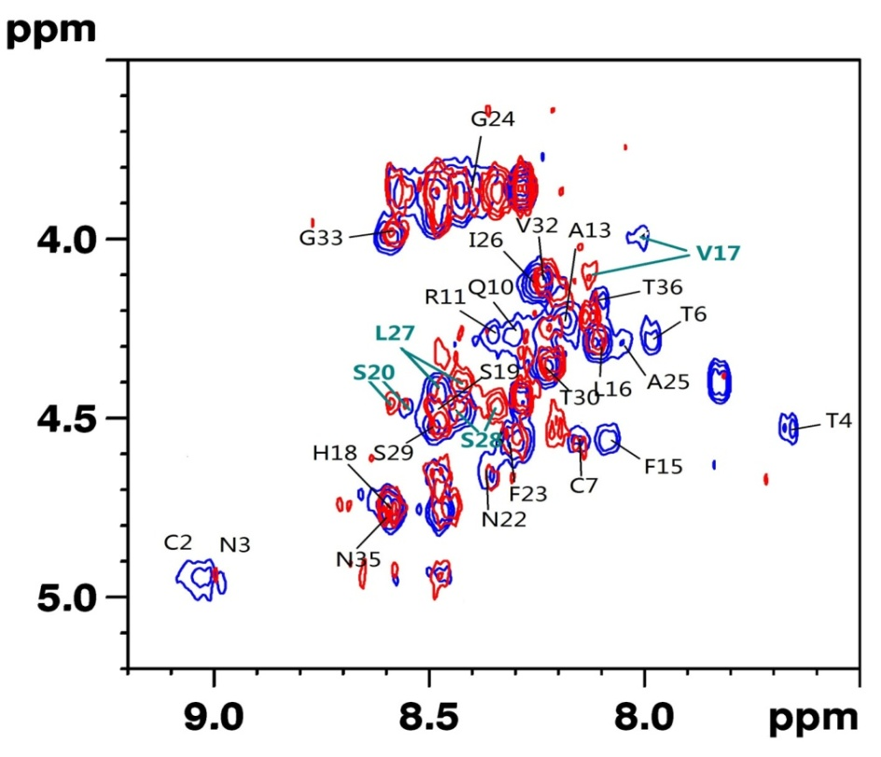
Fig. S17 ¹H-¹H TOCSY of 0.12 mM hIAPP in H₂O with 10% d6-DMSO at pH 5.5, 283K in the absence (blue) and presence (red) of 1.0 equiv of NAMI-A.

Fig. S18 Evaluation of the ability of Ru complexes to disaggregate hIAPP amyloid deposition as measured by ThT fluorescence. hIAPP amyloid deposition was incubated with ThT in the absence (black) and presence of equivalent amounts of NAMI-A (red), Ru(bipy)Cl₄ (blue), and Ru(bipy)₂Cl₂ (green).

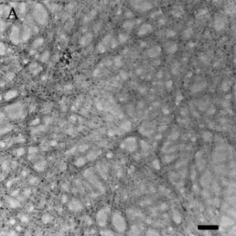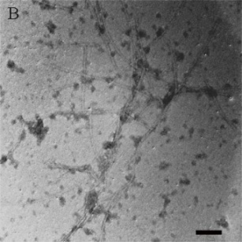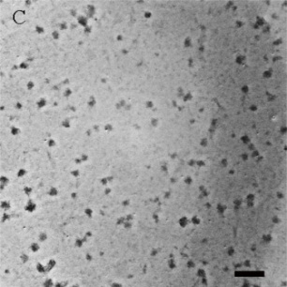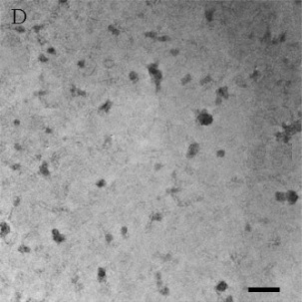
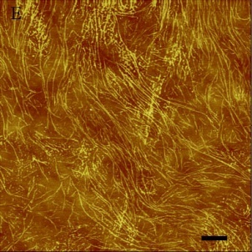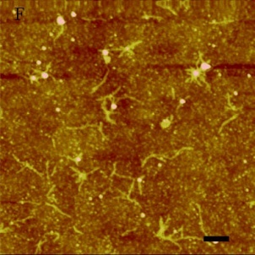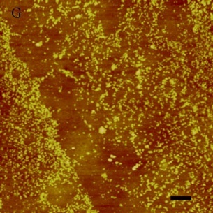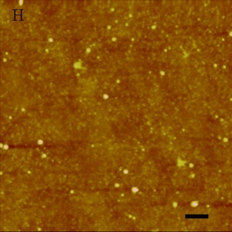
Fig. S19 TEM and AFM images of the comprehensive study of the disaggregation effects of Ru complexes on the hIAPP aggregates. (A and E) hIAPP aggregating alone, with addition of 3 equivalent amounts of (B and F) NAMI-A, (C and G) Ru(bipy)Cl₄, (D and H) Ru(bipy)₂Cl₂. The scale bar of TEM images is 100 nm. The scale bar of AFM images is 500 nm.

Fig. S20 (A) Evaluation of the ability of the Ru compounds to inhibit hIAPP aggregation as measured by ThT fluorescence. hIAPP was incubated with ThT in the absence (black) and presence of equivalent amounts of RuCl₃ (magenta), and Ru(bipy)₂Cl₂ (green). (B) ThT fluorescence intensity in the absence (black) and presence of equivalent amounts of RuCl₃ (magenta), and Ru(bipy)₂Cl₂ (green).

Fig. S21 Evaluation of the ability of Ru compounds to disaggregate hIAPP amyloid deposition as measured by ThT fluorescence. hIAPP amyloid deposition was incubated with ThT in the absence (black) and presence of equivalent amounts of RuCl₃ (magenta), and Ru(bipy)₂Cl₂ (green).

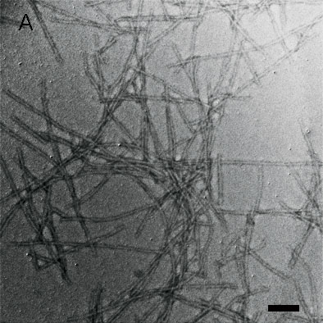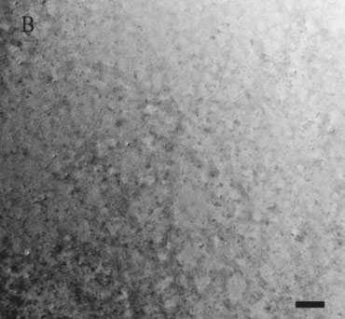
Fig. S22 TEM images of the inhibition study of RuCl₃ on hIAPP fibril formation. (A) Incubation of hIAPP in the absence of and (B) presence of equivalent amounts of RuCl₃. The scale bar is 100 nm.

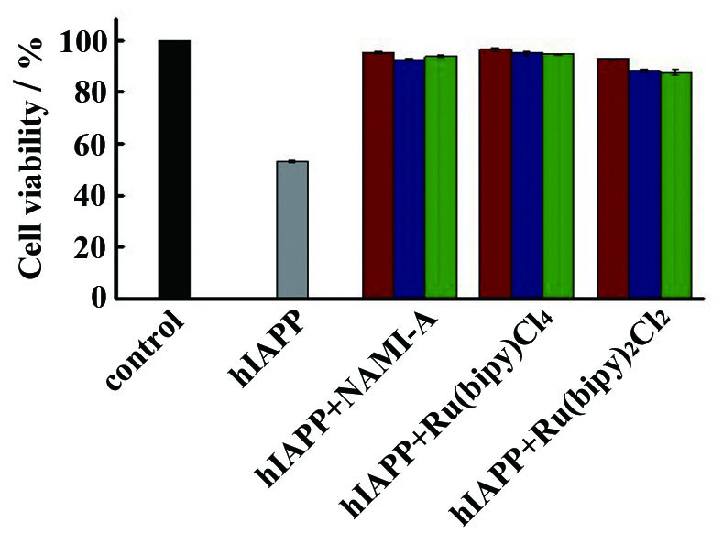
Fig. S23 Cell viability was monitored using the MTT assay. INS-1 cells were treated with hIAPP (15 μM) alone (grey column) or different concentrations of Ru complexes. 15 μM Ru complexes (red column), 45 μM Ru complexes (blue column), and 90μM Ru complexes (green column). The cytotoxicity test of treating with hIAPP alone was used for comparison. The data are shown as means ± SD.

Scheme S1. Proposed diagram of the suppositional fibrillization pathway (A) in the absence and (B) presence of metal complex.

