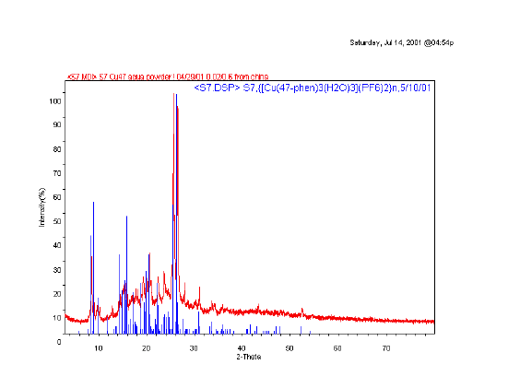
Cu(4,7-phen)(H₂O)₃(ClO₄)₂(4,7-phen)₂

Figure S1 Experimental and simulated powder X-ray diffraction pattern of 1.

