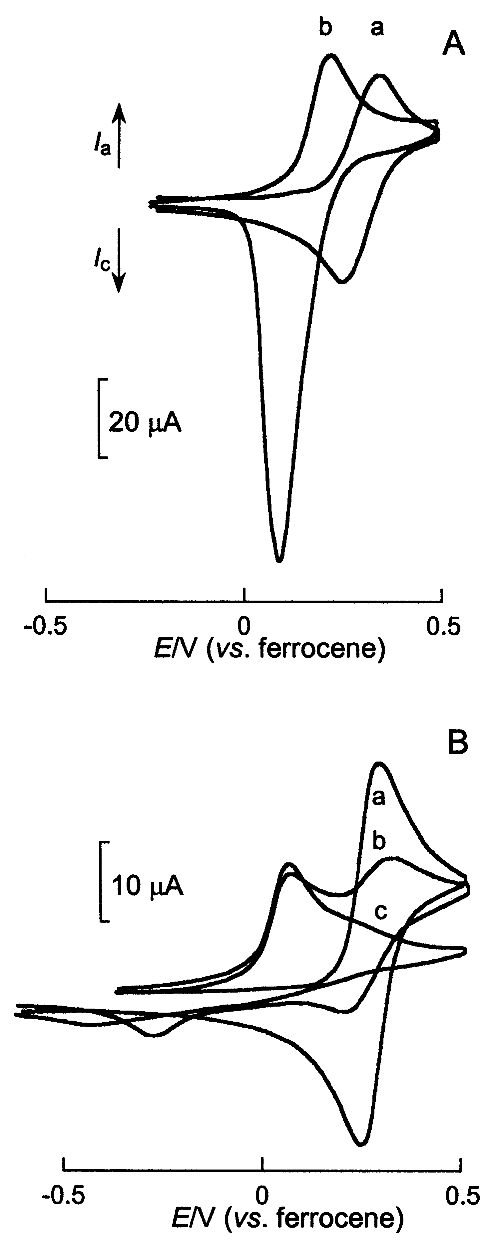

Figure S1 Cyclic voltammograms, recorded at a Pt disc electrode (5 mm in diameter), of (ferrocenemethyl)trimethylammonium 1 (0.6 mM) in CH₂Cl₂ (A) or CH₃CN (B) + 0.1 M TBAP in the presence of HSO₄– (A) or ATP^{2–} (B) ; A : (a) : free ligand; (b) HSO₄–/1 = 10 ; B : (a) : free ligand; (b) ATP^{2–}/1 = 0.9 ; (c) ATP^{2–}/1 = 1.5 ; Sweep rate 0.1Vs^{–1}.

