Figures captions for Electronic supplementary information

Fig. S1. ¹H NMR (D₂O) for dried 1 (showing traces of DMF in 1).
Fig. S2. ¹H NMR (D₂O) for dried 1, immersed in a mixture of acetoneCH₃CNCH₃OHC₂H₅OH (1:1:1:1), then dried in air, indicating that only ethanol molecules were absorbed.
Fig. S3. ¹H NMR (D₂Oacetone-d₆ = 4:1) for dried 1, immersed in a mixture of benzenetolueneTHFC₂H₅OH (1:1:1:1), then dried in air, indicating only ethanol molecules were absorbed (the trace of toluene is due to its higher boiling point, and it disappeared after a longer period of drying in air (over 2 h).
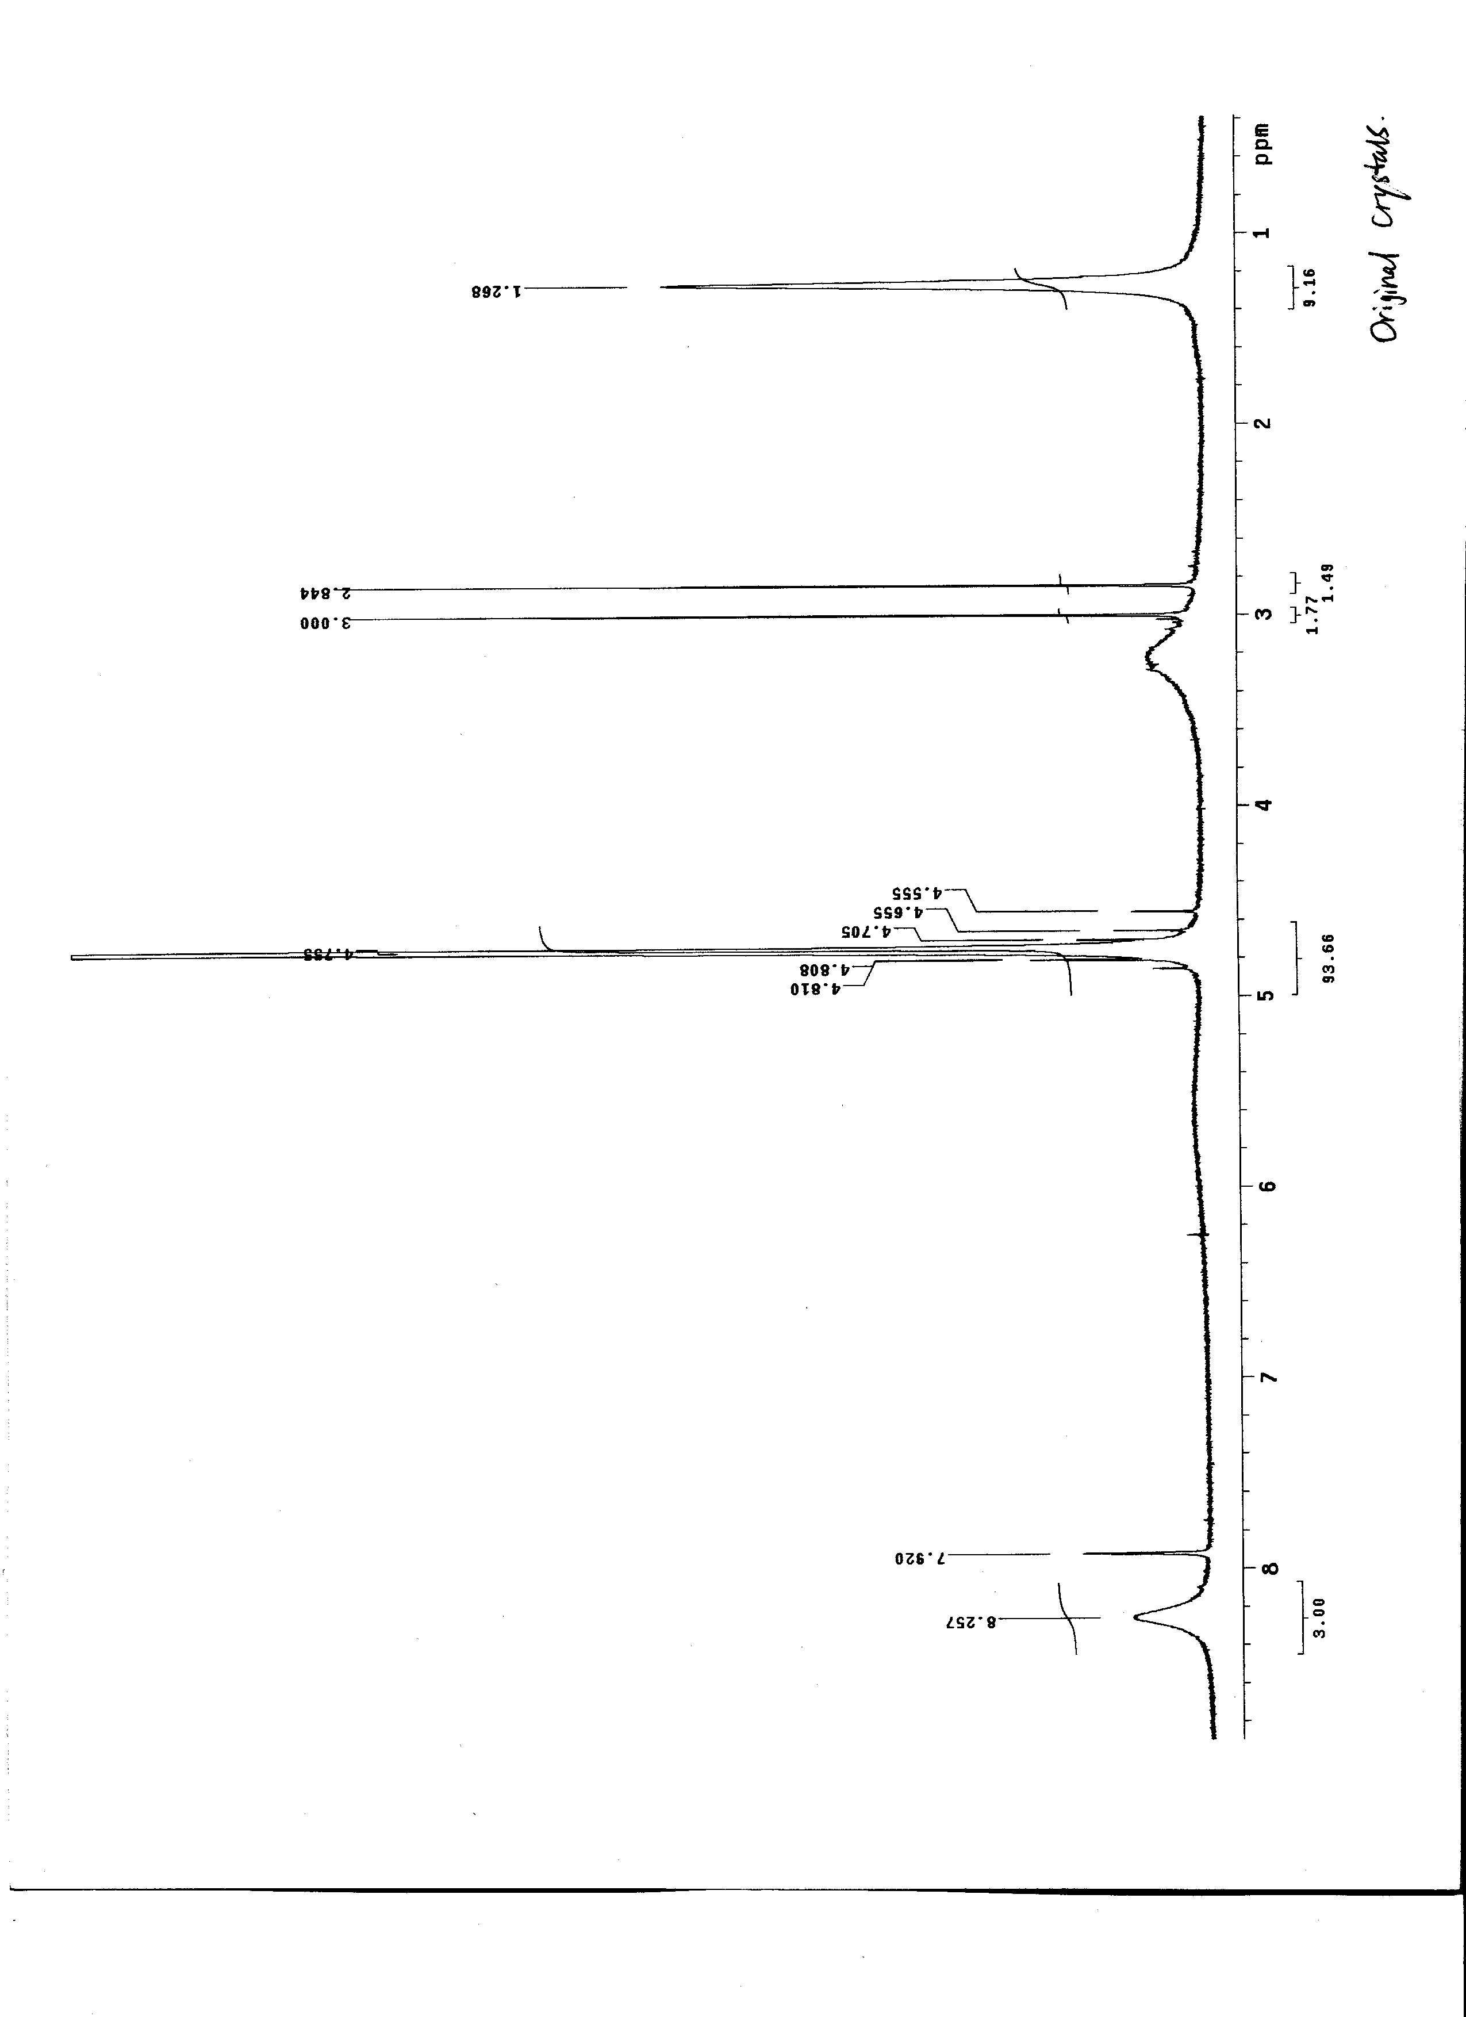

Fig. S1

Fig. S2
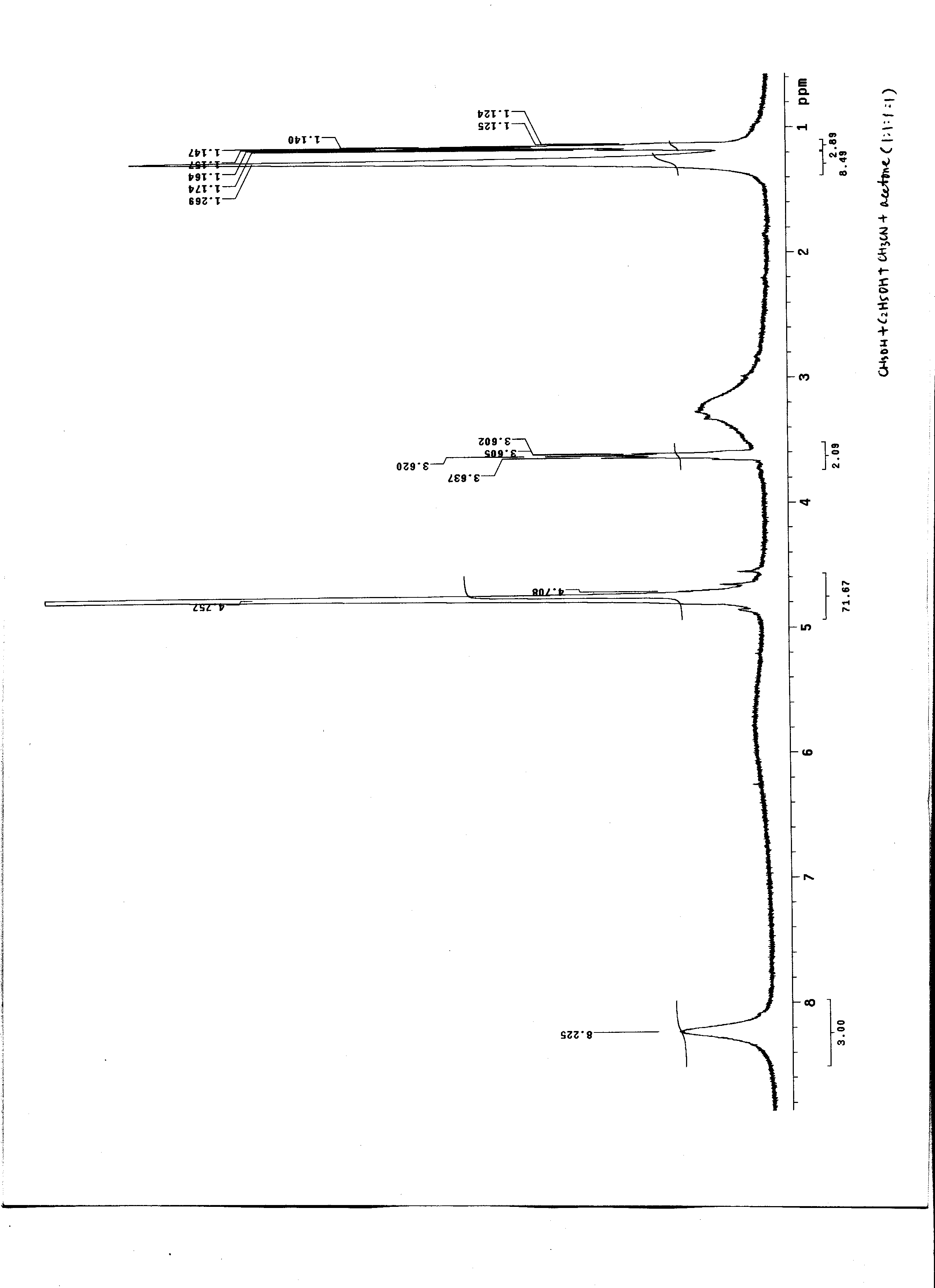

Fig. S3
