Fig. S1 Partial energy level diagram of [RuCl₂(bpy)L³], (1c).

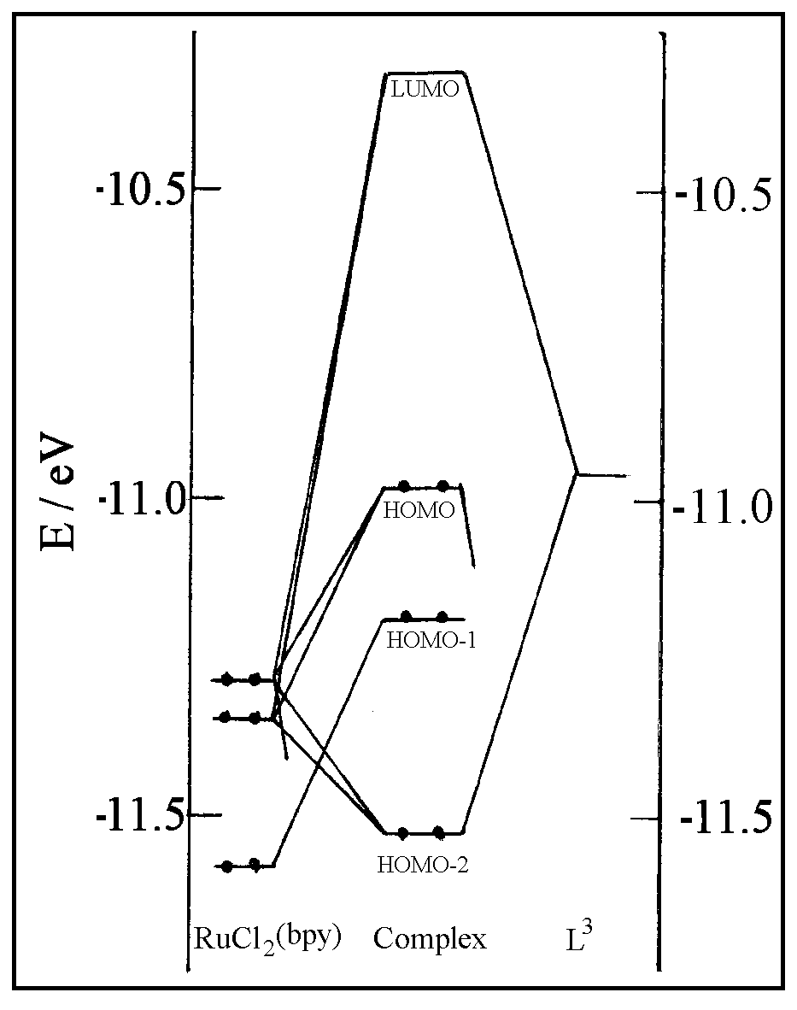

Fig. S2 Pictorial representation of MOs of [RuCl₂(bpy)L³], (1c) : (a) LUMO, (b)
HOMO, (c) HOMO-1, (d) HOMO-2.

