Supporting Information for :

Cationic Diphosphaferrocenes Gallium dichloride complexes

Xavier Sava, Mohand Melaimi, Nicolas Mézailles, Louis Ricard,

François Mathey* and Pascal Le Floch*

Table S1: Cartesian coordinates, optimized geometry of the [Ga (tmdpf) Cl₂]⁺ complex.
Table S2: Cartesian coordinates, optimized geometry of the tmdpf ligand.
Table S3: Cartesian coordinates, optimized geometry of the [Ga(dpe)Cl₂]⁺ 2 pages

Some MOs orbitals of the [Ga(tmdpf)Cl₂]⁺ complex as given by DFT. 3 pages

Some MOs orbitals of the tmdpf ligand as given by DFT. 3 pages.

TABLE S1: Bond distances and angles of the theoretical structure of the [Ga(tmdpf)Cl₂]⁺ complex.

---------------------------------------------------------------------
Center Atomic Atomic Coordinates (Angstroms)
Number Number Type X Y Z
---------------------------------------------------------------------
1 15 0 0.191583 0.000026 -1.989082
2 6 0 -1.027223 -1.306139 -1.663898
3 6 0 -2.324198 -0.722088 -1.537114
4 6 0 -1.029124 1.304488 -1.664179
5 6 0 -2.325259 0.718564 -1.537288
6 31 0 1.649791 0.000583 -0.000362
7 26 0 -1.149563 -0.000611 0.000141
8 17 0 2.714169 -1.889972 0.000094
9 17 0 2.712845 1.891902 -0.000410
10 6 0 -1.027317 -1.305092 1.664891
11 6 0 -2.324027 -0.720630 1.537839
12 6 0 -1.028051 1.305496 1.663962
13 6 0 -2.324482 0.720125 1.537235
14 15 0 0.192234 0.000551 1.989022
15 6 0 -0.740794 -2.778844 1.777361
16 6 0 -0.742491 2.779383 1.775541
17 6 0 -0.744169 2.778478 -1.776547
18 6 0 -0.740186 -2.779747 -1.775845
19 1 0 -3.232781 -1.315778 -1.409496
20 1 0 -3.234755 1.310871 -1.409772
21 1 0 -3.232912 -1.313924 1.410488
22 1 0 -3.233602 1.312914 1.409388
23 1 0 -0.758194 -3.077631 2.840165
24 1 0 0.250198 -3.040469 1.376192
25 1 0 -1.506641 -3.372905 1.255407
26 1 0 -0.760240 3.078758 2.838185
27 1 0 -1.508620 3.372697 1.253162
28 1 0 0.248438 3.041374 1.374450
29 1 0 0.246703 3.041053 -1.375701
30 1 0 -1.510434 3.371728 -1.254287
31 1 0 -0.762230 3.077394 -2.839310
32 1 0 0.251226 -3.040716 -1.375280
33 1 0 -0.758260 -3.079083 -2.838487
34 1 0 -1.505366 -3.373892 -1.253011
---------------------------------------------------------------------

SCF Done: E(RB-P86) = -5258.65410349

TABLE S2: Bond distances and angles of the theoretical structure of the tmdpf ligand.

---------------------------------------------------------------------
Center Atomic Atomic Coordinates (Angstroms)
Number Number Type X Y Z
---------------------------------------------------------------------
1 15 0 1.523270 0.025131 1.762527
2 6 0 -1.076004 0.737747 1.580841
3 6 0 -1.073547 -0.700378 1.599213
4 6 0 0.248260 -1.253250 1.670853
5 6 0 0.244019 1.296646 1.638718
6 6 0 0.524048 2.779465 1.694717
7 6 0 0.532776 -2.733307 1.764145
8 26 0 0.000000 0.000000 0.000000
9 15 0 1.523300 -0.024963 -1.762527
10 6 0 0.248276 1.253418 -1.670776
11 6 0 -1.073502 0.700638 -1.599182
12 6 0 -1.075989 -0.737549 -1.580948
13 6 0 0.244034 -1.296417 -1.638870
14 6 0 0.532898 2.733475 -1.763977
15 6 0 0.523956 -2.779373 -1.694931
16 1 0 -1.984222 1.341629 1.495026
17 1 0 -1.979630 -1.309494 1.528763
18 1 0 0.525269 3.126694 2.744171
19 1 0 1.507141 3.029984 1.265000
20 1 0 -0.242737 3.360153 1.154510
21 1 0 0.537888 -3.053726 2.822113
22 1 0 -0.234467 -3.328644 1.241196
23 1 0 1.515213 -2.992050 1.337921
24 1 0 -1.979600 1.309708 -1.528671
25 1 0 -1.984222 -1.341431 -1.495224
26 1 0 1.515060 2.992279 -1.337158
27 1 0 0.538635 3.053848 -2.821945
28 1 0 -0.234680 3.328873 -1.241500
29 1 0 -0.243027 -3.359940 -1.154922
30 1 0 0.525391 -3.126434 -2.744446
31 1 0 1.506943 -3.029907 -1.265015
---------------------------------------------------------------------

SCF Done: E(RB-P86) = -2413.58317085

TABLE S3: Bond distances and angles of the theoretical structure of the [Ga(dpe)Cl₂]⁺ complex.

---------------------------------------------------------------------
Center Atomic Atomic Coordinates (Angstroms)
Number Number Type X Y Z
---------------------------------------------------------------------
1 31 0 0.740283 0.001213 -0.000252
2 17 0 1.672242 1.878958 -0.476320
3 17 0 1.712958 -1.856301 0.470284
4 15 0 -1.071062 -0.430884 -1.611558
5 1 0 -1.047755 -1.613372 -2.390015
6 1 0 -1.306692 0.585310 -2.571647
7 15 0 -1.070638 0.411776 1.616280
8 1 0 -1.307187 -0.612972 2.567117
9 1 0 -1.048487 1.587439 2.404993
10 6 0 -2.614131 -0.531552 -0.568180
11 1 0 -3.502340 -0.395853 -1.204016
12 1 0 -2.654048 -1.556601 -0.164451
13 6 0 -2.612119 0.520622 0.571948
14 1 0 -3.501780 0.389574 1.206745
15 1 0 -2.645888 1.545916 0.168239
---------------------------------------------------------------------

SCF Done: E(RB-P86) = -3608.84642918

Molecular Orbitals of [Ga(tmdpf)Cl2]+ calculated at the BP86/DZVP2 (C, H, P, Fe) DZVP (Ga) level of theory.

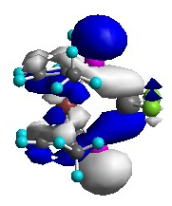
LUMO

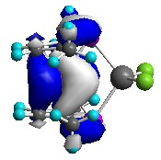
HOMO

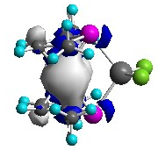
H-1

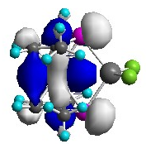
H-2

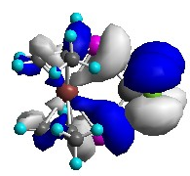
H-3

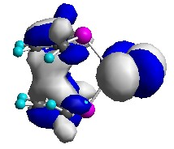
H-4

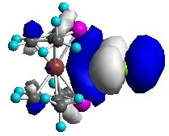
H-5

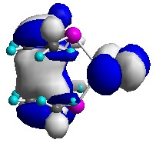
H-6

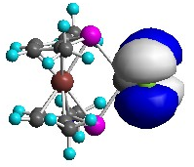
H-7

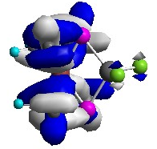
H-8

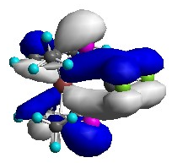
H-9

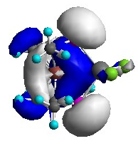
H-10

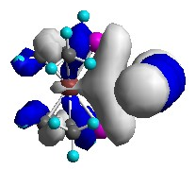
H-11

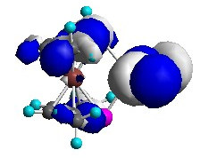
H-12

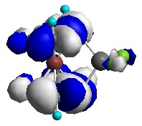
H-13

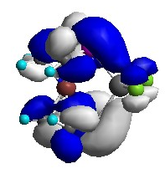
H-14

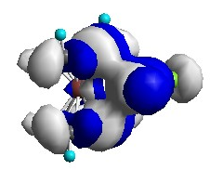
H-15

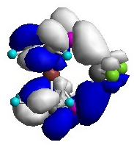
H-16

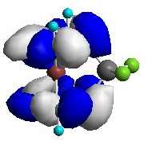
H-17

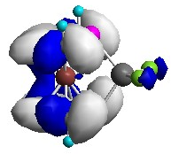
H-18

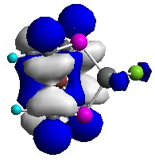
H-19

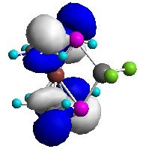
H-20

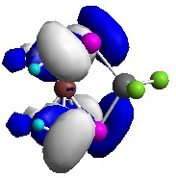
H-21

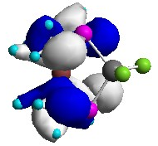
H-22

Molecular Orbitals of the tmdpf ligand calculated at the BP86/ DZVP2 (C, H, P, Fe) level of theory.

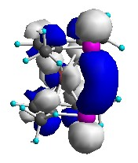
L+2

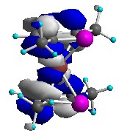
L+1

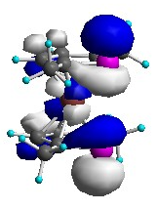
LUMO

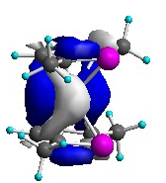
HOMO

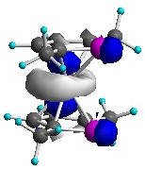
H-1

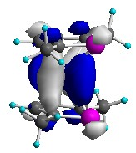
H-2

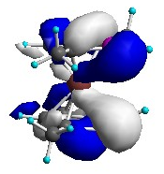
H-3

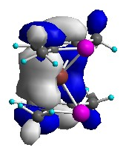
H-4

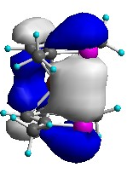
H-5

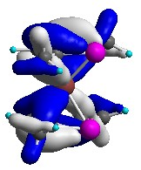
H-6

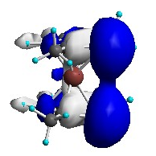
H-7

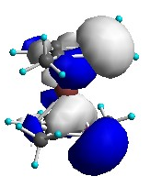
H-8

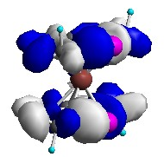
H-9

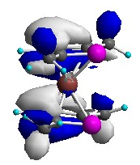
H-10

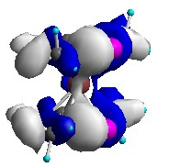
H-11

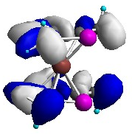
H-12

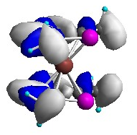
H-13

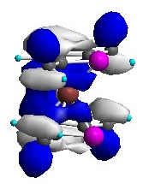
H-14

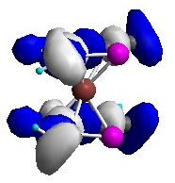
H-15

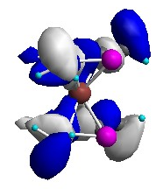
H-16

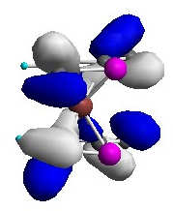
H-17

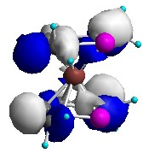
H-18

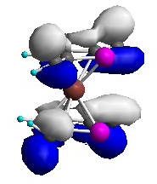
H-19

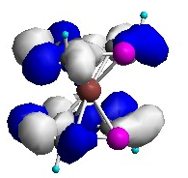
H-17

