Supplementary Figure
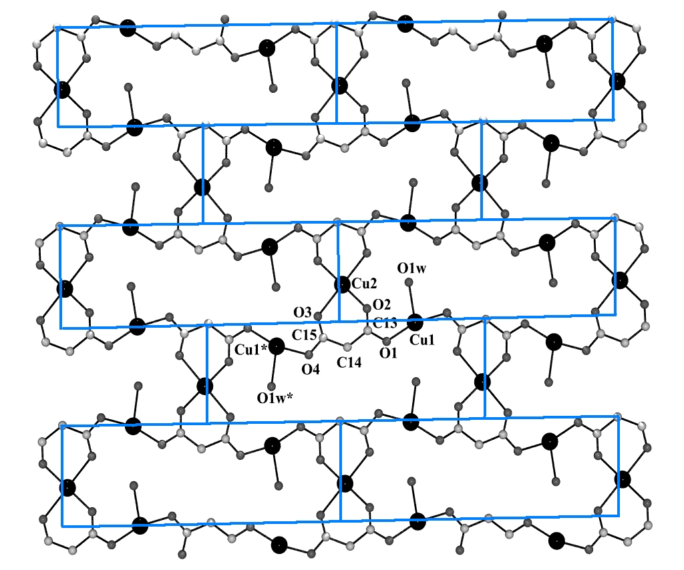

Fig S1: Showing the brick-walled shaped view of the [{Cu₃(malonate)₂(H₂O)₂}]_{n} layer

