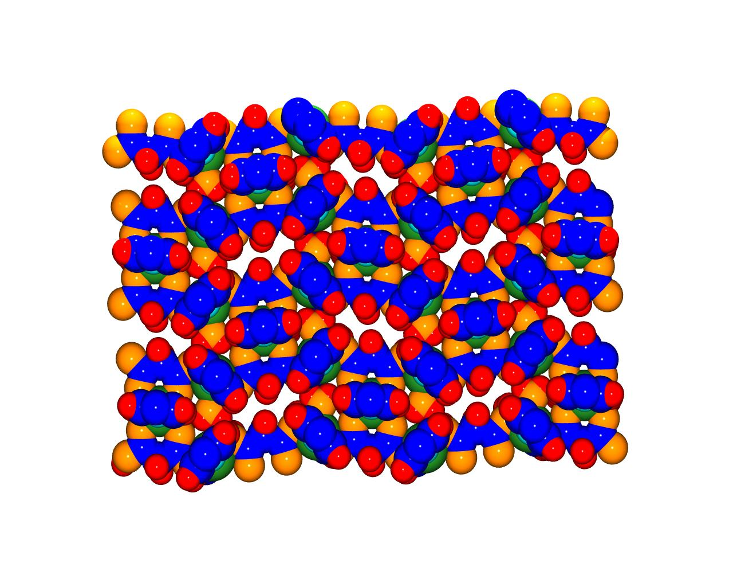
Supplementary figure Fig. S2 Space-filled diagram showing channels viewed down X-axis.

