The synthesis and characterization of a series of bis-bidentate Schiff base ligands and their coordination complexes with silver(I), copper(I) and zinc(II) d¹⁰ metal ions
Goutam Kumar Patra and Israel Goldberg*
School of Chemistry, Sackler Faculty of Exact Sciences, Tel Aviv University
69978 Ramat Aviv, Tel Aviv, Israel. E-mail: goldberg@post.tau.ac.il

Supplementary Figures

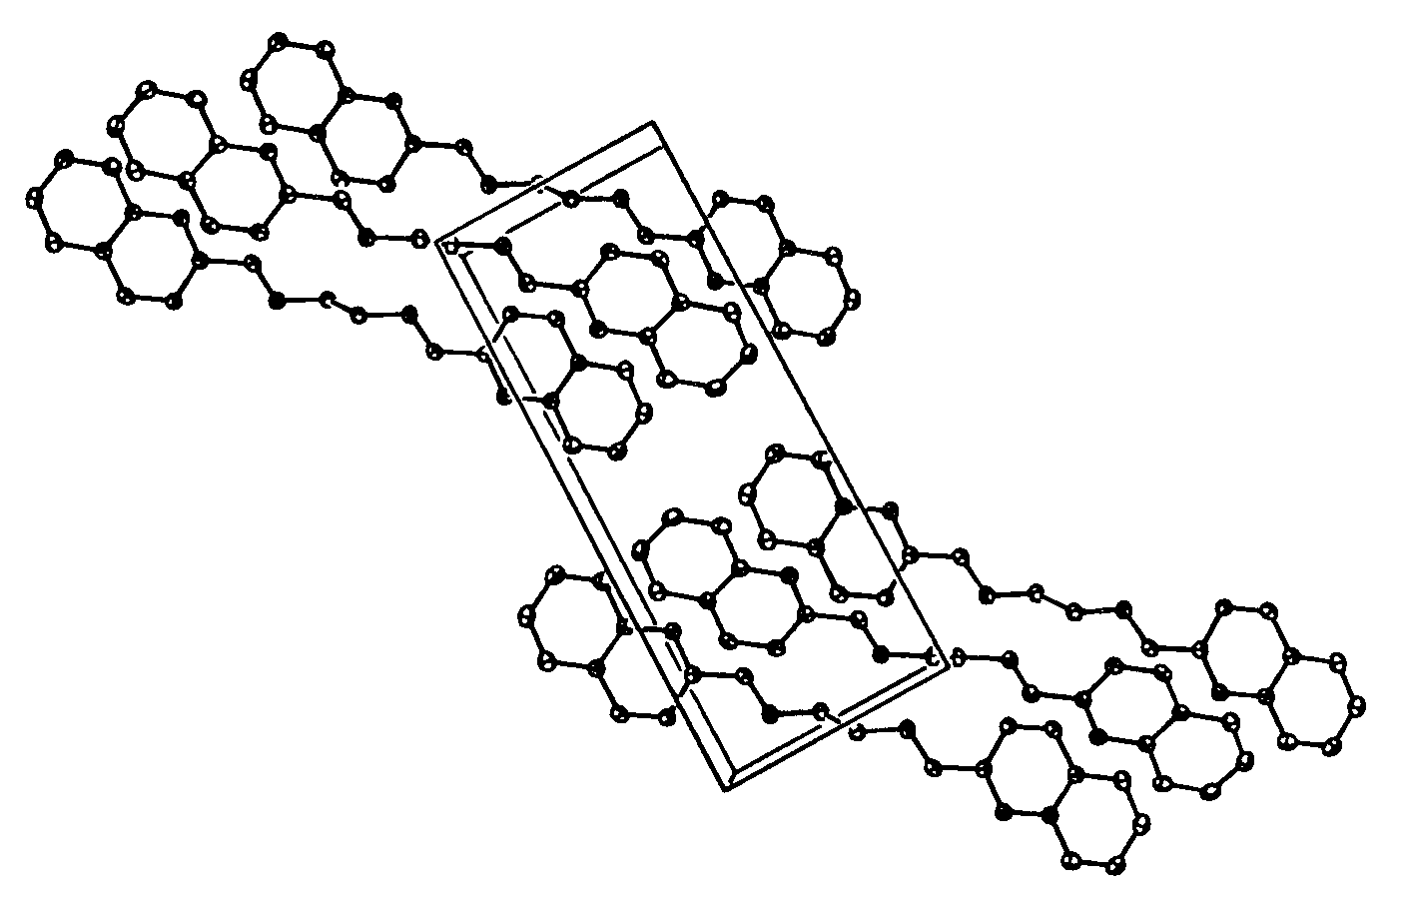

Fig. 1s View of the crystal structure of ligand 1, showing the parallel alignment of the extended molecules in the lattice.

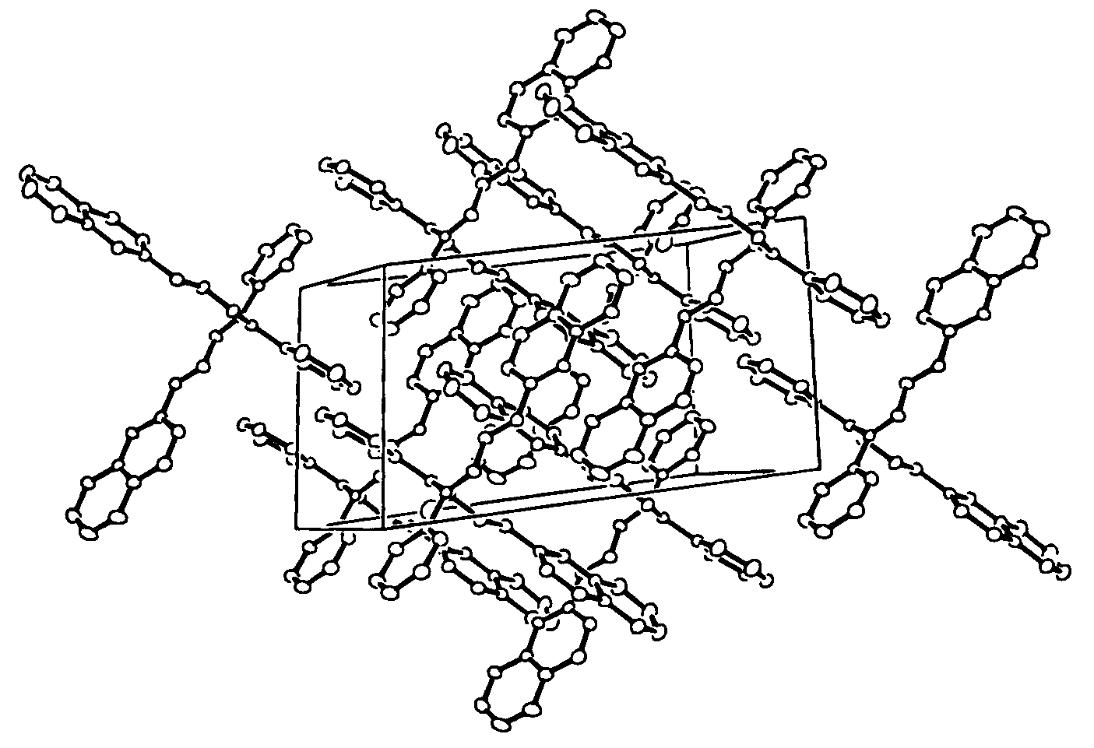

Fig. 2s View of the crystal structure of ligand 2. Note the parallel overlapping arrangements of the aromatic fragments in the lattice.

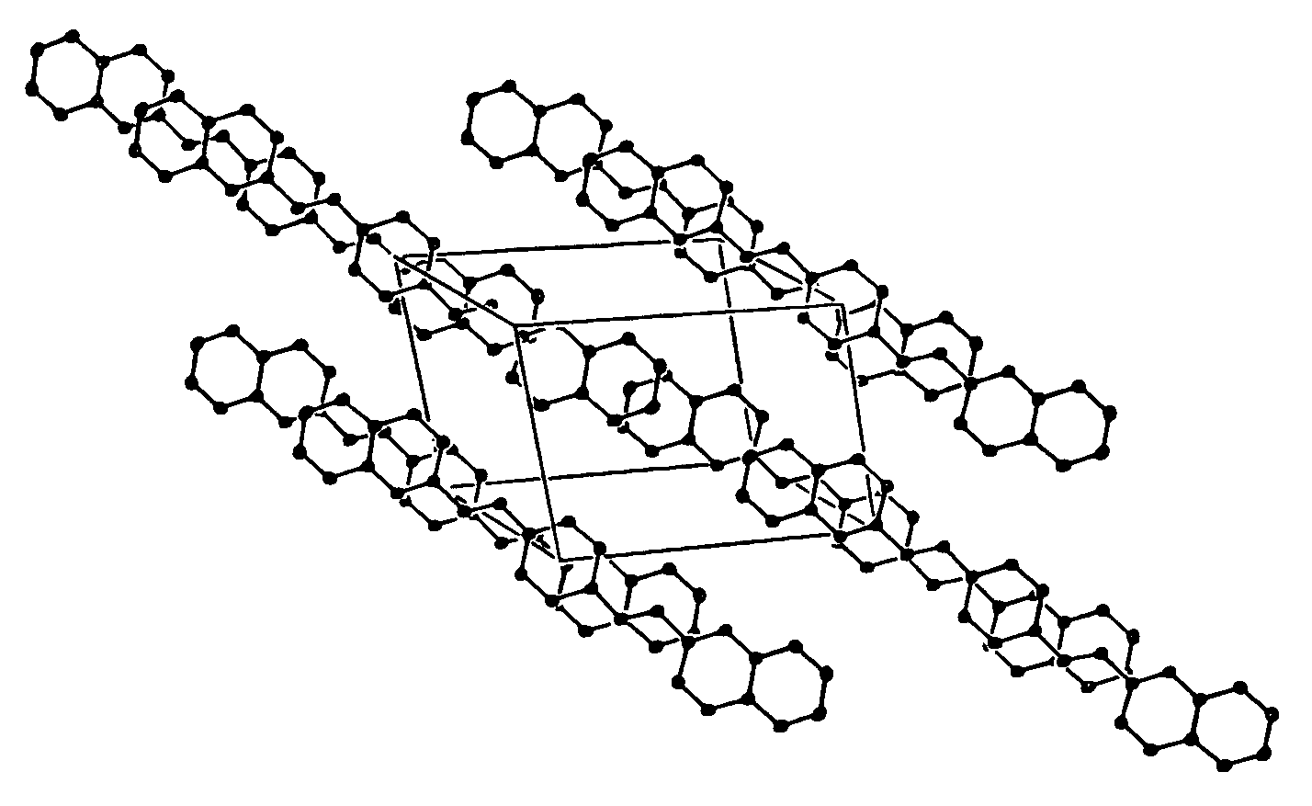

Fig. 3s View of the crystal structure of ligand 3.
The chloroform solvent species are located between the aromatic zones (viewed edge-on) of the structure.

