Supplementary information
Further evidence for the quality and composition of the as-obtained products were obtained by the X-ray photoelectron spectra (XPS) of the products, which were collected on an ESCALab MKII X-ray photoelectron spectrometer, using nonmonochromatized Mg-Kα X-ray as the excitation source. The binding energies obtained in the XPS analysis were corrected for specimen charging by referencing the C 1s to 284.60 eV. Fig. 1 shows XPS spectra taken from the Zn and O regions of the ZnO hollow spheres. In Fig. 1A, there is a strong peak at about 1022 eV, which is attributed to Zn2p_{3/2}. In Fig. 1B, we can see that the O_{1s} XPS is asymmetric, indicating that two oxygen species are present in the nearby region. The peak at about 531 eV can be indexed to the O(-2) in the ZnO, whereas the weaker shoulder peak at about 532 eV is due to chemisorbed oxygen caused by surface hydroxyl, which corresponds to O-H bonds. No obvious peaks for other elemental or impurities were observed. The atomic composition of Zn and O was calculated by using the integrated peak area and sensitivity factors, the atomic ratio of Zn:O is 1:1.10, close to the composition of ZnO.
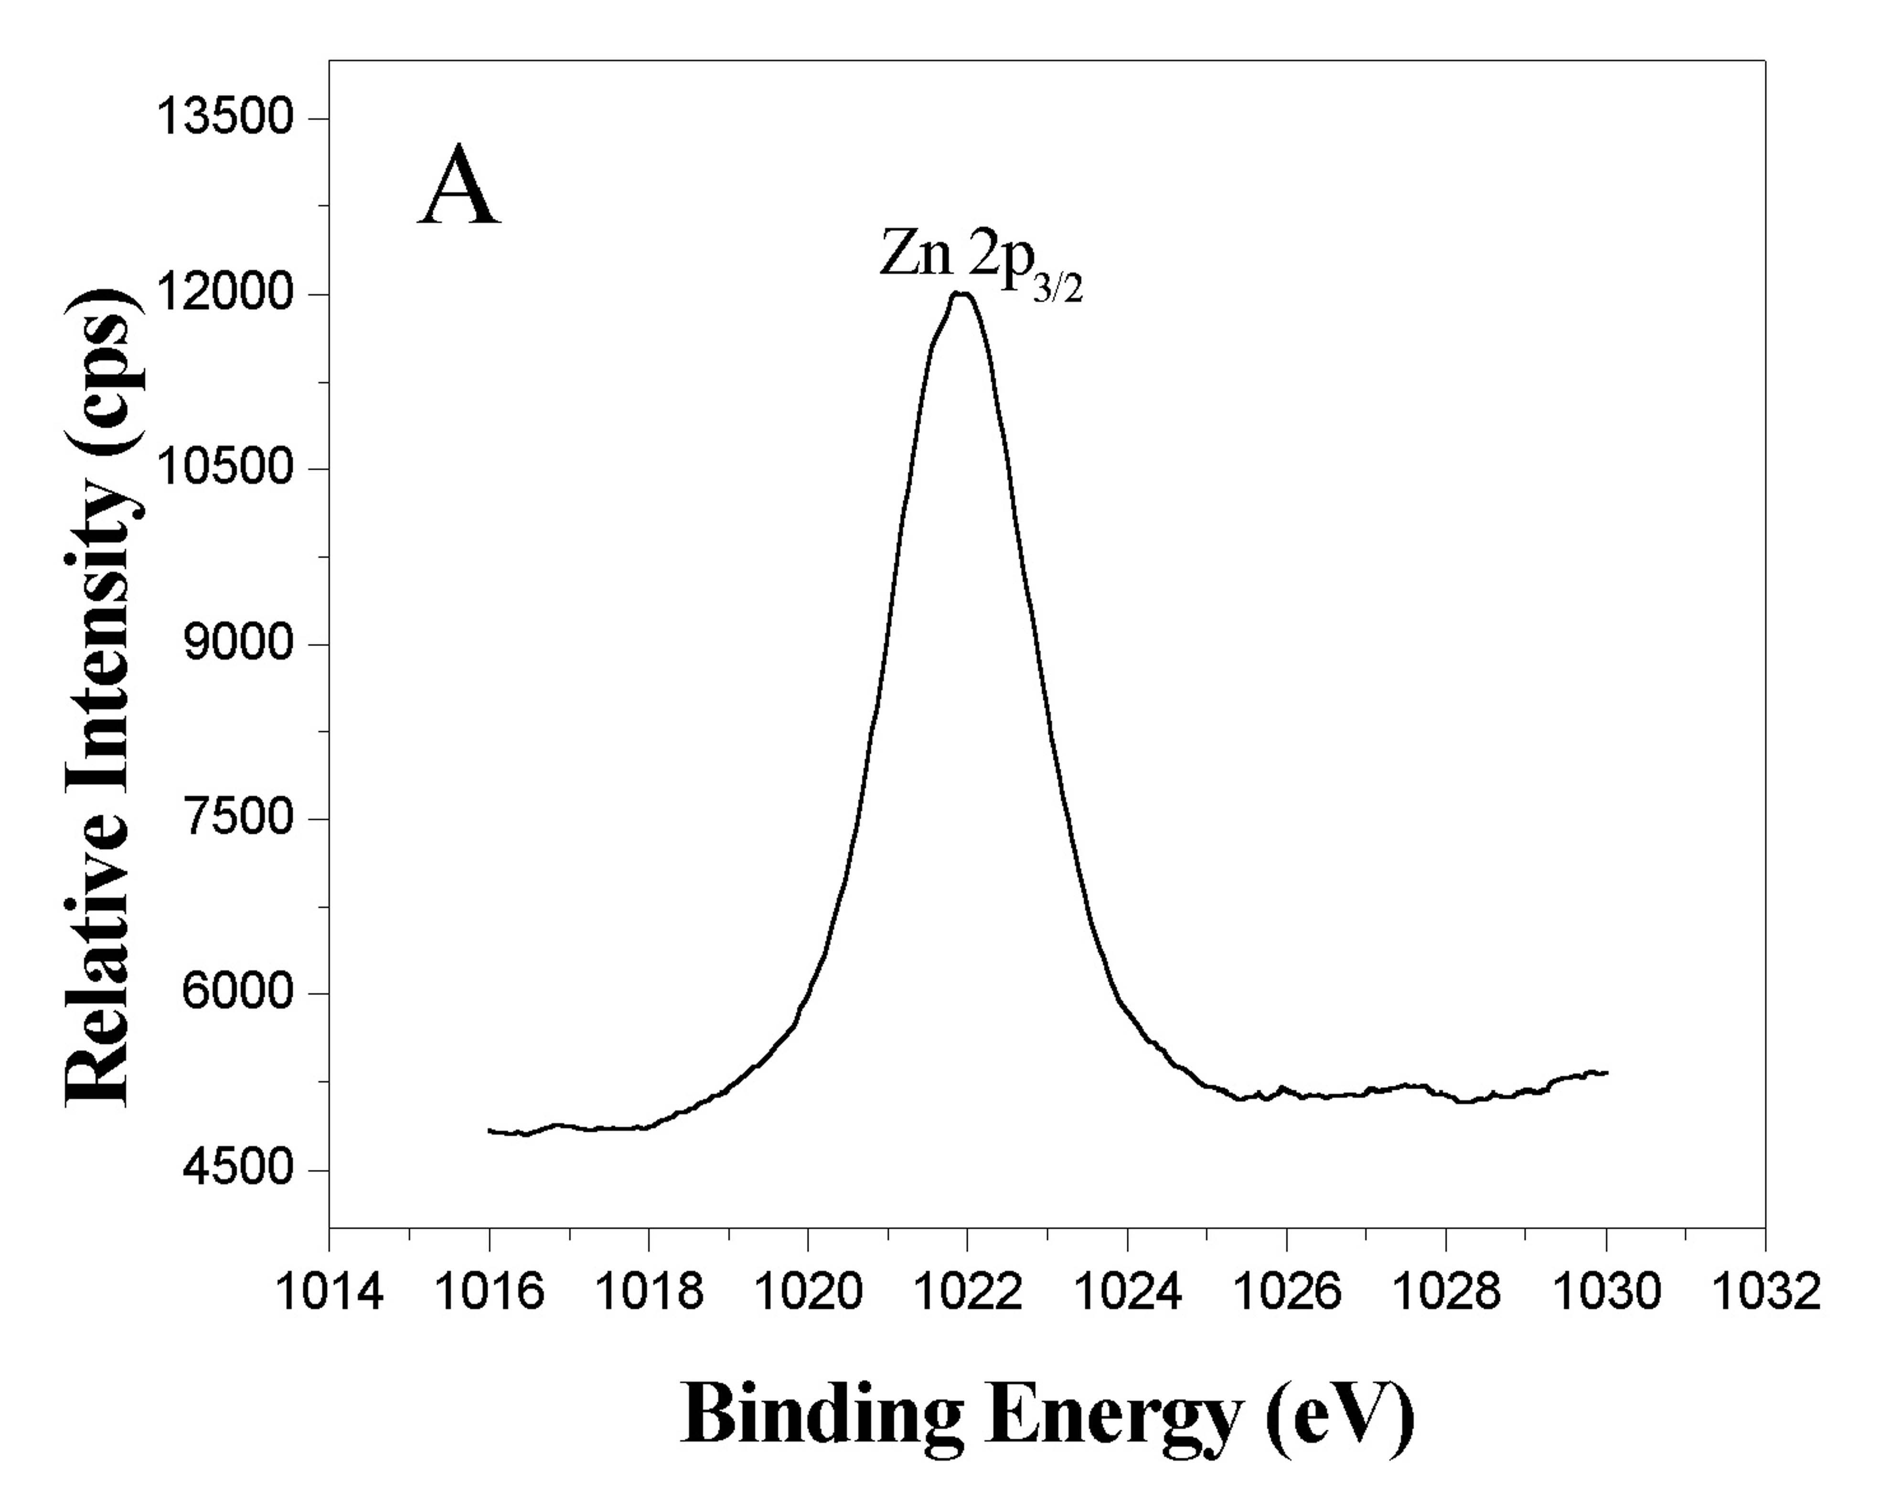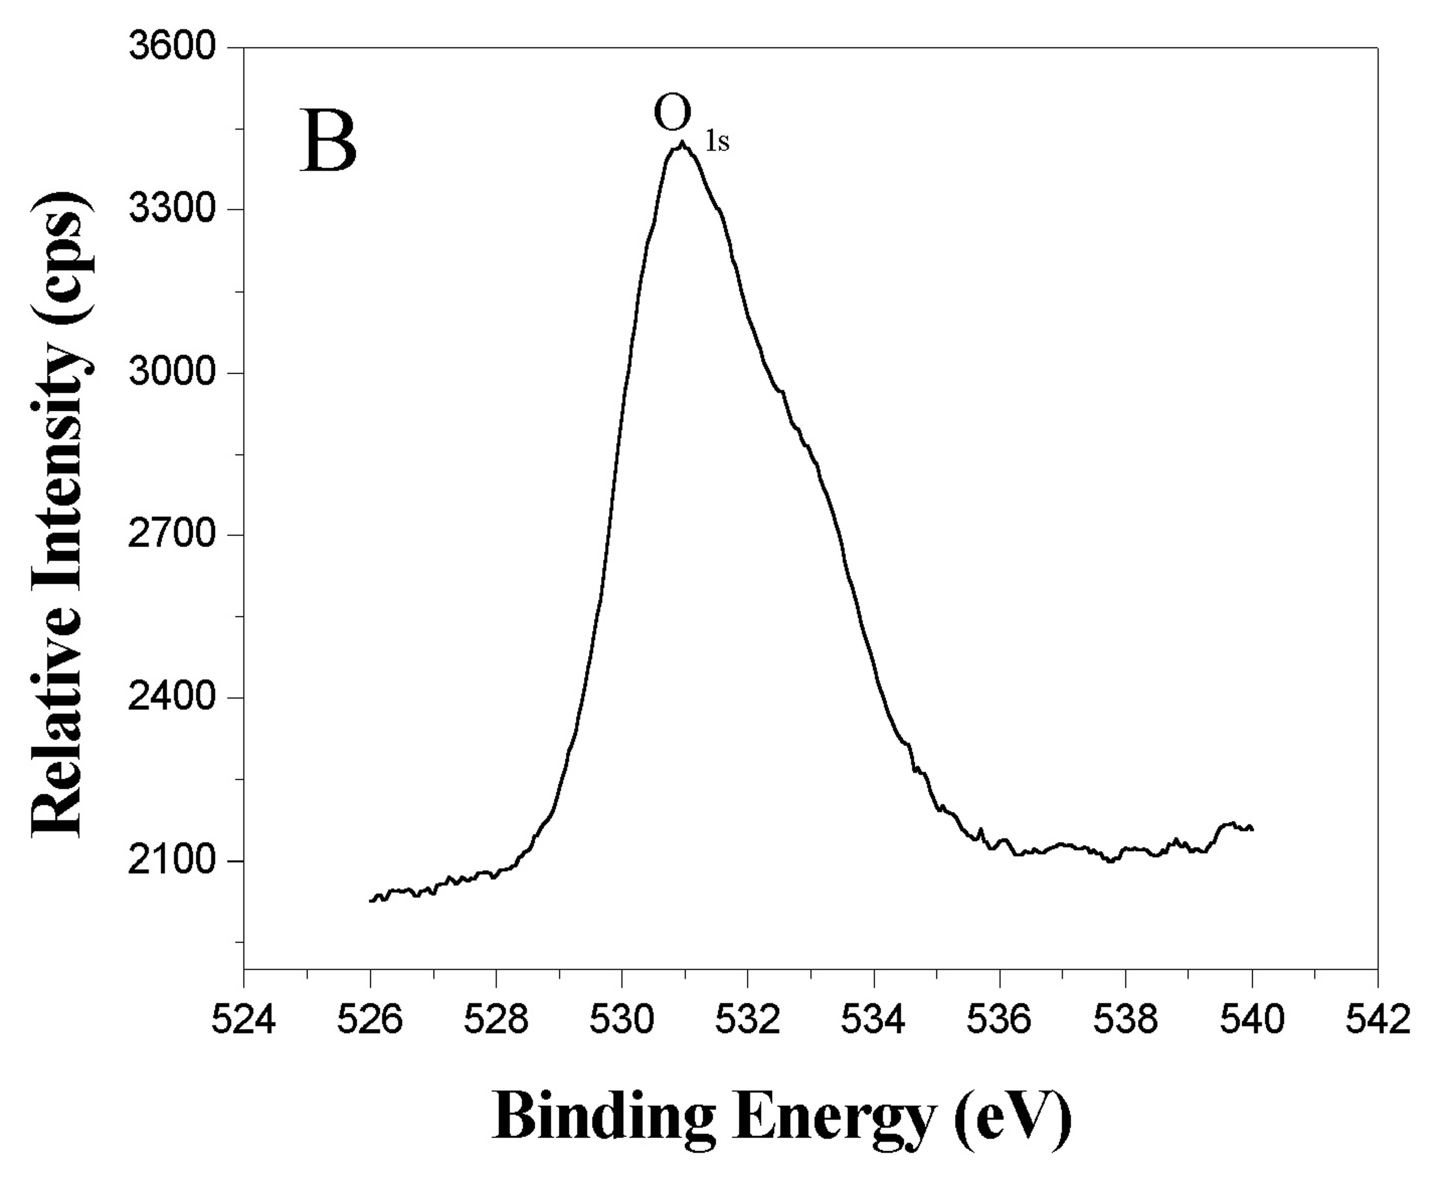
Fig. 1 XPS analysis of as-obtained products. (A) Zn region; (B) O region.

The energy-dispersive X-ray analysis (EDXA) was recorded on a JEOL-2010 TEM at an acceleration voltage of 200 kV, in which copper meshes were used to containing products. The data were collected from the hollow spheres structures. Element Zn and O can been clearly seen from Fig.2, which shows that the components of the hollow spheres are Zn and O. The ratio of Zn to O can be calculated out approximately to 1:1.08, indicating the products are ZnO hollow spheres. The Cu signals are attributed to the copper meshes.
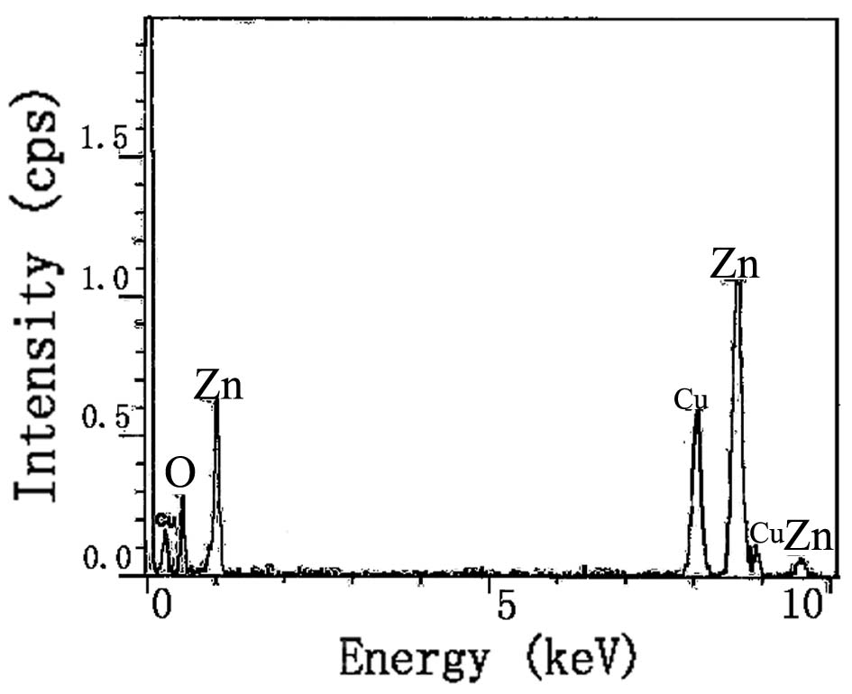
Fig. 2 EDXA spectrum of ZnO hollow spheres

