Supplementary material

A unique methoxo-fluoro-bridged triangular trinuclear Cu(II) species linked in a lattice via mononuclear Cu(II) units. Synthesis, X-ray structure and magnetism of [Cu₄(2-aminopyrimidine)₆(μ₃-OCH₃)₂(μ-F)₃(F)₂](BF₄).
G.A.van Albada, O. Roubeau, I. Mutikainen, U. Turpeinen and J. Reedijk.

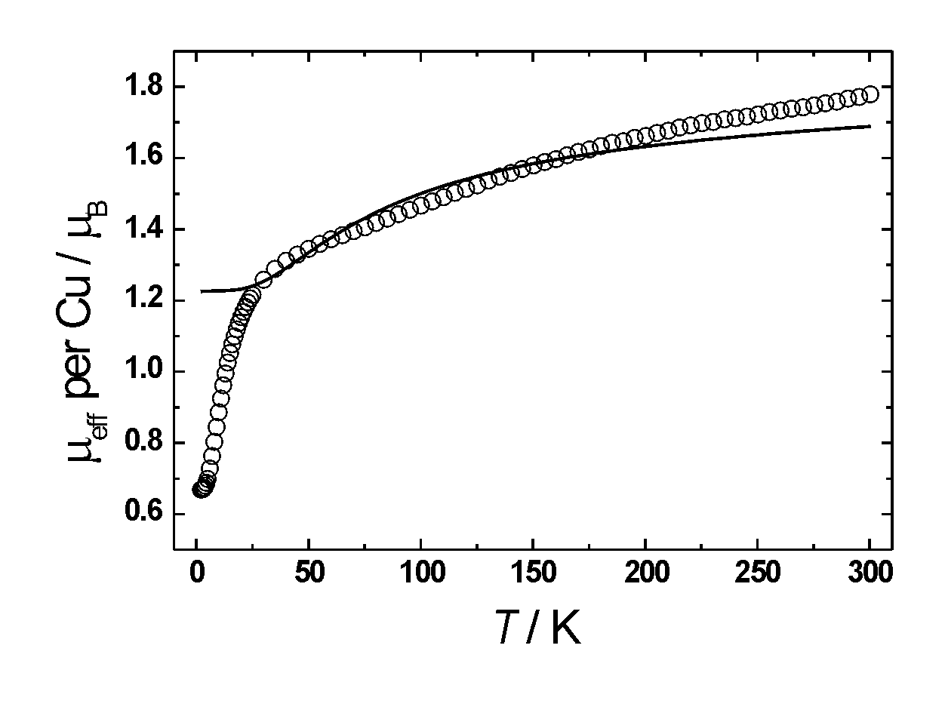

Supplementary fig.1

Fitting according to scheme 2A (Trimer (one J) + monomer)
Result: J = -54.9 cm⁻¹, g_{trimer} = g_{monomer} = 2, p = 0
(O = observed parameters, solid line is fitting result)

