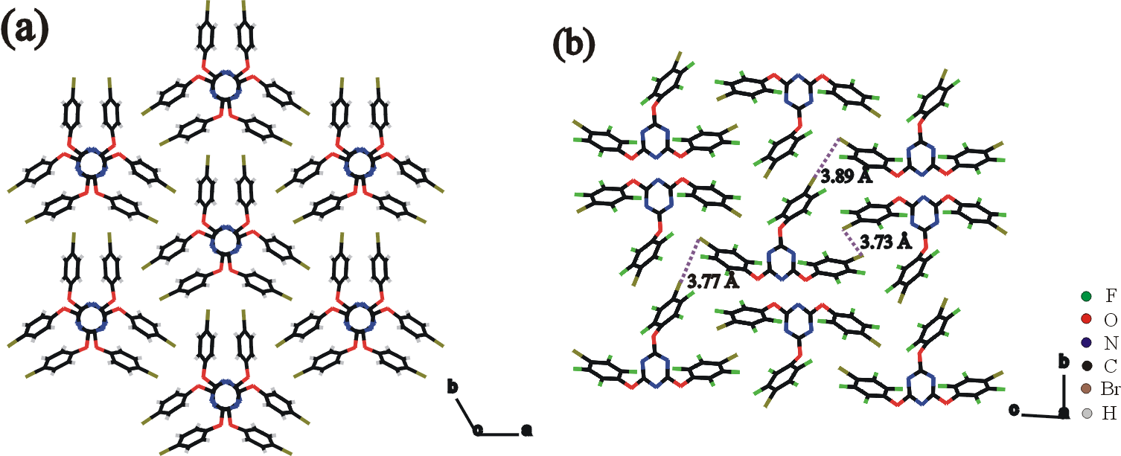

Fig. 2 Crystal structures of (a) 1 and (b) 2 (Br···Br interactions are emphasized by broken lines).

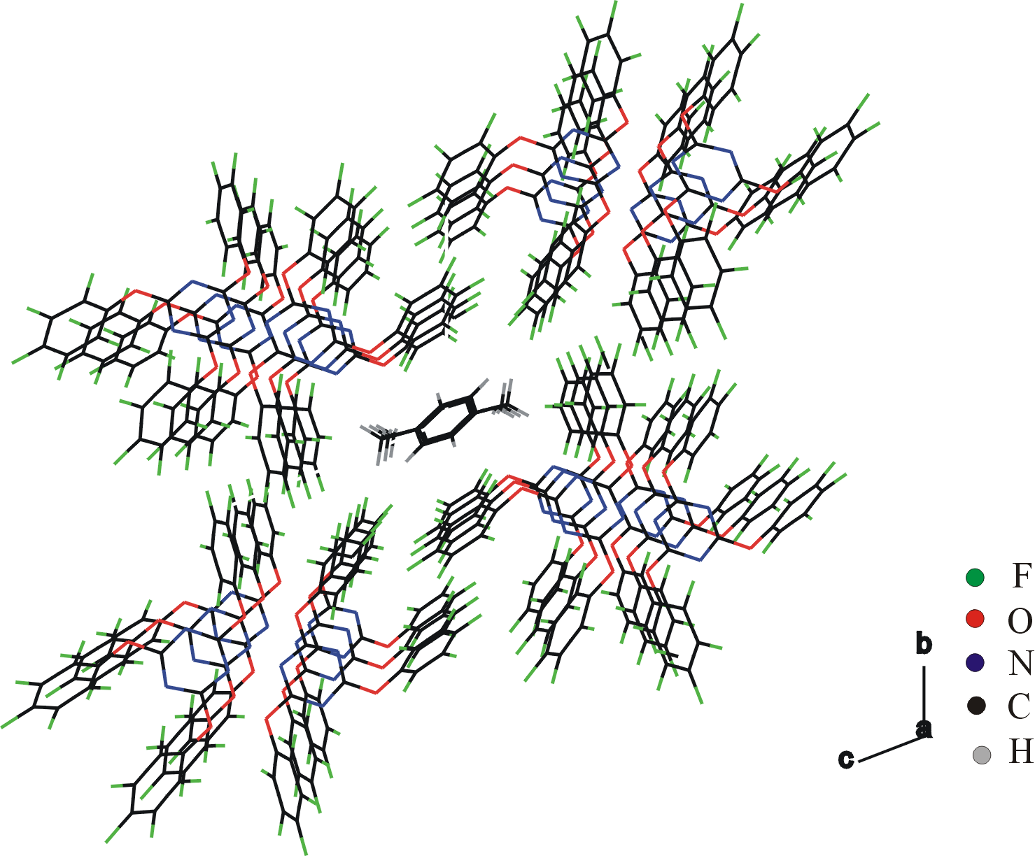

Fig. 3 Crystal structure of 3·(p-xylene)_{0.5}.
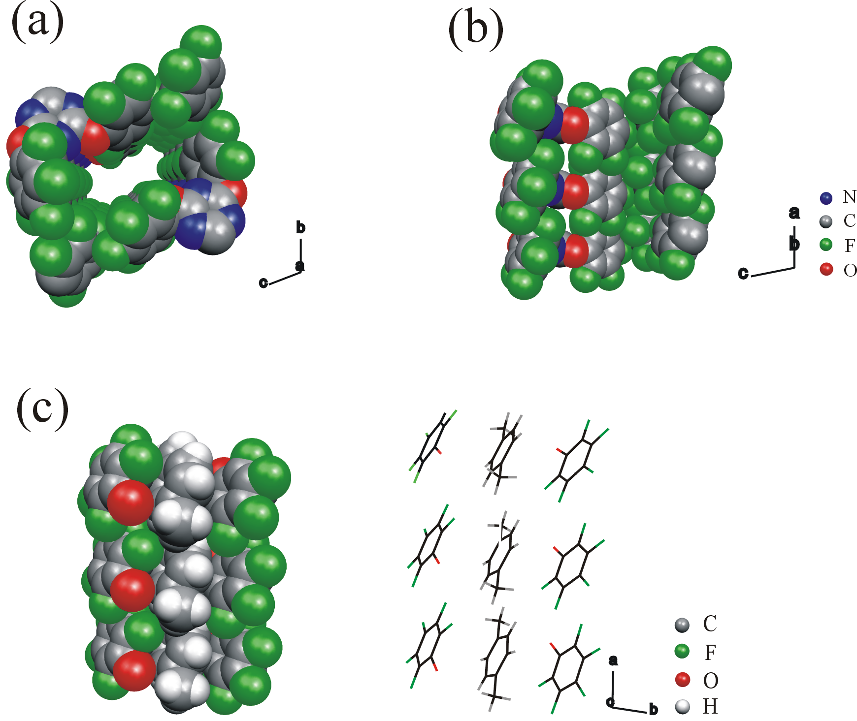

Fig. 4 Channel wall of 3·(p-xylene)_{0.5}: (a) view along the channels (a-axis); (b) view onto the channel wall (b-axis); (c) host-guest interaction.

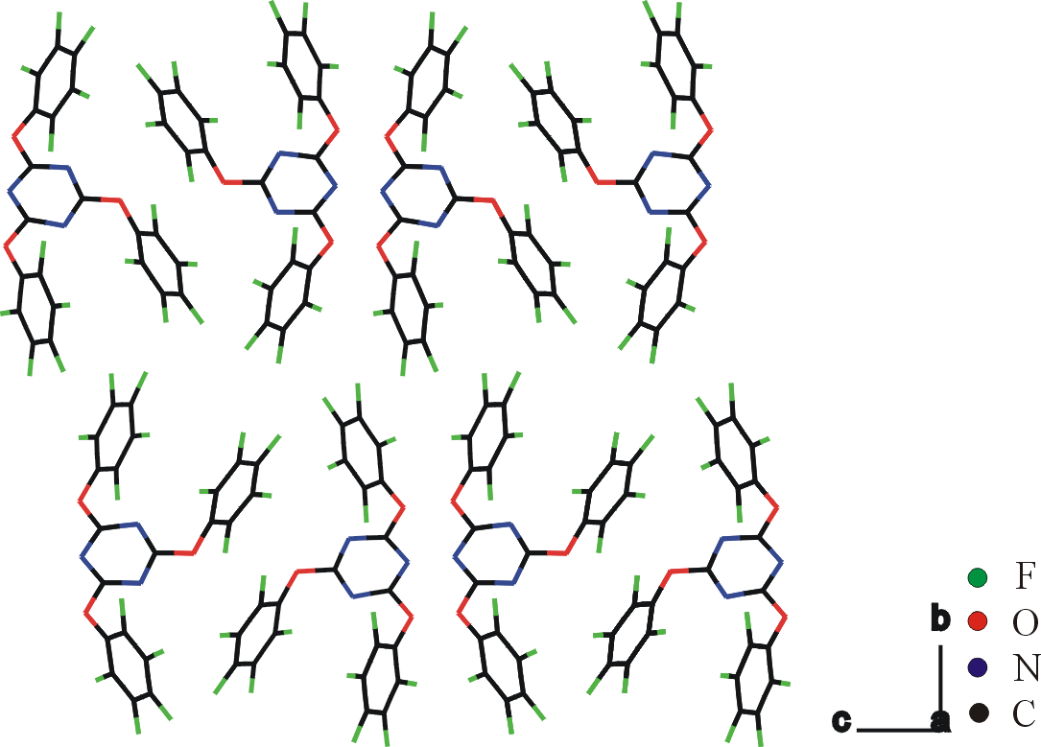

Fig. 5 Crystal structure of 3.

