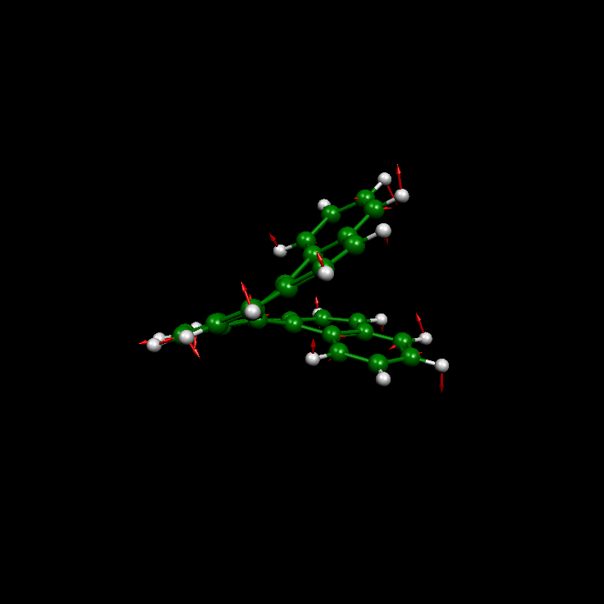

Caption: Normal mode of the 950 cm⁻¹ band. Calculations were performed at the B3LYP / 6-31G(d,p) level.

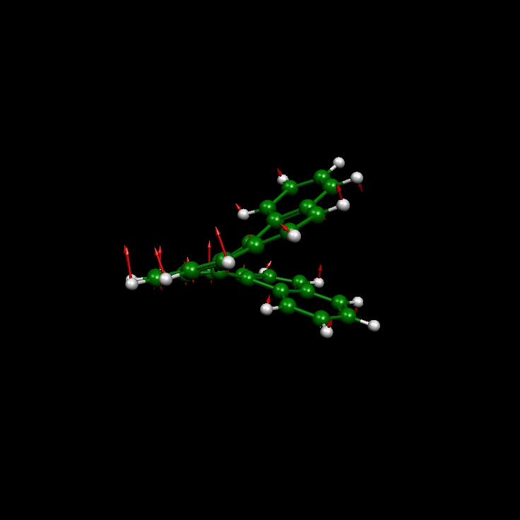
Caption: Normal mode (861 cm⁻¹) with the largest calculated IR and VCD activity. Calculations were performed at the B3LYP / 6-31G(d,p) level.

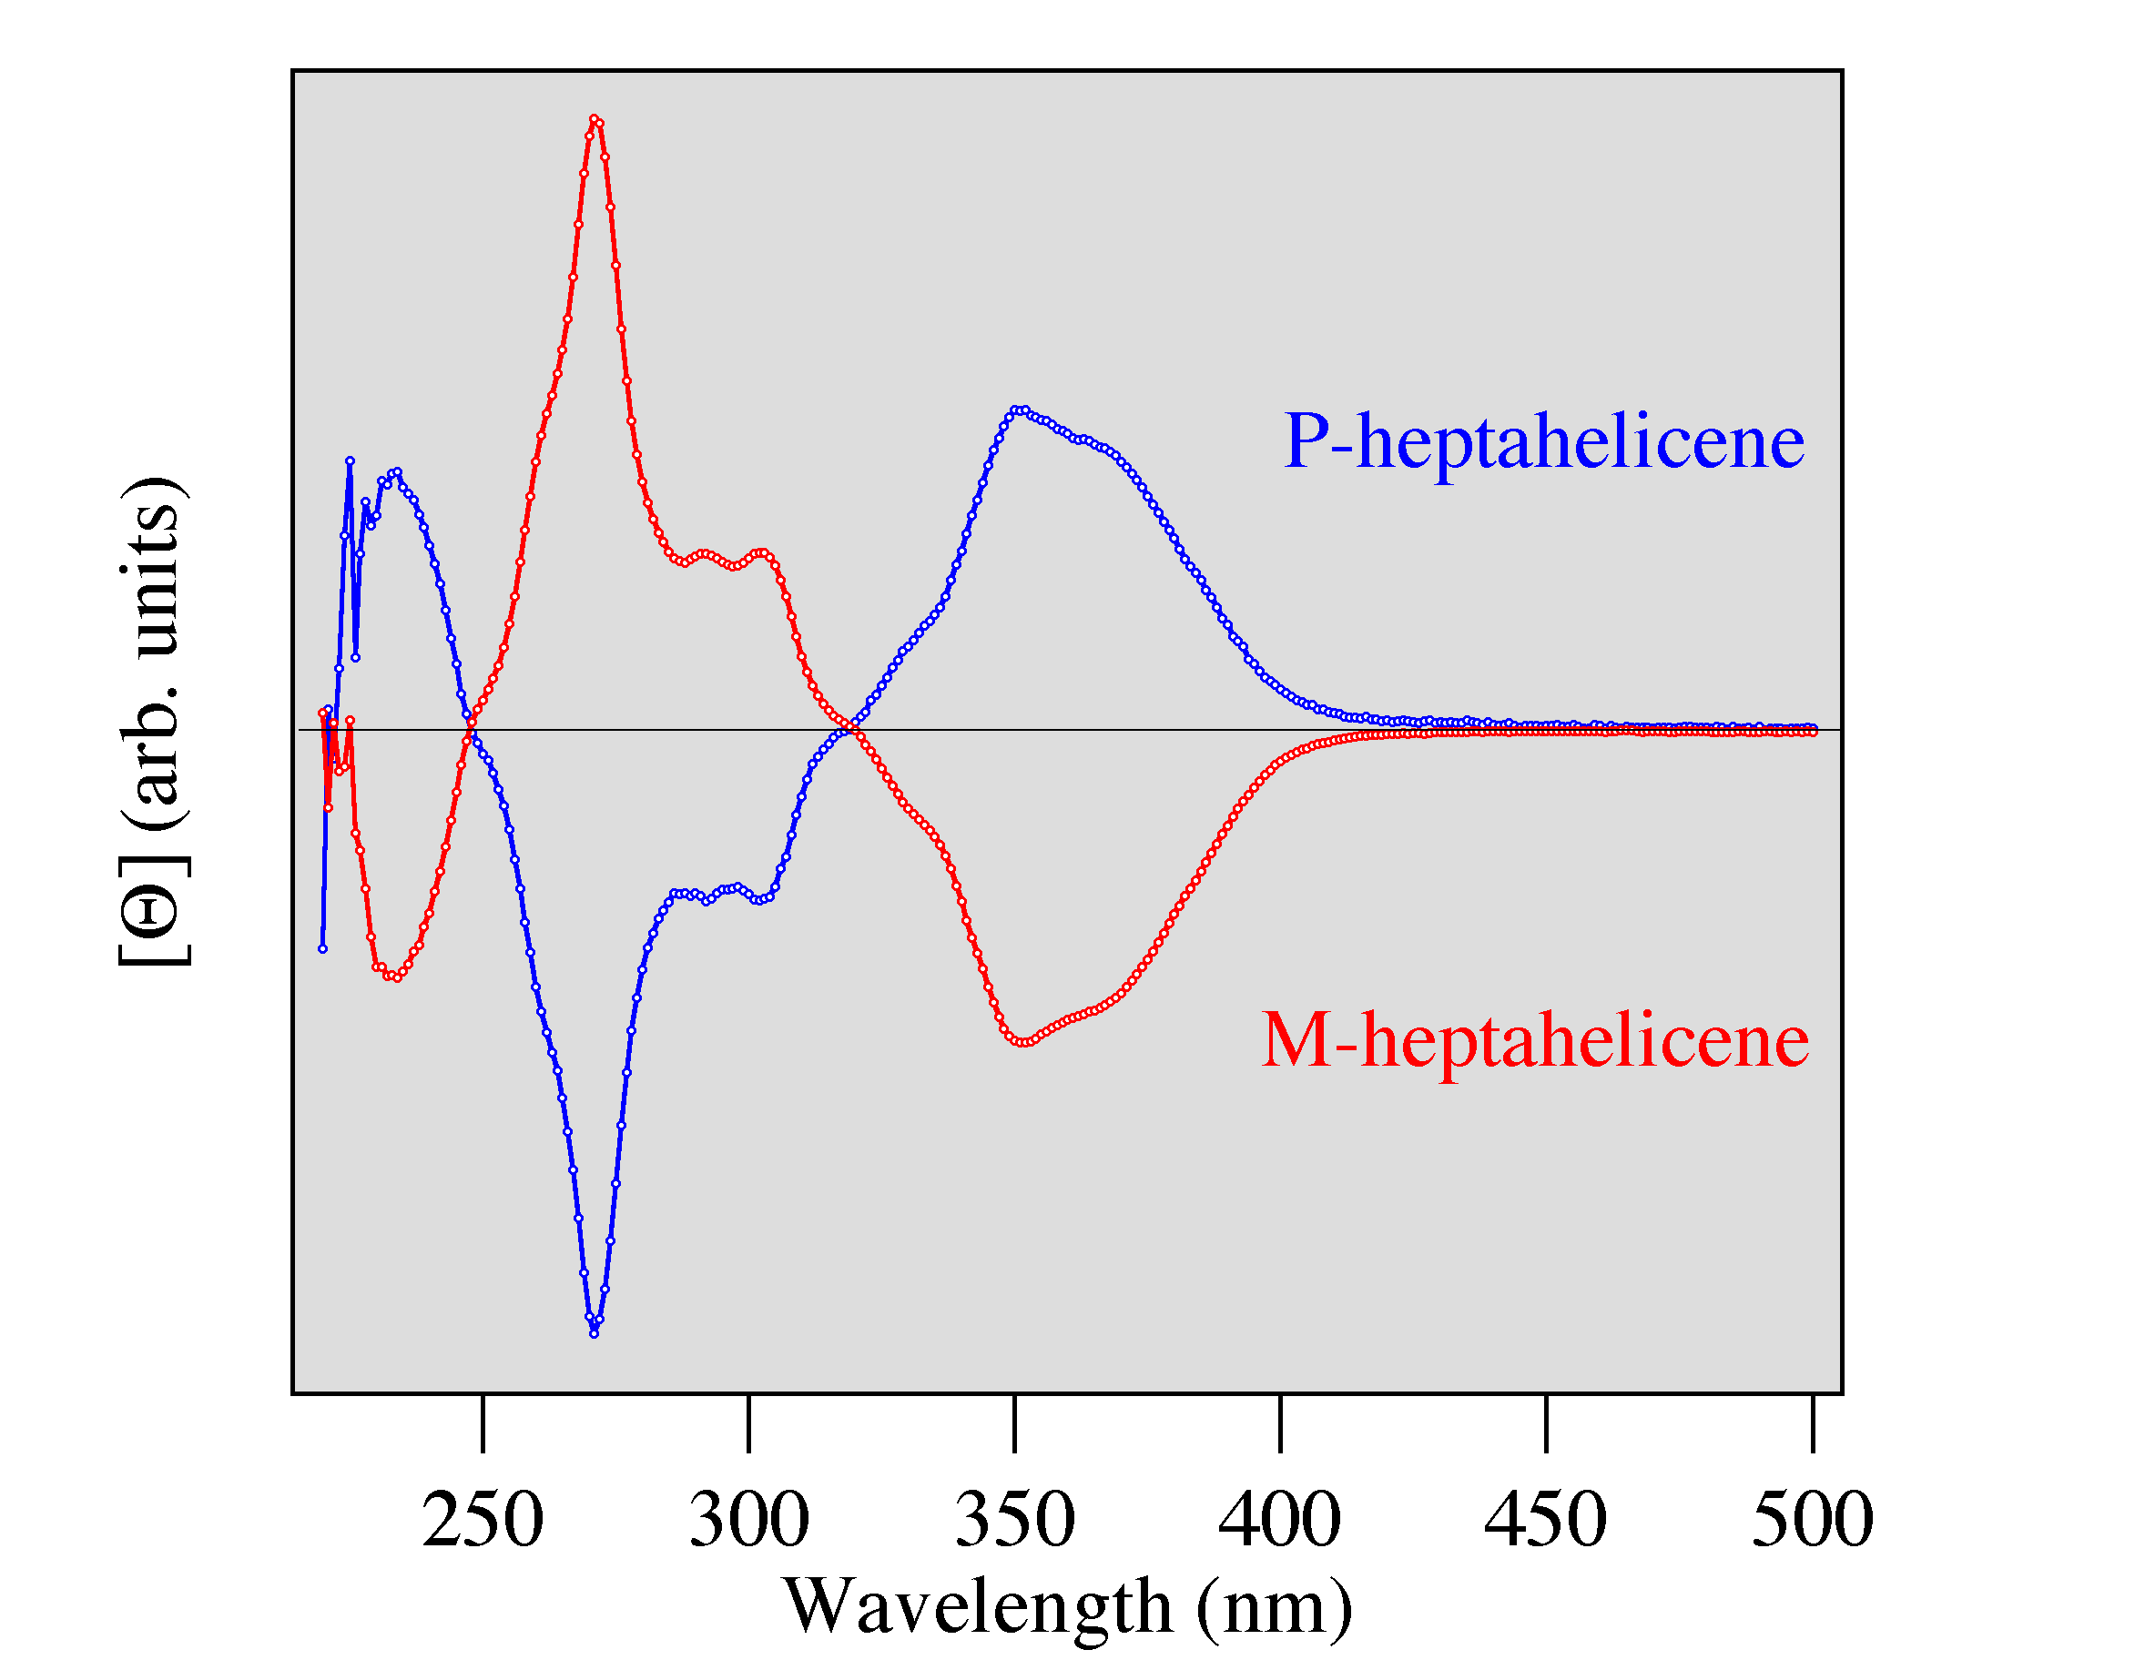

CD spectra of heptahelicene.

