Supplementary Information
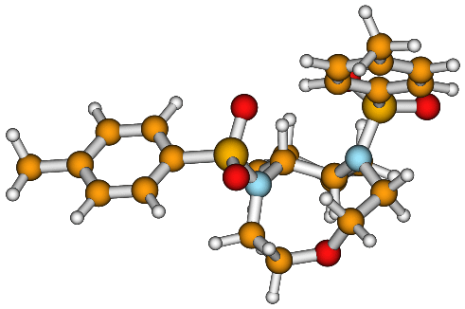

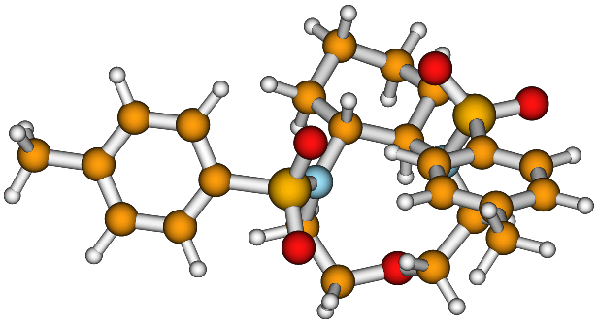

Supplementary Information 1. Different views of the C₁-symmetric conformer of 6.

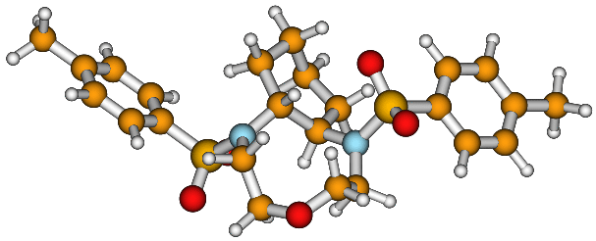

Conformer C₂-6a

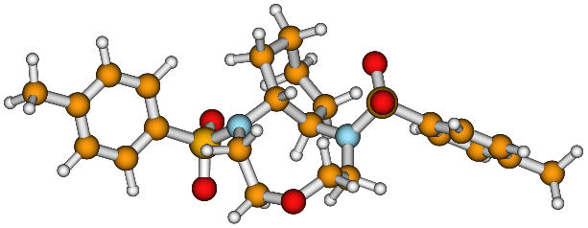

Conformer C₂-6b

Supplementary Information 2. Alternative views of C₂-symmetric conformers of 6 in which the distorted conformation of the 6-membered ring can be appreciated.

