Supplementary data

Conformationally tailored N-[(2-methyl-3-oxo-3,4-dihydro-2H-1,4-benzoxazin-2-yl)carbonyl]proline templates as molecular tools for the design of peptidomimetics. - Design and synthesis of fibrinogen receptor antagonists

Petra Štefanič, ª Zvone Simončič, ª Matej Breznik, ª Janez Plavec, ^{b} Marko Anderluh,ª Elisabeth Addicks,^{c} Athanassios Giannis^{c} and Danijel Kikelj*ª
ª University of Ljubljana, Faculty of Pharmacy, Aškerčeva 7, 1000 Ljubljana, Slovenia. Fax: +386 1 4258 031; Tel:+386 1 4769 561; E-mail: danijel.kikelj@ffa.uni-lj.si
^{b} National Institute of Chemistry, Hajdrihova 19, 1000 Ljubljana, Slovenia. Fax: +386 1 4760 300; Tel: +386 1 4760 200; E-mail: janez.plavec@ki.si
^{c} University of Leipzig, Institute for Organic Chemistry, Johannisallee 29, D-04103 Leipzig, Germany. Fax: +49 341 97 36 599; Tel.: +49 341 9736 527; E-mail: giannis@chemie.uni-leipzig.de

Table 1. Experimental proton-proton coupling constants (³J_{HH}) of the pyrrolidine ring of (S,S)-3, (S,S)-4, (S,S)-9, (R,S)-9 and (S,S)-11.ª

Coupling constant (Hz) | (S,S)-3 | (S,S)-4 | (S,S)-9 | trans-(R,S)-9 | (S,S)-11
J_{H1’H2’} | 4.7 | 4.8 | 5.0 | 5.0 | 4.9
J_{H1’H2”} | 8.7 | 8.7 | 8.8 | 8.6 | 8.8
J_{H2’H2”} | 12.8 | 12.7 | 12.7 | 13.5 | 12.8
J_{H2’H3’} | 6.8 | 6.7 | 6.7 | 6.7 | 6.9
J_{H2’H3”} | 6.2 | 6.2 | 6.3 | 6.2 | 6.3
J_{H2”H3’} | 7.4 | 7.6 | 7.5 | 6.4 | 7.3
J_{H2”H3”} | 7.0 | 7.0 | 7.4 | 7.4 | 7.6
J_{H3’H3”} | 12.3 | 12.4 | 12.2 | 12.2 | 12.3
J_{H3’H4’} | 6.6 | 6.6 | 7.0 | 6.2 | 7.4
J_{H3’H4”} | 7.1 | 6.3 | 6.9 | 7.3 | 7.4
J_{H3”H4’} | 6.7 | 6.8 | 6.4 | 7.0 | 6.1
J_{H3”H4”} | 6.2 | 7.0 | 6.4 | 6.7 | 6.2
J_{H4’H4”} | 10.6 | 10.4 | 10.7 | 10.5 | 10.4
ª J_{HH} values (in Hz, ±0.1 Hz) have been extracted from 1D ¹H-NMR spectra recorded at 300 MHz in D₂O at 300 K in DMSO-d₆. The complete set of J_{HH} and chemical shifts were simulated and iterated by the simulation module of VNMR software package.

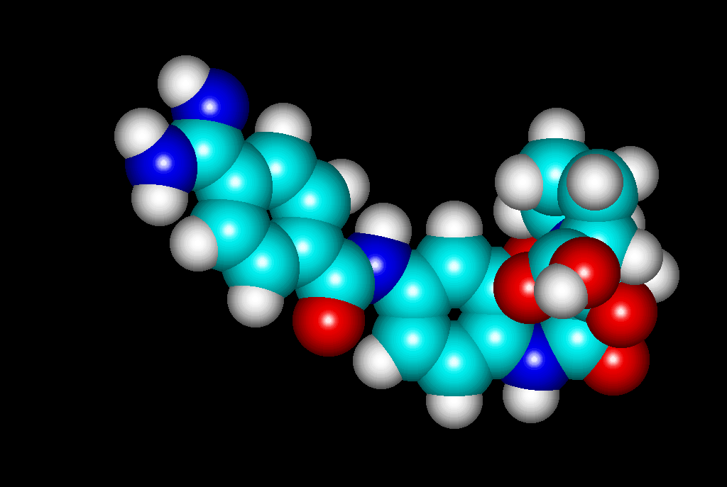
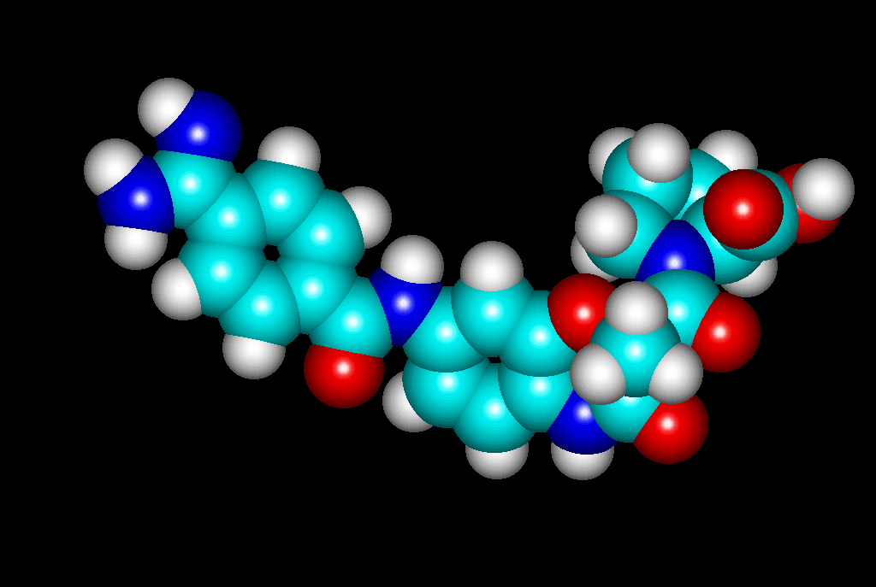
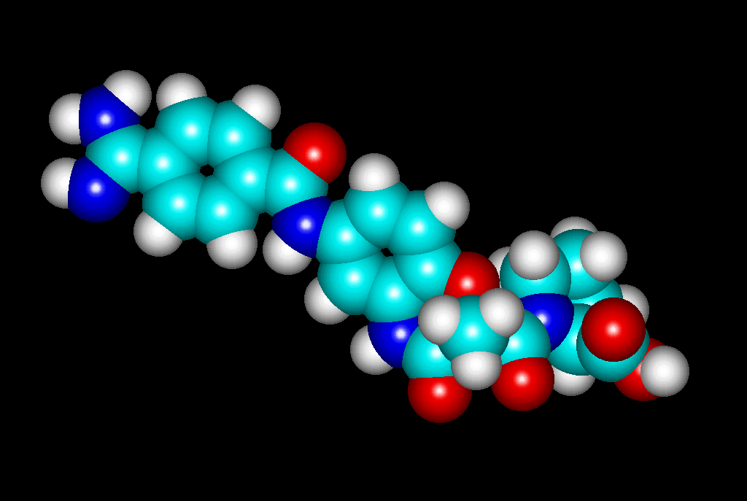
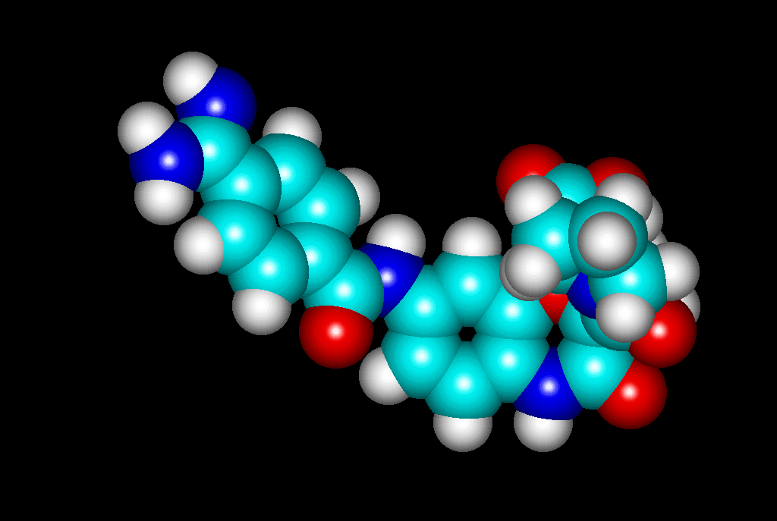
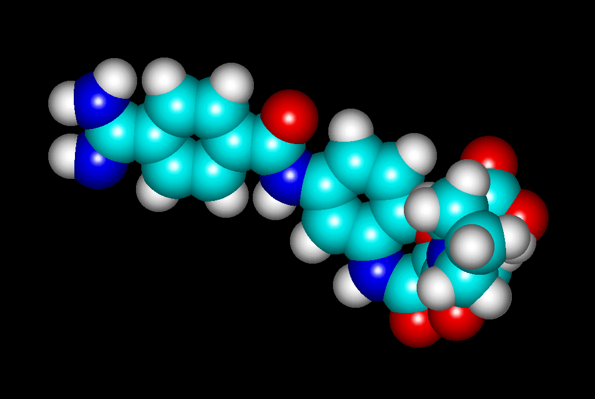
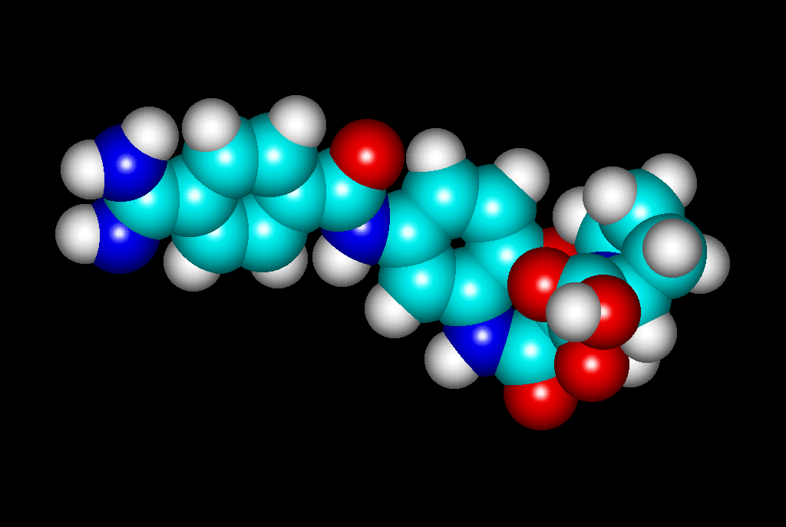

trans-(S,S)-16
trans-(R,S)-16
trans-(S,S)-16
trans-(S,S)-18
cis-(R,S)-16
cis-(R,S)-18
trans-(R,S)-18

Fig 1. The conformations of diastereomers trans-(S,S)-16, trans-(R,S)-16, trans-(S,S)-18, trans-(R,S)-18, cis-(R,S)-16 and cis-(R,S)-18 generated by HyperChem.

Ethyl 2-methyl-6-nitro-3-oxo-3,4-dihydro-2H-1,4-benzoxazine-2-carboxylate 8a
The procedure described yielded 8a (3.60 g, 66 %) as yellow crystals, mp 175-177 °C (lit.,²¹ 192-194 ºC); ν_{max}/cm⁻¹ 3261, 1689, 1520, 1450, 1344, 1231, 1134, 873, 746 and 530; δ_{H}(300 MHz; CDCl₃; Me₄Si) 1.22 (3H, t, J 7.2, CH₂CH₃), 1.93 (3H, s, CH₃), 4.16–4.27 (2H, m, CH₂CH₃), 7.19 (1H, d, J_{7,8} 9.0, H₈), 7.75 (1H, d, J_{5,7} 2.6, H₅) and 7.97 (1H, dd, J_{5,7} 2.6 Hz, J_{7,8} 9.0, H₇); m/z (EI): 280 (M⁺, 39%), 207 (100), 179 (34), 161 (24) and 133 (52).

2-Methyl-6-nitro-3-oxo-3,4-dihydro-2H-1,4-benzoxa-zine-2-carboxylic acid 8b
The procedure described yielded 8b (2.20 g, 70 %) as brown crystals, mp 176–179°C (lit.,²¹ 181-182 ºC); ν_{max}(KBr)/cm⁻¹ 3265, 1747, 1680, 1534, 1488, 1344, 1242, 1142, 1085, 874, 747, 713 and 531; δ_{H}(300 MHz; CDCl₃; Me₄Si) 1.97 (3H, s, CH₃), 6.93 (1H, d, J_{7,8} 9.0, H₈), 7.35 (1H, d, J_{5,7} 2.6, H₅), 7.63 (1H, dd, J_{5,7} 2.6, J_{7,8} 9.0, H₇); m/z (EI): 252 (M⁺, 43%) and 208 (100).

Benzyl (2S)-1-{[(2R)-2-methyl-7-nitro-3-oxo-3,4-dihydro-2H-1,4-benzoxazin-2-yl]carbonyl}-2-pyrroli-dinecarboxylate (R,S)-9
The procedure described yielded (R,S)-9 (0.28 g, 19 %) as yellow crystals, mp 140–145 °C; [α] -14.4 (c 0.338 in MeOH); ν_{max}(KBr)/cm⁻¹ 3226, 2956, 1723, 1644, 1531, 1448, 1324, 1159, 1076, 953, 744 and 529; δ_{H}(300 MHz; CDCl₃; Me₄Si) Larger set of signals (trans isomer) 1.73 (3H, s, CH₃), 1.60–1.71 (1H, m, J_{1’,2”} 8.6, J_{2’,2”} 13.5, J_{2”,3’} 6.4, J_{2”,3”} 7.4, H_{2”}), 1.80–1.96 (2H, m, J_{2’,3’} 6.7, J_{2’,3”} 6.2, J_{3’,3”} 12.2, J_{3’,4’} 6.2, J_{3’,4”} 7.3, J_{3”,4’} 7.0, J_{3”,4”} 6.7, H_{3’}, H_{3”}), 2.09–2.20 (1H, m, J_{1’,2’} 5.0, H_{2’}), 3.73–3.93 (2H, m, J_{4’,4”} 10.5, H_{4’}, H_{4”}), 4.33 (1H, dd, J_{1’,2’} 5.0, J_{1’,2”} 8.6, H_{1’}), 4.67 and 4.96 (each 1H, d, J 12.6, CH₂Ph), 7.04 (1H, d, J_{5,6} 8.7, H₅), 7.15–7.33 (5H, m, Ph), 7.92 (1H, dd, J_{6,8} 2.5, J_{5,6} 8.7, H₆) and 7.99 (1H, d, J_{6,8} 2.5, H₈); Smaller set of signals (cis isomer) 1.49 (3H, s, CH₃), 2.03–2.07 (2H, m, H_{2’}, H_{2”}), 1.60–1.99 (2H, m, H_{3’}, H_{3”}), 3.47–3.54 (2H, m, H_{4’}, H_{4”}), 4.57 (1H, dd, J_{1’,2’’} 8.2, J_{1’,2’} 1.4, H_{1’}), 4.91 and 5.06 (each 1H, d, J 12.5, CH₂Ph), 7.07–7.50 (6H, m, H₅, Ph), 7.87–7.95 (1H, m, H₆) and 7.68 (1H, d, J_{6,8} 2.5, H₈); m/z (EI): 439 (M⁺, 63%) and 91 (100). HR-MS Found: 439.138650, C₂₂H₂₁N₃O₇ requires: 439.137950.

Benzyl (2S)-1-{[(2S)-2-methyl-6-nitro-3-oxo-3,4-dihydro-2H-1,4-benzoxazin-2-yl]carbonyl}-2-pyrroli-dinecarboxylate (S,S)-11
The procedure described yielded (S,S)-11 (0.442 g, 30 %) as pale violet crystals, mp 91–93°C; [α] 28.5 (c 0.487 in MeOH); Found: C, 59.9; H, 5.0; N, 9.5. C₂₂H₂₁N₃O₇ requires C, 60.1; H, 4.8; N, 9.6%; ν_{max}(KBr)/cm⁻¹ 3468, 2976, 1723, 1641, 1530, 1449, 1345, 1157, 965, 746 and 698; δ_{H}(300 MHz; CDCl₃; Me₄Si) 1.66 (3H, s, CH₃), 1.72–1.81 (1H, m, J_{1’,2”} 8.8, J_{2’,2”} -12.8, J_{2”,3’} 7.3, J_{2”,3”} 7.6, H_{2”}), 1.80–1.99 (2H, m, J_{2’,3’} 6.9, J_{2’,3”} 6.3, J_{3’,3”} -12.3, J_{3’,4’} 7.4, J_{3’,4”} 7.4, J_{3”,4’} 6.1, J_{3”,4”} 6.2, H_{3’}, H_{3”}), 2.06–2.18 (1H, m, J_{1’,2’} 4.9, H_{2’}), 3.62–3.79 (2H, m, J_{4’,4”} -10.4, H_{4’}, H_{4”}), 4.32 (1H, dd, J_{1’,2’} 4.9, J_{1’,2”} 8.8, H_{1’}), 5.08 and 5.14 (each 1H, d, J 12.6, CH₂Ph), 7.32 (1H, d, J_{7.8} 8.9, H₈), 7.32–7.81 (5H, m, Ph), 7.77 (1H, d, J_{5,7} 2.8, H₅) and 7.88 (1H, dd, J_{5,7} 2.8 Hz, J_{7.8} 8.9, H₇); m/z (EI): 439 (M⁺, 29%) and 91 (100).

Benzyl (2S)-1-{[(2R)-2-methyl-6-nitro-3-oxo-3,4-dihydro-2H-1,4-benzoxazin-2-yl]carbonyl]}-2-pyrro-lidinecarboxylate (R,S)-11
The procedure described yielded (R,S)-11 (0.412 g, 28 %) as white crystals, mp 92–94°C; [α] = -84.2 (c 0.501 in MeOH); Found: C, 59.7; H, 4.7; N, 9.45. C₂₂H₂₁N₃O₇ requires C, 60.1; H, 4.8; N, 9.6%; ν_{max}(KBr)/cm⁻¹ 3471, 1712, 1643, 1529, 1449, 1345, 1239, 1159, 965, 886 and 746; δ_{H}(300 MHz; CDCl₃; Me₄Si) Larger set of signals (trans isomer) 1.63–1.75 (1H, m, H_{2”}), 1.73 (3H, s, CH₃), 1.87–1.97 (2H, m, H_{3’}, H_{3”}), 2.10–2.22 (1H, m, H_{2’}), 3.66–3.74 (1H, m, H_{4”}), 3.82–3.90 (1H, m, H_{4’}), 4.35 (1H, dd, J 5.5, J 8.8, H_{1’}), 4.79 and 4.94 (each 1H, d, J 12.7, CH₂Ph), 7.25–7.35 (5H, m, Ph), 7.35 (1H, d, J_{7.8} 8.8, H₈), 7.68 (1H, d, J_{5,7} 2.7, H₅) and 7.82 (1H, dd, J_{5,7} 2.7, J_{7.8} 8.8, H₇); Smaller set of signals (cis isomer) 1.51 (3H, s, CH₃), 1.75–1.85 (2H, m, H_{3’}, H_{3”}), 2.02–2.08 (2H, m, H_{2’}, H_{2”}), 3.50–3.45 (2H, m, H_{4’}, H_{4”}), 4.48 (1H, dd, H_{1’}), 4.87 and 5.03 (each 1H, d, J 12.7, CH₂Ph), 7.09 (1H, d, J_{7.8} 8.8, H₈), 7.10–7.19 (5H, m, Ph), 7.74 (1H, d, J_{5,7} 2.4, H₅) and 7.77 (1H, dd, J_{5,7} 2.4, J_{7.8} 8.8, H₇); m/z (EI): 439 (M⁺, 11%) and 91 (100).

Ethyl (2S)-1-{[(2R)-2-methyl-7-nitro-3-oxo-3,4-dihydro-2H-1,4-benzoxazin-2-yl]carbonyl}-2-pyrroli-dinecarboxylate (R,S)-10
The procedure described yielded (R,S)-10 (0.326 g, 9 %) as yellow crystals, mp 60–65 °C; [α] -18.0 (c 0.100 in MeOH); Found: C, 54.0; H, 5.2; N, 11.1. C₁₇H₁₉N₃O₇ requires: C, 54.1; H, 5.1; N, 11.1%; ν_{max} (film)/cm⁻¹ 3228, 2984, 1725, 1643, 1508, 1326, 1236, 1077, 916 and 745; δ_{H}(300 MHz; CDCl₃; Me₄Si) Larger set of signals (trans isomer) 0.91 (3H, t, J 7.2, CH₂CH₃), 1.62-1.74 (1H, m, H_{2’’}), 1.74 (3H, s, CH₃), 1.87-1.96 (2H, m, H_{3’}, H_{3’’}), 2.07-2.19 (1H, m, H_{2’}), 3.68-3.92 (4H, m, H_{4’}, H_{4’’}, CH₂CH₃), 4.25 (1H, dd, J₁ 8.9, J₂ 5.1, H_{1’}), 7.09 (1H, d, J_{5,6} 8.3, H₅), 7.97-8.01 (2H m, H_{6,} H₈) and 11.44 (1H, s, NH); Smaller set of signals (cis isomer) 1.09 (3H, t, J 7.0, CH₂CH₃), 1.53 (3H, s, CH₃), 3.39 (2H, q, J 7.0, CH₂CH₃), 3.46-3.52 (2H, m, H_{4’}, H_{4’’}), 4.49 (1H, d, J 7.9, H_{1’}), 7.15 (1H, d, J_{5,6} 8.7, H₅), 7.78 (1H, d, J_{6,8} 2.3, H₈) [signals for H_{2’}, H_{2”}, H_{3’,} H₃,,, H₆ and NH are under the corresponding signals of trans isomer]; m/z (FAB): 378 (MH⁺, 100%), 304 (34), 207 (17), 154 (80), 142 (38), 136 (65), 107 (25), 71 (57) and 55 (62).

Ethyl (2S)-1-{[(2S)-2-methyl-6-nitro-3-oxo-3,4-dihydro-2H-1,4-benzoxazin-2-yl]carbonyl}-2-pyrroli-dinecarboxylate (S,S)-12
The procedure described yielded (S,S)-12 (1.39 g, 37 %) as yellow crystals, mp 76-80 °C; [α] 33.6 (c 0.100 in MeOH); Found: C, 54.2; H, 5.4; N, 10.9, C₁₇H₁₉N₃O₇ requires: C, 54.1; H, 5.1; N, 11.1; ν_{max}(KBr)/cm⁻¹ 3524, 3254, 2985, 1734, 1646, 1532, 1345, 1188, 1025, 887, and 746; δ_{H}(300 MHz; DMSO-d₆; Me₄Si) 1.17 (3H, t, J 7.2, CH₂CH₃), 1.69 (3H, s, CH₃), 1.66-1.80 (1H, m, H₂,,), 1.82-1.98 (2H, m, H₃,, H₃,,), 2.03-2.13 (1H, m, H₂,), 3.62-3.80 (2H, m, H₄,, H₄,,), 4.02-4.12 (2H, m, CH₂CH₃), 4.22 (1H, dd, J₁ 8.5, J₂ 4.7, H₁,), 7.37 (1H, d, J_{7,8} 8.7, H₈), 7.77 (1H, d, J_{5,7} 2.6, H₅), 7.89 (1H, dd, J_{7,8} 8.7, J_{5,7} 2.6, H₇) and 11.32 (1H, s, NH); m/z (EI): 377 (M⁺, 4%), 332 (11), 304 (20), 207 (30), 170 (20), 142 (100), 133 (20), 98 (17), 83 (23) and 70 (75).

Ethyl (2S)-1-{[(2R)-2-methyl-6-nitro-3-oxo-3,4-dihydro-2H-1,4-benzoxazin-2-yl]carbonyl}-2-pyrroli-dinecarboxylate (R,S)-12
The procedure described yielded (R,S)-12 (0.678 g, 18 %) as pale yellow crystals, mp 85-88 °C; [α] -74.4 (c 0.100 in MeOH); Found: C, 54.3; H, 5.4; N, 10.8, C₁₇H₁₉N₃O₇ requires: C, 54.1; H, 5.1; N, 11.1%; ν_{max}(KBr)/cm⁻¹ 2979, 1717, 1649, 1527, 1344, 1282, 1120 and 747; δ_{H}(300 MHz; DMSO-d₆; Me₄Si) Larger set of signals (trans isomer) 0.94 (3H, t, J 7.2, CH₂CH₃), 1.61-1.73 (1H, m, H₂,,), 1.73 (3H, s, CH₃), 1.86-1.95 (2H, m, H₃,, H₃,,), 2.08-2.20 (1H, m, H₂,), 3.64-3.72 (1H, m, H₄,_{/4},,), 3.75-3.90 (3H, m, H₄,_{/4},,, CH₂CH₃), 4.26 (1H, dd, J₁ 8.7, J₂ 5.3, H₁,), 7.38 (1H, d, J_{7,8} 9.0, H₈), 7.76 (1H, d, J_{5,7} 2.9, H₅), 7.90 (1H, dd, J_{7,8} 9.0, J_{5,7} 2.9, H₇) and 11.20 (1H, s, NH); Smaller set of signals (cis isomer) 1.17 (3H, t, J 7.2, CH₂CH₃), 1.53 (3H, s, CH₃), 3.48-3.53 (1H, m, H₄,_{/4},,), 4.42 (1H, d, J 6.8, H₁,), 7.19 (1H, d, J_{7,8} 8.7, H₈) and 7.81 (1H, d, J_{5,7} 2.6, H₅); [signals for H₂,, H_{2”}, H₃,, H₃,,, CH₂CH₃, H₇ and NH are under the corresponding signals for trans isomer]; m/z (EI): 377 (M⁺, 2%), 304 (22), 207 (32), 170 (17), 142 (100), 133 (21), 98 (18), 83 (27) and 70 (74).

(2S)–1–{[(2R)–7–Amino–2–methyl–3–oxo–3,4–dihy-dro–2H–1,4–benzoxazin–2–yl]carbonyl}–2–pyrroli-dinecarboxylic acid (R,S)-4
The procedure described yielded (R,S)-4 (0.092 g, 84%) as pink crystals, mp 163-165 °C; [α] 23.1 (c 0.450 in MeOH); ν_{max}(KBr)/cm⁻¹ 3746, 1683, 1649, 1517 and 1456; δ_{H}(300 MHz; DMSO-d₆; Me₄Si) Larger set of signals (trans isomer) 1.50 (3H, s, CH₃), 1.70–1.80 (1H, m, H_{2”}), 1.84–1.93 (2H, m, H_{3’}, H_{3’’}), 2.05–2.14 (1H, m, H_{2’}), 2.60 (2H, s, NH₂), 3.48–3.55 (1H, m, H_{4”}), 3.71–3.78 (1H, m, H_{4’}), 4.18 (1H, dd, J₁ 4.6, J₂ 8.55, H_{1’}), 6.15-6.21(1H, m, H₅), 6.23 (1H, m, H₈), 6.57 (1H, dd, J_{6,8} 2.20, J_{5,6} 8.3, H₆) and 10.35 (1H, s, NH); Smaller set of signals (cis isomer) 1.41 (3H, s, CH₃), 1.84–1.93 (2H, m, H_{3’}, H_{3”}), 1.94–2.02 (2H, m, H_{2’}, H_{2”}), 2.60 (2H, s, NH₂), 3.40–3.45 (2H, m, H_{4’}, H_{4”}), 4.50 (1H, dd, J 3.9, J₂ 5.4, H_{1’}), 6.18 (1H, d, J_{5,6} 8.3, H₅), 6.15 (1H, d, J_{6,8} 2.2, H₈), 6.65 (1H, dd, J_{6,8} 2.2, J_{5,6} 8.3, H₆) and 10.45 (1H, s, NH); m/z (EI): 319 (M⁺, 89%) and 94 (100); HR-MS Found: 319.117230, C₁₅H₁₇N₃O₅ requires: 319.116821.

(2S)–1–{[(2S)–6–Amino–2–methyl–3–oxo–3,4–dihy-dro–2H–1,4–benzoxazin–2–yl]carbonyl}–2–pyrroli-dinecarboxylic acid (S,S)-3
The procedure described yielded (S,S)-3 (0.094 g, 87%) as brown crystals, mp 168–171 °C; [α] -67.9 (c 0.495 in MeOH); ν_{max}(KBr)/cm⁻¹ 3242, 2980, 1697, 1626, 1518, 1376, 1228, 1132, 933, 819 and 533; δ_{H}(300 MHz; DMSO-d₆; Me₄Si) 1.56 (3H, s, CH₃), 1.69–1.78 (1H, m, J_{1’,2”} 8.7, J_{2’,2”} -12.8, J_{2”,3”} 7.0, H_{2”}), 1.77–1.84 (1H, m, J_{2’,3”} 6.2, J_{3’,3”} -12.3, J_{3”,4’} 6.7, J_{3”,4”} 6.2, H_{3”}), 1.87–1.96 (1H, m, J_{2’,3’} 6.8, J_{2”,3’} 7.4, J_{3’,4’} 6.6, J_{3’,4”} 7.1, H_{3’}), 1.98–2.07 (1H, m, J_{1’,2’} 4.7, H_{2’}), 2.60 (2H, s, NH₂), 3.67–3.81 (2H, m, J_{4’4”} -10.6, H_{4’,} H_{4”}), 4.10 (1H, dd, J_{1’,2’} 4.7, J_{1’,2”} 8.7, H_{1’}), 6.10–6.15 (2H, m, H₅, H₇), 6.74 (1H, d, J_{7,8} 8.3, H₈) and 10.54 (1H, s, NH); m/z (EI): 319 (M⁺, 45%) and 178 (100); HR-MS Found: 319.117950, C₁₅H₁₇N₃O₅ requires: 319.116821.

(2S)–1–{[(2R)–6–Amino–2–methyl–3–oxo–3,4–dihy-dro–2H–1,4–benzoxazin–2–yl]carbonyl}–2–pyrroli-dinecarboxylic acid (R,S)-3
The procedure described yielded (R,S)-3 (0.090 g, 83%) as brown crystals, mp 167–171 °C; [α] -82.2 (c 0.383 in MeOH); ν_{max}(KBr)/cm⁻¹ 3236, 2982, 1698, 1629, 1518, 1376, 1228, 1130, 932, 816 and 594; δ_{H}(300 MHz; DMSO-d₆; Me₄Si) Larger set of signals (trans isomer) 1.51 (3H, s, CH₃), 1.66–1.81 (1H, m, H_{2”}), 1.82–1.95 (2H, m, H_{3’,} H_{3”}), 2.06–2.15 (1H, m, J_{1’,2’} 4.7, H_{2’}), 2.60 (2H, s, NH₂), 3.54–3.62 (1H, m, H_{4”}), 3.75–3.83 (1H, m, H_{4’}), 4.16 (1H, dd, J_{1’,2’} 4.8, J_{1’,2”} 8.7, H_{1’}), 6.09–6.14 (2H, m, H₅, H₇), 6.69 (1H, d, J_{7,8} 8.8, H₈) and 10.50 (1H, s, NH); Smaller set of signals (cis isomer) 1.44 (3H, s, CH₃), 1.72–1.81 (2H, m, H_{3’,} H_{3”}), 1.96–2.07 (2H, m, H_{2’,} H_{2”}), 2.60 (2H, s, NH₂), 3.30–3.40 (2H, m, H_{4’,} H_{4”}), 4.71 (1H, m, H_{1’}), 6.09–6.14 (2H, m, H₅, H₇), 6.62 (1H, d, J_{7,8} 8.3, H₈) and 10.54 (1H, s, NH); m/z (EI): 319 (M⁺, 46%) and 178 (100). HR-MS Found: 319.117755, C₁₅H₁₇N₃O₅ requires: 319.116821.

Ethyl (2S)-1-{[(2R)-7-amino-2-methyl-3-oxo-3,4-dihydro-2H-1,4-benzoxazin-2-yl]carbonyl}-2-pyrroli-dinecarboxylate (R,S)-13
The procedure described yielded (R,S)-13 (0.215 g, 62%) as pale brown crystals, mp 105-108 °C; [α] 99.6 (c 0.100 in MeOH); Found: C, 57.9; H, 6.2; N, 11.8. C₁₇H₂₁N₃O₅ x 1/3H₂O requires: C, 57.8; H, 6.2; N, 11.9; ν_{max}/(film)cm⁻¹ 3358, 2980, 1732, 1682, 1634, 1519, 1446, 1352, 1182, 1023 and 811; δ_{H}(300 MHz; DMSO-d₆; Me₄Si) Larger set of signals (trans isomer) 1.04 (t, 3H, J 7.2, CH₂CH₃), 1.54 (s, 3H, CH₃), 1.64-1.75 (m, 1H, H₂,,), 1.85-1.99 (m, 2H, H₃,, H₃,,), 2.06-2.19 (m, 1H, H₂,), 3.46-3.66 (m, 2H, H₄,, H₄,,), 3.77-3.97 (m, 2H, CH₂CH₃), 4.24 (dd, 1H, J_{1’,2’} 5.3, J_{1’,2”} 8.5, H₁,), 4.89 (s, 2H, NH₂), 6.21 (dd, 1H, J_{6,8} 2.3, J_{5,6} 8.3, H₆), 6.27 (d, 1H, J_{6,8} 2.3, H₈), 6.57 (d, 1H, J_{5,6} 8.3, H₅) and 10.33 (s, 1H, NH); Smaller set of signals (cis isomer) 0.95 (t, 3H, J 7.2, CH₂CH₃), 1.39 (s, 3H, CH₃), 3.46-3.51 (m, 1H, H₄,, H₄,,), 4.38 (m, 1H, H₁,), 4.95 (s, 2H, NH₂), 6.11 (d, 1H, J_{6,8} 2.6, H₈), 6.59 (d, 1H, J_{5,6} 7.5, H₅) and 10.54 (s, 1H, NH); [signals for H_{2’}, H_{2”}, H_{3’,} H_{3’’}, CH₂CH₃ and H₆ are under the signals of the corresponding trans isomer]; m/z (FAB): 348 (MH⁺, 100%), 274 (24), 205 (15), 177 (65), 154 (26), 142 (43), 136 (22) and 70 (22).

Ethyl (2S)-1-{[(2S)-6-amino-2-methyl-3-oxo-3,4-dihydro-2H-1,4-benzoxazin-2-yl]carbonyl}-2-pyrroli-dinecarboxylate (S,S)-14
The procedure described yielded (S,S)-14 (0.319 g, 92%) as pale brown crystals, mp 90-93 °C; [α] 40.8 (c 0.100 in MeOH); Found: C, 58.6; H, 6.2; N, 11.8, C₁₇H₂₁N₃O₅ requires: C, 58.8; H, 6.1; N, 12.1; ν_{max}(KBr)/cm⁻¹ 3362, 2982, 1740, 1631, 1519, 1448, 1374, 1227, 1134, 1023, 857, 744 and 610; δ_{H}(300 MHz; DMSO-d₆; Me₄Si) 1.17 (t, 3H, J 7.2, CH₂CH₃), 1.57 (s, 3H, CH₃), 1.70-1.97 (m, 3H, H_{2”}, H₃,, H₃,,), 2.01-2.11 (m, 1H, H_{2’}), 3.73-3.79 (m, 2H, H_{4’,} H_{4”}), 4.01-4.11 (m, 2H, CH₂CH₃), 4.16 (dd, 1H, J_{1’,2’} 4.9, J_{1’,2”} 8.7, H_{1’}), 4.88 (s, 2H, NH₂), 6.11-6.17 (m, 2H, H_{5,} H₇), 6.75 (d, 1H, J 8.7, H₈) and 11.55 (s, 1H, NH); m/z (FAB): 348 (MH⁺, 100%), 274 (8), 205 (8), 177 (58), 154 (21), 142 (46), 136 (16) and 70 (22).

Ethyl (2S)-1-{[(2R)-6-amino-2-methyl-3-oxo-3,4-dihydro-2H-1,4-bezoxazin-2-yl]carbonyl}-2-pyrroli-dinecarboxylate (R,S)-14
The procedure described yielded (R,S)-14 (0.344 g, 98%) as violet crystals, mp 103-106 °C; [α] -72.4 (c 0.100 in MeOH); Found: C, 58.5; H, 6.3; N, 11.8, C₁₇H₂₁N₃O₅ requires: C, 58.8; H, 6.1; N, 12.1; ν_{max}(KBr)/cm⁻¹ 3364, 2979, 1697, 1520, 1447, 1374, 1227, 1023 and 808; δ_{H}(300 MHz; DMSO-d₆; Me₄Si) Larger set of signals (trans isomer) 1.00 (t, 3H, J 7.2, CH₂CH₃), 1.56 (s, 3H, CH₃), 1.61-1.71 (m, 1H, H_{2”}), 1.77-1.97 (m, 2H, H_{3’,} H_{3’’}), 2.06-2.16 (m, 1H, H_{2’}), 3.74-3.97 (m, 4H, CH₂CH₃, H_{4’,} H_{4”}), 4.21 (dd, 1H, J_{1’,2’} 5.4, J_{1’,2”} 8.5, H_{1’}), 4.84 (s, 2H, NH₂), 6.12-6.18 (m, 2H, H_{5,} H₇), 6.74 (d, 1H, J_{7,8} 9.4 Hz, H₈) and 10.5 (s, 1H, NH); Smaller set of signals (cis isomer): 1.06 (t, 3H, J 7.0, CH₂CH₃), 1.38 (s, 3H, CH₃), 3.41-3.48 (m, 2H, H_{4’,} H_{4”}), 4.50 (m, 1H, H₁,), 4.89 (s, 2H, NH₂), 6.57 (d, 1H, J_{7,8} 8.3, H₈) and 10.68 (s, 1H, NH); [signals for H_{2’}, H_{2”}, H_{3’,} H_{3’’}, CH₂CH₃, H_{5,} and H₇ are under the signals of the corresponding trans isomer]; m/z (EI): 347 (M⁺ , 32%), 274 (5), 205 (35), 177 (50), 142 (100), 83 (39) and 70 (63).

Ethyl (2S)-1-({(2R)-7-[(4-cyanobenzoyl)amino]-2-methyl-3-oxo-3,4-dihydro-2H-1,4-benzoxazin-2-yl}-carbonyl)-2-pyrrolidinecarboxylate
The procedure described yielded 0.934 g (98%) of yellow crystals, mp 157-160 °C; [α] 87.5 (c 0.100 in MeOH); Found: C, 62.7; H, 5.3; N, 11.7, C₂₅H₂₄N₄O₆ reqiures: C, 63.0; H, 5.1; N, 11.7; ν_{max}(KBr)/cm⁻¹ 3266, 2980, 2231, 1703, 1617, 1617, 1518, 1413, 1257, 1182, 1018, 857 and 760; δ_{H}(300 MHz; DMSO-d₆; Me₄Si) Larger set of signals (trans isomer) 0.97 (t, 3H, J 7.2, CH₂CH₃), 1.65 (s, 3H, CH₃), 1.65-1.73 (m, 1H, H_{2”}), 1.87-1.99 (m, 3H, H_{3’,} H_{3’’}), 2.09-2.18 (m, 1H, H_{2’}), 3.66-3.97 (m, 4H, CH₂CH₃, H_{4’,} H_{4”}), 4.25 (dd, 1H, J_{1’,2’} 5.3, J_{1’,2”} 8.7, H_{1’}), 6.89 (d, 1H, J_{5,6} 8.6, H₅), 7.40 (dd, 1H, J_{5,6} 8.5, J_{6,8} 2.2, H₆), 7.62 (d, 1H, J_{6,8} 2.2, H₈), 8.00 (d, 2H, J 8.5, 4-CN-Ar-H), 8.08 (d, 2H, J 8.5, 4-CN-Ar-H), 10.44 (s, 1H, NH) and 10.78 (s, 1H, 4-CN-ArCONH-); Smaller set of signals (cis isomer) 0.91 (t, 3H, J 7.2, CH₂CH₃), 1.46 (s, 3H, CH₃), 3.48-3.53 (m, 2H, H_{4’,} H_{4”}), 4.43 (m, 1H, H_{1’}), 6.93 (d, 1H, J_{5,6} 8.7, H₅), 7.43-7.46 (m, 2H, H_{6,} H₈), 11.01 (s, 1H, 4-CN-ArCONH-); [signals for H_{2’}, H_{2”}, H_{3’,} H_{3’’}, CH₂CH₃, 4-CN-Ar-H and NH are under the corresponding signals of trans isomer]; m/z (FAB): 477 (MH⁺, 66%), 403 (13), 306 (27), 154 (49), 137 (39), 97 (52), 83 (55), 69 (83) and 57 (100).

Ethyl (2S)-1-{[(2R)-7-({4-[amino(imino)methyl]-benzoyl}amino)-2-methyl-3-oxo-3,4-dihydro-2H-1,4-benzoxazin-2-yl]carbonyl}-2-pyrrolidinecarboxylate acetate (R,S)-15
The procedure described yielded (R,S)-15 (0.357 g, 65%) as brown crystals, mp 211-215 °C; [α] 33.8 (c 0.100 in MeOH); Found: C, 56.4; H, 5.8; N, 12.0, C₂₇H₃₁N₅O₈ x H₂O reqiures: C, 56.7; H, 5.8; N, 12.3%; ν_{max}(KBr)/cm⁻¹ 3444, 1652, 1558, 1416, 1019 and 649; δ_{H}(300 MHz; DMSO-d₆; Me₄Si) Larger set of signals (trans isomer) 0.98 (t, 3H, J 7.2, CH₂CH₃), 1.65 (s, 3H, CH₃), 1.81 (s, 3H, CH₃COOH), 1.64-2.01 (m, 3H, H_{2”}, H_{3’,} H_{3’’}), 2.09-2.15 (m, 1H, H_{2’}), 3.69-3.97 (m, 4H, CH₂CH₃, H_{4’,} H_{4”}), 4.25 (dd, 1H, J_{1’,2’} 5.3, J_{1’,2”} 8.7, H_{1’}), 6.91 (d, 1H, J_{5,6} 8.7, H₅), 7.43-7.50 (m, 1H, H₆), 7.69 (d, 1H, J_{6,8} 2.3, H₈), 7.95 (d, 2H, J 8.3, 4-CN-Ar-H), 8.15 (d, 2H, J 8.3, 4-CN-Ar-H) and 10.61 (s, 1H, NH); [C(NH)NH₃⁺ gives together with H₂O a broad signal at 3.0-4.2 ppm; a signal of 4-CN-ArCONH- was not detected]; Smaller set of signals (cis isomer) 0.90 (t, 3H, J 7.2, CH₂CH₃), 1.46 (s, 3H, CH₃), 4.43-4.50 (m, 2H, H_{4’,} H_{4”}), 4.43 (d, 1H, J 7.5, H_{1’}), 6.97 (d, 1H, J_{5,6} 8.7, H₅), 7.53 (d, 1H, J_{6,8} 1.9, H₈), 7.95 (d, 2H, J 8.3, 4-CN-Ar-H) and 8.15 (d, 2H, J 8.3, 4-CN-Ar-H); [signals for H_{2’}, H_{2”}, H_{3’,} H_{3’’}, H₆, CH₂CH₃, and NH are under the corresponding signals of trans isomer]; [C(NH)NH₃⁺ gives together with H₂O a broad signal at 3.0-4.2 ppm; a signal of 4-CN-ArCONH- was not detected]; m/z (FAB): 494 (MH⁺, 14%), 413 (7), 369 (5), 329 (11), 193 (11), 176 (91), 154 (29), 136 (43), 81 (46), 69 (77) and 55 (100).

Ethyl (2S)-1-({(2S)-6-[(4-cyanobenzoyl)amino]-2-methyl-3-oxo-3,4-dihydro-2H-1,4-benzoxazin-2-yl}-carbonyl)-2-pyrrolidinecarboxylate
The procedure described yielded 0.915 g (96%) of pale brown crystals, mp 120-124 °C; [α] 31.3 (c 0.100 in MeOH); Found: C, 62.8; H, 5.2; N, 11.5, C₂₅H₂₄N₄O₆ requires: C, 63.0; H, 5.1; N, 11.8; ν_{max}(KBr)/cm⁻¹ 3268, 2983, 2231, 1704, 1621, 1516, 1376, 1280, 1230, 1130, 1019, 857, 759, 689 and 527; δ_{H}(300 MHz; DMSO-d₆; Me₄Si) 1.17 (t, 3H, J 7.0, CH₂CH₃), 1.64 (s, 3H, CH₃), 1.72-1.97 (m, 3H, H_{2”}, H_{3’,} H_{3’’}), 2.05-2.09 (m, 1H, H_{2’}), 3.76-3.81 (m, 2H, H_{4’,} H_{4”}), 4.03-4.11 (m, 2H, CH₂CH₃), 4.19 (dd, 1H, J_{1’,2’} 4.5, J_{1’,2”} 8.7, H_{1’}), 7.11 (d, 1H, J_{7,8} 8.7, H₈), 7.31 (dd, 1H, J_{7,8} 8.7, J_{5,7} 2.3, H₇), 7.51 (d, 1H, J_{5,7} 2.3, H₅), 8.02 (d, 2H, J 8.3, 4-CN-Ar-H), 8.08 (d, 2H, J 8.3, 4-CN-Ar-H), 10.46 (s, 1H, NH) and 10.96 (s, 1H, 4-CN-ArCONH-); m/z (FAB): 477 (MH⁺, 100%), 306 (42), 154 (36), 142 (64) and 70 (41).

Ethyl (2S)-1-{[(2S)-6-({4-[amino(imino)methyl]-benzoyl}amino)-2-methyl-3-oxo-3,4-dihydro-2H-1,4-benzoxazin-2-yl]carbonyl}-2-pyrrolidinecarboxylate acetate (S,S)-17
The procedure described yielded (S,S)-17 (0.260 g, 47%) as white crystals, mp 210-215 °C; [α] 52.6 (c 0.100 in MeOH); Found: C, 57.1; H, 5.9; N, 12.6, C₂₇H₃₁N₅O₈ x H₂O requires: C, 56.7; H, 5.8; N, 12.3; ν_{max}(KBr)/cm⁻¹ 3310, 1654, 1558, 1516, 1408, 1284, 1230, 1127, 1019, 862 and 705; δ_{H}(300 MHz; DMSO-d₆; Me₄Si) 1.17 (t, 3H, J 7.2, CH₂CH₃), 1.64 (s, 3H, CH₃), 1.77 (s, 3H, CH₃COOH), 1.72-1.80 (m, 1H, H_{2”}), 1.80-2.00 (m, 2H, H_{3’,} H_{3’’}), 2.00-2.11 (m, 1H, H₂,), 3.77-3.81 (m, 2H, H_{4’,} H_{4”}), 4.00-4.12 (m, 2H, CH₂CH₃), 4.19 (dd, 1H, J_{1’,2’} 4.7, J_{1’,2”} 8.5, H_{1’}), 7.12 (d, 1H, J_{7,8} 8.7, H₈), 7.32 (dd, 1H, J_{7,8} 8.7, J_{5,7} 2.4, H₇), 7.53 (d, 1H, J_{5,7} 2.4, H₅), 7.92 (d, 2H, J 8.7, 4-CN-Ar-H), 8.08 (d, 2H, J 8.7, 4-CN-Ar-H) and 10.44 (s, 1H, NH); [C(NH)NH₃⁺ gives together with H₂O a broad signal at 3.0-4.2 ppm; a signal of 4-CN-ArCONH- was not detected]; m/z (FAB): 494 (MH⁺, 80%), 460 (13), 392 (13), 307 (24), 289 (11), 154 (100), 137 (73), 107 (25), 71 (51) and 55 (55).

Ethyl (2S)-1-({(2R)-6-[(4-cyanobenzoyl)amino]-2-methyl-3-oxo-3,4-dihydro-2H-1,4-benzoxazin-2-yl}-carbonyl)-2-pyrrolidinecarboxylate
The procedure described yielded 0.778 g (82%) of pale violet crystals, mp 130-133 °C; [α] -73.9 (c 0.100 in MeOH); ν_{max}(KBr)/cm⁻¹ 3264, 2981, 2229, 1705, 1622, 1552, 1516, 1374, 1232, 1135, 1020, 854 and 753; δ_{H}(300 MHz; DMSO-d₆; Me₄Si) Larger set of signals (trans isomer) 0.96 (t, 3H, J 7.2, CH₂CH₃), 1.65 (s, 3H, CH₃), 1.61-1.72 (m, 1H, H_{2”}), 1.82-1.99 (m, 2H, H_{3’,} H_{3’’}), 2.08-2.17 (m, 1H, H_{2’}), 3.70-3.93 (m, 4H, H_{4’,} H_{4”}, CH₂CH₃), 4.24 (dd, 1H, J_{1’,2’} 5.5, J_{1’,2”} 8.6, H_{1’}), 7.10 (d, 1H, J_{7,8} 8.6, H₈), 7.32 (dd, 1H, J_{7,8} 8.6, J_{5,7} 2.4, H₇), 7.52 (d, 1H, J_{5,7} 2.4, H₅), 8.02 (d, 2H, J 8.5, 4-CN-Ar-H), 8.08 (d, 2H, J 8.5, 4-CN-Ar-H), 10.45 (s, 1H, NH) and 10.87 (s, 1H, 4-CN-Ar-CONH-); Smaller set of signals (cis isomer) 1.17 (t, 3H, J 7.0, CH₂CH₃), 1.46 (s, 3H, CH₃), 3.45-3.52 (m, 4H, H_{4’,} H_{4”}), 4.50 (d, 1H, J 6.0 Hz, H_{1’}), 6.93 (d, 1H, J 8.7 Hz, H₈), 7.58 (d, 1H, J 2.3 Hz, H₅), 10.47 (s, 1H, NH) and 10.09 (s, 1H, 4-CN-Ar-CONH-); [signals for H_{2’}, H_{2”}, H_{3’,} H_{3’’}, CH₂CH₃, H₇, and 4-CN-Ar-H are under the corresponding signals of trans isomer]; m/z (FAB): 477 (MH⁺, 97%), 441 (14), 403 (22), 306 (74), 154 (51), 142 (100), 73 (73) and 57 (85). HR-MS Found: 476.170630, C₂₅H₂₄N₄O₆ requires: 476.169585.

Ethyl (2S)-1-{[(2R)-6-({4-[amino(imino)methyl]-benzoyl}amino)-2-methyl-3-oxo-3,4-dihydro-2H-1,4-benzoxazin-2-yl]carbonyl}-2-pyrrolidinecarboxylate acetate (R,S)-17
The procedure described yielded (R,S)-17 0.448 g, 81%) as pale brown crystals, mp 281-286 °C; [α] -46.2 (c 0.100 in MeOH); Found: C, 56.6; H, 5.9; N, 12.2, C₂₇H₃₁N₅O₈ x H₂O requires: C, 56.7; H, 5.8; N, 12.3; ν_{max}(KBr)/cm⁻¹ 3402, 1637, 1564, 1414, 1020 and 644; δ_{H}(300 MHz; DMSO-d₆; Me₄Si) Larger set of signals (trans isomer) 0.96 (t, 3H, J 7.2, CH₂CH₃), 1.64 (s, 3H, CH₃), 1.64-1.93 (m, 3H, H_{2”}, H_{3’,} H_{3’’}), 1.86 (s, 3H, CH₃COOH), 2.08-2.17 (m, 1H, H_{2’}), 3.67-4.03 (m, 4H, H_{4’,} H_{4”}, CH₂CH₃), 4.24 (dd, 1H, J_{1’,2’} 5.6, J_{1’,2”} 8.7, H_{1’}), 7.09 (d, 1H, J_{7,8} 8.7, H₈), 7.33-7.36 (m, 1H, H₇), 7.56 (bs, 1H, H₅), 7.94 (d, 2H, J 8.3, 4-CN-Ar-H), 8.11 (d, 2H, J 8.3, 4-CN-Ar-H) and 10.55 (s, 1H, NH); [C(NH)NH₃⁺ gives together with H₂O a broad signal at 3.0-4.2 ppm; a signal of 4-CN-ArCONH- was not detected]; Smaller set of signals (cis isomer) 1.17 (t, 3H, J 7.2, CH₂CH₃), 1.46 (s, 3H, CH₃), 3.43-3.52 (m, 2H, H_{4’,} H_{4”}), 4.49 (d, 1H, J 7.5, H_{1’}), 6.92 (d, 1H, J_{7,8} 8.7, H₈) and 7.61 (bs, 1H, H₅); [signals for H_{2’}, H_{2”}, H_{3’,} H_{3’’}, CH₂CH₃, H₇, 4-CN-Ar-H and NH are under the corresponding signals of trans isomer]; [C(NH)NH₃⁺ gives together with H₂O a broad signal at 3.0-4.2 ppm]; a signal of 4-CN-ArCONH- was not detected]; m/z (FAB): 494 (MH⁺, 14%), 413 (15), 329 (14), 176 (100), 154 (40), 136 (39), 71 (42) and 55 (55).

(2S)-1-{[(2R)-7-({4-[amino(imino)methyl]benzoyl}-amino)-2-methyl-3-oxo-3,4-dihydro-2H-1,4-benzox-azin-2-yl]carbonyl}-2-pyrrolidinecarboxylic acid acetate (R,S)-16
The procedure described yielded (R,S)-16 (0.110 g, 42%) as brown crystals, mp 178-183 °C; [α] 30.8 (c 0.100 in MeOH); ν_{max}(KBr)/cm⁻¹ 3440, 1638, 1557, 1516, 1409, 1293, 1168, 1115, 1019 and 993; δ_{H}(300 MHz; DMSO-d₆ + CF₃COOH; Me₄Si) Larger set of signals (trans isomer) 1.62 (s, 3H, CH₃), 1.69-2.16 (m, 4H, H_{2”,} H_{2’}, H_{3’,} H_{3’’}) 1.91 (s, 3H, CH₃COOH), 3.58-3.66 (m, 1H, H_{4’/ 4”}), 3.80-3.89 (m, 1H, H_{4’/ 4”}), 4.20 (dd, 1H, J_{1’,2’} 4.9, J_{1’,2”} 8.7, H_{1’}), 6.88 (d, 1H, J_{5,6} 8.5, H₅), 7.41 (dd, 1H, J_{5,6} 8.5, J_{6,8} 2.1, H₆), 7.61 (d, 1H, J_{6,8} 2.1, H₈), 7.95 (d, 2H, J 8.5, 4-CN-Ar-H), 8.14 (d, 2H, J 8.5, 4-CN-Ar-H) and 10.43 (s, 1H, NH); [C(NH)NH₃⁺ gives together with H₂O a broad signal at 3.0-4.2 ppm]; signals of 4-CN-ArCONH- and COOH were not detected]; Smaller set of signals (cis isomer): 1.49 (s, 3H, CH₃), 4.56-4.58 (m, 1H, H_{1’}) and 10.46 (s, 1H, NH); [signals for H_{2’}, H_{2”}, H_{3’,} H_{3’’}, H_{4’}, H_{4”}, H_{5,} H_{6,} H₈ and 4-CN-Ar-H are under the corresponding signals of trans isomer]; [C(NH)NH₃⁺ gives together with H₂O a broad signal at 3.0-4.2 ppm]; signals of 4-CN-ArCONH- and COOH were not detected]; m/z (FAB): 466 (MH⁺, 2%), 329 (21), 176 (99), 154 (91), 136 (78), 107 (34), 71 (80) and 55 (100). HPLC: peak area > 95%.

(2S)-1-{[(2S)-6-({4-[amino(imino)methyl]benzoyl}-amino)-2-methyl-3-oxo-3,4-dihydro-2H-1,4-benzoxa-zin-2-yl]carbonyl}-2-pyrrolidinecarboxylic acid acetate (S,S)-18
The procedure described yielded (S,S)-18 (0.139 g, 53%) as pale yellow crystals, mp 270-273 °C; [α] 38.6 (c 0.100 in MeOH); Found: C, 55.6; H, 5.7; N, 13.5, C₂₅H₂₇N₅O₈ x 2/3H₂O requires: C, 55.9; H, 5.3; N, 13.0; ν_{max}(KBr)/cm⁻¹ 3442, 1686, 1624, 1560, 1388, 1231, 1131 and 1017; δ_{H}(300 MHz; DMSO-d₆; Me₄Si) 1.66 (s, 3H, CH₃), 1.79 (s, 3H, CH₃COOH), 1.66-2.00 (m, 4H, H_{3’,} H_{3’’}, H_{2’}, H_{2’’}), 3.70-3.76 (m, 2H, H_{4’,} H_{4”}), 3.98 (dd, 1H, J_{1’,2’} 4.1, J_{1’,2”} 7.9, H_{1’}), 7.08 (d, 1H, J_{7,8} 8.9, H₈), 7.31 (dd, 1H, J_{7,8} 8.9, J_{5,7} 2.1, H₇), 7.50 (d, 1H, J_{5,7} 2.1, H₅), 7.92 (d, 2H, J 8.5, 4-CN-Ar-H), 8.10 (d, 2H, J 8.5, 4-CN-Ar-H) and 10.46 (bs, 1H, NH); [C(NH)NH₃⁺ gives together with H₂O a broad signal at 3.0-4.2 ppm]; signals of 4-CN-ArCONH- and COOH were not detected]; m/z (FAB): 466 (MH⁺, 2%), 391 (9), 307 (20), 289 (11), 154 (100), 136 (79), 107 (32), 71 (74) and 55 (76).

(2S)-1-{[(2R)-6-({4-[amino(imino)methyl]benzoyl}-amino)-2-methyl-3-oxo-3,4-dihydro-2H-1,4-benz-oxazin-2-yl]carbonyl}-2-pyrrolidinecarboxylic acid acetate (R,S)-18
The procedure described yielded (R,S)-18 (0.181 g, 69%) as pale yellow crystals, mp 214-219 °C; [α] -24.3 (c 0.100 in MeOH); ν_{max}(KBr)/cm⁻¹ 3437, 1702, 1562, 1414, 1283, 1020, 668 and 523; δ_{H}(300 MHz; DMSO-d₆+D₂SO₄; Me₄Si) Larger set of signals (trans isomer) 1.61 (s, 3H, CH₃), 1.56-2.16 (m, 4H, H_{2”,} H_{2’}, H_{3’,} H_{3’’}) 1.90 (s, 3H, CH₃COOH), 3.60-3.86 (m, 2H, H_{4’,} H_{4”}), 4.16 (dd, 1H, J_{1’,2’} 5.1, J_{1’,2”} 8.9, H_{1’}), 7.56 (bs, 1H, H₅), 7.95 (d, 2H, J 8.1, 4-CN-Ar-H), 8.12 (d, 2H, J 8.1, 4-CN-Ar-H) and 10.43 (s, 1H, NH); [signals for H₇ and H₈ are under signal for H₂SO₄/H₂O]; [C(NH)NH₃⁺ gives together with H₂O and H₂SO₄ a broad signal at 6.7-7.2 ppm]; signals of 4-CN-ArCONH- and COOH were not detected]; Smaller set of signals (cis isomer) 1.48 (s, 3H, CH₃), 4.57-4.61 (m, 1H, H_{1’}) and 7.47 (bs, 1H, H₅); [signals for CH₃COOH, H_{2’}, H_{2”}, H_{3’,} H_{3’’}, H_{4’,} H_{4”}, H_{5,} H_{7,} H₈, 4-CN-Ar-H and NH are under the corresponding signals of trans isomer]; [signals for H₇ and H₈ are under signal for H₂SO₄/H₂O]; [C(NH)NH₃⁺ gives together with H₂O and H₂SO₄ a broad signal at 6.7-7.2 ppm]; m/z (FAB): 465 (M⁺, 2%), 323 (8), 301 (10), 269 (11), 197(24), 159 (30), 137 (57), 115 (100), 105 (56); HPLC: peak area > 95%.

