Supplementary data
Stereoselective Preparation of Conjugated E-Enynes from E-Vinylic Tellurides and Terminal Alkynes via Sonogashira Cross-Coupling
Gilson Zeni,*^{,a} Diego Alves,ª Jesus M. Pena,ª Antonio L. Braga,ª Helio A. Stefani,^{b} Cristina W. Nogueiraª

ªDepartamento de Química – Laboratório de Bioquímica Toxicológica – UFSM – Santa Maria – RS – Brazil - 97105-900; E-mail: gzeni@quimica.ufsm.br

bFaculdade de Ciências Farmacêuticas – USP – São Paulo – SP – Brazil

Materials and Methods

Proton nuclear magnetic resonance spectra (¹H NMR) were obtained at 200 MHz on a Bruker DPX-200 NMR spectrometer. Spectra were recorded in CDCl₃ solutions. Chemical shifts are reported in ppm, referenced to the solvent peak of CDCL₃. Data are reported as follows: chemical shift (δ), multiplicity, coupling constant (J) in Hertz and integrated intensity. Carbon-13 nuclear magnetic resonance spectra (¹³C NMR) were obtained either at 50 MHz on the Bruker DPX-200 NMR. Spectra were recorded in CDCl₃ solutions. Chemical shifts are reported in ppm, referenced to the solvent peak of CDCL₃. Abbreviations to denote the multiplicity of a particular signal are s (singlet), d (doublet), t (triplet), q (quartet), quint (quintet), sex (sextet) and m (multiplet). High resolution mass spectra were recorded on a Kratos MS50TC double focusing magnetic sector mass spectrometer using EI at 70 eV. Column chromatography was performed using Merck Silica Gel (230-400 mesh) following the methods described by Still. Thin layer chromatography (TLC) was performed using Merck Silica Gel GF₂₅₄, 0.25 mm thickness. For visualization, TLC plates were either placed under ultraviolet light, or stained with iodine vapor, or acidic vanillin. Most reactions were monitored by TLC for disappearance of starting material. The following solvents were dried and purified by distillation from the reagents indicated: tetrahydrofuran from sodium with a benzophenone ketyl indicator; dichloromethane from calcium hydride. All other solvents were ACS or HPLC grade unless otherwise noted. Air- and moisture-sensitive reactions were conducted in flame-dried or oven dried glassware equipped with tightly fitted rubber septa and under a positive atmosphere of dry nitrogen or argon. Reagents and solvents were handled using standard syringe techniques. Bath temperatures for reactions were maintained by adding dry ice to acetone (-78ºC), acetonitrile (-42ºC), or aqueous calcium chloride. Temperatures above room temperature were maintained by use of a mineral oil bath with an electrically heated coil connected to a Variac controller.

Typical procedure for the preparation of enynes 2: To a two-necked 25 mL round-bottomed flask under an argon atmosphere containing PdCl₂ (0.036 g, 20 mol%), CuI ( 0.038 g, 20 mol%) and dry methanol (5 mL) was added Z-vinylic tellurides 1a (0.287 g, 1 mmol). After stirring the mixture for 15 minutes at room temperature, 2-propyn-1-ol (0.112 g, 2 mmol) and Et₃N (0.8 mL) were added. The reaction was stirred at room temperature for 3 h. After this time the solid part was filtered under vacuum and the filtrate was treated with saturated brine and extracted with dichloromethane (3 x 25 mL). The combined organic layers were dried over MgSO₄ and concentrated under vacuum. The residue was purified by flash chromatography and eluted with hexane/ethyl acetate (80:20). Selected spectral and analytical data for 2a - (4E)-5-phenylpent-4-en-2-yn-1-ol: Yield 0.120 g (76%); RMN ¹H: CDCl₃, 200 MHz, δ(ppm): 7.21-7.15(m, 5H); 6.81(d, J = 16.3 Hz; 1H); 6.00(dt, J = 16.3 and 1.9 Hz; 1H); 4.32(s; 2H); 2.45(s, 1H); RMN ¹³C: CDCl₃, 50MHz, δ(ppm): 141.76; 135.88, 128.60, 126.20, 107.38, 89.39, 84.74, 51.46. MS m/z (%) 158 (55), 140 (50), 129 (100), 115 (52), 102 (12), 77 (15), 51 (12). IR (KBr, film) ν 3297, 3028, 2892, 2207, 1702, 1597, 1492, 1210, 954. HRMS Calcd. For C₁₁H₁₀O: 158.07316. Found: 158.07375.

2b - (6E)-7-phenylhept-6-en-4-yn-3-ol: Yield: 0.124 g (67%). RMN ¹H: CDCl₃, 200 MHz, δ(ppm): 7.18-7.13(m, 5H), 6.80(d, J = 16.3 Hz, 1H), 6.60(d, J = 16.3 Hz, 1H), 4.25-4.11(m, 1H), 2.59(s, 1H), 1.65(quint, J = 6.6 Hz, 2H), 0.91(t, J = 6.6 Hz, 3H). RMN ¹³C: CDCl₃, 50MHz, δ(ppm): 141.43, 135.99, 128.55, 128.49, 126.11, 107.48, 92.25, 83.90, 64.07, 30.80, 9.41. MS m/z (%) 186 (35), 157 (100), 128 (100), 115 (17), 102 (12), 91 (8), 77 (17), 51 (13). IR (KBr, film) ν 3356, 3029, 2875, 2208, 1661, 1492, 1210, 957. HRMS Calcd. For C₁₃H₁₄O: 186.10447. Found: 186.10431.

2c - (6E)-3-methyl-7-phenylhept-6-en-4-yn-3-ol: Yield: 0.136 g (68%). RMN ¹H: CDCl₃, 200 MHz, δ(ppm): 7.29-7.19(m, 5H), 6.84(d, J = 16.4 Hz, 1H), 6.08(d, J = 16.4 Hz, 1H), 2.15(s, 1H), 1.68(q, J = 7.6 Hz, 2H), 1.44(s, 3H), 0.99(t, J = 7.6 Hz, 3H). RMN ¹³C: CDCl₃, 50MHz, δ(ppm): 141.26, 136.11, 128.62, 128.51, 126.13, 107.60, 94.91, 82.45, 69.15, 36.55, 29.22, 9.03. MS m/z (%) 200 ( 33), 185 (8), 171 (89), 152 (13), 128 (42), 115 (11), 102 (8), 77 (5), 57 (8), 43 (100). IR (KBr, film) ν 3380, 3058, 2873, 2210, 1595, 1492, 1218, 954. HRMS Calcd. For C₁₄H₁₆O: 200.12012. Found: 200.12041

2d - (5E)-2-methyl-6-phenylhex-5-en-3-yn-2-ol: Yield: 0.130 g (70%). RMN ¹H: CDCl₃, 200 MHz, δ(ppm): 7.25-7.20(m, 5H), 6.86(d, J = 16.3 Hz, 1H), 6.06(d, J = 16.3 Hz, 1H), 2.47(s, 1H), 1.51(s, 6H). RMN ¹³C: CDCl₃, 50MHz, δ(ppm): 141.23, 136.08, 128.58, 128.47, 126.12, 107.56, 96.07, 81.21, 65.54, 31.36. MS m/z (%) 186 (39), 171 (42), 153 (17), 143 (21), 128 (50), 115 (15), 102 (6), 77 (7), 51 (8), 43 (100). IR (KBr, film) ν 3440, 3054, 2933, 2302, 1642, 1447, 1265, 935. HRMS Calcd. For C₁₃H₁₄O: 186.10447. Found: 186.10468.

2e - 1,1'-(1E)-but-1-en-3-yne-1,4-diyldibenzene: Yield: 0.153 g (75%). RMN ¹H: CDCl₃, 200 MHz, δ(ppm): 7.49-7.31(m, 10H), 7.04(d, J = 16.3 Hz, 1H), 6.38(d, J = 16.3 Hz, 1H), 6.91 (s, 2H), 2.10 (s, 2H), 1.44 (s, 6H), 1.00 (s, 18H). RMN ¹³C: CDCl₃, 50MHz, δ(ppm): 141.23, 136.28, 131.47, 128.70, 128.59, 128.31, 128.15, 126.27, 123.37, 108.09, 91.71, 88.85. MS m/z (%) 204 (100), 189 (5), 176 (6), 101 (50), 77 (12). IR (KBr, film) ν 2925, 2853, 2253, 1738, 1487, 1442, 952. HRMS Calcd. For C₁₆H₁₂: 204.0939. Found: 204.0921.

2f - (4E)-non-4-en-2-yn-1-ol: Yield: 0.107 g (78%). RMN ¹H: CDCl₃, 200 MHz, δ(ppm): 6.07(dt, J = 15.9 and 7.2 Hz, 1H), 5.36(dt, J = 15.9 and 1.6 Hz, 1H), 4.27(s, 2H), 2.34(s, 1H), 2.01(q, J = 7.2 Hz, 2H), 1.29 – 1.16(m, 4H), 0.80(t, J = 7.2 Hz, 3H). RMN ¹³C: CDCl₃, 50MHz, δ(ppm): 145.59, 108.17, 85.59, 84.36, 51.39, 32.63, 30.66, 22.03, 13.72. MS m/z (%) 138 (85), 109 (35), 95 (42), 81 (100), 67 (53), 53 (52), 41 (89). IR (KBr, film) ν 3342, 3055, 2957, 2863, 2214, 1631, 1454, 959. HRMS Calcd. For C₉H₁₄O: 138.10447. Found: 138.10471.

2g - (6E)-undec-6-en-4-yn-3-ol: Yield: 0.124 g (75%). RMN ¹H: CDCl₃, 200 MHz, δ(ppm): 6.07(dt, J = 15.9 and 7.0 Hz, 1H), 5.35(dt, J = 15.9 and 1.5 Hz, 1H), 4.34(t, J = 6.0 Hz, 1H), 2.28(s, 1H), 2.03(q, J = 6.8 Hz, 2H), 1.65(quint, J = 6.8 Hz, 2H), 1.49-1.28(m, 2H), 0.93(t, J = 6.8 Hz, 3H), 0.85(t, J = 6.8 Hz, 3H). RMN ¹³C: CDCl₃, 50MHz, δ(ppm): 145.15, 108.22, 88.35, 85.55, 64.02, 32.61, 30.87, 30.70, 22.02, 13.69, 9.36. MS m/z (%) 166 (12), 137 (100), 109 (39), 95 (25), 81 (100), 67 (50), 57 (45), 41 (38). IR (KBr, film) ν 3354, 3020, 2960, 2870, 2212, 1631, 1459, 1199, 960. HRMS Calcd. C₁₁H₁₈O: 166.13577. Found: 166.13560.

2h - (6E)-3-methylundec-6-en-4-yn-3-ol: Yield: 0.115 g (64%). RMN ¹H: CDCl₃, 200 MHz, δ(ppm): 6.05(dt, J = 15.9 and 7.0 Hz, 1H), 5.39(d, J = 15.9 Hz, 1H), 2.33-2.05(m, 3H), 1.64(quint, J = 7.0 Hz, 2H), 1.40(s, 3H), 1.35-1.28(m, 4H), 1.00( t, J = 7.0 Hz, 3H), 0.89(t, J = 7.0 Hz, 3H). RMN ¹³C: CDCl₃, 50MHz, δ(ppm): 144.96, 108.86, 91.00, 82.07, 69.01, 36.55, 32.67, 30.75, 29.26, 22.09, 13.79, 8.99. MS m/z (%) 180 (8), 151 (100), 123 (15), 109 (10), 95 (65), 43 (95). IR (KBr, film) ν 3330, 2964, 2871, 2219, 1721, 1460, 1266, 958. HRMS Calcd. For C₁₂H₂₀O: 180.15142. Found: 180.15173.

2i - (5E)-2-methyldec-5-en-3-yn-2-ol: Yield: 0.121 g (73%). RMN ¹H: CDCl₃, 200 MHz, δ(ppm): 6.12(dt, J = 15.9 and 7.0 Hz, 1H), 5.47(d, J = 15.9 Hz, 1H), 2.19(s, 1H), 2.05(q, J = 7.2 Hz, 2H), 1.52(s, 6H), 1.37-1.33(m, 4H), 0.89(t, J = 7.2 Hz, 3H). RMN ¹³C: CDCl₃, 50MHz, δ(ppm): 144.49, 108.85, 92.21, 80.84, 65.45, 32.63, 31.41, 30.75, 22.05, 13.74. MS m/z (%) 166 (12), 151 (100), 109 (50), 95 (50), 55 (33), 43 (100). IR (KBr, film) ν 3375, 2959, 2864, 2351, 1607, 1455, 1237, 954. HRMS Calcd. C₁₁H₁₈O: 166.13577. Found: 166.13542.

2j - (3E)-oct-3-en-1-ynylbenzene: Yield: 0.128 g (70%). RMN ¹H: CDCl₃, 200 MHz, δ(ppm): 7.52-7.26(m, 5H), 6.23(dt, J = 15.7 and 7.0 Hz, 1H), 5.68(d, J = 15.7 Hz, 1H), 2.15(q, J = 76.8 Hz, 2H), 1.45-1.36(m, 4H), 0.90(t, J = 6.8 Hz, 3H). RMN ¹³C: CDCl₃, 50MHz, δ(ppm): 145.10, 131.36, 128.18, 127.78, 123.66, 109. 38, 88.36, 87.82, 32.85, 30.86, 22.14, 13.81. MS m/z (%) 184 (63), 155 (42), 141 (73), 128 (100), 115 (78), 102 (12), 77 (9), 63 (8). IR (KBr, film) ν 3348, 3024, 2861, 2289, 1596, 1488, 955. HRMS Calcd. For C₁₄H₁₆: 184.1252. Found: 184.1272.

SELECTED SPECTRA
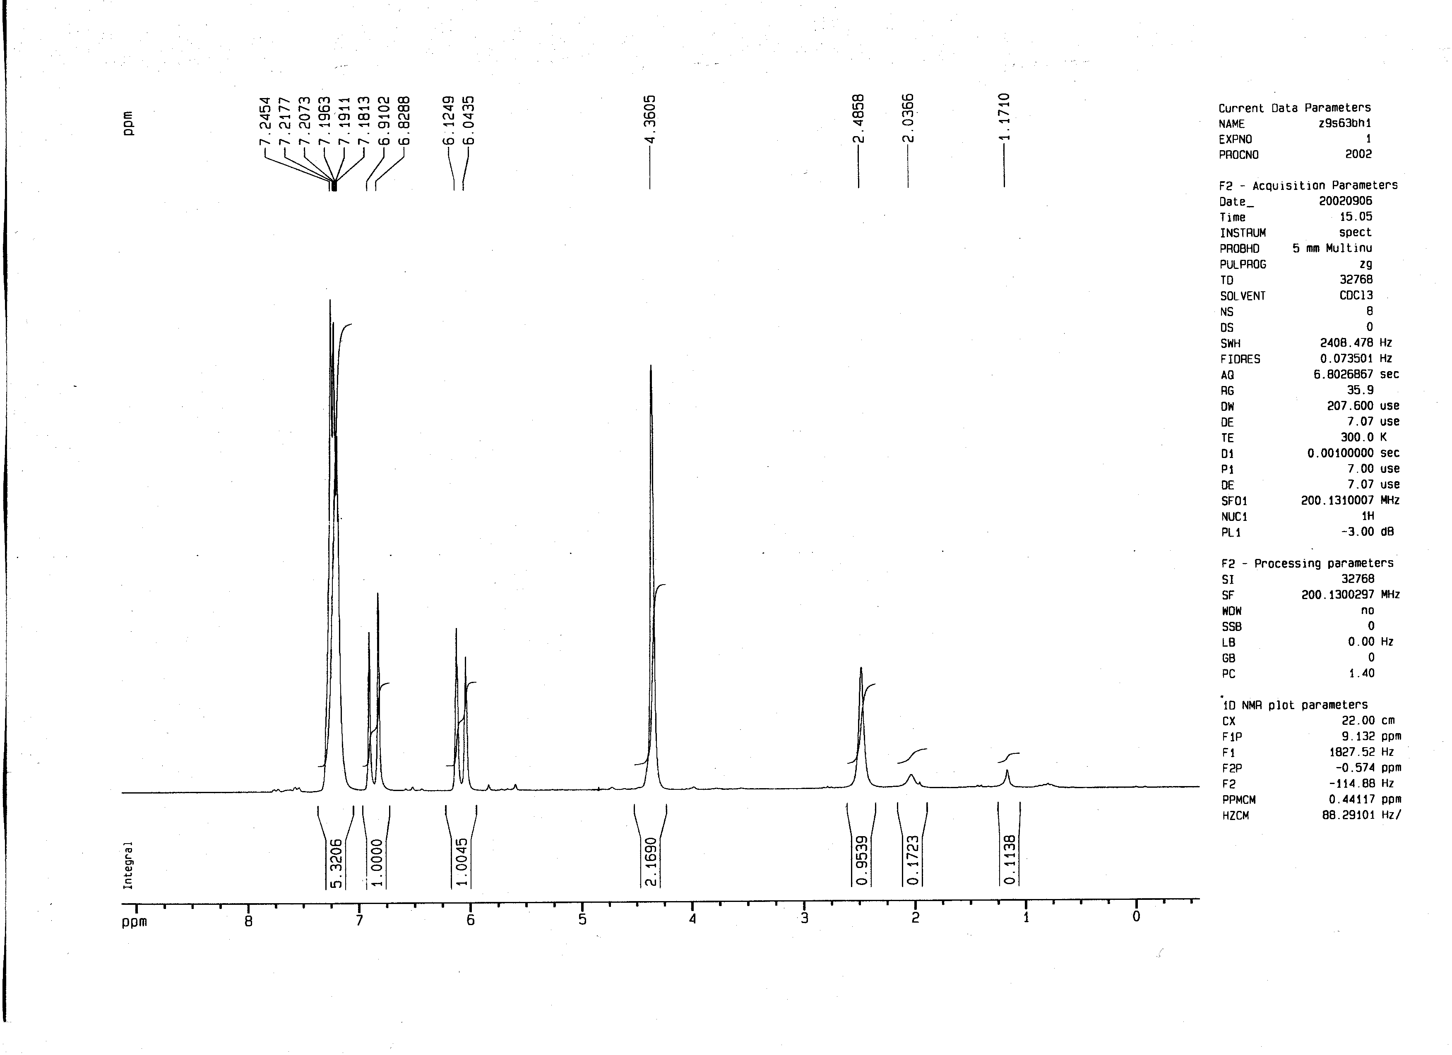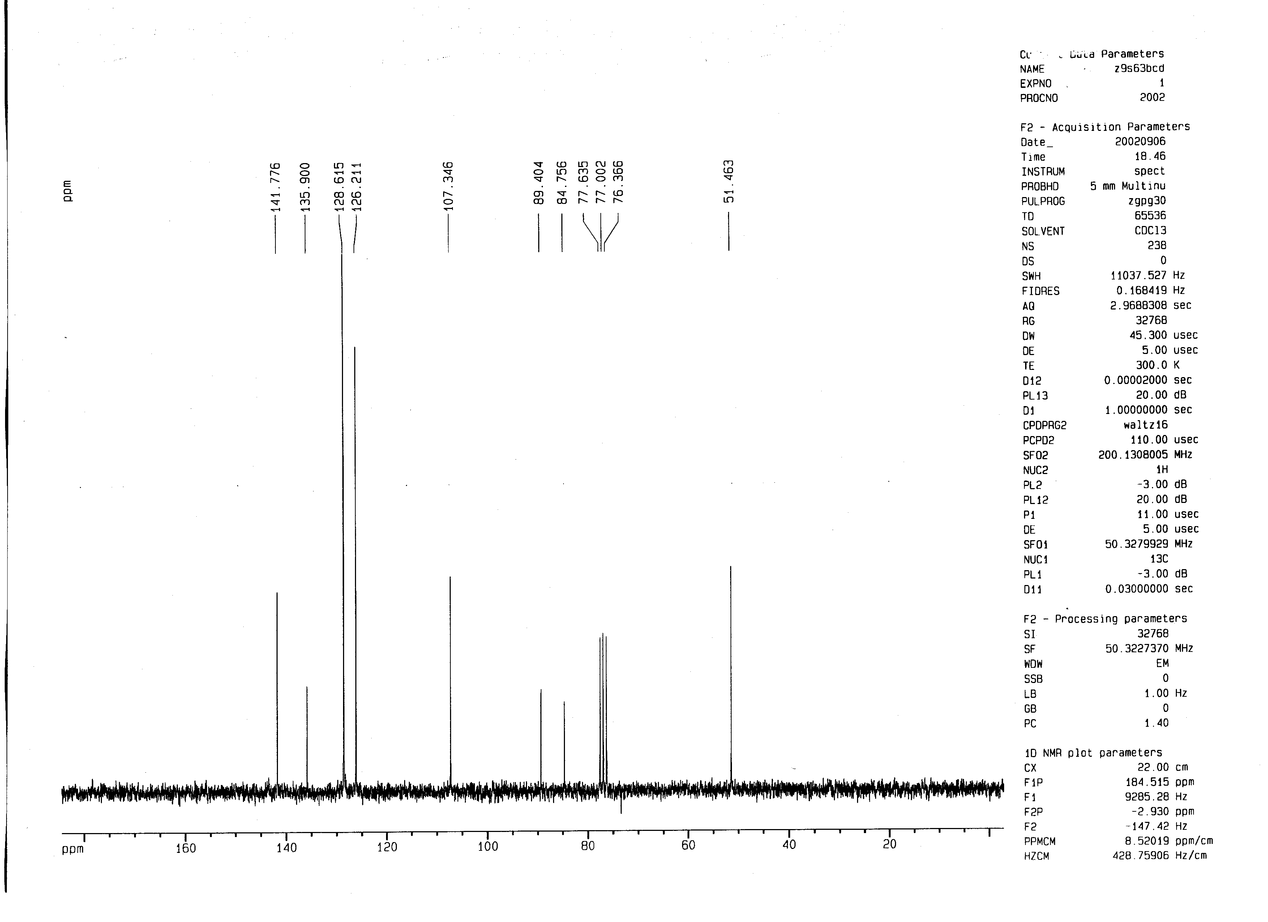
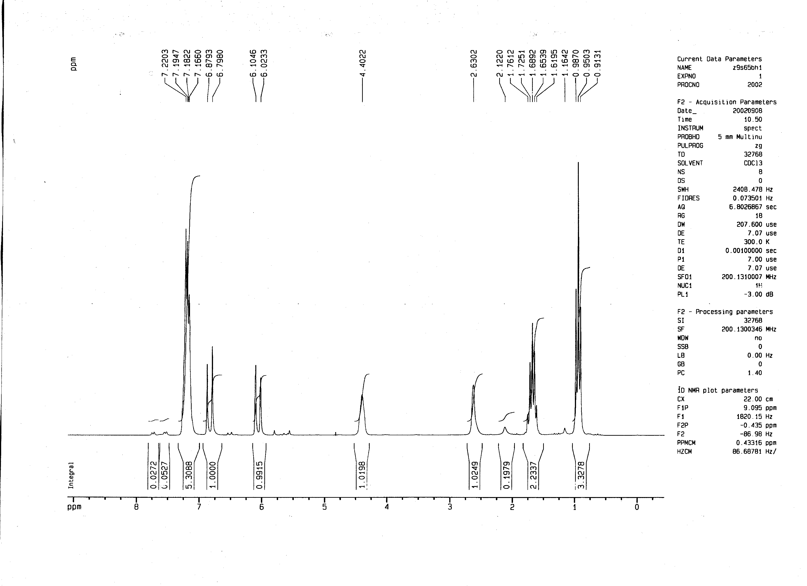
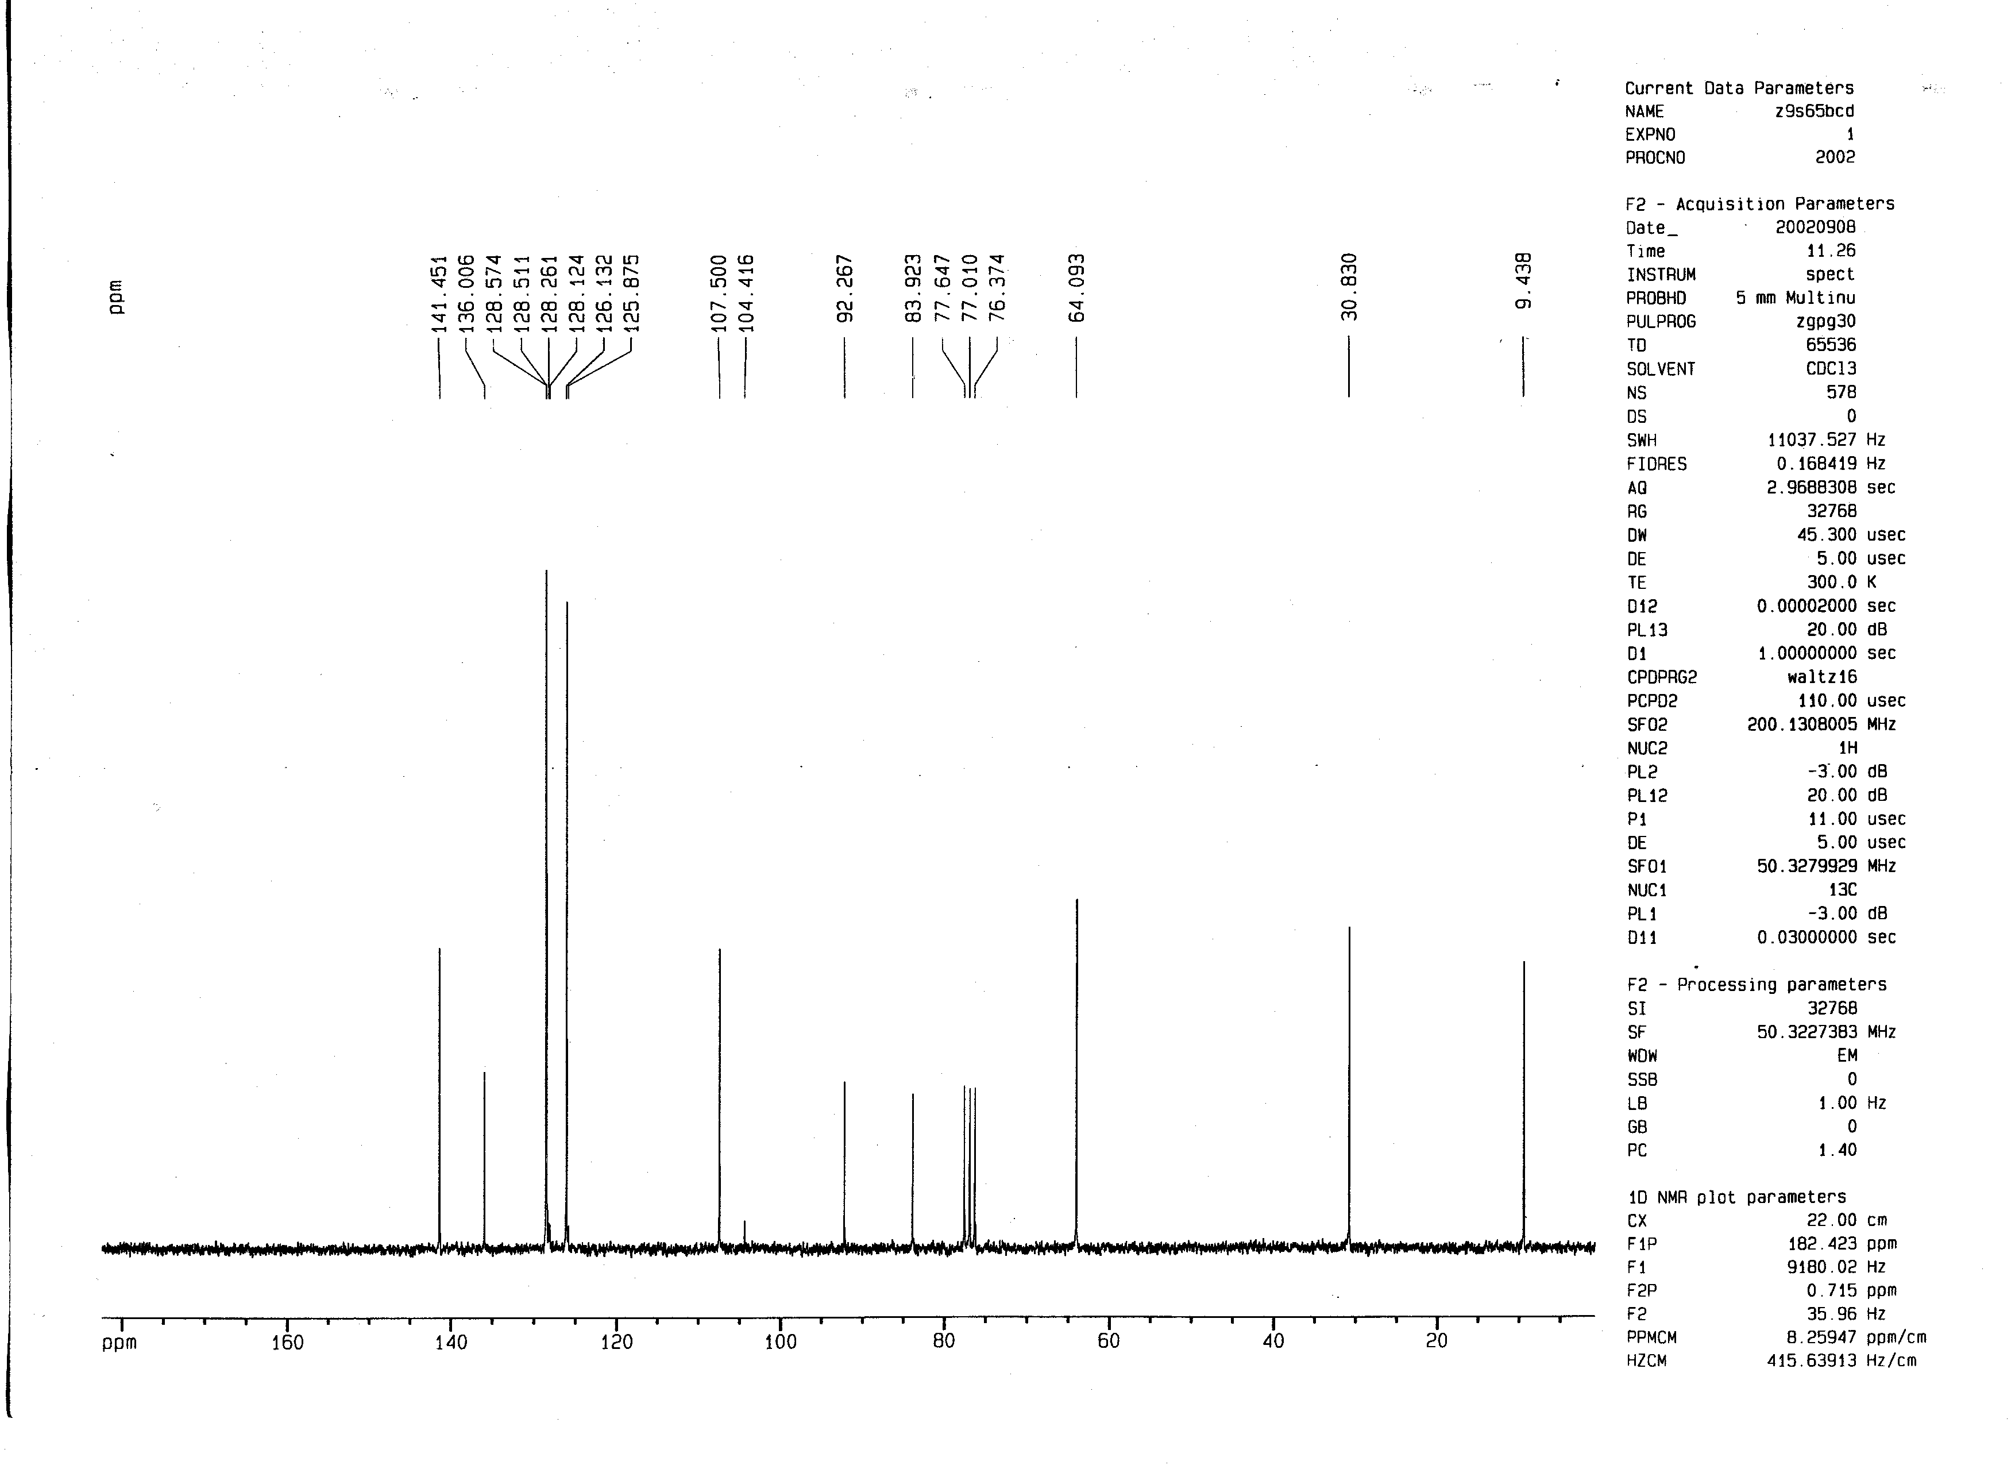
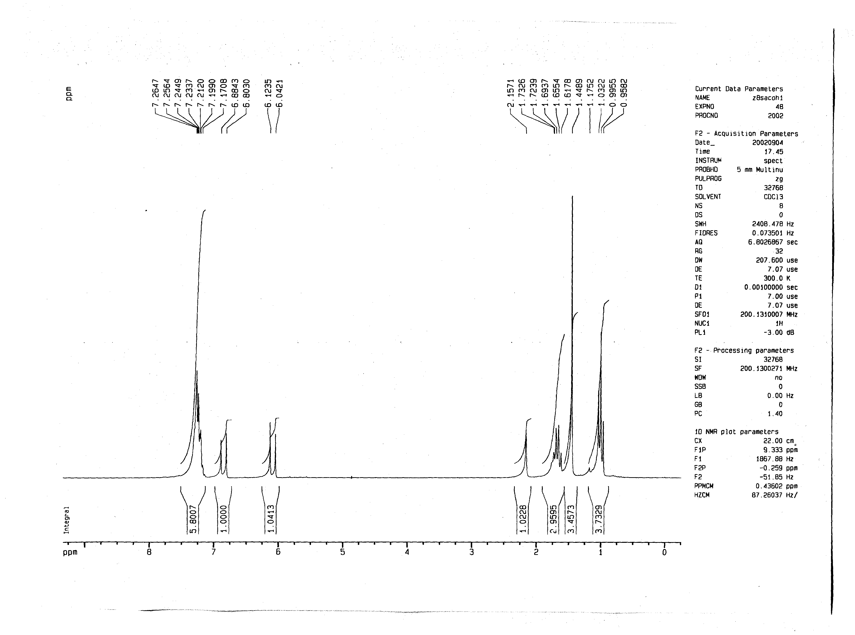
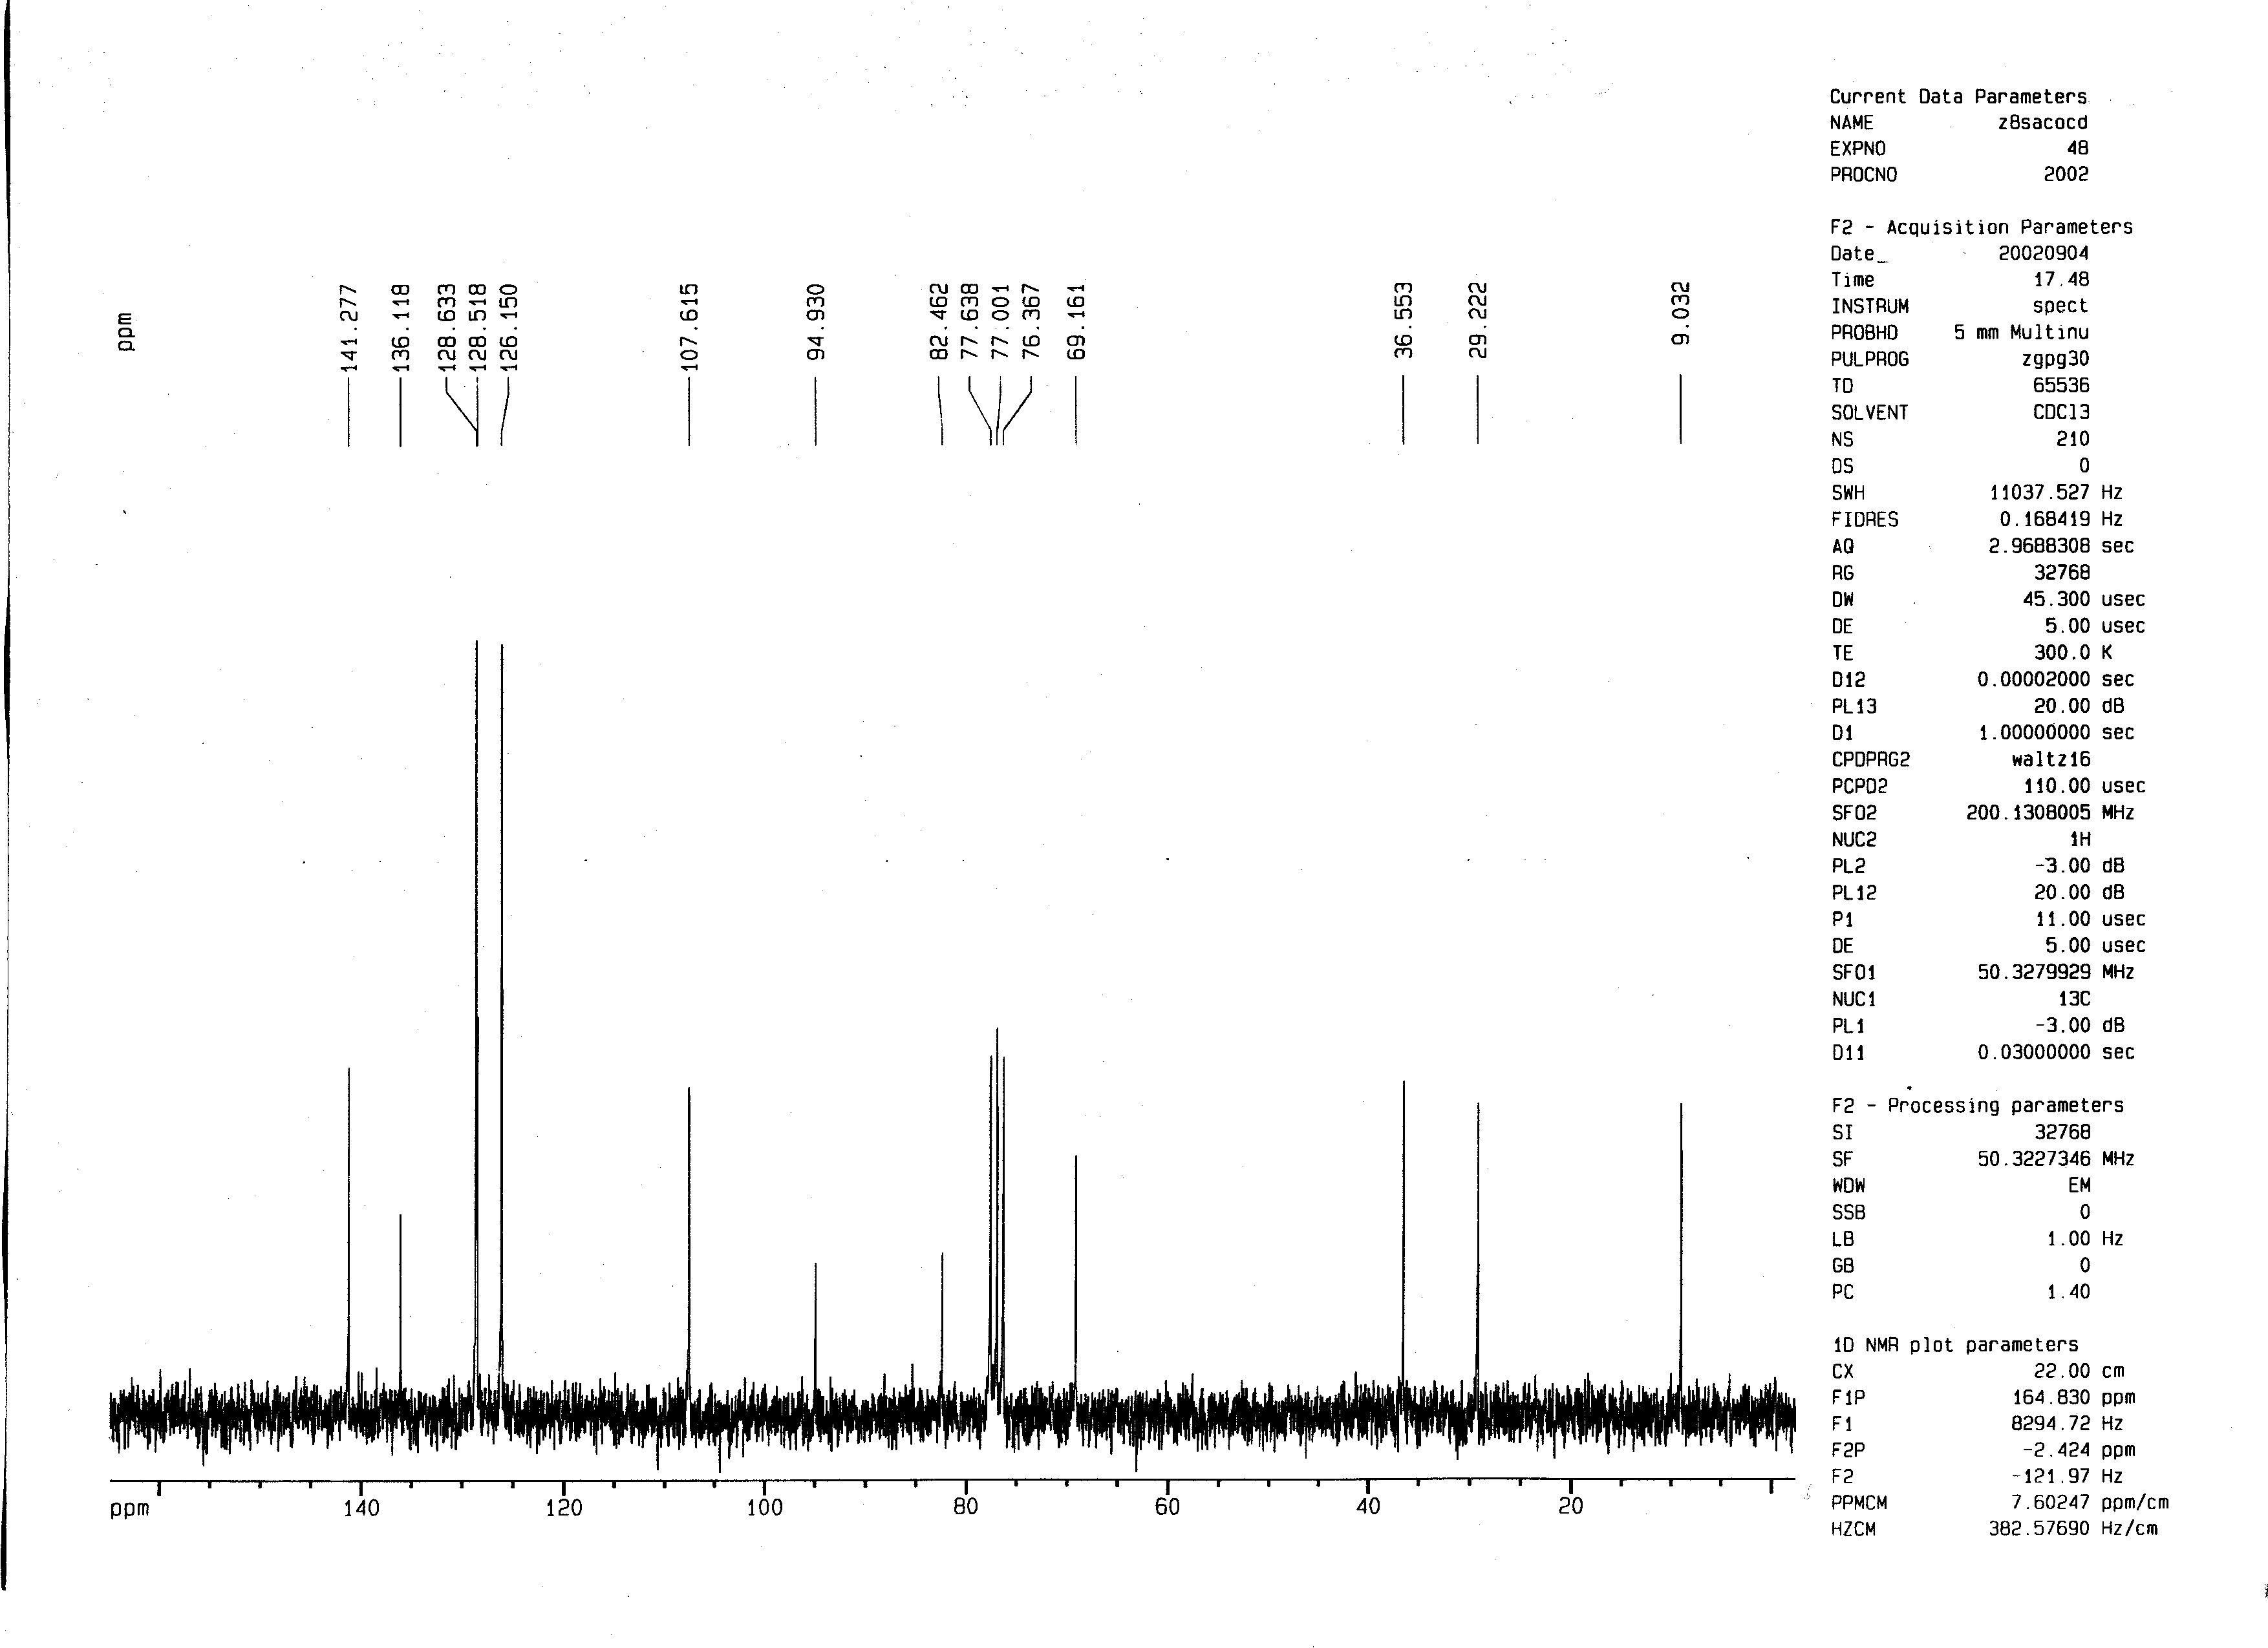
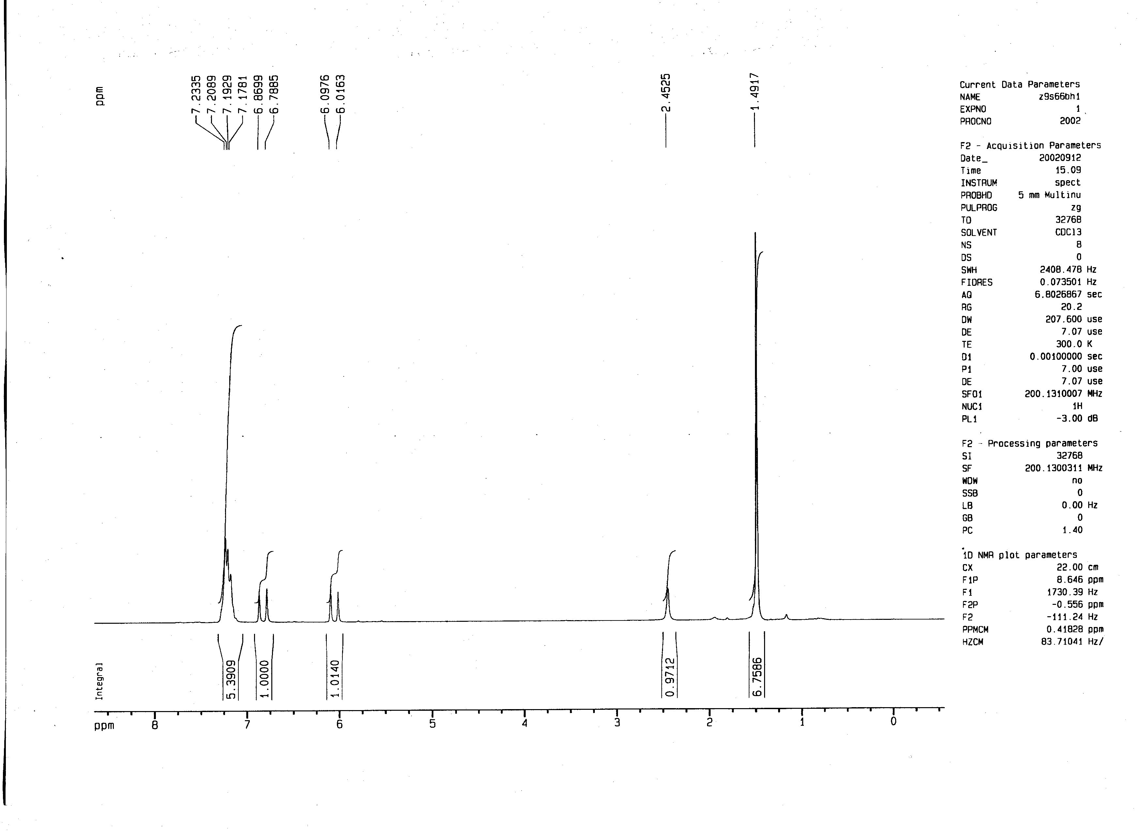
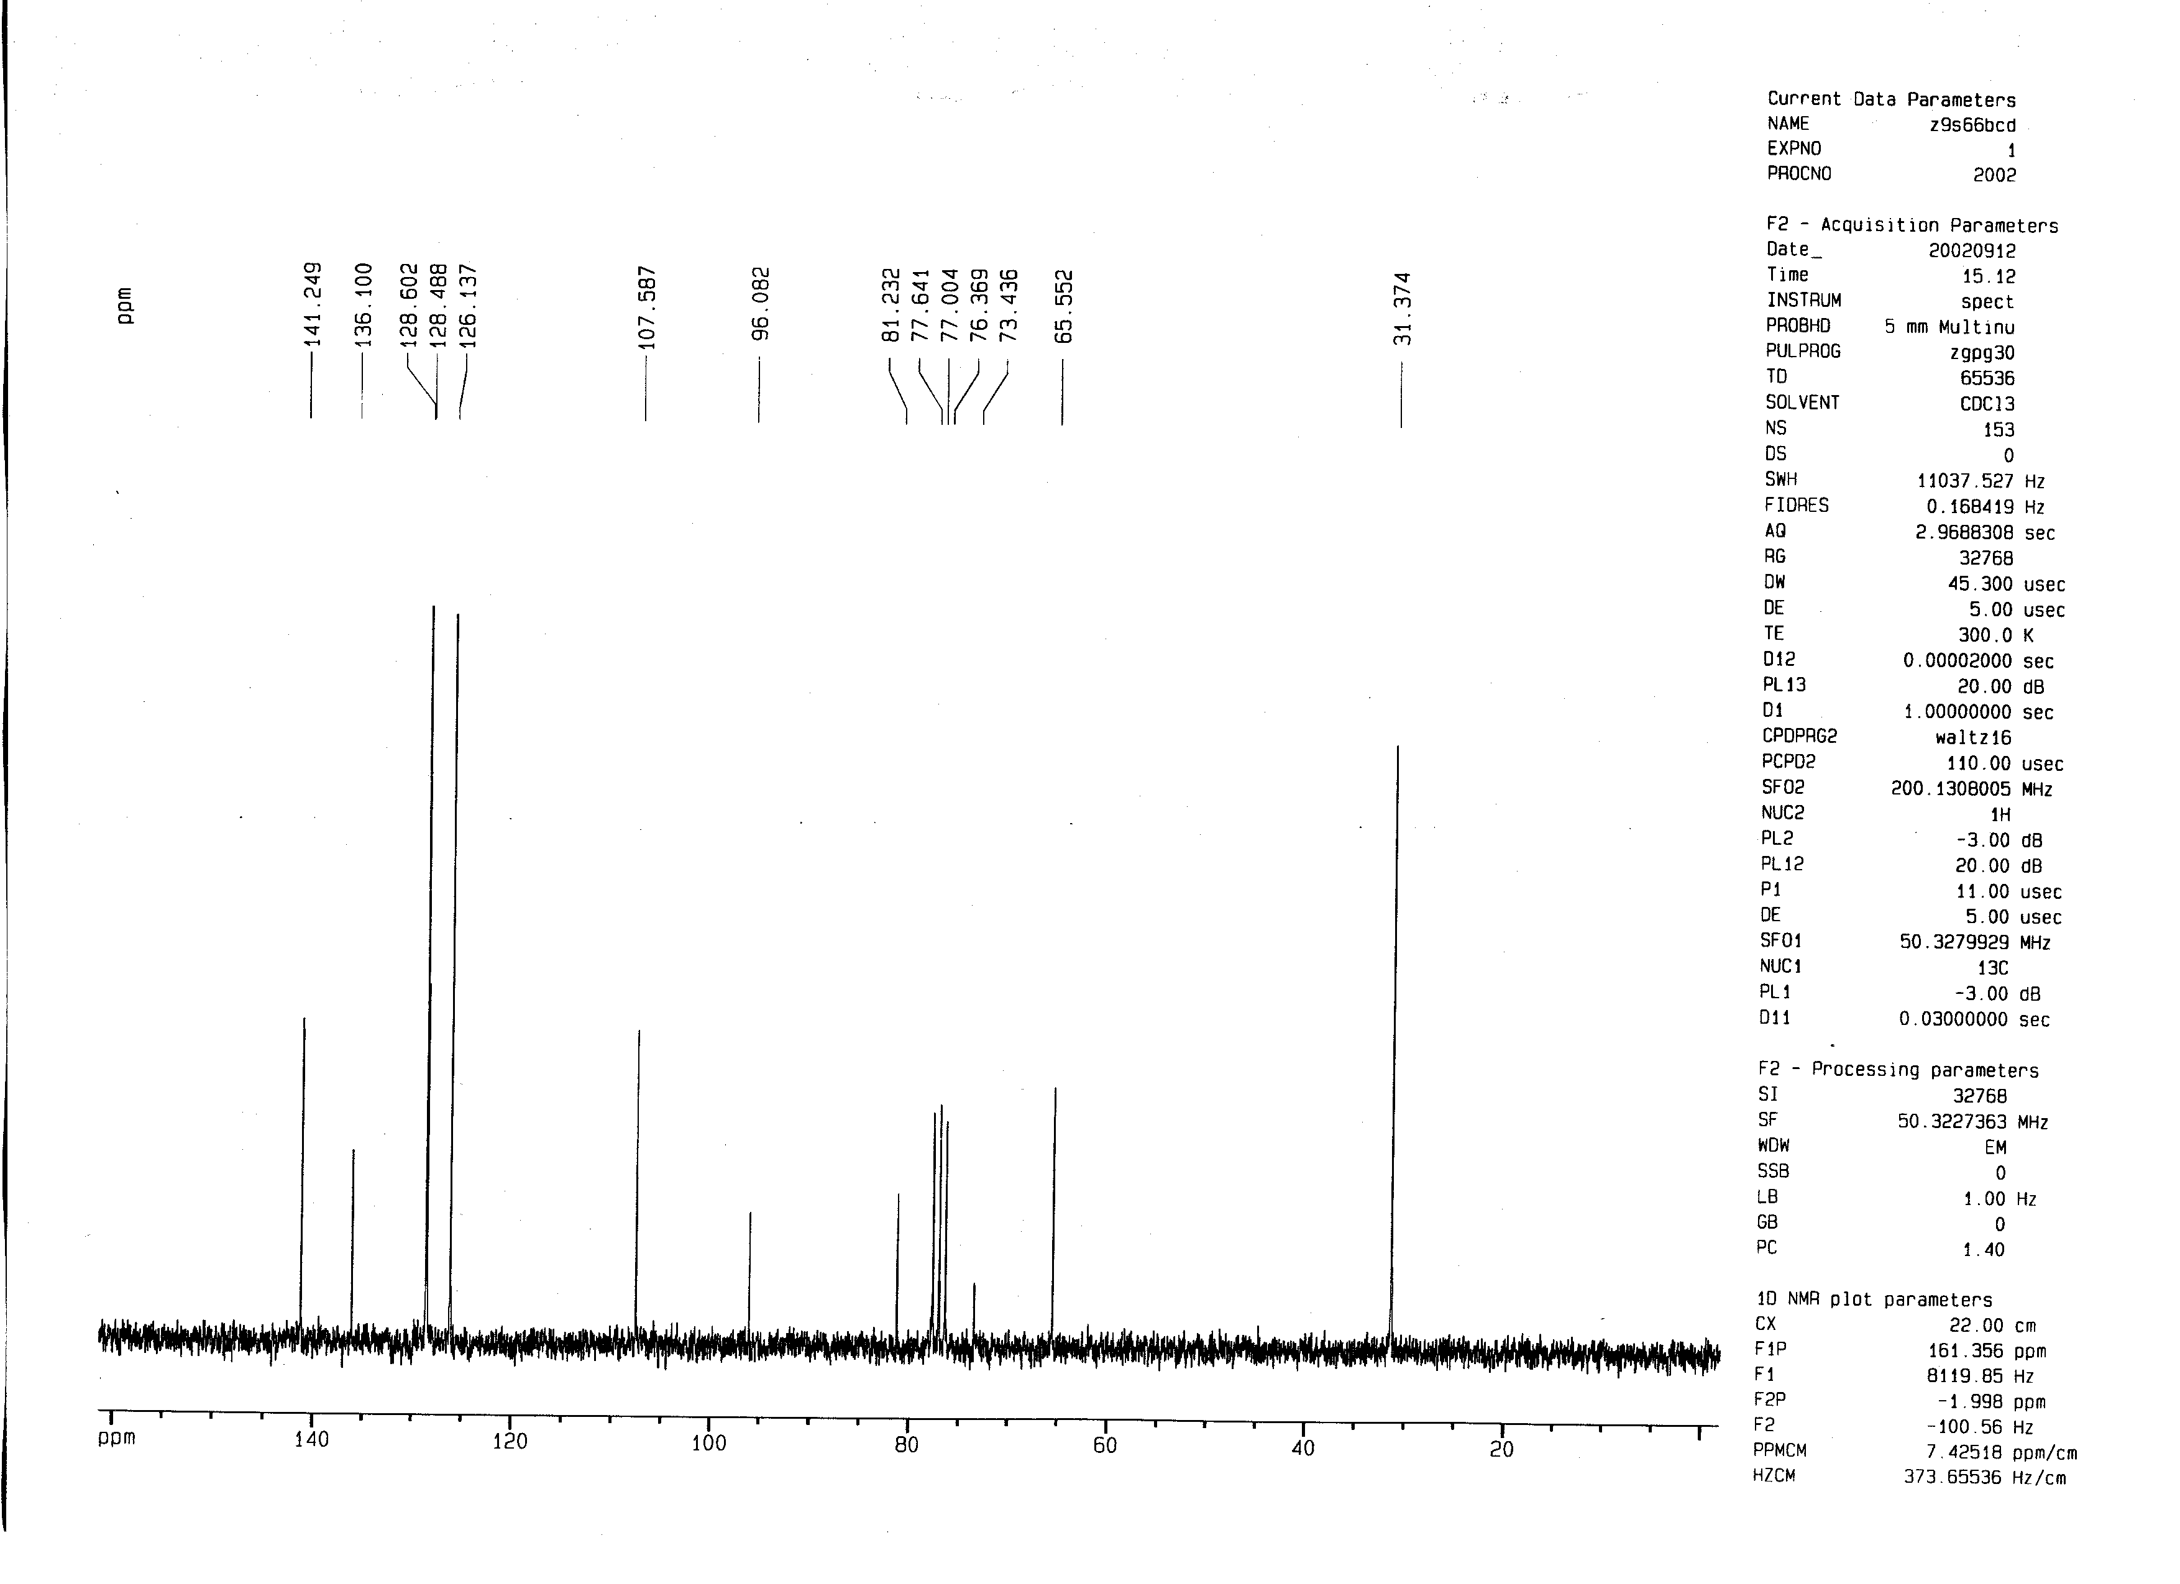
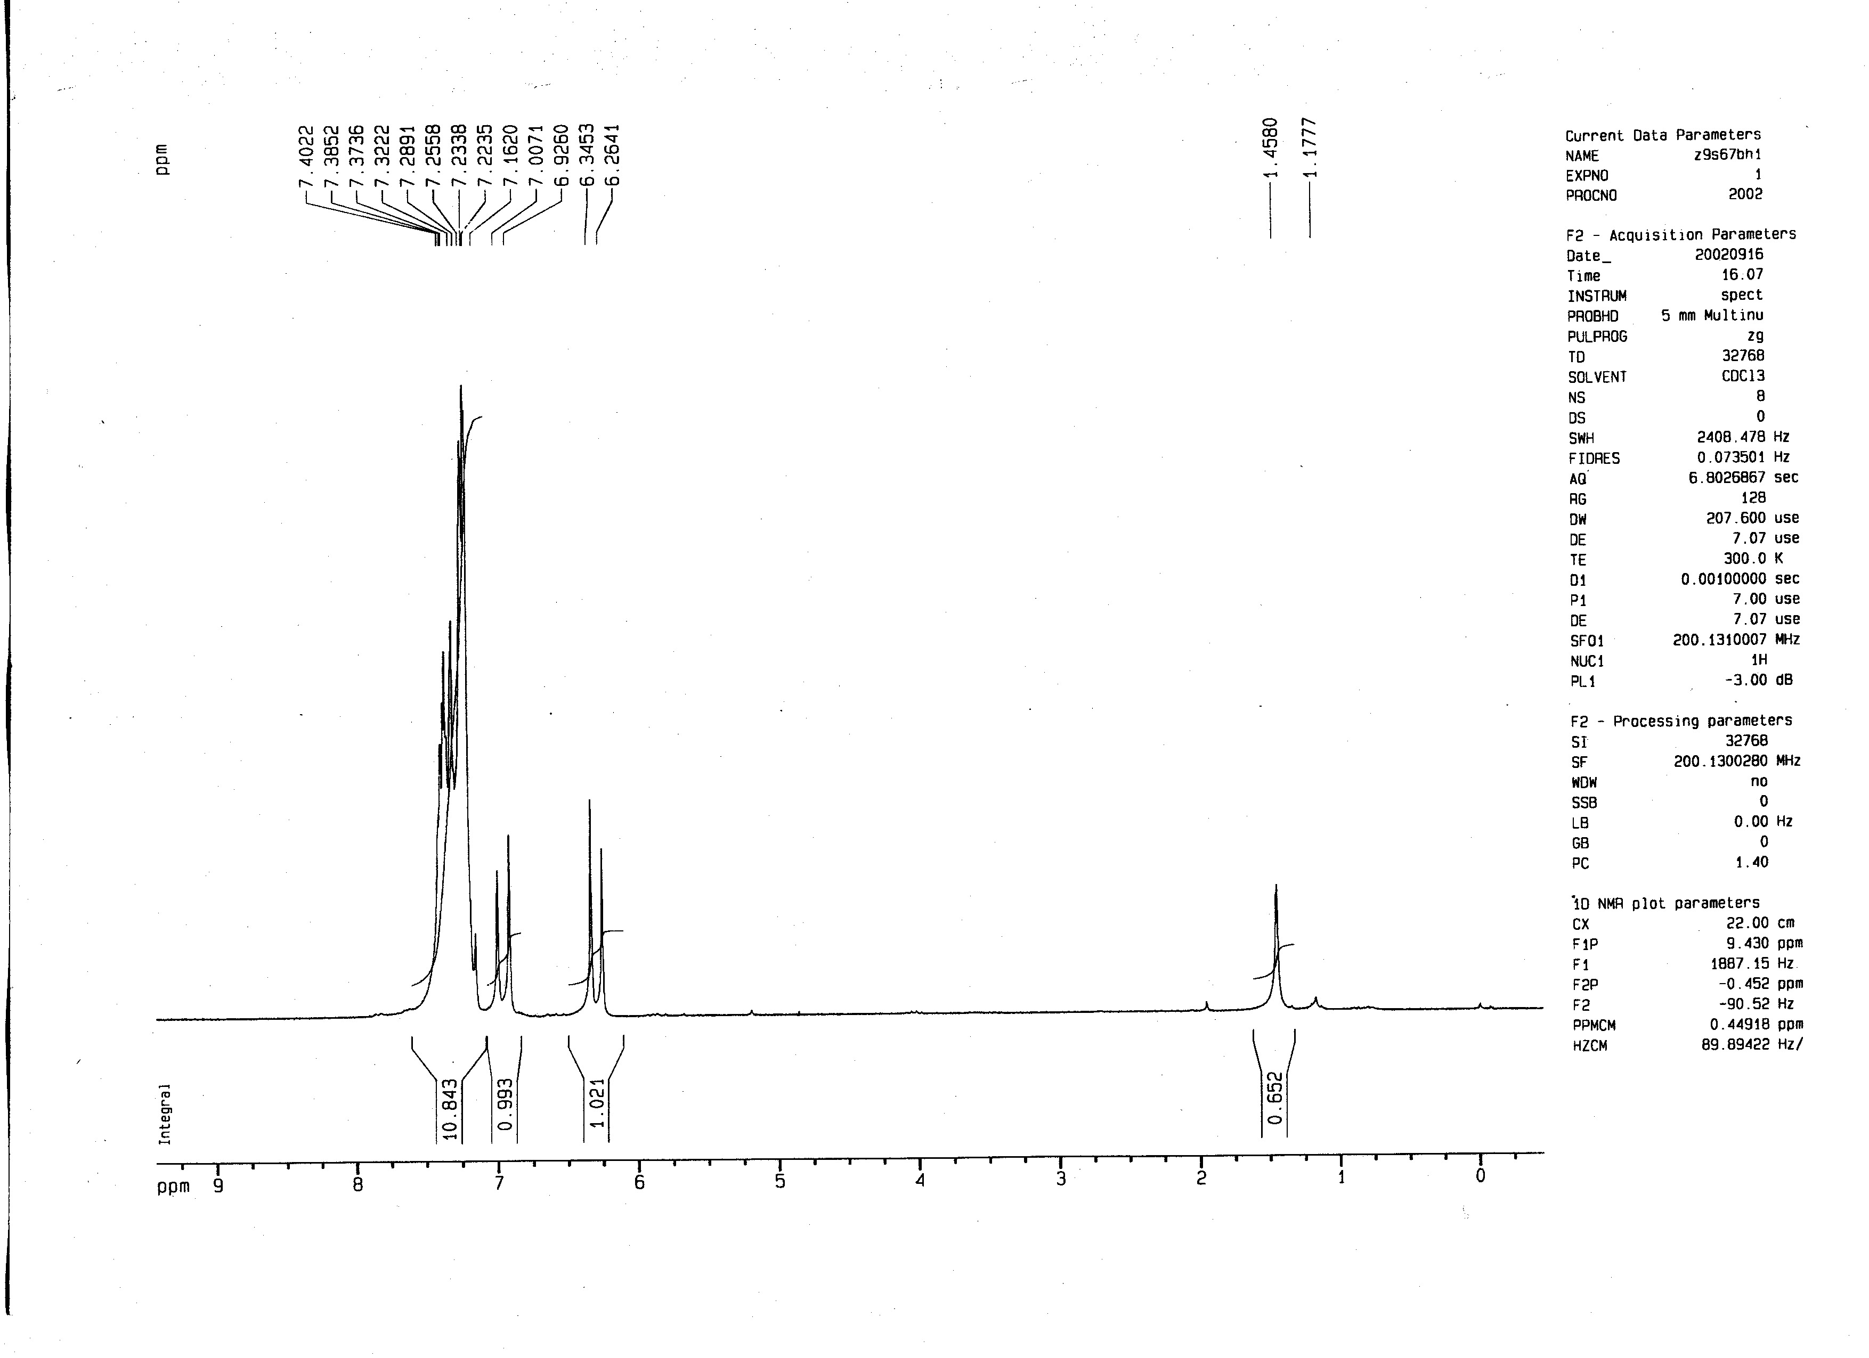
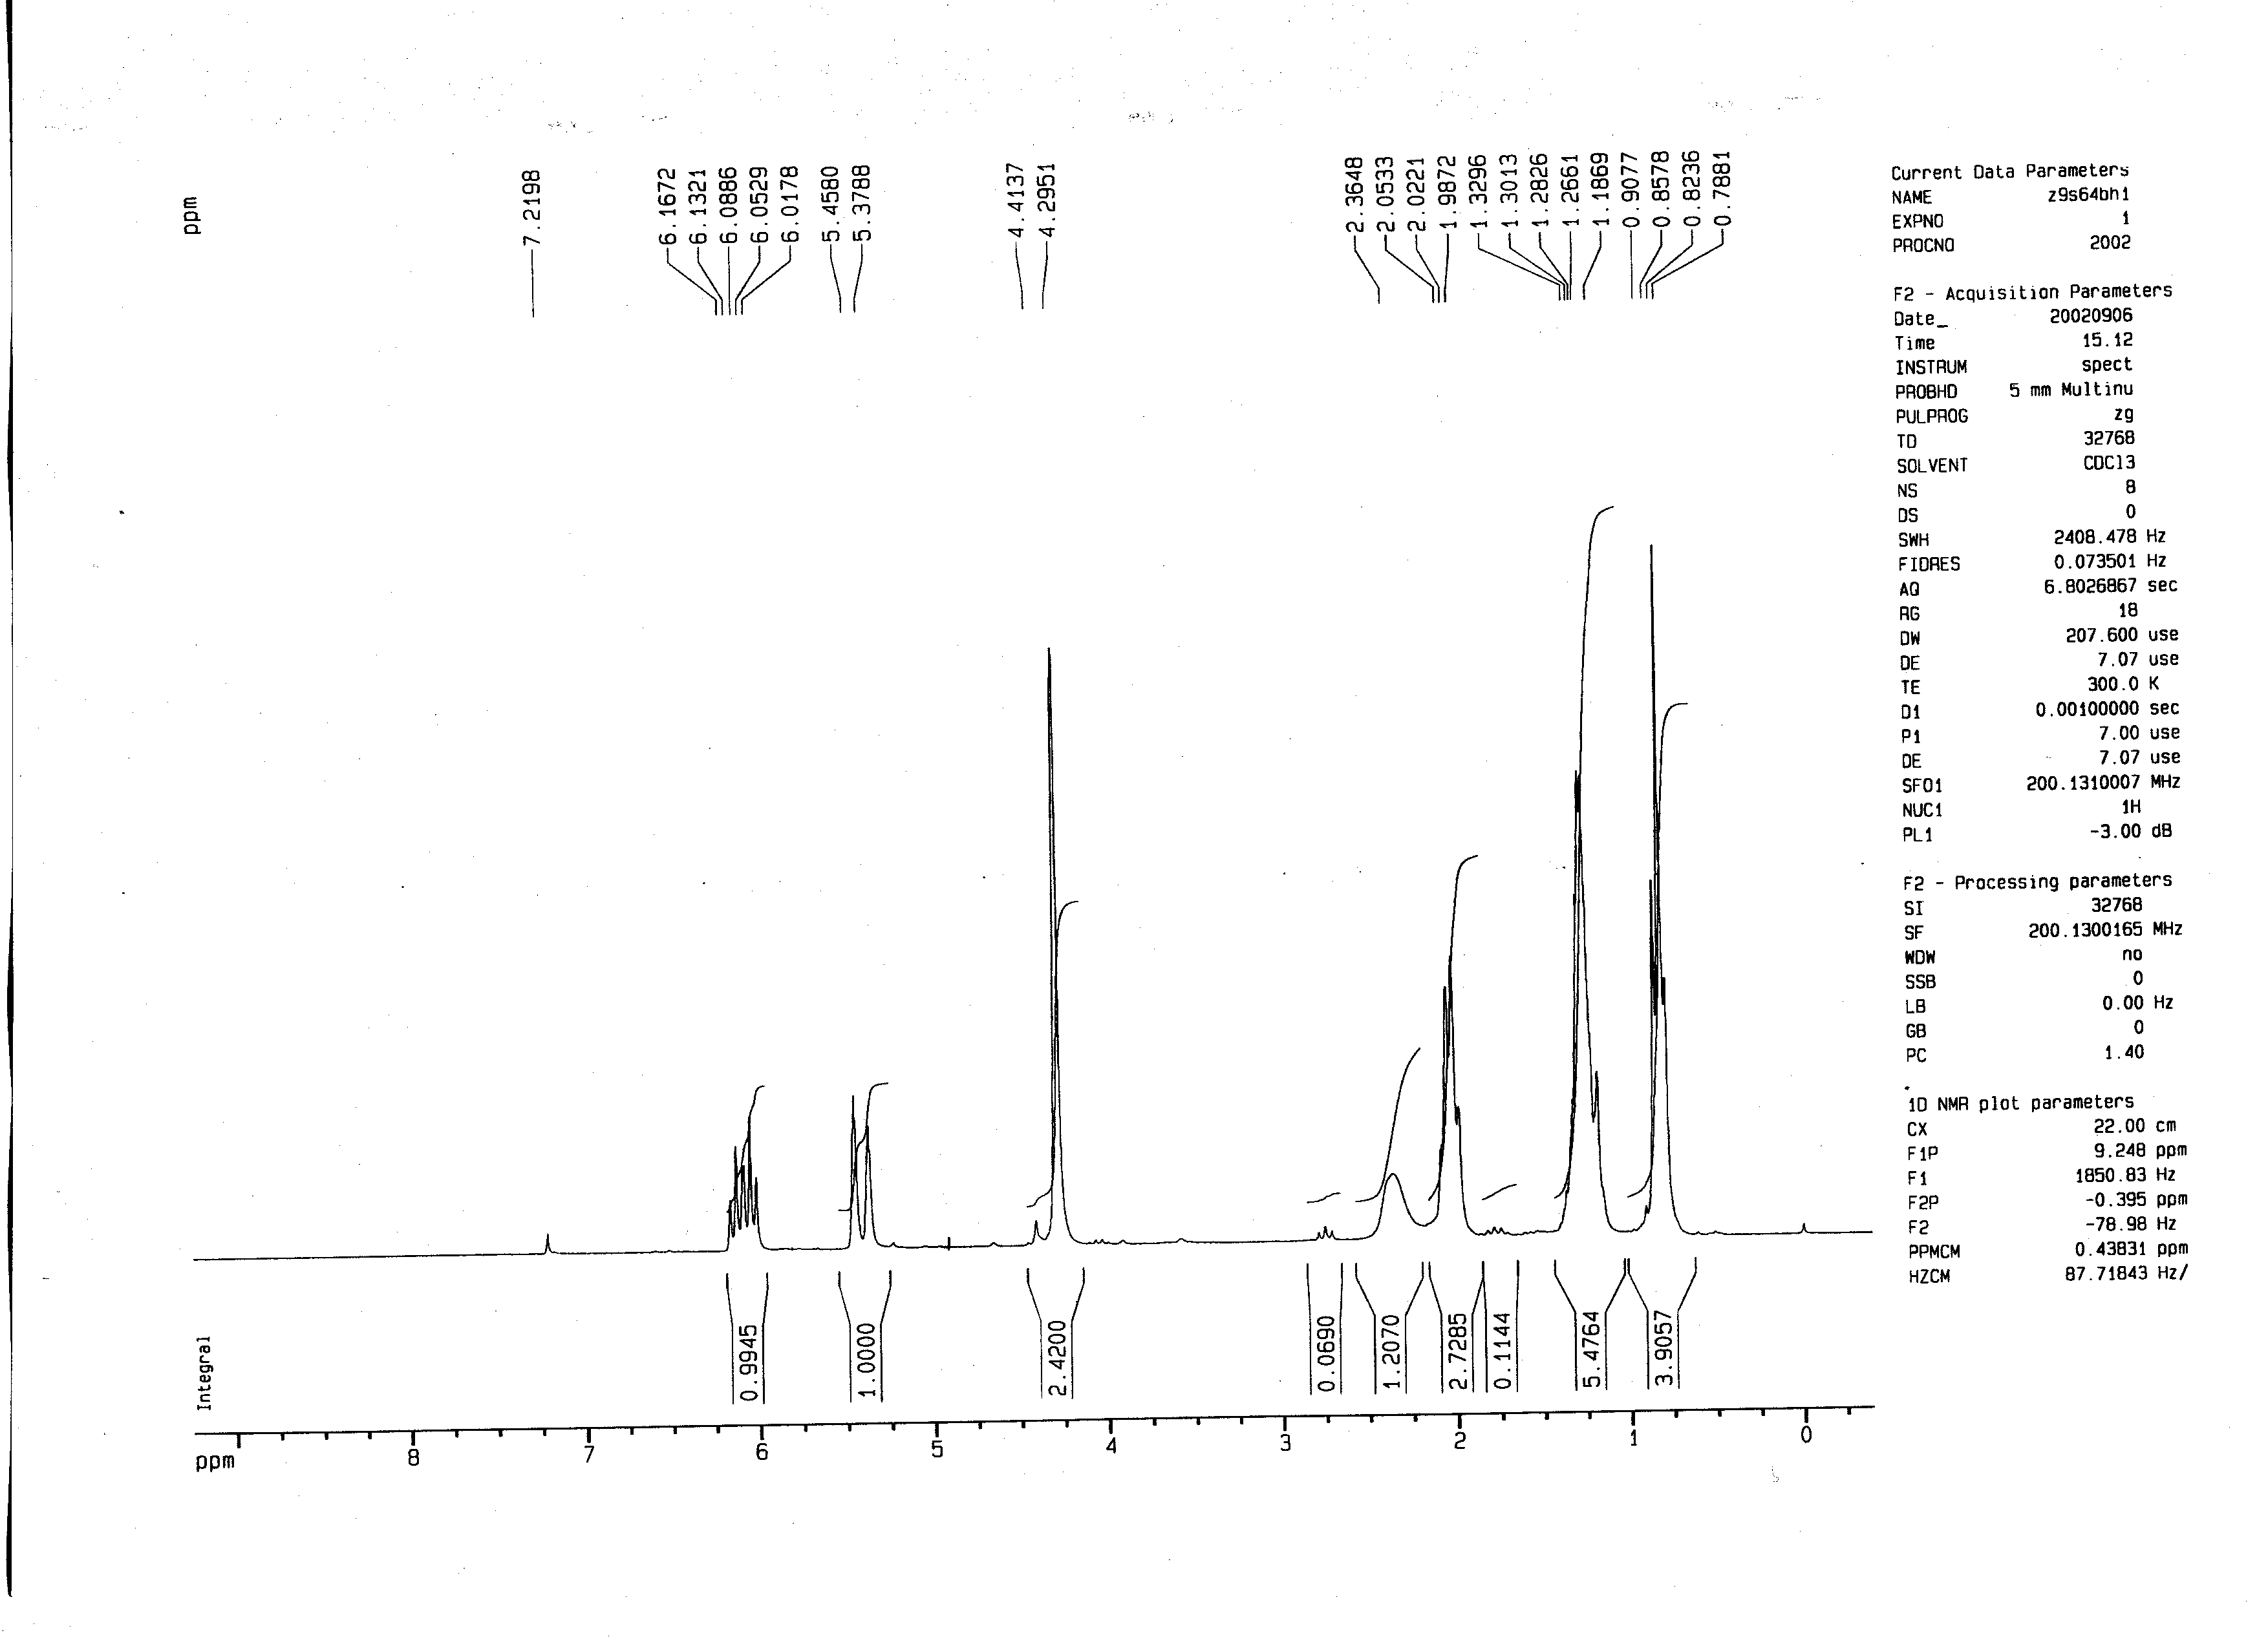
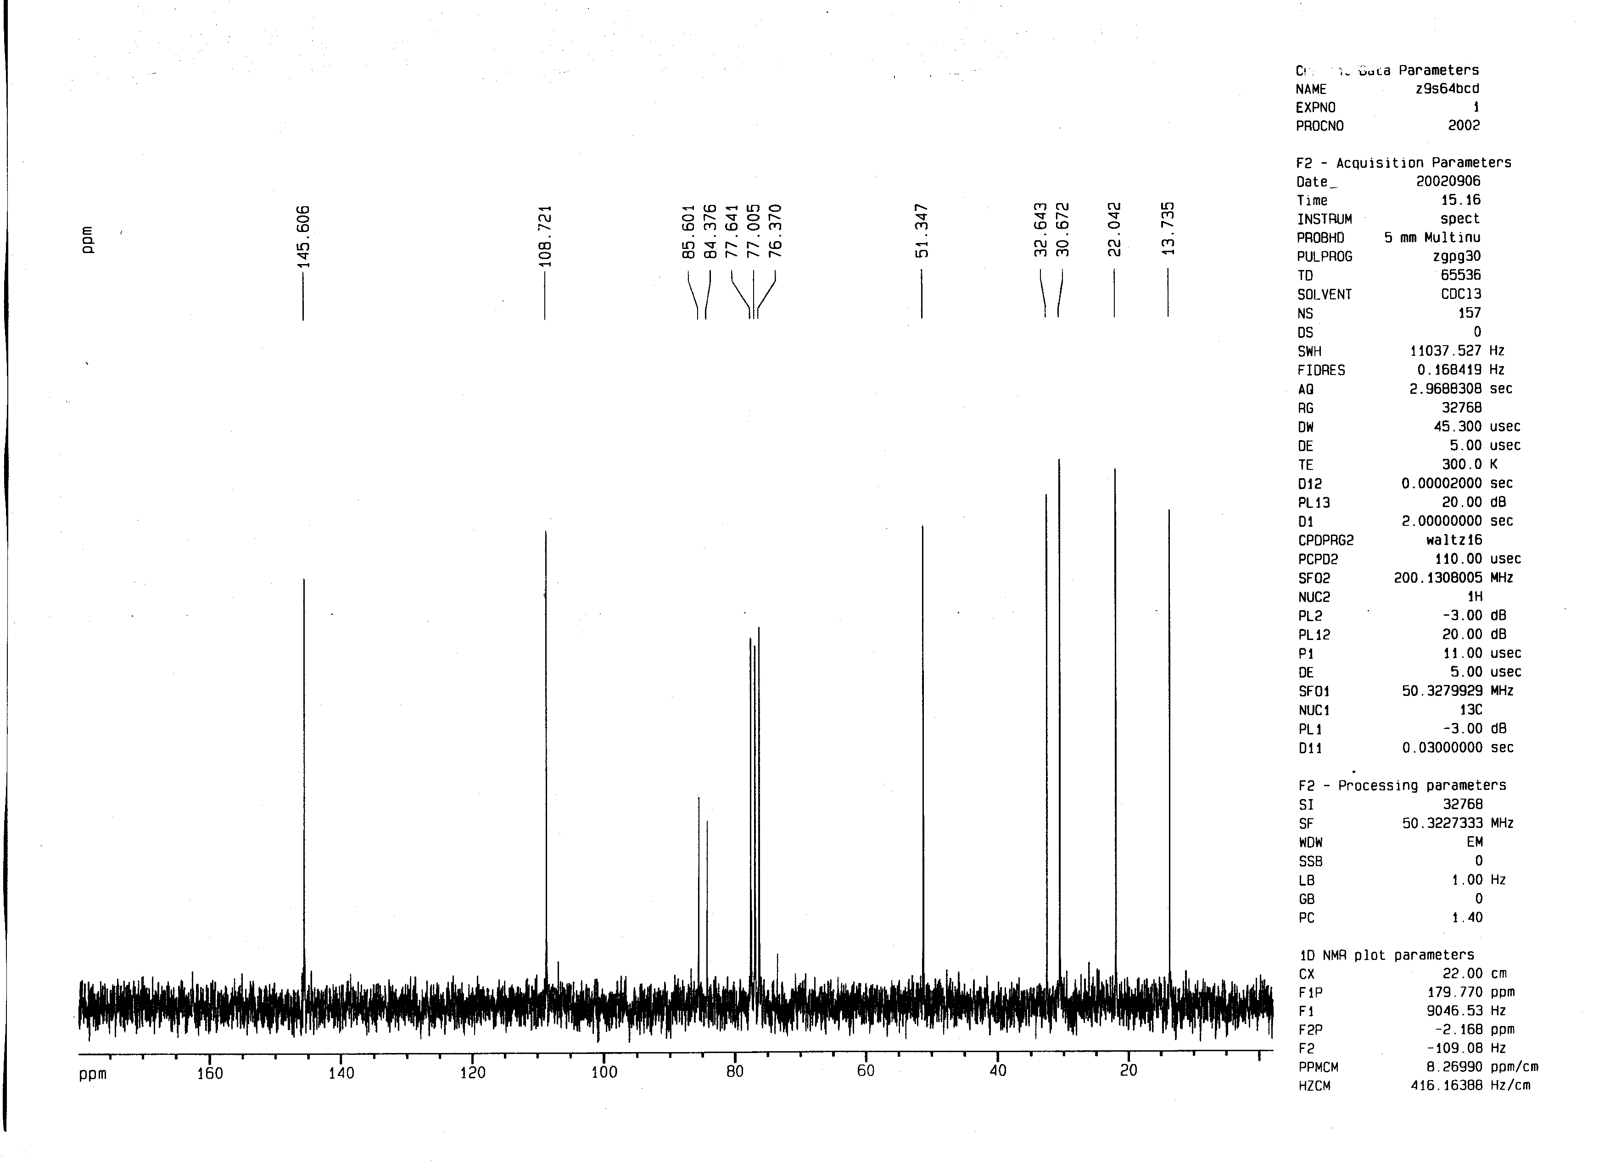
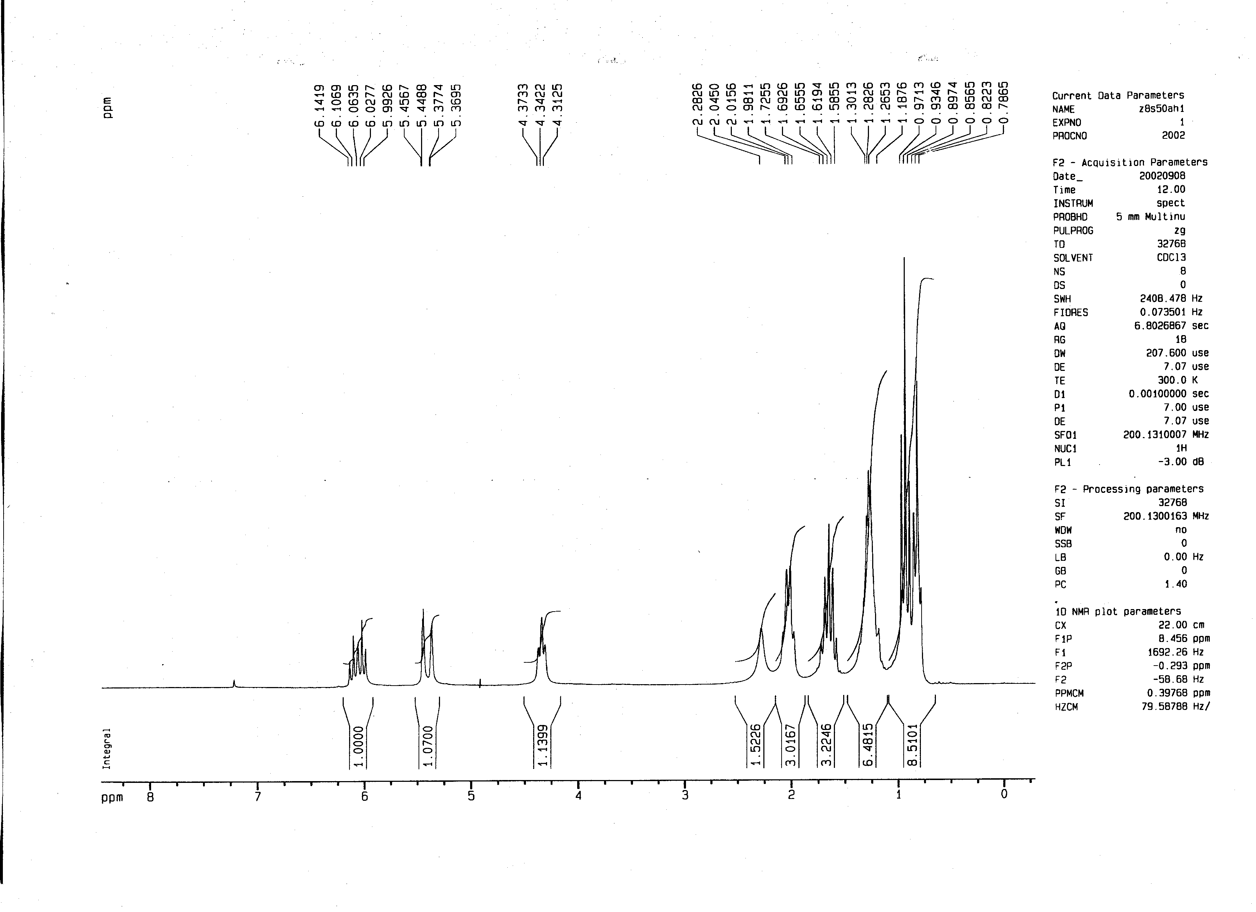
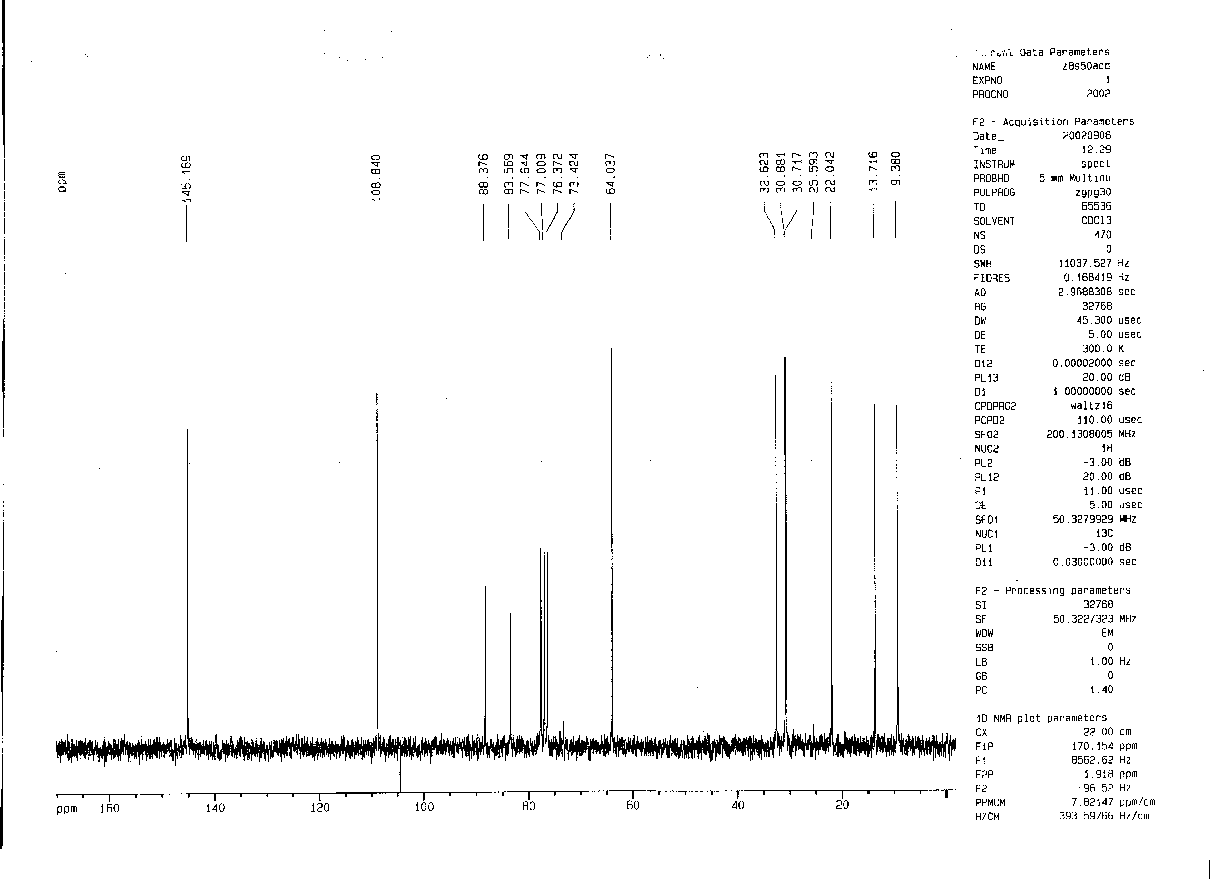
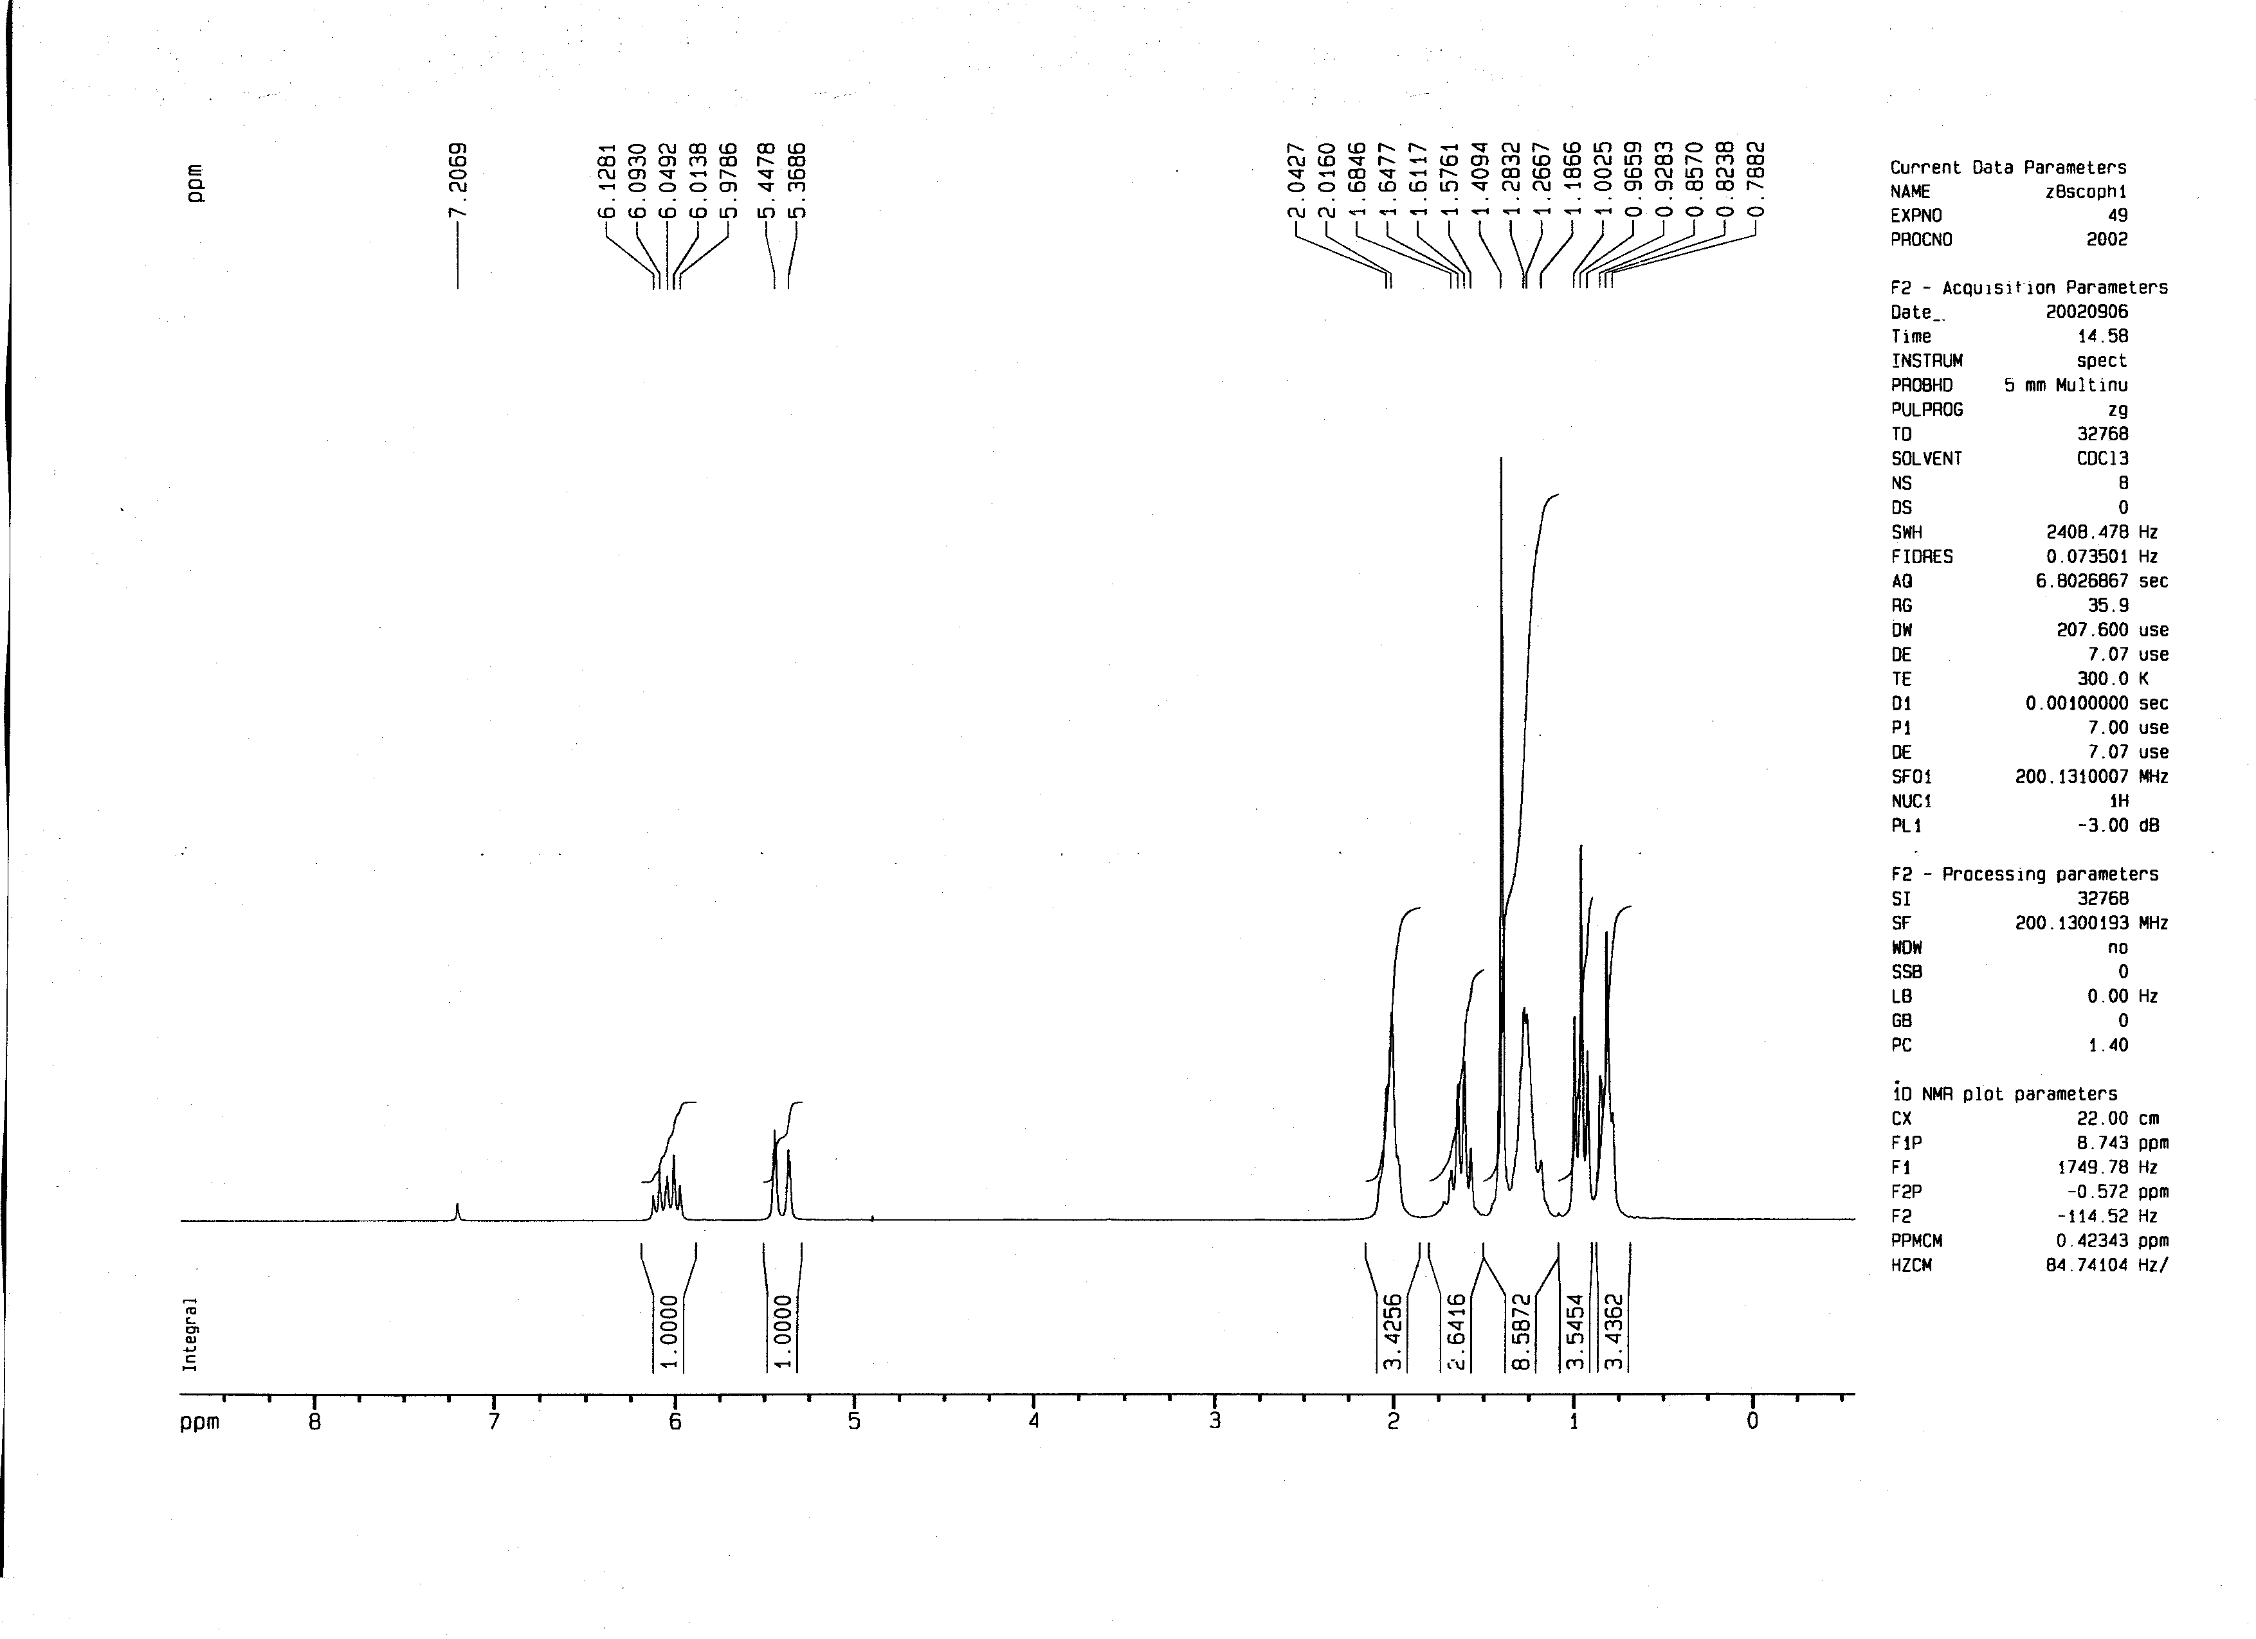
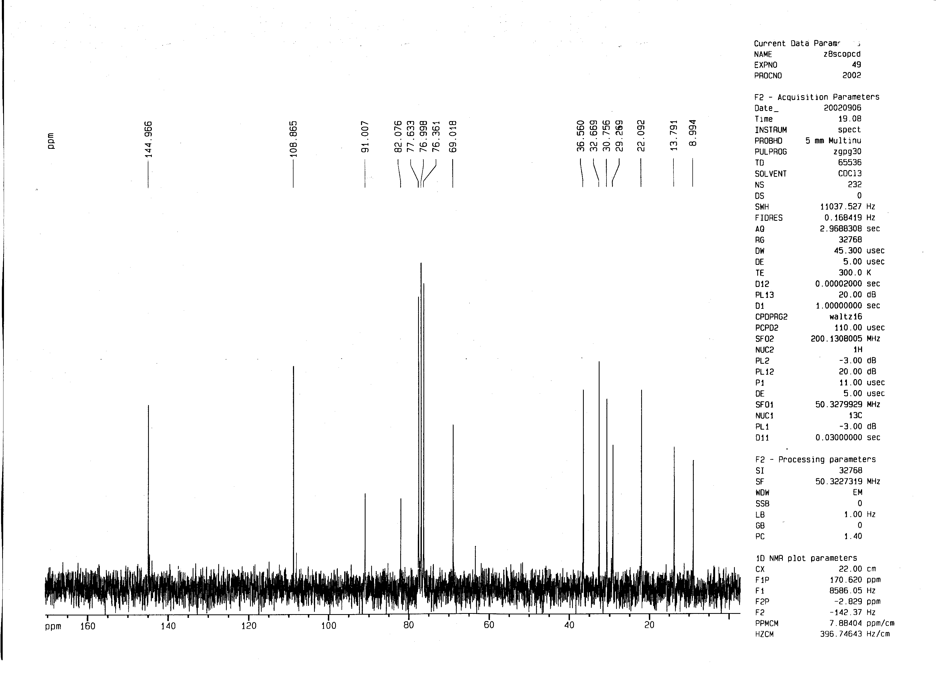
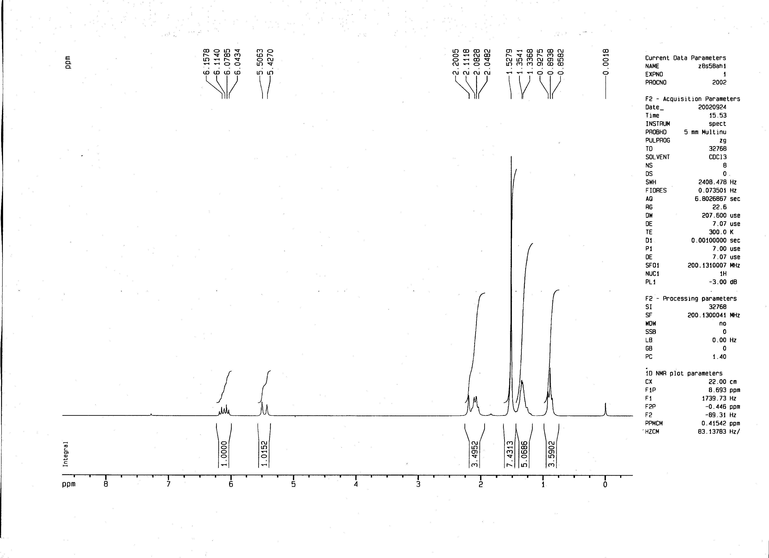
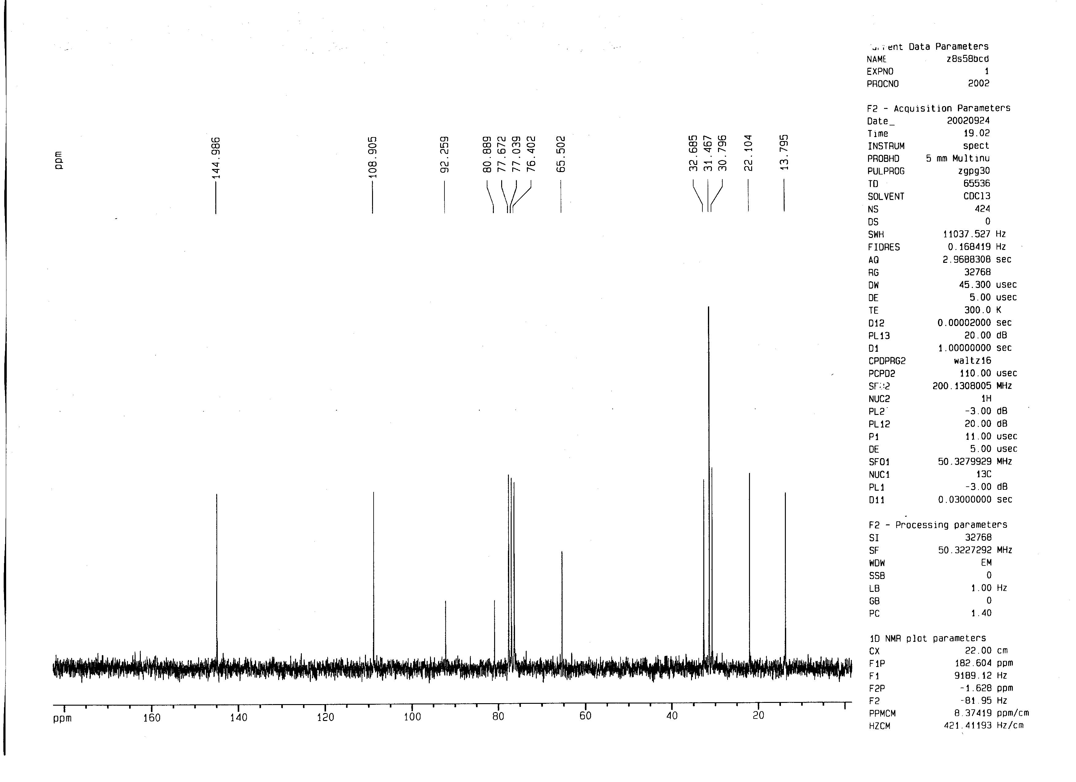
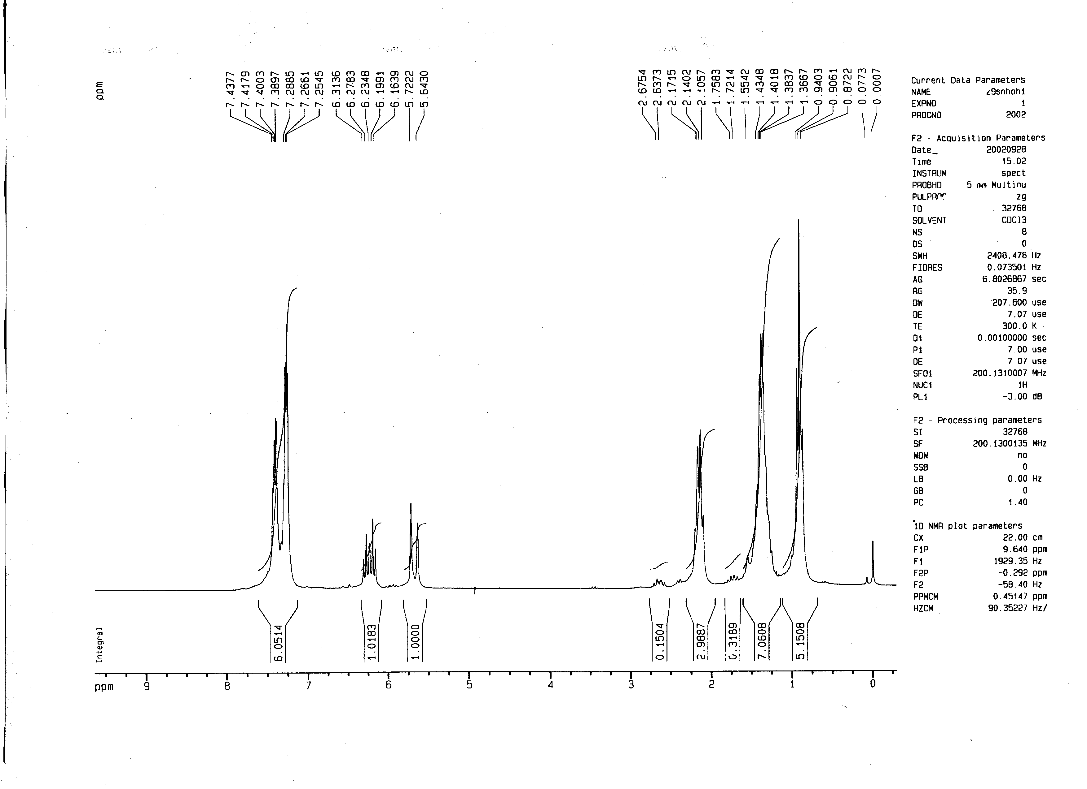

Still, W.C.; Kahn, M.; Mitra, A. J. Org. Chem. 1975, 43, 2923-2925

