Electronic Supplementary Information (ESI) for

Manuscript: Org. Biomol. Chem. (Title: Topochemical exploration of potent compounds using retro-enantiomer libraries of cyclic pentapeptides)

Experimental

General

Ion-spray (IS)-mass spectrum was obtained with a Sciex APIIIIE triple quadrupole mass spectrometer (Toronto, Canada). Optical rotations were measured in CHCl₃ with a JASCO DIP-360 digital polarimeter (Tokyo, Japan) or a Horiba high-sensitive polarimeter SEPA-200 (Kyoto, Japan). HPLC solvents were H2O and CH3CN, both containing 0.1% (v/v) TFA. For analytical HPLC, a Cosmosil 5C18-AR column (4.6 x 250 mm, Nacalai Tesque Inc., Kyoto, Japan) was eluted with a linear gradient of CH3CN at a flow rate of 1 mL/min on a Waters model 600 (Nihon Millipore, Ltd., Tokyo, Japan). Preparative HPLC was performed on a Waters Delta Prep 4000 equipped with a Cosmosil 5C18-AR column (20 x 250 mm, Nacalai Tesque Inc.) using an isocratic mode of CH3CN at a flow rate of 15 mL/min.

Peptide Synthesis

p-Nitrophenyl carbonate Wang resin (108 mg, 0.100 mmol) was treated with NH2NH2.H2O (485 μL, 1.00 mmol) in DMF (5 mL) at room temp. for 2 h to give a hydrazino linker. The protected peptide resin was constructed by Fmoc-based solid-phase peptide synthesis on the above resin using side-chain protecting groups: But for L/D-Tyr and 2,2,4,6,7-pentamethyl-dihydrobenzofuran-5-sulfonyl (Pbf) for L/D-Arg. The obtained resin was treated with 10% TFA in CHCl3 at room temp. for 1.5 h, and the mixture was filtered. The filtrate was concentrated under reduced pressure to afford the crude protected peptidyl hydrazide. To a stirred solution of the hydrazide in DMF (2 mL) were added a solution of 4 M HCl in DMF (66.4 μL, 0.300 mmol) and isoamyl nitrite (120 μL, 0.600 mmol) at – 30 °C, and the mixture was then stirred at – 10 °C for 20 min. To the mixture were added DMF (100 mL) and DIPEA (870 μL, 5.0 mmol) at – 40 °C, and the mixture was stirred at – 20 °C for 24 h. After concentration under reduced pressure, the oily residue was treated with aqueous 95% TFA at room temp. for 2 h. After concentration under reduced pressure, the crude product was purified by preparative HPLC to afford a fluffy white powder of the desired peptide. Characterization data of all the synthetic peptides are listed in Table S1.

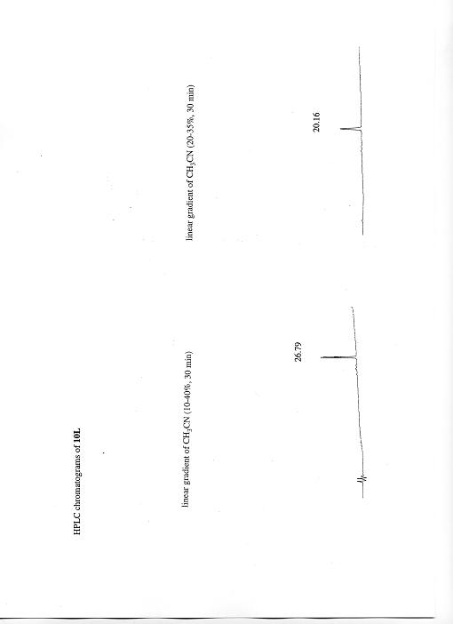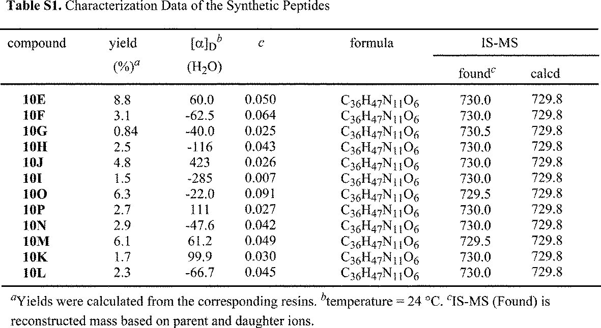

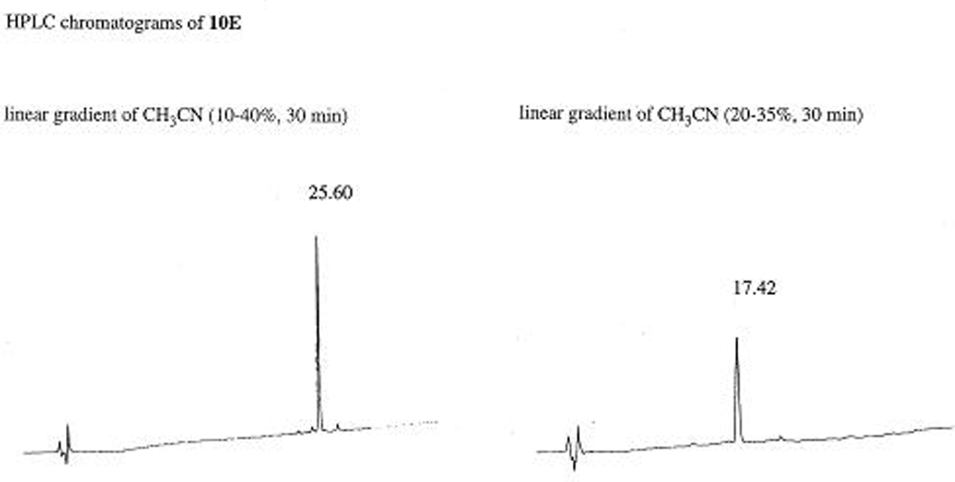

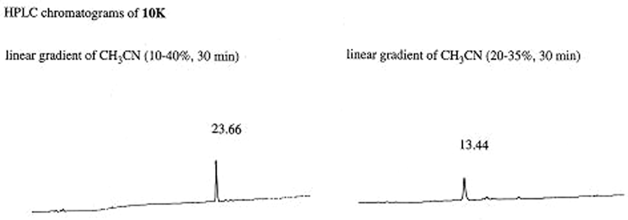

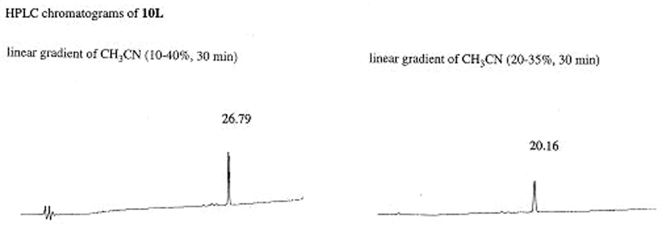

Cell Culture
Human T-cell lines, MT-4 and MOLT-4 cells were grown in RPMI 1640 medium containing 10% heat-inactivated fetal calf serum, 100 IU/mL penicillin and 100 μg/mL streptomycin.

Virus
A strain of X4-HIV-1, HIV-1IIIB, was used for the anti-HIV assay. This virus was obtained from the culture supernatant of HIV-1 persistently infected MOLT-4/HIV-1IIIB cells, and stored at –80 °C until used.
Anti-HIV-1 Assay

Anti-HIV-1 activity was determined based on the protection against HIV-1-induced cytopathogenicity in MT-4 cells. Various concentrations of test compounds were added to HIV-1-infected MT-4 cells at a multiplicity of infection (MOI) of 0.01, and placed in wells of a flat-bottomed microtiter tray (1.5 x 104 cells/well). After 5 days' incubation at 37°C in a CO2 incubator, the number of viable cells was determined using the MTT method (EC50). Cytotoxicity of compounds was determined based on the viability of mock-infected cells using the MTT method (CC50).

Inhibition Assay of Binding of SDF-1 to CXCR4 (Oil Cushion Method)

The CXCR4-transfected CHO cell lines suspended in Ham’s F-12 buffer (0.5% bovine serum albumin, 20 mM HEPES buffer) (5 x 105 cells/120 μL/well) were placed in silicone-coated tubes. Cold SDF-1α (final concentration 0.1 μM, 15 μL/well) and various concentrations of test compounds (15 μL/well) were added to the above tubes followed by addition of 125I-SDF-1α (Perkinelmer, final concentration 0.1 nM, 15 μL/well). After 1 h’s incubation at 0°C, oil (dibutyl phthalate : olive oil = 4 : 1 (v/v), 500 μL/well) were added followed by centrifugation at 14,000 rpm for 2 min. After removal of aqueous and organic layers and cutting the bottoms from the tubes, the bottoms were placed in RIA-tubes and the CPM was then counted by γ-counter. Inhibition percentage of T140 analogs against the binding of 125I-SDF-1α was calculated by the following equation.

Inhibition (%) = (Et – Ea) / (Et – Ec) x 100
Et: the quantity of radioactivity in the absence of a test compound
Ec: the quantity of radioactivity in the presence of cold SDF-1α as a test compound

Ea: the quantity of radioactivity in the presence of a test compound

