Atrazine Transformation Using Synthetic Enzymes Prepared by Molecular Imprinting
Toshifumi Takeuchi,*^{ab} Satoshi Ugata, ^{c} Shuichi Masuda, ^{c} Jun Matsui, ^{c} and Masayoshi Takaseª
ª Graduate School of Science and Technology, Kobe University, 1-1 Rokkodai-cho, Nada-ku, Kobe 657-8501, Japan. Fax/Tel: +81-78-803-6158; E-mail: takeuchi@scitec.kobe-u.ac.jp
^{b} PRESTO, Japan Science and Technology Agency (JST), Kawaguchi-shi, Saitama 332-0012, Japan
^{c} Faculty of Information Sciences, Hiroshima City University, Hiroshima 731-3194, Japan.

1) Binding Isotherm and Scatchard Plot for Ametryn in IP(S2M6)

[Scatchard plot for the estimation of a dissociation constant]
Scatchard analysis was performed from the binding data. It was provided by the Scatchard equation, B/F= (B_{max} – B)/K_{d}, where K_{d} is a dissociation constant, B is an amount of ametryn bound, F is a free ametryn concentration and B_{max} is an apparent maximum number of binding sites. A dissociation constant was estimated to be 6.5 x 10⁻⁶ M from the slope of the low concentration range.

2) Transformation of Simazine and Propazine by IP(S2M6)

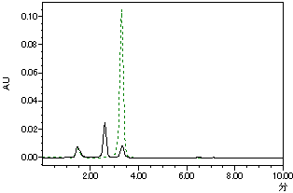
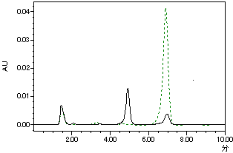
simazine
propazine

The polymer particles (3mg) were incubated with simazine or propazine (500 µM) in methanol/chloroform (1.5ml, 1/9,v/v) at 25 ºC. After 24 h, the suspensions were filtered (0.2 µm) and the filtrates were dried in vacuo. The residues were dissolved in acetonitrile (1 ml) and analyzed by the Waters with a reversed phase column (Supelco LC-8-DB) and an eluent of acetonitrile/0.1M ammonium acetate buffer (47:53, v/v, pH 6.0, 1 ml/min).

3) GC-MS of a Transformation Reaction Mixture with IP(S2M6)
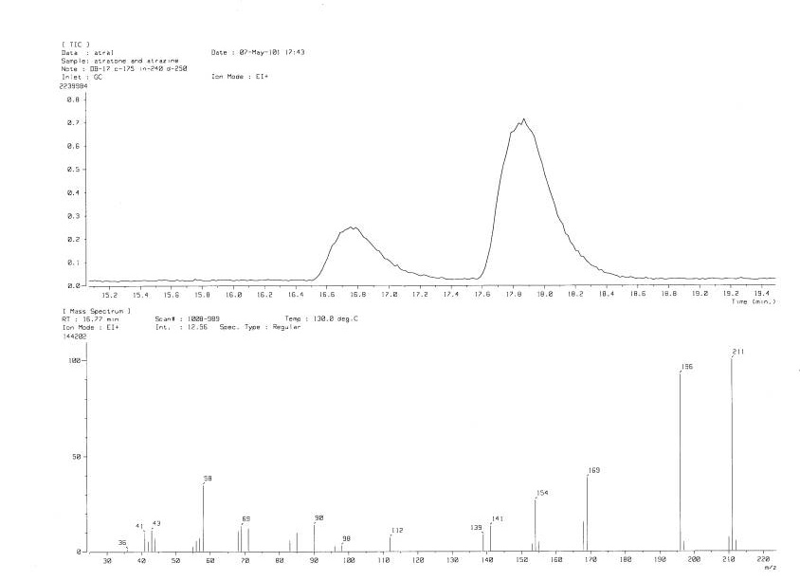
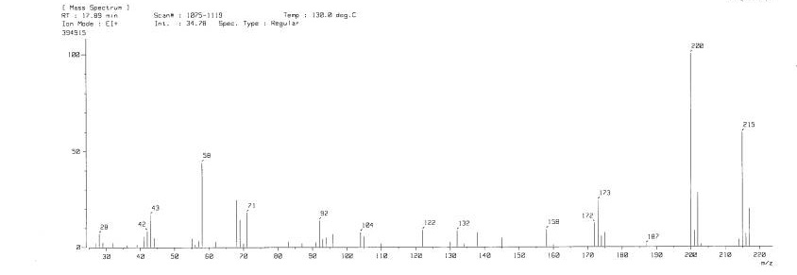
(A)
(B)
Mass Spectrum of (A)
Mass Spectrum of (B)
Atraton
Mw=211.14
Atrazine
Mw=215.09

