SUPPORTING INFORMATION
Synthesis of α-Bromo-β-lactam via a Novel Catalytic Hunsdiecker like Protocol

Dinabandhu Naskar and Sujit Roy*
Metallo-Organic Laboratory, Inorganic Division
Indian Institute of Chemical Technology, Hyderabad 500007, India

Experimental Section
General. ¹H (200 MHz) and ¹³C (50.3 MHz) NMR were recorded on a Varian GEMINI-200 spectrometer in CDCl₃. Chemical shifts are reported in δ (ppm) relative to TMS as internal standard. FTIR spectra were obtained using NICOLET-740 FTIR spectrometer. EIMS (70 eV) and CI (50 eV) spectra were taken using VG MicroMass 7070H and VG Autospec M mass spectrometers. Melting points (mp) were taken using FISHER-JOHNS apparatus and are uncorrected. Silica gel (Acme’s-India, 60-120 mesh and 100-200 mesh) was used for column chromatography. For reaction monitoring, precoated silica gel 60 F₂₅₄ TLC sheets (MERCK) was used. Analyses were performed using Elementar Analyzer VARIO EL instrument.
Semi-empirical calculations (AM1) were performed using the program Hyperchem® 5.0 (Hypercube Inc., Ontario, Canada). Restricted Hartree-Fock calculations were carried out for singlet ground states. The optimized structures correspond to energy minima as checked by converged geometry optimization with imposed bond length and bond angle constraints around C-Br, C-C/C=C substructures.
Materials. N-Bromosuccinimide (Loba) and acrylamide (Loba) were recrystallised from water and ethylacetate respectively prior to use. Solvents were purified by standard protocol. All other reagents used were as received.
General method for the preparation of α,β-unsaturated aromatic amides. Amides 1 were synthesized from the corresponding bromo compounds (Lancaster) and acryl amide via. modified Heck reaction (Patel, B. A.; Ziegler, C. B.; Cortese, N. A.; Plevyak, J. E.; Zebovitz, T. C.; Terpko, M.; Heck, R. F. J. Org. Chem. 1977, 42, 3903). In a typical procedure, a mixture of 4-bromotoluene (1 mM), palladium acetate (10 mol%), tri(p-tolyl)phosphine (30 mol%), lithium chloride (20 mol%), dry triethylamine (3 mM), acrylamide (3 mM) and dry N,N-dimethylformamide (3 mL) were taken in a flask equipped with reflux condenser. The mixture was allowed to stir at 120°C under nitrogen for 20 h. Following solvent removal under reduced pressure, the residue was dissolved in methanol and filtered. The filtrate was concentrated and subjected to column chromatography (silicagel, 85% ethylacetate/hexane). Finally, the product 1a was recrystallized from 2% methanol/chloroform
All the amides were fully characterized by spectroscopic and analytical tools and also checked with authentic samples where ever possible. The purity of the amides were >98%.
General Procedure for the preparation of α-bromo-β-lactam 2. Amide 1 (1 mM) was added to a solution of NaOAc (0.2 mM) in acetonitrile-water (3 mL, 97:3 v/v). After the mixture was stirred for 5 min at room temperature, N-bromosuccinimide (2 mM) was added in portions. The progress of the reaction was monitored by TLC (eluent 20% ethylacetate/hexane). After completion of the reaction, solvent was removed under reduced pressure and the mixture was subjected to column chromatography (silica gel, eluent ethylacetate/hexane) to afford α-bromo-β-lactam 2.
Spectral Characteristics of α-Bromo-β-lactam:
2a. TLC (silica gel / ethylacetate/hexane 20%), R_{f} =0.33. mp 123-124°C. ¹H NMR (CDCl₃): δ 2.39 (s, 3H), 4.5 (t, 1H, J=2.4 Hz), 4.76 (d, 1H, J=2.4 Hz), 6.44 (b, 1H), 7.18 (d, 2H, J=8 Hz), 7.26 (d, 2H, J=8 Hz). ¹³C NMR (CDCl₃): δ 164.49, 138.81, 134.36, 129.68, 125.55, , 62.24, 51.27, 21.19. IR (KBr) cm⁻¹: 1123 (m), 1723 (vs), 2908 (m). EIMS m/z (rel intensity): 239 (M⁺, 5%), 196 (68%), 160 (42%), 132 (12%), 117 (100 %), 91 (70%), 77 (15%), 65 (39%), 39 (48%). Anal. Calcd for C₁₀H₁₀BrNO: C, 50.02; H, 4.19; N, 5.84. Found: C, 49.71; H, 3.98; N, 5.79.
2b. TLC (silica gel/20% ethylacetate/hexane), R_{f} =0.32. Liquid. ¹H NMR (CDCl₃): δ 3.81 (s, 3H), 4.48 (d, 1H, J=2.2 Hz), 4.74 (d, 1H, J=2.2 Hz), 6.58 (b, 1H), 6.87 (d, 2H, J=8 Hz), 7.27 (d, 2H, J=8 Hz). IR (neat) cm⁻¹: 1154 (m), 1231 (s), 1477(s), 1597(m), 1759 (vs), 2847(m). CIMS m/z (rel intensity): 256 (M⁺, 15%), 218 (4%), 176 (42%), 117 (100 %), 73 (8%), 59 (59%).
2c. TLC (silica gel/20% ethylacetate/hexane), R_{f} =0.38. mp 116-117°C. ¹H NMR (CDCl₃): δ 4.5 (t, 1H, J=2.4 Hz), 4.76 (d, 1H, J=2.4 Hz), 6.71 (b, 1H), 7.17 (d, 2H, J=9 Hz), 7.26 (d, 2H, J=9 Hz). IR (KBr) cm⁻¹: 1108 (m), 1492 (m), 1661 (vs), 3092 (w).
2d. TLC (silica gel/20% ethylacetate/hexane), R_{f} =0.40. mp 134-135°C. ¹H NMR (CDCl₃): δ 4.57 (d, 1H, J=2.2 Hz), 4.84 (d, 1H, J=2.2 Hz), 6.52 (b, 1H), 7.43 (s, 5H). IR (neat) cm⁻¹: 1132 (m), 1182 (m), 1752 (vs), 2978 (w), 3083 (w). CIMS m/z (rel intensity): 226 (M⁺, 46%), 182 (5%), 117 (100%).
2e. TLC (silica gel/20% ethylacetate/hexane), R_{f} =0.30. mp 154-155°C. ¹H NMR (CDCl₃): δ 4.55 (t, 1H, J=2.4 Hz), 5.55 (d, 1H, J=2.4 Hz), 6.61 (b, 1H), 7.62-7.39 (m, 4H), 7.85 (m, 2H), 8.06 (d, 1H, J=8 Hz). ¹³C NMR (CDCl₃): δ 164.31, 133.67, 133.38, 130.14, 129.21, 128.99, 127.11, 126.42, 125.23, 123.12, 121.96, 59.89, 50.79. IR (KBr) cm⁻¹: 1139 (m), 1745 (vs), 2954 (w). EIMS m/z (rel intensity): 275 (M⁺, 24%), 232 (36%), 234 (29%), 196 (67%), 167 (6 %), 154 (50%), 127 (9%), 86 (17%), 76 (100%). Anal. Calcd for C₁₃H₁₀BrNO: C, 56.54; H, 3.65; N; 5.07. Found: C, 56.35; H, 3.93; N, 5.19.
2f. TLC (silica gel/20% ethylacetate/hexane), R_{f} =0.30. mp 178-179°C. ¹H NMR (CDCl₃): δ 4.58 (t, 1H, J=2.2 Hz), 5.5 (d, 1H, J=2.2 Hz), 6.48 (b, 1H), 7.74-7.54 (m, 5H), 7.83 (dd, 1H, J=8, 2 Hz), 8.13 (m, 1H), 8.61 (d, 1H, J=8 Hz), 8.72 (m, 1H). IR (KBr) cm⁻¹: 723 (vs), 1692 (m), 1780 (s), 2862 (m). EIMS m/z (rel intensity): 325 (M⁺, 10%), 246 (61%), 248 (11%), 204 (100%), 117 (18 %), 101 (23%), 57 (9%), 43 (11%). Anal. Calcd for C₁₇H₁₂BrNO: C, 62.59; H, 3.72; N; 4.29. Found: C, 62.97; H, 3.95; N, 4.07.
2g. TLC (silica gel/20% ethylacetate/hexane), R_{f} =0.35. mp 109-110°C. ¹H NMR (CDCl₃): δ 4.58 (d, 1H, J=2.4 Hz), 4.87 (d, 1H, J=2.4 Hz), 6.75 (b, 1H), 7.09 (dd, 1H, J=8, 3 Hz), 7.35 (s, 1H), 7.4 (dd, 1H, J=8, 3 Hz). ¹³C NMR (CDCl₃): δ 164.35, 138.74, 127.67, 124.79, 122.88, 58.28, 50. IR (KBr) cm⁻¹: 1146 (m), 1745 (vs), 2892 (w). EIMS m/z (rel intensity): 231 (M⁺, 5%), 188 (62%), 152 (27%), 109 (100%), 97 (8 %), 82 (18%), 69 (21%), 65 62. (27%), 39 (59%). Anal. Calcd for C₇H₆BrNOS: C, 36.22; H, 2.61; N; 6.04. Found: C, 35.91; H, 3.05; N, 6.04.

AM1 derived optimized structure of I (X=O).
1.34 Å
1.46 Å

AM1 derived optimized structure of II (X=O).

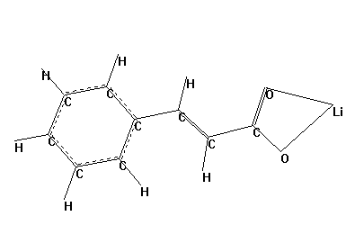
1.48 Å
1.34 Å

AM1 derived HOMO Orbital diagram of II (X=O).

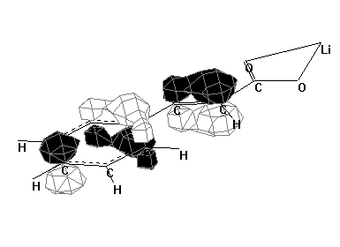

AM1 derived optimized structure of III (X=O).

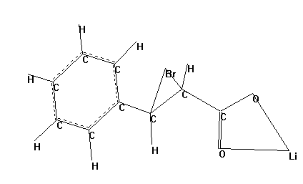
1.53 Å
1.95 Å
2.73 Å
1.47 Å

AM1 derived optimized structure of IV (X=O).

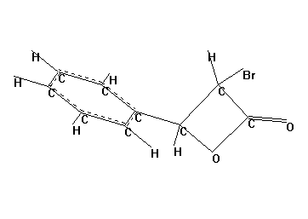
1.53 Å
1.57 Å

AM1 derived optimized structure of V (X=O).
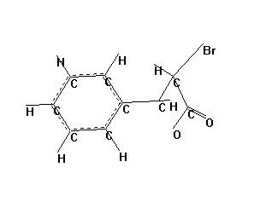
1.53 Å
1.57 Å
1.86 Å
1.34Å
AM1 derived optimized structure of VI (X=O).

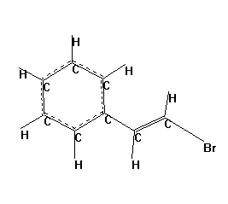

AM1 derived optimized structure of I (X=NH).

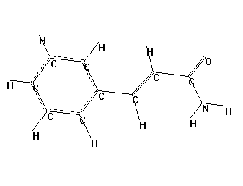
1.34 Å
1.48 Å

AM1 derived optimized structure of II (X=NH).

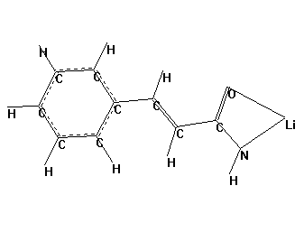
1.34 Å
1.49 Å

AM1 derived optimized structure of III (X=NH).

1.94 Å
2.73 Å
1.56 Å
1.47 Å

AM1 derived optimized structure of IV (X=NH).
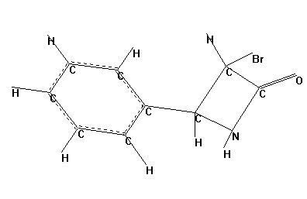
1.54 Å
1.57 Å

AM1 derived optimized structure of V (X=NH
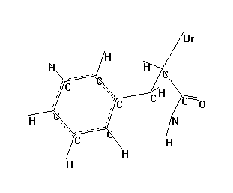
1.54 Å
1.57 Å
AM1 derived heat of formation values (H_{f} kcal/mol) (refer to scheme 1).
Species | H_{f} kcal/mol
LiOAc | -90.2
AcOH | -97.2
OAc⁻ | -115.5
CO₂ | -79.9
HNCO | -15.2
Succinimide | -77.5
NBS | -39.6
I (X=O) | -54.5
I (X= NH) | -2.4
II (X=O) | -41.9
II (X=NH) | 8.4
III (X=O) | 131.5
III (X=NH) | 179.6
IV (X=O) | -17.2
IV (X=NH) | 25.7
V (X=O) | -17.2
V (X=NH) | 25.7
VI | 40.3
AM1 derived heat of formation values (H_{f} kcal/mol) of species in CHR of acid (refer to scheme 1).
Species | H_{f} kcal/mol
I + LiOAC + NBS | -184.4
II + HOAc + NBS | -178.7
III + OAc⁻+ succinimide | -61.6
IV + LiOAc + succinimide | -184.9
V + LiOAc + succinimide | -184.9
VI + LiOAc + succinimide + CO₂ | -207.3

AM1 derived heat of formation values (H_{f} kcal/mol) of species in CHR of amide (refer to scheme 1)
Species | H_{f} kcal/mol
I + LiOAC + NBS | -132.3
II + HOAc + NBS | -128.5
III + OAc⁻+ succinimide | -13.4
IV + LiOAc + succinimide | -142.0
V + LiOAc + succinimide | -142.0
VI + LiOAc + succinimide + HNCO | -142.6

