Supplementary data

Heterocyclic free radicals. Part 1. 4,5-Diazafluorene derivatives of Koelsch’s free radical: an EPR and metal-ion complexation study
M. John Plater, * Steven Kemp and Eric Lattmann
Department of Chemistry, University of Aberdeen, Meston Walk, Aberdeen, Scotland, UK AB24 3UE

Fig. S1 ESR spectra of free radicals 26, 27, 28, 33 and 34.

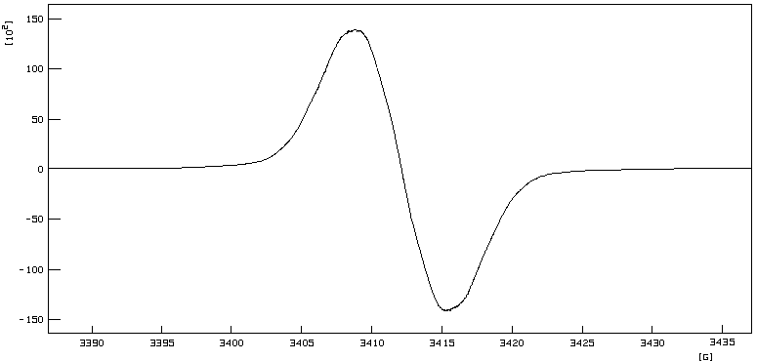

ESR spectrum of radical 26 in toluene at 183.0 K (modulation amplitude = 0.093 G, frequency = 9.5635640 GHz, power = 5.07 mW)

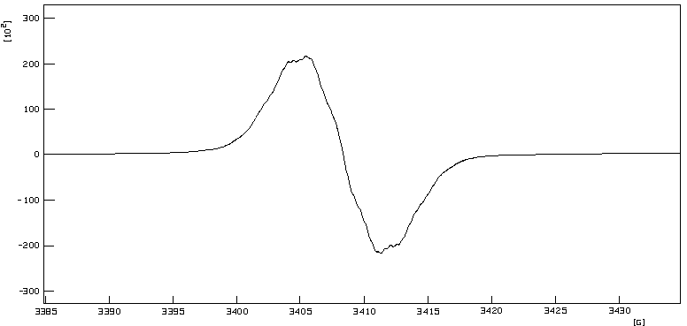

ESR spectrum of radical 27 in toluene at 183.0 K (modulation amplitude = 0.104 G, frequency = 9.5633220 GHz, power = 5.08 mW)

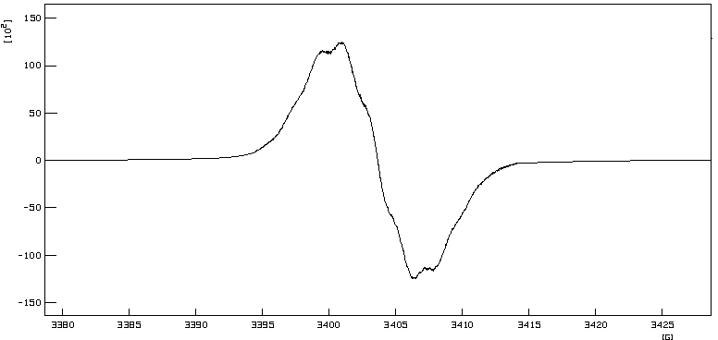

ESR spectrum of radical 28 in toluene at 183.0 K (modulation amplitude = 0.104 G, frequency = 9.5499100 GHz, power = 5.08 mW)

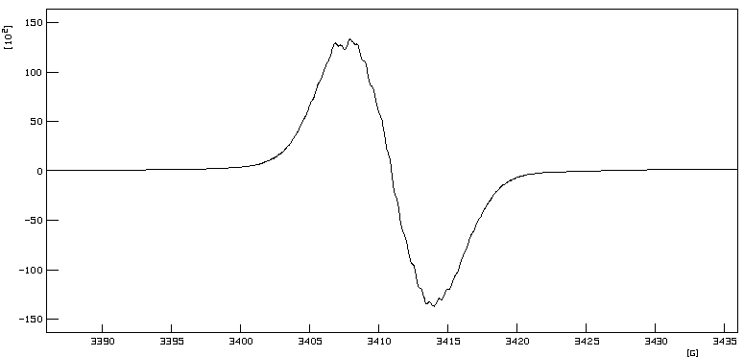

ESR spectrum of radical 33 in toluene at 183.0 K (modulation amplitude = 0.104 G, frequency = 9.5599850 GHz, power = 5.07 mW)

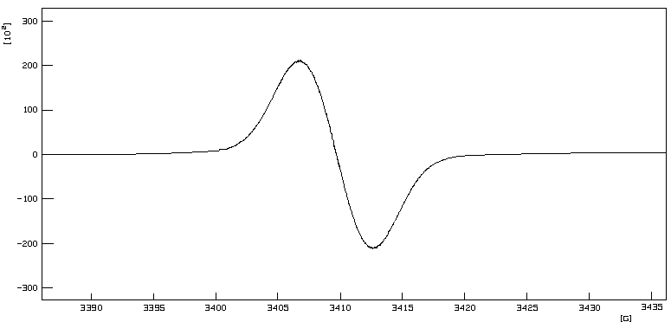

ESR spectrum of radical 34 in toluene at 183.0 K (modulation amplitude = 0.104 G, frequency = 9.5563010 GHz, power = 5.07 mW)

