Supplementary data

Problems in the synthesis of cyclic peptides through use of the Dmab protecting group

Tony Johnson,* Mark Liley, Timothy J. Cheeseright and Farida Begum

Peptide Therapeutics, Peterhouse Technology Park, 100 Fulbourn Road, Cambridge, UK CB1 9PT

HPLC chromatograms

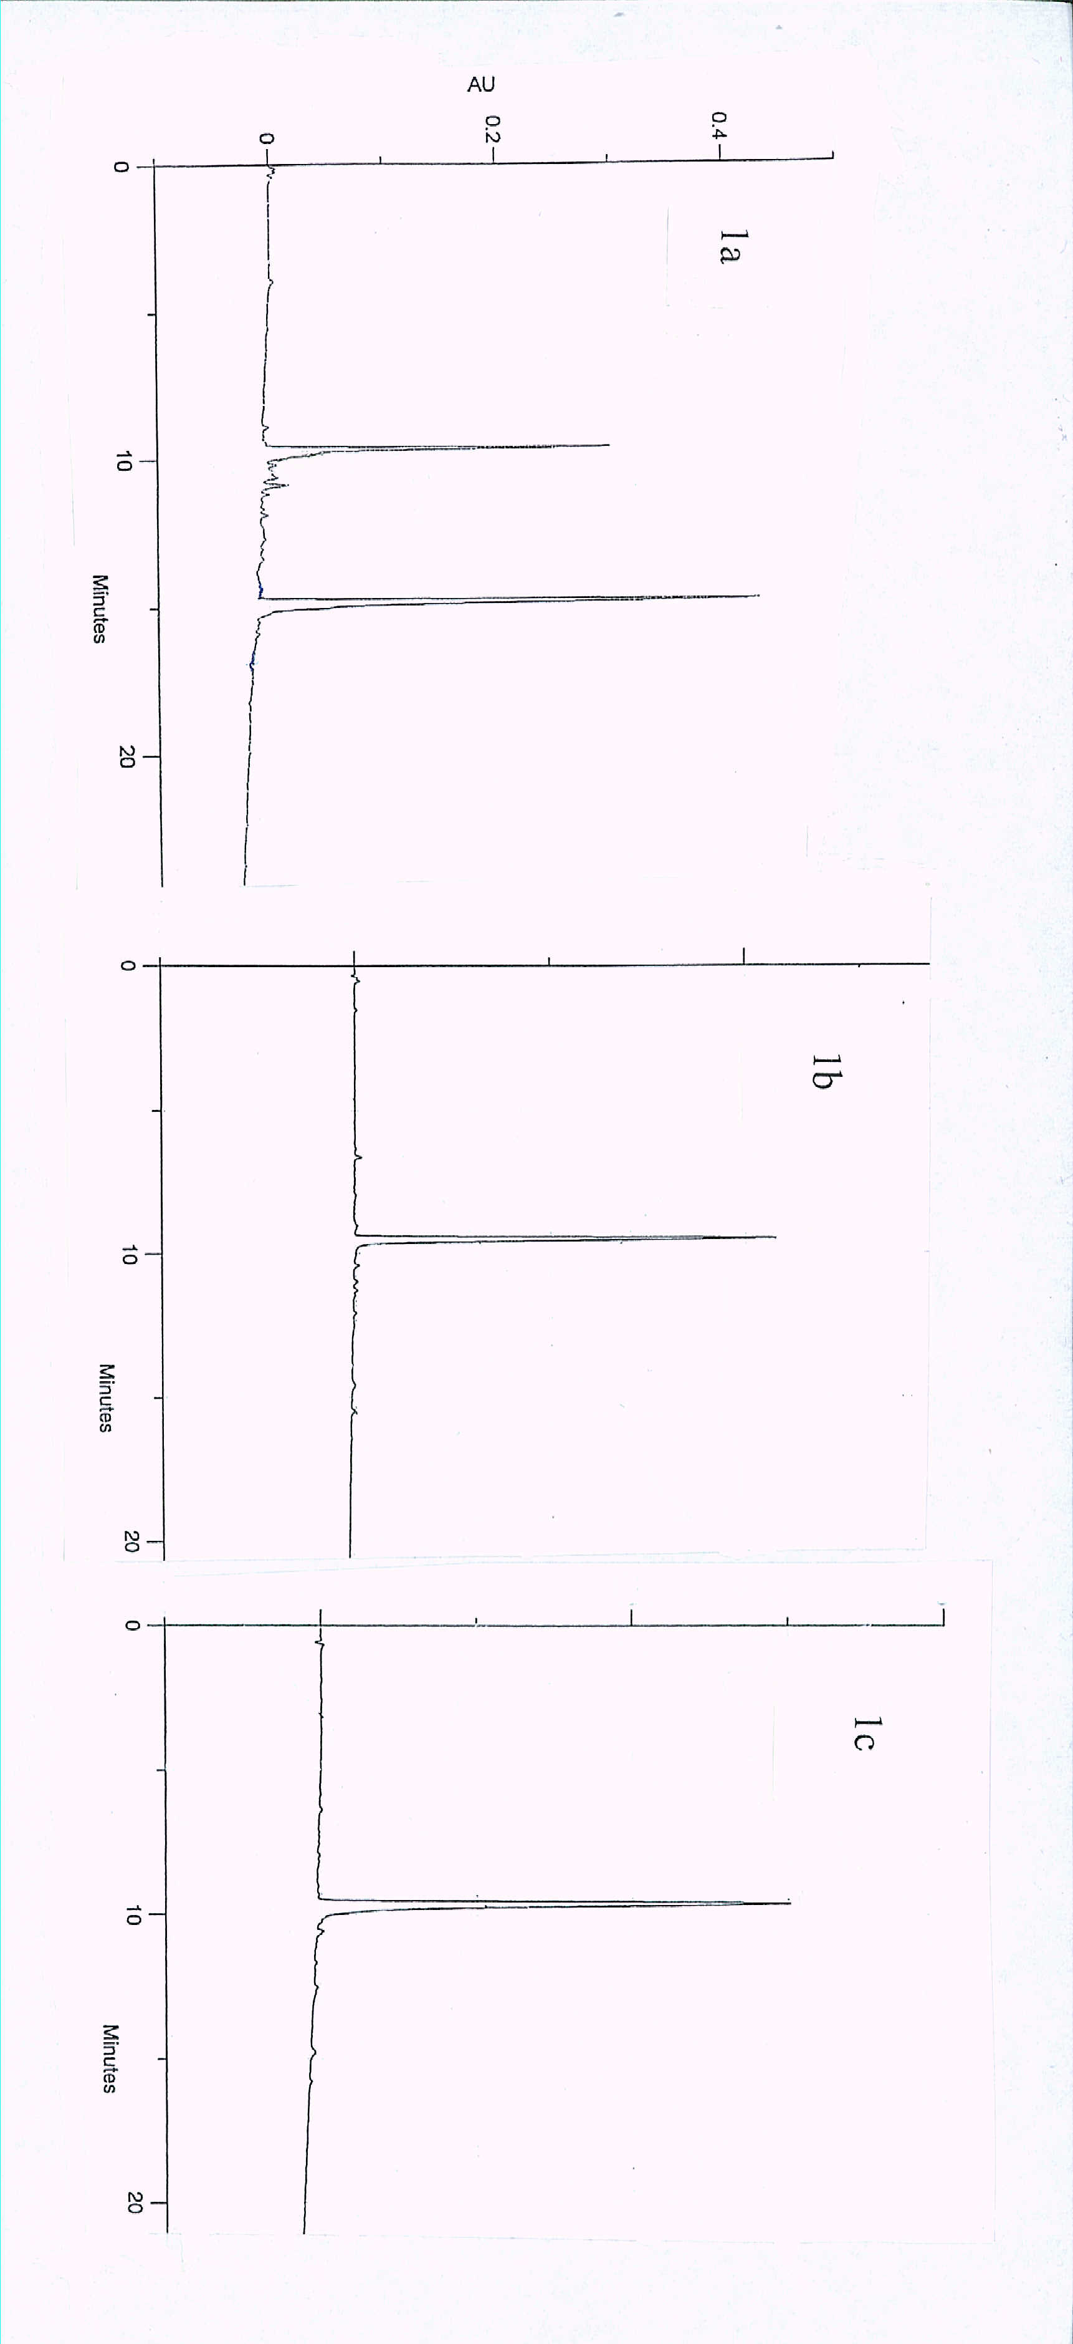
Fig. 1Analytical HPLC chromatograms of (a) small scale cleavage product from peptide-resin 3a [via Glu(ODmab), Scheme 1]; (b) small scale cleavage product from peptide-resin 3g [via Glu(OBu^{t}), Scheme 1]; (c) small scale cleavage product from peptide-resin 6 (Glp peptide, Scheme 2). HPLC conditions: Phenomenex reverse phase C4 column (250 x 4.6 mm), 10-90% B in A linear gradient over a period of 25 min (flow rate 1.5 cm³ min⁻¹; 215 nm UV detection) where buffer A = 0.1% aq. TFA and buffer B = 90% acetonitrile/10% buffer A.

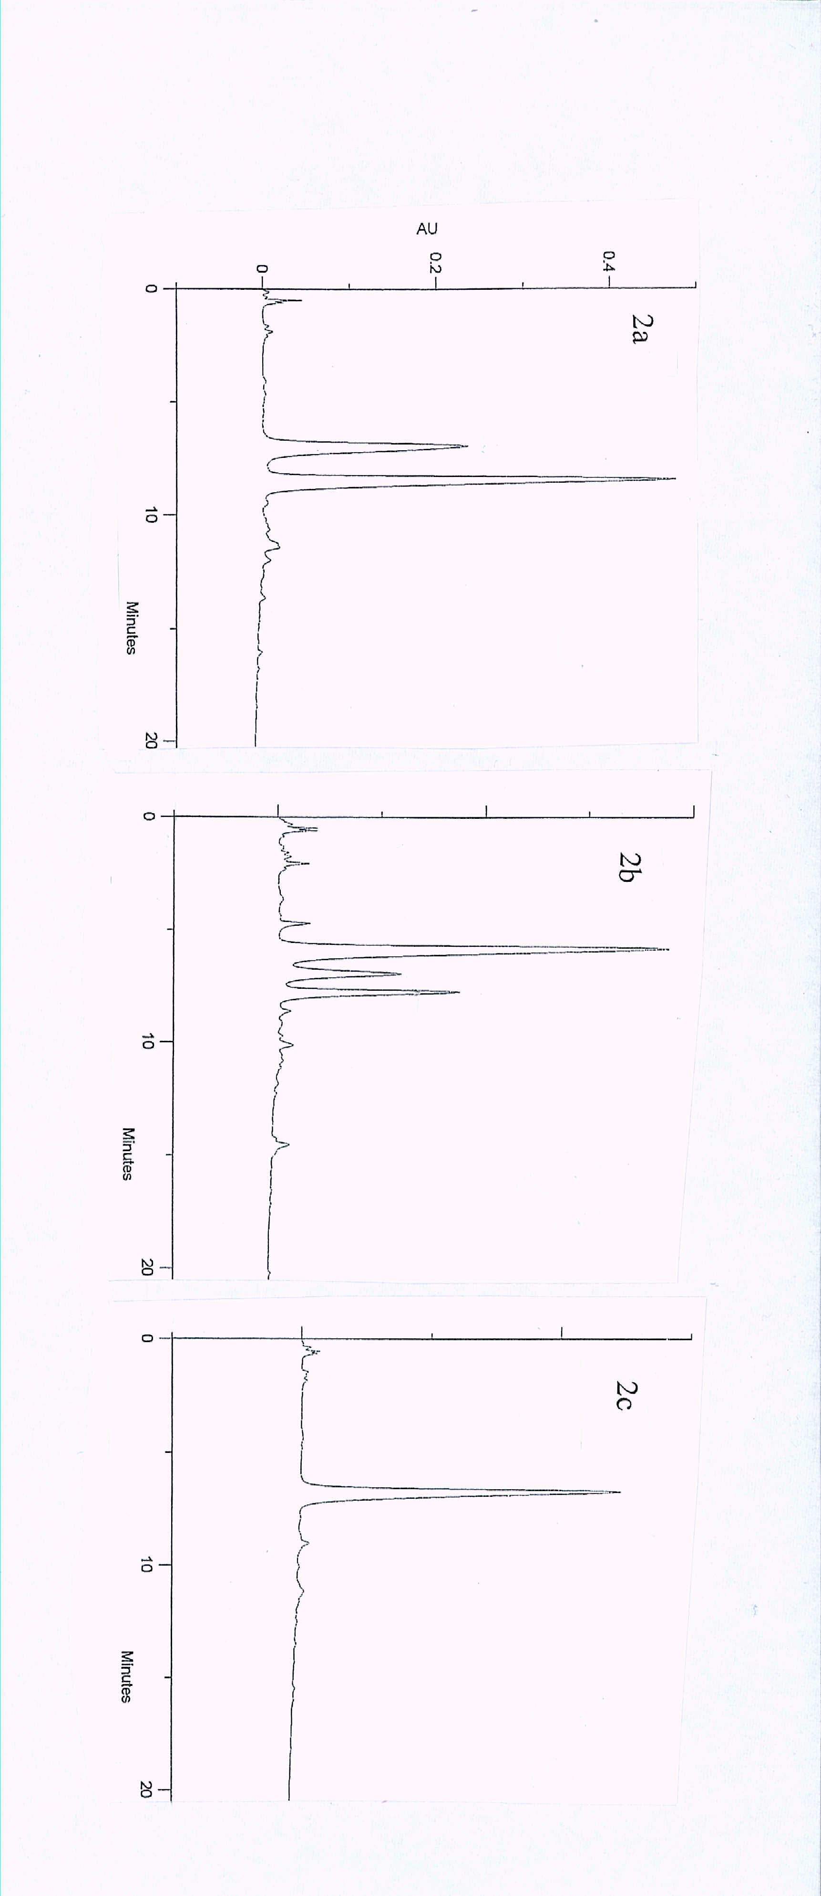
Fig. 2Analytical HPLC chromatograms of (a) crude peptide 5e [via Glu(ODmab), Scheme 1]; (b) crude peptide 5f [via Glu(OBu^{t}), Scheme 1]; (c) crude peptide 5f (post incubation in acetonitrile/0.1% aq. TFA for 24 hours). HPLC conditions: Phenomenex reverse phase C4 column (250 x 4.6 mm), 10-90% B in A linear gradient over a period of 25 min (flow rate 1.5 cm³ min⁻¹; 215 nm UV detection) where buffer A = 0.1% aq. TFA and buffer B = 90% acetonitrile/10% buffer A.

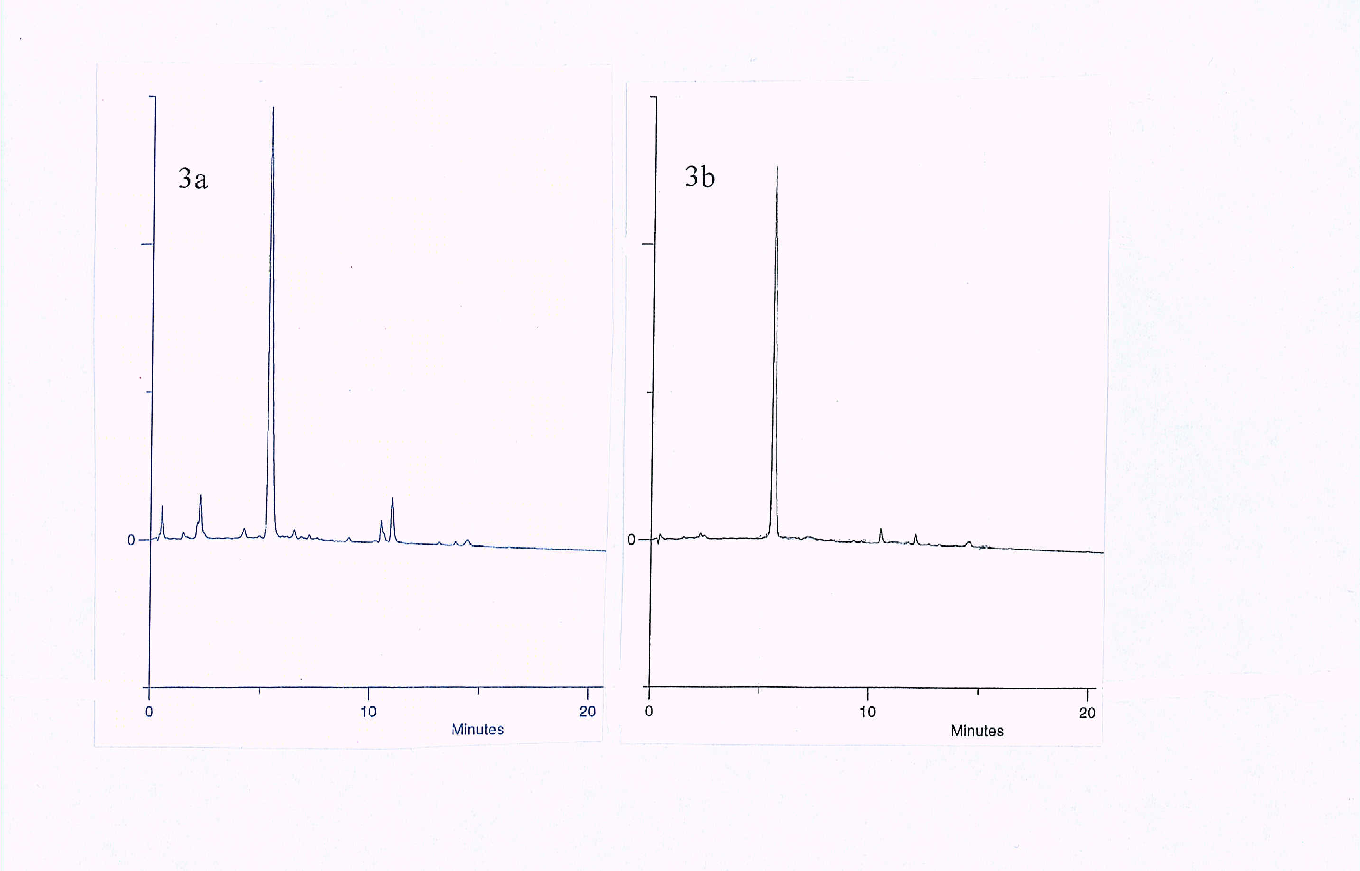

Fig. 3 Analytical HPLC chromatograms of (a) crude peptide 5g [via Glu(OBu^{t}), Scheme 1]; (b) crude peptide 8 (Glp peptide, scheme 2). HPLC conditions: Phenomenex reverse phase C4 column (250 x 4.6 mm), 10-90% B in A linear gradient over a period of 25 min (flow rate 1.5 cm³ min⁻¹; 215 nm UV detection) where buffer A = 0.1% aq. TFA and buffer B = 90% acetonitrile/10% buffer A.

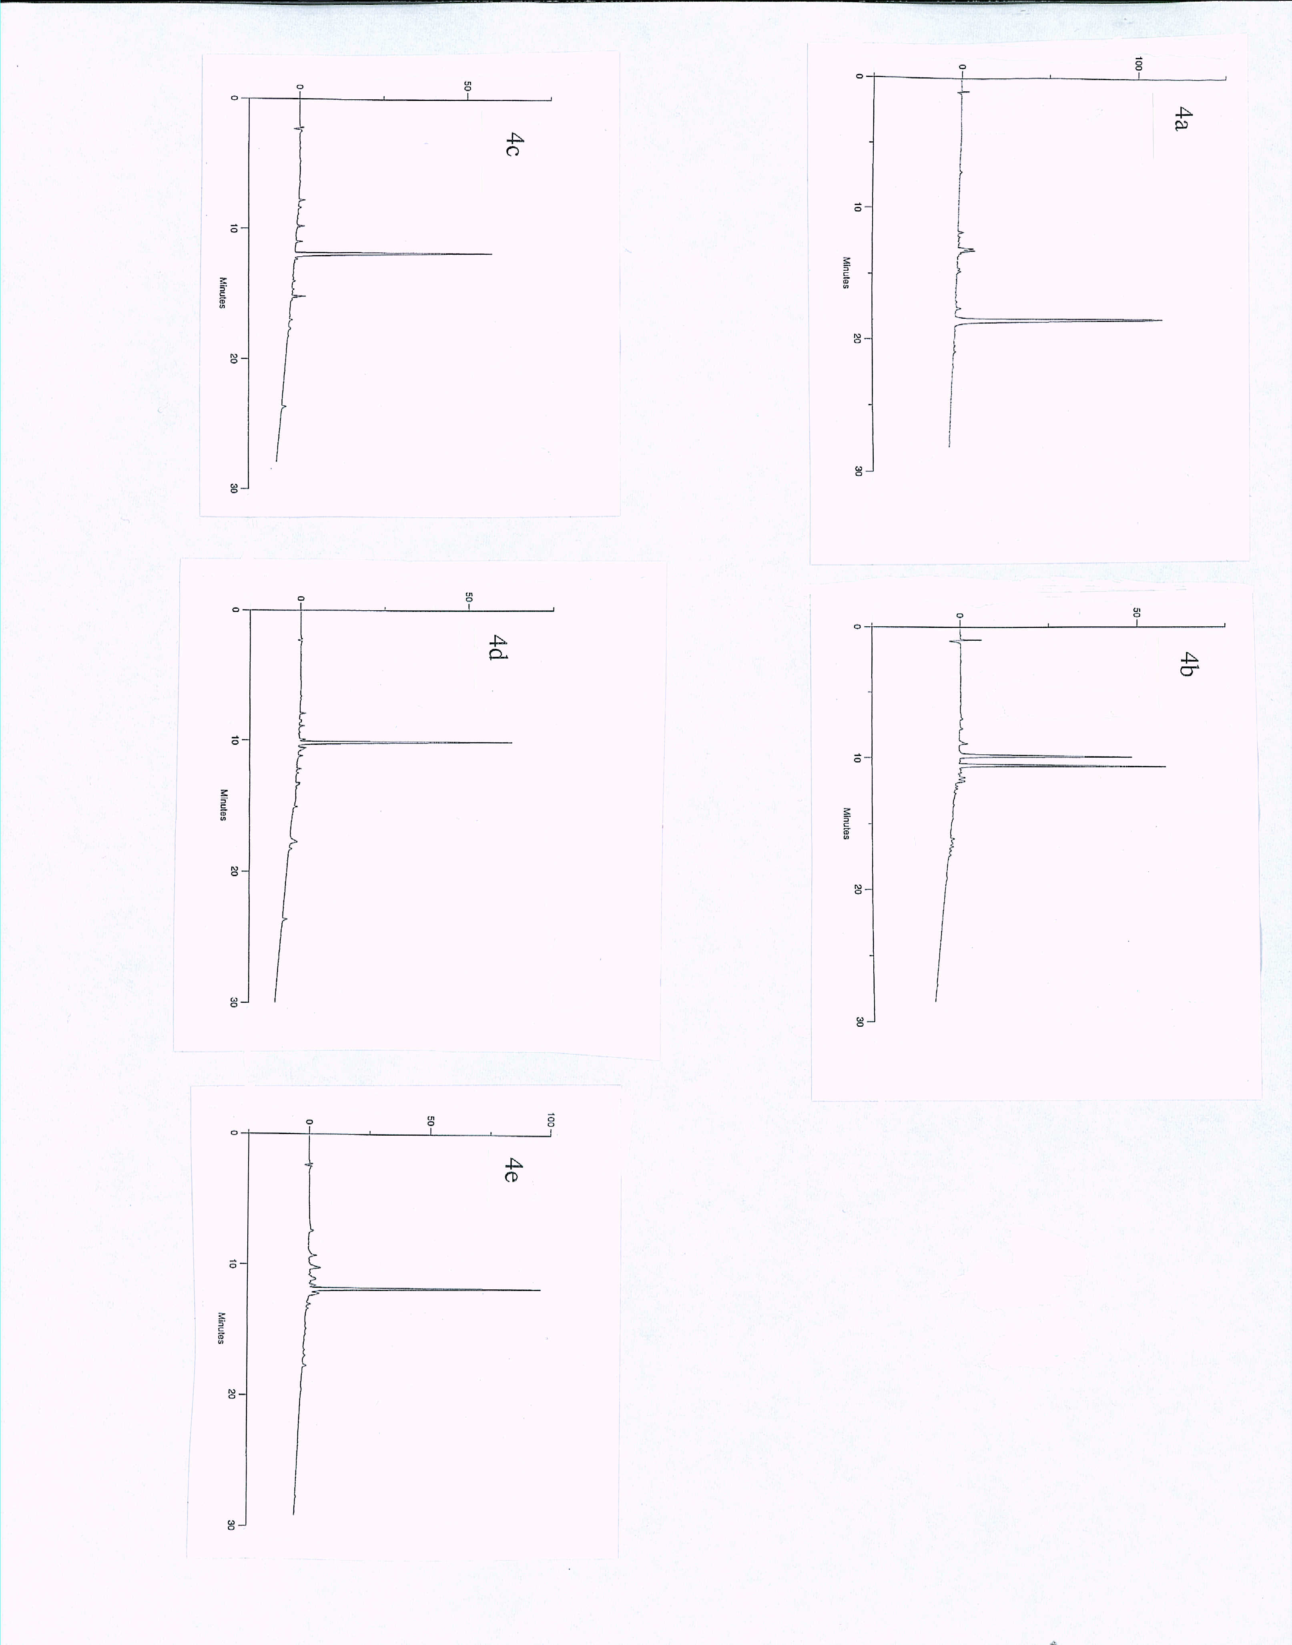
Fig. 4Analytical HPLC chromatograms of (a) small scale cleavage product from peptide-resin 9a [via Glu(ODmab), Scheme 3]; (b) crude cyclic peptide 13 [via Glu(ODmab), Scheme 3]; (c) small scale cleavage product from peptide-resin 10b [via Glu(OAllyl), Scheme 3]; (d) small scale cleavage product from peptide-resin 11 (via Glu(Allyl), Scheme 3); (e) crude cyclic peptide 13 [via Glu(OAllyl), Scheme 3]; HPLC conditions: Phenomenex reverse phase C4 column (250 x 4.6 mm), 10-90% B in A linear gradient over a period of 25 min (flow rate 1.5 cm³ min⁻¹; 215 nm UV detection) where buffer A = 0.1% aq. TFA and buffer B = 90% acetonitrile/10% buffer A.

