Supplementary data

Synthesis and biological evaluation of phospholane and phospholene analogues of the glutamate receptor agonist AP4

Stuart J. Conway,^{a†} Jacqueline C. Miller,ª Andrew D. Bond,^{b} Barry P. Clark,^{c} and David E. Janeª*
ª Department of Pharmacology, School of Medical Sciences, University of Bristol, Bristol, BS8 1TD, UK. Fax: +44 117 927 9839; Tel: +44 117 9287639; E-mail: david.jane@bristol.ac.uk
^{b} Department of Chemistry, University of Cambridge, Lensfield Road, Cambridge, CB2 1EW, U.K.
^{c} Eli Lilly & Co., Erl Wood Manor, Windlesham, Surrey, GU20 6PH, UK.

Mode of epoxide ring-opening

Whilst carrying out the reaction it was noted that when one equivalent of diethyl acetamidomalonate was added to the epoxide (16) an intermediate was formed that had the same R_{f} by TLC as an authentic sample of the allylic alcohol (18) (Figure 3). In addition, the ¹H NMR spectrum of the reaction mixture contained peaks corresponding to those of authentic 18.

Figure 3: 1-Diisopropylamino-4-hydroxy-1-oxo-2-phospholene (18), a possible intermediate in the reaction of the epoxide and diethyl acetamidomalonate.

On addition of another two equivalents of the sodium salt of diethyl acetamidomalonate to the reaction mixture, the allylic alcohol (18) reacted to give a new product as adjudged by TLC.

The structure of 16 determined by X-ray crystallography shows that the epoxide forms exclusively on the opposite face of the ring to that of the N-diisopropylamino moiety. Epoxide opening in an antiperiplanar fashion would require attack by the bulky diethyl acetamidomalonate anion (19) on the same face of the molecule as the N-diisopropylamino group, which would be sterically unfavourable. It is proposed that instead, the allylic alcohol (18) is formed by one equivalent of the diethyl acetamidomalonate (19) extracting a methylene proton, on the opposite face of the molecule to the N-diisopropylamino group. Once the anion has been formed ring opening of the epoxide (16) occurs leading to the formation of the intermediate allylic alcohol (18) (Scheme 4).

A second molecule of the diethyl acetamidomalonate anion (19) then attacks the double bond of 18 in a 1,4-manner (from the opposite face of the molecule to that of the N-diispropylamino group) to yield intermediate 20 (Scheme 4). Spontaneous formation of a 5-membered lactone ring between one of the ethyl esters and the hydroxyl group and subsequent proton elimination and lactone opening to give the product (21), is one possibility.

It is also possible that instead of direct 1,4-addition to the C=C as shown in Scheme 4, transesterification of the alcohol (18) by one of the malonate ester groups occurs leading to a facile intramolecular 1,4-addition to form the lactone (20).

Scheme 4: Proposed mechanism of epoxide opening.

Aside from the evidence for the intermediate formation of 18 the proposed mechanism is also supported by the observation that the reaction proceeds well in DMF as a solvent, but not when THF is used. It was noted that when the reaction is carried out in THF a precipitate formed, which is thought to be the alkoxy anion of 18. This anion does not dissolve in THF, but does dissolve in DMF. If the epoxide was opened directly then the solvent used should not affect the reaction. Further studies are underway to confirm the validity of this mechanism.

Spectroscopic and physical data for 2 and 3

(±)-2-((2-amino)-1-carboxyethyl)-1-hydroxy-1-oxophospholane (2) are as follows: m.p.: 180.0-182.5ºC. ¹H NMR (270 MHz) (D₂O) δ 1.10-1.60 (m, 9H, CH₂ and CH-P), 1.60-2.00 (m, 9H, CH₂ and CH-P), (3.64 (t, J=6.5, 1H, Cα-H), 3.73 (t, J=6.5, 1H, Cα-H)). ¹³C NMR (68 MHz) (D₂O) δ (21.3 (d, J_{CP}=3.0, C-C-P) 21.4 (d, J_{CP}=3.0, C-C-P)), (26.1 (d, J_{CP}=19.9, C-C (amino acid)-P), 27.3 (d, J_{CP}=19.9, C-C (amino acid)-P)), (30.6 (d, J_{CP}=4.4, P-C-C-Cα), 30.8 (d, J_{CP}=4.4, P-C-C-Cα)), 31.1 (d, J_{CP}=55.3, C-C-P, only one doublet observed), (34.4 (d, J_{CP}=51.0, C-C (amino acid)-P), 35.6 (d, J_{CP}=51.0, C-C (amino acid)-P)), (53.8 (d, J_{CP}=10.6, Cα-NH₂), 54.2 (d, J_{CP}=9.9, Cα-NH₂)), (174.3, 174.7). Two sets of peaks were observed, one for each diastereomer. The two numbers that represent the same carbon in different diastereomers are bracketed together. Elemental analysis calculated for C₇H₁₄NO₄P.(0.80 H₂O): C=37.93, H=7.10, N=6.32. Found: C=37.91, H=7.14, N=6.47.

Spectroscopic and physical data for (±)-4-((2-amino)carboxy-methyl)-1-hydroxy-1-oxo-2-phospholene (3) are as follows: m.p.: 245-250ºC dec. ¹H NMR (300 MHz) (D₂O) δ 1.28-1.46 (m, 1H, CH₂), 1.66-1.90 (m, 1H, CH₂), 3.26-3.43 (m, 1H, CH-CH=CH), 4.00 (dd, J=15.0, 6.0, 1H, Cα-H), 6.04-6.26 (m, 1H, CH=CH-P), 6.41-6.66 (m, 1H, CH=CH-P). ¹³C NMR (68 MHz) (D₂O) δ (24.8 (d, JCP=95.8, Cα-C-C-P) 25.5 (d, J_{CP}=94.5, Cα-C-C-P)), (41.1 (d, J_{CP}=17.4, Cα-C-C-P), 41.3 (d, J_{CP}=17.4, Cα-C-C-P)), (56.5 (d, J_{CP}=6.8, Cα-NH₂), 56.8 (d, J_{CP}=7.5, Cα-NH₂)), (129.2 (d, J_{CP}=116.9, C=C-P), 131.4 (d, J_{CP}=116.2, C=C-P)), (146.5 (d, J_{CP}=24.9, C=C-P), 147.4 (d, J_{CP}=23.6, C=C-P)), (171.0, 171.6). Two sets of peaks were observed, one for each diastereomer. The two numbers that represent the same carbon in different diastereomers are bracketed together. Elemental analysis calculated for C₆H₁₀NO₄P.(1.45 H₂O): C=33.17, H=5.98, N=6.44. Found: C=33.56, H=5.70, N=6.07.

Crystal data for epoxide 16. C₁₀H₂₀NO₂P, M = 217.24, monoclinic, a = 6.3138(3), b = 7.7287(3), c = 24.0590(12) Å, β = 90.762(2)°, U = 1173.9(1) Å³, T = 180(2) K, space group P2₁/c, Z = 4, ρ_{calc} = 1.229 g cm⁻³, μ(Mo-Kα) = 0.212 mm⁻¹, 6063 reflections measured, 2622 unique (R_{int} = 0.042) which were used in all calculations. The final R1 = 0.043 [I > 2σ(I)], wR2 = 0.113 [all data] and goodness-of-fit on F² = 1.06.

Pharmacological characterisation of 2 and 3

Glutamate receptors have been broadly classified into the ionotropic (ligand gated ion channels) and metabotropic (G-protein coupled) subtypes. Ionotropic glutamate receptors have been subdivided into the N-methyl-d-aspartic acid (NMDA), (S)-α-amino-3-hydroxy-5-methyl-4-isoxazolepropionic acid (AMPA) and kainate receptors whilst metabotropic glutamate (mGlu) receptors have been divided into three main groups, namely group I (mGlu1 and 5), group II (mGlu2 and 3) and group III (mGlu4, 6, 7 and 8) according to their sequence homology and agonist pharmacology.
Selective antagonists for the NMDA and AMPA/kainate subtypes of iGlu receptors were used in order to determine the ionotropic glutamate receptor subtype(s) responsible for mediating the depolarising activity of compounds 2 and 3. On application of 2 and 3 in the presence of the selective NMDA receptor antagonist (R)-2-amino-5-phosphonopentanoic acid (d-AP5) both compounds still caused depolarisations (Figure 4). As the depolarisations were of a comparable size to those in the absence of d-AP5 it is likely that these compounds are not acting through NMDA receptors. On application of 2 and 3 in the presence of the AMPA selective antagonist 6-nitro-7-sulfamoylbenzo(f)-quinoxaline-2,3-dione (NBQX) both depolarisations were abolished (n = 3) (Figure 4), suggesting that 2 and 3 are acting on AMPA receptors. As NBQX is only 30-fold selective for AMPA over kainate receptors it is possible that 2 and 3 compounds are also acting on kainate receptors.

On continuous application of both 2 and 3 no desensitisation was observed, suggesting that these compounds are not acting as agonists on group I mGlu receptors.

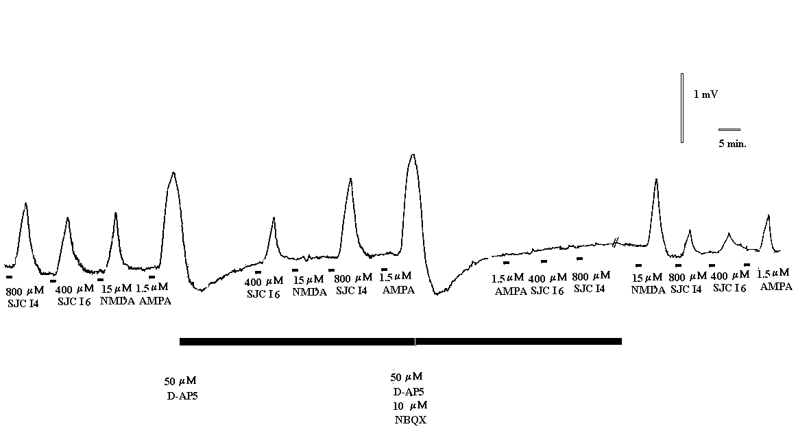

Figure 4: A typical trace showing the effect of application of SJC I4 (3) and SJC I6 (2) to the neonatal rat spinal cord, alone, in the presence of d-AP5 and in the presence of d-AP5 and NBQX. All agonist-induced responses recovered upon washout of the antagonists.

