Supplementary data

Use of chiral lanthanide shift reagents in the elucidation of NMR signals from enantiomeric mixtures of polycyclic compounds
Mariane Axt, João Alifantes, Valentim Emílio Uberti Costa*
Instituto de Química da Universidade Federal do Rio Grande do Sul. Av. Bento Gonçalves, 9500-91.501-970-Porto Alegre-RS-Brasil; Fax: 055 051 3191499. E-mail: valentim@if.ufrgs.br
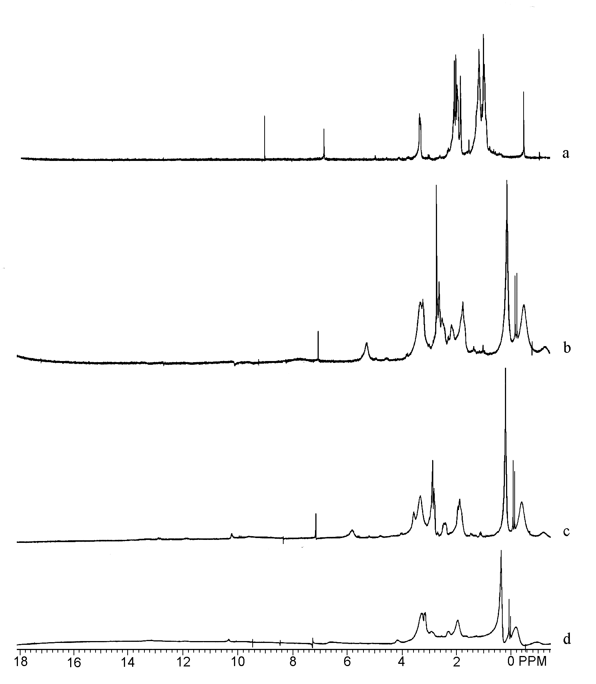
¹H (200 MHz) spectra of alcohol 3 in presence of Eu(tfc)₃. The portion of C-CSR is ca. (a) 0; (b) 15; (c) 20 and (d) 30 mg to 10 mg of substrate.

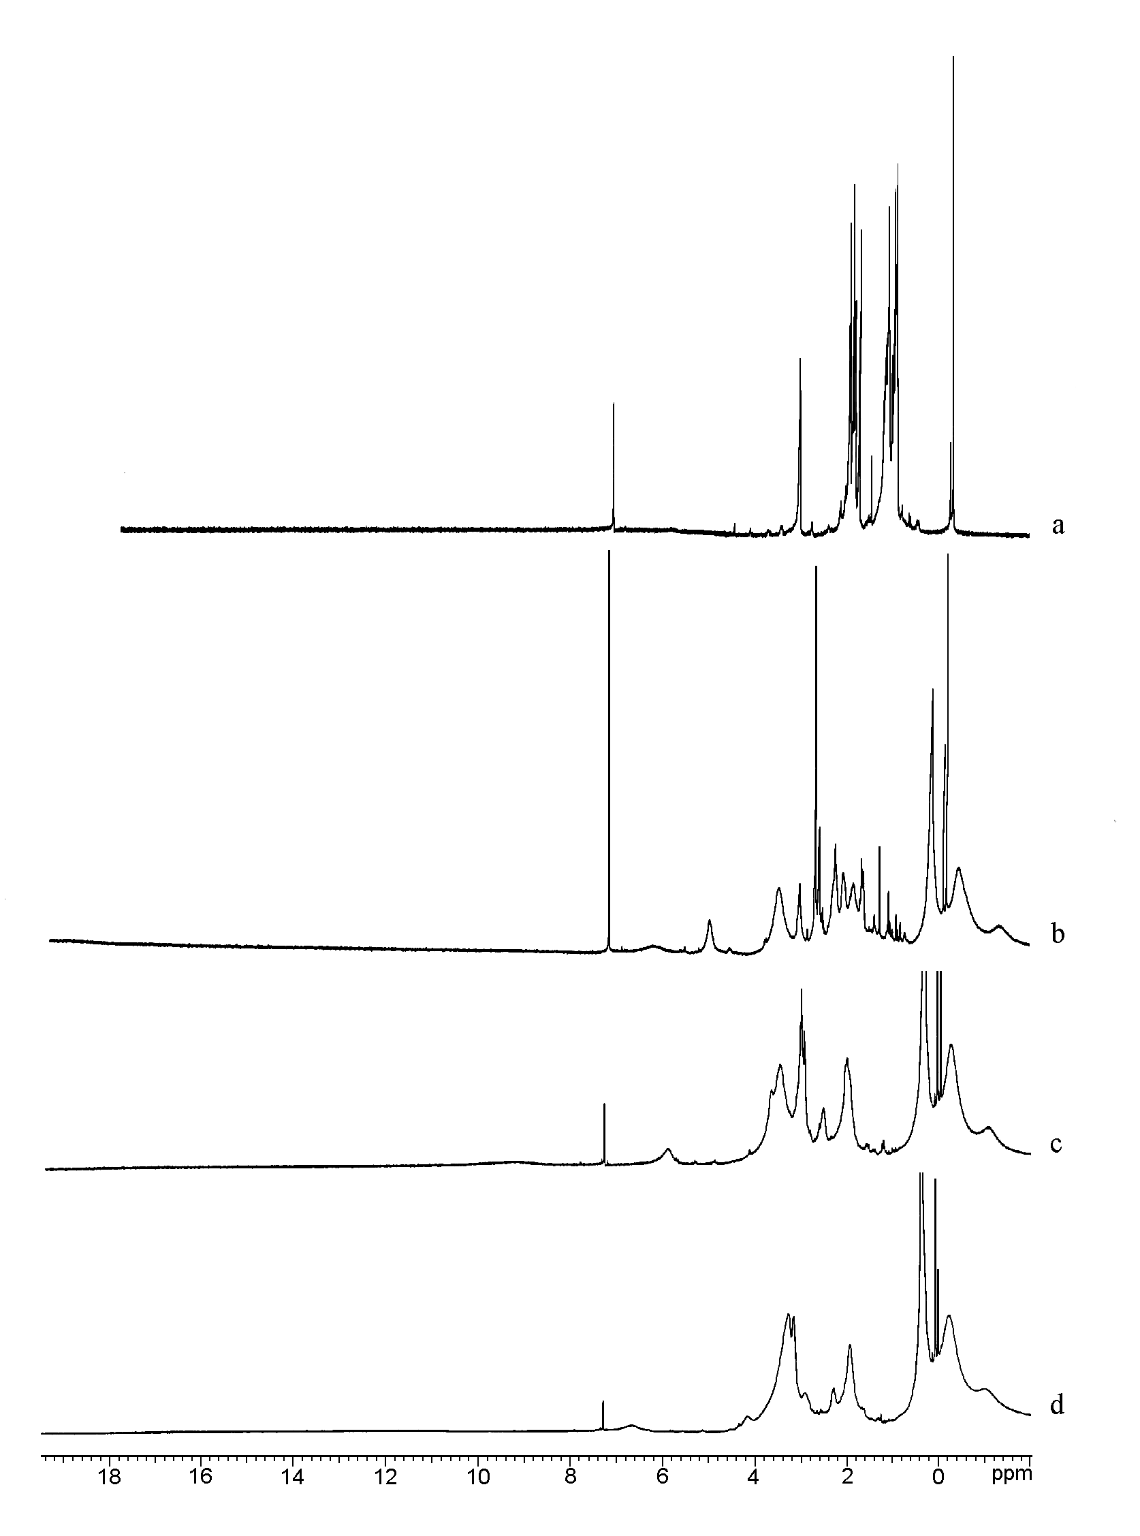
¹H (300 MHz) spectra of alcohol 3 in presence of Eu(tfc)₃. The portion of C-CSR is ca. (a) 0; (b) 15; (c) 20 and (d) 30 mg to 10 mg of substrate.
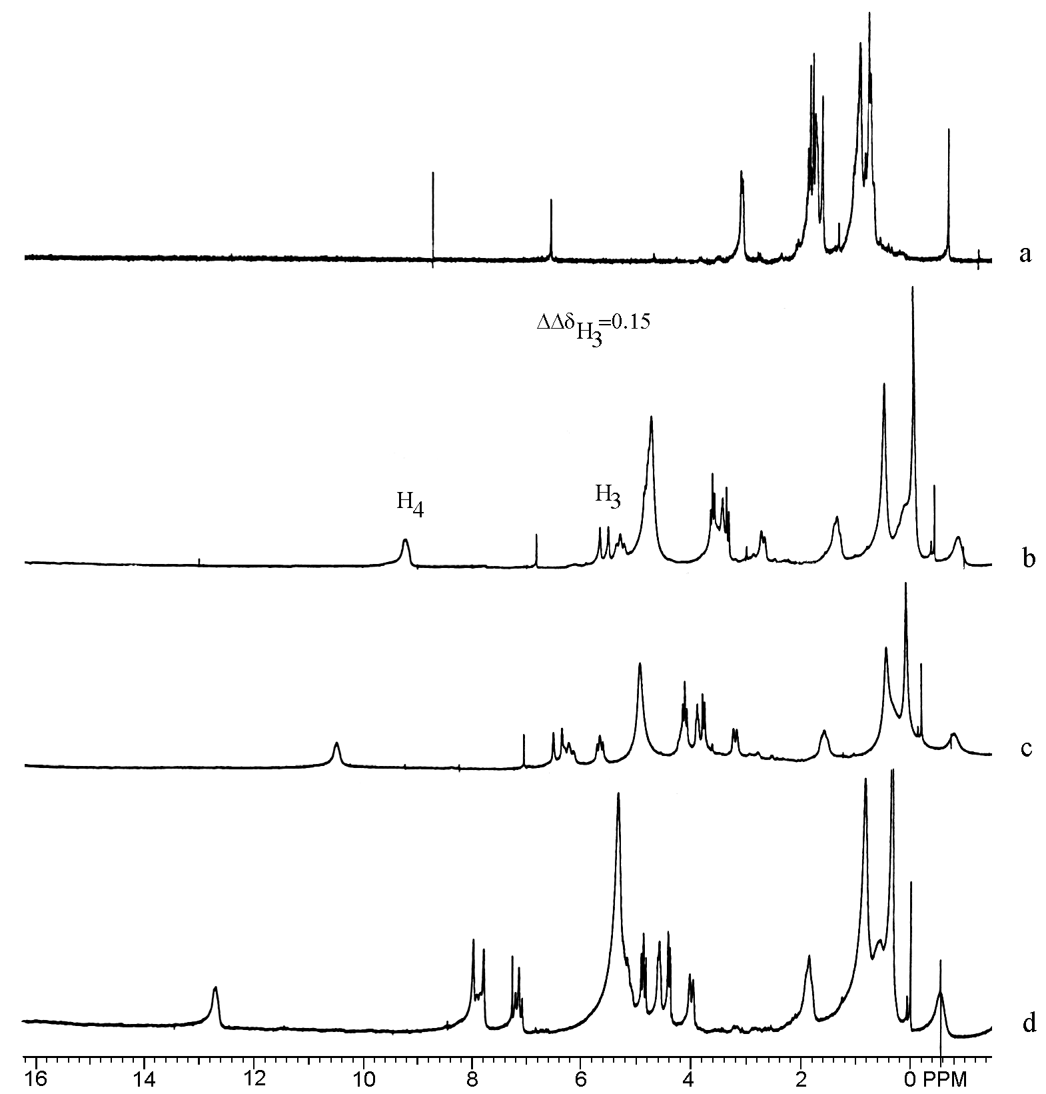
¹H (200 MHz) spectra of alcohol 3 in presence of Eu(hfc)₃. The portion of C-CSR is ca. (a) 0; (b) 10; (c) 15 and (d) 20 mg to 10 mg of substrate.

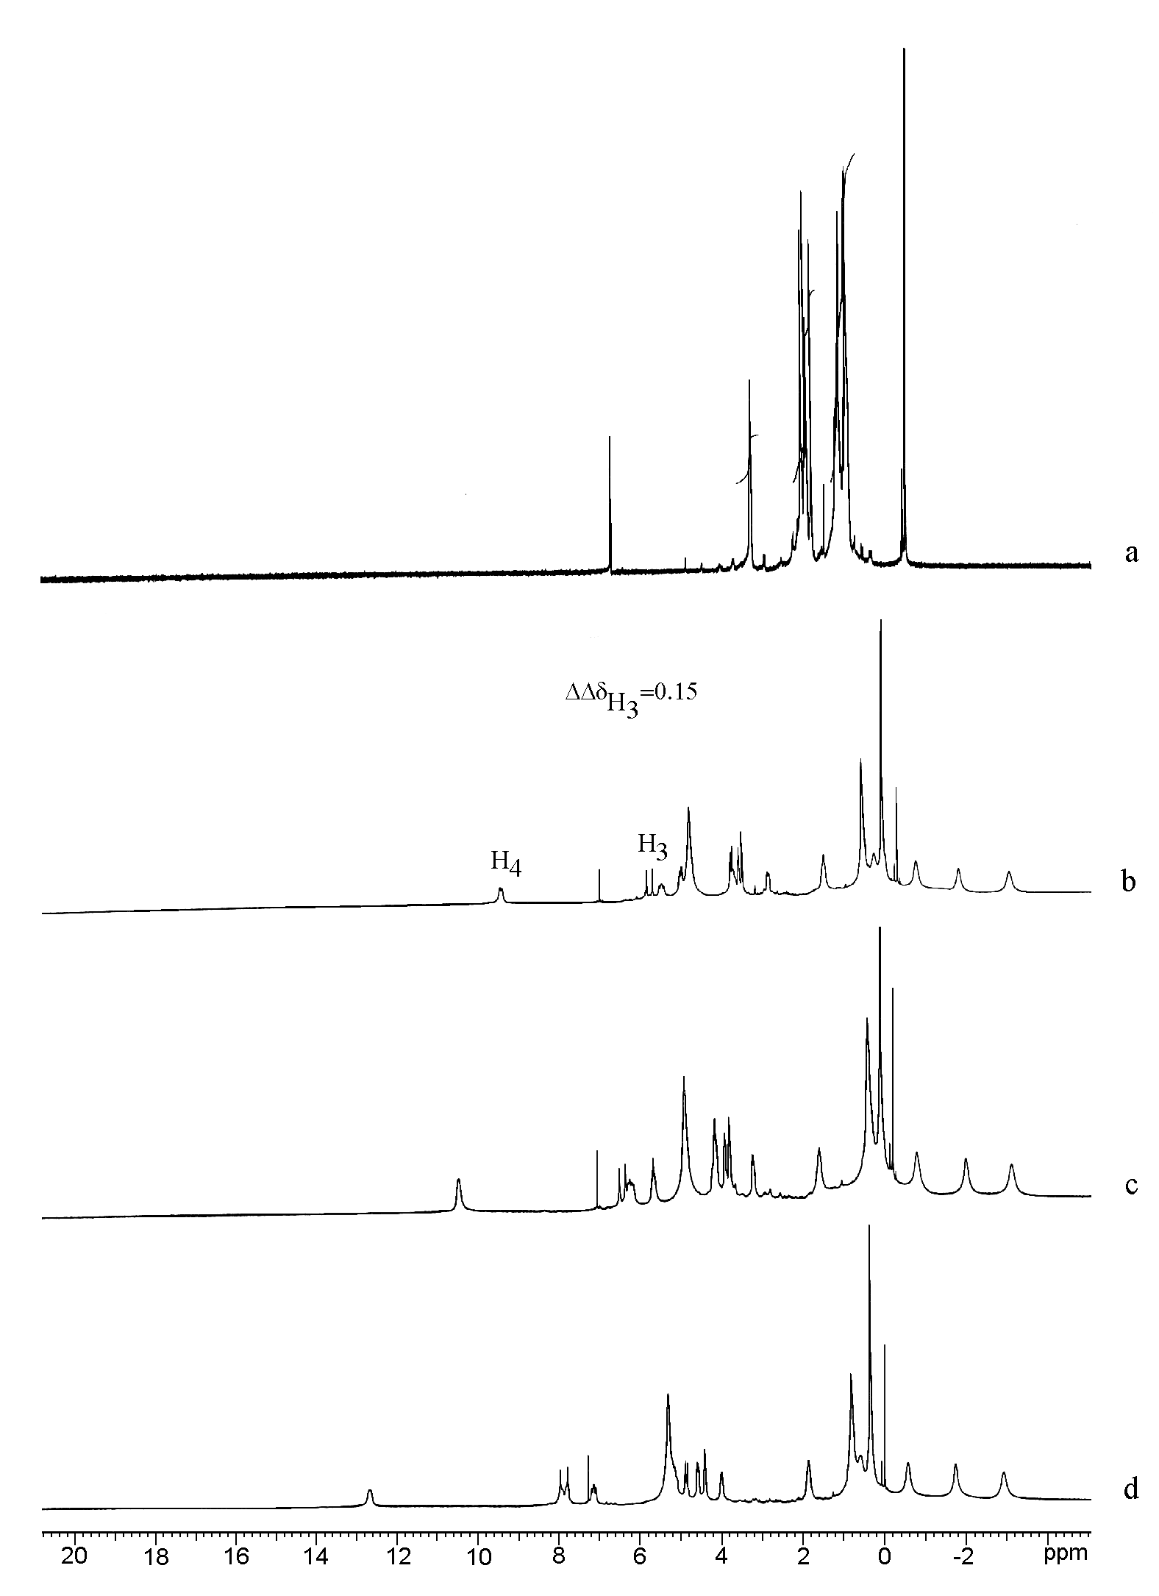
¹H (300 MHz) spectra of alcohol 3 in presence of Eu(hfc)₃. The portion of C-CSR is ca. (a) 0; (b) 10; (c) 15 and (d) 20 mg to 10 mg of substrate.

