Supplementary data

Cycloadditions of mesitonitrile oxide with amino- and nitrostilbenes

Antonino Corsaro,*ª Ugo Chiacchio,ª Venerando Pistarà,ª Antonio Rescifina,ª
Giuseppe Buemiª and Giovanni Romeo^{b}

ª Dipartimento di Scienze Chimiche Università degli Studi di Catania,viale A. Doria 6, 95125 Catania, Italy
^{b} Dipartimento Farmaco-Chimico Università degli Studi di Messina, viale SS. Annunziata, 95100 Messina, Italy

PM3 and AM1 calculations of total energies and Z-matrices for transition states 12–19

PM3 calculations

Total energies and Z-matrix for transition states 12-19
TS for TS for compound 12a

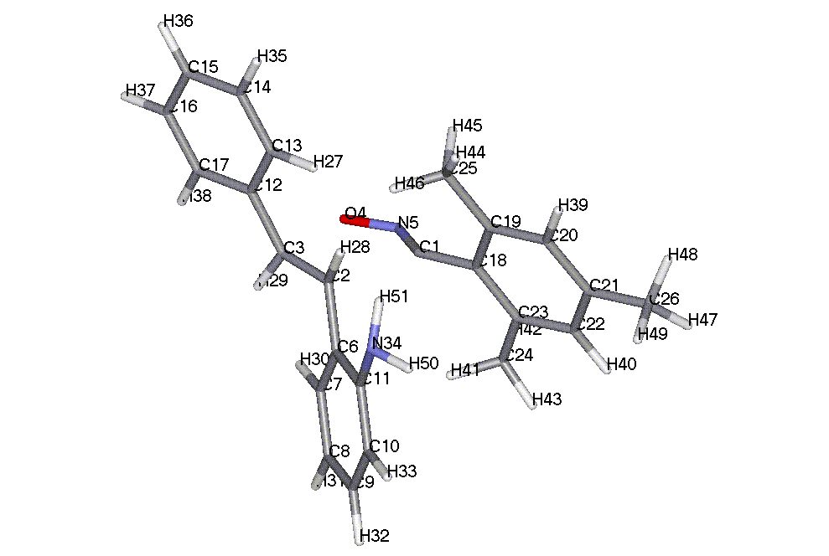

TOTAL ENERGY = -3826.75566 EV

ATOM CHEMICAL BOND LENGTH BOND ANGLE TWIST ANGLE
NUMBER SYMBOL (ANGSTROMS) (DEGREES) (DEGREES)
(I) NA:I NB:NA:I NC:NB:NA:I NA NB NC

1 C
2 C 2.11325 * 1
3 C 1.39595 * 102.56742 * 2 1
4 O 2.09431 * 101.29017 * 7.37467 * 3 2 1
5 N 1.23884 * 98.98132 * -7.29653 * 1 2 3
6 C 1.46939 * 100.48111 * 117.11067 * 2 1 4
7 C 1.39917 * 119.88636 * -86.52820 * 6 2 1
8 C 1.38701 * 121.25903 * 179.27018 * 7 6 2
9 C 1.39147 * 119.84174 * .30161 * 8 7 6
10 C 1.38686 * 120.14289 * .54675 * 9 8 7
11 C 1.40324 * 120.35622 * -.34162 * 10 9 8
12 C 1.46313 * 121.51962 * 151.95953 * 3 2 6
13 C 1.39917 * 121.48639 * -97.72764 * 12 3 4
14 C 1.38834 * 120.49009 * -179.26977 * 13 12 3
15 C 1.39101 * 120.06316 * .01139 * 14 13 12
16 C 1.39141 * 119.86916 * -.01503 * 15 14 13
17 C 1.38919 * 120.28066 * .00023 * 16 15 14
18 C 1.43133 * 116.55677 * -63.91881 * 1 2 6
19 C 1.40624 * 119.61529 * 104.61902 * 18 1 5
20 C 1.39372 * 119.49774 * -179.08713 * 19 18 1
21 C 1.39462 * 120.61327 * -.33922 * 20 19 18
22 C 1.39423 * 119.69804 * -.67774 * 21 20 19
23 C 1.39430 * 120.70081 * .46125 * 22 21 20
24 C 1.48614 * 119.49499 * -178.94698 * 23 22 21
25 C 1.48638 * 121.07118 * .97010 * 19 18 1
26 C 1.48560 * 120.13192 * -179.79121 * 21 20 19
27 H 1.10556 * 118.80536 * 179.85854 * 13 12 17
28 H 1.11609 * 90.13093 * -125.60649 * 2 1 5
29 H 1.10806 * 118.20351 * -6.46455 * 3 2 6
30 H 1.10115 * 118.29628 * 177.27782 * 7 6 11
31 H 1.09440 * 119.99633 * -179.94635 * 8 7 6
32 H 1.09475 * 119.99387 * -179.84747 * 9 8 7
33 H 1.09673 * 119.34022 * 179.43729 * 10 9 8
34 N 1.43068 * 118.51064 * 174.65161 * 11 10 9
35 H 1.09465 * 119.88966 * .12386 * 14 13 27
36 H 1.09461 * 120.06456 * 179.99315 * 15 14 13
37 H 1.09490 * 119.89735 * -179.88976 * 16 15 14
38 H 1.09609 * 119.99672 * -179.55666 * 17 16 15
39 H 1.09726 * 119.75925 * 179.46253 * 20 19 18
40 H 1.09736 * 119.60908 * -179.37705 * 22 21 20
41 H 1.10168 * 110.95338 * 133.91026 * 24 23 22
42 H 1.09852 * 110.78523 * -106.37889 * 24 23 22
43 H 1.09817 * 112.09748 * 13.59956 * 24 23 22
44 H 1.09782 * 112.21595 * -16.50968 * 25 19 20
45 H 1.09850 * 110.64761 * 103.66752 * 25 19 20
46 H 1.10968 * 111.27826 * -137.17413 * 25 19 20
47 H 1.09809 * 111.82481 * 29.99320 * 26 21 22
48 H 1.09809 * 111.83740 * 150.76777 * 26 21 22
49 H 1.09878 * 110.32251 * -89.60752 * 26 21 22
50 H .99565 * 111.44643 * 36.30415 * 34 11 10
51 H 1.00113 * 111.01480 * 160.85802 * 34 11 10

TS for TS for compound 12b

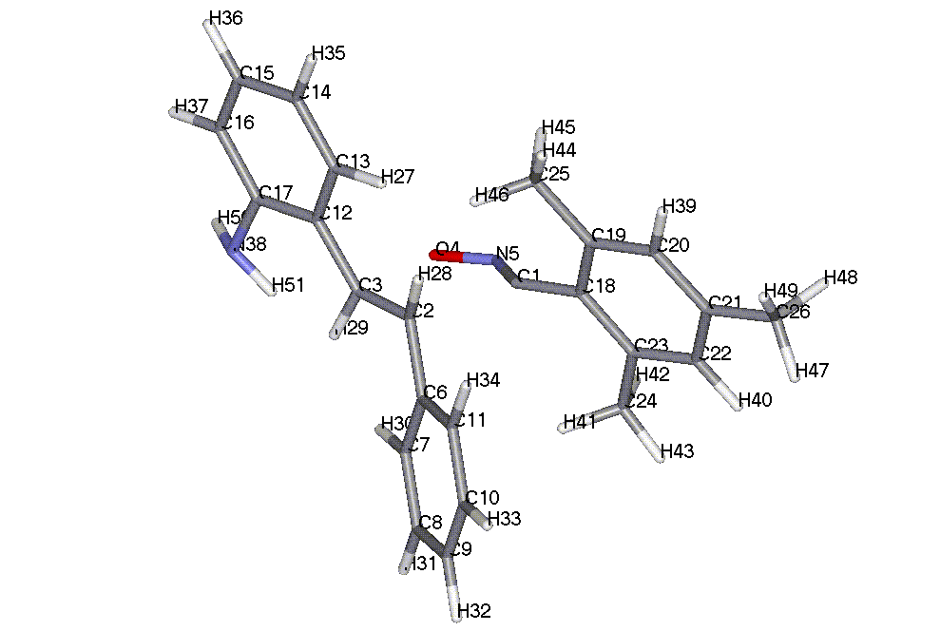

TOTAL ENERGY = -3826.79243 EV

ATOM CHEMICAL BOND LENGTH BOND ANGLE TWIST ANGLE
NUMBER SYMBOL (ANGSTROMS) (DEGREES) (DEGREES)
(I) NA:I NB:NA:I NC:NB:NA:I NA NB NC

1 C
2 C 2.09862 * 1
3 C 1.39606 * 102.81852 * 2 1
4 O 2.11033 * 101.02663 * 7.58966 * 3 2 1
5 N 1.22793 * 100.42352 * -8.41048 * 4 3 2
6 C 1.46830 * 100.29752 * 116.93830 * 2 1 4
7 C 1.39916 * 121.28554 * 20.08966 * 6 2 3
8 C 1.38854 * 120.45900 * -179.35157 * 7 6 2
9 C 1.39116 * 120.09330 * .36640 * 8 7 6
10 C 1.39106 * 119.83124 * .13960 * 9 8 7
11 C 1.38955 * 120.28435 * -.34592 * 10 9 8
12 C 1.46195 * 121.96604 * 152.15502 * 3 2 6
13 C 1.39997 * 120.46006 * 8.84497 * 12 3 2
14 C 1.38590 * 121.30333 * 179.57056 * 13 12 3
15 C 1.39225 * 119.84287 * -.33662 * 14 13 12
16 C 1.38621 * 120.19574 * .24439 * 15 14 13
17 C 1.40388 * 120.32730 * .22319 * 16 15 14
18 C 1.43204 * 116.14793 * 172.14140 * 1 2 3
19 C 1.40604 * 119.75053 * 105.40447 * 18 1 5
20 C 1.39390 * 119.49652 * -179.15778 * 19 18 1
21 C 1.39434 * 120.63387 * -.23690 * 20 19 18
22 C 1.39432 * 119.68780 * -.89359 * 21 20 19
23 C 1.39401 * 120.68399 * .63851 * 22 21 20
24 C 1.48628 * 119.44823 * -178.88624 * 23 22 21
25 C 1.48607 * 121.11875 * -178.15262 * 19 18 23
26 C 1.48558 * 120.15529 * 178.88434 * 21 20 19
27 H 1.10626 * 118.52635 * -179.85229 * 13 12 17
28 H 1.11306 * 90.92488 * -126.37304 * 2 1 5
29 H 1.11164 * 117.69549 * -7.42482 * 3 2 6
30 H 1.10067 * 118.69234 * 177.98500 * 7 6 11
31 H 1.09474 * 119.85168 * -179.95391 * 8 7 6
32 H 1.09452 * 120.08076 * 179.87167 * 9 8 7
33 H 1.09483 * 119.93098 * 179.65199 * 10 9 8
34 H 1.09604 * 119.94248 * -179.66885 * 11 10 9
35 H 1.09432 * 120.05523 * -.36614 * 14 13 27
36 H 1.09485 * 119.93790 * -179.75881 * 15 14 13
37 H 1.09675 * 119.38369 * -179.76996 * 16 15 14
38 N 1.42784 * 118.49051 * 175.13405 * 17 16 15
39 H 1.09721 * 119.74699 * 179.86635 * 20 19 18
40 H 1.09727 * 119.60738 * -178.95548 * 22 21 20
41 H 1.10115 * 110.87166 * 133.09424 * 24 23 22
42 H 1.09849 * 110.84330 * -107.18030 * 24 23 22
43 H 1.09818 * 112.11010 * 12.84571 * 24 23 22
44 H 1.09778 * 112.24708 * -14.66803 * 25 19 20
45 H 1.09851 * 110.70772 * 105.59475 * 25 19 20
46 H 1.10915 * 111.18015 * -135.24726 * 25 19 20
47 H 1.09810 * 111.85941 * -29.79960 * 26 21 22
48 H 1.09879 * 110.25484 * 89.78612 * 26 21 22
49 H 1.09809 * 111.87145 * -150.62089 * 26 21 22
50 H .99530 * 111.60782 * 38.49253 * 38 17 16
51 H .99984 * 111.41130 * 163.90566 * 38 17 16

TS for compound 13a

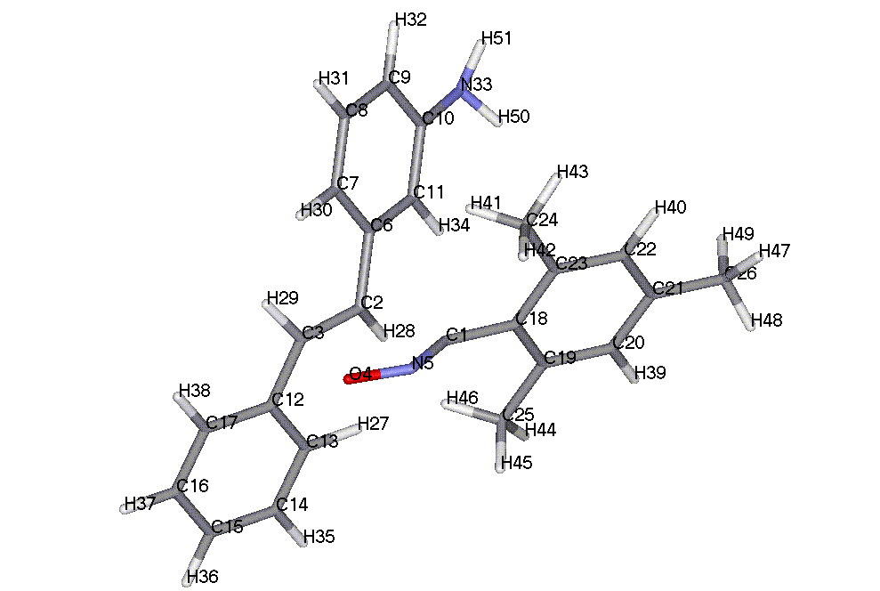

TOTAL ENERGY = -3826.81040 EV

ATOM CHEMICAL BOND LENGTH BOND ANGLE TWIST ANGLE
NUMBER SYMBOL (ANGSTROMS) (DEGREES) (DEGREES)
(I) NA:I NB:NA:I NC:NB:NA:I NA NB NC

1 C
2 C 2.11374 * 1
3 C 1.39527 * 102.71849 * 2 1
4 O 2.09531 * 101.22228 * 7.05015 * 3 2 1
5 N 1.22622 * 100.85905 * -7.72656 * 4 3 2
6 C 1.46814 * 100.08388 * 117.51299 * 2 1 4
7 C 1.39941 * 121.05258 * 19.70411 * 6 2 3
8 C 1.38813 * 120.30279 * -179.38516 * 7 6 2
9 C 1.38895 * 120.55207 * .33361 * 8 7 6
10 C 1.40181 * 119.57321 * .34469 * 9 8 7
11 C 1.39653 * 119.38997 * -159.02272 * 6 2 3
12 C 1.46323 * 121.37794 * 151.97996 * 3 2 6
13 C 1.39930 * 121.39711 * 10.38055 * 12 3 2
14 C 1.38831 * 120.46461 * -179.31185 * 13 12 3
15 C 1.39107 * 120.06663 * .01079 * 14 13 12
16 C 1.39138 * 119.87772 * -.02799 * 15 14 13
17 C 1.38926 * 120.27722 * .00642 * 16 15 14
18 C 1.43121 * 116.40451 * 172.47189 * 1 2 3
19 C 1.40608 * 119.70058 * 105.38334 * 18 1 5
20 C 1.39392 * 119.47877 * -179.19370 * 19 18 1
21 C 1.39437 * 120.63633 * -.29607 * 20 19 18
22 C 1.39427 * 119.69710 * -.68805 * 21 20 19
23 C 1.39409 * 120.67999 * .40491 * 22 21 20
24 C 1.48625 * 119.48417 * -178.85389 * 23 22 21
25 C 1.48615 * 121.12298 * -178.31941 * 19 18 23
26 C 1.48567 * 120.10668 * -179.82004 * 21 20 19
27 H 1.10597 * 118.78340 * 179.92589 * 13 12 17
28 H 1.11289 * 90.46529 * -125.68946 * 2 1 5
29 H 1.10827 * 118.23242 * -6.45325 * 3 2 6
30 H 1.10040 * 118.73641 * 178.01173 * 7 6 11
31 H 1.09496 * 119.73162 * -179.93119 * 8 7 6
32 H 1.09612 * 119.67220 * 179.86430 * 9 8 7
33 N 1.43077 * 119.95716 * 174.74692 * 10 9 8
34 H 1.09771 * 119.42483 * -179.87395 * 11 6 7
35 H 1.09466 * 119.88788 * .10541 * 14 13 27
36 H 1.09461 * 120.06005 * -179.99778 * 15 14 13
37 H 1.09489 * 119.89960 * -179.86758 * 16 15 14
38 H 1.09607 * 120.00747 * -179.52771 * 17 16 15
39 H 1.09720 * 119.75877 * 179.61957 * 20 19 18
40 H 1.09725 * 119.61603 * -179.47470 * 22 21 20
41 H 1.10116 * 110.88721 * 133.30998 * 24 23 22
42 H 1.09853 * 110.82983 * -106.98970 * 24 23 22
43 H 1.09816 * 112.11851 * 13.00348 * 24 23 22
44 H 1.09779 * 112.21927 * -15.60032 * 25 19 20
45 H 1.09853 * 110.67222 * 104.61402 * 25 19 20
46 H 1.10925 * 111.25307 * -136.20743 * 25 19 20
47 H 1.09808 * 111.87580 * -152.05593 * 26 21 20
48 H 1.09810 * 111.79284 * -31.28475 * 26 21 20
49 H 1.09875 * 110.33005 * 88.29389 * 26 21 20
50 H .99595 * 111.55852 * -29.95096 * 33 10 11
51 H .99592 * 111.50682 * -154.68621 * 33 10 11

TS for compound 13b

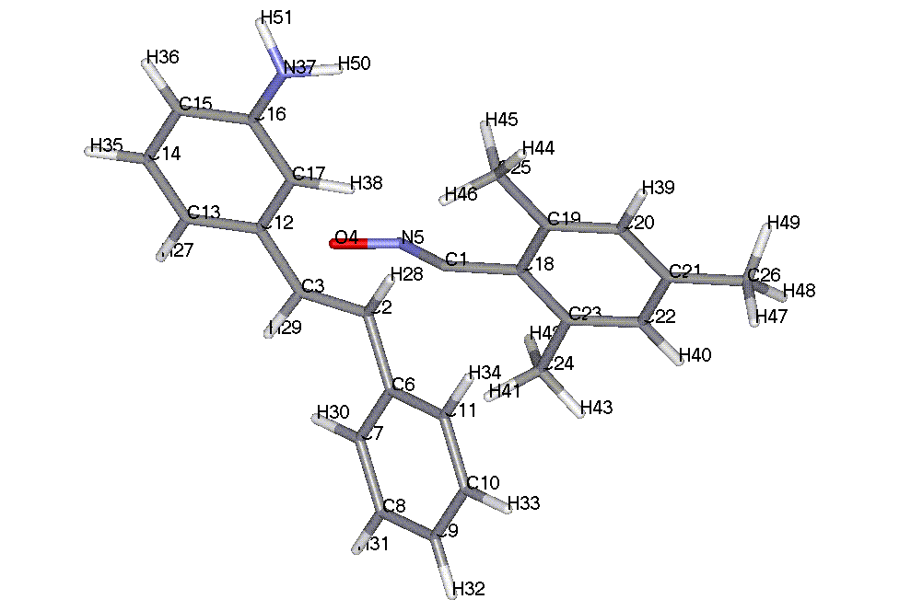

TOTAL ENERGY = -3826.80653 EV

ATOM CHEMICAL BOND LENGTH BOND ANGLE TWIST ANGLE
NUMBER SYMBOL (ANGSTROMS) (DEGREES) (DEGREES)
(I) NA:I NB:NA:I NC:NB:NA:I NA NB NC

1 C
2 C 2.11572 * 1
3 C 1.39523 * 102.71258 * 2 1
4 O 2.09310 * 101.24383 * 6.95265 * 3 2 1
5 N 1.22649 * 100.95680 * -7.60945 * 4 3 2
6 C 1.46735 * 100.04248 * 117.60506 * 2 1 4
7 C 1.39926 * 121.18980 * 19.41369 * 6 2 3
8 C 1.38850 * 120.43743 * -179.34356 * 7 6 2
9 C 1.39120 * 120.09688 * .38046 * 8 7 6
10 C 1.39105 * 119.83897 * .14166 * 9 8 7
11 C 1.38955 * 120.28230 * -.35702 * 10 9 8
12 C 1.46417 * 121.48163 * 151.85734 * 3 2 6
13 C 1.39975 * 119.29456 * -167.47686 * 12 3 2
14 C 1.38913 * 120.07196 * 179.29744 * 13 12 3
15 C 1.38899 * 120.71622 * .11981 * 14 13 12
16 C 1.40164 * 119.59712 * -.15832 * 15 14 13
17 C 1.39703 * 121.17151 * 11.82172 * 12 3 2
18 C 1.43113 * 116.47554 * 172.69084 * 1 2 3
19 C 1.40608 * 119.70656 * 105.56626 * 18 1 5
20 C 1.39379 * 119.50277 * -179.21651 * 19 18 1
21 C 1.39441 * 120.62323 * -.34598 * 20 19 18
22 C 1.39429 * 119.69577 * -.62681 * 21 20 19
23 C 1.39405 * 120.68851 * .36421 * 22 21 20
24 C 1.48625 * 119.46856 * -178.78310 * 23 22 21
25 C 1.48617 * 121.10758 * -178.20352 * 19 18 23
26 C 1.48560 * 120.14363 * -179.66594 * 21 20 19
27 H 1.09574 * 119.89621 * 179.48028 * 13 12 17
28 H 1.11279 * 90.41623 * -125.65893 * 2 1 5
29 H 1.10833 * 118.19038 * -6.37938 * 3 2 6
30 H 1.10082 * 118.65618 * 177.99542 * 7 6 11
31 H 1.09474 * 119.84804 * -179.92773 * 8 7 6
32 H 1.09451 * 120.07749 * 179.87398 * 9 8 7
33 H 1.09481 * 119.93024 * 179.63651 * 10 9 8
34 H 1.09602 * 119.96263 * -179.68558 * 11 10 9
35 H 1.09510 * 119.70462 * .48533 * 14 13 27
36 H 1.09623 * 119.66789 * 179.95846 * 15 14 13
37 N 1.43178 * 120.13744 * -175.31423 * 16 15 14
38 H 1.10750 * 118.44800 * 179.60874 * 17 12 13
39 H 1.09718 * 119.76783 * 179.70241 * 20 19 18
40 H 1.09728 * 119.60056 * -179.30417 * 22 21 20
41 H 1.10106 * 110.86488 * 132.94138 * 24 23 22
42 H 1.09850 * 110.85605 * -107.33552 * 24 23 22
43 H 1.09818 * 112.11078 * 12.69602 * 24 23 22
44 H 1.09781 * 112.22289 * -15.47801 * 25 19 20
45 H 1.09849 * 110.69913 * 104.77041 * 25 19 20
46 H 1.10918 * 111.18591 * -136.04025 * 25 19 20
47 H 1.09878 * 110.29533 * -89.46703 * 26 21 22
48 H 1.09808 * 111.83501 * 30.12628 * 26 21 22
49 H 1.09807 * 111.84980 * 150.92202 * 26 21 22
50 H .99622 * 111.32425 * 31.46861 * 37 16 17
51 H .99597 * 111.44545 * 155.86702 * 37 16 17

TS for compound 14a

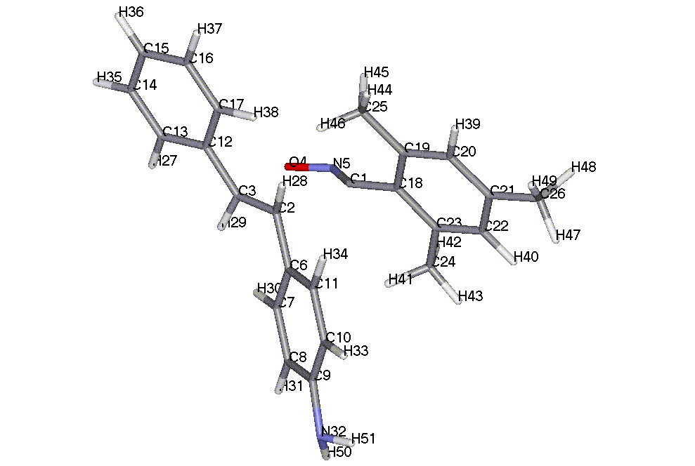

TOTAL ENERGY = -3826.80950 EV

ATOM CHEMICAL BOND LENGTH BOND ANGLE TWIST ANGLE
NUMBER SYMBOL (ANGSTROMS) (DEGREES) (DEGREES)
(I) NA:I NB:NA:I NC:NB:NA:I NA NB NC

1 C
2 C 2.11294 * 1
3 C 1.39546 * 102.64171 * 2 1
4 O 2.09714 * 101.24731 * 7.34822 * 3 2 1
5 N 1.22613 * 100.79800 * -8.06597 * 4 3 2
6 C 1.46690 * 100.40390 * 117.35227 * 2 1 4
7 C 1.39895 * 121.26830 * 18.98384 * 6 2 3
8 C 1.38615 * 120.88253 * -179.18045 * 7 6 2
9 C 1.40206 * 119.82838 * .49855 * 8 7 6
10 C 1.40201 * 119.62498 * -.23974 * 9 8 7
11 C 1.38704 * 120.01139 * .02016 * 10 9 8
12 C 1.46297 * 121.43672 * 151.87977 * 3 2 6
13 C 1.40011 * 119.47520 * -169.19644 * 12 3 2
14 C 1.38920 * 120.19541 * 179.27956 * 13 12 3
15 C 1.39140 * 120.28026 * .02569 * 14 13 12
16 C 1.39102 * 119.86943 * .00733 * 15 14 13
17 C 1.38832 * 120.07084 * -.02831 * 16 15 14
18 C 1.43139 * 116.49400 * 172.28727 * 1 2 3
19 C 1.40604 * 119.72267 * 105.62431 * 18 1 5
20 C 1.39395 * 119.49478 * -179.28302 * 19 18 1
21 C 1.39430 * 120.63867 * -.19920 * 20 19 18
22 C 1.39433 * 119.68475 * -.89544 * 21 20 19
23 C 1.39397 * 120.67911 * .62095 * 22 21 20
24 C 1.48629 * 119.46451 * -178.93574 * 23 22 21
25 C 1.48611 * 121.12308 * -178.25904 * 19 18 23
26 C 1.48560 * 120.14477 * 178.85492 * 21 20 19
27 H 1.09604 * 119.79939 * 179.50994 * 13 12 17
28 H 1.11288 * 90.33163 * -125.95665 * 2 1 5
29 H 1.10813 * 118.23994 * -6.52310 * 3 2 6
30 H 1.10112 * 118.54450 * 178.16390 * 7 6 11
31 H 1.09636 * 119.46443 * 179.96992 * 8 7 6
32 N 1.43019 * 120.09890 * 174.84033 * 9 8 7
33 H 1.09645 * 120.58474 * 179.83705 * 10 9 8
34 H 1.09629 * 119.63815 * -179.81131 * 11 10 9
35 H 1.09487 * 119.82340 * .35029 * 14 13 27
36 H 1.09458 * 120.06488 * 179.97333 * 15 14 13
37 H 1.09465 * 120.04501 * 179.97608 * 16 15 14
38 H 1.10589 * 120.75082 * -179.89397 * 17 16 15
39 H 1.09720 * 119.74592 * 179.88096 * 20 19 18
40 H 1.09721 * 119.60232 * -179.03680 * 22 21 20
41 H 1.10089 * 110.88279 * 133.47038 * 24 23 22
42 H 1.09853 * 110.82979 * -106.82445 * 24 23 22
43 H 1.09815 * 112.10508 * 13.16905 * 24 23 22
44 H 1.09778 * 112.22840 * -15.34692 * 25 19 20
45 H 1.09852 * 110.68173 * 104.88634 * 25 19 20
46 H 1.10915 * 111.22730 * -135.94524 * 25 19 20
47 H 1.09808 * 111.87511 * 150.83565 * 26 21 20
48 H 1.09878 * 110.25935 * -89.56850 * 26 21 20
49 H 1.09809 * 111.85693 * 30.01554 * 26 21 20
50 H .99587 * 111.52227 * 29.97937 * 32 9 8
51 H .99587 * 111.52216 * 154.73158 * 32 9 8

TS for compound 14b

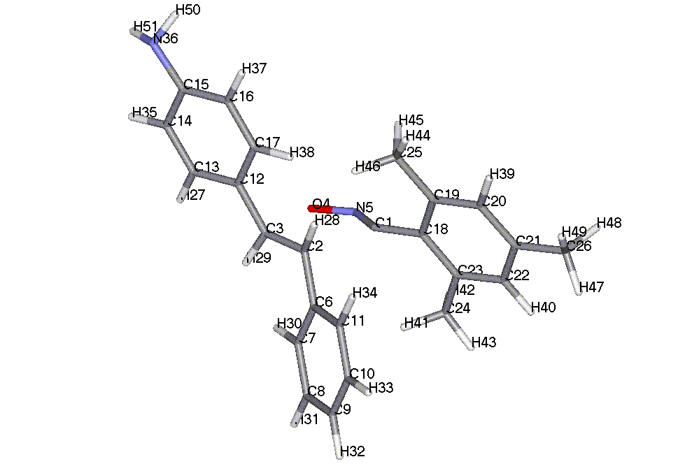

TOTAL ENERGY = -3826.82442 EV

ATOM CHEMICAL BOND LENGTH BOND ANGLE TWIST ANGLE
NUMBER SYMBOL (ANGSTROMS) (DEGREES) (DEGREES)
(I) NA:I NB:NA:I NC:NB:NA:I NA NB NC

1 C
2 C 2.11150 * 1
3 C 1.39562 * 102.79276 * 2 1
4 O 2.10179 * 101.08689 * 7.30950 * 3 2 1
5 N 1.22686 * 100.76816 * -8.02609 * 4 3 2
6 C 1.46726 * 100.14491 * 117.27327 * 2 1 4
7 C 1.39931 * 121.19671 * 19.58133 * 6 2 3
8 C 1.38849 * 120.44440 * -179.34095 * 7 6 2
9 C 1.39119 * 120.10096 * .37428 * 8 7 6
10 C 1.39105 * 119.83245 * .13481 * 9 8 7
11 C 1.38953 * 120.28482 * -.34482 * 10 9 8
12 C 1.46126 * 121.47692 * 151.98225 * 3 2 6
13 C 1.40043 * 119.52972 * -169.35542 * 12 3 2
14 C 1.38630 * 120.63526 * 179.45170 * 13 12 3
15 C 1.40274 * 120.01335 * -.02984 * 14 13 12
16 C 1.40229 * 119.65257 * .23452 * 15 14 13
17 C 1.38568 * 119.79704 * -.28675 * 16 15 14
18 C 1.43134 * 116.30054 * 172.26811 * 1 2 3
19 C 1.40606 * 119.71451 * 105.38457 * 18 1 5
20 C 1.39387 * 119.49984 * -179.24032 * 19 18 1
21 C 1.39436 * 120.62861 * -.23429 * 20 19 18
22 C 1.39431 * 119.69074 * -.89895 * 21 20 19
23 C 1.39403 * 120.68524 * .63709 * 22 21 20
24 C 1.48625 * 119.46826 * -178.85642 * 23 22 21
25 C 1.48615 * 121.10898 * -178.14370 * 19 18 23
26 C 1.48560 * 120.15694 * 178.88580 * 21 20 19
27 H 1.09633 * 119.67083 * 179.46391 * 13 12 17
28 H 1.11280 * 90.49075 * -125.97184 * 2 1 5
29 H 1.10814 * 118.23614 * -6.69353 * 3 2 6
30 H 1.10079 * 118.64830 * 178.03523 * 7 6 11
31 H 1.09472 * 119.84683 * -179.92033 * 8 7 6
32 H 1.09448 * 120.08142 * 179.88261 * 9 8 7
33 H 1.09480 * 119.92874 * 179.66647 * 10 9 8
34 H 1.09599 * 119.95867 * -179.64814 * 11 10 9
35 H 1.09653 * 119.43549 * .36960 * 14 13 27
36 N 1.42868 * 120.10345 * -175.09302 * 15 14 13
37 H 1.09627 * 120.68922 * 179.86912 * 16 15 14
38 H 1.10628 * 120.43918 * -179.79673 * 17 16 15
39 H 1.09717 * 119.75156 * 179.88298 * 20 19 18
40 H 1.09726 * 119.60745 * -178.94229 * 22 21 20
41 H 1.10109 * 110.86074 * 133.00406 * 24 23 22
42 H 1.09849 * 110.84707 * -107.28525 * 24 23 22
43 H 1.09817 * 112.11402 * 12.75139 * 24 23 22
44 H 1.09778 * 112.23027 * -15.14907 * 25 19 20
45 H 1.09849 * 110.69071 * 105.09600 * 25 19 20
46 H 1.10919 * 111.20565 * -135.73456 * 25 19 20
47 H 1.09810 * 111.85298 * 150.28886 * 26 21 20
48 H 1.09878 * 110.26039 * -90.12718 * 26 21 20
49 H 1.09808 * 111.87535 * 29.47268 * 26 21 20
50 H .99578 * 111.63656 * 30.18595 * 36 15 16
51 H .99579 * 111.65630 * 155.25431 * 36 15 16

TS for compound 15a

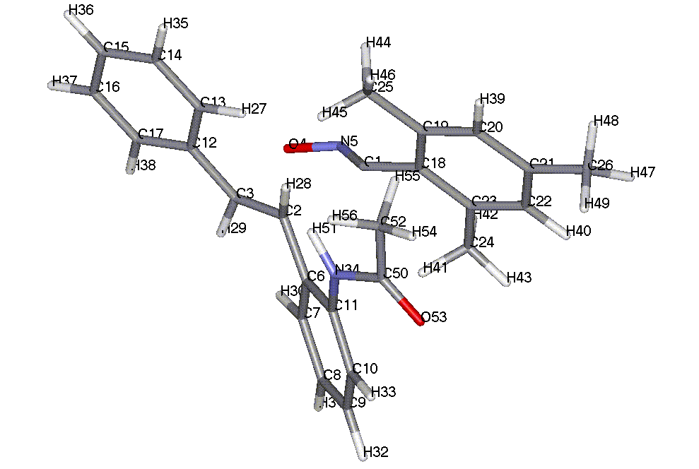

TOTAL ENERGY = -4388.41178 EV

ATOM CHEMICAL BOND LENGTH BOND ANGLE TWIST ANGLE
NUMBER SYMBOL (ANGSTROMS) (DEGREES) (DEGREES)
(I) NA:I NB:NA:I NC:NB:NA:I NA NB NC

1 C
2 C 2.12090 * 1
3 C 1.39661 * 102.41992 * 2 1
4 O 2.08137 * 101.48299 * 7.29692 * 3 2 1
5 N 1.23788 * 98.50791 * -7.16187 * 1 2 3
6 C 1.47103 * 101.11763 * 117.32663 * 2 1 4
7 C 1.39914 * 119.04225 * -86.08422 * 6 2 1
8 C 1.38700 * 121.38476 * -178.73435 * 7 6 2
9 C 1.38971 * 119.68652 * 1.03103 * 8 7 6
10 C 1.38865 * 120.30854 * -.17147 * 9 8 7
11 C 1.40086 * 120.35465 * -1.08654 * 10 9 8
12 C 1.46391 * 121.48046 * -98.26370 * 3 2 1
13 C 1.39904 * 121.54779 * -96.83208 * 12 3 4
14 C 1.38835 * 120.50984 * -179.30216 * 13 12 3
15 C 1.39100 * 120.05305 * .02909 * 14 13 12
16 C 1.39142 * 119.86578 * -.04638 * 15 14 13
17 C 1.38925 * 120.28397 * .00840 * 16 15 14
18 C 1.43071 * 116.87237 * -63.59624 * 1 2 6
19 C 1.40597 * 119.69726 * 104.93256 * 18 1 5
20 C 1.39374 * 119.51526 * -179.10867 * 19 18 1
21 C 1.39477 * 120.61299 * -.19486 * 20 19 18
22 C 1.39441 * 119.67736 * -.80231 * 21 20 19
23 C 1.39413 * 120.71425 * .39013 * 22 21 20
24 C 1.48615 * 119.48994 * -178.58257 * 23 22 21
25 C 1.48668 * 121.22529 * 1.34838 * 19 18 1
26 C 1.48531 * 120.20287 * -179.49935 * 21 20 19
27 H 1.10531 * 118.82079 * -179.96463 * 13 12 17
28 H 1.11539 * 89.92333 * -124.71645 * 2 1 5
29 H 1.10832 * 118.23228 * 103.75395 * 3 2 1
30 H 1.10116 * 118.39187 * 177.77563 * 7 6 11
31 H 1.09453 * 120.01148 * -179.53204 * 8 7 6
32 H 1.09499 * 120.05259 * 179.42643 * 9 8 7
33 H 1.09718 * 118.64019 * 179.23262 * 10 9 8
34 N 1.43641 * 120.73401 * 177.90495 * 11 10 9
35 H 1.09466 * 119.90475 * .05698 * 14 13 27
36 H 1.09466 * 120.06430 * -179.98862 * 15 14 13
37 H 1.09496 * 119.89739 * -179.84905 * 16 15 14
38 H 1.09616 * 119.98480 * -179.51041 * 17 16 15
39 H 1.09749 * 119.74447 * 179.90390 * 20 19 18
40 H 1.09745 * 119.56181 * -178.90254 * 22 21 20
41 H 1.10142 * 110.97060 * 134.49132 * 24 23 22
42 H 1.09853 * 110.80606 * -105.73556 * 24 23 22
43 H 1.09822 * 112.05209 * 14.25892 * 24 23 22
44 H 1.09828 * 110.73873 * -79.39811 * 25 19 18
45 H 1.10939 * 111.38139 * 40.00806 * 25 19 18
46 H 1.09861 * 112.00060 * 160.41288 * 25 19 18
47 H 1.09809 * 111.75056 * -148.97910 * 26 21 20
48 H 1.09802 * 111.94884 * -28.14965 * 26 21 20
49 H 1.09898 * 110.20078 * 91.54651 * 26 21 20
50 C 1.42182 * 127.21232 * 36.87297 * 34 11 10
51 H 1.00191 * 113.83321 * -167.86024 * 34 11 10
52 C 1.51153 * 115.21141 * 168.02247 * 50 34 11
53 O 1.22107 * 121.64580 * -168.27807 * 50 34 51
54 H 1.09808 * 111.30653 * 170.37083 * 52 50 34
55 H 1.10175 * 110.39683 * 110.79841 * 52 50 53
56 H 1.09811 * 112.09755 * -128.72838 * 52 50 53

TS for compound 15b

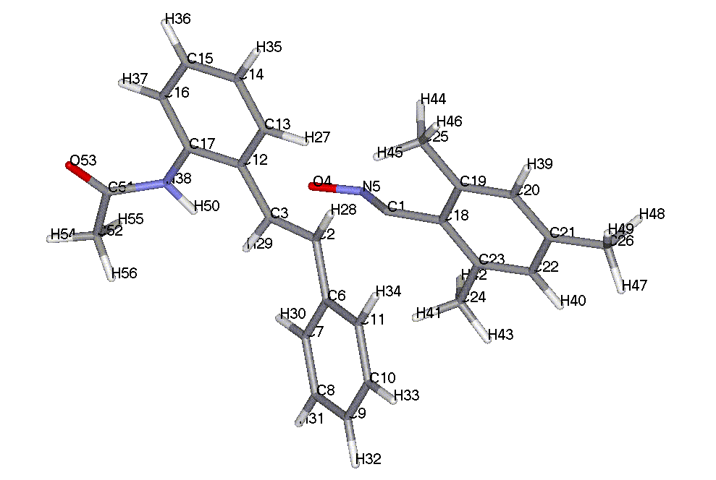

TOTAL ENERGY = -4388.41536 EV

ATOM CHEMICAL BOND LENGTH BOND ANGLE TWIST ANGLE
NUMBER SYMBOL (ANGSTROMS) (DEGREES) (DEGREES)
(I) NA:I NB:NA:I NC:NB:NA:I NA NB NC

1 C
2 C 2.10271 * 1
3 C 1.39633 * 102.85961 * 2 1
4 O 2.09867 * 101.04330 * 7.36931 * 3 2 1
5 N 1.23922 * 99.27423 * -7.10313 * 1 2 3
6 C 1.46823 * 100.16118 * 117.16528 * 2 1 4
7 C 1.39909 * 121.31922 * -90.61607 * 6 2 1
8 C 1.38856 * 120.47750 * -179.37103 * 7 6 2
9 C 1.39113 * 120.08008 * .36946 * 8 7 6
10 C 1.39111 * 119.83257 * .11322 * 9 8 7
11 C 1.38955 * 120.28936 * -.33117 * 10 9 8
12 C 1.46397 * 121.97374 * -98.67103 * 3 2 1
13 C 1.39941 * 119.88294 * -97.55862 * 12 3 4
14 C 1.38625 * 121.34518 * -179.68725 * 13 12 3
15 C 1.39045 * 119.72987 * -.44163 * 14 13 12
16 C 1.38831 * 120.36662 * .07036 * 15 14 13
17 C 1.40100 * 120.26734 * .53286 * 16 15 14
18 C 1.43171 * 116.36999 * -63.57239 * 1 2 6
19 C 1.40605 * 119.73612 * 105.43072 * 18 1 5
20 C 1.39387 * 119.48953 * -179.15317 * 19 18 1
21 C 1.39438 * 120.63287 * -.24682 * 20 19 18
22 C 1.39439 * 119.69021 * -.89866 * 21 20 19
23 C 1.39396 * 120.68590 * .65233 * 22 21 20
24 C 1.48630 * 119.44572 * -178.91994 * 23 22 21
25 C 1.48605 * 121.11535 * 1.07313 * 19 18 1
26 C 1.48555 * 120.15490 * 178.87646 * 21 20 19
27 H 1.10617 * 118.64739 * -179.92985 * 13 12 17
28 H 1.11301 * 90.77188 * -126.14424 * 2 1 5
29 H 1.11136 * 117.27105 * 102.40768 * 3 2 1
30 H 1.10037 * 118.69612 * 178.13745 * 7 6 11
31 H 1.09474 * 119.87098 * -179.90080 * 8 7 6
32 H 1.09457 * 120.07898 * 179.87497 * 9 8 7
33 H 1.09490 * 119.92682 * 179.67671 * 10 9 8
34 H 1.09610 * 119.94115 * -179.65684 * 11 10 9
35 H 1.09445 * 120.04860 * -.18641 * 14 13 27
36 H 1.09508 * 119.99509 * -179.73438 * 15 14 13
37 H 1.09718 * 118.74950 * -179.64134 * 16 15 14
38 N 1.43282 * 121.08784 * -177.72660 * 17 16 15
39 H 1.09725 * 119.74561 * 179.84930 * 20 19 18
40 H 1.09730 * 119.60348 * -178.96255 * 22 21 20
41 H 1.10114 * 110.89545 * 133.19615 * 24 23 22
42 H 1.09851 * 110.83842 * -107.05932 * 24 23 22
43 H 1.09820 * 112.10313 * 12.94909 * 24 23 22
44 H 1.09853 * 110.71578 * -74.85188 * 25 19 18
45 H 1.10904 * 111.16527 * 44.31946 * 25 19 18
46 H 1.09779 * 112.24461 * 164.88478 * 25 19 18
47 H 1.09810 * 111.86167 * 150.41226 * 26 21 20
48 H 1.09880 * 110.24741 * -90.00510 * 26 21 20
49 H 1.09809 * 111.87364 * 29.58409 * 26 21 20
50 H 1.00127 * 114.27497 * 160.85423 * 38 17 16
51 C 1.41748 * 127.85623 * -34.96043 * 38 17 16
52 C 1.51100 * 115.32412 * -10.82767 * 51 38 50
53 O 1.22175 * 121.32469 * 170.48670 * 51 38 50
54 H 1.09828 * 111.23451 * -177.99287 * 52 51 38
55 H 1.09846 * 111.40239 * 120.45655 * 52 51 53
56 H 1.09836 * 111.38544 * -119.08549 * 52 51 53

TS for compound 16a

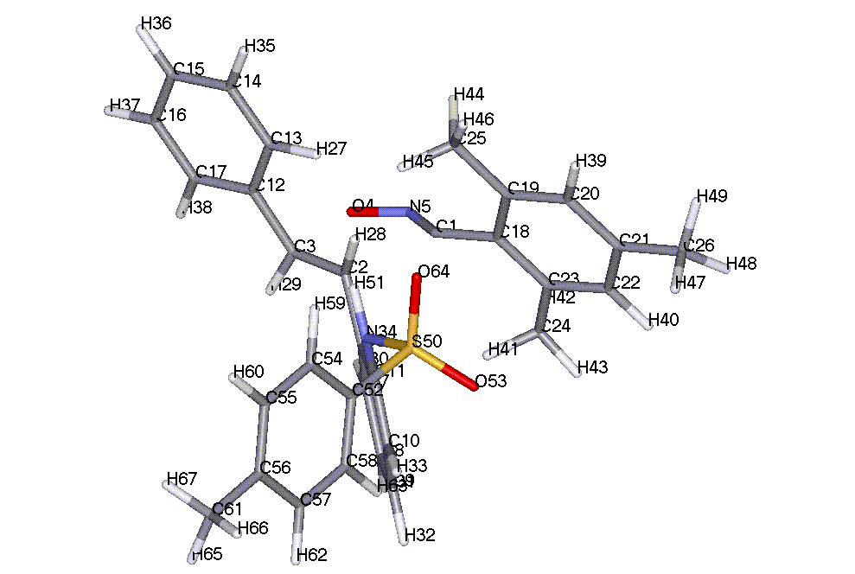

TOTAL ENERGY = -5521.33277 EV

ATOM CHEMICAL BOND LENGTH BOND ANGLE TWIST ANGLE
NUMBER SYMBOL (ANGSTROMS) (DEGREES) (DEGREES)
(I) NA:I NB:NA:I NC:NB:NA:I NA NB NC

1 C
2 C 2.12225 * 1
3 C 1.39565 * 102.75858 * 2 1
4 O 2.07988 * 101.15399 * 7.63013 * 3 2 1
5 N 1.23794 * 98.26430 * -7.18453 * 1 2 3
6 C 1.47075 * 101.89590 * 117.81724 * 2 1 4
7 C 1.39872 * 119.93794 * -70.43392 * 6 2 1
8 C 1.38839 * 121.31142 * -178.63734 * 7 6 2
9 C 1.38948 * 119.87347 * .36887 * 8 7 6
10 C 1.38783 * 120.11910 * .02472 * 9 8 7
11 C 1.40114 * 120.40292 * -.61979 * 10 9 8
12 C 1.46595 * 121.23409 * 150.68120 * 3 2 6
13 C 1.39892 * 121.67649 * -97.55847 * 12 3 4
14 C 1.38849 * 120.51196 * -179.22754 * 13 12 3
15 C 1.39091 * 120.07434 * .01518 * 14 13 12
16 C 1.39137 * 119.84976 * -.03040 * 15 14 13
17 C 1.38917 * 120.27435 * .01545 * 16 15 14
18 C 1.43080 * 116.84507 * -63.03039 * 1 2 6
19 C 1.40649 * 119.69969 * 105.82973 * 18 1 5
20 C 1.39373 * 119.52526 * -179.92986 * 19 18 1
21 C 1.39441 * 120.64623 * -.15294 * 20 19 18
22 C 1.39433 * 119.66272 * -.00230 * 21 20 19
23 C 1.39384 * 120.71736 * -.23391 * 22 21 20
24 C 1.48628 * 119.22379 * -179.45605 * 23 22 21
25 C 1.48632 * 121.30638 * -179.37610 * 19 18 23
26 C 1.48524 * 120.12384 * -178.86073 * 21 20 19
27 H 1.10587 * 118.91713 * -179.98151 * 13 12 17
28 H 1.11649 * 89.44072 * -124.69646 * 2 1 5
29 H 1.10375 * 119.36248 * -6.56913 * 3 2 6
30 H 1.09739 * 119.42246 * 179.71373 * 7 6 11
31 H 1.09457 * 119.94779 * -179.71909 * 8 7 6
32 H 1.09480 * 120.11183 * 179.98148 * 9 8 7
33 H 1.10214 * 118.70659 * 179.84143 * 10 9 8
34 N 1.43931 * 119.43692 * 176.41962 * 11 10 9
35 H 1.09476 * 119.85531 * .04125 * 14 13 27
36 H 1.09461 * 120.07499 * -179.96093 * 15 14 13
37 H 1.09488 * 119.90333 * -179.82348 * 16 15 14
38 H 1.09616 * 119.94133 * -179.48360 * 17 16 15
39 H 1.09749 * 119.73907 * -179.47135 * 20 19 18
40 H 1.09728 * 119.56314 * -179.56835 * 22 21 20
41 H 1.10161 * 111.11324 * 133.75215 * 24 23 22
42 H 1.09854 * 110.77209 * -106.43197 * 24 23 22
43 H 1.09827 * 112.07043 * 13.49800 * 24 23 22
44 H 1.09844 * 110.71027 * 105.37061 * 25 19 20
45 H 1.10862 * 111.31053 * -135.36343 * 25 19 20
46 H 1.09809 * 112.19643 * -14.97565 * 25 19 20
47 H 1.09899 * 110.11844 * 88.49027 * 26 21 20
48 H 1.09801 * 111.91275 * -151.92155 * 26 21 20
49 H 1.09804 * 111.84047 * -31.02001 * 26 21 20
50 S 1.76802 * 127.59746 * 36.42369 * 34 11 10
51 H 1.00892 * 110.10215 * -177.54162 * 34 11 10
52 C 1.77467 * 100.65636 * -99.12688 * 50 34 11
53 O 1.45547 * 110.76781 * -127.20306 * 50 34 51
54 C 1.39718 * 120.92878 * -101.28971 * 52 50 34
55 C 1.38879 * 120.82109 * -178.62228 * 54 52 50
56 C 1.39582 * 120.32831 * -.00406 * 55 54 52
57 C 1.39666 * 119.20912 * -.31756 * 56 55 54
58 C 1.38733 * 120.16623 * .21445 * 57 56 55
59 H 1.09914 * 119.76690 * 1.01292 * 54 52 50
60 H 1.09633 * 119.80349 * -179.98485 * 55 54 52
61 C 1.48442 * 120.43209 * 179.19357 * 56 55 54
62 H 1.09620 * 119.90741 * -179.63108 * 57 56 55
63 H 1.10410 * 119.70329 * -179.30825 * 58 57 56
64 O 1.46504 * 103.93065 * 1.18599 * 50 34 51
65 H 1.09812 * 111.84314 * -30.48045 * 61 56 57
66 H 1.09894 * 110.17660 * 89.04971 * 61 56 57
67 H 1.09811 * 111.89039 * -151.38601 * 61 56 57

TS for compound 16b

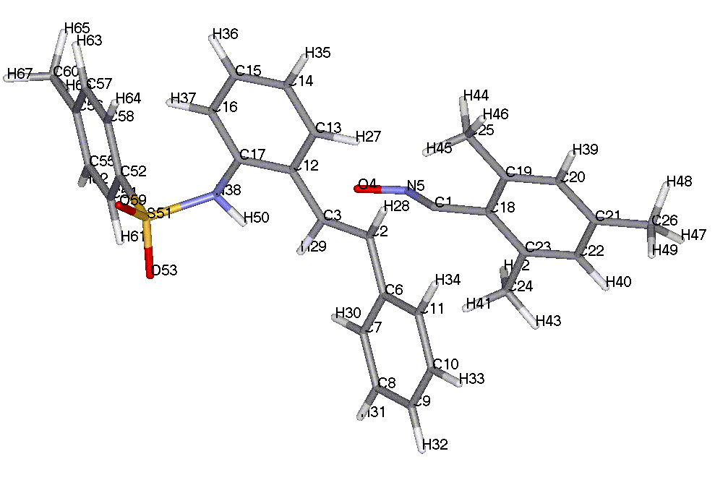

TOTAL ENERGY = -5521.36337 EV

ATOM CHEMICAL BOND LENGTH BOND ANGLE TWIST ANGLE
NUMBER SYMBOL (ANGSTROMS) (DEGREES) (DEGREES)
(I) NA:I NB:NA:I NC:NB:NA:I NA NB NC

1 C
2 C 2.10702 * 1
3 C 1.39607 * 102.87956 * 2 1
4 O 2.09812 * 101.07624 * 6.81993 * 3 2 1
5 N 1.23895 * 99.09478 * -6.66564 * 1 2 3
6 C 1.46814 * 100.04794 * 117.71536 * 2 1 4
7 C 1.39916 * 121.31457 * -91.53684 * 6 2 1
8 C 1.38857 * 120.44792 * -179.26939 * 7 6 2
9 C 1.39120 * 120.09125 * .33113 * 8 7 6
10 C 1.39103 * 119.84053 * .14837 * 9 8 7
11 C 1.38955 * 120.27815 * -.33335 * 10 9 8
12 C 1.46388 * 121.85333 * -99.00277 * 3 2 1
13 C 1.40009 * 119.94242 * -95.61313 * 12 3 4
14 C 1.38628 * 121.43291 * -179.67598 * 13 12 3
15 C 1.39092 * 119.79986 * -.12151 * 14 13 12
16 C 1.38742 * 120.17505 * -.06728 * 15 14 13
17 C 1.40173 * 120.36255 * .30124 * 16 15 14
18 C 1.43157 * 116.49015 * -63.03989 * 1 2 6
19 C 1.40602 * 119.71547 * 105.48233 * 18 1 5
20 C 1.39384 * 119.49816 * -179.13369 * 19 18 1
21 C 1.39436 * 120.62378 * -.35867 * 20 19 18
22 C 1.39434 * 119.69663 * -.62791 * 21 20 19
23 C 1.39401 * 120.68922 * .37349 * 22 21 20
24 C 1.48627 * 119.46316 * -178.78486 * 23 22 21
25 C 1.48611 * 121.09929 * 1.06993 * 19 18 1
26 C 1.48559 * 120.15865 * -179.66723 * 21 20 19
27 H 1.10640 * 118.52132 * 179.76703 * 13 12 17
28 H 1.11291 * 90.64247 * -125.66941 * 2 1 5
29 H 1.11222 * 117.35192 * 102.28928 * 3 2 1
30 H 1.10081 * 118.77414 * 177.94171 * 7 6 11
31 H 1.09485 * 119.82869 * 179.90517 * 8 7 6
32 H 1.09454 * 120.07356 * 179.82407 * 9 8 7
33 H 1.09481 * 119.93659 * 179.61906 * 10 9 8
34 H 1.09603 * 119.93566 * -179.71332 * 11 10 9
35 H 1.09443 * 120.04010 * .09068 * 14 13 27
36 H 1.09486 * 120.03244 * 179.87751 * 15 14 13
37 H 1.10210 * 118.99522 * 179.69576 * 16 15 14
38 N 1.43721 * 119.18286 * -176.98966 * 17 16 15
39 H 1.09720 * 119.75536 * 179.67509 * 20 19 18
40 H 1.09728 * 119.59546 * -179.29650 * 22 21 20
41 H 1.10115 * 110.86736 * 132.92240 * 24 23 22
42 H 1.09849 * 110.85879 * -107.34490 * 24 23 22
43 H 1.09819 * 112.11019 * 12.68465 * 24 23 22
44 H 1.09850 * 110.71798 * -75.32723 * 25 19 18
45 H 1.10903 * 111.15187 * 43.85177 * 25 19 18
46 H 1.09777 * 112.23418 * 164.40793 * 25 19 18
47 H 1.09808 * 111.81894 * -150.33440 * 26 21 20
48 H 1.09807 * 111.86615 * -29.53741 * 26 21 20
49 H 1.09878 * 110.29442 * 90.08463 * 26 21 20
50 H 1.00869 * 110.06339 * 167.89756 * 38 17 16
51 S 1.76772 * 126.64565 * -46.18587 * 38 17 16
52 C 1.77503 * 100.56741 * -110.80461 * 51 38 50
53 O 1.46282 * 104.38024 * 4.06043 * 51 38 50
54 C 1.39717 * 120.91165 * 104.11503 * 52 51 38
55 C 1.38883 * 120.82673 * 178.66146 * 54 52 51
56 C 1.39576 * 120.32724 * .03297 * 55 54 52
57 C 1.39659 * 119.20721 * .32584 * 56 55 54
58 C 1.38741 * 120.16884 * -.23311 * 57 56 55
59 O 1.45514 * 110.12326 * 132.60684 * 51 38 50
60 C 1.48445 * 120.43248 * -179.19711 * 56 55 54
61 H 1.09922 * 119.76625 * 179.81013 * 54 52 58
62 H 1.09630 * 119.80065 * 179.98360 * 55 54 52
63 H 1.09616 * 119.90098 * 179.60449 * 57 56 55
64 H 1.10392 * 119.62407 * 179.31224 * 58 57 56
65 H 1.09811 * 111.84307 * 30.45004 * 60 56 57
66 H 1.09810 * 111.88589 * 151.34761 * 60 56 57
67 H 1.09893 * 110.18208 * -89.08592 * 60 56 57

TS for compound 17a

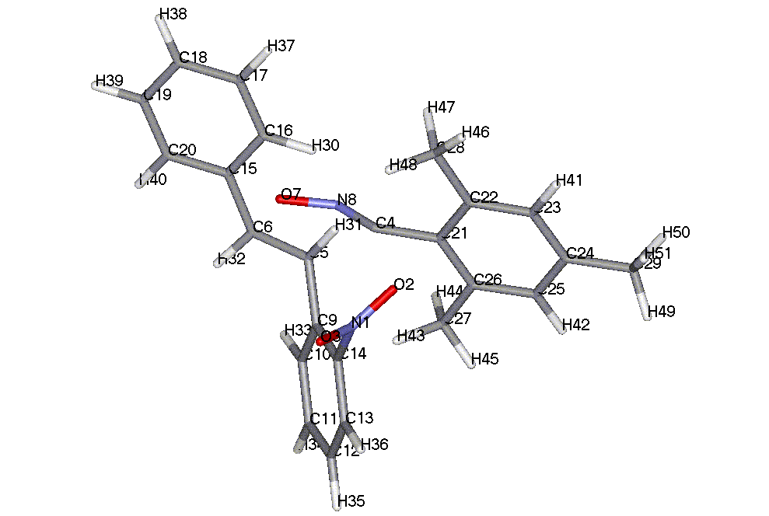

TOTAL ENERGY = -4380.12411 EV

ATOM CHEMICAL BOND LENGTH BOND ANGLE TWIST ANGLE
NUMBER SYMBOL (ANGSTROMS) (DEGREES) (DEGREES)
(I) NA:I NB:NA:I NC:NB:NA:I NA NB NC

1 N
2 O 1.21503 * 1
3 O 1.21434 * 121.16122 * 1 2
4 C 4.21118 * 94.35435 * -150.70898 * 2 1 3
5 C 2.14719 * 47.31445 * 35.96395 * 4 2 1
6 C 1.39790 * 102.39034 * 160.14069 * 5 4 2
7 O 2.03978 * 101.54256 * 7.54813 * 6 5 4
8 N 1.23199 * 102.73968 * -8.96273 * 7 6 5
9 C 1.46740 * 101.91972 * 117.08280 * 5 4 7
10 C 1.40372 * 119.80601 * 46.78210 * 9 5 6
11 C 1.38579 * 121.29516 * -179.69363 * 10 9 5
12 C 1.39276 * 120.12157 * .49656 * 11 10 9
13 C 1.38550 * 119.70919 * .82242 * 12 11 10
14 C 1.40104 * 120.38528 * -.92371 * 13 12 11
15 C 1.46774 * 120.87848 * 150.42042 * 6 5 9
16 C 1.39874 * 121.60237 * 10.59210 * 15 6 5
17 C 1.38853 * 120.43176 * -179.18985 * 16 15 6
18 C 1.39109 * 120.07663 * -.04881 * 17 16 15
19 C 1.39130 * 119.88645 * -.01275 * 18 17 16
20 C 1.38936 * 120.24948 * .03542 * 19 18 17
21 C 3.97801 * 107.73066 * -165.68698 * 2 1 3
22 C 1.40675 * 67.47331 * 172.13824 * 21 2 1
23 C 1.39435 * 119.47305 * 104.50416 * 22 21 2
24 C 1.39379 * 120.69869 * .19660 * 23 22 21
25 C 1.39468 * 119.65471 * -.20035 * 24 23 22
26 C 1.39339 * 120.70798 * -.06894 * 25 24 23
27 C 1.48639 * 119.06984 * 179.74160 * 26 25 24
28 C 1.48586 * 121.36225 * -179.90145 * 22 21 26
29 C 1.48548 * 120.13775 * 179.36814 * 24 23 22
30 H 1.10629 * 119.00663 * 179.90622 * 16 15 20
31 H 1.11283 * 88.22320 * -124.35727 * 5 4 8
32 H 1.10458 * 119.24167 * -5.02674 * 6 5 9
33 H 1.09782 * 119.25901 * 178.18379 * 10 9 14
34 H 1.09556 * 119.92409 * -179.59148 * 11 10 9
35 H 1.09512 * 120.21025 * -179.75606 * 12 11 10
36 H 1.09792 * 119.22062 * 178.35350 * 13 12 11
37 H 1.09487 * 119.84267 * .02403 * 17 16 30
38 H 1.09476 * 120.05463 * 179.95742 * 18 17 16
39 H 1.09494 * 119.92750 * -179.89584 * 19 18 17
40 H 1.09617 * 119.91885 * -179.58924 * 20 19 18
41 H 1.09741 * 119.68573 * -179.22560 * 23 22 21
42 H 1.09727 * 119.56312 * -179.76105 * 25 24 23
43 H 1.10096 * 111.29077 * 135.08418 * 27 26 25
44 H 1.09866 * 110.68440 * -105.10199 * 27 26 25
45 H 1.09834 * 112.07707 * 14.72387 * 27 26 25
46 H 1.09797 * 112.17163 * -14.30233 * 28 22 23
47 H 1.09855 * 110.70389 * 106.03846 * 28 22 23
48 H 1.10830 * 111.30822 * -134.52901 * 28 22 23
49 H 1.09806 * 111.91866 * 152.55964 * 29 24 23
50 H 1.09879 * 110.28353 * -87.78204 * 29 24 23
51 H 1.09814 * 111.75987 * 31.77970 * 29 24 23

TS for compound 17b

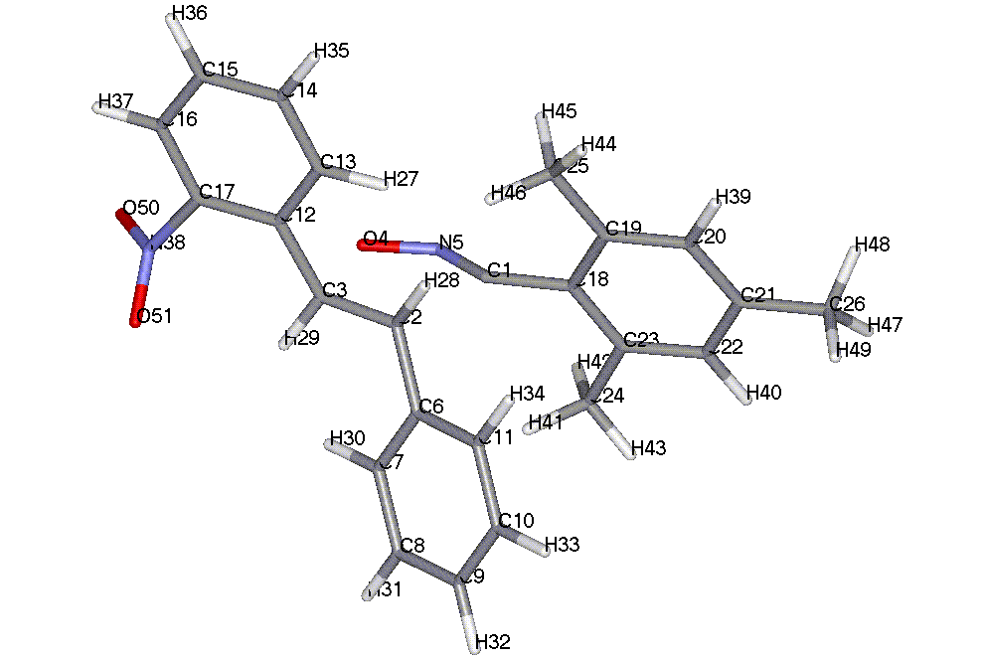

TOTAL ENERGY = -4380.14666 EV

ATOM CHEMICAL BOND LENGTH BOND ANGLE TWIST ANGLE
NUMBER SYMBOL (ANGSTROMS) (DEGREES) (DEGREES)
(I) NA:I NB:NA:I NC:NB:NA:I NA NB NC

1 C
2 C 2.10669 * 1
3 C 1.39757 * 102.52561 * 2 1
4 O 2.07685 * 101.56692 * 6.11437 * 3 2 1
5 N 1.22529 * 101.03593 * -6.49401 * 4 3 2
6 C 1.46908 * 100.32642 * 118.41553 * 2 1 4
7 C 1.39899 * 121.38674 * 18.12408 * 6 2 3
8 C 1.38875 * 120.39232 * -179.25246 * 7 6 2
9 C 1.39120 * 120.11346 * .32832 * 8 7 6
10 C 1.39105 * 119.85543 * .16136 * 9 8 7
11 C 1.38952 * 120.25124 * -.34365 * 10 9 8
12 C 1.46621 * 121.63509 * 151.89515 * 3 2 6
13 C 1.40368 * 119.52872 * 8.82729 * 12 3 2
14 C 1.38529 * 121.56569 * -179.64912 * 13 12 3
15 C 1.39181 * 119.97222 * -.46259 * 14 13 12
16 C 1.38662 * 119.69755 * -.20721 * 15 14 13
17 C 1.40031 * 120.55666 * .66495 * 16 15 14
18 C 1.43131 * 116.74640 * 173.08153 * 1 2 3
19 C 1.40620 * 119.60673 * 105.13607 * 18 1 5
20 C 1.39360 * 119.46692 * -179.19906 * 19 18 1
21 C 1.39465 * 120.62044 * -.34896 * 20 19 18
22 C 1.39432 * 119.70729 * -.62741 * 21 20 19
23 C 1.39411 * 120.69841 * .37379 * 22 21 20
24 C 1.48621 * 119.48270 * -178.84798 * 23 22 21
25 C 1.48645 * 121.15793 * -178.30429 * 19 18 23
26 C 1.48554 * 120.14363 * -179.68877 * 21 20 19
27 H 1.10718 * 118.69424 * -179.10182 * 13 12 17
28 H 1.11288 * 90.51206 * -125.69121 * 2 1 5
29 H 1.10901 * 116.23521 * -6.13863 * 3 2 6
30 H 1.10137 * 118.90006 * 177.80179 * 7 6 11
31 H 1.09498 * 119.79516 * 179.89926 * 8 7 6
32 H 1.09466 * 120.07163 * 179.83768 * 9 8 7
33 H 1.09485 * 119.95458 * 179.61402 * 10 9 8
34 H 1.09608 * 119.88510 * -179.67787 * 11 10 9
35 H 1.09539 * 119.98466 * -.54414 * 14 13 27
36 H 1.09516 * 120.25463 * -179.87529 * 15 14 13
37 H 1.09843 * 119.09154 * -178.76040 * 16 15 14
38 N 1.50150 * 116.70560 * -179.76386 * 17 16 15
39 H 1.09725 * 119.77569 * 179.65012 * 20 19 18
40 H 1.09739 * 119.60138 * -179.33148 * 22 21 20
41 H 1.10089 * 110.91580 * 133.14712 * 24 23 22
42 H 1.09856 * 110.85398 * -107.08677 * 24 23 22
43 H 1.09823 * 112.09764 * 12.90992 * 24 23 22
44 H 1.09785 * 112.18922 * -15.61848 * 25 19 20
45 H 1.09850 * 110.69177 * 104.57226 * 25 19 20
46 H 1.10909 * 111.28471 * -136.14742 * 25 19 20
47 H 1.09810 * 111.82264 * 30.46353 * 26 21 22
48 H 1.09809 * 111.86574 * 151.26524 * 26 21 22
49 H 1.09881 * 110.28514 * -89.11470 * 26 21 22
50 O 1.21347 * 118.90521 * 52.78814 * 38 17 16
51 O 1.21568 * 119.73994 * -124.49831 * 38 17 16

TS for compound 18a

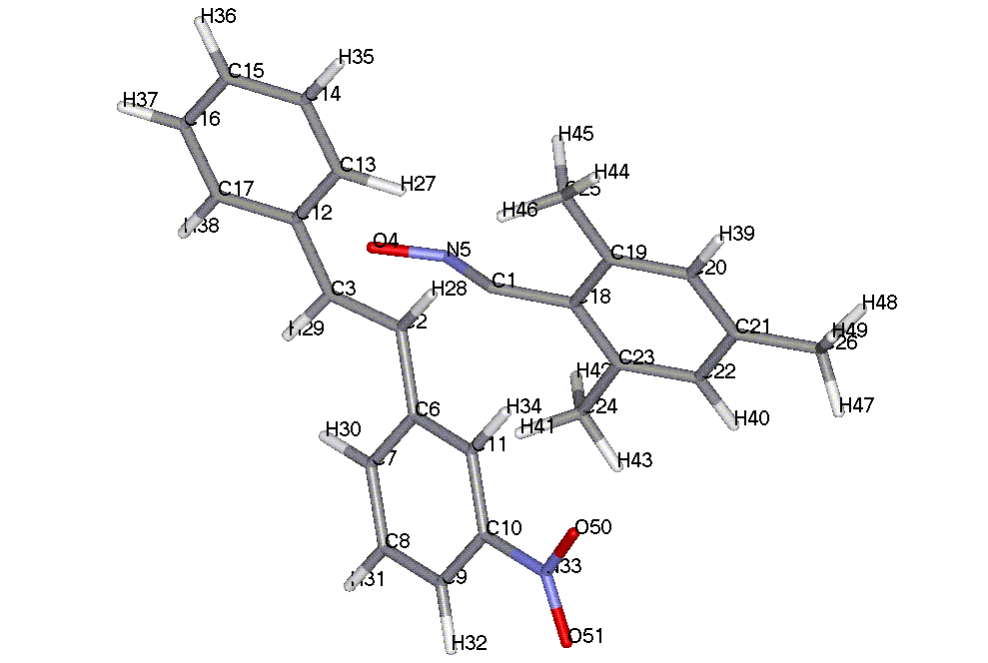

TOTAL ENERGY = -4380.31418 EV

ATOM CHEMICAL BOND LENGTH BOND ANGLE TWIST ANGLE
NUMBER SYMBOL (ANGSTROMS) (DEGREES) (DEGREES)
(I) NA:I NB:NA:I NC:NB:NA:I NA NB NC

1 C
2 C 2.12806 * 1
3 C 1.39637 * 102.61175 * 2 1
4 O 2.06694 * 101.36151 * 7.07707 * 3 2 1
5 N 1.22828 * 101.78094 * -8.05220 * 4 3 2
6 C 1.46564 * 100.04603 * 117.68624 * 2 1 4
7 C 1.39915 * 121.31045 * 17.59404 * 6 2 3
8 C 1.38871 * 120.46917 * -179.53202 * 7 6 2
9 C 1.38920 * 120.41967 * .32487 * 8 7 6
10 C 1.40004 * 119.60352 * .23763 * 9 8 7
11 C 1.39795 * 120.11951 * -.36508 * 10 9 8
12 C 1.46441 * 121.19238 * 151.57693 * 3 2 6
13 C 1.39916 * 121.38283 * 10.78557 * 12 3 2
14 C 1.38834 * 120.43510 * -179.30797 * 13 12 3
15 C 1.39119 * 120.06150 * -.01541 * 14 13 12
16 C 1.39134 * 119.89545 * -.03230 * 15 14 13
17 C 1.38938 * 120.26506 * .02155 * 16 15 14
18 C 1.43004 * 116.52946 * 172.33439 * 1 2 3
19 C 1.40646 * 119.74769 * 105.72666 * 18 1 5
20 C 1.39382 * 119.46077 * -179.92042 * 19 18 1
21 C 1.39453 * 120.67593 * -.02153 * 20 19 18
22 C 1.39461 * 119.66955 * -.56747 * 21 20 19
23 C 1.39371 * 120.68695 * .28147 * 22 21 20
24 C 1.48652 * 119.32070 * -179.41408 * 23 22 21
25 C 1.48623 * 121.24951 * -179.05406 * 19 18 23
26 C 1.48537 * 120.14085 * 179.24321 * 21 20 19
27 H 1.10607 * 118.86410 * 179.98363 * 13 12 17
28 H 1.11282 * 90.25062 * -125.36650 * 2 1 5
29 H 1.10869 * 118.30447 * -5.66306 * 3 2 6
30 H 1.10185 * 118.61032 * 178.14291 * 7 6 11
31 H 1.09557 * 119.85121 * -179.88019 * 8 7 6
32 H 1.09869 * 119.61454 * -179.81768 * 9 8 7
33 N 1.49594 * 119.96316 * 179.71536 * 10 9 8
34 H 1.10045 * 120.67055 * -179.81462 * 11 10 9
35 H 1.09479 * 119.88429 * .06816 * 14 13 27
36 H 1.09475 * 120.04807 * -179.99553 * 15 14 13
37 H 1.09497 * 119.91281 * -179.84664 * 16 15 14
38 H 1.09607 * 119.97045 * -179.50179 * 17 16 15
39 H 1.09743 * 119.75286 * -179.72401 * 20 19 18
40 H 1.09748 * 119.58327 * -179.33198 * 22 21 20
41 H 1.09999 * 111.14342 * 135.21702 * 24 23 22
42 H 1.09865 * 110.73791 * -105.02850 * 24 23 22
43 H 1.09835 * 112.07968 * 14.85747 * 24 23 22
44 H 1.09793 * 112.19276 * -15.25752 * 25 19 20
45 H 1.09858 * 110.63540 * 104.90625 * 25 19 20
46 H 1.10884 * 111.41307 * -135.83801 * 25 19 20
47 H 1.09814 * 111.88288 * 151.52361 * 26 21 20
48 H 1.09880 * 110.25502 * -88.83756 * 26 21 20
49 H 1.09815 * 111.80558 * 30.75747 * 26 21 20
50 O 1.21568 * 119.60660 * 12.22752 * 33 10 11
51 O 1.21588 * 119.48561 * -167.70771 * 33 10 11

TS for compound 18b

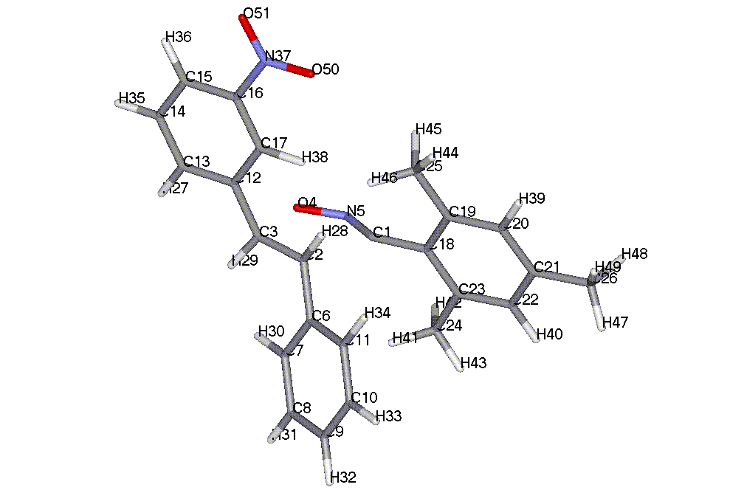

TOTAL ENERGY = -4380.33461 EV

ATOM CHEMICAL BOND LENGTH BOND ANGLE TWIST ANGLE
NUMBER SYMBOL (ANGSTROMS) (DEGREES) (DEGREES)
(I) NA:I NB:NA:I NC:NB:NA:I NA NB NC

1 C
2 C 2.11147 * 1
3 C 1.39600 * 102.61259 * 2 1
4 O 2.07657 * 101.50777 * 6.24074 * 3 2 1
5 N 1.22781 * 101.20149 * -6.81012 * 4 3 2
6 C 1.46772 * 100.22872 * 118.24766 * 2 1 4
7 C 1.39907 * 121.20564 * 19.27127 * 6 2 3
8 C 1.38857 * 120.41902 * -179.28573 * 7 6 2
9 C 1.39121 * 120.08219 * .35903 * 8 7 6
10 C 1.39111 * 119.85905 * .11270 * 9 8 7
11 C 1.38963 * 120.28052 * -.32120 * 10 9 8
12 C 1.46401 * 121.41185 * 151.36606 * 3 2 6
13 C 1.40066 * 119.42594 * -168.00416 * 12 3 2
14 C 1.38914 * 120.18961 * 179.41041 * 13 12 3
15 C 1.38969 * 120.60128 * .07027 * 14 13 12
16 C 1.39989 * 119.64064 * .06747 * 15 14 13
17 C 1.39707 * 121.22530 * 11.63550 * 12 3 2
18 C 1.43084 * 116.51665 * 173.02337 * 1 2 3
19 C 1.40626 * 119.65757 * 104.98919 * 18 1 5
20 C 1.39402 * 119.40681 * -179.17935 * 19 18 1
21 C 1.39435 * 120.65673 * -.25240 * 20 19 18
22 C 1.39463 * 119.71132 * -.91347 * 21 20 19
23 C 1.39371 * 120.67510 * .66218 * 22 21 20
24 C 1.48631 * 119.47288 * -178.92933 * 23 22 21
25 C 1.48618 * 121.26990 * -178.16880 * 19 18 23
26 C 1.48551 * 120.13842 * 178.86842 * 21 20 19
27 H 1.09690 * 119.78743 * 179.39961 * 13 12 17
28 H 1.11342 * 90.38725 * -125.10331 * 2 1 5
29 H 1.10853 * 118.13887 * -6.29633 * 3 2 6
30 H 1.10070 * 118.73189 * 178.14677 * 7 6 11
31 H 1.09480 * 119.85490 * -179.90805 * 8 7 6
32 H 1.09464 * 120.06620 * 179.89152 * 9 8 7
33 H 1.09494 * 119.94253 * 179.70344 * 10 9 8
34 H 1.09623 * 119.95871 * -179.60716 * 11 10 9
35 H 1.09575 * 119.83665 * .28946 * 14 13 27
36 H 1.09885 * 119.56811 * -179.94093 * 15 14 13
37 N 1.49451 * 120.15904 * 179.87827 * 16 15 14
38 H 1.11161 * 118.23294 * -179.74224 * 17 12 13
39 H 1.09745 * 119.68073 * 179.84831 * 20 19 18
40 H 1.09730 * 119.60793 * -178.95843 * 22 21 20
41 H 1.10091 * 110.92192 * 133.14424 * 24 23 22
42 H 1.09852 * 110.84564 * -107.08668 * 24 23 22
43 H 1.09822 * 112.09488 * 12.90374 * 24 23 22
44 H 1.09810 * 112.32745 * -16.16261 * 25 19 20
45 H 1.09857 * 110.74706 * 104.00728 * 25 19 20
46 H 1.10892 * 111.41027 * -136.65488 * 25 19 20
47 H 1.09809 * 111.87863 * 150.66356 * 26 21 20
48 H 1.09882 * 110.23330 * -89.74703 * 26 21 20
49 H 1.09811 * 111.86091 * 29.81994 * 26 21 20
50 O 1.21699 * 119.46081 * 3.55473 * 37 16 17
51 O 1.21507 * 119.69802 * -176.44919 * 37 16 17

TS for compound 19a

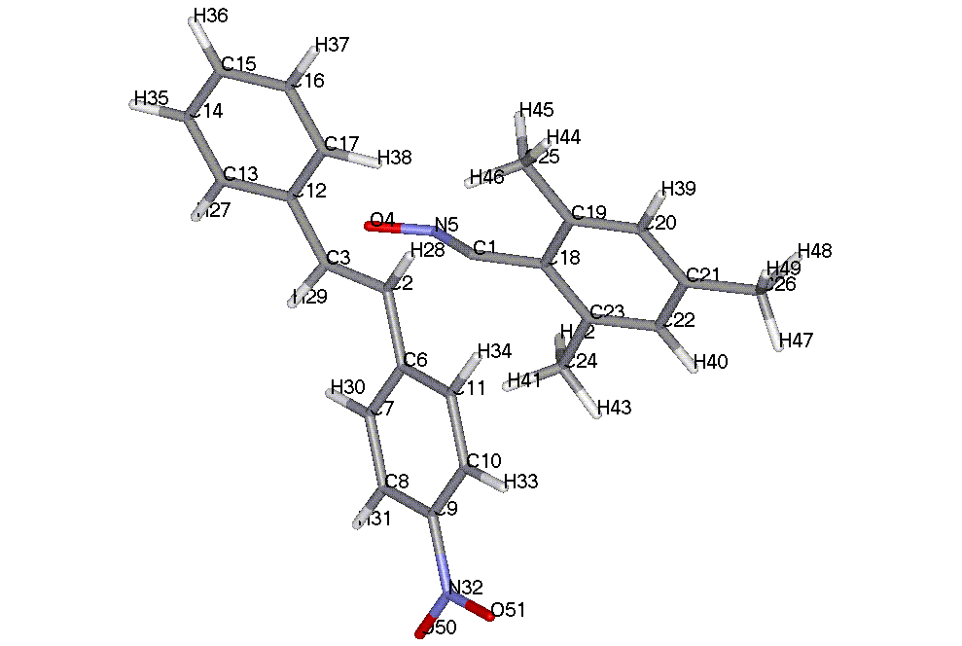

TOTAL ENERGY = -4380.34363 EV

ATOM CHEMICAL BOND LENGTH BOND ANGLE TWIST ANGLE
NUMBER SYMBOL (ANGSTROMS) (DEGREES) (DEGREES)
(I) NA:I NB:NA:I NC:NB:NA:I NA NB NC

1 C
2 C 2.13738 * 1
3 C 1.39746 * 102.53849 * 2 1
4 O 2.05339 * 101.46352 * 6.81493 * 3 2 1
5 N 1.22919 * 102.20791 * -7.72605 * 4 3 2
6 C 1.46216 * 99.72008 * 117.87164 * 2 1 4
7 C 1.40092 * 121.35664 * 17.28543 * 6 2 3
8 C 1.38519 * 120.84370 * -179.42389 * 7 6 2
9 C 1.40134 * 119.96345 * .28116 * 8 7 6
10 C 1.40134 * 119.53420 * .32132 * 9 8 7
11 C 1.38615 * 120.14571 * -.45077 * 10 9 8
12 C 1.46491 * 121.08344 * 151.50786 * 3 2 6
13 C 1.39968 * 119.42220 * -168.01416 * 12 3 2
14 C 1.38947 * 120.14977 * 179.34222 * 13 12 3
15 C 1.39132 * 120.26292 * .04468 * 14 13 12
16 C 1.39126 * 119.90537 * .01647 * 15 14 13
17 C 1.38831 * 120.05330 * -.02954 * 16 15 14
18 C 1.42946 * 116.58491 * 172.20627 * 1 2 3
19 C 1.40649 * 119.69099 * 104.93408 * 18 1 5
20 C 1.39378 * 119.45269 * -179.61292 * 19 18 1
21 C 1.39455 * 120.65867 * -.09010 * 20 19 18
22 C 1.39456 * 119.68938 * -.69508 * 21 20 19
23 C 1.39381 * 120.69104 * .45228 * 22 21 20
24 C 1.48637 * 119.36498 * -179.43302 * 23 22 21
25 C 1.48624 * 121.22562 * -178.86922 * 19 18 23
26 C 1.48542 * 120.18864 * 179.00717 * 21 20 19
27 H 1.09617 * 119.87279 * 179.47072 * 13 12 17
28 H 1.11257 * 90.14863 * -125.14277 * 2 1 5
29 H 1.10925 * 118.20570 * -5.20103 * 3 2 6
30 H 1.10175 * 118.57412 * 178.10539 * 7 6 11
31 H 1.09903 * 119.36504 * -179.88352 * 8 7 6
32 N 1.49150 * 120.23584 * -179.84917 * 9 8 7
33 H 1.09909 * 120.55959 * 179.58432 * 10 9 8
34 H 1.09683 * 119.67295 * -179.59850 * 11 10 9
35 H 1.09503 * 119.81879 * .35192 * 14 13 27
36 H 1.09480 * 120.05299 * 179.97553 * 15 14 13
37 H 1.09478 * 120.05044 * 179.96056 * 16 15 14
38 H 1.10605 * 120.71239 * -179.93212 * 17 16 15
39 H 1.09739 * 119.74177 * 179.95750 * 20 19 18
40 H 1.09751 * 119.58663 * -179.21939 * 22 21 20
41 H 1.10009 * 111.12644 * 135.27478 * 24 23 22
42 H 1.09867 * 110.74166 * -104.97384 * 24 23 22
43 H 1.09834 * 112.08280 * 14.91901 * 24 23 22
44 H 1.09790 * 112.19924 * -15.50377 * 25 19 20
45 H 1.09861 * 110.63358 * 104.62865 * 25 19 20
46 H 1.10898 * 111.41499 * -136.11993 * 25 19 20
47 H 1.09815 * 111.83063 * 149.54598 * 26 21 20
48 H 1.09884 * 110.23043 * -90.89929 * 26 21 20
49 H 1.09810 * 111.90608 * 28.70667 * 26 21 20
50 O 1.21634 * 119.60773 * .91205 * 32 9 8
51 O 1.21640 * 119.62272 * -179.31151 * 32 9 8

TS for compound 19b

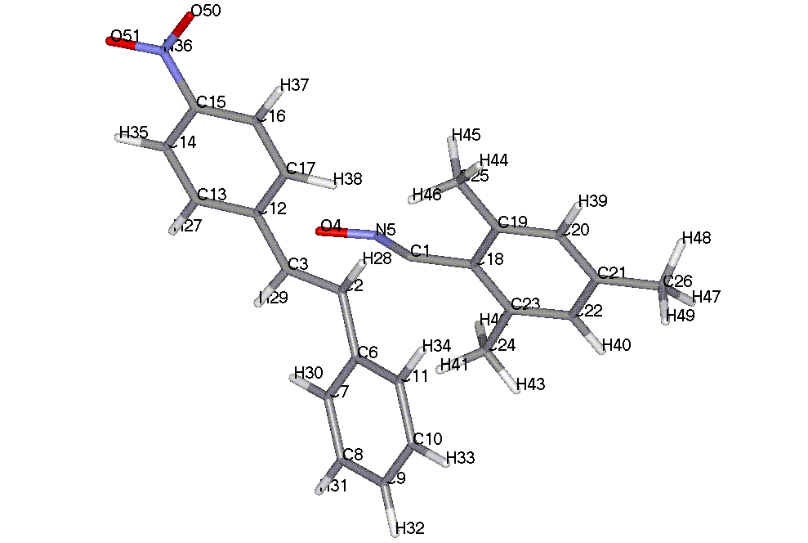

TOTAL ENERGY = -4380.32693 EV

ATOM CHEMICAL BOND LENGTH BOND ANGLE TWIST ANGLE
NUMBER SYMBOL (ANGSTROMS) (DEGREES) (DEGREES)
(I) NA:I NB:NA:I NC:NB:NA:I NA NB NC

1 C
2 C 2.10672 * 1
3 C 1.39688 * 102.59407 * 2 1
4 O 2.07766 * 101.51458 * 6.27629 * 3 2 1
5 N 1.22600 * 101.01910 * -6.76646 * 4 3 2
6 C 1.46794 * 100.34982 * 118.25691 * 2 1 4
7 C 1.39905 * 121.17791 * 19.15343 * 6 2 3
8 C 1.38859 * 120.40995 * -179.27699 * 7 6 2
9 C 1.39127 * 120.08043 * .35976 * 8 7 6
10 C 1.39110 * 119.86682 * .11881 * 9 8 7
11 C 1.38965 * 120.26993 * -.33035 * 10 9 8
12 C 1.46246 * 121.24074 * 151.54788 * 3 2 6
13 C 1.40059 * 119.59748 * -168.00955 * 12 3 2
14 C 1.38680 * 120.53754 * 179.49604 * 13 12 3
15 C 1.40111 * 120.12420 * -.09469 * 14 13 12
16 C 1.40073 * 119.60029 * .06323 * 15 14 13
17 C 1.38550 * 119.93285 * -.06598 * 16 15 14
18 C 1.43119 * 116.68384 * 172.88901 * 1 2 3
19 C 1.40624 * 119.61518 * 104.79443 * 18 1 5
20 C 1.39365 * 119.45804 * -179.17756 * 19 18 1
21 C 1.39462 * 120.62712 * -.34625 * 20 19 18
22 C 1.39441 * 119.70664 * -.62694 * 21 20 19
23 C 1.39400 * 120.69300 * .38071 * 22 21 20
24 C 1.48625 * 119.47151 * -178.90948 * 23 22 21
25 C 1.48638 * 121.17574 * -178.32982 * 19 18 23
26 C 1.48551 * 120.13886 * -179.69946 * 21 20 19
27 H 1.09685 * 119.75975 * 179.56574 * 13 12 17
28 H 1.11341 * 90.48771 * -125.09479 * 2 1 5
29 H 1.10863 * 118.17334 * -6.26743 * 3 2 6
30 H 1.10081 * 118.74009 * 178.09723 * 7 6 11
31 H 1.09487 * 119.85432 * -179.93323 * 8 7 6
32 H 1.09470 * 120.06244 * 179.87270 * 9 8 7
33 H 1.09495 * 119.94272 * 179.67047 * 10 9 8
34 H 1.09611 * 119.94683 * -179.63675 * 11 10 9
35 H 1.09919 * 119.31683 * .39846 * 14 13 27
36 N 1.49306 * 120.23849 * 179.98554 * 15 14 13
37 H 1.09891 * 120.68247 * 179.92079 * 16 15 14
38 H 1.10710 * 120.47515 * -179.85019 * 17 16 15
39 H 1.09733 * 119.76369 * 179.63295 * 20 19 18
40 H 1.09738 * 119.59841 * -179.35294 * 22 21 20
41 H 1.10088 * 110.93795 * 133.50298 * 24 23 22
42 H 1.09855 * 110.83678 * -106.71975 * 24 23 22
43 H 1.09824 * 112.08896 * 13.25753 * 24 23 22
44 H 1.09788 * 112.19767 * -15.81721 * 25 19 20
45 H 1.09855 * 110.70248 * 104.36946 * 25 19 20
46 H 1.10900 * 111.28191 * -136.34338 * 25 19 20
47 H 1.09810 * 111.83217 * 30.27537 * 26 21 22
48 H 1.09810 * 111.85692 * 151.07944 * 26 21 22
49 H 1.09881 * 110.28259 * -89.31075 * 26 21 22
50 O 1.21638 * 119.52580 * 2.25237 * 36 15 16
51 O 1.21585 * 119.62808 * -177.66469 * 36 15 16

AM1 calculations

Total energies and Z-matrix for transition states 12-19

The TS have the same numbers as used for PM3 calculations.
TS for compound 12a

TOTAL ENERGY = -4132.99499 EV

ATOM CHEMICAL BOND LENGTH BOND ANGLE TWIST ANGLE
NUMBER SYMBOL (ANGSTROMS) (DEGREES) (DEGREES)
(I) NA:I NB:NA:I NC:NB:NA:I NA NB NC

1 C
2 C 2.08077 * 1
3 C 1.39915 * 101.37988 * 2 1
4 O 2.10410 * 99.54470 * 14.62911 * 3 2 1
5 N 1.20461 * 104.43000 * -16.67329 * 4 3 2
6 C 1.46532 * 101.51938 * 123.15295 * 2 1 3
7 C 1.40267 * 119.18616 * -70.54998 * 6 2 1
8 C 1.38972 * 121.71130 * -177.68627 * 7 6 2
9 C 1.39432 * 119.54181 * -.22932 * 8 7 6
10 C 1.38727 * 120.22239 * -.47963 * 9 8 7
11 C 1.41714 * 121.06158 * .81927 * 10 9 8
12 C 1.45770 * 123.05779 * -90.04367 * 3 2 1
13 C 1.40249 * 121.93981 * -24.94178 * 12 3 2
14 C 1.39373 * 120.39765 * -177.99621 * 13 12 3
15 C 1.39421 * 120.26372 * -.17153 * 14 13 12
16 C 1.39528 * 119.78280 * .10667 * 15 14 13
17 C 1.39210 * 120.16218 * .10509 * 16 15 14
18 C 1.42959 * 115.51459 * 163.76510 * 1 2 3
19 C 1.40992 * 119.76140 * -78.05872 * 18 1 2
20 C 1.39764 * 119.47747 * 177.59945 * 19 18 1
21 C 1.39761 * 120.88256 * .83918 * 20 19 18
22 C 1.39806 * 119.37235 * .46570 * 21 20 19
23 C 1.39702 * 120.86653 * -.73262 * 22 21 20
24 C 1.48137 * 119.73554 * 178.45803 * 23 22 21
25 C 1.48221 * 121.37842 * -3.99154 * 19 18 1
26 C 1.48123 * 120.41494 * -179.31557 * 21 20 19
27 H 1.10026 * 120.18988 * .86758 * 13 12 3
28 H 1.10461 * 89.56937 * -118.52283 * 2 1 3
29 H 1.10539 * 120.07346 * 103.46716 * 3 2 1
30 H 1.10324 * 118.72635 * 2.85990 * 7 6 2
31 H 1.09892 * 120.14050 * 179.69890 * 8 7 6
32 H 1.10020 * 120.06747 * 179.74576 * 9 8 7
33 H 1.10085 * 119.19713 * -179.89576 * 10 9 8
34 N 1.40154 * 119.13526 * 175.47428 * 11 10 9
35 H 1.09984 * 119.75134 * 179.66274 * 14 13 12
36 H 1.09964 * 120.10880 * -179.94378 * 15 14 13
37 H 1.09996 * 120.01234 * -179.77247 * 16 15 14
38 H 1.10163 * 120.44110 * -178.68354 * 17 16 15
39 H 1.10075 * 119.43240 * -179.71356 * 20 19 18
40 H 1.10081 * 119.60133 * 179.07372 * 22 21 20
41 H 1.12095 * 110.66772 * 138.79384 * 24 23 22
42 H 1.11967 * 109.73121 * -101.87107 * 24 23 22
43 H 1.11746 * 111.22994 * 18.02309 * 24 23 22
44 H 1.11798 * 110.93450 * 150.73672 * 25 19 18
45 H 1.12026 * 109.41547 * -89.99524 * 25 19 18
46 H 1.11936 * 111.76323 * 29.43223 * 25 19 18
47 H 1.11800 * 110.88472 * -146.19041 * 26 21 20
48 H 1.11773 * 111.12441 * -25.44927 * 26 21 20
49 H 1.11955 * 109.80764 * 94.29667 * 26 21 20
50 H .99741 * 113.49812 * 21.27881 * 34 11 10
51 H .99624 * 114.43823 * 151.83788 * 34 11 10

TS for compound 12b

TOTAL ENERGY = -4133.16621 EV

ATOM CHEMICAL BOND LENGTH BOND ANGLE TWIST ANGLE
NUMBER SYMBOL (ANGSTROMS) (DEGREES) (DEGREES)
(I) NA:I NB:NA:I NC:NB:NA:I NA NB NC

1 C
2 C 2.04150 * 1
3 C 1.39792 * 102.67838 * 2 1
4 O 2.18852 * 98.20474 * 14.16266 * 3 2 1
5 N 1.20334 * 102.15210 * -16.07667 * 4 3 2
6 C 1.46583 * 100.73392 * 109.67076 * 2 1 4
7 C 1.40289 * 121.64750 * 39.77571 * 6 2 3
8 C 1.39303 * 120.40040 * -178.47679 * 7 6 2
9 C 1.39478 * 120.23923 * -.20963 * 8 7 6
10 C 1.39461 * 119.73854 * -.22126 * 9 8 7
11 C 1.39312 * 120.23411 * .28278 * 10 9 8
12 C 1.45040 * 123.99715 * 158.90413 * 3 2 6
13 C 1.40497 * 120.49593 * -17.91580 * 12 3 2
14 C 1.38711 * 121.90043 * -177.23157 * 13 12 3
15 C 1.39688 * 119.59159 * -.31777 * 14 13 12
16 C 1.38416 * 120.30457 * -.29426 * 15 14 13
17 C 1.42055 * 121.01731 * .53923 * 16 15 14
18 C 1.43111 * 114.31195 * 165.78393 * 1 2 3
19 C 1.40823 * 120.36925 * 109.67286 * 18 1 5
20 C 1.39852 * 119.46594 * 179.27396 * 19 18 1
21 C 1.39676 * 120.92298 * .33307 * 20 19 18
22 C 1.39879 * 119.36503 * -.00651 * 21 20 19
23 C 1.39595 * 120.82455 * -.19656 * 22 21 20
24 C 1.48163 * 119.93228 * 179.34604 * 23 22 21
25 C 1.48226 * 121.73849 * 179.94832 * 19 18 23
26 C 1.48120 * 120.47161 * 179.27398 * 21 20 19
27 H 1.10168 * 119.45078 * 179.89467 * 13 12 17
28 H 1.10762 * 90.74739 * -135.70615 * 2 1 5
29 H 1.10587 * 117.96003 * -9.44526 * 3 2 6
30 H 1.10145 * 119.53379 * -178.80991 * 7 6 11
31 H 1.09993 * 119.76688 * 179.78865 * 8 7 6
32 H 1.09934 * 120.13149 * 179.85675 * 9 8 7
33 H 1.09988 * 119.98489 * -179.79547 * 10 9 8
34 H 1.10002 * 119.82609 * 179.98742 * 11 10 9
35 H 1.09872 * 120.26828 * .33049 * 14 13 27
36 H 1.10064 * 119.89765 * 179.93026 * 15 14 13
37 H 1.10081 * 119.37750 * -179.67778 * 16 15 14
38 N 1.39121 * 119.38335 * 176.71526 * 17 16 15
39 H 1.10066 * 119.31199 * -179.87789 * 20 19 18
40 H 1.10073 * 119.56583 * 179.91415 * 22 21 20
41 H 1.12120 * 110.38286 * 134.66673 * 24 23 22
42 H 1.11946 * 109.93585 * -106.04183 * 24 23 22
43 H 1.11737 * 111.25802 * 14.05898 * 24 23 22
44 H 1.12016 * 109.81634 * -76.50742 * 25 19 20
45 H 1.11851 * 110.42267 * 42.63629 * 25 19 20
46 H 1.11876 * 111.74784 * 163.43481 * 25 19 20
47 H 1.11798 * 110.86479 * -35.14923 * 26 21 22
48 H 1.11961 * 109.78484 * 84.34958 * 26 21 22
49 H 1.11766 * 111.14493 * -155.91129 * 26 21 22
50 H .99599 * 114.49592 * 20.60844 * 38 17 16
51 H .99778 * 115.40628 * 154.87112 * 38 17 16

TS for compound 13a

TOTAL ENERGY = -4133.06017 EV

ATOM CHEMICAL BOND LENGTH BOND ANGLE TWIST ANGLE
NUMBER SYMBOL (ANGSTROMS) (DEGREES) (DEGREES)
(I) NA:I NB:NA:I NC:NB:NA:I NA NB NC

1 C
2 C 2.08439 * 1
3 C 1.39702 * 101.64920 * 2 1
4 O 2.10387 * 99.75340 * 13.02422 * 3 2 1
5 N 1.20399 * 104.41674 * -14.79812 * 4 3 2
6 C 1.46490 * 100.92418 * 111.42534 * 2 1 4
7 C 1.40235 * 121.52056 * 35.75696 * 6 2 3
8 C 1.39184 * 119.91848 * -178.13818 * 7 6 2
9 C 1.38993 * 120.99963 * -.31501 * 8 7 6
10 C 1.41412 * 120.02113 * .19686 * 9 8 7
11 C 1.39877 * 118.85737 * -143.03151 * 6 2 3
12 C 1.45718 * 123.29855 * 158.57015 * 3 2 6
13 C 1.40241 * 122.14922 * -21.33798 * 12 3 2
14 C 1.39375 * 120.40985 * -178.12312 * 13 12 3
15 C 1.39416 * 120.27227 * -.18895 * 14 13 12
16 C 1.39534 * 119.77781 * .03269 * 15 14 13
17 C 1.39195 * 120.15352 * .15193 * 16 15 14
18 C 1.42932 * 115.77082 * 165.90395 * 1 2 3
19 C 1.40937 * 119.97656 * 101.62158 * 18 1 5
20 C 1.39789 * 119.43638 * 177.92521 * 19 18 1
21 C 1.39744 * 120.90198 * .74931 * 20 19 18
22 C 1.39822 * 119.39174 * .37542 * 21 20 19
23 C 1.39666 * 120.82937 * -.68672 * 22 21 20
24 C 1.48143 * 119.88366 * 178.79853 * 23 22 21
25 C 1.48216 * 121.49338 * 176.98194 * 19 18 23
26 C 1.48126 * 120.31153 * -179.32535 * 21 20 19
27 H 1.10020 * 120.22822 * 179.29871 * 13 12 17
28 H 1.10628 * 90.65313 * -133.70100 * 2 1 5
29 H 1.10576 * 119.83311 * -8.11483 * 3 2 6
30 H 1.10030 * 119.85034 * -178.70051 * 7 6 11
31 H 1.10085 * 119.60734 * 179.75699 * 8 7 6
32 H 1.09962 * 119.69584 * 179.64494 * 9 8 7
33 N 1.40097 * 120.66876 * 175.75393 * 10 9 8
34 H 1.10050 * 119.30370 * 179.80273 * 11 6 7
35 H 1.09985 * 119.74697 * .57073 * 14 13 27
36 H 1.09964 * 120.11473 * -179.95262 * 15 14 13
37 H 1.09995 * 120.01014 * -179.68112 * 16 15 14
38 H 1.10149 * 120.41662 * -178.59144 * 17 16 15
39 H 1.10068 * 119.41520 * -179.66729 * 20 19 18
40 H 1.10071 * 119.62236 * 179.17134 * 22 21 20
41 H 1.12133 * 110.50672 * 136.15313 * 24 23 22
42 H 1.11957 * 109.81792 * -104.56766 * 24 23 22
43 H 1.11735 * 111.26882 * 15.42140 * 24 23 22
44 H 1.11807 * 110.82340 * -33.76521 * 25 19 20
45 H 1.12015 * 109.45714 * 85.48536 * 25 19 20
46 H 1.11910 * 111.76644 * -154.95604 * 25 19 20
47 H 1.11785 * 111.00406 * -150.37600 * 26 21 20
48 H 1.11784 * 111.02160 * -29.62131 * 26 21 20
49 H 1.11955 * 109.79031 * 90.00487 * 26 21 20
50 H .99609 * 114.09219 * -26.14194 * 33 10 11
51 H .99604 * 114.03944 * -158.02579 * 33 10 11

TS for compound 13b

TOTAL ENERGY = -4133.04368 EV

ATOM CHEMICAL BOND LENGTH BOND ANGLE TWIST ANGLE
NUMBER SYMBOL (ANGSTROMS) (DEGREES) (DEGREES)
(I) NA:I NB:NA:I NC:NB:NA:I NA NB NC

1 C
2 C 2.08696 * 1
3 C 1.39707 * 101.66047 * 2 1
4 O 2.09922 * 99.74444 * 13.03798 * 3 2 1
5 N 1.20411 * 104.60803 * -14.82691 * 4 3 2
6 C 1.46339 * 100.86823 * 111.46549 * 2 1 4
7 C 1.40317 * 121.73682 * 35.62882 * 6 2 3
8 C 1.39306 * 120.41391 * -178.07322 * 7 6 2
9 C 1.39474 * 120.25741 * -.19918 * 8 7 6
10 C 1.39466 * 119.72542 * -.23942 * 9 8 7
11 C 1.39296 * 120.23571 * .29560 * 10 9 8
12 C 1.45897 * 123.57846 * 158.39802 * 3 2 6
13 C 1.40406 * 118.68320 * 160.91182 * 12 3 2
14 C 1.39112 * 120.04033 * 178.22141 * 13 12 3
15 C 1.39022 * 120.86973 * -.23504 * 14 13 12
16 C 1.41365 * 120.08292 * -.15320 * 15 14 13
17 C 1.39821 * 121.74476 * -20.95390 * 12 3 2
18 C 1.42913 * 115.86204 * 165.88036 * 1 2 3
19 C 1.40946 * 119.92799 * 101.36574 * 18 1 5
20 C 1.39766 * 119.46928 * 177.76413 * 19 18 1
21 C 1.39754 * 120.88149 * .73006 * 20 19 18
22 C 1.39822 * 119.38867 * .47582 * 21 20 19
23 C 1.39669 * 120.84232 * -.76438 * 22 21 20
24 C 1.48144 * 119.84402 * 178.77151 * 23 22 21
25 C 1.48217 * 121.40315 * 176.89327 * 19 18 23
26 C 1.48121 * 120.37964 * -179.17434 * 21 20 19
27 H 1.10049 * 119.33212 * 178.32487 * 13 12 17
28 H 1.10611 * 90.58716 * -133.78294 * 2 1 5
29 H 1.10589 * 119.77540 * -7.92845 * 3 2 6
30 H 1.10136 * 119.59212 * -178.83273 * 7 6 11
31 H 1.09997 * 119.75172 * 179.76244 * 8 7 6
32 H 1.09933 * 120.13858 * 179.80535 * 9 8 7
33 H 1.09988 * 119.98010 * -179.82376 * 10 9 8
34 H 1.10006 * 119.82648 * 179.92716 * 11 10 9
35 H 1.10080 * 119.68489 * 1.34217 * 14 13 27
36 H 1.09998 * 119.65861 * -179.59817 * 15 14 13
37 N 1.40202 * 120.60370 * -175.34185 * 16 15 14
38 H 1.10053 * 119.76340 * 179.03577 * 17 12 13
39 H 1.10064 * 119.44137 * -179.60491 * 20 19 18
40 H 1.10077 * 119.60352 * 179.23821 * 22 21 20
41 H 1.12107 * 110.52431 * 136.55555 * 24 23 22
42 H 1.11956 * 109.81767 * -104.12601 * 24 23 22
43 H 1.11741 * 111.25303 * 15.87257 * 24 23 22
44 H 1.11801 * 110.82895 * -32.36941 * 25 19 20
45 H 1.12015 * 109.45139 * 86.90994 * 25 19 20
46 H 1.11919 * 111.68355 * -153.57231 * 25 19 20
47 H 1.11963 * 109.76054 * -86.90802 * 26 21 22
48 H 1.11792 * 110.93569 * 32.62518 * 26 21 22
49 H 1.11773 * 111.10041 * 153.39851 * 26 21 22
50 H .99610 * 114.04234 * 26.43247 * 37 16 17
51 H .99630 * 113.91885 * 157.95974 * 37 16 17

TS for compound 14a

TOTAL ENERGY = -4133.06871 EV

ATOM CHEMICAL BOND LENGTH BOND ANGLE TWIST ANGLE
NUMBER SYMBOL (ANGSTROMS) (DEGREES) (DEGREES)
(I) NA:I NB:NA:I NC:NB:NA:I NA NB NC

1 C
2 C 2.08033 * 1
3 C 1.39716 * 101.49405 * 2 1
4 O 2.10868 * 99.71746 * 13.74152 * 3 2 1
5 N 1.20405 * 104.19765 * -15.58576 * 4 3 2
6 C 1.46244 * 101.27489 * 110.85521 * 2 1 4
7 C 1.40198 * 121.93239 * 35.94400 * 6 2 3
8 C 1.38816 * 121.12383 * -178.08145 * 7 6 2
9 C 1.41454 * 120.53182 * .26545 * 8 7 6
10 C 1.41446 * 118.21127 * -1.14329 * 9 8 7
11 C 1.38807 * 120.51181 * 1.14251 * 10 9 8
12 C 1.45690 * 123.33749 * 158.88018 * 3 2 6
13 C 1.40571 * 118.98268 * 160.05852 * 12 3 2
14 C 1.39193 * 120.51471 * 178.32402 * 13 12 3
15 C 1.39534 * 120.15688 * -.17369 * 14 13 12
16 C 1.39414 * 119.77187 * .14808 * 15 14 13
17 C 1.39375 * 120.27386 * .02806 * 16 15 14
18 C 1.42959 * 115.64891 * 165.23861 * 1 2 3
19 C 1.40927 * 119.97324 * 101.70042 * 18 1 5
20 C 1.39798 * 119.44495 * 177.83279 * 19 18 1
21 C 1.39732 * 120.90207 * .73101 * 20 19 18
22 C 1.39835 * 119.38628 * .42687 * 21 20 19
23 C 1.39649 * 120.82283 * -.73266 * 22 21 20
24 C 1.48149 * 119.88652 * 178.82278 * 23 22 21
25 C 1.48215 * 121.47862 * 176.98022 * 19 18 23
26 C 1.48123 * 120.36313 * -179.22411 * 21 20 19
27 H 1.10148 * 119.04497 * 178.44222 * 13 12 17
28 H 1.10651 * 90.56363 * -134.44660 * 2 1 5
29 H 1.10549 * 119.84189 * -8.05606 * 3 2 6
30 H 1.10234 * 119.42522 * -178.70144 * 7 6 11
31 H 1.10024 * 119.33526 * 179.60605 * 8 7 6
32 N 1.39917 * 120.85103 * 175.15075 * 9 8 7
33 H 1.10016 * 120.11733 * -179.54391 * 10 9 8
34 H 1.10102 * 119.25379 * 179.65766 * 11 10 9
35 H 1.09994 * 119.83644 * 1.25217 * 14 13 27
36 H 1.09961 * 120.11029 * -179.87267 * 15 14 13
37 H 1.09984 * 119.97911 * -179.88387 * 16 15 14
38 H 1.10019 * 119.35906 * -179.33128 * 17 16 15
39 H 1.10068 * 119.40639 * -179.62127 * 20 19 18
40 H 1.10065 * 119.59918 * 179.21194 * 22 21 20
41 H 1.12114 * 110.47800 * 136.13956 * 24 23 22
42 H 1.11956 * 109.82708 * -104.58466 * 24 23 22
43 H 1.11733 * 111.25729 * 15.41107 * 24 23 22
44 H 1.11806 * 110.82762 * -33.54436 * 25 19 20
45 H 1.12013 * 109.46276 * 85.71767 * 25 19 20
46 H 1.11920 * 111.75364 * -154.73130 * 25 19 20
47 H 1.11788 * 110.96185 * -148.59989 * 26 21 20
48 H 1.11777 * 111.07028 * -27.83592 * 26 21 20
49 H 1.11959 * 109.77109 * 91.82907 * 26 21 20
50 H .99580 * 114.27314 * 25.34959 * 32 9 8
51 H .99578 * 114.27131 * 157.95713 * 32 9 8

TS for compound 14b

TOTAL ENERGY = -4133.11209 EV

ATOM CHEMICAL BOND LENGTH BOND ANGLE TWIST ANGLE
NUMBER SYMBOL (ANGSTROMS) (DEGREES) (DEGREES)
(I) NA:I NB:NA:I NC:NB:NA:I NA NB NC

1 C
2 C 2.07861 * 1
3 C 1.39687 * 102.39113 * 2 1
4 O 2.13580 * 99.39367 * 10.76649 * 3 2 1
5 N 1.20165 * 103.82416 * -12.27680 * 4 3 2
6 C 1.46371 * 100.01466 * 113.27959 * 2 1 4
7 C 1.40318 * 121.78683 * 37.02575 * 6 2 3
8 C 1.39302 * 120.43038 * -178.25618 * 7 6 2
9 C 1.39469 * 120.26265 * -.20897 * 8 7 6
10 C 1.39464 * 119.71195 * -.20915 * 9 8 7
11 C 1.39291 * 120.24097 * .28435 * 10 9 8
12 C 1.45027 * 124.49545 * 157.27903 * 3 2 6
13 C 1.40736 * 118.66754 * -175.33762 * 12 3 2
14 C 1.38540 * 121.39827 * 179.11764 * 13 12 3
15 C 1.41646 * 120.45879 * -.11905 * 14 13 12
16 C 1.41486 * 118.14519 * .66576 * 15 14 13
17 C 1.38778 * 120.58845 * -.70426 * 16 15 14
18 C 1.43007 * 115.70538 * 170.19092 * 1 2 3
19 C 1.40855 * 120.35750 * 109.54964 * 18 1 5
20 C 1.39796 * 119.53282 * 178.78162 * 19 18 1
21 C 1.39710 * 120.88492 * .45516 * 20 19 18
22 C 1.39850 * 119.36678 * .11655 * 21 20 19
23 C 1.39622 * 120.84037 * -.33975 * 22 21 20
24 C 1.48157 * 119.91303 * 179.23135 * 23 22 21
25 C 1.48196 * 121.37340 * 179.48346 * 19 18 23
26 C 1.48120 * 120.42869 * 179.32805 * 21 20 19
27 H 1.10184 * 119.23403 * 178.87602 * 13 12 17
28 H 1.10640 * 91.07883 * -131.63375 * 2 1 5
29 H 1.10651 * 118.92403 * -9.92957 * 3 2 6
30 H 1.10128 * 119.59856 * -178.84458 * 7 6 11
31 H 1.09993 * 119.75273 * 179.79792 * 8 7 6
32 H 1.09926 * 120.14663 * 179.86703 * 9 8 7
33 H 1.09987 * 119.97682 * -179.80062 * 10 9 8
34 H 1.10002 * 119.82488 * 179.93083 * 11 10 9
35 H 1.10023 * 119.46668 * .82017 * 14 13 27
36 N 1.39490 * 120.84640 * -175.69921 * 15 14 13
37 H 1.10013 * 120.06000 * 179.69993 * 16 15 14
38 H 1.10182 * 118.62756 * 179.94651 * 17 16 15
39 H 1.10064 * 119.40778 * -179.76774 * 20 19 18
40 H 1.10076 * 119.56957 * 179.77265 * 22 21 20
41 H 1.12119 * 110.34938 * 133.38370 * 24 23 22
42 H 1.11944 * 109.95307 * -107.33072 * 24 23 22
43 H 1.11736 * 111.27975 * 12.79984 * 24 23 22
44 H 1.12020 * 109.85452 * -85.78982 * 25 19 20
45 H 1.11825 * 110.71248 * 33.55530 * 25 19 20
46 H 1.11874 * 111.19970 * 154.24062 * 25 19 20
47 H 1.11794 * 110.89439 * 146.88932 * 26 21 20
48 H 1.11961 * 109.78799 * -93.58436 * 26 21 20
49 H 1.11768 * 111.11401 * 26.13205 * 26 21 20
50 H .99495 * 114.89962 * 24.58981 * 36 15 16
51 H .99504 * 114.87463 * 159.47994 * 36 15 16

TS for compound 15a

TOTAL ENERGY = -4736.96577 EV

ATOM CHEMICAL BOND LENGTH BOND ANGLE TWIST ANGLE
NUMBER SYMBOL (ANGSTROMS) (DEGREES) (DEGREES)
(I) NA:I NB:NA:I NC:NB:NA:I NA NB NC

1 C
2 C 2.09136 * 1
3 C 1.40067 * 101.19887 * 2 1
4 O 2.06588 * 99.94699 * 14.11556 * 3 2 1
5 N 1.20726 * 105.52502 * -16.28457 * 4 3 2
6 C 1.46599 * 101.79052 * 122.89387 * 2 1 3
7 C 1.40242 * 118.93418 * -66.68344 * 6 2 1
8 C 1.38988 * 121.59887 * -179.76327 * 7 6 2
9 C 1.39336 * 119.53699 * -.01994 * 8 7 6
10 C 1.38939 * 120.42912 * .75777 * 9 8 7
11 C 1.41315 * 120.74080 * -.23280 * 10 9 8
12 C 1.45863 * 123.19104 * -90.79022 * 3 2 1
13 C 1.40216 * 122.14208 * -21.61312 * 12 3 2
14 C 1.39370 * 120.45192 * -178.02465 * 13 12 3
15 C 1.39421 * 120.24362 * -.18107 * 14 13 12
16 C 1.39529 * 119.77285 * .03486 * 15 14 13
17 C 1.39211 * 120.16499 * .15048 * 16 15 14
18 C 1.42871 * 115.88240 * 163.66607 * 1 2 3
19 C 1.41038 * 119.58486 * -77.83964 * 18 1 2
20 C 1.39728 * 119.51039 * 177.11686 * 19 18 1
21 C 1.39770 * 120.86472 * .76507 * 20 19 18
22 C 1.39801 * 119.35932 * .78393 * 21 20 19
23 C 1.39706 * 120.90252 * -.97104 * 22 21 20
24 C 1.48126 * 119.58531 * 178.27696 * 23 22 21
25 C 1.48227 * 121.41053 * -4.52652 * 19 18 1
26 C 1.48111 * 120.53758 * -178.90994 * 21 20 19
27 H 1.09990 * 120.22574 * 1.21730 * 13 12 3
28 H 1.10420 * 88.10955 * -119.05455 * 2 1 3
29 H 1.10615 * 119.64243 * 104.43900 * 3 2 1
30 H 1.10305 * 118.70774 * 1.09662 * 7 6 2
31 H 1.09929 * 120.08332 * -179.87228 * 8 7 6
32 H 1.10036 * 120.14548 * -179.50333 * 9 8 7
33 H 1.10296 * 119.18800 * -179.87837 * 10 9 8
34 N 1.40583 * 120.92791 * 176.86974 * 11 10 9
35 H 1.09983 * 119.78683 * 179.77462 * 14 13 12
36 H 1.09970 * 120.10906 * -179.93273 * 15 14 13
37 H 1.10007 * 120.00929 * -179.67776 * 16 15 14
38 H 1.10160 * 120.42856 * -178.62159 * 17 16 15
39 H 1.10067 * 119.44444 * -179.59673 * 20 19 18
40 H 1.10089 * 119.56310 * 179.19355 * 22 21 20
41 H 1.12049 * 110.75635 * 139.97333 * 24 23 22
42 H 1.11966 * 109.71731 * -100.54814 * 24 23 22
43 H 1.11763 * 111.16575 * 19.30860 * 24 23 22
44 H 1.12027 * 109.42670 * -90.22584 * 25 19 18
45 H 1.11915 * 111.80962 * 29.24511 * 25 19 18
46 H 1.11799 * 110.91441 * 150.54462 * 25 19 18
47 H 1.11813 * 110.76827 * -141.57677 * 26 21 20
48 H 1.11754 * 111.25385 * -20.80761 * 26 21 20
49 H 1.11971 * 109.73973 * 99.05867 * 26 21 20
50 C 1.38889 * 126.81493 * 26.08436 * 34 11 10
51 H .99461 * 116.01021 * -158.30352 * 34 11 10
52 C 1.51276 * 115.89899 * 178.33374 * 50 34 11
53 O 1.24408 * 123.16327 * -2.05123 * 50 34 11
54 H 1.11740 * 108.48037 * 178.70171 * 52 50 34
55 H 1.11636 * 110.52579 * -61.94663 * 52 50 34
56 H 1.11641 * 110.69595 * 59.21901 * 52 50 34
TS for compound 15b

TOTAL ENERGY = -4737.11760 EV

ATOM CHEMICAL BOND LENGTH BOND ANGLE TWIST ANGLE
NUMBER SYMBOL (ANGSTROMS) (DEGREES) (DEGREES)
(I) NA:I NB:NA:I NC:NB:NA:I NA NB NC

1 C
2 C 2.04958 * 1
3 C 1.39854 * 102.85266 * 2 1
4 O 2.16196 * 98.18788 * 13.87884 * 3 2 1
5 N 1.20403 * 103.10207 * -15.80329 * 4 3 2
6 C 1.46581 * 100.49666 * 123.56372 * 2 1 3
7 C 1.40281 * 121.68681 * -71.45788 * 6 2 1
8 C 1.39305 * 120.41108 * -178.44822 * 7 6 2
9 C 1.39476 * 120.22958 * -.19974 * 8 7 6
10 C 1.39466 * 119.74108 * -.23283 * 9 8 7
11 C 1.39311 * 120.23724 * .28311 * 10 9 8
12 C 1.45344 * 124.21336 * -92.35022 * 3 2 1
13 C 1.40450 * 120.16114 * -13.80030 * 12 3 2
14 C 1.38815 * 121.87220 * -175.25342 * 13 12 3
15 C 1.39450 * 119.58498 * -.17349 * 14 13 12
16 C 1.38750 * 120.37478 * -1.01229 * 15 14 13
17 C 1.41460 * 120.83865 * .44914 * 16 15 14
18 C 1.43048 * 114.86932 * 166.22300 * 1 2 3
19 C 1.40842 * 120.31932 * -71.48828 * 18 1 2
20 C 1.39835 * 119.45430 * 179.19889 * 19 18 1
21 C 1.39693 * 120.92051 * .33204 * 20 19 18
22 C 1.39879 * 119.37207 * .00040 * 21 20 19
23 C 1.39596 * 120.82734 * -.19483 * 22 21 20
24 C 1.48161 * 119.92469 * 179.29871 * 23 22 21
25 C 1.48221 * 121.70246 * -.37717 * 19 18 1
26 C 1.48118 * 120.44327 * 179.26558 * 21 20 19
27 H 1.10139 * 119.65999 * 3.78863 * 13 12 3
28 H 1.10716 * 90.53070 * -120.96989 * 2 1 3
29 H 1.10596 * 117.55790 * 101.34532 * 3 2 1
30 H 1.10128 * 119.54225 * 2.23472 * 7 6 2
31 H 1.09994 * 119.78219 * 179.81833 * 8 7 6
32 H 1.09941 * 120.13068 * 179.85052 * 9 8 7
33 H 1.09996 * 119.98383 * -179.79842 * 10 9 8
34 H 1.10008 * 119.82742 * 179.97057 * 11 10 9
35 H 1.09921 * 120.15467 * 179.49034 * 14 13 12
36 H 1.10072 * 120.09307 * 179.30819 * 15 14 13
37 H 1.10332 * 119.16963 * -179.85769 * 16 15 14
38 N 1.40096 * 121.11330 * -177.06598 * 17 16 15
39 H 1.10072 * 119.32744 * -179.88368 * 20 19 18
40 H 1.10078 * 119.56946 * 179.89617 * 22 21 20
41 H 1.12114 * 110.40576 * 134.68756 * 24 23 22
42 H 1.11948 * 109.93078 * -105.98367 * 24 23 22
43 H 1.11741 * 111.25231 * 14.09249 * 24 23 22
44 H 1.11854 * 110.45341 * -138.90631 * 25 19 18
45 H 1.11869 * 111.71517 * -18.13461 * 25 19 18
46 H 1.12021 * 109.80794 * 101.94915 * 25 19 18
47 H 1.11796 * 110.89307 * 146.51209 * 26 21 20
48 H 1.11965 * 109.77005 * -93.97452 * 26 21 20
49 H 1.11769 * 111.12689 * 25.73740 * 26 21 20
50 H .99850 * 115.95276 * 153.11264 * 38 17 16
51 C 1.39031 * 126.89320 * -22.67363 * 38 17 16
52 C 1.51203 * 115.82379 * 177.54146 * 51 38 17
53 O 1.24437 * 123.10181 * -3.13729 * 51 38 17
54 H 1.11722 * 108.52851 * -179.63654 * 52 51 38
55 H 1.11677 * 110.55602 * -60.06371 * 52 51 38
56 H 1.11651 * 110.55928 * 60.87043 * 52 51 38
TS for compound 16a

TOTAL ENERGY = -5946.24830 EV

ATOM CHEMICAL BOND LENGTH BOND ANGLE TWIST ANGLE
NUMBER SYMBOL (ANGSTROMS) (DEGREES) (DEGREES)
(I) NA:I NB:NA:I NC:NB:NA:I NA NB NC

1 C
2 C 2.09480 * 1
3 C 1.39938 * 102.21759 * 2 1
4 O 2.08967 * 99.83070 * 9.64253 * 3 2 1
5 N 1.20341 * 105.22893 * -11.24185 * 4 3 2
6 C 1.46506 * 99.86823 * 122.95727 * 2 1 3
7 C 1.40366 * 119.28785 * -70.64555 * 6 2 1
8 C 1.38955 * 121.56452 * -177.80257 * 7 6 2
9 C 1.39384 * 119.66551 * -.59985 * 8 7 6
10 C 1.38907 * 120.28666 * -.49826 * 9 8 7
11 C 1.41450 * 120.73380 * 1.01838 * 10 9 8
12 C 1.45560 * 124.20297 * -94.45506 * 3 2 1
13 C 1.40238 * 123.07819 * 8.75680 * 12 3 2
14 C 1.39370 * 120.56433 * -178.91949 * 13 12 3
15 C 1.39388 * 120.30614 * -.09268 * 14 13 12
16 C 1.39540 * 119.69446 * -.14114 * 15 14 13
17 C 1.39152 * 120.17447 * .09940 * 16 15 14
18 C 1.42913 * 116.36598 * 171.75571 * 1 2 3
19 C 1.40916 * 120.33379 * -71.35085 * 18 1 2
20 C 1.39734 * 119.53648 * 178.27275 * 19 18 1
21 C 1.39776 * 120.88653 * .48273 * 20 19 18
22 C 1.39828 * 119.35388 * .45393 * 21 20 19
23 C 1.39645 * 120.85943 * -.70255 * 22 21 20
24 C 1.48156 * 119.84115 * 179.14038 * 23 22 21
25 C 1.48202 * 121.35526 * -1.57997 * 19 18 1
26 C 1.48106 * 120.28696 * -179.03529 * 21 20 19
27 H 1.10067 * 120.33134 * 1.46134 * 13 12 3
28 H 1.10399 * 90.03382 * -118.82731 * 2 1 3
29 H 1.10663 * 119.03740 * 100.67517 * 3 2 1
30 H 1.10292 * 118.80894 * 2.65326 * 7 6 2
31 H 1.09961 * 120.06015 * 179.56354 * 8 7 6
32 H 1.10038 * 120.18095 * -179.88558 * 9 8 7
33 H 1.10494 * 119.15623 * -179.01704 * 10 9 8
34 N 1.40587 * 119.57404 * -179.84759 * 11 10 9
35 H 1.10002 * 119.72385 * -179.89657 * 14 13 12
36 H 1.09963 * 120.17150 * -179.90875 * 15 14 13
37 H 1.10002 * 119.97690 * -179.59400 * 16 15 14
38 H 1.10079 * 119.86307 * -179.21689 * 17 16 15
39 H 1.10095 * 119.45788 * -179.69751 * 20 19 18
40 H 1.10094 * 119.58977 * 179.39211 * 22 21 20
41 H 1.12087 * 110.42694 * 133.22562 * 24 23 22
42 H 1.11951 * 109.94677 * -107.41301 * 24 23 22
43 H 1.11747 * 111.26350 * 12.67245 * 24 23 22
44 H 1.11838 * 110.74113 * -148.42544 * 25 19 18
45 H 1.11865 * 111.12756 * -27.83644 * 25 19 18
46 H 1.12044 * 109.92973 * 92.31991 * 25 19 18
47 H 1.11982 * 109.70922 * 88.66226 * 26 21 20
48 H 1.11778 * 111.05002 * -151.71687 * 26 21 20
49 H 1.11786 * 111.00370 * -30.89825 * 26 21 20
50 S 1.63017 * 127.95954 * -41.36026 * 34 11 10
51 H .99722 * 112.97880 * 140.69399 * 34 11 10
52 C 1.67928 * 103.88049 * -67.99888 * 50 34 11
53 O 1.40850 * 111.32576 * 48.87075 * 50 34 11
54 C 1.40130 * 120.66111 * -87.14759 * 52 50 34
55 C 1.38990 * 121.06928 * -178.82355 * 54 52 50
56 C 1.40142 * 120.20824 * .11236 * 55 54 52
57 C 1.40059 * 119.14654 * .24136 * 56 55 54
58 C 1.39066 * 120.21247 * -.25913 * 57 56 55
59 H 1.10445 * 119.16651 * .14980 * 54 52 50
60 H 1.10038 * 120.02031 * -179.90440 * 55 54 52
61 C 1.48035 * 120.29635 * 179.47233 * 56 55 54
62 H 1.10041 * 119.85284 * 179.71171 * 57 56 55
63 H 1.10495 * 119.81964 * 179.19948 * 58 57 56
64 O 1.41448 * 106.29709 * 176.88226 * 50 34 11
65 H 1.11778 * 111.15344 * 155.36673 * 61 56 55
66 H 1.11993 * 109.66796 * -84.95615 * 61 56 55
67 H 1.11807 * 110.90368 * 34.50469 * 61 56 55

TS for compound 16b

TOTAL ENERGY = -5946.32448 EV

ATOM CHEMICAL BOND LENGTH BOND ANGLE TWIST ANGLE
NUMBER SYMBOL (ANGSTROMS) (DEGREES) (DEGREES)
(I) NA:I NB:NA:I NC:NB:NA:I NA NB NC

1 C
2 C 2.04346 * 1
3 C 1.39843 * 103.06654 * 2 1
4 O 2.17018 * 97.94509 * 13.98734 * 3 2 1
5 N 1.20481 * 102.91346 * -15.81287 * 4 3 2
6 C 1.46611 * 100.42903 * 123.61968 * 2 1 3
7 C 1.40279 * 121.67406 * -71.83041 * 6 2 1
8 C 1.39310 * 120.38464 * -178.35830 * 7 6 2
9 C 1.39481 * 120.22996 * -.21044 * 8 7 6
10 C 1.39464 * 119.75319 * -.22679 * 9 8 7
11 C 1.39315 * 120.23035 * .28471 * 10 9 8
12 C 1.45443 * 123.83675 * -92.89278 * 3 2 1
13 C 1.40520 * 119.54516 * -19.82791 * 12 3 2
14 C 1.38761 * 121.95080 * -175.58448 * 13 12 3
15 C 1.39482 * 119.50113 * .49050 * 14 13 12
16 C 1.38648 * 120.38786 * -.90851 * 15 14 13
17 C 1.41755 * 120.93625 * -.30135 * 16 15 14
18 C 1.43059 * 114.70515 * 166.07641 * 1 2 3
19 C 1.40847 * 120.29670 * -71.50532 * 18 1 2
20 C 1.39828 * 119.44790 * 179.29601 * 19 18 1
21 C 1.39699 * 120.91672 * .24350 * 20 19 18
22 C 1.39880 * 119.37582 * .17142 * 21 20 19
23 C 1.39601 * 120.83374 * -.36987 * 22 21 20
24 C 1.48160 * 119.93010 * 179.38024 * 23 22 21
25 C 1.48226 * 121.70124 * -.29401 * 19 18 1
26 C 1.48118 * 120.46040 * -179.32684 * 21 20 19
27 H 1.10161 * 119.49284 * 3.40403 * 13 12 3
28 H 1.10767 * 90.48057 * -120.80630 * 2 1 3
29 H 1.10609 * 117.67559 * 101.05526 * 3 2 1
30 H 1.10151 * 119.60873 * 2.23702 * 7 6 2
31 H 1.10008 * 119.75564 * 179.73821 * 8 7 6
32 H 1.09947 * 120.12043 * 179.81984 * 9 8 7
33 H 1.09994 * 119.99020 * -179.82297 * 10 9 8
34 H 1.10003 * 119.81937 * 179.95706 * 11 10 9
35 H 1.09915 * 120.23078 * 179.87553 * 14 13 12
36 H 1.10092 * 120.10303 * 178.82020 * 15 14 13
37 H 1.10426 * 118.68686 * 178.70438 * 16 15 14
38 N 1.39585 * 119.87993 * -177.78015 * 17 16 15
39 H 1.10072 * 119.32772 * 179.98097 * 20 19 18
40 H 1.10082 * 119.56847 * 179.66768 * 22 21 20
41 H 1.12121 * 110.41258 * 134.74245 * 24 23 22
42 H 1.11946 * 109.95109 * -105.92377 * 24 23 22
43 H 1.11742 * 111.25098 * 14.15312 * 24 23 22
44 H 1.11851 * 110.46355 * -138.95090 * 25 19 18
45 H 1.11850 * 111.72256 * -18.14739 * 25 19 18
46 H 1.12020 * 109.80964 * 101.89918 * 25 19 18
47 H 1.11800 * 110.87079 * -145.46243 * 26 21 20
48 H 1.11768 * 111.15009 * -24.69603 * 26 21 20
49 H 1.11963 * 109.77113 * 95.05232 * 26 21 20
50 H 1.00143 * 113.16077 * -177.01471 * 38 17 16
51 S 1.64110 * 129.85133 * 13.62664 * 38 17 16
52 C 1.67846 * 103.81949 * 71.85057 * 51 38 17
53 O 1.40966 * 106.19310 * -172.36803 * 51 38 17
54 C 1.40086 * 121.91582 * 51.66135 * 52 51 38
55 C 1.39162 * 121.00750 * 177.18249 * 54 52 51
56 C 1.39977 * 120.32040 * .13000 * 55 54 52
57 C 1.40156 * 119.09657 * .33743 * 56 55 54
58 C 1.38927 * 120.21288 * -.31527 * 57 56 55
59 O 1.40948 * 111.63256 * -45.02466 * 51 38 17
60 C 1.48038 * 120.51258 * -179.13090 * 56 55 54
61 H 1.10649 * 119.89657 * -3.60573 * 54 52 51
62 H 1.10050 * 119.78616 * 179.96082 * 55 54 52
63 H 1.10028 * 119.80339 * 179.66809 * 57 56 55
64 H 1.10554 * 119.77622 * 179.80232 * 58 57 56
65 H 1.11789 * 111.02849 * -149.81631 * 60 56 55
66 H 1.11788 * 111.05715 * -28.92063 * 60 56 55
67 H 1.11993 * 109.63948 * 90.64437 * 60 56 55

TS for compound 17a

TOTAL ENERGY = -4742.83335 EV

ATOM CHEMICAL BOND LENGTH BOND ANGLE TWIST ANGLE
NUMBER SYMBOL (ANGSTROMS) (DEGREES) (DEGREES)
(I) NA:I NB:NA:I NC:NB:NA:I NA NB NC

1 N
2 O 1.20262 * 1
3 O 1.20401 * 120.98796 * 1 2
4 C 4.03559 * 100.42557 * 173.64566 * 2 1 3
5 C 2.10410 * 41.59679 * 66.71640 * 4 2 1
6 C 1.40111 * 102.01214 * 156.06429 * 5 4 2
7 O 2.06378 * 99.98942 * 10.13692 * 6 5 4
8 N 1.20598 * 105.98942 * -12.21753 * 7 6 5
9 C 1.46137 * 99.85132 * 113.10057 * 5 4 7
10 C 1.40997 * 118.76945 * 43.89889 * 9 5 6
11 C 1.38753 * 121.79395 * -179.08379 * 10 9 5
12 C 1.39699 * 120.06864 * .21626 * 11 10 9
13 C 1.38745 * 119.81293 * .36874 * 12 11 10
14 C 1.41103 * 120.18680 * -.40585 * 13 12 11
15 C 1.45663 * 123.71650 * 157.33380 * 6 5 9
16 C 1.40250 * 122.86518 * -3.05421 * 15 6 5
17 C 1.39393 * 120.40375 * -178.67011 * 16 15 6
18 C 1.39397 * 120.34093 * -.18883 * 17 16 15
19 C 1.39545 * 119.75169 * -.04701 * 18 17 16
20 C 1.39152 * 120.12491 * .14380 * 19 18 17
21 C 3.95820 * 103.24307 * 152.83328 * 2 1 3
22 C 1.40870 * 67.17324 * -148.16659 * 21 2 1
23 C 1.39887 * 119.38886 * 113.36450 * 22 21 2
24 C 1.39643 * 120.97182 * .26738 * 23 22 21
25 C 1.39939 * 119.37866 * .24352 * 24 23 22
26 C 1.39511 * 120.79998 * -.43647 * 25 24 23
27 C 1.48183 * 119.79252 * 178.99340 * 26 25 24
28 C 1.48141 * 121.59096 * -179.55126 * 22 21 26
29 C 1.48113 * 120.36908 * -179.20854 * 24 23 22
30 H 1.10143 * 120.50893 * -179.99308 * 16 15 20
31 H 1.10559 * 89.47179 * -129.37623 * 5 4 8
32 H 1.10692 * 119.28044 * -6.88720 * 6 5 9
33 H 1.10351 * 118.33803 * 179.84489 * 10 9 14
34 H 1.10110 * 119.95930 * -179.76986 * 11 10 9
35 H 1.10012 * 120.31982 * -179.88322 * 12 11 10
36 H 1.10441 * 119.94232 * 179.00685 * 13 12 11
37 H 1.10011 * 119.66392 * .09136 * 17 16 30
38 H 1.09977 * 120.14514 * -179.97912 * 18 17 16
39 H 1.09996 * 120.01071 * -179.66670 * 19 18 17
40 H 1.10085 * 120.02658 * -178.98927 * 20 19 18
41 H 1.10094 * 119.29062 * -179.70129 * 23 22 21
42 H 1.10071 * 119.56253 * 179.48817 * 25 24 23
43 H 1.12032 * 110.53771 * 134.83734 * 27 26 25
44 H 1.11963 * 109.93681 * -105.78115 * 27 26 25
45 H 1.11753 * 111.23917 * 14.21721 * 27 26 25
46 H 1.11809 * 110.74657 * 33.72856 * 28 22 23
47 H 1.11843 * 111.40049 * 154.59458 * 28 22 23
48 H 1.12267 * 109.39666 * -85.49613 * 28 22 23
49 H 1.11780 * 111.02595 * -150.37601 * 29 24 23
50 H 1.11785 * 111.01660 * -29.57051 * 29 24 23
51 H 1.11972 * 109.72563 * 90.00067 * 29 24 23

TS for compound 17b

TOTAL ENERGY = -4742.74240 EV

ATOM CHEMICAL BOND LENGTH BOND ANGLE TWIST ANGLE
NUMBER SYMBOL (ANGSTROMS) (DEGREES) (DEGREES)
(I) NA:I NB:NA:I NC:NB:NA:I NA NB NC

1 C
2 C 2.08577 * 1
3 C 1.39904 * 102.15369 * 2 1
4 O 2.07961 * 100.07239 * 9.04468 * 3 2 1
5 N 1.20288 * 105.18104 * -10.31980 * 4 3 2
6 C 1.46425 * 100.09475 * 123.52791 * 2 1 3
7 C 1.40292 * 121.80168 * -74.28862 * 6 2 1
8 C 1.39326 * 120.34959 * -178.48178 * 7 6 2
9 C 1.39470 * 120.27110 * -.21991 * 8 7 6
10 C 1.39469 * 119.74943 * -.16545 * 9 8 7
11 C 1.39291 * 120.21061 * .22667 * 10 9 8
12 C 1.45890 * 123.69836 * -92.75410 * 3 2 1
13 C 1.40622 * 120.62715 * -11.76086 * 12 3 2
14 C 1.39102 * 121.75881 * 179.94890 * 13 12 3
15 C 1.39389 * 120.24565 * -.57838 * 14 13 12
16 C 1.39090 * 119.73443 * .35169 * 15 14 13
17 C 1.40549 * 119.91864 * .66921 * 16 15 14
18 C 1.42896 * 116.46323 * 171.40119 * 1 2 3
19 C 1.40856 * 120.21540 * -71.48888 * 18 1 2
20 C 1.39787 * 119.43329 * 179.13993 * 19 18 1
21 C 1.39736 * 120.88540 * .17373 * 20 19 18
22 C 1.39876 * 119.40895 * .10274 * 21 20 19
23 C 1.39608 * 120.83604 * -.28419 * 22 21 20
24 C 1.48152 * 120.04345 * 179.53663 * 23 22 21
25 C 1.48227 * 121.54729 * -.32509 * 19 18 1
26 C 1.48118 * 120.44222 * -179.38091 * 21 20 19
27 H 1.10132 * 119.58915 * -.30248 * 13 12 3
28 H 1.10630 * 89.86842 * -121.09624 * 2 1 3
29 H 1.10787 * 118.03372 * 101.72120 * 3 2 1
30 H 1.10174 * 119.77579 * 1.77281 * 7 6 2
31 H 1.10016 * 119.70384 * 179.65039 * 8 7 6
32 H 1.09948 * 120.13008 * 179.83439 * 9 8 7
33 H 1.09988 * 119.99730 * -179.87816 * 10 9 8
34 H 1.09998 * 119.78081 * 179.94334 * 11 10 9
35 H 1.10101 * 119.78346 * 179.61483 * 14 13 12
36 H 1.10027 * 120.45919 * -179.42456 * 15 14 13
37 H 1.10391 * 120.01315 * -178.85118 * 16 15 14
38 N 1.49303 * 116.41192 * 179.36827 * 17 16 15
39 H 1.10070 * 119.38076 * 179.90960 * 20 19 18
40 H 1.10087 * 119.57371 * 179.73621 * 22 21 20
41 H 1.12129 * 110.35857 * 133.45640 * 24 23 22
42 H 1.11953 * 109.99910 * -107.20783 * 24 23 22
43 H 1.11740 * 111.26382 * 12.90783 * 24 23 22
44 H 1.12018 * 109.77781 * 98.55536 * 25 19 18
45 H 1.11843 * 110.56607 * -142.20127 * 25 19 18
46 H 1.11835 * 111.57857 * -21.42790 * 25 19 18
47 H 1.11804 * 110.85585 * -145.15200 * 26 21 20
48 H 1.11768 * 111.16035 * -24.39258 * 26 21 20
49 H 1.11964 * 109.76995 * 95.37194 * 26 21 20
50 O 1.20144 * 118.06120 * 35.75836 * 38 17 16
51 O 1.20112 * 119.95130 * -141.34885 * 38 17 16

TS for compound 18a

TOTAL ENERGY = -4742.93917 EV

ATOM CHEMICAL BOND LENGTH BOND ANGLE TWIST ANGLE
NUMBER SYMBOL (ANGSTROMS) (DEGREES) (DEGREES)
(I) NA:I NB:NA:I NC:NB:NA:I NA NB NC

1 C
2 C 2.09777 * 1
3 C 1.39828 * 102.26981 * 2 1
4 O 2.08424 * 99.86043 * 9.45300 * 3 2 1
5 N 1.20368 * 105.38260 * -11.01768 * 4 3 2
6 C 1.46222 * 99.40612 * 114.66450 * 2 1 4
7 C 1.40359 * 121.93438 * 35.73494 * 6 2 3
8 C 1.39319 * 120.70485 * -178.51177 * 7 6 2
9 C 1.39267 * 120.70644 * -.40836 * 8 7 6
10 C 1.40418 * 118.67472 * -.10168 * 9 8 7
11 C 1.40215 * 121.20150 * .38628 * 10 9 8
12 C 1.45523 * 124.02933 * 156.44080 * 3 2 6
13 C 1.40249 * 122.91033 * 8.93047 * 12 3 2
14 C 1.39357 * 120.51386 * -178.92863 * 13 12 3
15 C 1.39407 * 120.29448 * -.11804 * 14 13 12
16 C 1.39539 * 119.72993 * -.13959 * 15 14 13
17 C 1.39164 * 120.16455 * .10546 * 16 15 14
18 C 1.42814 * 116.27793 * 171.58459 * 1 2 3
19 C 1.40907 * 120.31600 * 109.42408 * 18 1 5
20 C 1.39762 * 119.47814 * 178.25540 * 19 18 1
21 C 1.39751 * 120.90337 * .46107 * 20 19 18
22 C 1.39885 * 119.37398 * .48850 * 21 20 19
23 C 1.39589 * 120.83139 * -.71428 * 22 21 20
24 C 1.48173 * 119.84747 * 178.96974 * 23 22 21
25 C 1.48187 * 121.33308 * 179.07897 * 19 18 23
26 C 1.48102 * 120.36417 * -178.99181 * 21 20 19
27 H 1.10085 * 120.29518 * -179.31242 * 13 12 17
28 H 1.10611 * 91.07046 * -129.94329 * 2 1 5
29 H 1.10669 * 119.07462 * -8.35231 * 3 2 6
30 H 1.10260 * 119.47942 * -178.77587 * 7 6 11
31 H 1.10097 * 119.85557 * 179.67917 * 8 7 6
32 H 1.10274 * 120.82566 * -179.98010 * 9 8 7
33 N 1.48689 * 119.42910 * -179.62476 * 10 9 8
34 H 1.10358 * 120.18929 * 179.79105 * 11 10 9
35 H 1.10005 * 119.73574 * -.30262 * 14 13 27
36 H 1.09978 * 120.15294 * -179.99117 * 15 14 13
37 H 1.10008 * 119.98729 * -179.67031 * 16 15 14
38 H 1.10077 * 119.85563 * -179.27953 * 17 16 15
39 H 1.10092 * 119.42906 * -179.70021 * 20 19 18
40 H 1.10096 * 119.56492 * 179.31220 * 22 21 20
41 H 1.12045 * 110.53670 * 135.35311 * 24 23 22
42 H 1.11965 * 109.89753 * -105.29853 * 24 23 22
43 H 1.11755 * 111.25144 * 14.71057 * 24 23 22
44 H 1.12024 * 109.89332 * -87.50620 * 25 19 20
45 H 1.11836 * 110.72929 * 31.81631 * 25 19 20
46 H 1.11863 * 111.16508 * 152.42243 * 25 19 20
47 H 1.11787 * 110.99708 * -149.35169 * 26 21 20
48 H 1.11779 * 111.06687 * -28.52674 * 26 21 20
49 H 1.11988 * 109.69304 * 91.08847 * 26 21 20
50 O 1.20232 * 119.07797 * .90034 * 33 10 11
51 O 1.20232 * 118.98571 * -179.03130 * 33 10 11

TS for compound 18b

TOTAL ENERGY = -4742.93805 EV

ATOM CHEMICAL BOND LENGTH BOND ANGLE TWIST ANGLE
NUMBER SYMBOL (ANGSTROMS) (DEGREES) (DEGREES)
(I) NA:I NB:NA:I NC:NB:NA:I NA NB NC

1 C
2 C 2.09203 * 1
3 C 1.39816 * 102.01949 * 2 1
4 O 2.07359 * 100.32596 * 8.71684 * 3 2 1
5 N 1.20445 * 105.28268 * -10.01890 * 4 3 2
6 C 1.46335 * 100.11589 * 115.48252 * 2 1 4
7 C 1.40292 * 121.87120 * 35.63615 * 6 2 3
8 C 1.39316 * 120.40912 * -178.17473 * 7 6 2
9 C 1.39466 * 120.24998 * -.20086 * 8 7 6
10 C 1.39474 * 119.73541 * -.22257 * 9 8 7
11 C 1.39292 * 120.23511 * .28235 * 10 9 8
12 C 1.45671 * 124.02318 * 155.93533 * 3 2 6
13 C 1.40739 * 118.58369 * -169.37801 * 12 3 2
14 C 1.39184 * 120.85878 * 179.15029 * 13 12 3
15 C 1.39338 * 120.63798 * .17387 * 14 13 12
16 C 1.40349 * 118.65225 * .09757 * 15 14 13
17 C 1.40032 * 122.44649 * 10.29419 * 12 3 2
18 C 1.42885 * 116.67098 * 172.10049 * 1 2 3
19 C 1.40918 * 120.20822 * 107.85839 * 18 1 5
20 C 1.39779 * 119.42847 * 178.56916 * 19 18 1
21 C 1.39737 * 120.89875 * .46378 * 20 19 18
22 C 1.39875 * 119.40712 * .16678 * 21 20 19
23 C 1.39600 * 120.83230 * -.35953 * 22 21 20
24 C 1.48154 * 119.92473 * 179.07693 * 23 22 21
25 C 1.48170 * 121.35891 * 179.32043 * 19 18 23
26 C 1.48116 * 120.37855 * 179.33320 * 21 20 19
27 H 1.10200 * 119.36940 * 178.96111 * 13 12 17
28 H 1.10663 * 90.91122 * -129.28563 * 2 1 5
29 H 1.10636 * 119.06260 * -8.61700 * 3 2 6
30 H 1.10109 * 119.72742 * -178.82362 * 7 6 11
31 H 1.10002 * 119.75508 * 179.81763 * 8 7 6
32 H 1.09948 * 120.13526 * 179.86978 * 9 8 7
33 H 1.10004 * 119.99251 * -179.77792 * 10 9 8
34 H 1.10026 * 119.81544 * 179.97160 * 11 10 9
35 H 1.10104 * 119.94099 * .43533 * 14 13 27
36 H 1.10302 * 120.81000 * 179.96819 * 15 14 13
37 N 1.48663 * 119.47282 * 179.91493 * 16 15 14
38 H 1.10454 * 120.73288 * -179.00886 * 17 12 13
39 H 1.10095 * 119.38749 * -179.77544 * 20 19 18
40 H 1.10082 * 119.57667 * 179.68367 * 22 21 20
41 H 1.12098 * 110.41421 * 133.32488 * 24 23 22
42 H 1.11950 * 109.94440 * -107.29850 * 24 23 22
43 H 1.11745 * 111.26668 * 12.77033 * 24 23 22
44 H 1.12025 * 110.02175 * -89.48849 * 25 19 20
45 H 1.11843 * 110.91069 * 29.87186 * 25 19 20
46 H 1.11839 * 111.19402 * 150.41278 * 25 19 20
47 H 1.11791 * 110.93663 * 148.00908 * 26 21 20
48 H 1.11970 * 109.75070 * -92.44566 * 26 21 20
49 H 1.11777 * 111.08750 * 27.21641 * 26 21 20
50 O 1.20291 * 118.98734 * -.21265 * 37 16 17
51 O 1.20173 * 119.05367 * 179.90590 * 37 16 17

TS for compound 19a

TOTAL ENERGY = -4742.94895 EV

ATOM CHEMICAL BOND LENGTH BOND ANGLE TWIST ANGLE
NUMBER SYMBOL (ANGSTROMS) (DEGREES) (DEGREES)
(I) NA:I NB:NA:I NC:NB:NA:I NA NB NC

1 C
2 C 2.10341 * 1
3 C 1.39968 * 101.62010 * 2 1
4 O 2.06166 * 100.03074 * 12.04981 * 3 2 1
5 N 1.20627 * 105.85398 * -13.98511 * 4 3 2
6 C 1.45993 * 100.13393 * 112.51898 * 2 1 4
7 C 1.40478 * 121.77907 * 34.14476 * 6 2 3
8 C 1.38995 * 120.92513 * -178.39233 * 7 6 2
9 C 1.40483 * 119.29720 * -.30500 * 8 7 6
10 C 1.40480 * 120.60937 * -.13093 * 9 8 7
11 C 1.38980 * 119.27304 * .24880 * 10 9 8
12 C 1.45810 * 123.15317 * 157.91682 * 3 2 6
13 C 1.40567 * 118.77801 * 162.31763 * 12 3 2
14 C 1.39202 * 120.48671 * 178.48009 * 13 12 3
15 C 1.39533 * 120.13961 * -.19041 * 14 13 12
16 C 1.39429 * 119.79504 * .16455 * 15 14 13
17 C 1.39374 * 120.27165 * .03874 * 16 15 14
18 C 1.42725 * 116.13501 * 166.88989 * 1 2 3
19 C 1.40969 * 119.97310 * 101.58584 * 18 1 5
20 C 1.39783 * 119.41193 * 177.68632 * 19 18 1
21 C 1.39747 * 120.91028 * .81543 * 20 19 18
22 C 1.39874 * 119.39612 * .31773 * 21 20 19
23 C 1.39620 * 120.84033 * -.58526 * 22 21 20
24 C 1.48159 * 119.73569 * 178.47138 * 23 22 21
25 C 1.48211 * 121.55577 * 176.94185 * 19 18 23
26 C 1.48111 * 120.46845 * 179.45389 * 21 20 19
27 H 1.10148 * 119.13247 * 178.48854 * 13 12 17
28 H 1.10573 * 90.69994 * -132.35926 * 2 1 5
29 H 1.10643 * 119.78706 * -6.70760 * 3 2 6
30 H 1.10227 * 119.63195 * -178.68118 * 7 6 11
31 H 1.10357 * 120.44445 * 179.75783 * 8 7 6
32 N 1.48347 * 119.70614 * -179.97372 * 9 8 7
33 H 1.10347 * 120.24948 * -179.87522 * 10 9 8
34 H 1.10097 * 119.31973 * 179.98984 * 11 10 9
35 H 1.10011 * 119.83342 * 1.20023 * 14 13 27
36 H 1.09987 * 120.10158 * -179.85480 * 15 14 13
37 H 1.09999 * 119.98264 * -179.89129 * 16 15 14
38 H 1.10014 * 119.27755 * -179.42308 * 17 16 15
39 H 1.10088 * 119.38726 * -179.47622 * 20 19 18
40 H 1.10100 * 119.57558 * 179.43613 * 22 21 20
41 H 1.12033 * 110.75687 * 139.94630 * 24 23 22
42 H 1.11980 * 109.74855 * -100.65462 * 24 23 22
43 H 1.11768 * 111.20782 * 19.17498 * 24 23 22
44 H 1.11819 * 110.79170 * -34.77092 * 25 19 20
45 H 1.12027 * 109.43517 * 84.41058 * 25 19 20
46 H 1.11882 * 111.84890 * -155.98267 * 25 19 20
47 H 1.11809 * 110.84470 * 144.85671 * 26 21 20
48 H 1.11971 * 109.75515 * -95.68353 * 26 21 20
49 H 1.11766 * 111.17253 * 24.06805 * 26 21 20
50 O 1.20267 * 119.05838 * .27796 * 32 9 8
51 O 1.20275 * 119.05327 * -179.83464 * 32 9 8

TS for compound 19b

TOTAL ENERGY = -4742.91244 EV

ATOM CHEMICAL BOND LENGTH BOND ANGLE TWIST ANGLE
NUMBER SYMBOL (ANGSTROMS) (DEGREES) (DEGREES)
(I) NA:I NB:NA:I NC:NB:NA:I NA NB NC

1 C
2 C 2.09119 * 1
3 C 1.39864 * 101.53115 * 2 1
4 O 2.06284 * 100.32300 * 11.52974 * 3 2 1
5 N 1.20579 * 105.42385 * -13.11696 * 4 3 2
6 C 1.46316 * 100.95091 * 113.08868 * 2 1 4
7 C 1.40298 * 121.78988 * 34.77637 * 6 2 3
8 C 1.39317 * 120.39477 * -177.99353 * 7 6 2
9 C 1.39474 * 120.24731 * -.20313 * 8 7 6
10 C 1.39475 * 119.74497 * -.25735 * 9 8 7
11 C 1.39297 * 120.22896 * .30346 * 10 9 8
12 C 1.45926 * 123.23202 * 157.53439 * 3 2 6
13 C 1.40597 * 118.86028 * 161.50332 * 12 3 2
14 C 1.38988 * 120.98149 * 178.41530 * 13 12 3
15 C 1.40487 * 119.15644 * -.18817 * 14 13 12
16 C 1.40352 * 120.69374 * .18901 * 15 14 13
17 C 1.39156 * 119.30415 * -.04902 * 16 15 14
18 C 1.42858 * 116.52389 * 167.58192 * 1 2 3
19 C 1.40967 * 119.91808 * 101.14872 * 18 1 5
20 C 1.39758 * 119.42394 * 177.83473 * 19 18 1
21 C 1.39768 * 120.88998 * .71284 * 20 19 18
22 C 1.39845 * 119.40044 * .45583 * 21 20 19
23 C 1.39648 * 120.84855 * -.72376 * 22 21 20
24 C 1.48143 * 119.84211 * 178.69297 * 23 22 21
25 C 1.48212 * 121.48859 * 176.91030 * 19 18 23
26 C 1.48115 * 120.38838 * -179.20571 * 21 20 19
27 H 1.10251 * 119.12620 * 178.39608 * 13 12 17
28 H 1.10624 * 90.48150 * -132.03259 * 2 1 5
29 H 1.10605 * 119.80927 * -7.40942 * 3 2 6
30 H 1.10122 * 119.70186 * -178.78472 * 7 6 11
31 H 1.10010 * 119.75329 * 179.76662 * 8 7 6
32 H 1.09955 * 120.12904 * 179.80382 * 9 8 7
33 H 1.10003 * 119.99037 * -179.79503 * 10 9 8
34 H 1.10017 * 119.80530 * 179.98053 * 11 10 9
35 H 1.10355 * 120.51115 * 1.31799 * 14 13 27
36 N 1.48541 * 119.69337 * -179.84817 * 15 14 13
37 H 1.10345 * 120.28343 * -179.95323 * 16 15 14
38 H 1.10098 * 118.82017 * -179.40238 * 17 16 15
39 H 1.10085 * 119.42261 * -179.64566 * 20 19 18
40 H 1.10088 * 119.59348 * 179.22743 * 22 21 20
41 H 1.12089 * 110.58124 * 136.68230 * 24 23 22
42 H 1.11963 * 109.81607 * -103.91898 * 24 23 22
43 H 1.11750 * 111.23579 * 16.02625 * 24 23 22
44 H 1.11816 * 110.86238 * -32.52089 * 25 19 20
45 H 1.12027 * 109.48283 * 86.74260 * 25 19 20
46 H 1.11864 * 111.71722 * -153.67028 * 25 19 20
47 H 1.11798 * 110.91897 * 33.35314 * 26 21 22
48 H 1.11776 * 111.11960 * 154.13534 * 26 21 22
49 H 1.11968 * 109.74579 * -86.16237 * 26 21 22
50 O 1.20258 * 118.96739 * .93190 * 36 15 16
51 O 1.20206 * 119.04281 * -179.04816 * 36 15 16

