Supplementary Data

Reaction of VX and GD with Gaseous Ozone

George W. Wagner,*^{,a} Philip W. Bartram,ª Mark D. Brickhouse,^{b} Theresa R. Connell,^{c} William R. Creasy,^{c} Vikki D. Henderson,ª Joseph W. Hovanec,ª Kevin M. Morrissey,^{c} John R. Stuff^{c} and Barry R. Williams^{c}

ªResearch and Technology Directorate, U.S. Army Edgewood Chemical and Biological Center, Aberdeen Proving Ground, MD 21010-5423
^{b}Geo-Centers, Inc., Gunpowder Branch Box 68, Aberdeen Proving Ground, MD 21010-0068; Current address: Hercules, Inc., Wilmington, DE 19894-0001
^{c}EAI Corporation, 1308 Continental Dr., Abingdon, MD 21009
Figure S-1 ³¹P NMR spectra for: (top) VX-NO in CH₃CN; (middle) VX-NO/CH₃CN added to acetonitrile extract of the 2.0 h reaction of neat VX with dry ozone; (bottom) acetonitrile extract of the 2.0 h reaction of neat VX with dry ozone (immediately before the addition of VX-NO/ CH₃CN). Besides VX-NO, the top spectrum contains residual VX (left peak). In the middle spectrum, the appearance of the VX-NO peak is accompanied by an appropriate increase in the VX peak (left-most peak). Considerable peak shifting occurs owing to matrix/solvent effects, but the relative positions remain unchanged. The VX-NO peak is not coincident with any detectable peak.

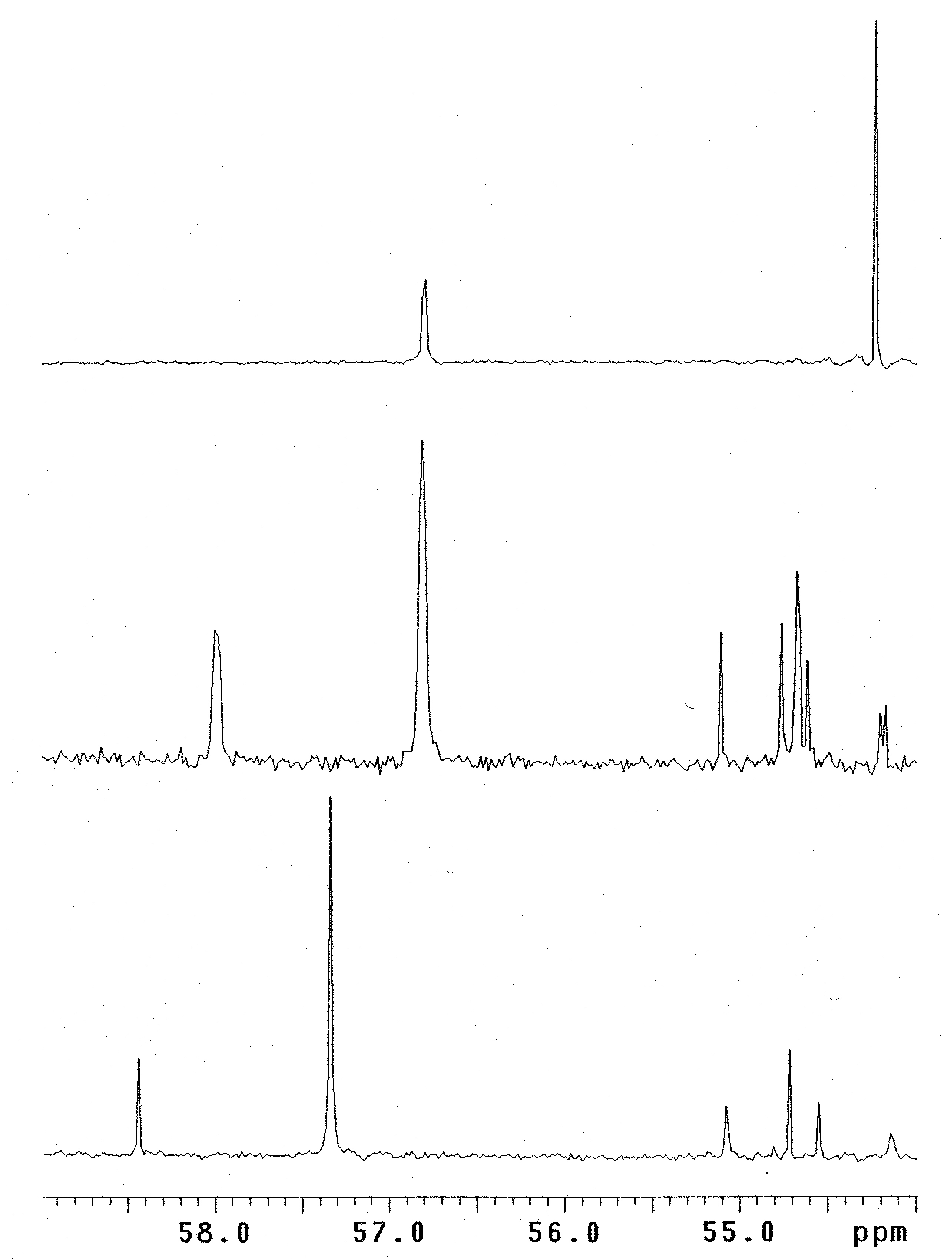

Figure S-2 ³¹P NMR spectra for: (top) authentic compound 2 in CH₃CN; (middle) 2 (neat) added to aged acetonitrile extract of the 2.0 h reaction of neat VX with humidified ozone; (bottom) aged acetonitrile extract of the 2.0 h reaction of neat VX with humidified ozone immediately before the addition 2. Shifting of the peak for 2 occurs on addition to the extract owing to matrix/solvent effects, but product peaks in the extract remain unshifted. The peak for 2 is coincident with a small, but detectable peak in the bottom spectrum. The coincident peak was much larger in the fresh sample, but diminished over time.

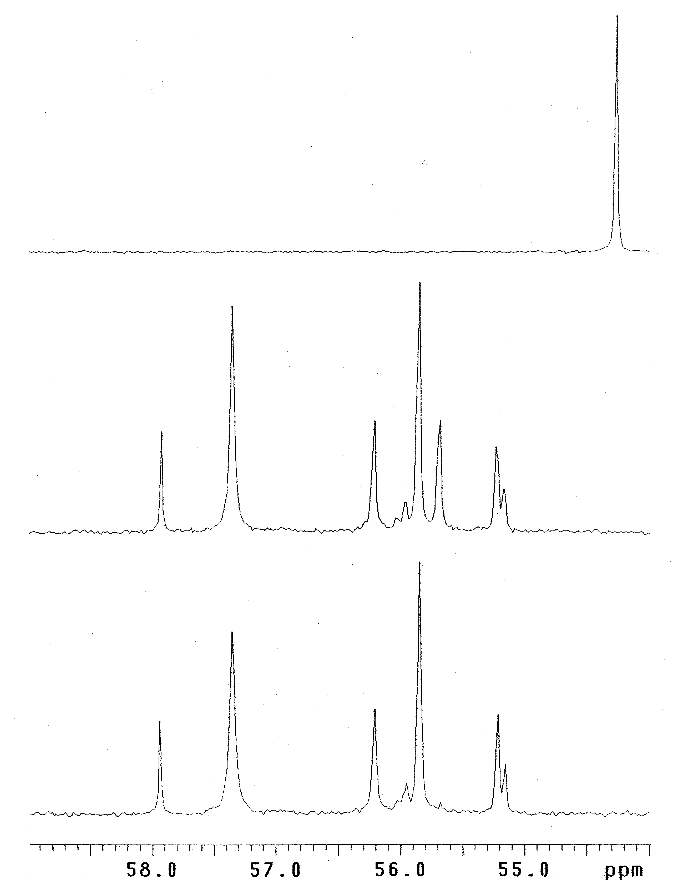

Figure S-3 Liquid Chromatogram with extracted ion chromatograms of initial part of a gradient run of the VX/ozone reaction mass, showing a peak for 125 (EMPA, 7) and 102 (diisopropylamine)

Figure S-4 Liquid chromatogram with extracted ion chromatograms of the final part of a gradient run of the VX/ozone reaction mass, showing the M+H⁺ which are labelled

Figure S-5 Liquid chromatogram with extracted ion chromatograms of the isocratic run using method B of the VX/ozone reaction mass, showing the M+H⁺ peaks which are labelled

Figure S-6 Liquid chromatogram UV absorption trace for 210 nm of the same isocratic run as in Figure S-5

Figure S-7 GC-IRD/MS chromatogram obtained for the derivatized VX/ozone extract showing peaks for compounds 6, 7 (off scale), 1, VX, 4, 2, and 3.

Figure S-8 GC-IRD/MS-EI Data for N,N-diisopropylformamide (6)

NAME: N,N-Diisopropylformamide
CAS: 2700-30-3
ABBR: DIF
MW: 129.12
MOLECULAR FORMULA: C₇H₁₅NO

Figure S-9 GC-IRD/MS-EI data for O-ethyl S-[2-(isopropylamino)ethyl] methylphosphonothioate (1)
NAME: O-ethyl S-[2-(isopropylamino)ethyl] methylphosphonothioate
CAS: TBD
ABBR: Isopropyl-VX
MW: 225.10
MOLECULAR FORMULA: C₈H₂₀NO₂PS

Figure S-10 GC-IRD/MS-EI data for Authentic O-ethyl S-[2-(isopropylamino)ethy] methylphosphonothioate (1).
NAME: O-ethyl S-[2-(isopropylamino)ethyl] methylphosphonothioate
CAS: NA
ABBR: Isopropyl-VX
MW: 225.10
MOLECULAR FORMULA: C₈H₂₀NO₂PS
Figure S-11 GC/MS-EI data for TMS derivative of 1: O-ethyl S-[2-(N-isopropyl-N-trimethylsilylamino)ethyl] methylphosphonothioate.
NAME: O-ethyl S-[2-(N-isopropyl-N-trimethylsilylamino)ethyl] methylphosphonothioate
CAS: TBD
ABBR:
MW: 297.13
MOLECULAR FORMULA: C₁₁H₂₈NO₂PSSi
IR spectrum
not obtained

Figure S-12 GC-IRD/MS-EI data for O-ethyl S-[2-(N,N-diisopropylamino)-2-oxoethyl] methylphosphonothioate (2)
NAME: O-ethyl S-[2-(N,N-diisopropylamino)-2-oxoethyl] methylphosphonothioate
CAS:
ABBR: 2-acetamido-VX
MW: 281.12
MOLECULAR FORMULA: C₁₁H₂₄NO₃PS
Figure S-13 GC-IRD/MS-EI data for O-ethyl S-[2-(N-acetyl-N-isopropylamino)ethyl] methylphosphonothioate (3)
NAME: O-ethyl S-[2-(N-acetyl-N-isopropylamino)ethyl] methylphosphonothioate
CAS:
ABBR: VX-acetamide
MW: 267.11
MOLECULAR FORMULA: C₁₀H₂₂NO₃PS

Figure S-14 GC-IRD/MS-EI data for O-ethyl S-[2-(N-formyl-N-isopropylamino)ethyl] methylphosphonothioate (4)
NAME: O-ethyl S-[2-(N-formyl-N-isopropylamino)ethyl] methylphosphonothioate
CAS:
ABBR: VX-formamide
MW: 253.09
MOLECULAR FORMULA: C₉H₂₀NO₃PS
Figure S-15 GC-AED phosphorus specific chromatogram for diluted, derivatized acetonitrile extract of VX/ozone reaction

Figure S-16 GC/MS-EI total ion chromatogram of the diluted, derivatized acetonitrile extract of the VX/ozone reaction

Figure S-17 (A) EI, (B) CH₄-CI, and ( C) NH₃-CI MS for the first peak of the triplet shown in Figure S-16 (identified as compound 4).

Figure S-18 (A) EI, (B) CH₄-CI, and ( C) NH₃-CI MS for the second peak of the triplet shown in Figure S-16 (identified as compound 2).

Figure S-19 (A) EI, (B) CH₄-CI, and ( C) NH₃-CI MS for the third peak of the triplet shown in Figure S-16 (identified as compound 3).

