Supplementary data

Isolation and characterisation of forty-nine fluorinated derivatives of [70]fullerene

Ala’a K. Abdul-Sada, Olga V. Boltalina, Joan M. Street and Roger Taylor

The Chemistry Laboratory, CPES School, Sussex University, Brighton, UK BN1 9QJ

Further IR and ¹⁹F NMR spectra (Figs. S1–S26)

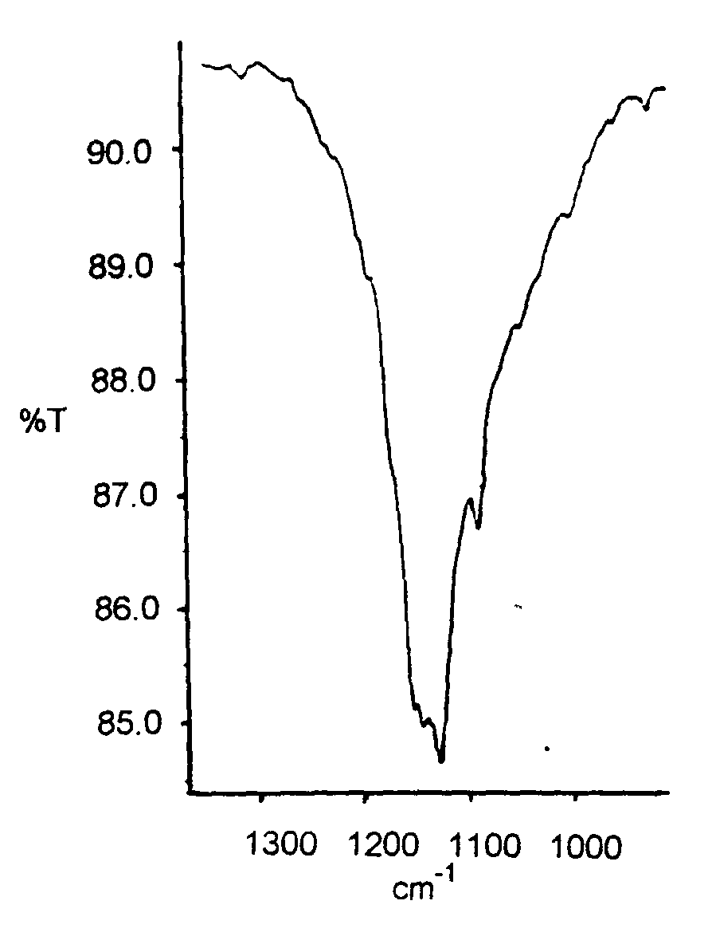

Fig. S1 IR spectrum (KBr) for C₇₀F₃₄ (1).
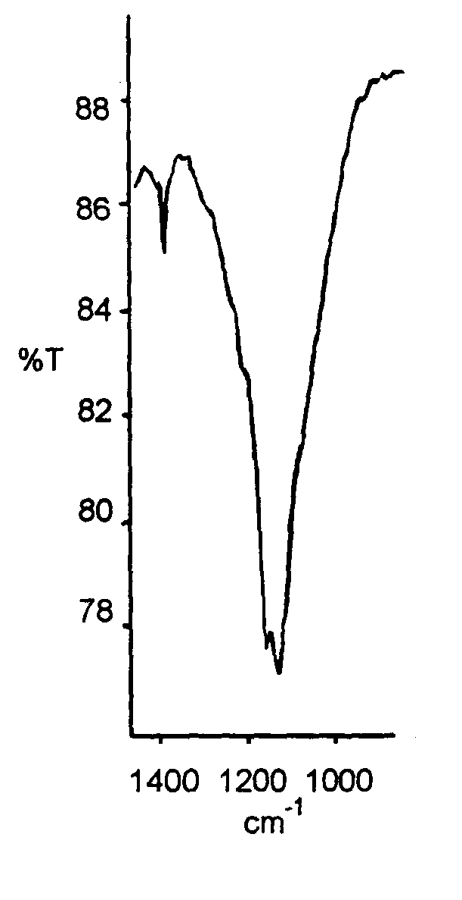
Fig. S2 IR spectrum (KBr) for C₇₀F₃₆ (2).
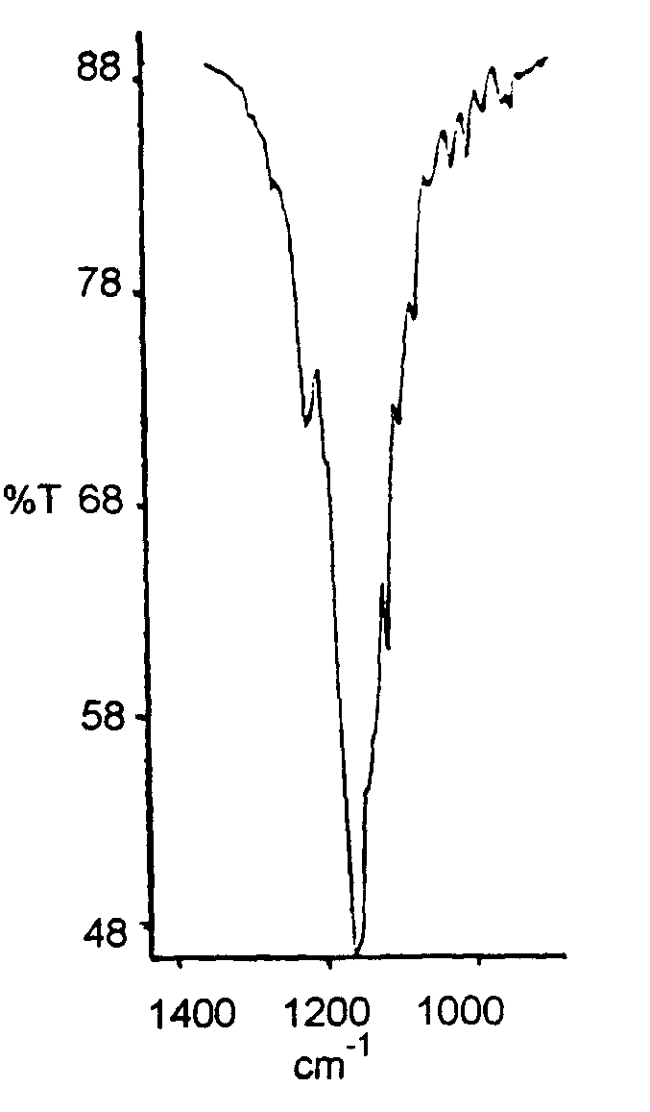
Fig. S3 IR spectrum (KBr) for C₇₀F₃₈ (8).
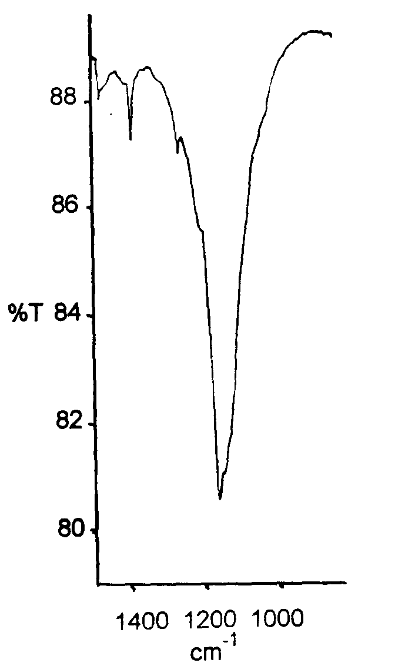

Fig. S4 IR spectrum (KBr) for C₇₀F₃₈ (11).
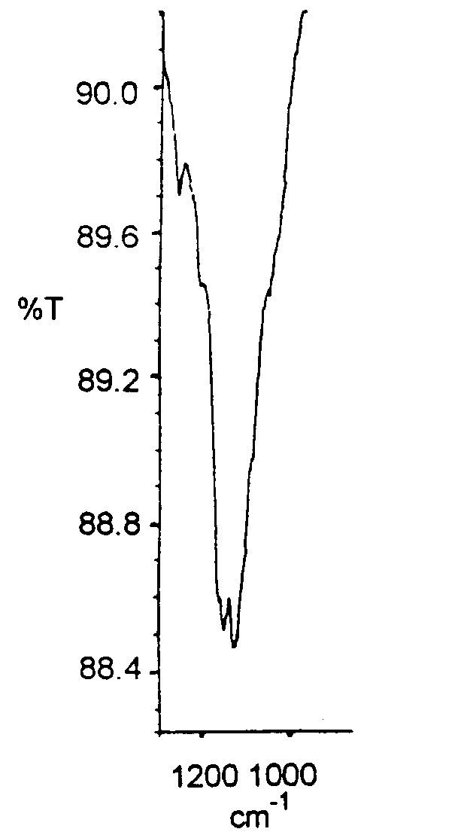
Fig. S5 IR spectrum (KBr) for C₇₀F₄₀ (16).
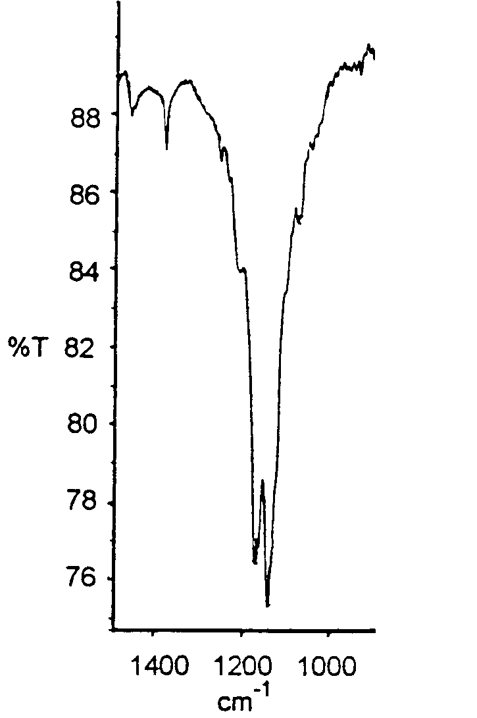

Fig. S6 IR spectrum (KBr) for C₇₀F₄₀ (17).
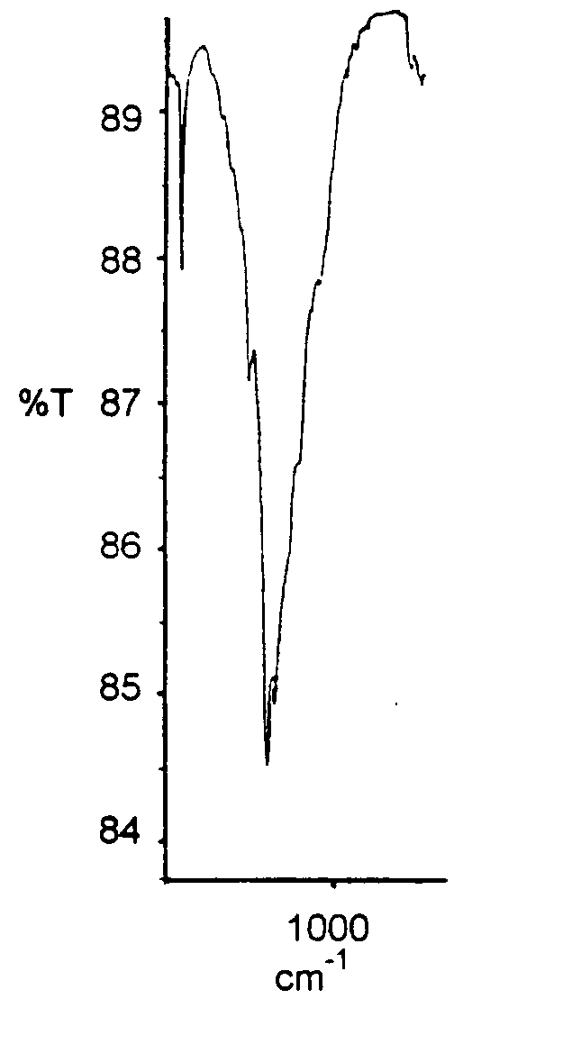

Fig. S7 IR spectrum (KBr) for C₇₀F₄₀ (18).
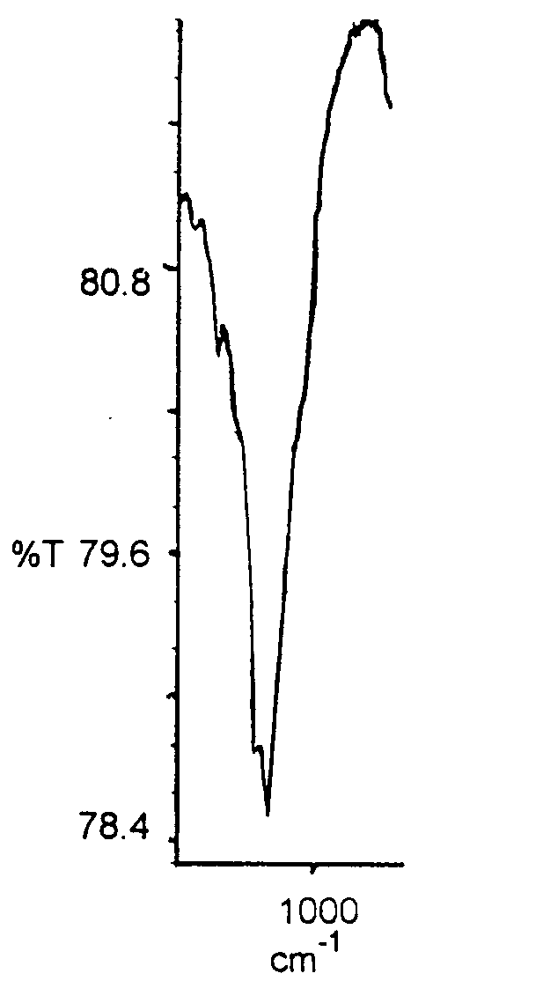

Fig. S8 IR spectrum (KBr) for C₇₀F₃₆O (28).
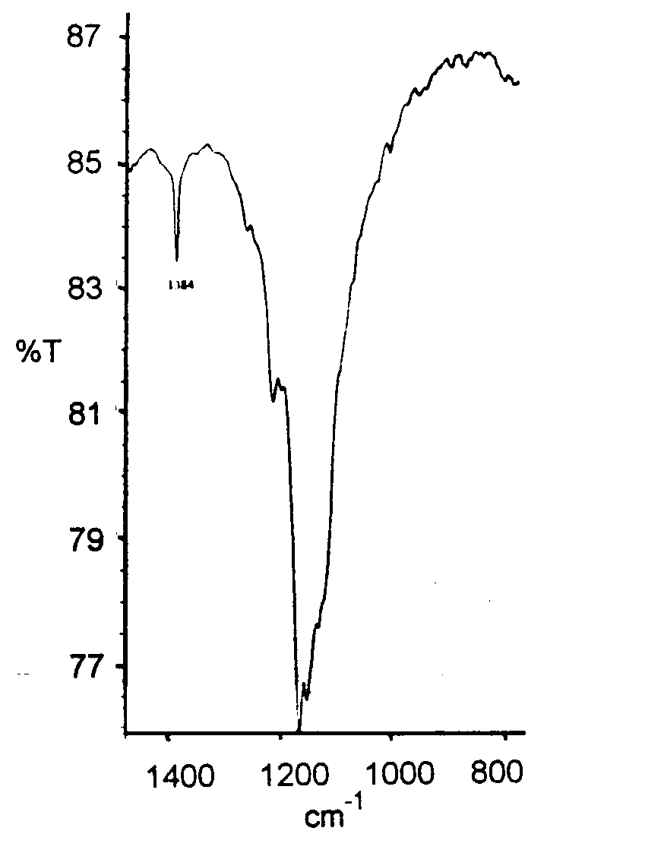

Fig. S9 IR spectrum (KBr) for C₇₀F₃₈O (29).
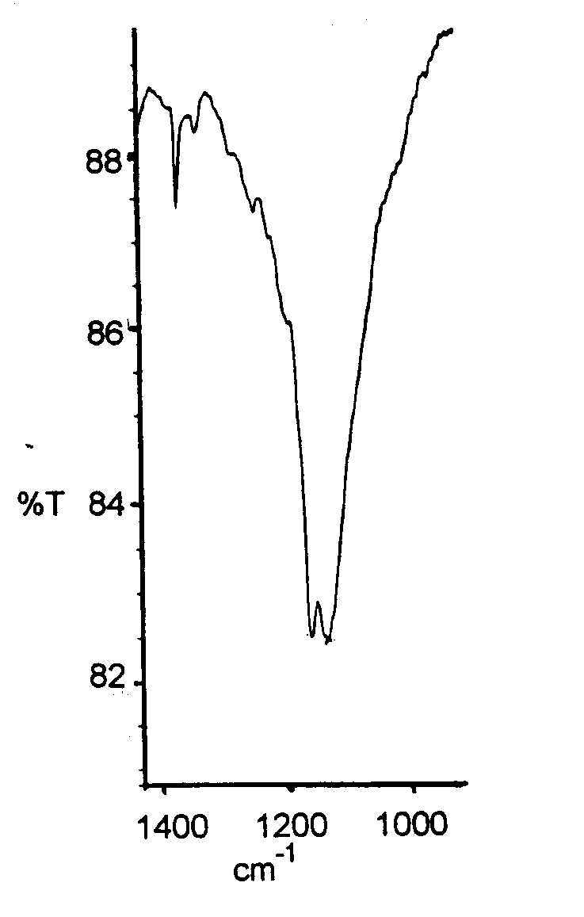

Fig. S10 IR spectrum (KBr) for C₇₀F₃₈O (31).
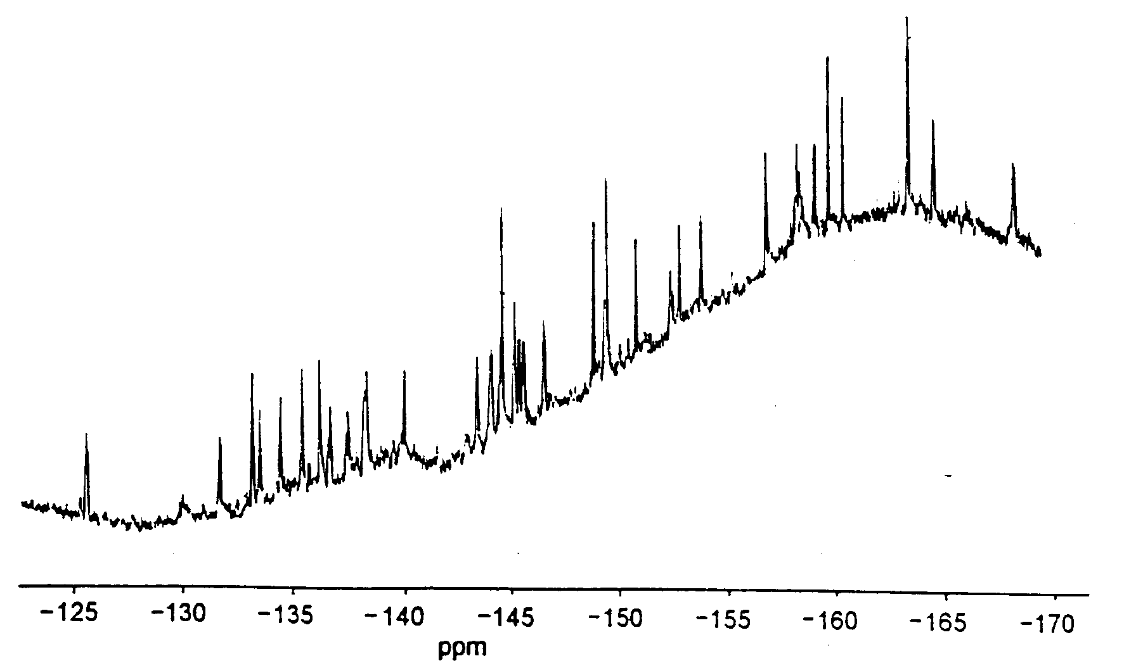

Fig. S11 ¹⁹F NMR spectrum for C₇₀F₃₆ (2).
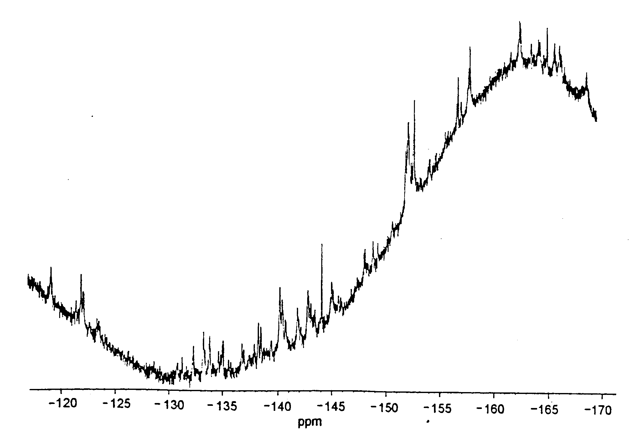

Fig. S12 ¹⁹F NMR spectrum for C₇₀F₃₆ (3).
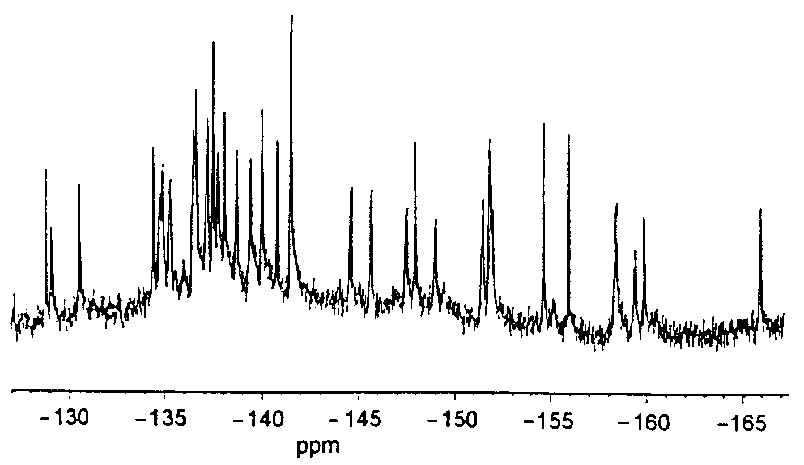

Fig. S13 ¹⁹F NMR spectrum for C₇₀F₃₆ (5).
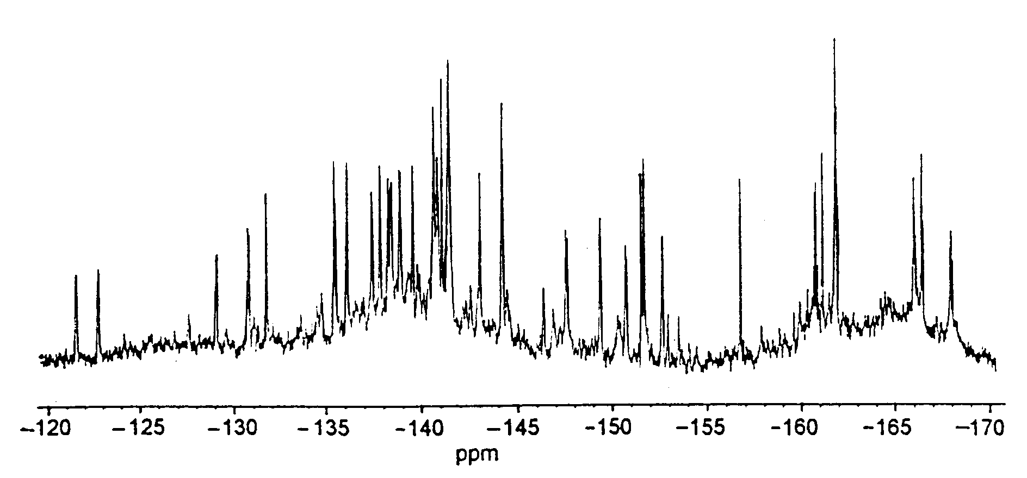

Fig. S14 ¹⁹F NMR spectrum for C₇₀F₃₆ (7).
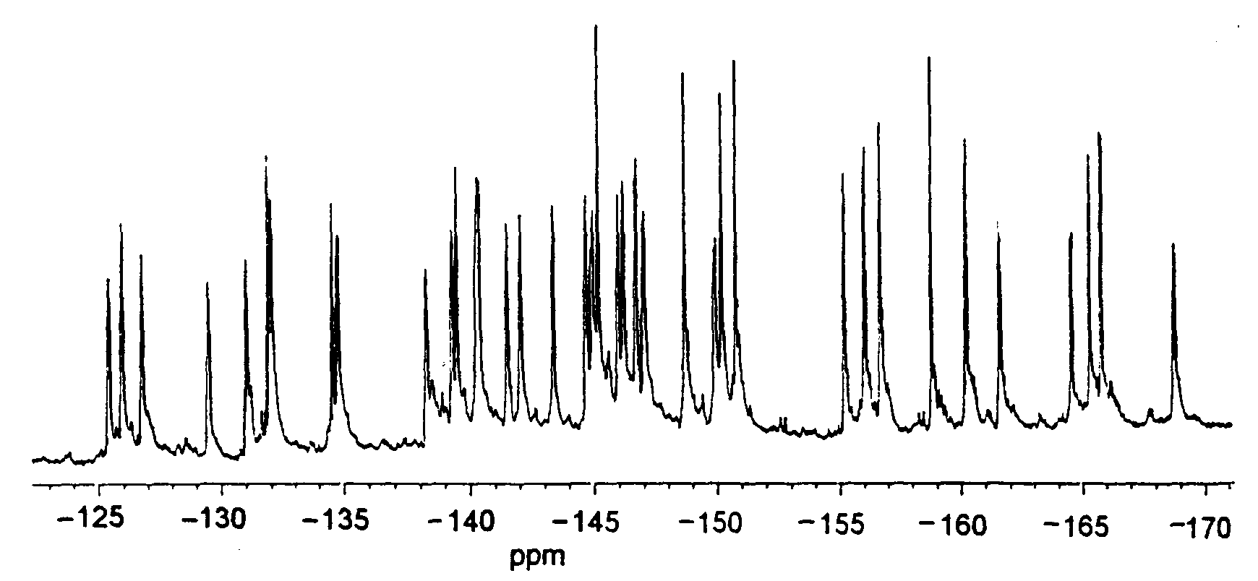

Fig. S15 ¹⁹F NMR spectrum for C₇₀F₃₈ (8).
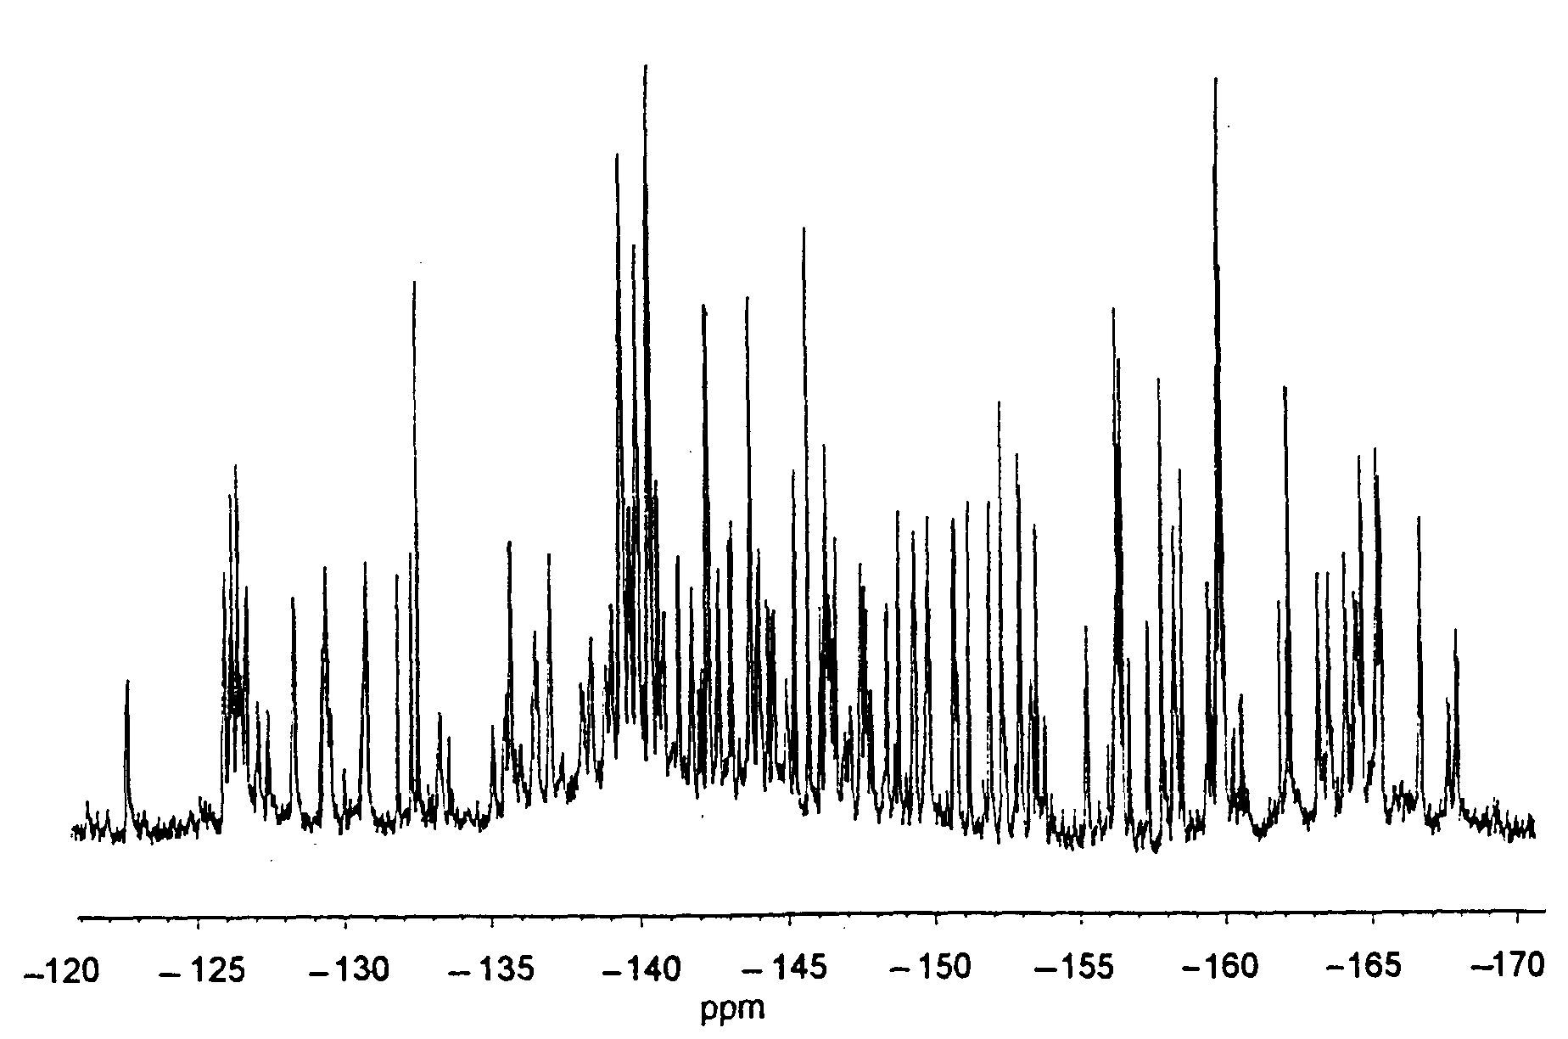

Fig. S16 ¹⁹F NMR spectrum for C₇₀F₃₈ (13/13a).
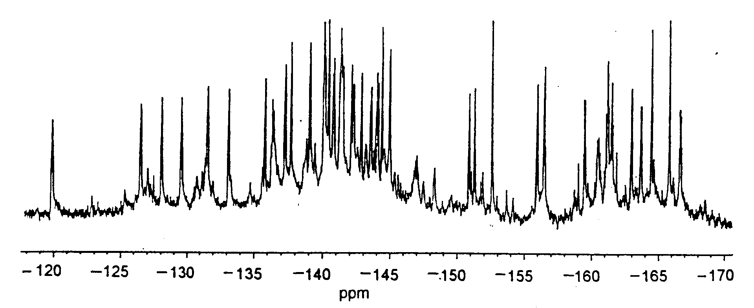

Fig. S17 ¹⁹F NMR spectrum for C₇₀F₄₀ (16).
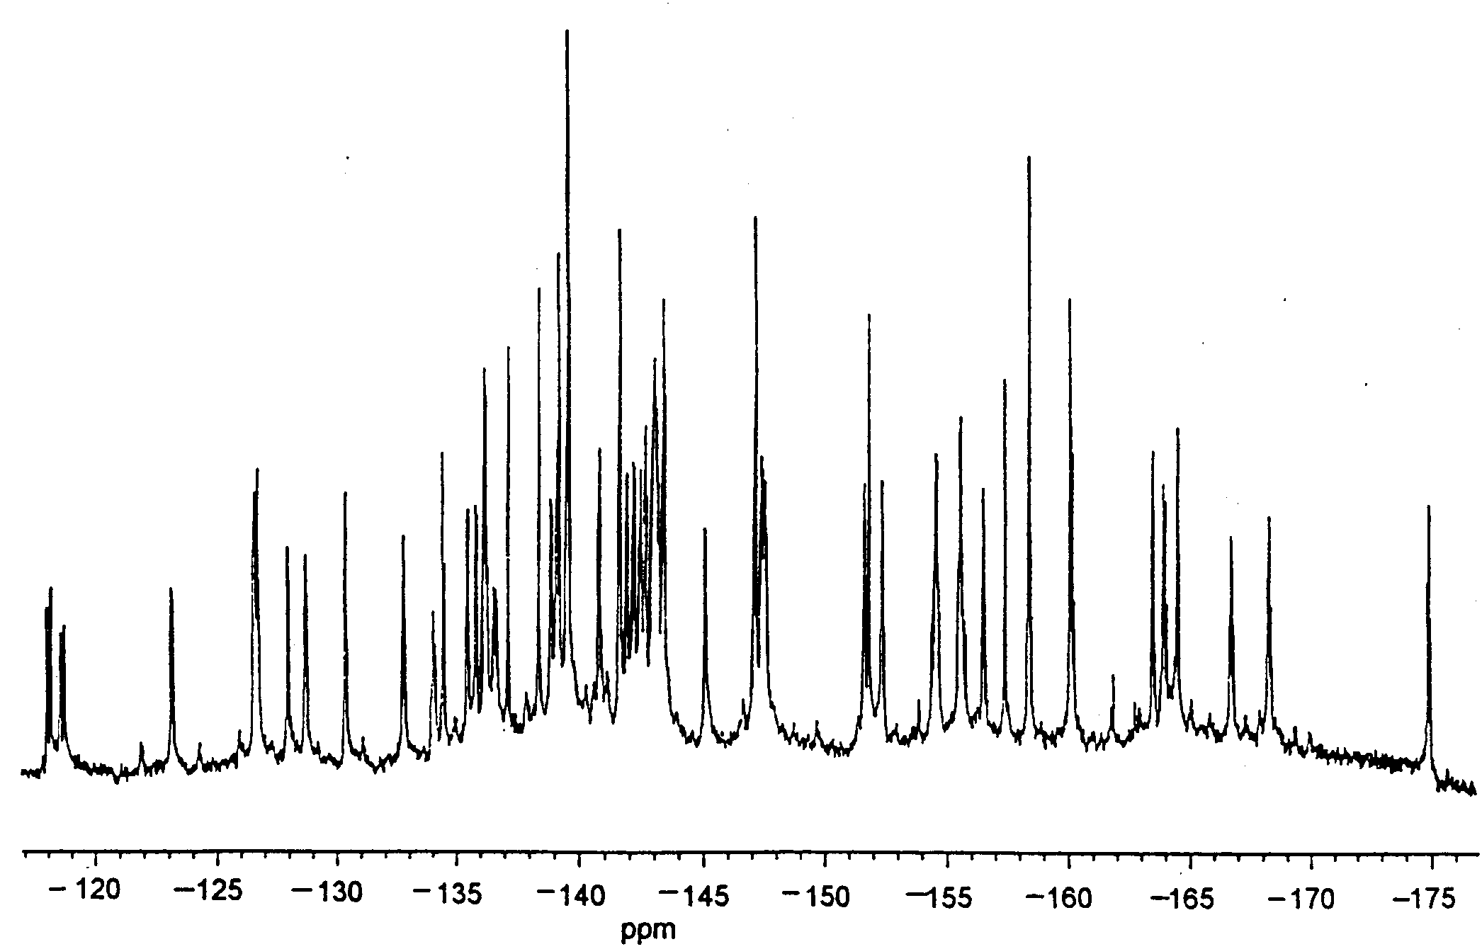

Fig. S18 ¹⁹F NMR spectrum for C₇₀F₄₀ (17).
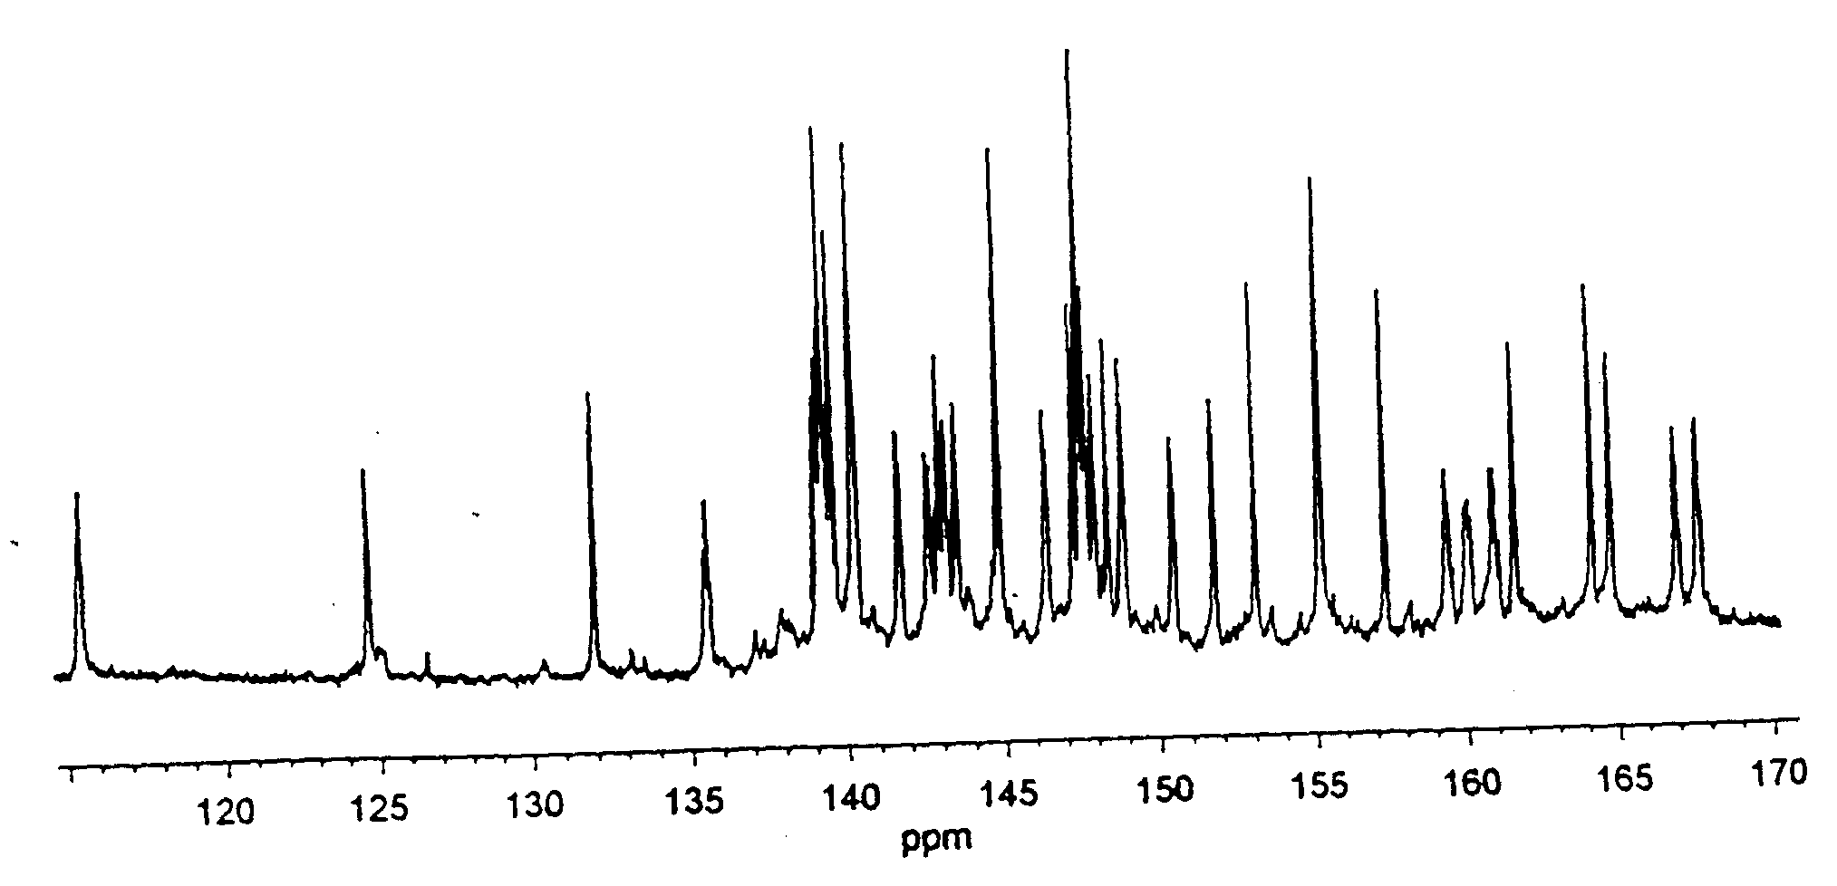

Fig. S19 ¹⁹F NMR spectrum for C₇₀F₄₀ (18).
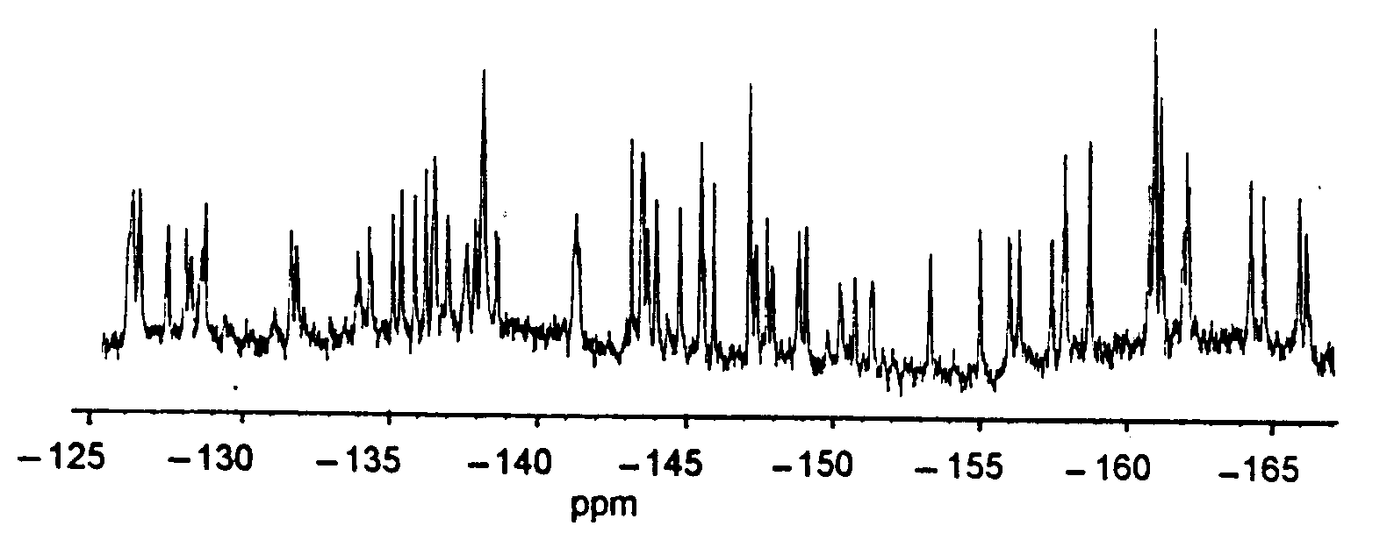

Fig. S20 ¹⁹F NMR spectrum for C₇₀F₃₆O (21/21a).
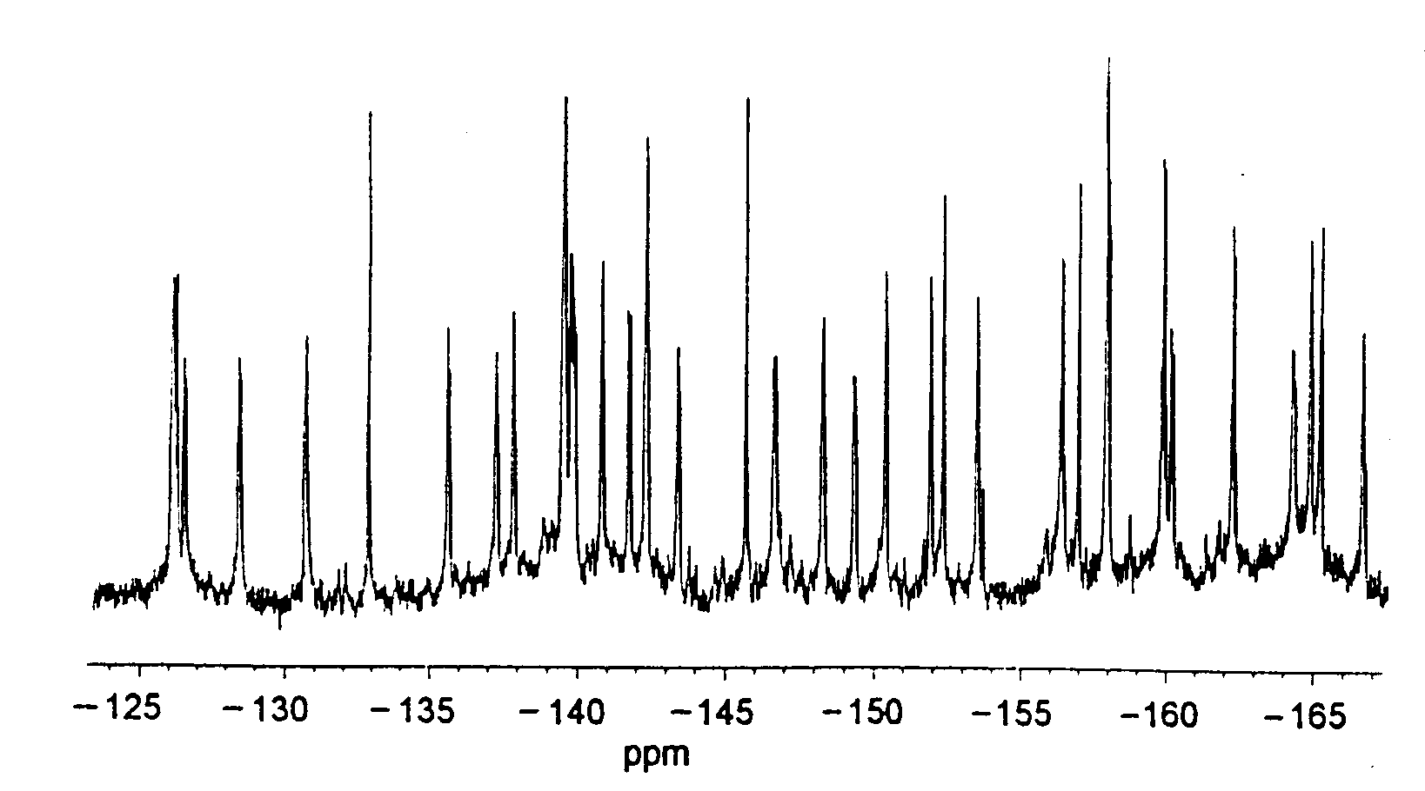

Fig. S21 ¹⁹F NMR spectrum for C₇₀F₃₆O (26).
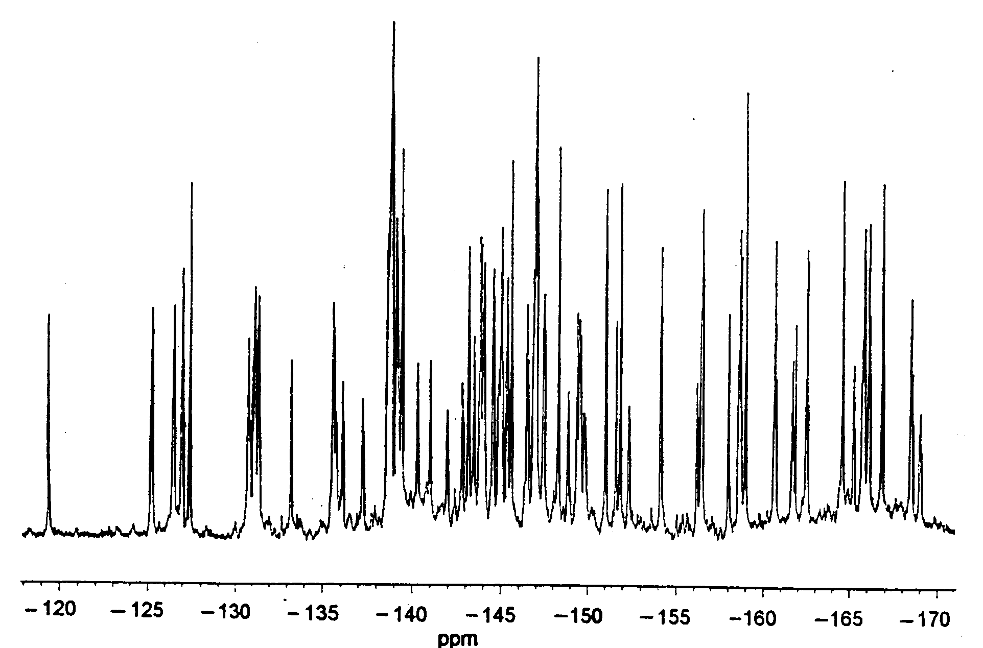

Fig. S22 ¹⁹F NMR spectrum for C₇₀F₃₈O (29/29a). Three peaks (not shown) occur at −78.9, −91.2, and −93.5 ppm in a 2:2:1-ratio (see text).
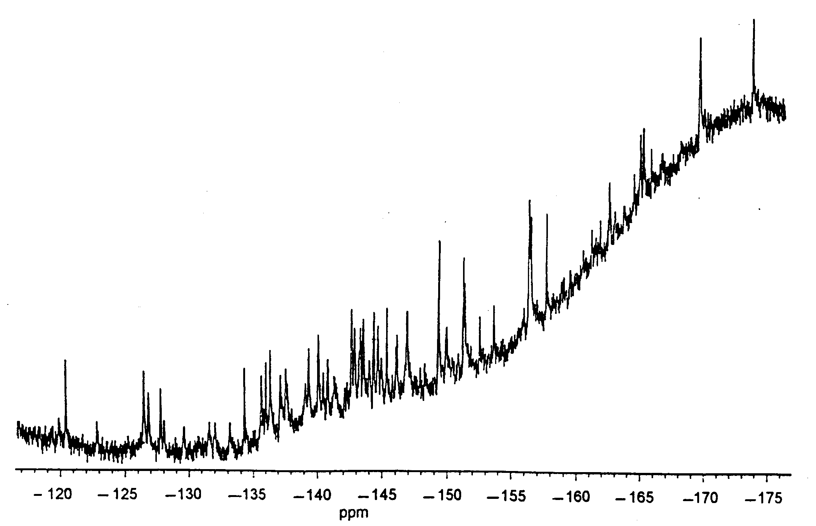

Fig. S23 ¹⁹F NMR spectrum for C₇₀F₃₈O (33).
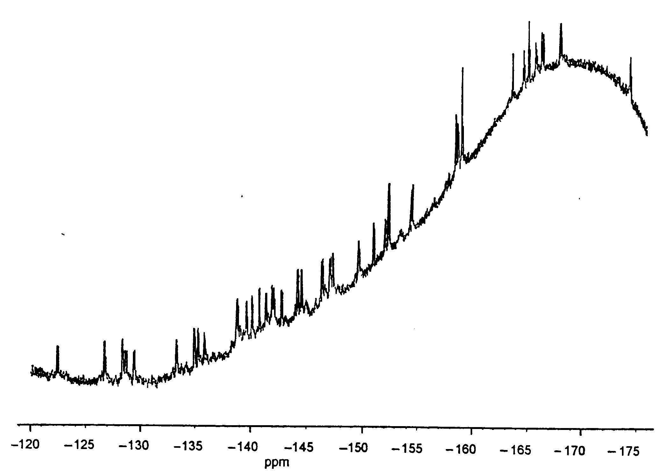

Fig. S24 ¹⁹F NMR spectrum for C₇₀F₄₀O (36); there is also a peak (not shown) at −100.2 ppm.
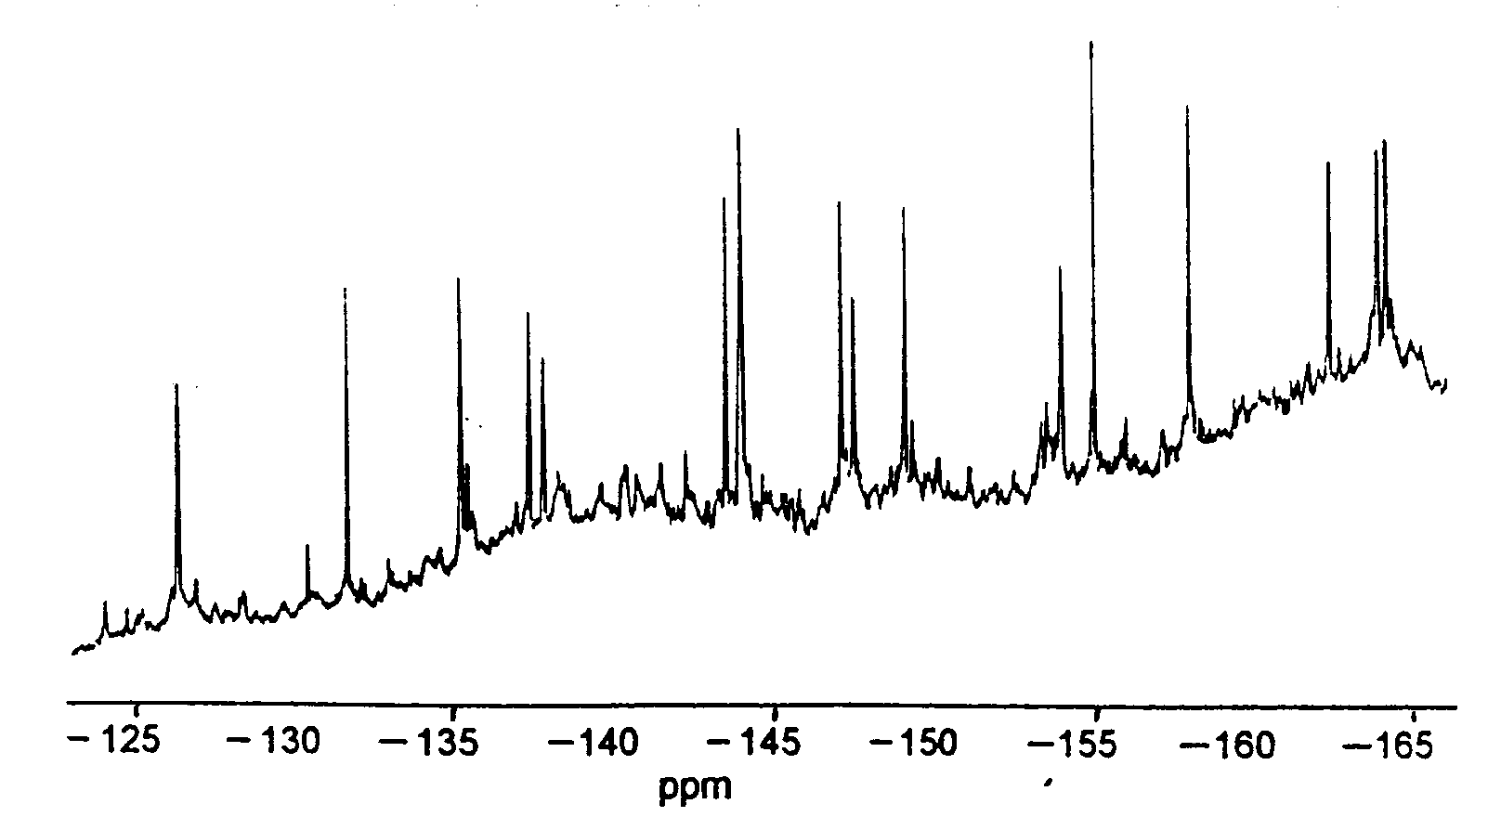

Fig. S25 ¹⁹F NMR spectrum for C₇₀F₃₄O₃ (40).
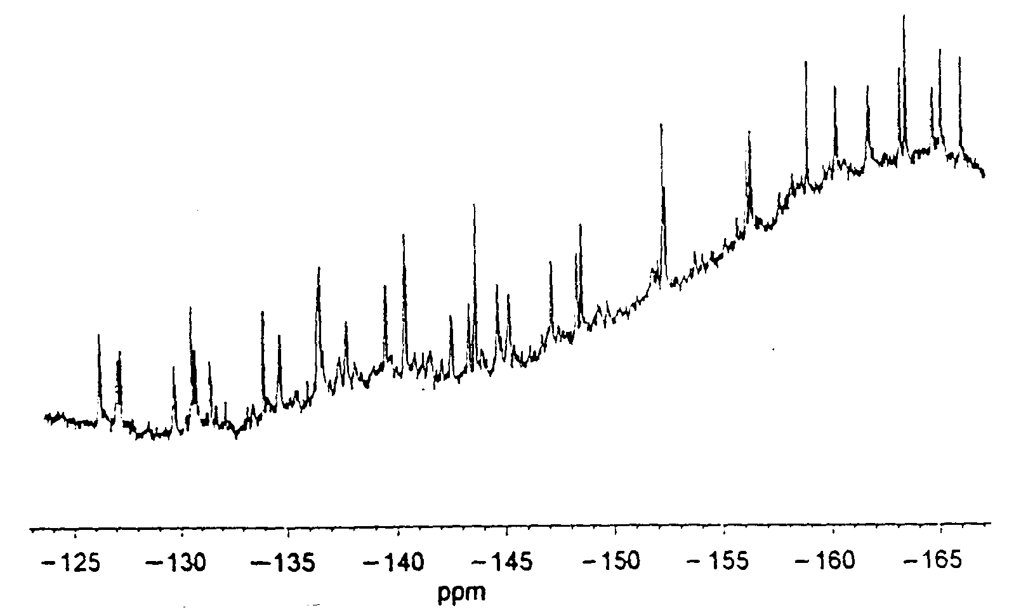

Fig. S26 ¹⁹F NMR spectrum for C₇₀F₃₅O.OH (41).

