Supplementary data
Calix[4]arene-5,17-dicarboxylic acids and their interactions with aliphatic amines. Part I. Studies in solution.

Mikkel Jørgensen* and Frederik C. Krebs

Condensed Matter Physics and Chemistry Department, Materials Chemistry, Risø National Laboratory, P. O. Box 49, DK-4000 Roskilde, Denmark. Fax: +45 4677 4791; E-mail: mikkel.joergensen@risoe.dk

Details of a prototype sensor device for detecting ephedrine
A prototype sensor device was made by spin casting a polyvinyl chloride (PVC) solution in tetrahydrofurane containing calixarene 9 onto a glass plate which was then mounted as one wall in an UV-VIS cell. When solutions of the various amines in water where placed in the cell spectral changes were observed in agreement with those obtained from solutions of 9 and the amines in chloroform. The concentrations required to effect these changes where however quite high (about 10⁻³M for ephedrine) leaving room for considerable improvement. The interesting fact is that the sensor device is at all able to measure amines in a polar solvent such as water. PVC acts as a nonpolar environment for the calixarene diacid and neutral amines can be extracted from the water phase even though the partition coefficient may be low.

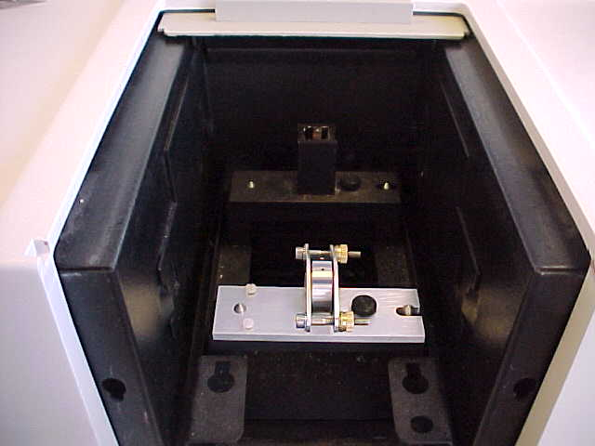

Fig. S1 Custom build optical cell (left) where the circular windows can be spincoated with a PVC solution of the receptor calixarene 9. Water solutions of amines can be introduced via a syringe through small holes at the top. A view of the cell in the optical path in the spectrometer bay (right).

Sensor device
A solution was prepared from tetrahydrofuran (10 mL), PVC (1.0 g) (MW 85000 from Aldrich chemical company), dioctyl adipate plastisiser (0.5 g) and diphenylazo-calix[4]arene dicarboxylic acid 9 (50 mg). This solution was spincoated onto circular glass disks (ø=2 cm). After evaporation of the solvent the disk was mounted as one wall in the custom build optical cell shown in the figure. The cell has two small holes in the upper part allowing for addition of water solutions via a syringe. Solutions with increasing concentrations of either triethyl amine or ephedrine was loaded into the cell which was then placed in the spectrometer and the UV-VIS spectrum taken. With pure water in the cell the spectrum was similar to the solution spectrum of 9 in chloroform. Addition of ephedrine solutions with a concentration of 10⁻³ M or higher produced changes in accordance with those observed in chloroform solution.

