Phototautomerism of o-nitrobenzyl compounds:
o-quinonoid aci-nitro species studied by matrix isolation and
DFT calculations

Ian R. Dunkin, Mariusz Kiszka, Jerzy Gębicki and D. Sanín-Leira

Supplementary data

Tables S1 and S2 are full versions of Tables 2 and 3, respectively, giving complete details of the B3PW91/6-31G(d) computations of the IR transitions of syn-EE- and syn-EZ-3 and of syn-E- and syn-Z-12 as well as the experimental IR transitions and assignments. Tables S3 and S4 give computed IR data for anti-EZ-, syn-ZE-, syn-ZZ- and anti-ZZ-3, the benzo[c]isoxazol-1-ol 7, anti-Z-12, and the benzo[c]isoxazol-1-ol 13.

Fig. S1 shows the results of AM1 computations of the relative energies of the N–OH rotamers of E- and Z-12; while Fig. S2 shows similar results for EE-, EZ-, ZE- and ZZ-3. The data for these Figures were computed using Spartan Pro v1.0.3. In each case, the H–O–N⁺–O⁻ dihedral angle was constrained to a series of fixed values at 10° intervals (or closer near local minima) and geometry optimizations were carried out.

Table S1

IR bands (cm⁻¹) assigned to o-quinonoid species 3, arising after 254 nm photolysis of 1 in Ar and N₂ matrices at 12 K, and diminishing upon subsequent long wavelength photolysis (460 ± 10 nm); compared with calculated IR transitions for syn-EE- and syn-EZ-3.

Experimental |  |  |  | Calculated ª |  |  |  | Assignment ^{b}
Ar matrix | N₂ matrix |  | syn-EE-3 | syn-EZ-3
3533 w ^{c} | 3519 w ^{c} |  | 3556 (23.8) | 3533 (42.1) |  | v(OH)
 |  |  | 3128 (0.8) | 3138 (1.3) |  | v(CH) exocyclic C=CH
 |  |  | 3126 (0.3) | 3121 (1.1)
 |  |  | 3102 (1.4) | 3106 (1.9) |  | v(CH) ring
 |  |  | 3080 (2.8) | 3081 (4.4) |  | v(CH) ring
 |  |  | 3067 (2.5) | 3067 (4.4)
 |  |  | 3044 (3.0) | 3044 (4.6)
 |  |  | 2984 (6.5) | 2978 (11.0) |  | v(CH) Me
2943 w | 2946 w |  | 2915 (18.1) | 2911 (30.9)
2115 w | 2115 w |  |  |  |  | combination band
 |  |  | 1649 (17.7) | 1645 (41.7) |  | v(C=N) + δ(NOH)
 |  |  | 1627 (8.4) | 1630 (28.8) |  | v(C=C) ring
 | 1587 w
1556 s | 1552 s |  | 1563 (35.4) | 1569 (77.8) |  | v(C=C) exocyclic
 |  |  | 1533 (0.2) | 1542 (0.2) |  | v(C=C) ring
 |  |  | 1460 (6.5) | 1460 (13.3) |  | δ(HCH) Me
 |  |  | 1452 (1.3) | 1453 (2.1) |  | δ(HCH) Me
 |  |  | 1439 (0.2) | 1438 (0.9)
 |  |  | 1432 (1.3) | 1427 (1.8)
 |  |  | 1394 (0.1) | 1403 (10.6)
1384 m | 1384 m |  | 1373 (27.8) | 1339 (0.2)
 |  |  | 1295 (5.7) | 1312 (9.3)
1267 m | 1270 s |  | 1273 (26.6) | 1277 (74.9) |  | δ(NOH)
 |  |  |  | 1237 (67.5) |  | v(N⁺–O⁻) + δ(NOH)
1244 vs | 1243 vs |  | 1241 (100.0) | 1233 (100.0) |  | v(C– OMe) + δ(NOH)
 |  |  | 1220 (4.8) |  |  | v(N⁺–O⁻) + δ(NOH) + δ(CH) ring
1205 m | 1203 m |  | 1193 (9.0) | 1190 (17.1) |  | δ(CH)
 |  |  | 1150 (0.7)
1147 s | 1149 s |  | 1141 (19.8) | 1143 (27.9) |  | ρ(Me)
 |  |  |  | 1139 (2.1) |  | δ(CH) ring
 |  |  | 1134 (0.1) | 1134 (0.1) |  | ρ(Me)
1124 s | 1124 s |  | 1119 (4.9) | 1095 (43.0)
1101 w | 1098 m
 |  |  | 1001 (1.4) | 1002 (7.2)
993 w | 991 w |  | 987 (2.9) | 990 (0.2)
950 s | 956 s |  | 948 (47.9) | 957 (36.0) |  | δ(NOH) + ring deformation
 |  |  | 942 (<0.1) | 945 (<0.1) |  | γ(CH) ring
 |  |  |  |  |  | Continued....
 |  |  | 924 (<0.1) | 928 (0.1) |  | γ(CH) ring
842 w | 844 w |  | 828 (7.3) | 835 (3.2) |  | ring deformation
 |  |  | 802 (0.8) | 801 (0.2) |  | γ(CH) ring + exocyclic C=CH
 |  |  | 795 (0.3) | 794 (1.2) |  | γ(CH) ring + exocyclic C=CH
 |  |  | 730 (1.7)
740 w | 746 w |  | 727 (9.1) | 732 (13.3) |  | γ(CH) ring
 |  |  |  | 731 (3.7)
 |  |  | 674 (0.9) | 676 (0.7)
 |  |  | 605 (0.4) | 606 (0.3)
 |  |  | 572 (0.8) | 575 (5.0) |  | δ(ONO)
 |  |  | 532 (0.8) | 529 (6.9)
 |  |  | 519 (2.2) | 525 (4.7)
 |  |  | 456 (2.3) | 459 (8.5)
 |  |  | 401 (6.1) | 407 (6.5)
 |  |  | 390 (0.4) | 400 (4.8)
 |  |  | 370 (0.3) | 378 (0.8)
 |  |  | 322 (0.8) | 363 (24.6)
 |  |  | 303 (7.8) | 317 (1.0)
 |  |  | 282 (15.5) | 280 (0.1)
 |  |  | 239 (<0.1) | 244 (0.3)
 |  |  | 186 (<0.1) | 184 (<0.1)
 |  |  | 135 (1.0) ^{d} | 139 (0.4)
 |  |  |  | 135 (0.6)
 |  |  | 98 (0.1) | 104 (<0.1)
 |  |  | 79 (0.2) | 55 (0.5)
 |  |  | 56 (0.8) | 46 (0.4)

ª Calculated frequencies from B3PW91/6-31G(d) computations have been scaled by the standard factor of 0.9573 (refs. 42 and 43); computed band intensities relative to the strongest band at 1241 or 1233 cm⁻¹ (100.0) are given in parentheses. ^{b} Assignments are approximate characterizations derived from the computed vibrational modes. ^{c} Experimental IR bands are denoted vs (very strong), s (strong), m (medium), w (weak), or vw (very weak). ^{d} Overlap of two fundamental bands.

Table S2

IR bands (cm⁻¹) assigned to o-quinonoid species 12, arising after 254 nm photolysis of 11 in Ar and N₂ matrices at 12 K, and diminishing upon subsequent long wavelength photolysis (395 ± 10 nm); compared with calculated IR transitions for syn-E- and syn-Z-12.

Experimental |  |  |  | Calculated ª |  |  |  | Assignment ^{b}
Ar matrix | N₂ matrix |  | syn-E-12 | syn-Z-12
 | 3521 w
3524 m ^{c} | 3506 m ^{c} |  | 3548 (67.4) | 3526 (58.4) |  | v(OH)
 | 3481 w
 |  |  | 3193 (1.2) | 3194 (0.6) |  | v(CH) C=CH₂
 |  |  | 3128 (1.0) | 3121 (1.4)
 |  |  | 3087 (9.1) | 3087 (6.1) |  | v(CH) ring
 |  |  | 3075 (10.3) | 3076 (8.8)
 |  |  | 3062 (0.4) | 3064 (1.1) |  | v(CH) ring + C=CH₂
 |  |  | 3055 (2.5) | 3061 (0.6) |  | v(CH) ring + C=CH₂
1614 s | 1611 s |  | 1652 (73.5) | 1640 (53.6) |  | v(C=N) + δ(NOH)
 |  |  | 1632 (5.0) | 1635 (69.7) |  | v(C=C) ring
 |  |  | 1554 (2.7) | 1563 (4.6) |  | v(C=C) exocyclic
 |  |  | 1536 (3.9) | 1545 (0.6) |  | v(C=C) ring
 |  |  | 1434 (0.7) | 1431 (<0.1) |  | δ(CH)
 |  |  | 1407 (3.0) | 1418 (0.9) |  | δ(CH) ring + C=CH₂
 |  |  | 1384 (12.0) | 1373 (3.4)
1326 m | 1327 m |  | 1315 (24.8) | 1306 (4.0)
1270 vs | 1271 s |  | 1278 (91.8) | 1273 (100.0) |  | v(N⁺–O⁻) + δ(NOH)
1256 m |  |  | 1241 (43.9) | 1255 (26.5) |  | δ(NOH) + δ(CH)
1210 w |  |  | 1226 (2.6) | 1213 (0.5) |  | δ(CH)
 |  |  | 1151 (4.9) |  |  | δ(CH) ring
 |  |  | 1145 (1.1) | 1146 (0.6) |  | δ(CH) ring + C=CH₂
 |  |  |  | 1123 (9.1) |  | δ(CH) ring + C=CH₂
1003 vw |  |  | 996 (5.4) | 1002 (12.4)
979 w,br |  |  |  | 976 (48.0) |  | v(N–OH) + δ(CH)
959 m | 959w |  | 947 (<0.1) | 948 (0.1) |  | γ(CH) ring
947 s,br |  |  | 946 (100.0) |  |  | v(N–OH) + δ(CH)
 |  |  | 934 (0.2) | 938 (1.4) |  | ρ(CH₂)
 |  |  | 926 (0.6) | 933 (0.5) |  | γ(CH) ring
878 m | 881 m |  | 861 (25.8) | 847 (20.4) |  | γ(CH) C=CH₂
827 m | 828 m |  | 815 (6.0) | 829 (0.3) |  | ring deformation
 |  |  | 804 (<0.1) | 805 (0.8) |  | γ(CH)
751 m | 755 w |  | 742 (16.1) | 746 (10.4) |  | γ(CH)
 |  |  | 701 (0.2) | 699 (0.3)
 |  |  | 691 (2.5) | 683 (1.0)
648 w | 650 w |  | 641 (9.0) | 630 (7.4) |  | γ(CH) ring + C=CH₂
 |  |  |  |  |  | Continued...
 |  |  | 588 (3.5) | 588 (6.0) |  | δ(ONO) + ring deformation
540 vw |  |  | 552 (4.4) | 561 (6.1)
 |  |  | 537 (0.9) | 536 (2.1) |  | ring deformation
 |  |  | 495 (2.0) | 522 (1.9)
 |  |  | 466 (3.4) | 473 (10.2)
 |  |  | 399 (4.5) | 414 (21.8)
 |  |  | 385 (4.6) | 388 (1.5)
 |  |  | 361 (5.0) | 364 (4.4)
 |  |  | 324 (54.1) | 359 (15.1)
 |  |  | 253 (0.3) | 258 (0.2)
 |  |  | 209 (1.2) | 211 (0.8)
 |  |  | 118 (<0.1) | 117 (0.1)
 |  |  | 89 (0.3) | 64 (0.2)

ª Calculated frequencies from B3PW91/6-31G(d) computations have been scaled by the standard factor of 0.9573 (refs. 42 and 43); computed band intensities relative to the strongest band at 946 or 1273 cm⁻¹ (100.0) are given in parentheses. ^{b} Assignments are approximate characterizations derived from the computed vibrational modes. ^{c} Experimental IR bands are denoted vs (very strong), s (strong), m (medium), w (weak), or vw (very weak).

Table S3

Computed IR frequencies (cm⁻¹) and relative IR band intensities (in parentheses) for anti-EZ-, syn-ZE-, syn-ZZ- and anti-ZZ-3, and for the benzo[c]isoxazol-1-ol 7. ª

anti-EZ-3 | syn-ZE-3 | syn-ZZ-3 | anti-ZZ-3 | 7
3382 (2.3) | 3565 (52.8) | 3542 (39.8) | 3207 (57.6) | 3597 (29.9)
3120 (0.9) | 3119 (1.3) | 3110 (1.3) | 3119 (1.2) | 3100 (3.1)
3106 (1.2) | 3081 (11.0) | 3082 (5.5) | 3089 (5.1) | 3088 (9.0)
3083 (3.2) | 3066 (9.1) | 3070 (7.0) | 3073 (5.2) | 3077 (5.8)
3072 (2.3) | 3053 (0.6) | 3052 (0.5) | 3066 (1.5) | 3066 (0.3)
3069 (3.6) | 3048 (7.7) | 3043 (4.7) | 3061 (1.7) | 3029 (12.0)
3045 (3.3) | 3006 (5.7) | 3013 (2.9) | 3053 (0.6) | 2968 (18.5)
2974 (9.0) | 2990 (11.7) | 2976 (9.8) | 3000 (7.0) | 2888 (53.9)
2908 (24.5) | 2911 (39.4) | 2908 (29.9) | 2926 (23.0) | 2884 (8.4)
1628 (1.3) | 1654 (64.0) | 1651 (64.8) | 1629 (2.3) | 1613 (2.9)
1600 (91.6) | 1624 (38.0) | 1626 (28.1) | 1592 (50.8) | 1607 (3.6)
1563 (60.2) | 1593 (54.3) | 1600 (58.0) | 1573 (100.0) | 1472 (4.0)
1535 (5.7) | 1529 (3.1) | 1537 (1.4) | 1537 (2.1) | 1465 (3.2)
1459 (11.0) | 1463 (3.4) | 1461 (4.8) | 1460 (7.3) | 1450 (10.1)
1453 (2.1) | 1445 (6.0) | 1450 (5.3) | 1450 (2.6) | 1445 (3.1)
1437 (1.7) | 1433 (0.7) | 1435 (1.7) | 1431 (2.3) | 1428 (1.3)
1425 (2.2) | 1431 (0.6) | 1425 (0.1) | 1425 (3.2) | 1391 (33.5)
1400 (5.3) | 1400 (33.5) | 1392 (3.6) | 1412 (18.1) | 1348 (18.7)
1346 (13.4) | 1374 (3.0) | 1380 (12.1) | 1373 (7.7) | 1341 (20.1)
1309 (3.6) | 1295 (58.3) | 1289 (15.6) | 1369 (16.0) | 1301 (6.3)
1298 (10.6) | 1282 (100.0) | 1281 (100.0) | 1282 (5.6) | 1247 (1.4)
1254 (100.0) | 1240 (68.0) | 1263 (59.8) | 1256 (44.8) | 1207 (3.6)
1227 (29.4) | 1221 (5.3) | 1222 (44.0) | 1208 (17.3) | 1172 (26.4)
1187 (11.1) | 1197 (28.2) | 1187 (2.7) | 1182 (13.1) | 1160 (13.9)
1141 (22.3) | 1147 (21.1) | 1147 (20.7) | 1138 (10.7) | 1137 (1.2)
1137 (1.7) | 1146 (2.9) | 1137 (0.3) | 1135 (1.6) | 1134 (2.3)
1134 (1.0) | 1131 (4.6) | 1129 (5.7) | 1126 (38.8) | 1100 (100.0)
1097 (27.8) | 1124 (19.1) | 1109 (10.6) | 1109 (23.0) | 1086 (7.6)
997 (3.5) | 1000 (22.1) | 1003 (14.8) | 1008 (8.3) | 1009 (2.9)
986 (1.2) | 977 (2.6) | 980 (19.0) | 976 (18.2) | 983 (14.3)
948 (8.7) | 938 (98.5) | 963 (25.4) | 967 (2.4) | 976 (68.9)
945 (5.7) | 934 (2.4) | 936 (1.0) | 937 (0.3) | 956 (28.9)
930 (0.7) | 914 (5.0) | 916 (0.7) | 920 (0.5) | 943 (0.1)
842 (7.2) | 845 (10.6) | 860 (1.1) | 860 (0.3) | 907 (2.5)
831 (0.6) | 811 (18.6) | 810 (10.0) | 786 (2.1) | 889 (11.0)
799 (1.0) | 777 (2.1) | 780 (0.8) | 745 (16.9) | 840 (1.2)
738 (11.0) | 710 (21.7) | 710 (12.4) | 721 (5.5) | 824 (39.3)
725 (6.3) | 697 (5.0) | 692 (0.9) | 691 (4.8) | 754 (23.0)
677 (0.1) | 683 (1.0) | 681 (0.4) | 672 (1.1) | 739 (24.5)
 |  |  |  | Continued...
613 (1.9) | 604 (1.7) | 605 (0.8) | 653 (8.4) | 716 (3.4)  Continued.....
597 (0.4) | 571 (2.6) | 578 (5.6) | 605 (0.7) | 697 (1.6)
554 (4.5) | 543 (2.0) | 540 (3.9) | 575 (0.4) | 617 (5.1)
522 (2.2) | 515 (5.8) | 527 (2.0) | 564 (7.1) | 587 (1.2)
469 (1.8) | 475 (2.3) | 493 (2.2) | 526 (0.1) | 547 (1.0)
424 (15.3) | 461 (1.8) | 440 (1.9) | 493 (0.9) | 516 (2.6)
422 (1.8) | 413 (0.1) | 408 (0.3) | 453 (3.5) | 509 (8.2)
384 (2.2) | 360 (3.2) | 360 (1.1) | 406 (2.1) | 428 (18.7)
367 (1.6) | 329 (5.1) | 342 (15.1) | 361 (0.6) | 392 (6.7)
321 (0.5) | 299 (23.3) | 306 (13.8) | 328 (1.5) | 385 (14.0)
278 (5.5) | 276 (28.9) | 281 (5.1) | 321 (0.3) | 327 (1.5)
239 (1.9) | 227 (0.6) | 223 (0.2) | 244 (0.6) | 288 (0.2)
184 (1.1) | 205 (1.7) | 196 (0.2) | 200 (0.7) | 239 (0.5)
150 (0.1) | 162 (0.4) | 156 (<0.1) | 168 (<0.1) | 176 (0.8)
122 (0.6) | 140 (0.8) | 139 (0.7) | 143 (0.2) | 133 (1.3)
106 (1.7) | 101 (0.2) | 101 (0.1) | 102 (0.4) | 111 (1.5)
80 (<0.1) | 80 (0.5) | 73 (0.2) | 96 (0.3) | 91 (0.1)
50 (0.9) | 57 (3.4) | 57 (1.2) | 43 (0.7) | 61 (1.2)

ª Calculated frequencies from B3PW91/6-31G(d) computations have been scaled by the standard factor of 0.9573 (refs. 42 and 43); computed band intensities relative to the strongest band for each species (100.0) are given in parentheses.

Table S4

Computed IR frequencies (cm⁻¹) and relative IR band intensities (in parentheses) for anti-Z-12 and for 3H-benzo[c]isoxazol-1-ol 13. ª

anti-Z-12 | 13
3289 (3.6) | 3602 (61.7)
3135 (0.9) | 3097 (9.3)
3121 (0.6) | 3084 (26.5)
3089 (2.1) | 3073 (14.1)
3078 (3.5) | 3063 (0.9)
3064 (0.3) | 2984 (23.5)
3055 (<0.1) | 2908 (50.2)
1630 (1.7) | 1613 (1.0)
1606 (100.0) | 1599 (13.5)
1547 (9.9) | 1463 (15.4)
1534 (4.7) | 1457 (1.7)
1431 (0.7) | 1448 (12.7)
1420 (2.3) | 1359 (54.2)
1377 (0.7) | 1344 (13.2)
1341 (22.4) | 1295 (4.2)
1309 (5.8) | 1243 (0.9)
1249 (7.6) | 1206 (2.9)
1210 (0.4) | 1153 (4.8)
1145 (0.6) | 1150 (1.7)
1122 (1.7) | 1138 (0.4)
998 (2.9) | 1080 (2.2)
977 (12.3) | 1009 (3.5)
948 (0.2) | 998 (0.6)
941 (0.5) | 957 (31.7)
931 (0.3) | 943 (0.2)
846 (0.8) | 905 (5.3)
820 (5.5) | 898 (51.4)
809 (1.9) | 845 (1.6)
761 (12.7) | 827 (7.2)
708 (2.8) | 816 (90.2)
693 (0.6) | 800 (31.6)
682 (0.7) | 739 (100.0)
618 (0.6) | 714 (6.8)
588 (3.3) | 691 (6.5)
539 (0.5) | 600 (2.3)
525 (0.4) | 545 (6.0)
486 (11.3) | 536 (4.7)
471 (3.6) | 476 (8.0)
391 (1.5) | 426 (16.2)  Continued.....
 | Continued...
377 (0.2) | 402 (59.2)
348 (1.9) | 360 (36.1)
258 (1.9) | 313 (2.0)
201 (0.2) | 210 (10.9)
120 (0.3) | 145 (0.2)
101 (0.5) | 107 (1.8)

ª Calculated frequencies from B3PW91/6-31G(d) computations have been scaled by the standard factor of 0.9573 (refs. 42 and 43); computed band intensities relative to the strongest band for each species (100.0) are given in parentheses.

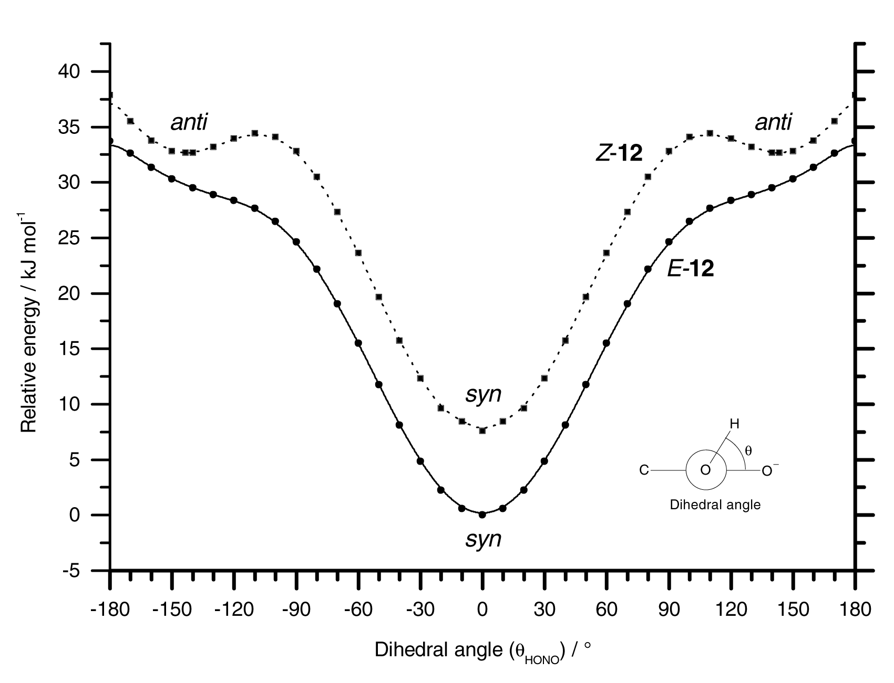

Fig. S1
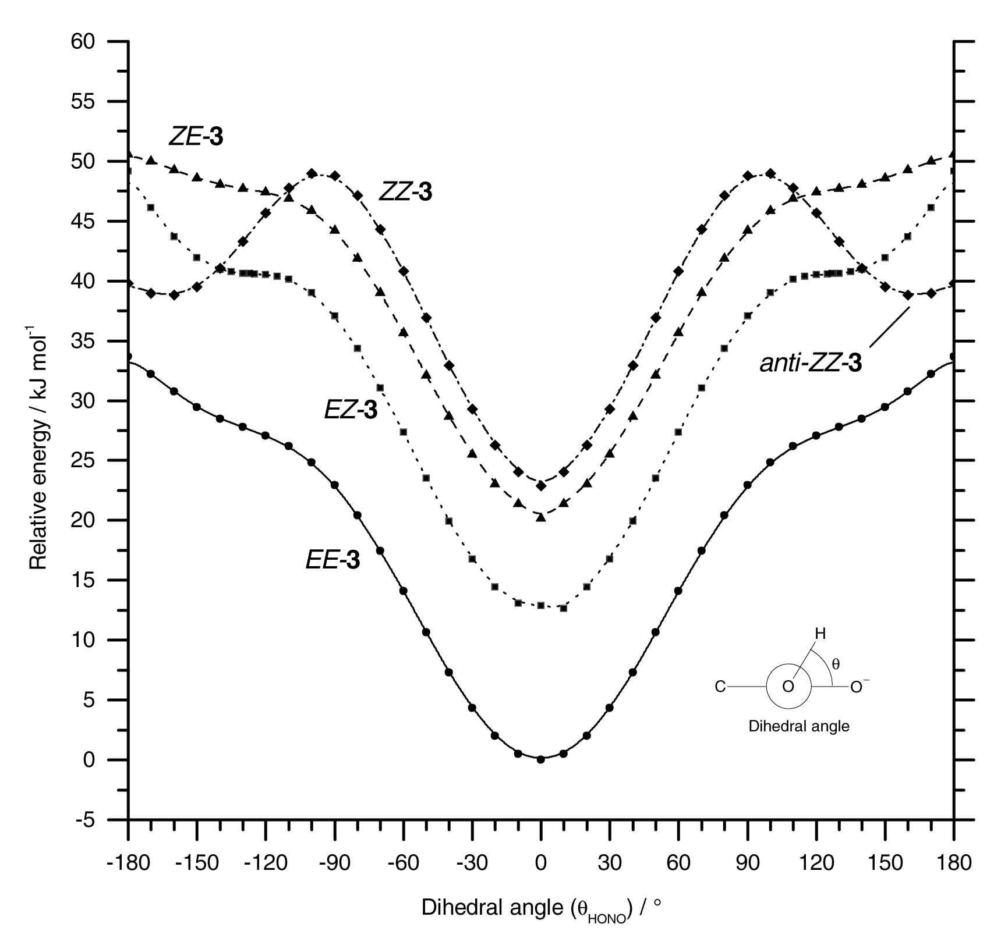

Fig. S2

