Supplementary data
Table 1S. Results obtained from geometry optimisation (bond lengths, Å; angles, deg; total energy E, a.u.) for the most stable conformer 2.I (Fig.1).
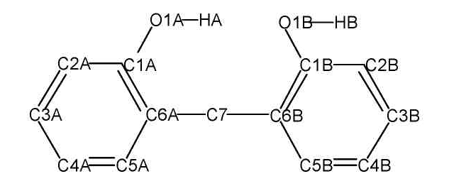

Ring A |  |  | Ring В
 | Calculated | Experimentª | Calculated | Experimentª
O1-C1 | 1.363 | 1.381 | 1.385 | 1.385
C1-C2 | 1.401 | 1.384 | 1.395 | 1.385
C2-C3 | 1.391 | 1.369 | 1.394 | 1.384
C3-C4 | 1.397 | 1.376 | 1.395 | 1.400
C4-C5 | 1.394 | 1.398 | 1.395 | 1.371
C5-C6 | 1.401 | 1.389 | 1.399 | 1.385
C6-C1 | 1.410 | 1.383 | 1.402 | 1.389
C6-C7 | 1.524 | 1.509 | 1.523 | 1.510
O-C1-C2 | 116.1 | 119.8 | 121.3 | 120.3
O-C1-C6 | 123.8 | 119.1 | 116.9 | 118.3
C2-C1-C6 | 120.1 | 121.2 | 121.7 | 121.5
C1-C2-C3 | 120.6 | 120.5 | 119.7 | 118.2
C2-C3-C4 | 120.1 | 119.8 | 119.8 | 120.9
C3-C4-C5 | 119.1 | 119.5 | 119.6 | 119.7
C4-C5-C6 | 122.1 | 121.2 | 121.9 | 120.3
C5-C6-C1 | 118.0 | 117.8 | 117.3 | 119.3
Table 1 (continued)
 | Calculated | Experimentª
C6A-C7-C6B | 114.7 | 113.9
C1A-C6A-C7-C6B | -80.4 | -74.4
C1B-C6B-C7-C6A | 98.7 | 107.3
O1A...O1B | 2.825 | 2.787
E | -653.0536 | -
ª Reference ⁹

