Supplementary data

On the Novel Function of the Additive DBU.
Catalytic Stereoselective Deprotonation by a Mixed Dimer
of Lithiated DBU and a Chiral Lithium Amide

Daniel Pettersen, Mohamed Amedjkouh, Sten O. Nilsson Lill and Per Ahlberg*

Organic Chemistry, Department of Chemistry, Göteborg University,
SE-412 96 Göteborg, Sweden
Phone: +46 31 772 2899, Fax: +46 31 772 2908,
E-mail: Per.Ahlberg@oc.chalmers.se

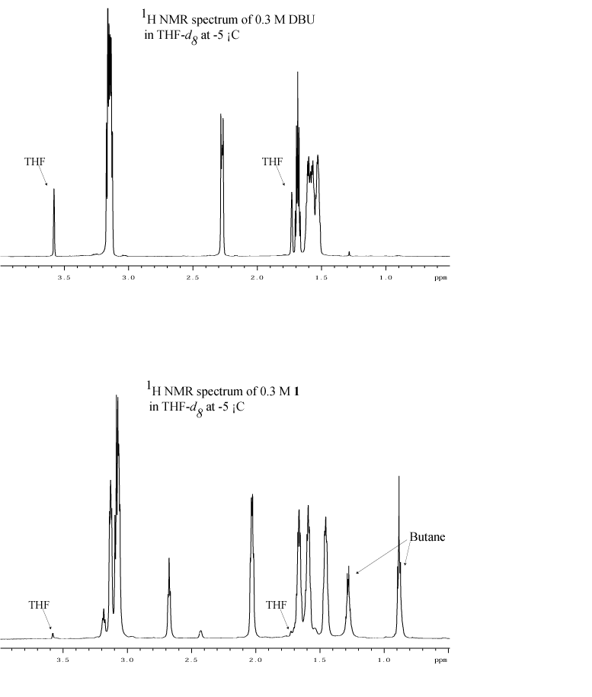
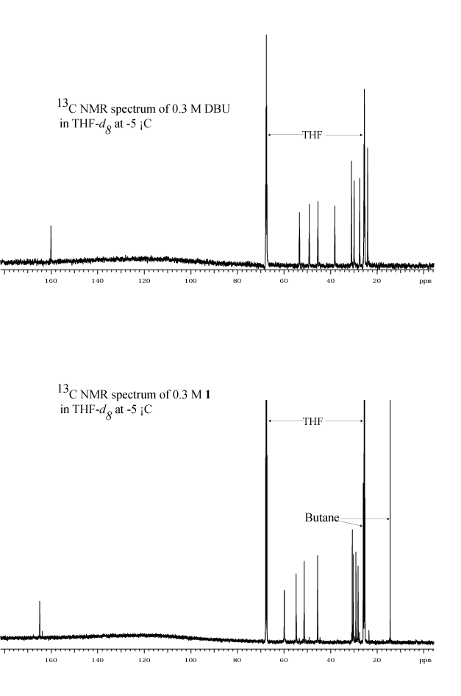
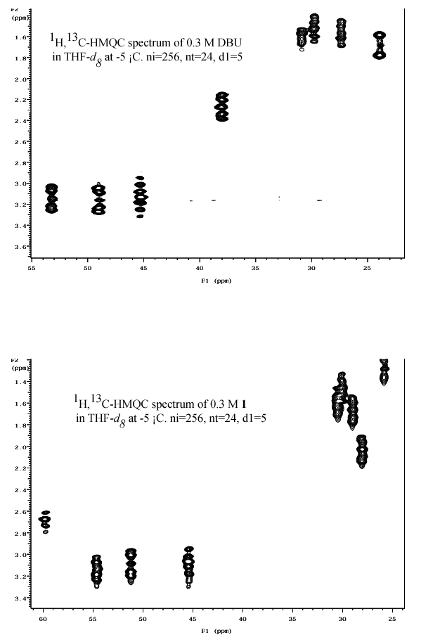
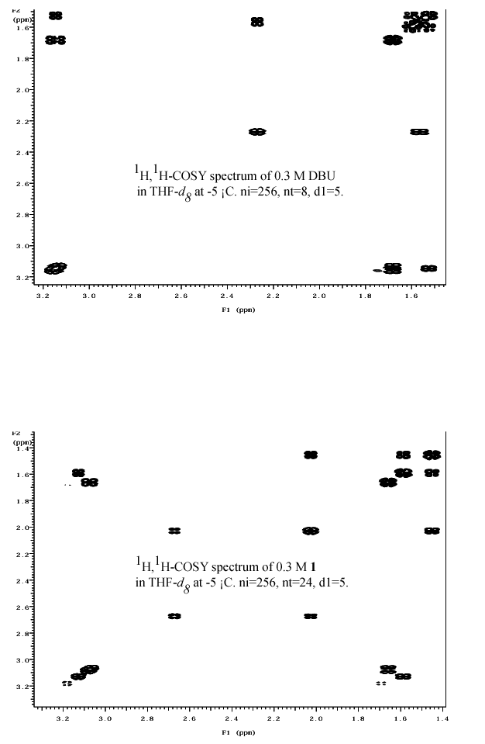
Other possible structures of the homodimer 12 of lithiated DBU 11.

