Supplementary data

A Screw Sense Preference of Nonpolar L-Amino Acid Residue
Second from N-Terminal Position

Yoshihito Inai,* Yuji Kurokawa, and Takahiro Kojima

Department of Environmental Technology and Urban Planning,
Graduate School of Engineering, Nagoya Institute of Technology,
Gokiso-cho, Showa-ku, Nagoya 466-8555, Japan

Main-chain energy contour map of X* for Ac-Aib-X*-(Aib-Δ^{Z}Phe)₂-Aib-OMe (X* = L-Ala, L-Val, L-Phe, and L-Nap) in the lowest-energy left-handed helix (a) or right-handed helix (b) shown in Table 3. The contours are drawn in 0.5 kcal mol⁻¹ increments from the minimum points (55°, 65°) for (a) and (-65°, -50°) for (b) to 5 kcal mol⁻¹. For X* = L-Leu, see ref. 17.
X* = L-Ala
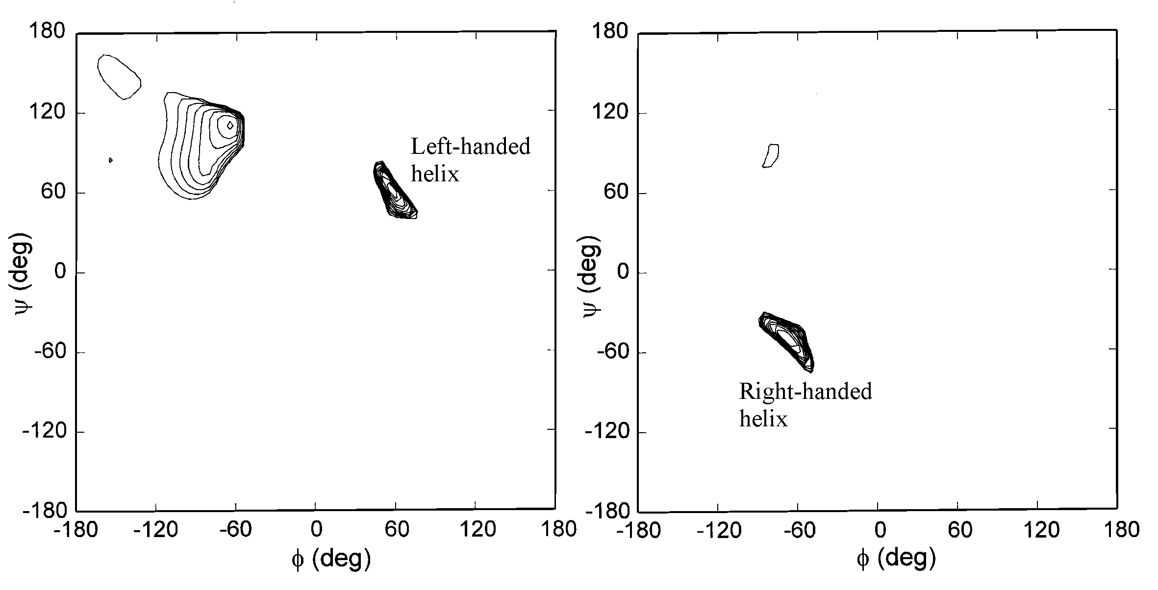
(a) (b)

X* = L-Val
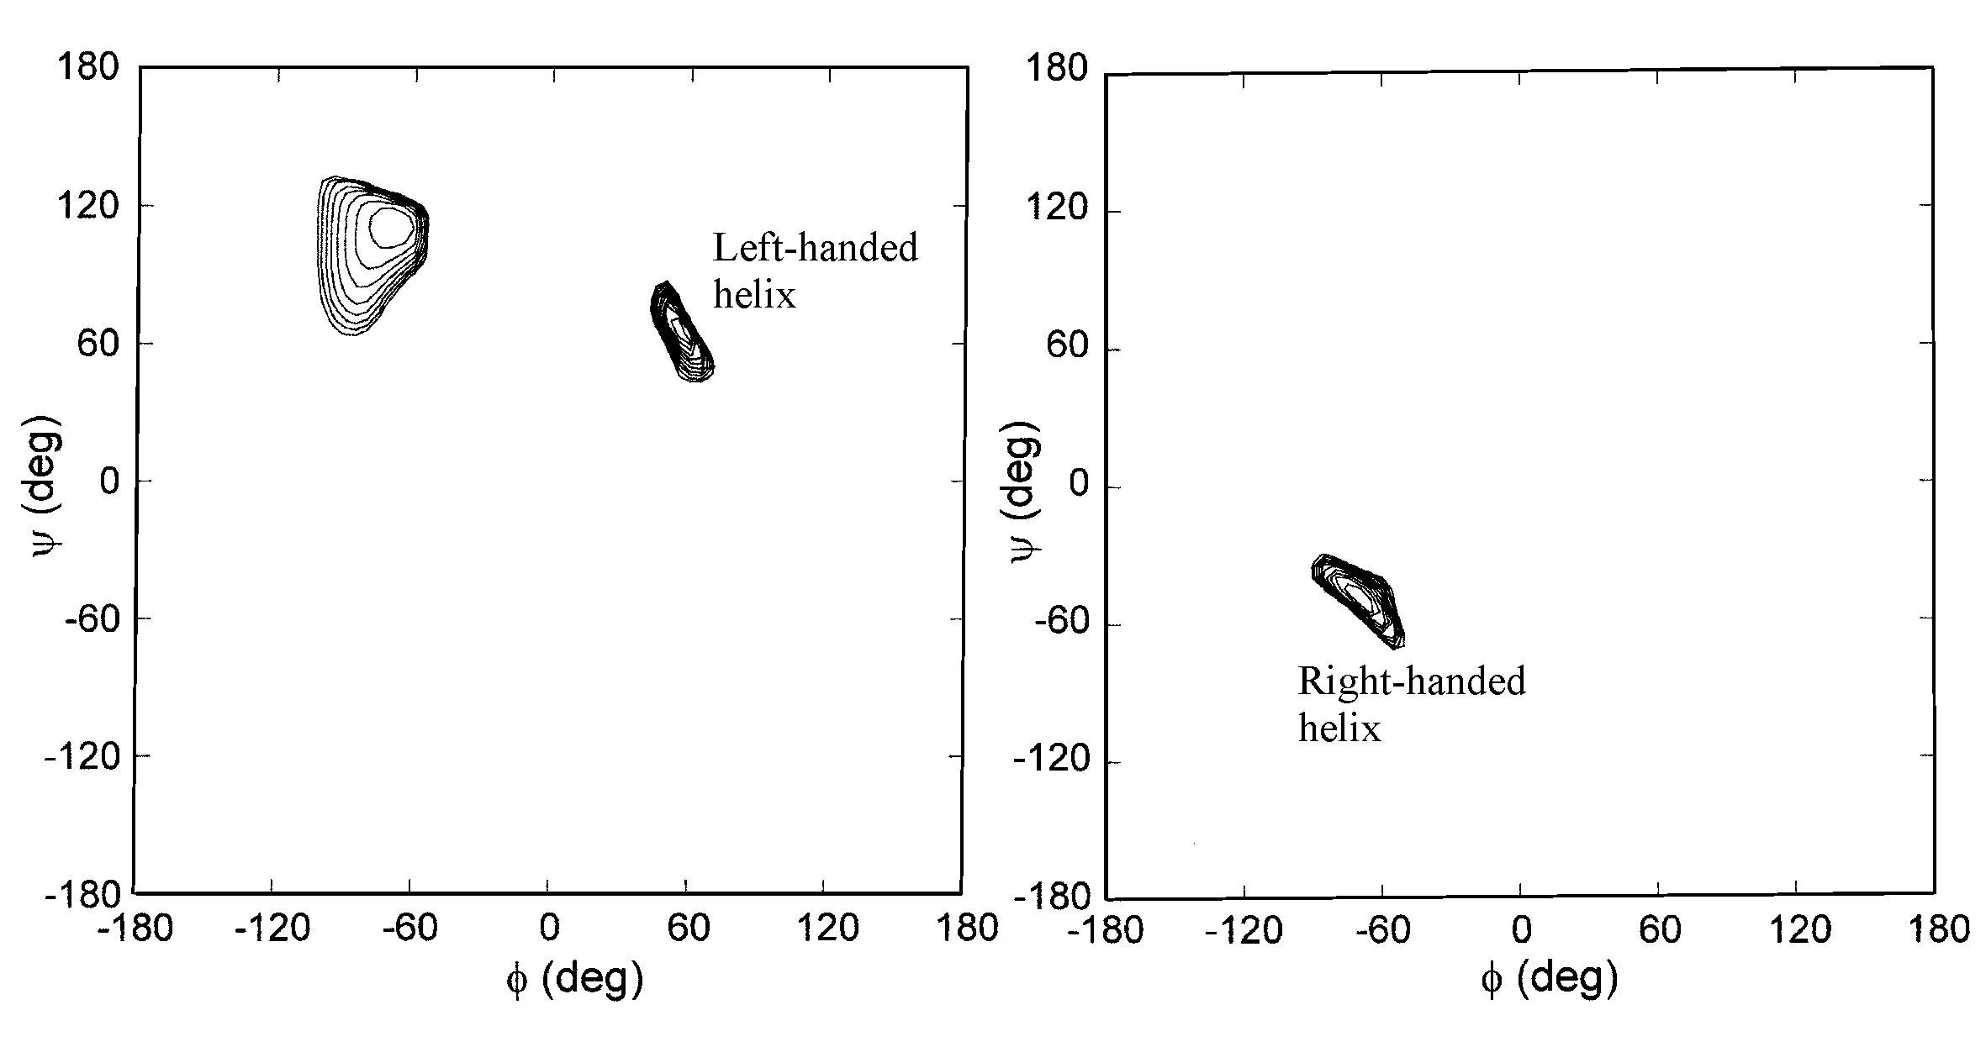
(a) (b)

X* = L-Phe
(a) (b)
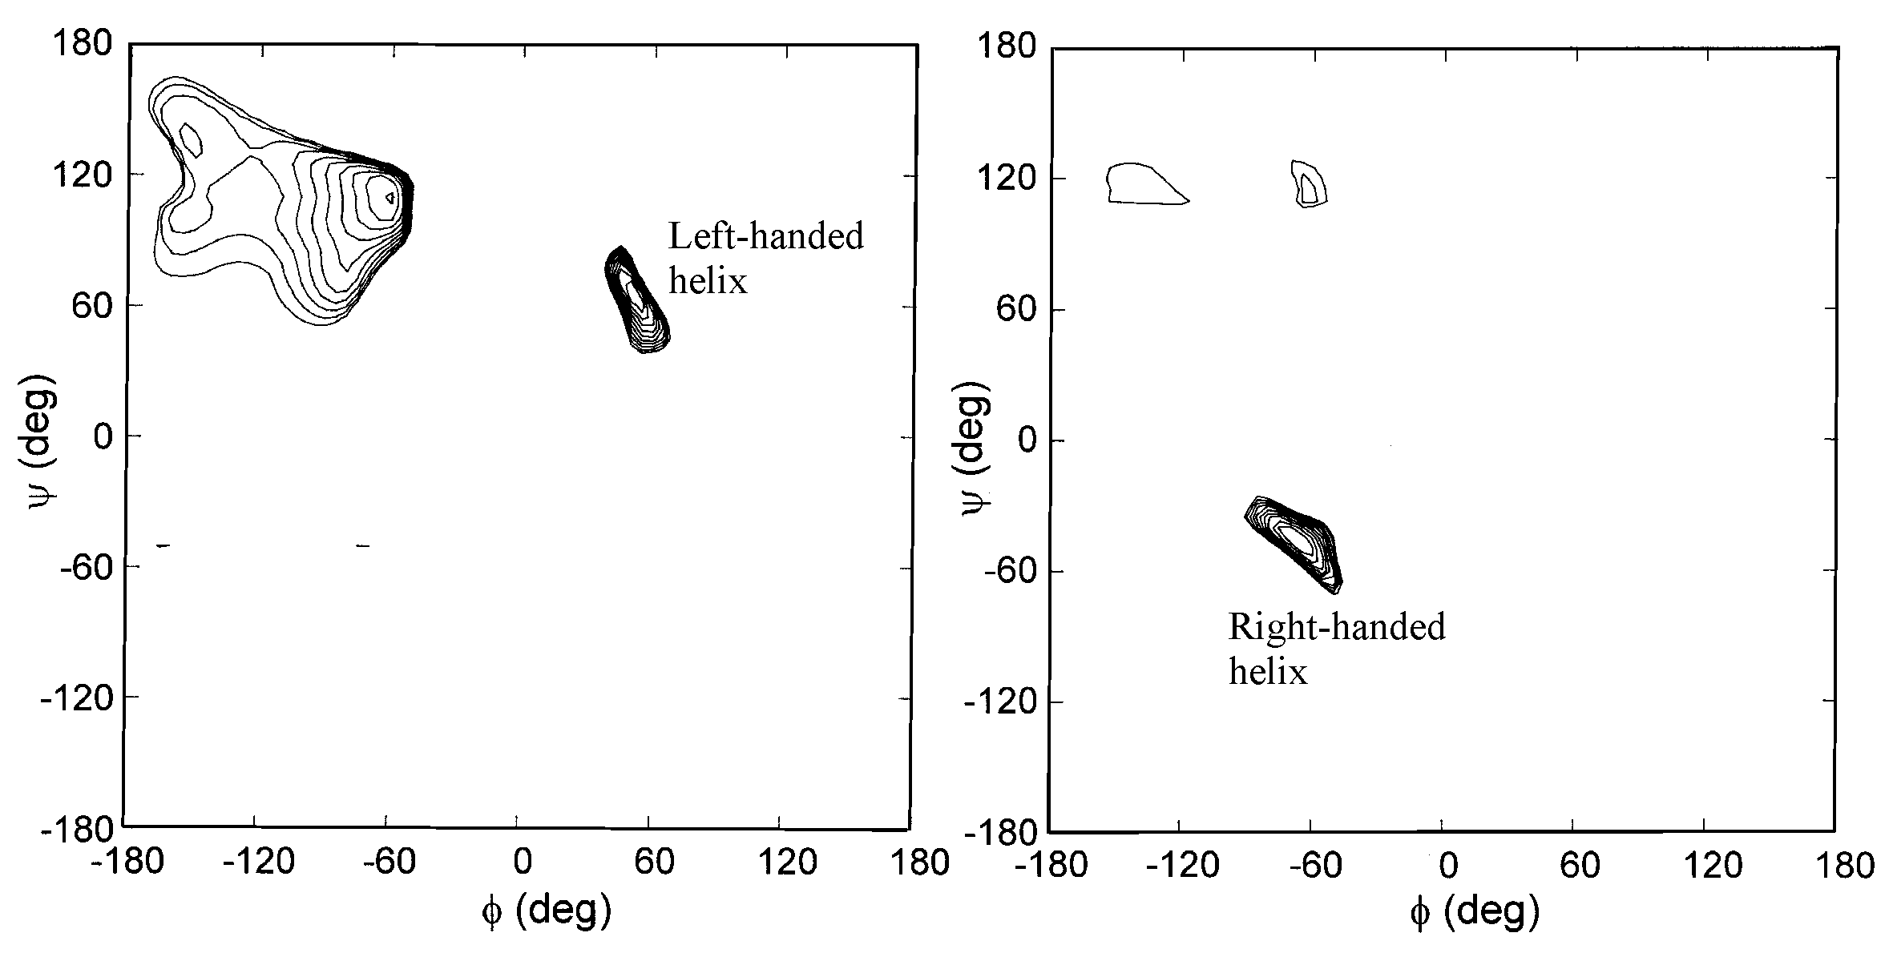
X* = L-Nap
(a) (b)
