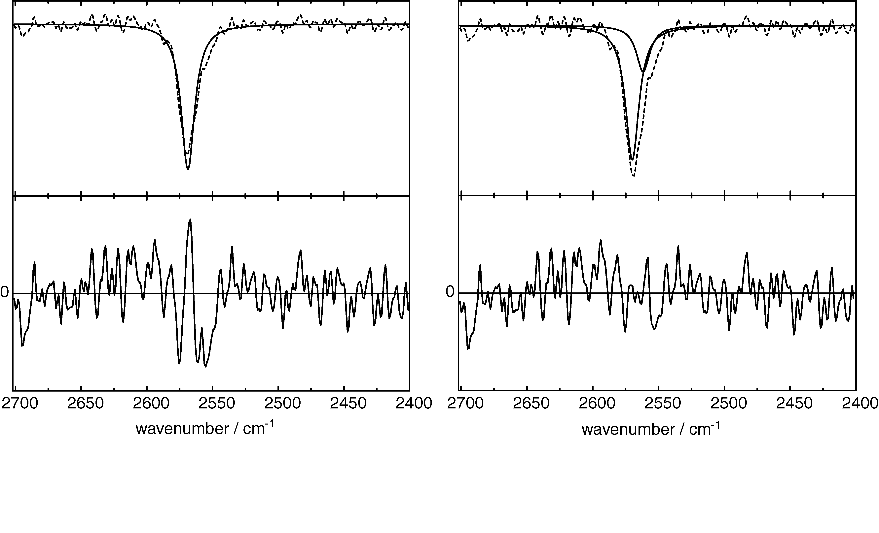

Fig S1: (Top) Lorentzian fitting to the IR difference spectrum of LOV1 in the S-H stretching region. Solid lines indicate the fit with one (left panel) and with the sum of two Lorentzians (right). (Bottom) Residuals of the fits magnified by a factor of 6.5.

