Electronic Supplementary Information
Carbohydrate globules: molecular asterisk-cored dendrimers for carbohydrate presentation.†
Lucy G. Weaver,ª Yogendra Singh,ª George Vamvounis,^{b} Mark F. Wyatt,^{c} Paul L. Burn,^{b*} and Joanne T. Blanchfield^{a*}
ª The School of Chemistry and Molecular Biosciences, University of Queensland, St Lucia, QLD 4072, Australia
^{b} Centre for Organic Photonics & Electronics, University of Queensland, St Lucia, QLD 4072, Australia
^{c} EPSRC National Mass Spectrometry Service Centre (NMSSC), College of Medicine, Swansea University, Swansea, SA2 8PP, UK
*Corresponding Author. E-mail: p.burn2@uq.edu.au; j.blanchfield@uq.edu.au.

Table of Contents.
Experimental materials and methods S4
Experimental procedures S6
¹H NMR spectrum of Compound 1 (500 MHz; CDCl₃) S17
¹³C NMR spectrum of Compound 1 (125 MHz; CDCl₃) S17
2D-TOCSY NMR spectrum of Compound 1 (500 MHz; CDCl₃) S18
HSQC NMR spectrum of Compound 1 (500 MHz; CDCl₃) S18
¹H NMR spectrum of Compound 2 (500 MHz; CDCl₃) S19
¹³C NMR spectrum of Compound 2 (125 MHz; CDCl₃) S19
HSQC NMR spectrum of Compound 2 (500 MHz; CDCl₃) S20
¹H NMR spectrum of Compound 3 (500 MHz; CDCl₃) S20
¹³C NMR spectrum of Compound 3 (125 MHz; CDCl₃) S21
COSY NMR spectrum of Compound 3 (500 MHz; CDCl₃) S21
HSQC NMR spectrum of Compound 3 (500 MHz; CDCl₃) S22
HMBC NMR spectrum of Compound 3 (500 MHz; CDCl₃) S22
GPC trace – Compound 3 S23
¹H NMR spectrum of Compound 4 (400 MHz; CDCl₃) S24
¹³C NMR spectrum of Compound 4 (100 MHz; CDCl₃) S24
COSY NMR spectrum of Compound 4 (500 MHz; CDCl₃) S25
HSQC NMR spectrum of Compound 4 (500 MHz; CDCl₃) S25
GPC trace – Compound 4 S26
¹H NMR spectrum of Compound 9 (500 MHz; CD₃OD) S27
HSQC NMR spectrum of Compound 9 (500 MHz; CD₃OD) S27
¹H NMR spectrum of Compound 10 (400 MHz; CDCl₃/CD₃OD) S28
2D-TOCSY NMR spectrum of Compound 10 (500 MHz; CDCl₃/CD₃OD) S28
HSQC NMR spectrum of Compound 10 (500 MHz; CDCl₃/CD₃OD) S29
MALDI-TOF mass spectrum of Compound 10 S29
¹H NMR spectrum of Compound 11 (500 MHz; CDCl₃/CD₃OD) S30
COSY NMR spectrum of Compound 11 (500 MHz; CDCl₃/CD₃OD) S30
2D-TOCSY NMR spectrum of Compound 11 (500 MHz; CDCl₃/CD₃OD) S31
HSQC NMR spectrum of Compound 11 (500 MHz; CDCl₃/CD₃OD) S31
MALDI-TOF mass spectrum of Compound 11 S32
¹H NMR spectrum of Compound 12 (500 MHz; CDCl₃/CD₃OD) S32
2D-TOCSY NMR spectrum of Compound 12 (500 MHz; CDCl₃/CD₃OD) S33
HSQC NMR spectrum of Compound 12 (500 MHz; CDCl₃/CD₃OD) S33
¹H NMR spectrum of Compound 13 (500 MHz; D₂O; water suppressed) S34
HSQC NMR spectrum of Compound 13 (500 MHz; D₂O) S34
¹H NMR spectrum of Compound 14 (500 MHz; D₂O; water suppressed) S35
HSQC NMR spectrum of Compound 14 (500 MHz; D₂O) S35
¹H NMR spectrum of Compound 15 (500 MHz; D₂O; water suppressed) S36
HSQC NMR spectrum of Compound 15 (500 MHz; D₂O) S36
Normalised UV-Visible absorption spectra for compounds 3, 13, 14, and 15 S37
Table S1 - UV-Visible absorption spectroscopy data for compounds 3, 13, 14, and 15 and calculated molar extinction coefficients S37
Experimental materials and methods.
Materials obtained commercially were reagent grade unless otherwise stated. Tetrahydrofuran was distilled from sodium-benzophenone ketyl prior to use. Anhydrous dichloromethane and toluene were obtained by distillation from calcium hydride. Thin layer chromatography (TLC) was performed on aluminium-backed silica plates and were visualised in either anisidine phthalate dip or under a UV lamp. Flash column chromatography was performed using silica gel 60 (0.04-0.06 mm, 230-400 mesh, Scharlau or Merck) unless otherwise stated. High-resolution mass spectrometry (HR-ESIMS) was performed in positive electrospray ionization mode. Matrix-Assisted Laser Desorption Ionisation -Time of Flight Mass Spectrometric (MALDI-TOF) analyses were performed in positive-reflectron mode with dithranol/NaOAc matrix for compounds 3, 10, 11 and 12, and with DCTB matrix for compound 4. UV-Visible absorption measurements were recorded on a Perkin Elmer Lambda 35 Spectrometer. Gel Permeation Chromatography for all compounds was carried out on a Polymer Laboratory Gel Permeation Chromatograph (PL-GPC 50), fitted with two PL-gel 3μm MIXED-E columns (7.5 x 300 mm; Polymer Laboratories) held in series and at a constant temperature of 40 °C for all analyses. Tetrahydrofuran was used as the eluent, under a flow rate of 0.5 mL/min. Calibration was carried out using narrow molecular weight polystyrene standards (PDI < 1.1) ranging between 162-38,000 gmol⁻¹. Sample detection was achieved using a Polymer Laboratories 410 refractive index detector and a Polymer Laboratories Photodiode Array Detector (254 nm), which were connected in series. Hydrodynamic radii were calculated from the GPC viscosity molecular weight and intrinsic viscosity values for polystyrene in THF using the Hester-Mitchell equation, under the assumption that the hydrodynamic volume of the constructs is the same as the hydrodynamic volume of a polystyrene standard with the same elution time. Intrinsic viscosity measurements were calculated from the analytical GPC using the Mark-Houwink relationship [η]=KMw^{α}, as the constants α and K are known to be 0.725 and 11x10⁻⁵ dl g⁻¹, respectively, for polystyrene in THF at 25 °C.²⁴ NMR spectra were recorded on either a 400 MHz or 500 MHz spectrometer. Proton and carbon assignments were made using COSY, HSQC and HMBC experiments. Spectra of experiments run in CDCl₃ were referenced to residual CHCl₃ at δ 7.26 ppm for ¹H NMR and to CDCl₃ at δ 77.0 ppm for ¹³C NMR. Coupling constants are quoted to the nearest 0.5 Hz. ¹H assignments: s-Ph-H = surface phenyl H, G1-b-Ph-H = first generation branching phenyl H, l-Ph-H = linking phenyl H, THP-H = tetrahydropyranyl H. ¹³C assignments: s-Ph-C = surface phenyl quat. C, G1-b-Ph-C = first generation branching phenyl quat. C, l-Ph-C = linking phenyl quat. C, THP-CH = tetrahydropyranyl CH.
Experimental procedures.
1-Bromo-[3,5-bis(4-(3-tetrahydro-2H-pyranpropoxy)phenyl]benzene (1)
A small amount of 2-[3-(4-bromophenoxy)propoxy]tetrahydro-2H-pyran¹⁵ (6.3 g, 20 mmol) in tetrahydrofuran (25 mL) was added to a mixture of magnesium turnings (0.48 g, 20 mmol) and anhydrous tetrahydrofuran (50 mL) under argon. The Grignard reaction was initiated by gentle heating and then the remainder of the bromide was added over 1 h. The reaction mixture was then heated at reflux for 2 h. After allowing to cool to room temperature a solution of 2,4,6-tribromoiodobenzene¹⁶ (2.17 g, 4.92 mmol) in tetrahydrofuran (25 mL) was added over 1 h and the mixture was heated at reflux for 48 h. The reaction mixture was then cooled to room temperature, quenched with solid sodium sulfate decahydrate, filtered and the solvent removed. The residue was purified by flash column chromatography over silica using petroleum spirit (40-60 °C) containing increasing quantities of ethyl acetate as eluent to give 1 as a colourless oil (1.86 g, 60%). Elem. Anal. Found: C, 65.3; H, 6.5. C₃₄H₄₁BrO₆ requires C, 65.3; H, 6.6%; λ_{max} (THF)/nm 272 (log ε/dm³ mol⁻¹ cm⁻¹ 4.64) and 217 (4.63); δ_{H} (500 MHz; CDCl₃) 1.49-1.62 (8 H, m, THP-H), 1.69-1.76 (2 H, m, THP-H), 1.78-1.88 (2 H, m, THP-H), 2.11 (4 H, m, propyl-CH₂), 3.48-3.54 (2 H, m, THP-H) 3.60 (2 H, dt, J 10, 6.5 Hz, propyl-CH₂), 3.84-3.89 (2 H, m, THP-H), 3.95 (2 H, dt, J 10, 6.5 Hz, propyl-CH₂), 4.10-4.17 (4 H, m, propyl-CH₂), 4.62 (2 H, dd, J 4.5, 3 Hz, THP-H), 6.99 and 7.52 (8 H, AA’BB’, s-Ph-H), 7.61 (2 H, d, J 1.5 Hz, G1-b-Ph-H), 7.62 (1 H, dd, J 1.5 Hz, G1-b-Ph-H); δ_{C} (125 MHz; CDCl₃) 19.6 (THP-CH₂), 25.4 (THP-CH₂), 29.7 (propyl-CH₂), 30.7 (THP-CH₂), 62.3 (THP-CH₂), 63.9 (propyl-CH₂), 65.0 (propyl-CH₂), 98.9 (THP-CH), 114.9 (Ph-CH), 123.1 (Ph-C), 123.8 (Ph-CH), 127.8 (Ph-CH), 128.2 (Ph-CH), 132.2 (Ph-C), 143.2 (Ph-C), 159.1 (Ph-C); HR-ESIMS: m/z 647.1985 / 649.1972. C₃₄H₄₁BrNaO₆ [M+Na]⁺ requires m/z 647.1979 / 649.1958.

2-(3,5-Bis[4-(3-tetrahydro-2H-pyranpropoxy)phenyl]benzene)-4,4,5,5-tetramethyl-1,3,2-dioxaborolane (2)
n-Butyllithium (1.1 M in hexane, 2.30 mL, 2.53 mmol) was added dropwise to a solution of 1 (1.2 g, 2.0 mmol) in anhydrous tetrahydrofuran (25 mL) at -78 °C under argon. After stirring the mixture at -78 °C for a further 1.5 h 2-isopropoxy-4,4,5,5-tetramethyl-1,3,2-dioxaborolane (0.55 mL, 2.64 mmol) was added. The reaction mixture was then allowed to warm to room temperature and stirred for a further 15 h. The solvent was removed and the residue was taken up in diethyl ether (250 mL) and washed with water (3 x 100 mL). The organic layer was dried over anhydrous magnesium sulfate, filtered and the solvent removed. The residue was purified by flash column chromatography over silica using petroleum spirit (40-60 °C) containing increasing quantities of diethyl ether as eluent to give 2 as a colourless oil (1.08 g, 84%). Elem. Anal. Found C, 71.2; H, 7.8. C₄₀H₅₃BO₈ requires C, 71.4; H, 7.9%; λ_{max} (THF)/nm 280 (log ε/dm³ mol⁻¹ cm⁻¹ 4.00); δ_{H} (500 MHz; CDCl₃) 1.38 (12 H, s, 4 x Me), 1.49-1.64 (8 H, m, THP-H), 1.70-1.77 (2 H, m, THP-H), 1.79-1.88 (2 H, m, THP-H), 2.12 (4 H, m, propyl-CH₂), 3.49-3.55 (2 H, m, THP-H), 3.61 (2 H, dt, J 10, 6.5 Hz, propyl-CH₂), 3.84-3.90 (2 H, m, THP-H), 3.96 (2 H, dt, J 10, 6.5 Hz, propyl-CH₂), 4.11-4.17 (4 H, m, propyl-CH₂), 4.63 (2 H, dd, J 4, 3 Hz, THP-H), 7.00 and 7.62 (8 H, AA’BB’, s-Ph-H), 7.84 (1 H, dd, J 2, 2 Hz, G1-b-Ph-H), 7.97 (2 H, d, J 2 Hz, G1-b-Ph-H); δ_{C} (125 MHz; CDCl₃) 19.5 (THP-CH₂), 24.8 (4 x Me), 25.4 (THP-CH₂), 29.6 (propyl-CH₂), 30.6 (THP-CH₂), 62.2 (THP-CH₂), 63.9 (propyl-CH₂), 64.9 (propyl-CH₂), 83.8 (Me₂C), 98.8 (THP-CH), 114.6 (Ph-CH), 127.9 (Ph-CH), 128.2 (Ph-CH), 131.4 (Ph-CH), 133.5 (Ph-C), 140.6 (Ph-C), 158.5 (Ph-C); HR-ESIMS: m/z 695.3722. C₄₀H₅₃BNaO₈ [M+Na]⁺ requires m/z 695.3726.
1,2,3,4,5,6-Hexakis-[4-(3,5-bis[4-(3-tetrahydro-2H-pyranpropoxy)phenyl]phenyl)phenyl]benzene (3)
A mixture of 2 (358 mg, 0.53 mmol), hexakis(4-iodophenyl)benzene¹⁷ (70 mg, 0.06 mmol), tetra-n-butylammonium hydroxide30H₂O [1.6 g in H₂O (6.4 mL)] and toluene (20 mL) was degassed-purged three times in a Schlenk tube, and then purged with argon for a further 20 min. Tetrakis(triphenyl)phosphine palladium(0) (45 mg, 0.04 mmol) was added and the mixture was purged with argon for another 5 min. The reaction mixture was then heated at reflux under argon for 4 d before being allowed to cool to room temperature. The organic layer was separated and the aqueous layer was extracted with dichloromethane (3 x 15 mL). The combined extract was dried over anhydrous magnesium sulfate, filtered and the solvent removed. The residue was dissolved in dichloromethane, adsorbed on silica and purified by flash column chromatography over silica using diethyl ether containing increasing quantities of dichloromethane as eluent. The desired 3 eluted in a 30-40% dichloromethane/diethyl ether mixture, and was obtained as a white solid (133 mg, 60%). mp 178-180 °C (dec.); λ_{max} (THF)/nm 275 (log ε/dm³ mol⁻¹ cm⁻¹ 5.53) and 215 (5.50); δ_{H} (500 MHz; CDCl₃) 1.46-1.62 (48 H, m, THP-H), 1.67-1.74 (12 H, m, THP-H), 1.75-1.86 (12 H, m, THP-H), 2.07 (24 H, m, propyl-CH₂), 3.46-3.53 (12 H, m, THP-H), 3.58 (12 H, dt, J 10, 6.5 Hz, propyl-CH₂), 3.81-3.87 (12 H, m, THP-H), 3.92 (12 H, dt, J 10, 6.5 Hz, propyl-CH₂), 4.02-4.12 (24 H, m, propyl-CH₂), 4.60 (12 H, dd, J 4.5, 3 Hz, THP-H), 6.88 and 7.48 (48 H, AA’BB’, s-Ph-H), 7.06 and 7.32 (24 H, AA’BB’, l-Ph-H), 7.55 (18 H, m, G1-b-Ph-H); δ_{C} (125 MHz; CDCl₃) 19.6 (THP-CH₂), 25.4 (THP-CH₂), 29.7 (propyl-CH₂), 30.7 (THP-CH₂), 62.3 (THP-CH₂), 64.0, (propyl-CH₂), 65.0 (propyl-CH₂), 98.9 (THP-CH), 114.7 (s-Ph-CH), 123.6 (G1-b-Ph-CH), 124.0 (G1-b-Ph-CH), 125.5 (l-Ph-CH), 128.2 (s-Ph-CH), 132.0 (l-Ph-CH), 133.7 (G1-b-Ph-C), 137.6 (G1-b-Ph-C), 139.9 (l-Ph-C), 140.4 (l-Ph-C), 141.4 (c-Ph-C), 141.7 (s-Ph-C), 158.6 (s-Ph-C); MALDI-TOF: m/z 3824.8. C₂₄₆H₂₇₀NaO₃₆ [M+Na]⁺ requires m/z 3824.9; GPC: Mn: 3835; Mw: 3846; PDI: 1.00.
1,2,3,4,5,6-Hexakis[4-(3,5-bis[4-(3-[propargyloxy]propoxy)phenyl]phenyl)phenyl]benzene (4)
A solution of 3 (47.1 mg, 12.4 µmol) in a mixture of distilled tetrahydrofuran/methanol (2:1, 10 mL) was stirred with concentrated hydrochloric acid (32%, 10 drops) in the dark at room temperature for 19 h. The solvent was removed under reduced pressure and the residue was dried thoroughly under high vacuum to give the intermediate dendrimer containing twelve hydroxyl surface groups as a white solid (34.6 mg, quant.). v_{max}/cm⁻¹ 3350 (OH), 2925 (-CH₂), 1510 and 824 (Ph-H), and 1235 (C-O); δ_{H} (400 MHz; (CD₃)₂OS) 1.85 (24 H, quin., propyl-CH₂), 3.54 (24 H, q, J 6.5, 5.5 Hz, propyl-CH₂), 3.99 (24 H, t, J 6.5, 6.0 Hz, propyl-CH₂), 4.53 (12 H, t, J 5.0 Hz, CH₂OH), 6.88 and 7.58 (48 H, AA’BB’, s-Ph-H), 7.18 and 7.47 (24 H, AA’BB’, l-Ph-H), 7.54 (18 H, br s, G1-b-Ph-H).

A solution of 1,2,3,4,5,6-hexakis[4-(3,5-bis[4-(3-[hydroxy]propoxy)phenyl]phenyl)phenyl]benzene (34.6 mg, 12.4 µmol) in dry tetrahydrofuran (12 mL) and dry N,N-dimethylformamide (0.2 mL) was cooled in an ice-water bath under anhydrous conditions. Sodium hydride (60% dispersion in oil, 33.3 mg, 0.83 mmol) was added to the reaction mixture and stirred for 1 h at room temperature. The reaction mixture was then cooled in an ice-water bath before propargyl bromide (80% wt in toluene, 0.1 mL, 0.90 mmol) was added and the reaction mixture was allowed to warm to room temperature. A catalytic amount of tetra-n-butylammonium iodide was added, followed by 15-crown-5 ether (0.17 mL, 0.86 mmol) before the reaction vessel was purged with dry argon, sealed, and stirred for 4 d, protected from light. After this time, the excess sodium hydride was quenched with 2-propanol (4 drops) and the solvent was removed under reduced pressure. The crude product was purified using flash column chromatography over silica (Davisil® LC150Å 35-70 μm) with diethyl ether containing increasing quantities of dichloro-methane as the eluent. The title compound 4 eluted in 20-30% dichloromethane/diethyl ether and was dried to give a cream-coloured solid (12.2 mg, 30%). λ_{max} (THF)/nm: 274 (log ε/dm³ mol⁻¹ cm⁻¹ 5.46); v_{max}/cm⁻¹ 3285 and 2116 (C≡CH), 2930 (-CH₂), 1509 and 825 (Ph-H), 1236 and 1092 (C-O); δ_{H} (400 MHz; CDCl₃) 2.07 (24 H, quin., J 6.2, 6.0 Hz, propyl-CH₂), 2.41 (12 H, t, ⁴J 2.4 Hz, HC≡C-CH₂), 3.70 (24 H, t, J 6.0 Hz, propyl-CH₂), 4.04 (24 H, t, J 6.2 Hz, propyl-CH₂), 4.15 (24 H, d, ⁴J 2.4 Hz, HC≡C-CH₂), 6.88 and 7.48 (48 H, AA’BB’, s-Ph-H), 7.05 and 7.32 (24 H, AA’BB’, l-Ph-H), 7.55 (18 H, br s, G1-b-Ph-H); δ_{C} (100 MHz; CDCl₃) 29.5 (propyl-CH₂), 58.2 (HC≡C-CH₂), 64.7 (propyl-CH₂), 66.7 (propyl-CH₂), 74.3 (HC≡C-CH₂), 79.8 (HC≡C-CH₂), 114.7 (s-Ph-CH), 123.6 (G1-b-Ph-CH), 124.0 (G1-b-Ph-CH), 125.5 (l-Ph-CH), 128.2 (s-Ph-CH), 132.0 (l-Ph-CH), 133.7 (Ph-C-), 137.6 (Ph-C-), 140.0 (Ph-C-), 141.6 (Ph-C-), 158.5 (Ph-C-); MALDI-TOF: m/z 3249.4. C₂₂₂H₁₉₈O₂₄ M^{+•} requires m/z = 3249.4; GPC: Mn: 3991; Mw: 4032; PDI: 1.01.

1,2,3,4,5,6-Hexakis[4-(3,5-bis[4-(3-[1-(6-O-[2-acetamido-3,4,6-tri-O-acetyl-2-deoxy-β-D-glucopyranosyl]-2-acetamido-3,4-di-O-acetyl-2-deoxy-β-D-glucopyranosyl)-1H-1,2,3-triazol-4-yl]propoxy)phenyl]phenyl)phenyl]benzene (9)
A solution of 6-O-[3,4,6-tri-O-acetyl-2-acetamido-2-deoxy-β-D-glucopyranosyl]-3,4-di-O-acetyl-2-acetamido-2-deoxy-β-D-glucopyranosyl azide^{23b} 5 (40.6 mg, 61.6 µmol) in a mixture of toluene (0.5 mL) and N,N-dimethylformamide (0.4 mL) was added to a solution of 4 (11.1 mg, 3.42  µmol) in toluene (1 mL) under an atmosphere of argon. N,N,N’,N”,N”-pentamethyldiethylenetriamine (14 µL, 67.1 µmol) was then added, and the reaction mixture was purged with argon for 20 min. Copper(I) bromide (9.3 mg, 64.6 µmol) was added and the mixture was purged for a further 3 min before being left to stir at room temperature for 6 d, protected from light. Air was slowly bubbled through the dark green solution for 10 min and the resultant mixture was filtered through Celite® using dichloromethane and N,N-dimethylformamide as eluents to remove the solid copper(II) bromide. The solvent was removed to yield crude 9 (52.3 mg). A methanolic sodium methoxide solution (cat.; 1 mg sodium in 0.5 mL of methanol) was added to a solution of 9 (6.8 mg) in methanol (1 mL). A white precipitate formed immediately, and water (1 mL) was then added and the reaction mixture was stirred at room temperature for 1 h. After this time, strong cation exchange resin was added to neutralise the mixture (pH ~7) and stirred for 5 min. After filtration and removal of the solvent the residue was purified using a solid phase extraction column, washing first with methanol and then gradient elution with increasing amounts of water to 100% water. The hydroxylated conjugate eluted in 50% methanol:water and was lyophilized. The brown solid was then redissolved in water (3 mL), transferred to a dialysis cassette and dialysed in water for 7 d. The water was changed daily. After this time, the purified product was dried to give a brown solid (4.6 mg, 40%, 2 steps). Finally, the hydroxyl intermediate (3.4 mg, 0.39 µmol) was dissolved in a mixture of dry pyridine (1.0 mL) and acetic anhydride (3.3 µL, 35.1 µmol), and stirred under anhydrous conditions at room temperature for 21 h. The solvent was removed and the residue was dried under high vacuum to give 9 as a brown solid (3.1 mg, 71%; 29% overall conversion, 36 reactions). v_{max}/cm⁻¹ 2936 (-CH₂), 1741 (C=O), 1229 and 1035 (C-O), and 827 (Ph-H); δ_{H} (500 MHz; CD₃OD) 1.60-2.23 (276 H, br m, OCOCH₃, NHCOCH₃, propyl-CH₂), 3.37-4.44 (156 H, br m, propyl-CH₂, H-1^{II}, H-2, H-5, H-6), 4.45-4.76 (24 H, br s, O-CH₂-C-), 4.91-5.58 (36 H, br m, H-3, H-4), 5.83 (12 H, br s, H-3), 6.11 (12 H, s, H-1^{I}), 6.24-7.96 (90 H, br m, s-Ph-H, l-Ph-H, G1-b-Ph-H), 8.19 (12 H, s, triazole-H); GPC: Mn: 6840; Mw: 6916; PDI: 1.01.

1,2,3,4,5,6-Hexakis[4-(3,5-bis[4-(3-[1-(6-O-[2-trifluoroacetamido-3,4,6-tri-O-benzoyl-2-deoxy-β-D-glucopyranosyl]-2-acetamido-3,4-di-O-benzoyl-2-deoxy-β-D-glucopyranosyl)-1H-1,2,3-triazol-4-yl]propoxy)phenyl]phenyl)phenyl]benzene (10)
A solution of 6-O-(2-trifluoroacetamido-3,4,6-tri-O-benzoyl-2-deoxy-β-D-glucopyranosyl)-2-acetamido-3,4-di-O-benzoyl-2-deoxy-β-D-glucopyranosyl azide^{23a} 6 (57.9 mg, 56.5 μmol), compound 4 (5.76 mg, 1.77 μmol) and N,N,N’,N”,N”-pentamethyldiethylenetriamine (20.0 µL, 95.8 μmol) in dry toluene (5 mL) and dry N,N-dimethylformamide (0.35 mL) was purged with argon for 20 min. Copper(I) bromide (11.0 mg, 76.6 μmol) was then added and the reaction mixture was purged with argon for a further 5 min, before being sealed, and left to stir at room temperature for 5 d, protected from light. After this time, air was slowly bubbled through the dark green solution for 10 min, the solvent was removed under reduced pressure, and the residue was dried further under high vacuum. The crude product was redissolved in dichloromethane (100 mL) and washed with water (5 x 30 mL). The organic layer was dried with anhydrous magnesium sulfate, filtered and the solvent removed under reduced pressure. The residue was then redissolved in dichloromethane (1.0 mL) and triturated with diethyl ether (40 mL). The precipitate was isolated by centrifugation (3000 rpm, 3 min) and the process was repeated twice more before the solid was dried under high vacuum to give the title compound 10 as a brown solid (19.2 mg, 70%). λ_{max} (THF)/nm 234 (log ε/dm³ mol⁻¹ cm⁻¹ 5.89), 273 (5.27), 282 (5.19), and 313 (4.81); v_{max}/cm⁻¹ 2935 (-CH₂), 1723 (C=O), 1266 and 1068 (C-O), 827 and 707 (Ph-H); δ_{H} (400 MHz; CDCl₃/CD₃OD) 1.46 (36 H, br s, NHCOCH₃), 1.96 (24 H, br s, propyl-CH₂), 3.63 (36 H, br s, propyl-CH₂, H-6), 3.84-4.45 (108 H, br m, propyl-CH₂, H-2, H-5, H-6), 4.46-4.82 (36 H, br m, H-1^{II}, O-CH₂-C-), 5.40-5.71 (36 H, br m, H-3, H-4), 5.90 (12 H, br s, H-3), 6.14 (12 H, br s, H-1^{I}), 6.73 (24 H, br s, s-Ph-H), 6.99 (24 H, br s, s-Ph-H), 7.03-7.57 (222 H, br m, s-Ph-H, l-Ph-H, G1-b-Ph-H, Ph-H), 7.59-7.92 (132 H, br m, Ph-H, triazole-H); GPC: Mn: 9582; Mw: 9694; PDI: 1.01.

1,2,3,4,5,6-Hexakis[4-(3,5-bis[4-(3-[1-(6-O-[6-O-(2-trifluoroacetamido-3,4,6-tri-O-benzoyl-2-deoxy-β-D-glucopyranosyl)-2-trifluoroacetamido-3,4-di-O-benzoyl-2-deoxy-β-D-glucopyranosyl]-2-acetamido-3,4-di-O-benzoyl-2-deoxy-β-D-glucopyranosyl)-1H-1,2,3-triazol-4-yl]propoxy)phenyl]phenyl)phenyl]benzene (11)
A solution of 6-O-[6-O-(2-trifluoroacetamido-3,4,6-tri-O-benzoyl-2-deoxy-β-D-glucopyranosyl)-2-trifluoroacetamido-3,4-di-O-benzoyl-2-deoxy-β-D-glucopyranosyl]-2-acetamido-3,4-di-O-benzoyl-2-deoxy-β-D-glucopyranosyl azide^{23a} 7 (51.3 mg, 34.4 μmol), compound 4 (4.7 mg, 1.43 μmol) and N,N,N’,N”,N”-pentamethyldiethylenetriamine (12.2 µL, 58.5 μmol) in dry toluene (5 mL) and dry N,N-dimethylformamide (0.5 mL) was purged with argon for 20 min. Copper(I) bromide (6.7 mg, 46.8 μmol) was then added and the reaction mixture was purged with argon for a further 5 min, before being sealed, and left to stir at room temperature for 5 d, protected from light. After this time, air was slowly bubbled through the dark green solution for 10 min, the solvent was removed under reduced pressure, and the residue was dried further under high vacuum. The crude product was redissolved in dichloromethane (100 mL) and washed with water (5 x 30 mL). The organic layer was dried with anhydrous magnesium sulfate, filtered and the solvent removed under reduced pressure. The residue was then redissolved in dichloromethane (1.0 mL) and triturated with diethyl ether (40 mL). The precipitate was isolated by centrifugation (3000 rpm, 3 min) and the process was repeated twice more before the solid was dried under high vacuum to give the title compound 11 as a brown solid (27.1 mg, 89%). λ_{max} (THF)/nm 229 (log ε/dm³ mol⁻¹ cm⁻¹ 6.09), 274 (4.73), 283 (4.25), and 316 (4.63); v_{max}/cm⁻¹ 2947 (-CH₂), 1723 (C=O), 1267 and 1067 (C-O), 828 and 707 (Ph-H); δ_{H} (500 MHz; CDCl₃/CD₃OD) 1.51 (36 H, br s, NHCOCH₃), 1.98 (24 H, br s, propyl-CH₂), 3.60 (48 H, br s, propyl-CH₂, H-6), 3.81 (12 H, br s, H-5), 3.87-4.18 (72 H, br m, propyl-CH₂, H-2, H-5, H-6), 4.19-4.45 (48 H, br m, H-2, H-5, H-6), 4.47-4.71 (48 H, br m, O-CH₂-C-, H-1, H-2), 4.77 (12 H, br d, H-1), 5.15 (12 H, br t, H-4), 5.46-5.80 (48 H, br m, H-3, H-4), 5.97 (12 H, br t, H-3), 6.16 (12 H, br s, H-1^{I}), 6.78 (24 H, br s, s-Ph-H), 6.92-7.57 (306 H, br m, s-Ph-H, G1-b-Ph-H, l-Ph-H, Ph-H), 7.61-7.94 (192 H, br m, triazole-H, Ph-H); GPC: Mn: 11354; Mw: 11503; PDI: 1.01.
1,2,3,4,5,6-Hexakis[4-(3,5-bis[4-(3-[1-(6-O-[6-O-(6-O-[2-trifluoroacetamido-3,4,6-tri-O-benzoyl-2-deoxy-β-D-glucopyranosyl]-2-trifluoroacetamido-3,4-di-O-benzoyl-2-deoxy-β-D-glucopyranosyl)-2-trifluoroacetamido-3,4-di-O-benzoyl-2-deoxy-β-D-glucopyranosyl]-2-acetamido-3,4-di-O-benzoyl-2-deoxy-β-D-glucopyranosyl)-1H-1,2,3-triazol-4-yl]propoxy)phenyl]phenyl)phenyl]benzene (12)
A solution of 6-O-[6-O-(6-O-[2-trifluoroacetamido-3,4,6-tri-O-benzoyl-2-deoxy-β-D-glucopyranosyl]-2-trifluoroacetamido-3,4-di-O-benzoyl-2-deoxy-β-D-glucopyranosyl)-2-trifluoroacetamido-3,4-di-O-benzoyl-2-deoxy-β-D-glucopyranosyl]-2-acetamido-3,4-di-O-benzoyl-2-deoxy-β-D-glucopyranosyl azide^{23a} 8 (66.1 mg, 33.8 μmol), compound 4 (4.6 mg, 1.41 μmol) and N,N,N’,N”,N”-pentamethyldiethylenetriamine (12.0 µL, 57.5 μmol) in dry toluene (5 mL) and dry N,N-dimethylformamide (0.5 mL) was purged with argon for 20 min. Copper(I) bromide (6.6 mg, 46.0 μmol) was then added and the reaction mixture was purged with argon for a further 5 min, before being sealed, and left to stir at room temperature for 5 d, protected from light. After this time, air was slowly bubbled through the dark green solution for 10 min, the solvent was removed under reduced pressure, and the residue was dried further under high vacuum. The crude product was redissolved in dichloromethane (100 mL) and washed with water (5 x 30 mL). The organic layer was dried with anhydrous magnesium sulfate, filtered and the solvent removed under reduced pressure. The residue was then redissolved in dichloromethane (1.0 mL) and triturated with diethyl ether (40 mL). The precipitate was isolated by centrifugation (3000 rpm, 3 min) and the process was repeated twice more before the solid was dried under high vacuum to give the title compound 12 as a brown solid (23.2 mg, 62%). λ_{max} (THF)/nm 230 (log ε/dm³ mol⁻¹ cm⁻¹ 6.62), 274 (6.12), and 283 (6.07); v_{max}/cm⁻¹ 2934 (-CH₂), 1721 (C=O), 1268 and 1067 (C-O), 826 and 708 (Ph-H); δ_{H} (500 MHz; CDCl₃/CD₃OD) 1.51 (36 H, br s, NHCOCH₃), 2.02 (24 H, br s, propyl-CH₂), 3.52-4.15 (144 H, br m, propyl-CH₂, H-5, H-6), 4.17-5.02 (156 H, br m, O-CH₂-C-, propyl-CH₂, H-1, H-2, H-5, H-6), 5.27 (12 H, br s, H-4), 5.38-5.58 (24 H, br m, H-3, H-4), 5.60-5.79 (36H, br m, H-3, H-4), 5.85 (12 H, br s, H-3), 6.07 (12 H, br s, H-3), 6.26 (12 H, br s, H-1^{I}), 6.81 (24 H, br s, s-Ph-H), 6.94-7.68 (414 H, br m, s-Ph-H, l-Ph-H, G1-b-Ph-H, Ph-H), 7.74-8.04 (204 H, br m, Ph-H, triazole-H); GPC: Mn: 12494; Mw: 12669; PDI: 1.01.

1,2,3,4,5,6-Hexakis[4-(3,5-bis[4-(3-[1-(6-O-[2-amino-2-deoxy-β-D-glucopyranosyl]-2-acetamido-2-deoxy-β-D-glucopyranosyl)-1H-1,2,3-triazol-4-yl]propoxy)phenyl]phenyl)phenyl]benzene (13)
A solution of the protected disaccharide construct 10 (10.0 mg, 0.64 μmol) in tetrahydrofuran (4 mL) and methanol (2 mL) was treated with aqueous sodium hydroxide solution (0.1 M, 4 mL) at room temperature for 18 h. After this time, aqueous hydrochloric acid solution (0.1 M) was added until pH 6 was reached, and the solvent was then removed. The crude deprotected disaccharide construct was purified by size exclusion chromatography using water as the eluent. The fractions containing the title compound were dried to give 13 as a clear amber solid (3.8 mg, 73%). λ_{abs} (H₂O)/nm: 272 (log ε/M⁻¹cm⁻¹, 5.34); δ_{H} (500 MHz; D₂O; all signals are broad) 1.45-2.15 (60 H, m, propyl-CH₂, NHCOCH₃), 2.70 (12 H, s, H-6^{II}), 3.18-4.74 (228 H, m, O-CH₂-C-, propyl-CH₂, H-1^{II}, H-2, H-3, H-4, H-5, H-6), 5.89 (12 H, s, H-1^{I}), 6.03-8.04 (90 H, s, s-Ph-H, l-Ph-H, G1-b-Ph-H), 8.27 (12 H, s, triazole-H).

1,2,3,4,5,6-Hexakis[4-(3,5-bis[4-(3-[1-(6-O-[6-O-(2-amino-2-deoxy-β-D-glucopyranosyl)-2-amino-2-deoxy-β-D-glucopyranosyl]-2-acetamido-2-deoxy-β-D-glucopyranosyl)-1H-1,2,3-triazol-4-yl]propoxy)phenyl]phenyl)phenyl]benzene (14)
A solution of the protected trisaccharide construct 11 (12.3 mg, 0.58 μmol) in tetrahydrofuran (2 mL) and methanol (1 mL) was treated with aqueous sodium hydroxide solution (0.1 M, 2 mL) at room temperature for 18 h. After this time, aqueous hydrochloric acid solution (0.1 M) was added until pH 6 was reached, and the solvent was then removed. The crude deprotected trisaccharide construct was purified by size exclusion chromatography using water as the eluent. The fractions containing the title compound were dried to give 14 as a clear amber solid (5.3 mg, 90%). λ_{abs} (H₂O)/nm: 272 (log ε/M⁻¹cm⁻¹, 5.33); δ_{H} (500 MHz; D₂O; all signals are broad) 1.43-2.26 (60 H, m, NHCOCH₃, propyl-CH₂), 3.03 (24 H, s, H-6^{III}), 3.34-4.13 (192 H, m, propyl-CH₂, H-2, H-3, H-4, H-5, H-6), 4.15-4.54 (48 H, m, H-6^{I}, H-6^{II}, propyl-CH₂), 4.59-4.97 (48 H, m, H-1^{II}, H-1^{III}, O-CH₂-C-), 5.95 (12 H, s, H-1^{I}), 6.09-8.15 (90 H, s, s-Ph-H, l-Ph-H, G1-b-Ph-H), 8.30 (12 H, s, triazole-H).

1,2,3,4,5,6-Hexakis[4-(3,5-bis[4-(3-[1-(6-O-[6-O-(6-O-[2-amino-2-deoxy-β-D-glucopyranosyl]-2-amino-2-deoxy-β-D-glucopyranosyl)-2-amino-2-deoxy-β-D-glucopyranosyl]-2-acetamido-2-deoxy-β-D-glucopyranosyl)-1H-1,2,3-triazol-4-yl]propoxy)phenyl]phenyl)phenyl]benzene (15)
A solution of the protected tetrasaccharide construct 12 (9.4 mg, 0.35 μmol) in tetrahydrofuran (2 mL) and methanol (1 mL) was treated with aqueous sodium hydroxide solution (0.1 M, 2 mL) at room temperature for 18 h. After this time, aqueous hydrochloric acid solution (0.1 M) was added until pH 6 was reached, and the solvent was then removed. The crude deprotected tetrasaccharide construct was purified by size exclusion chromatography using water as the eluent. The fractions containing the title compound were dried to give 15 as a clear amber solid (2.37 mg, 56%). λ_{abs} (H₂O)/nm: 272 (log ε/M⁻¹cm⁻¹, 5.46); δ_{H} (500 MHz; D₂O; all signals are broad) 1.40-2.18 (60 H, m, NHCOCH₃, propyl-CH₂), 2.95 (24 H, s, H-6^{IV}), 3.17-4.10 (264 H, m, propyl-CH₂, H-2, H-3, H-4, H-5, H-6), 4.15-4.49 (48 H, m, propyl-CH₂, H-6), 4.53-4.83 (60 H, m, O-CH₂-C-, H-1^{II}, H-1^{III}, H-1^{IV}), 5.91 (12 H, s, H-1^{I}), 6.02-8.08 (90 H, s, s-Ph-H, l-Ph-H, G1-b-Ph-H), 8.24 (12 H, s, triazole-H).
¹H NMR spectrum of Compound 1 (500 MHz; CDCl₃)
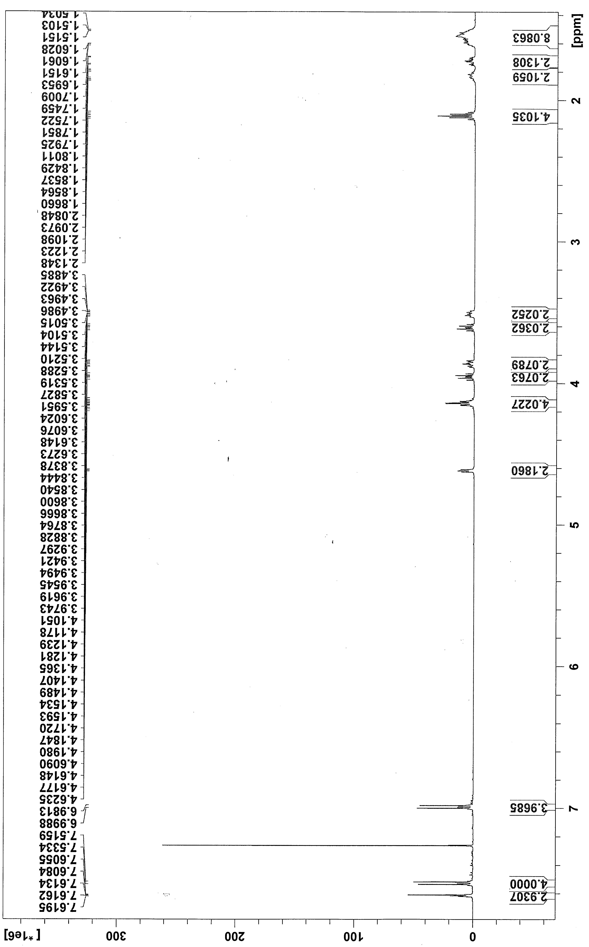
¹³C NMR spectrum of Compound 1 (125 MHz; CDCl₃)
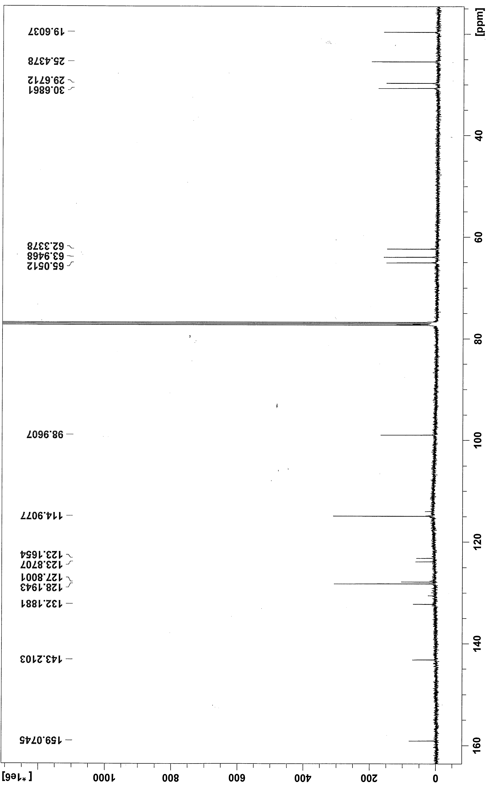
2D-TOCSY NMR spectrum of Compound 1 (500 MHz; CDCl₃)
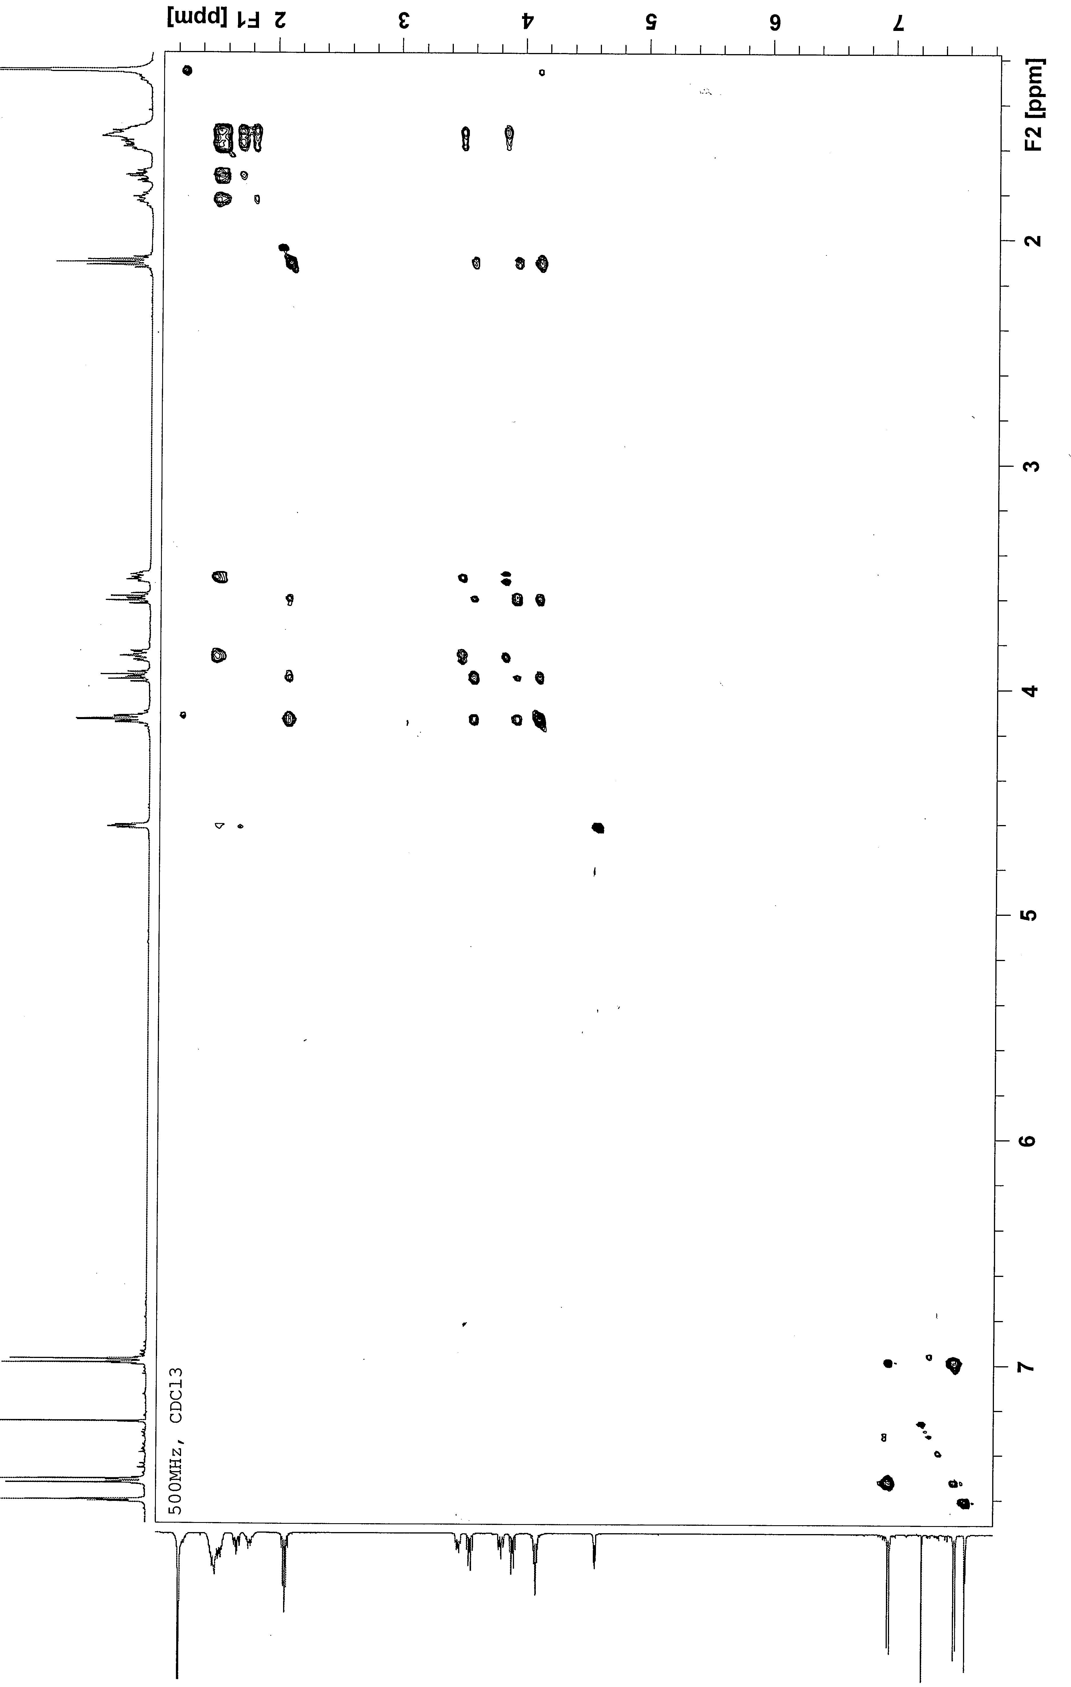
HSQC NMR spectrum of Compound 1 (500 MHz; CDCl₃)
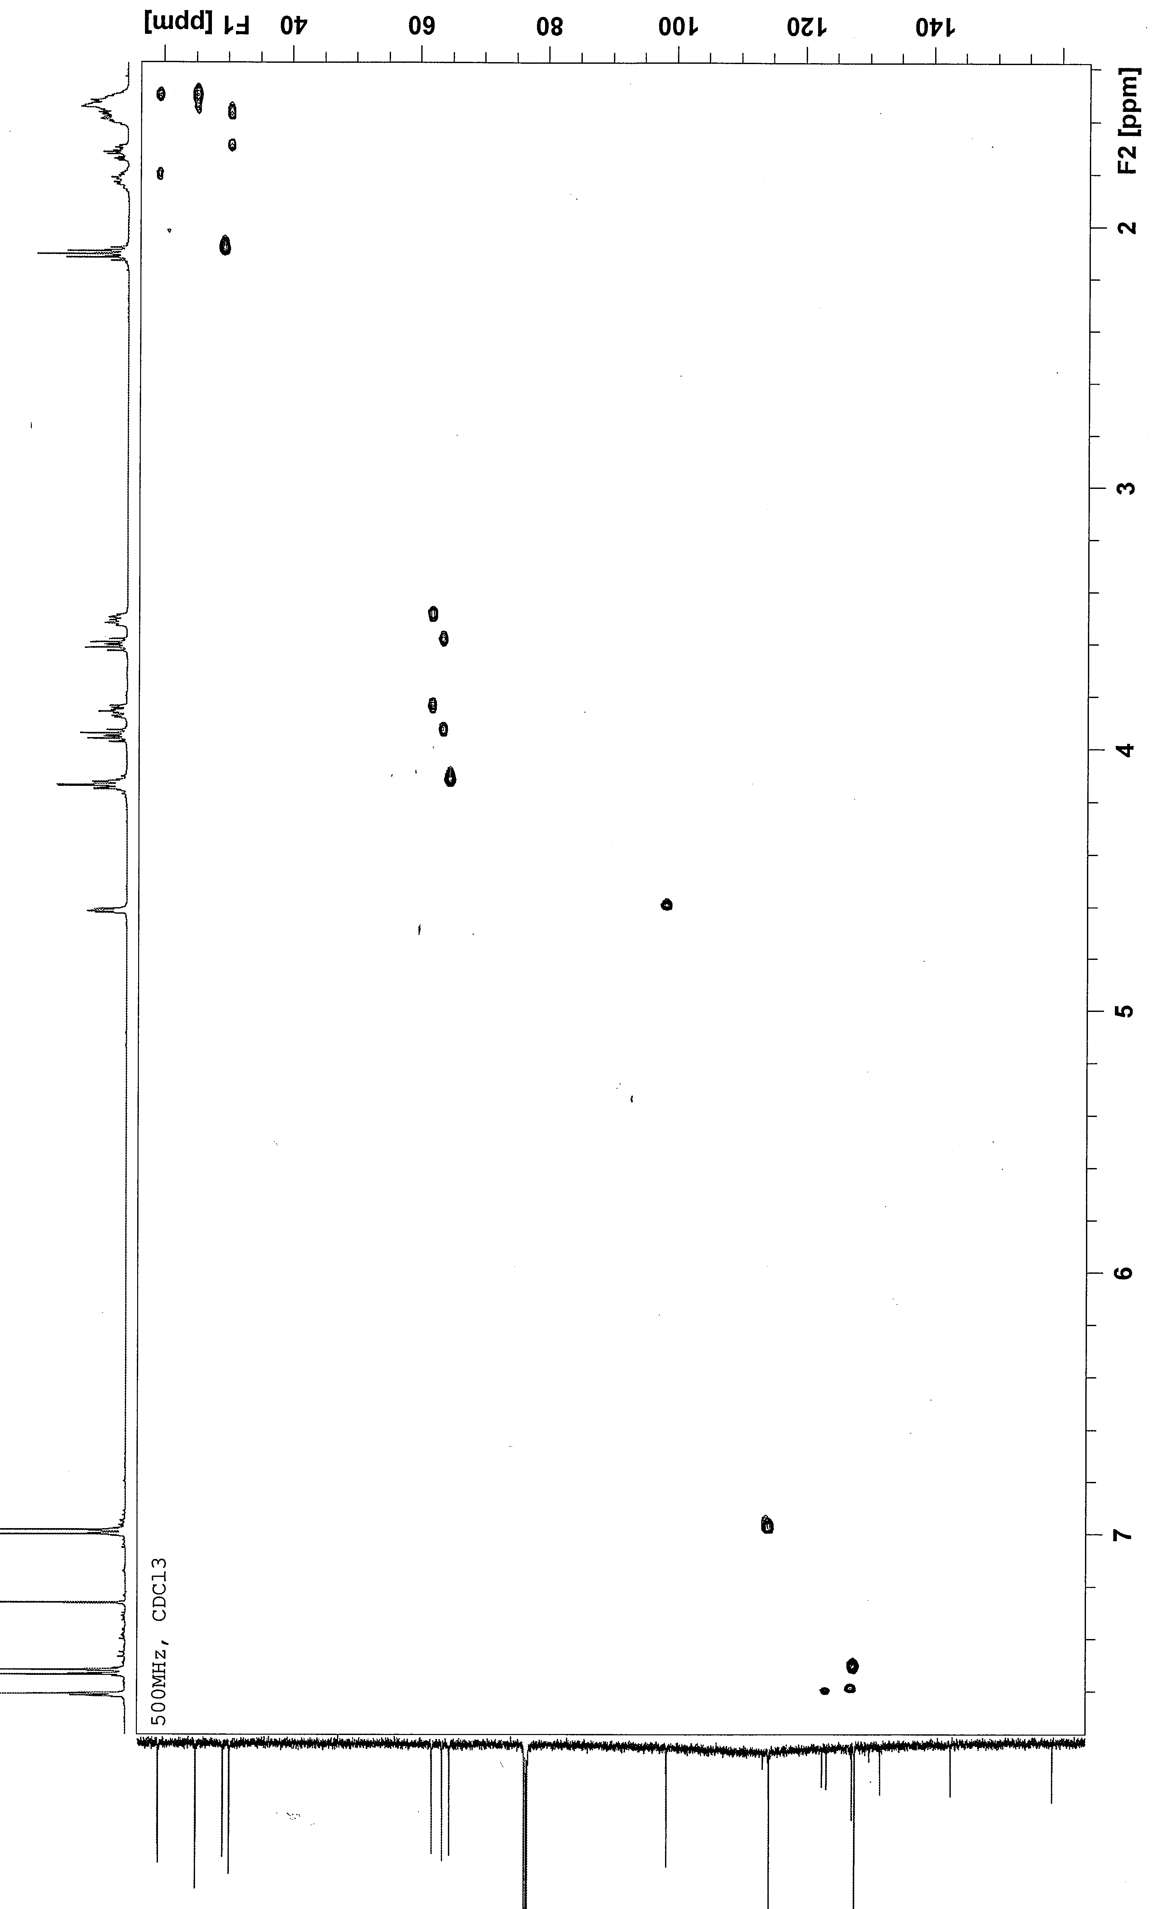
¹H NMR spectrum of Compound 2 (500 MHz; CDCl₃)
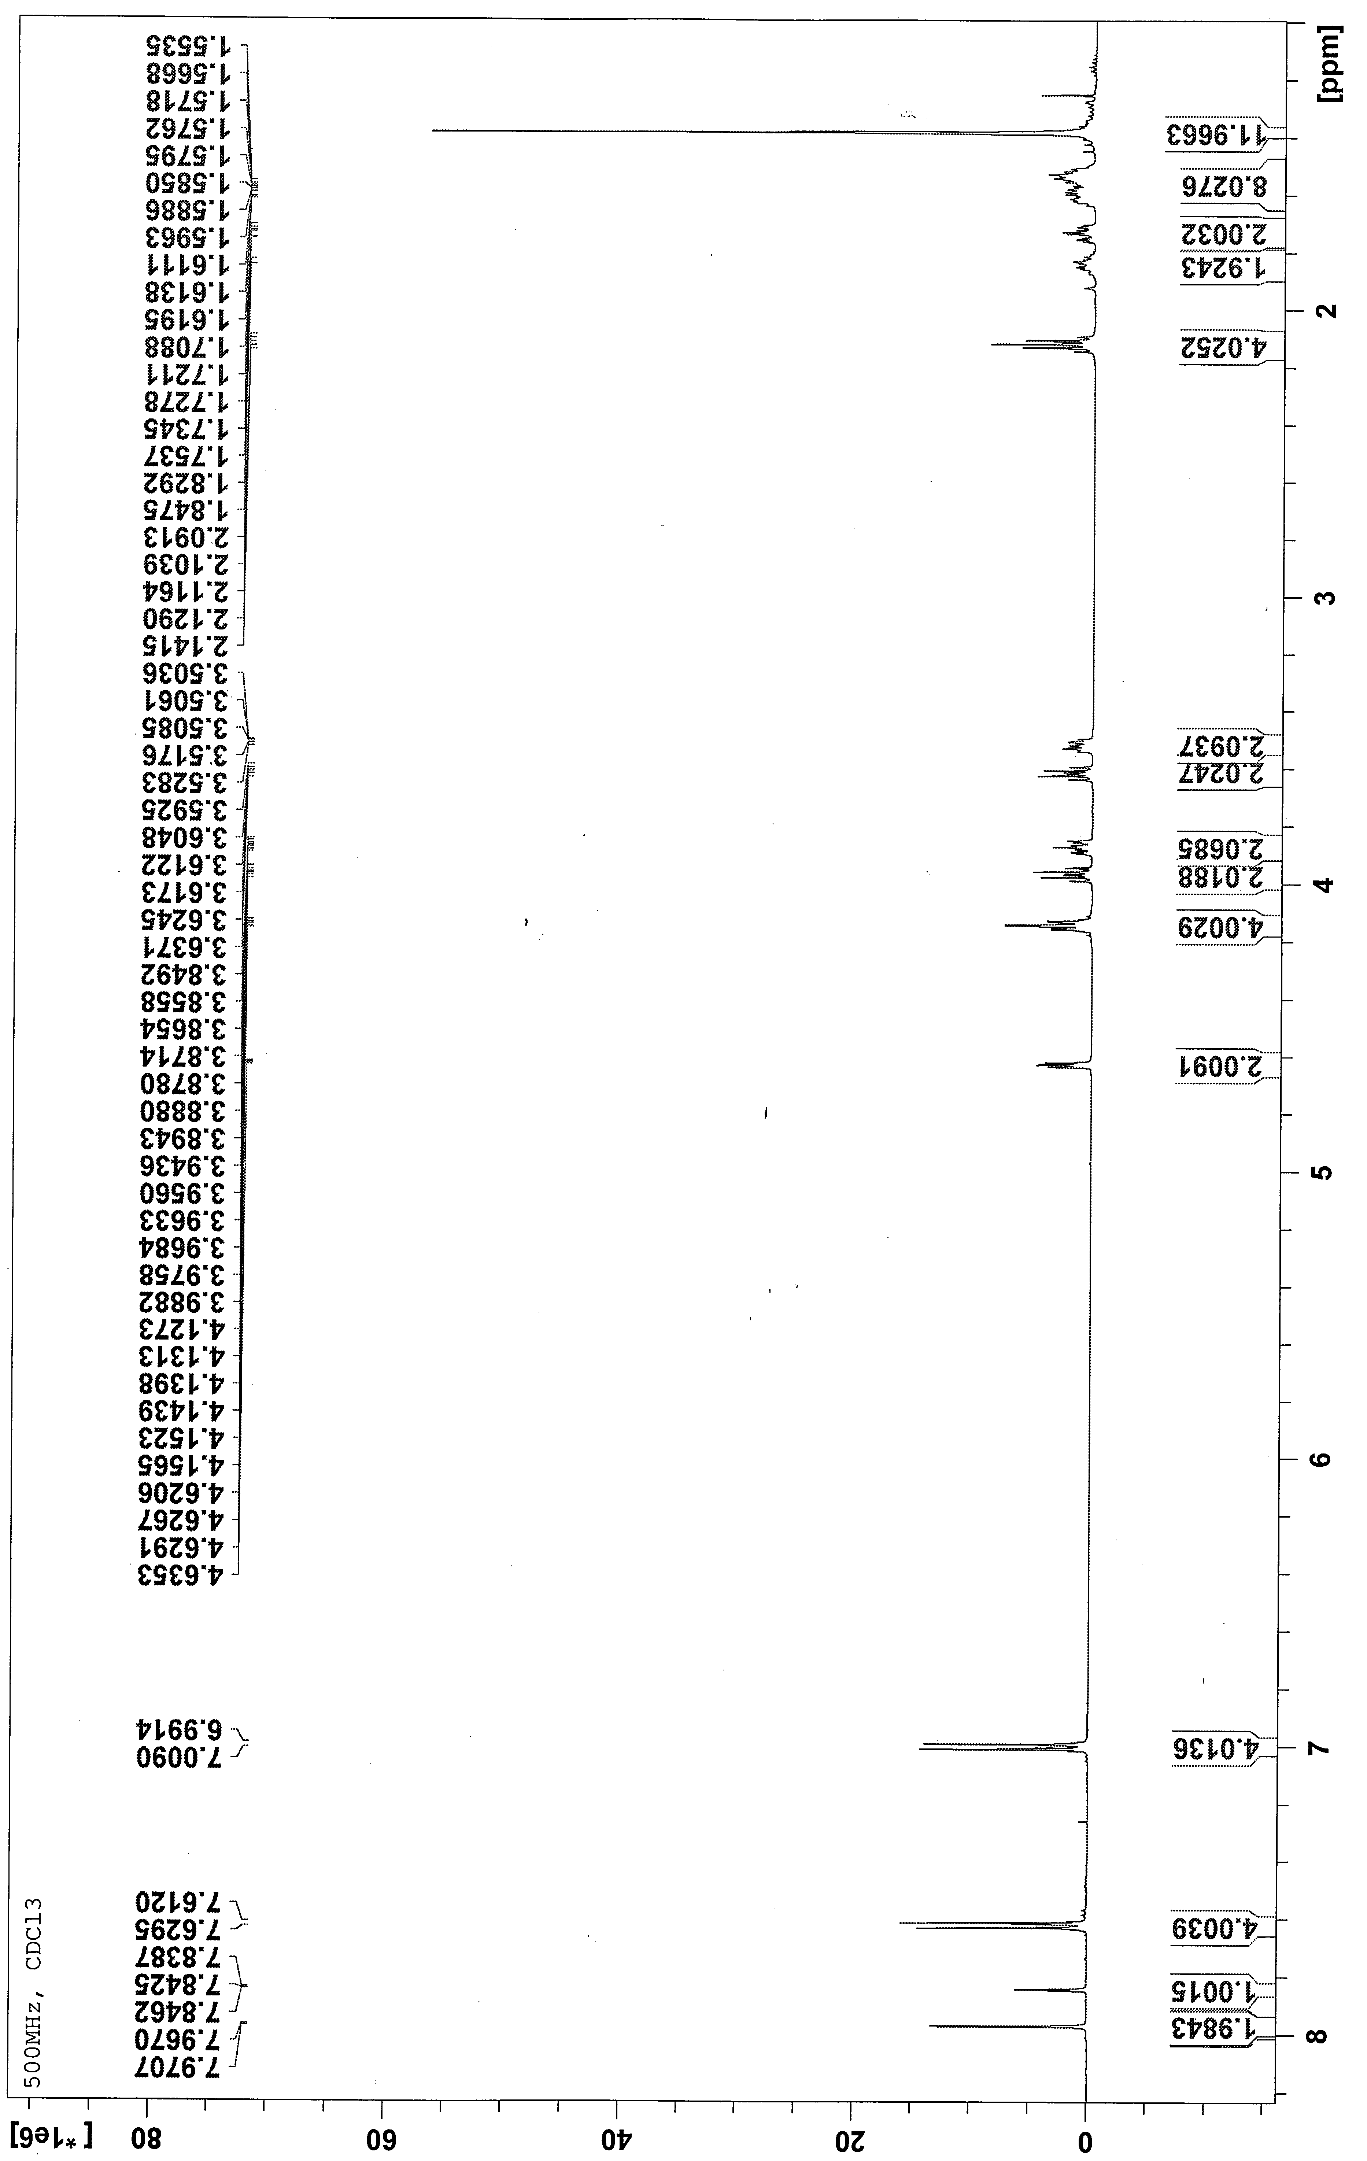
¹³C NMR spectrum of Compound 2 (125 MHz; CDCl₃)
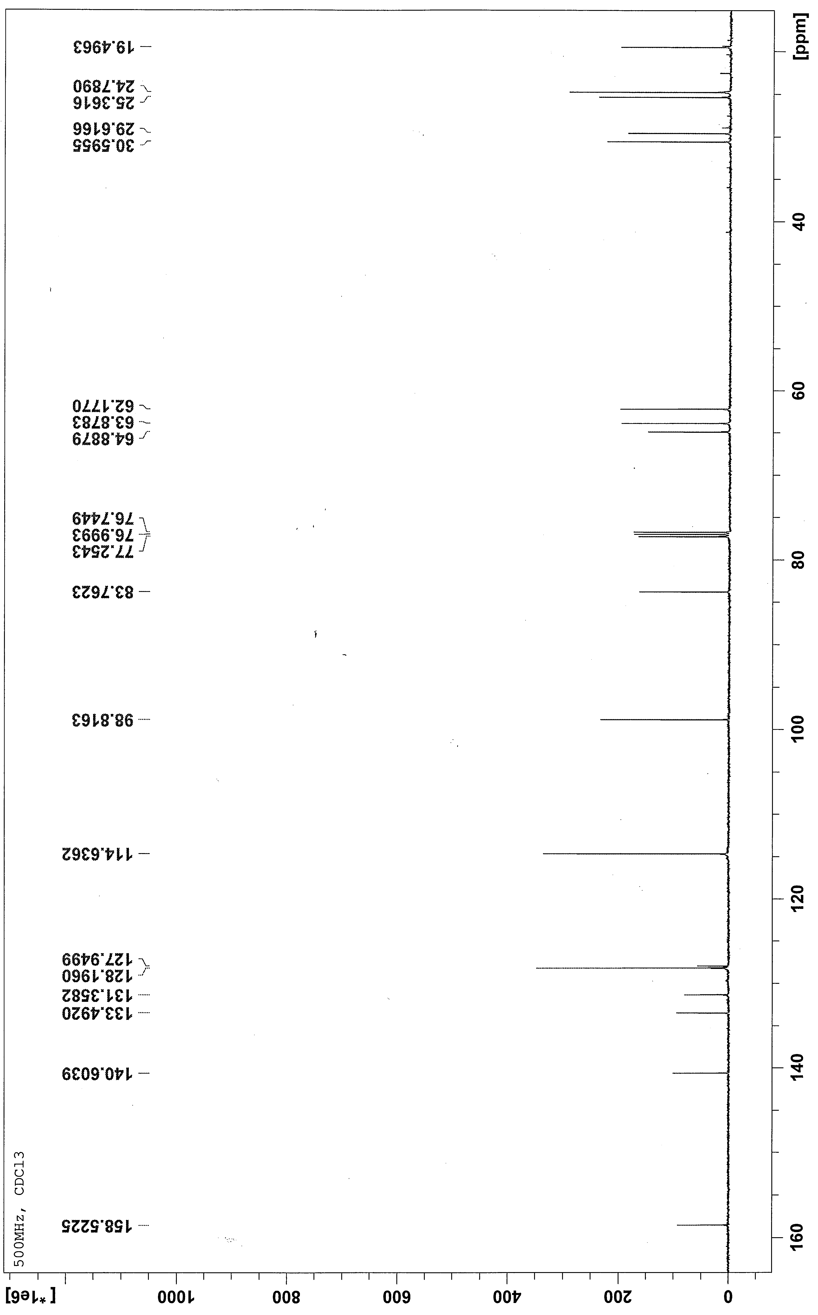
HSQC NMR spectrum of Compound 2 (500 MHz; CDCl₃)
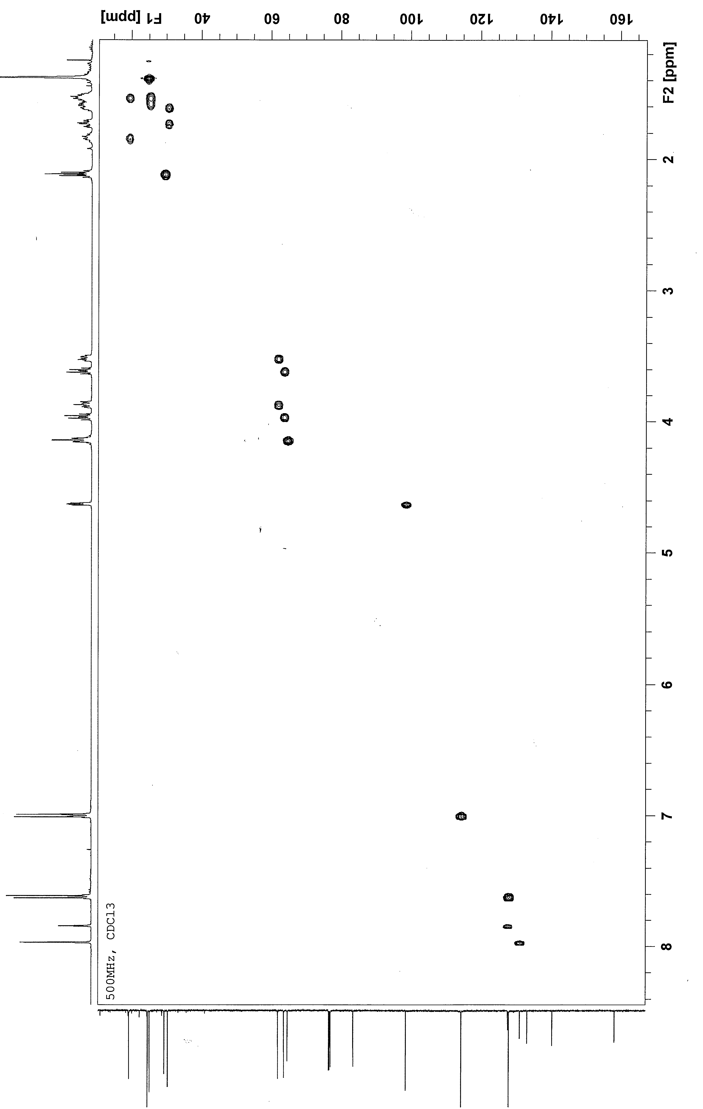
¹H NMR spectrum of Compound 3 (500 MHz; CDCl₃)
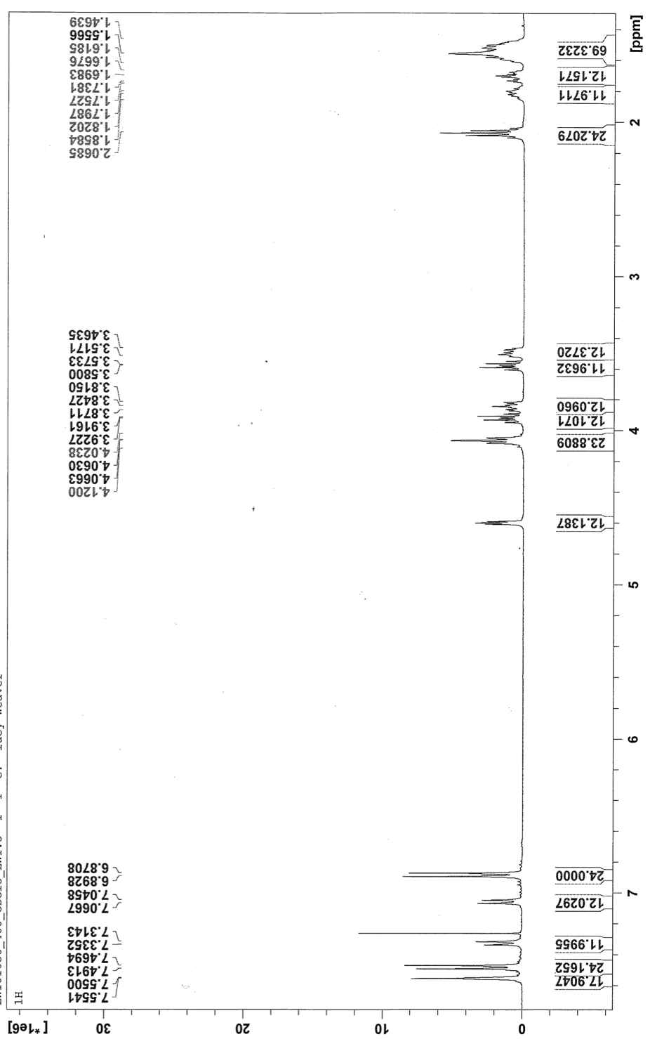
¹³C NMR spectrum of Compound 3 (125 MHz; CDCl₃)
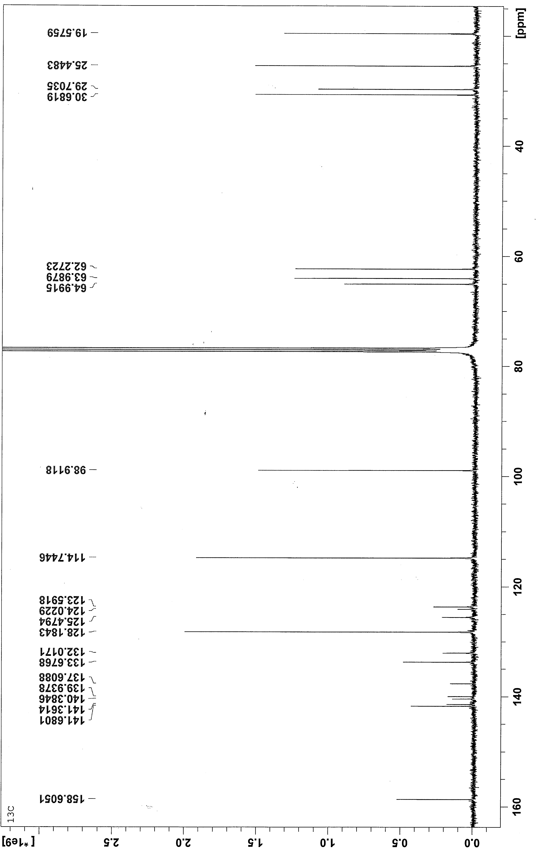
COSY NMR spectrum of Compound 3 (500 MHz; CDCl₃)
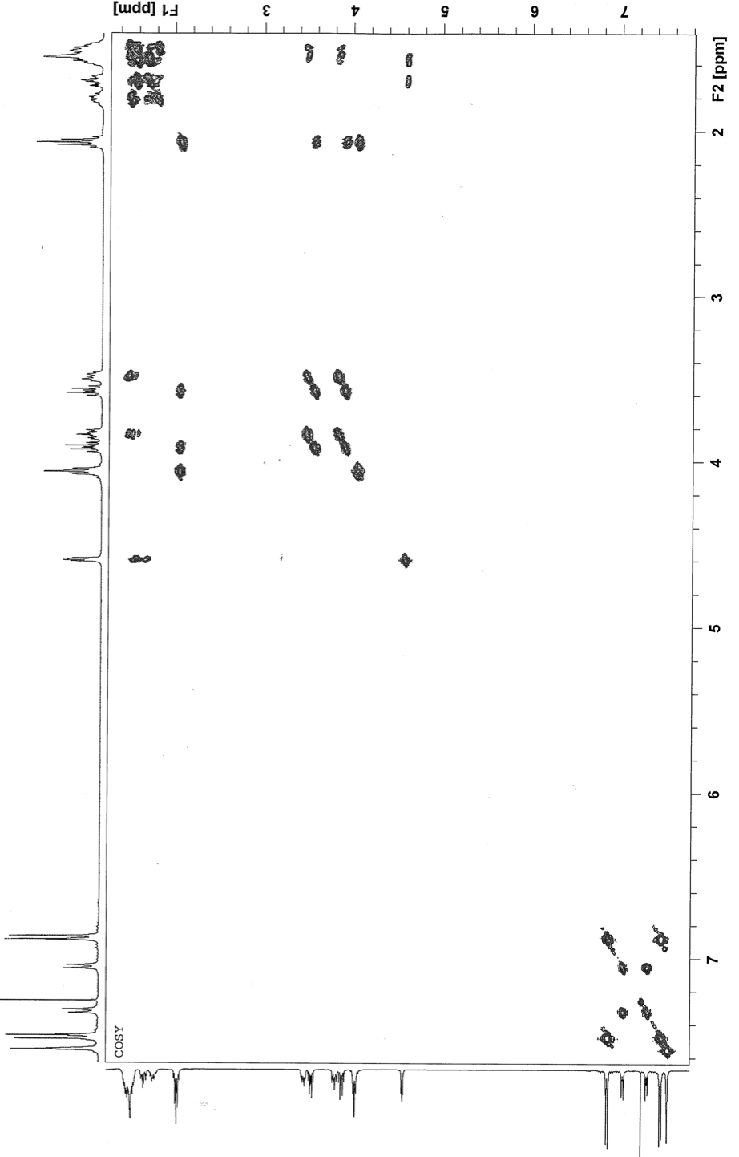
HSQC NMR spectrum of Compound 3 (500 MHz; CDCl₃)
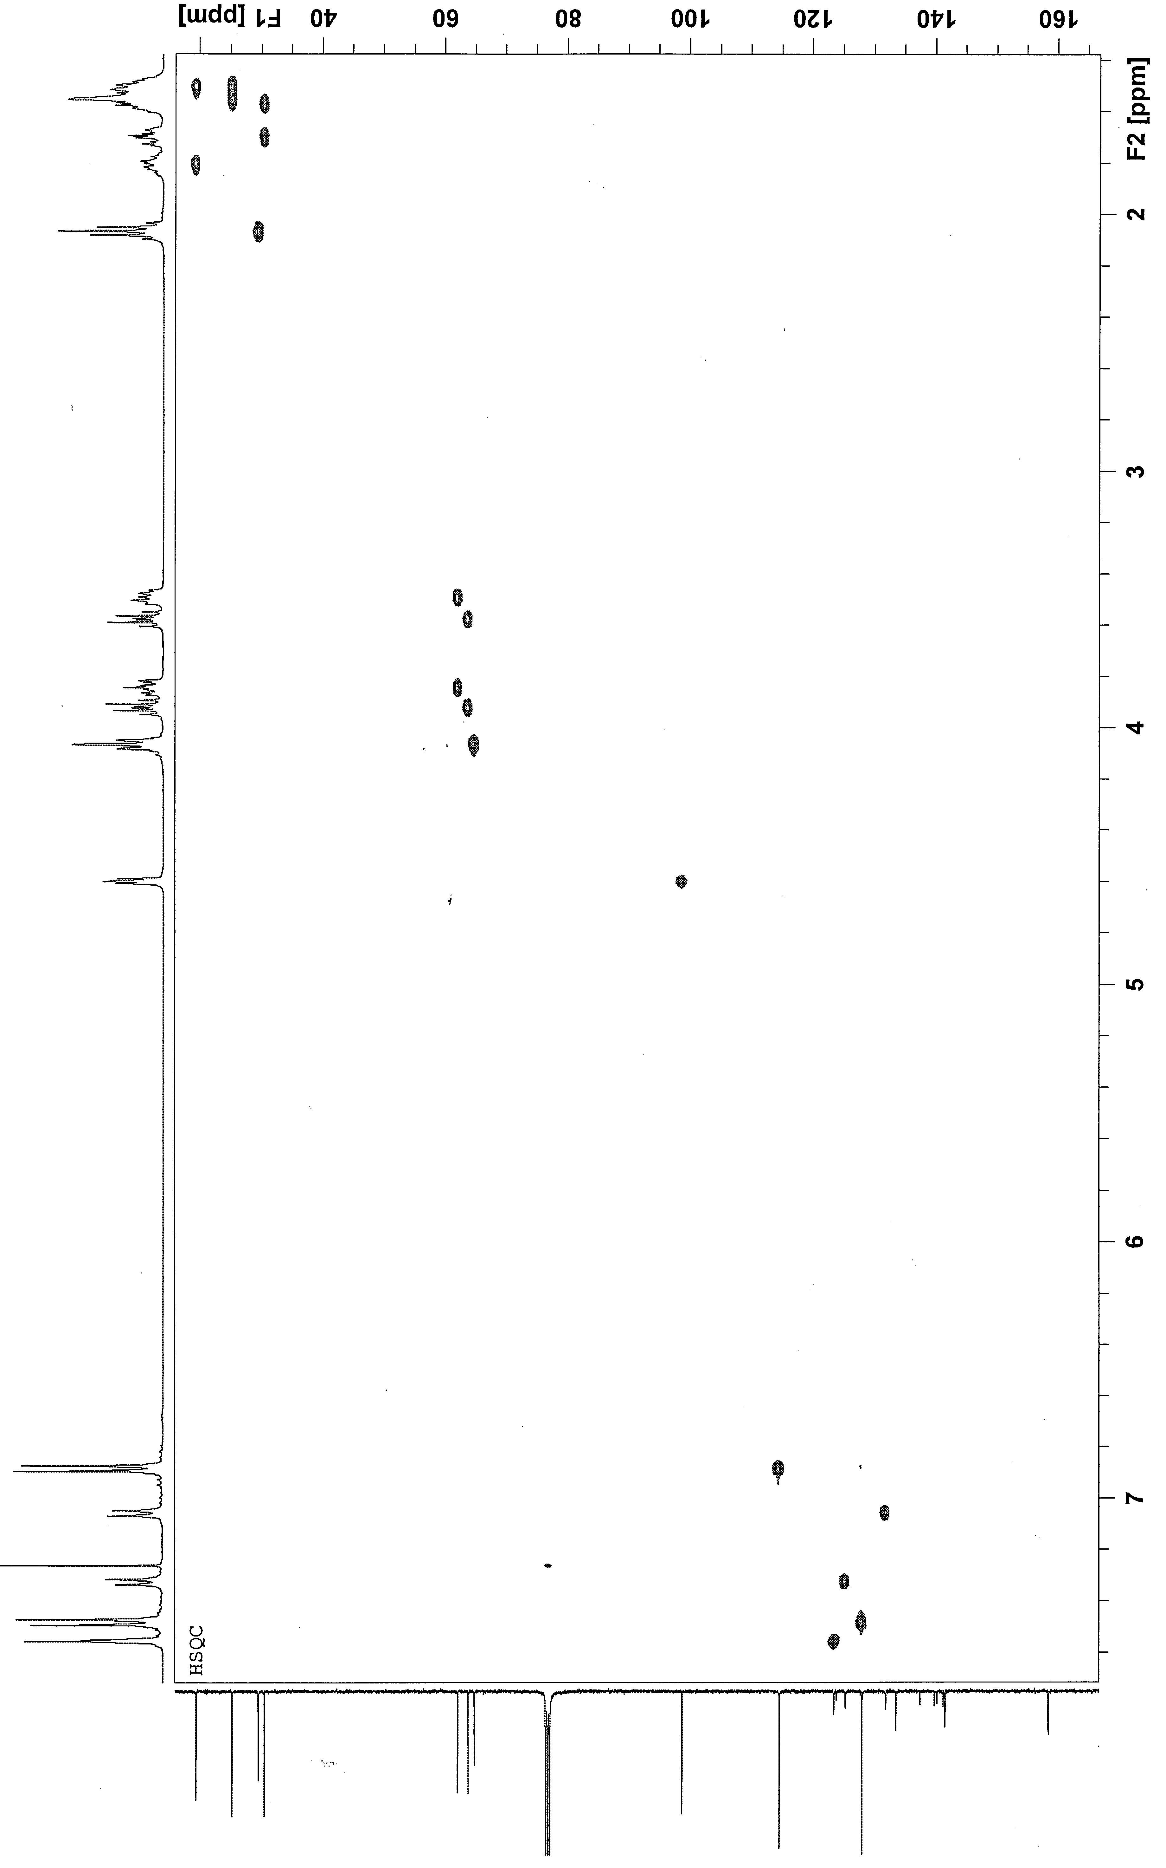
HMBC NMR spectrum of Compound 3 (500 MHz; CDCl₃)
GPC trace – Compound 3
¹H NMR spectrum of Compound 4 (400 MHz; CDCl₃)
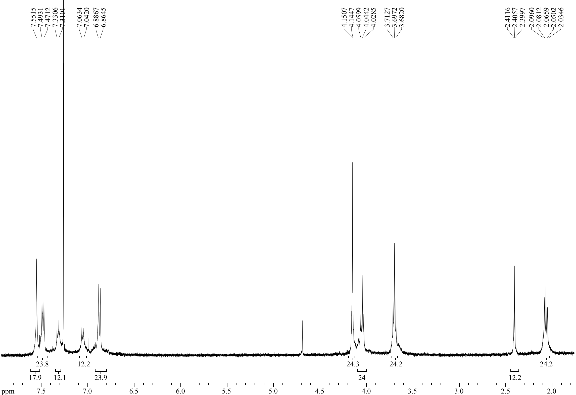
¹³C NMR spectrum of Compound 4 (100 MHz; CDCl₃)
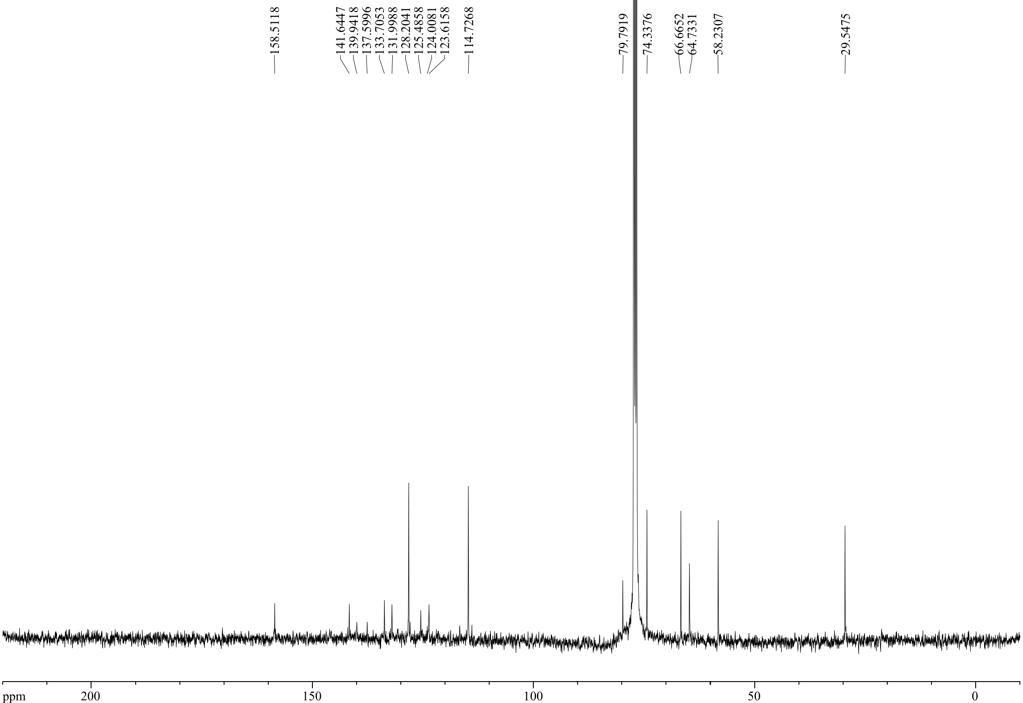
COSY NMR spectrum of Compound 4 (500 MHz; CDCl₃)
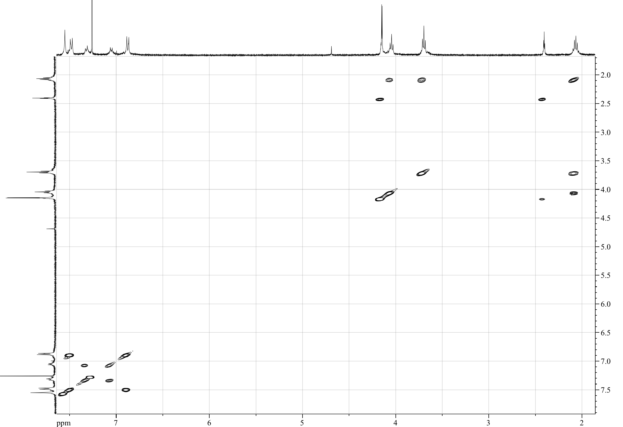

HSQC NMR spectrum of Compound 4 (500 MHz; CDCl₃)

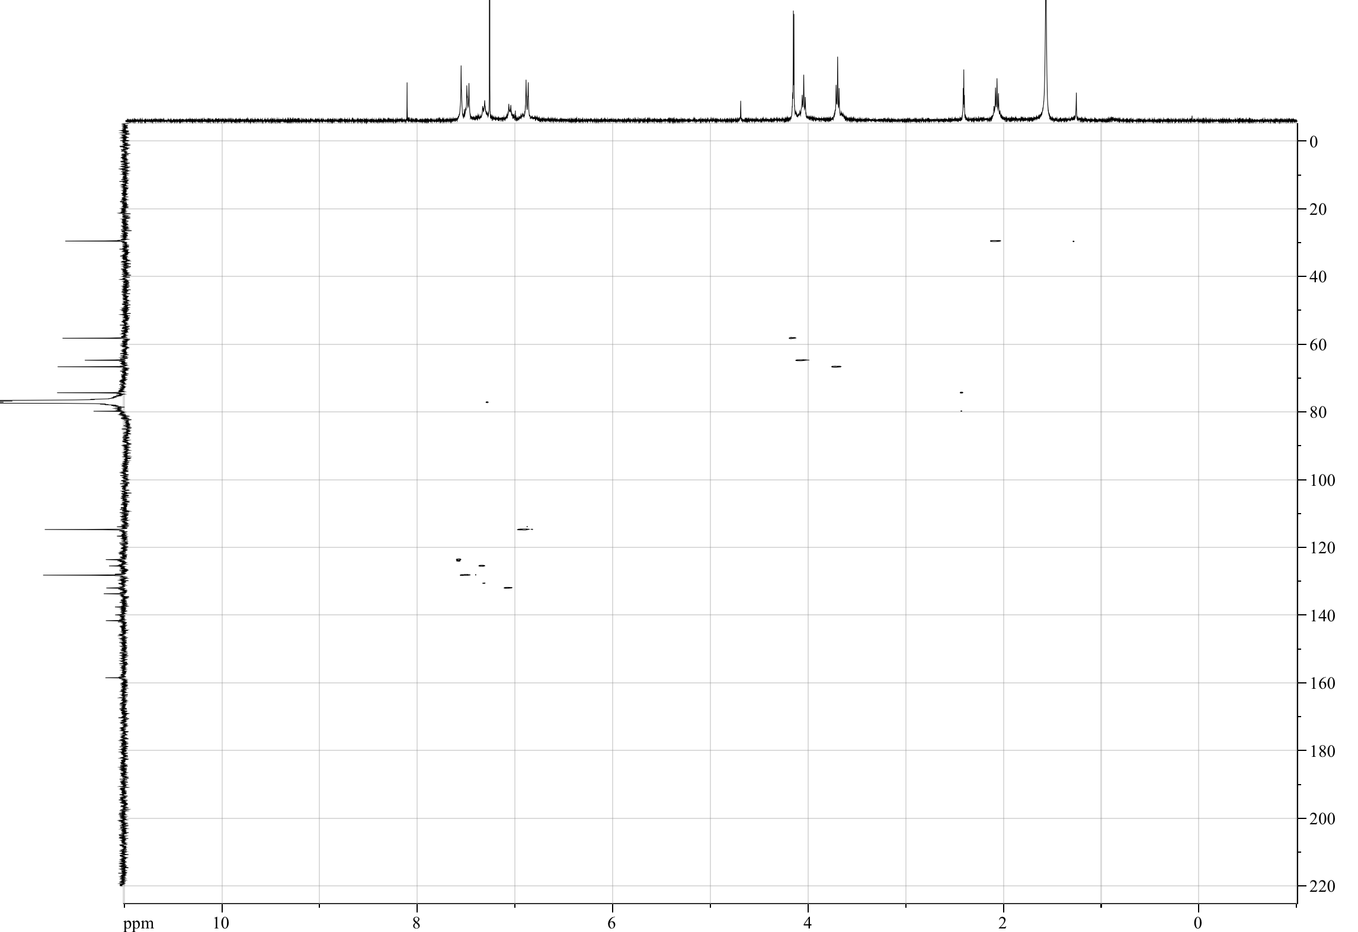

GPC trace – Compound 4

¹H NMR spectrum of Compound 9 (500 MHz; CD₃OD)

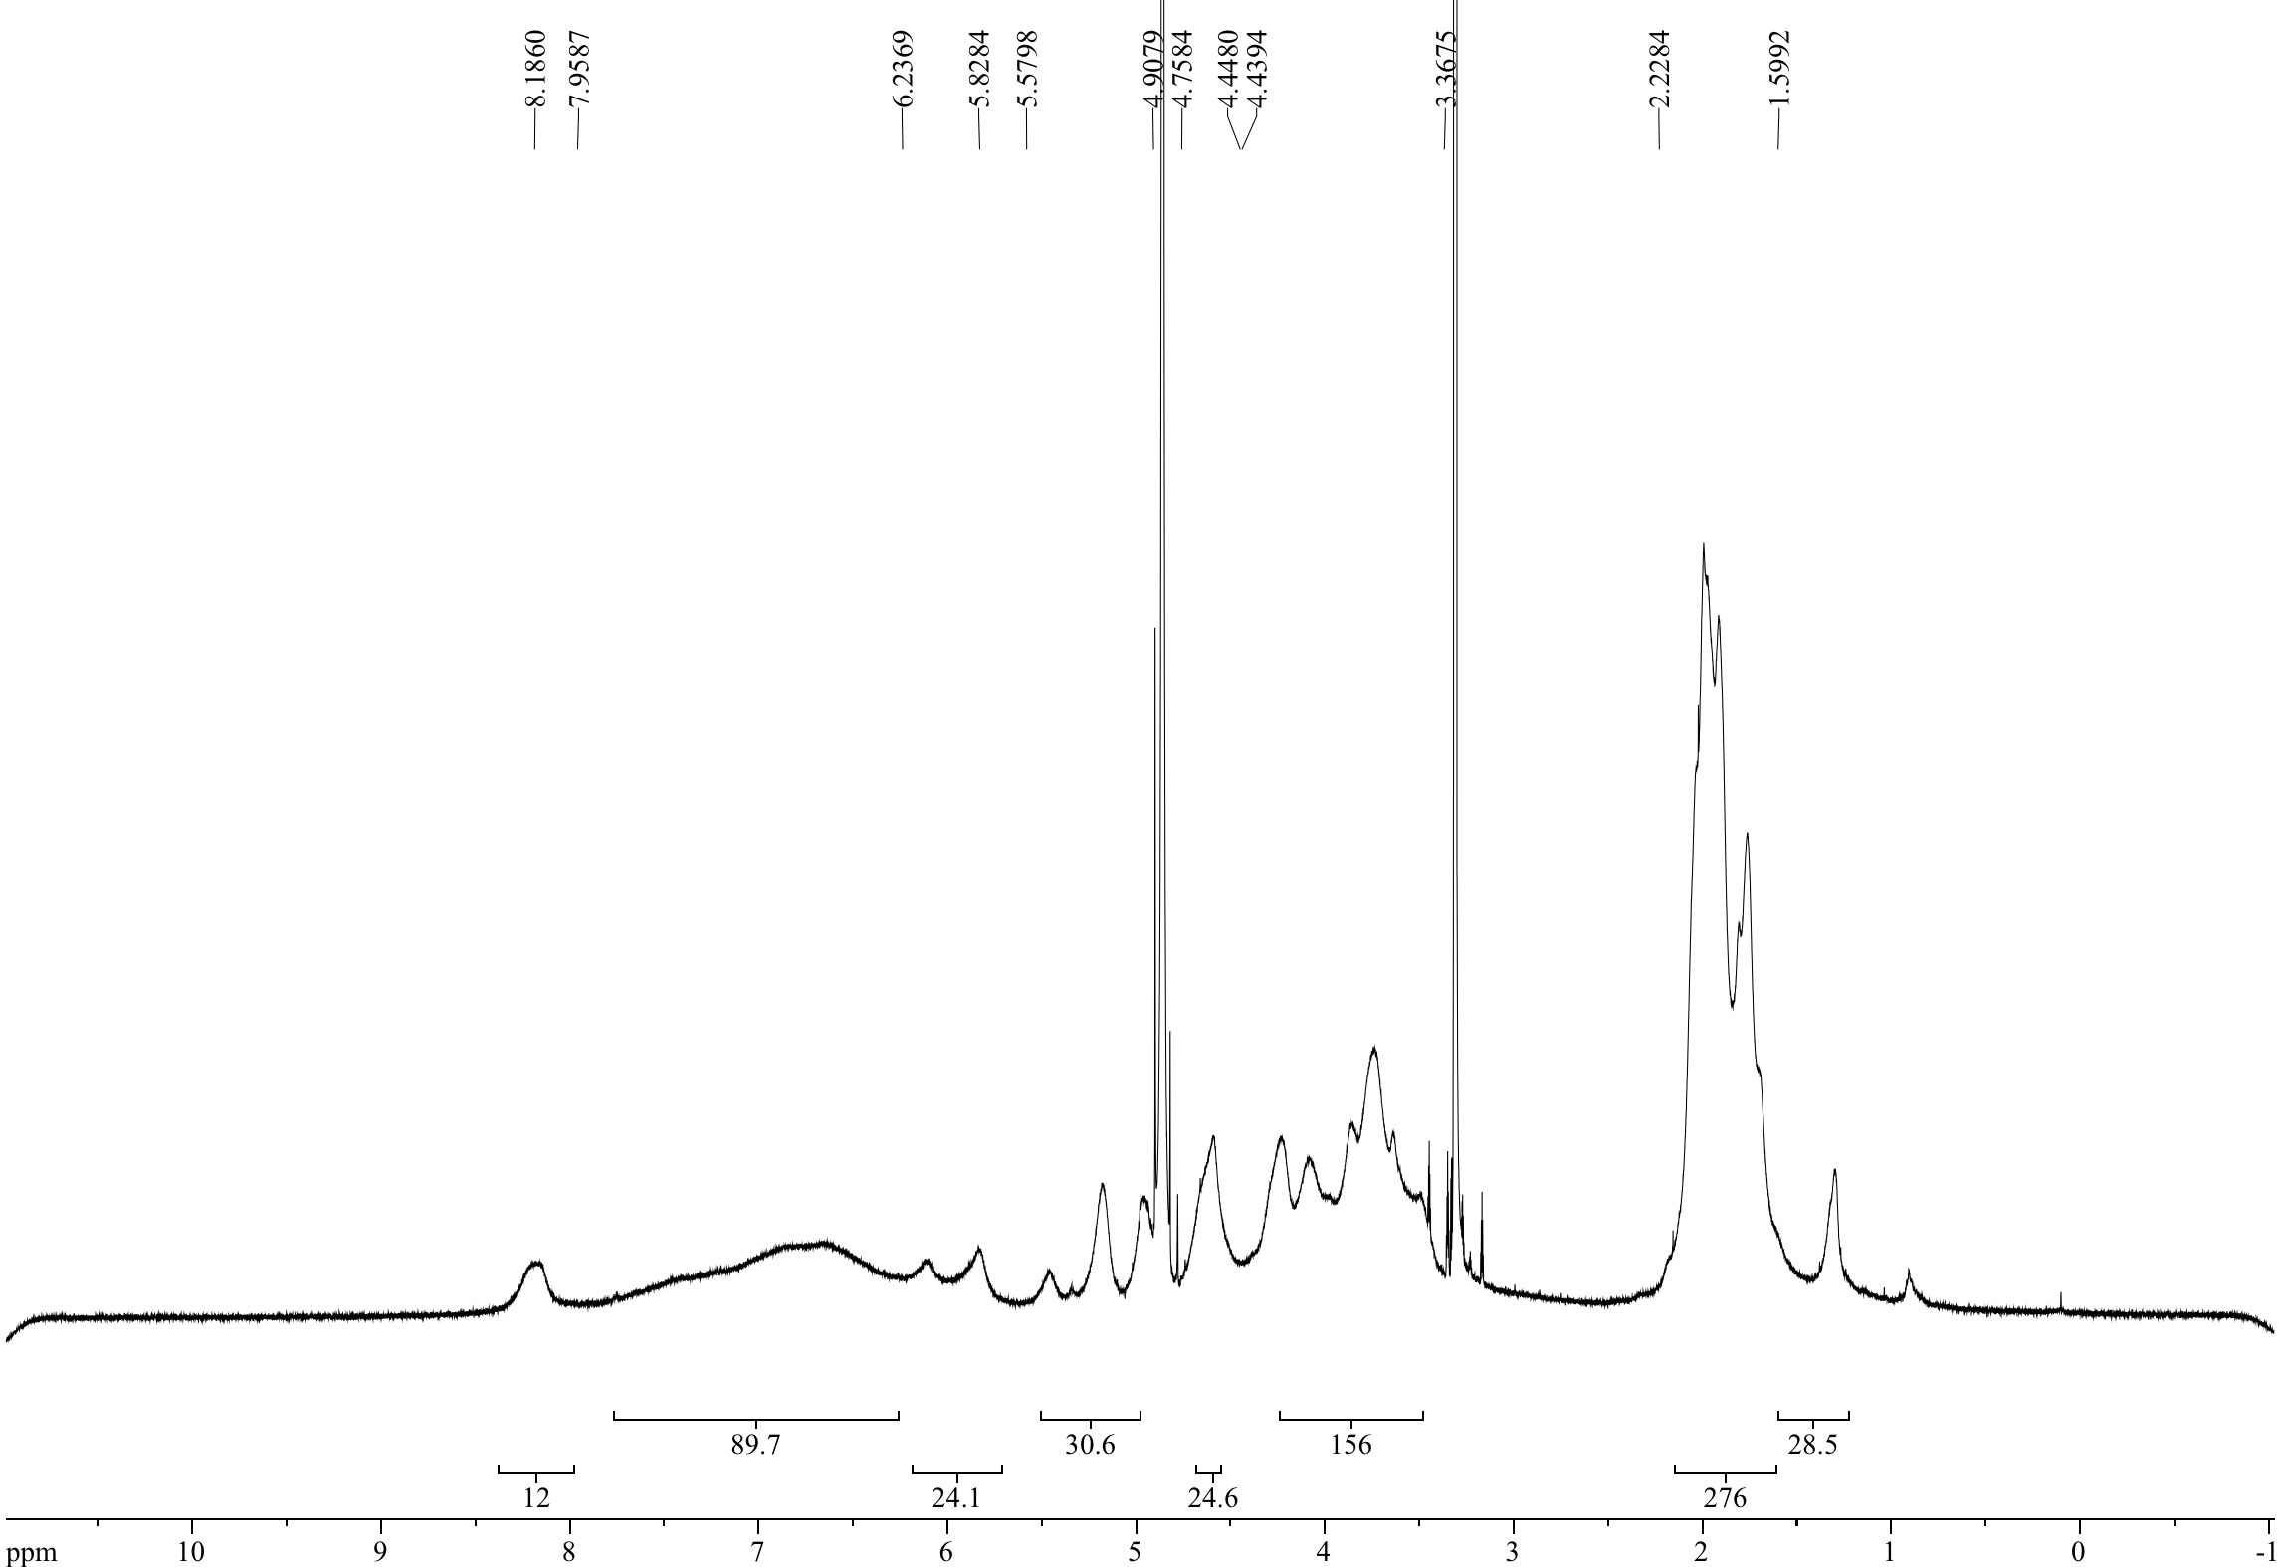

HSQC NMR spectrum of Compound 9 (500 MHz; CD₃OD)

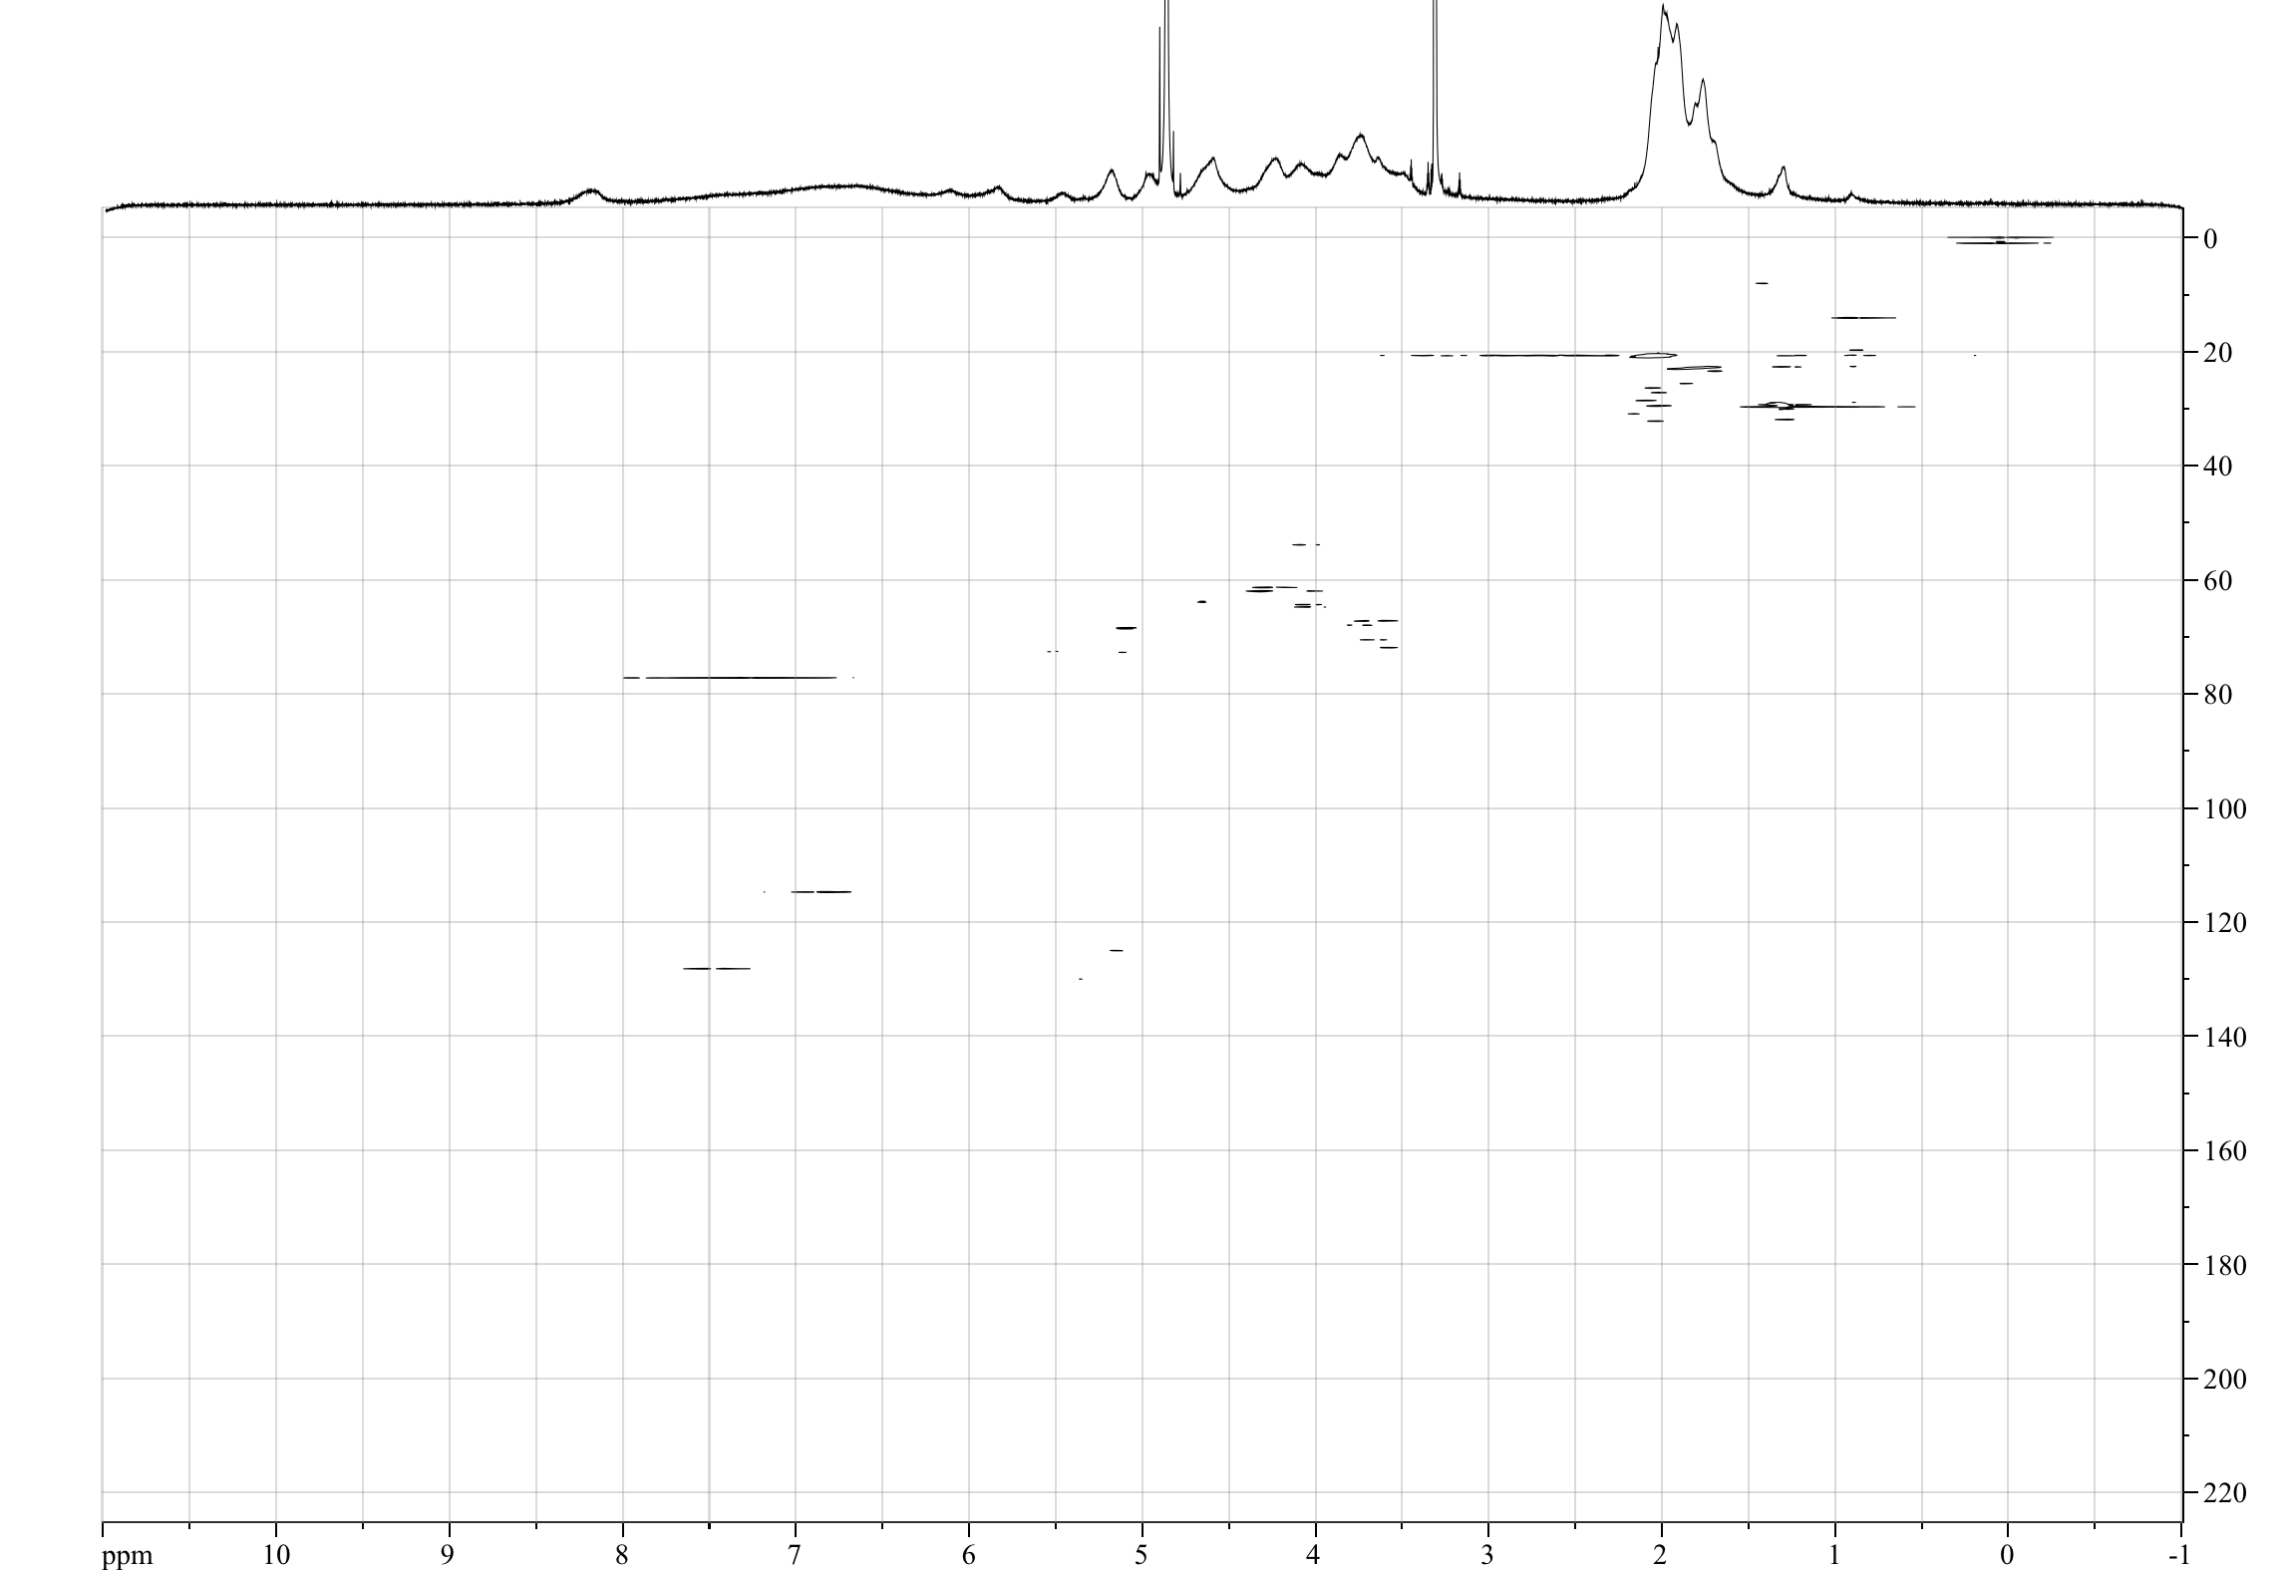
¹H NMR spectrum of Compound 10 (400 MHz; CDCl₃/CD₃OD)
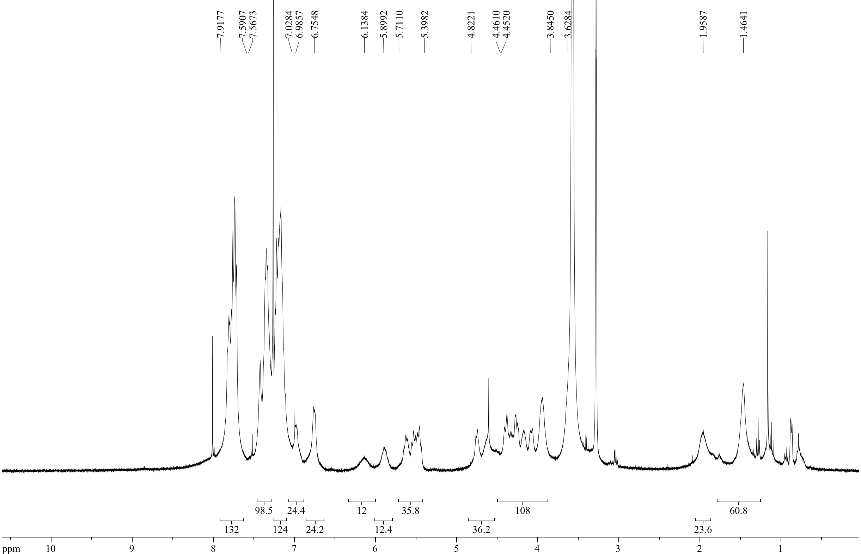

2D-TOCSY NMR spectrum of Compound 10 (500 MHz; CDCl₃/CD₃OD)

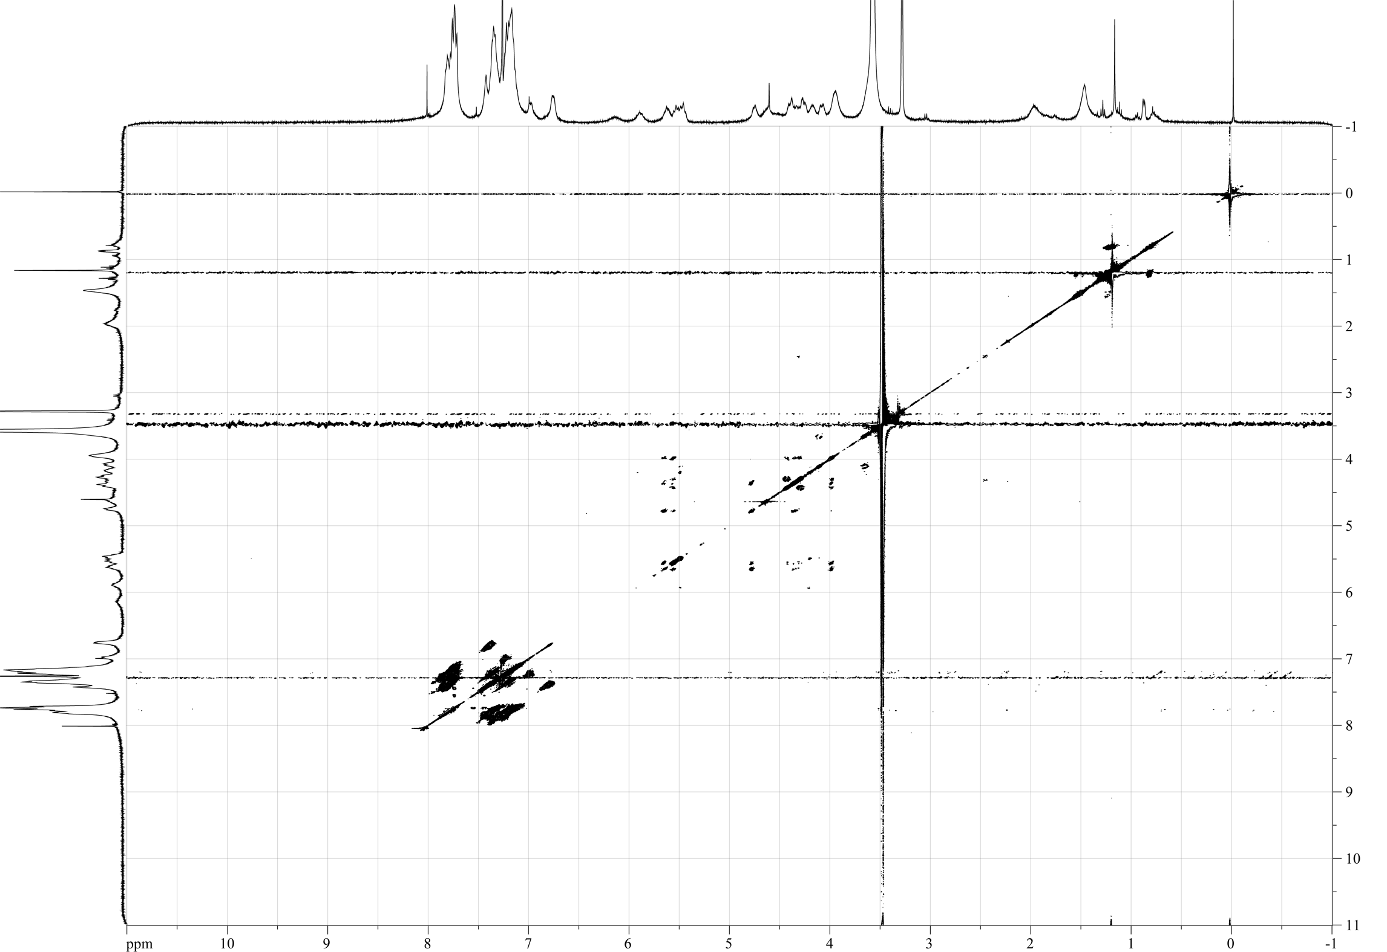
HSQC NMR spectrum of Compound 10 (500 MHz; CDCl₃/CD₃OD)
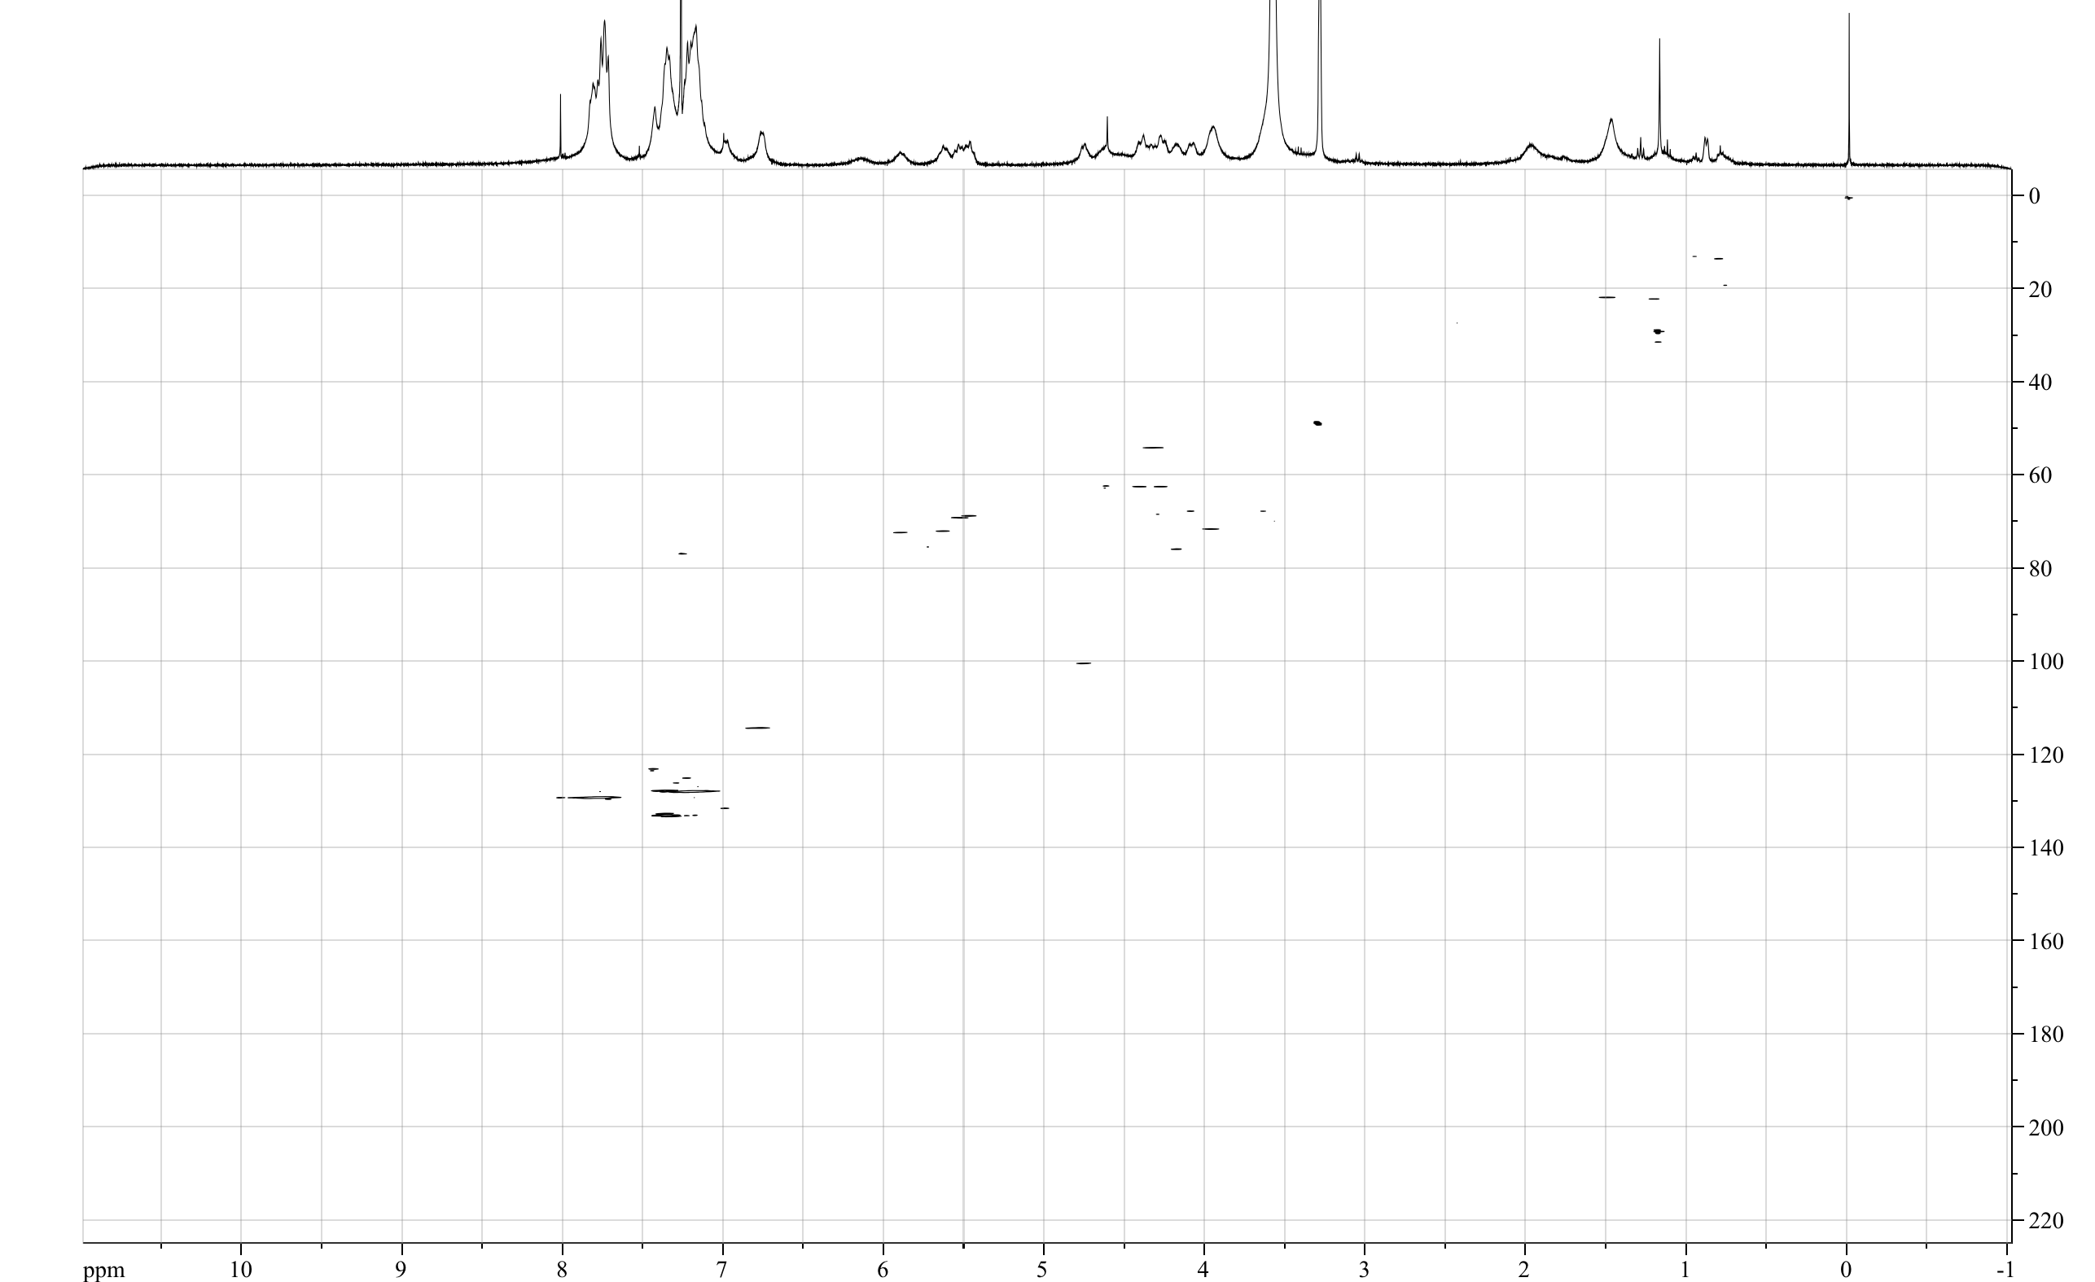

MALDI-TOF mass spectrum of Compound 10

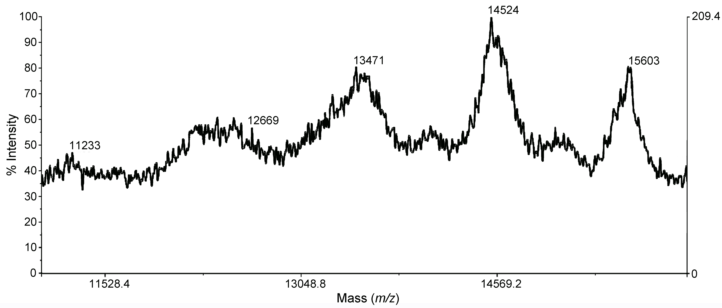
¹H NMR spectrum of Compound 11 (500 MHz; CDCl₃/CD₃OD)

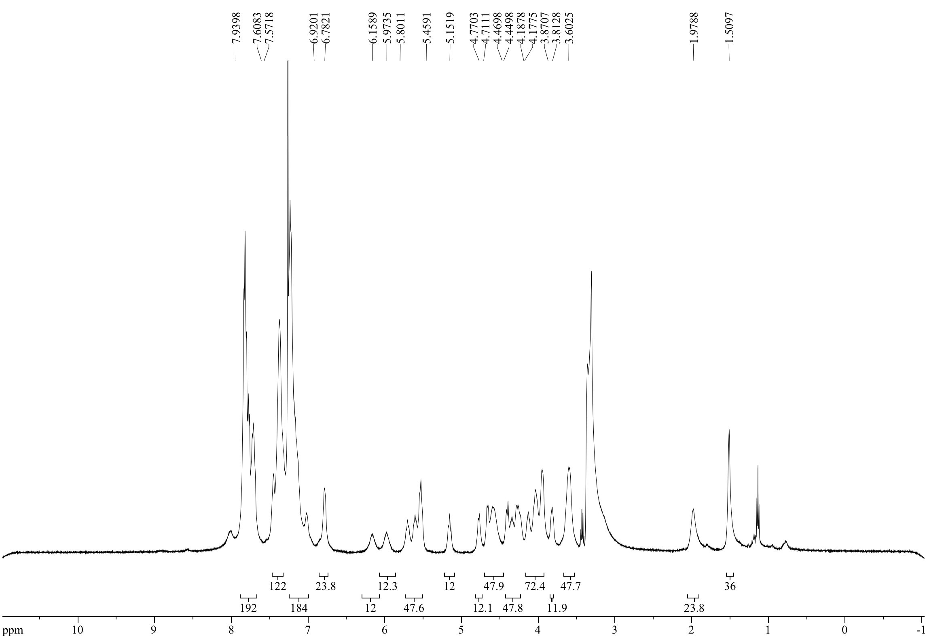

COSY NMR spectrum of Compound 11 (500 MHz; CDCl₃/CD₃OD)

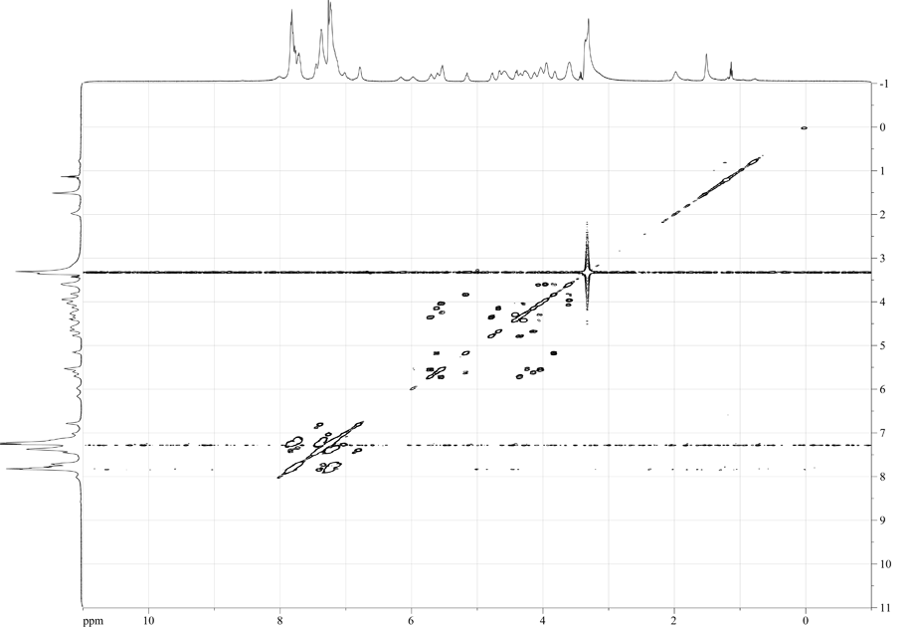

2D-TOCSY NMR spectrum of Compound 11 (500 MHz; CDCl₃/CD₃OD)
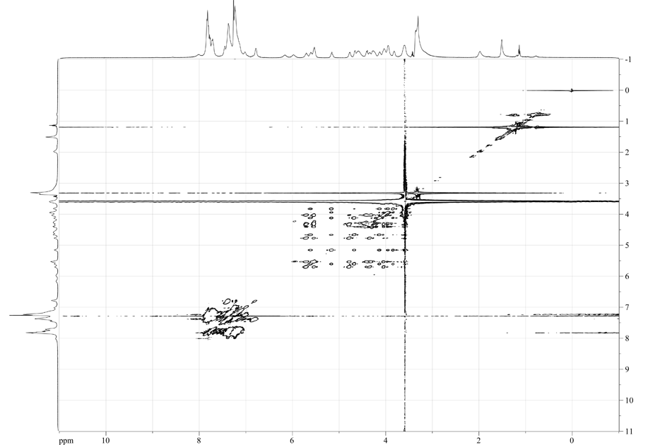

HSQC NMR spectrum of Compound 11 (500 MHz; CDCl₃/CD₃OD)
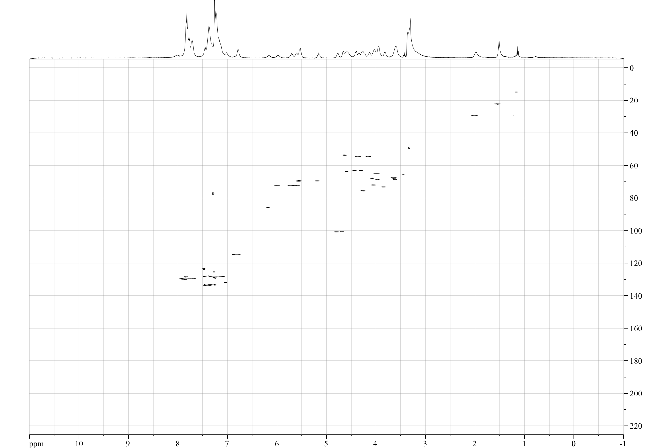
MALDI-TOF mass spectrum of Compound 11

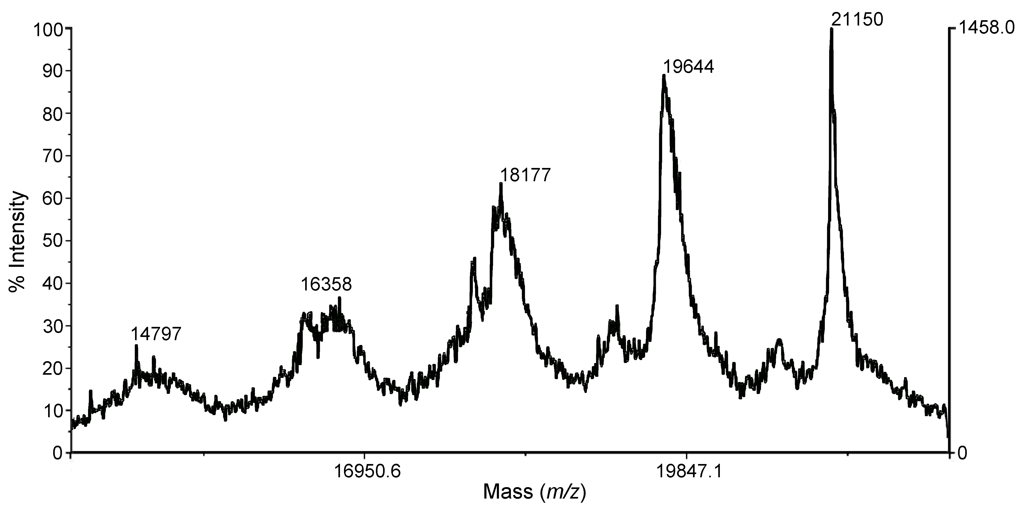

¹H NMR spectrum of Compound 12 (500 MHz; CDCl₃/CD₃OD)

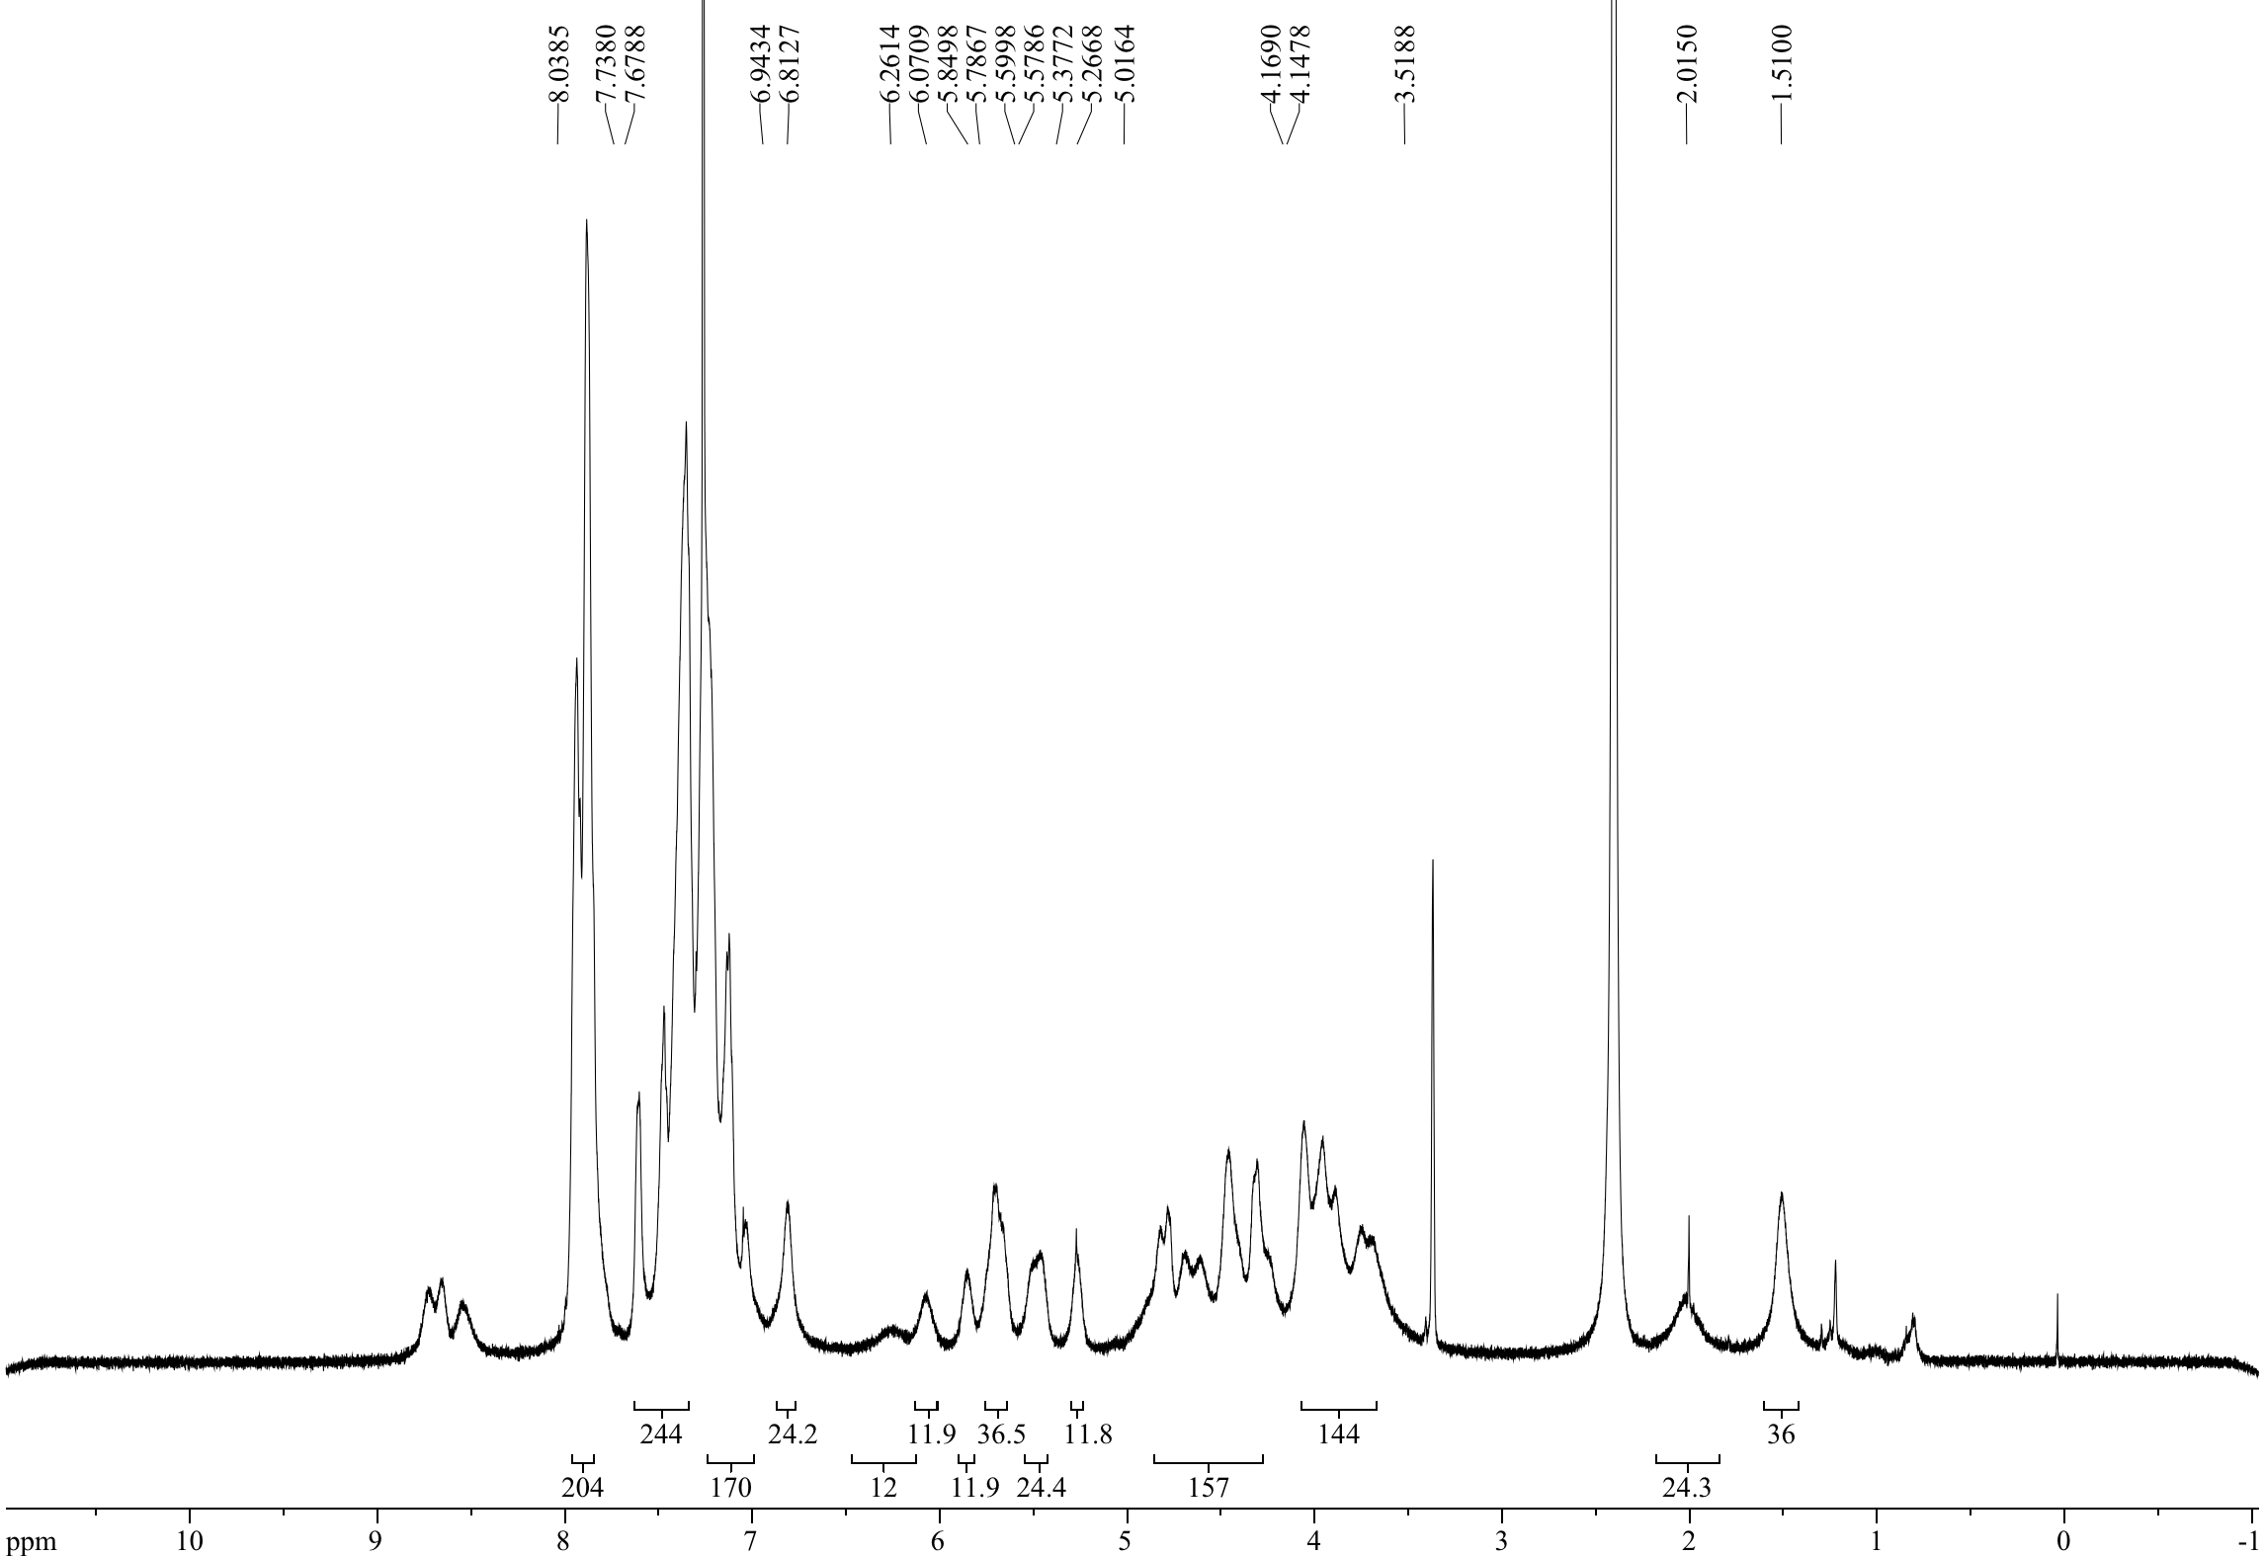

2D-TOCSY NMR spectrum of Compound 12 (500 MHz; CDCl₃/CD₃OD)

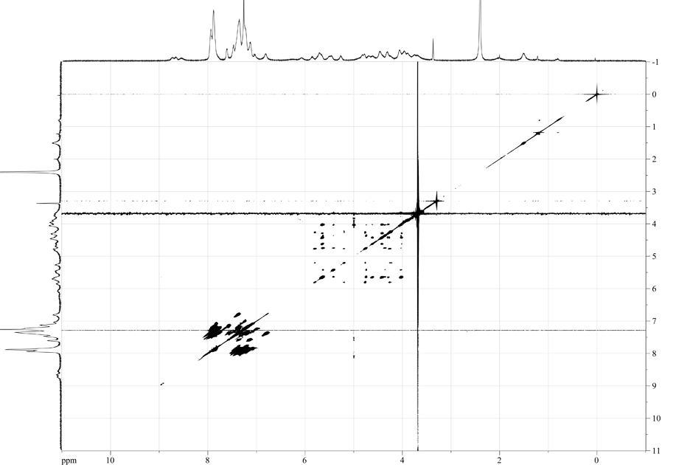

HSQC NMR spectrum of Compound 12 (500 MHz; CDCl₃/CD₃OD)

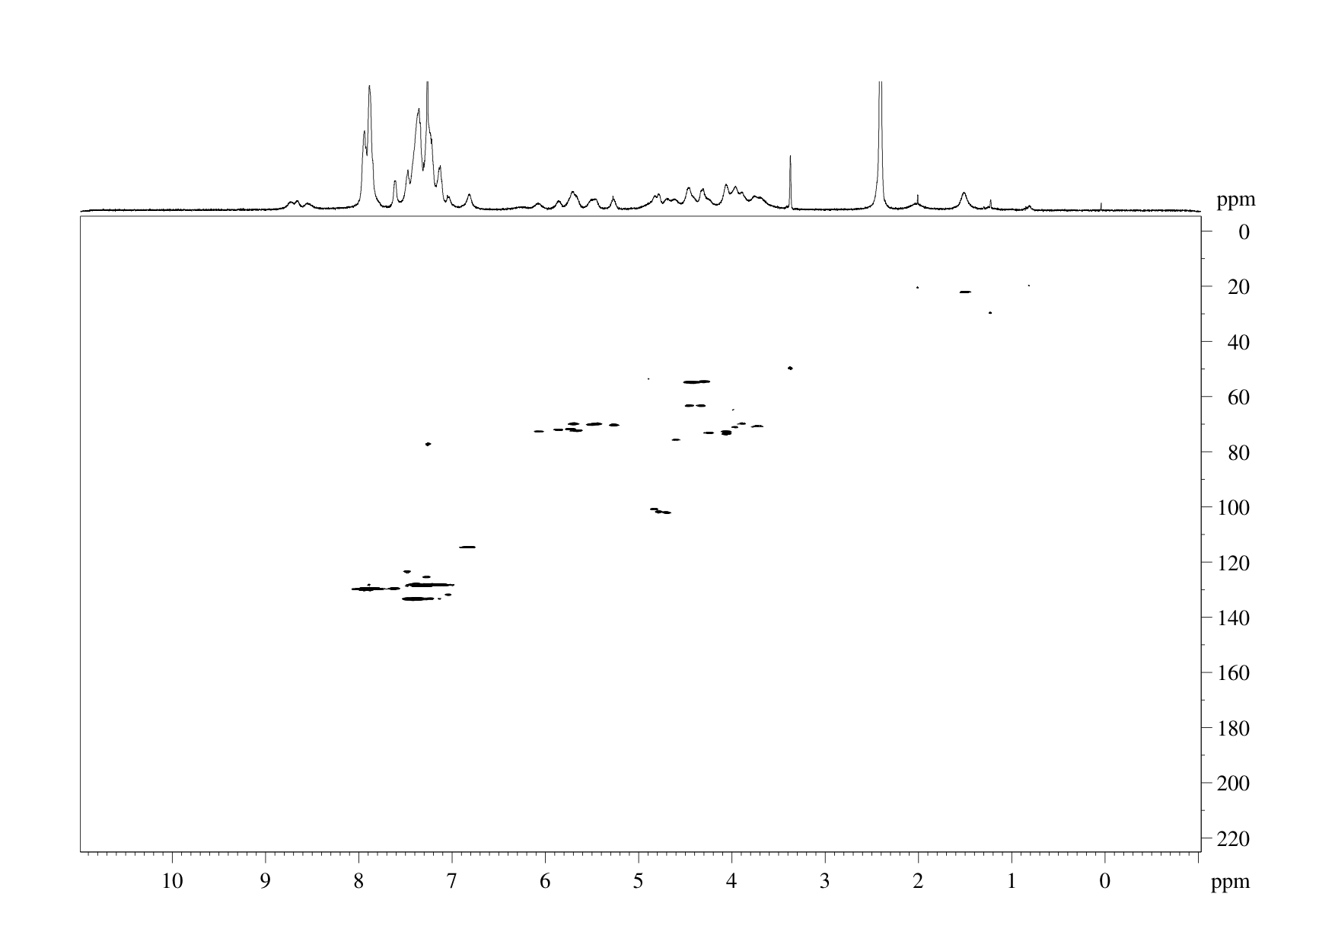

¹H NMR spectrum of Compound 13 (500 MHz; D₂O; water suppressed)
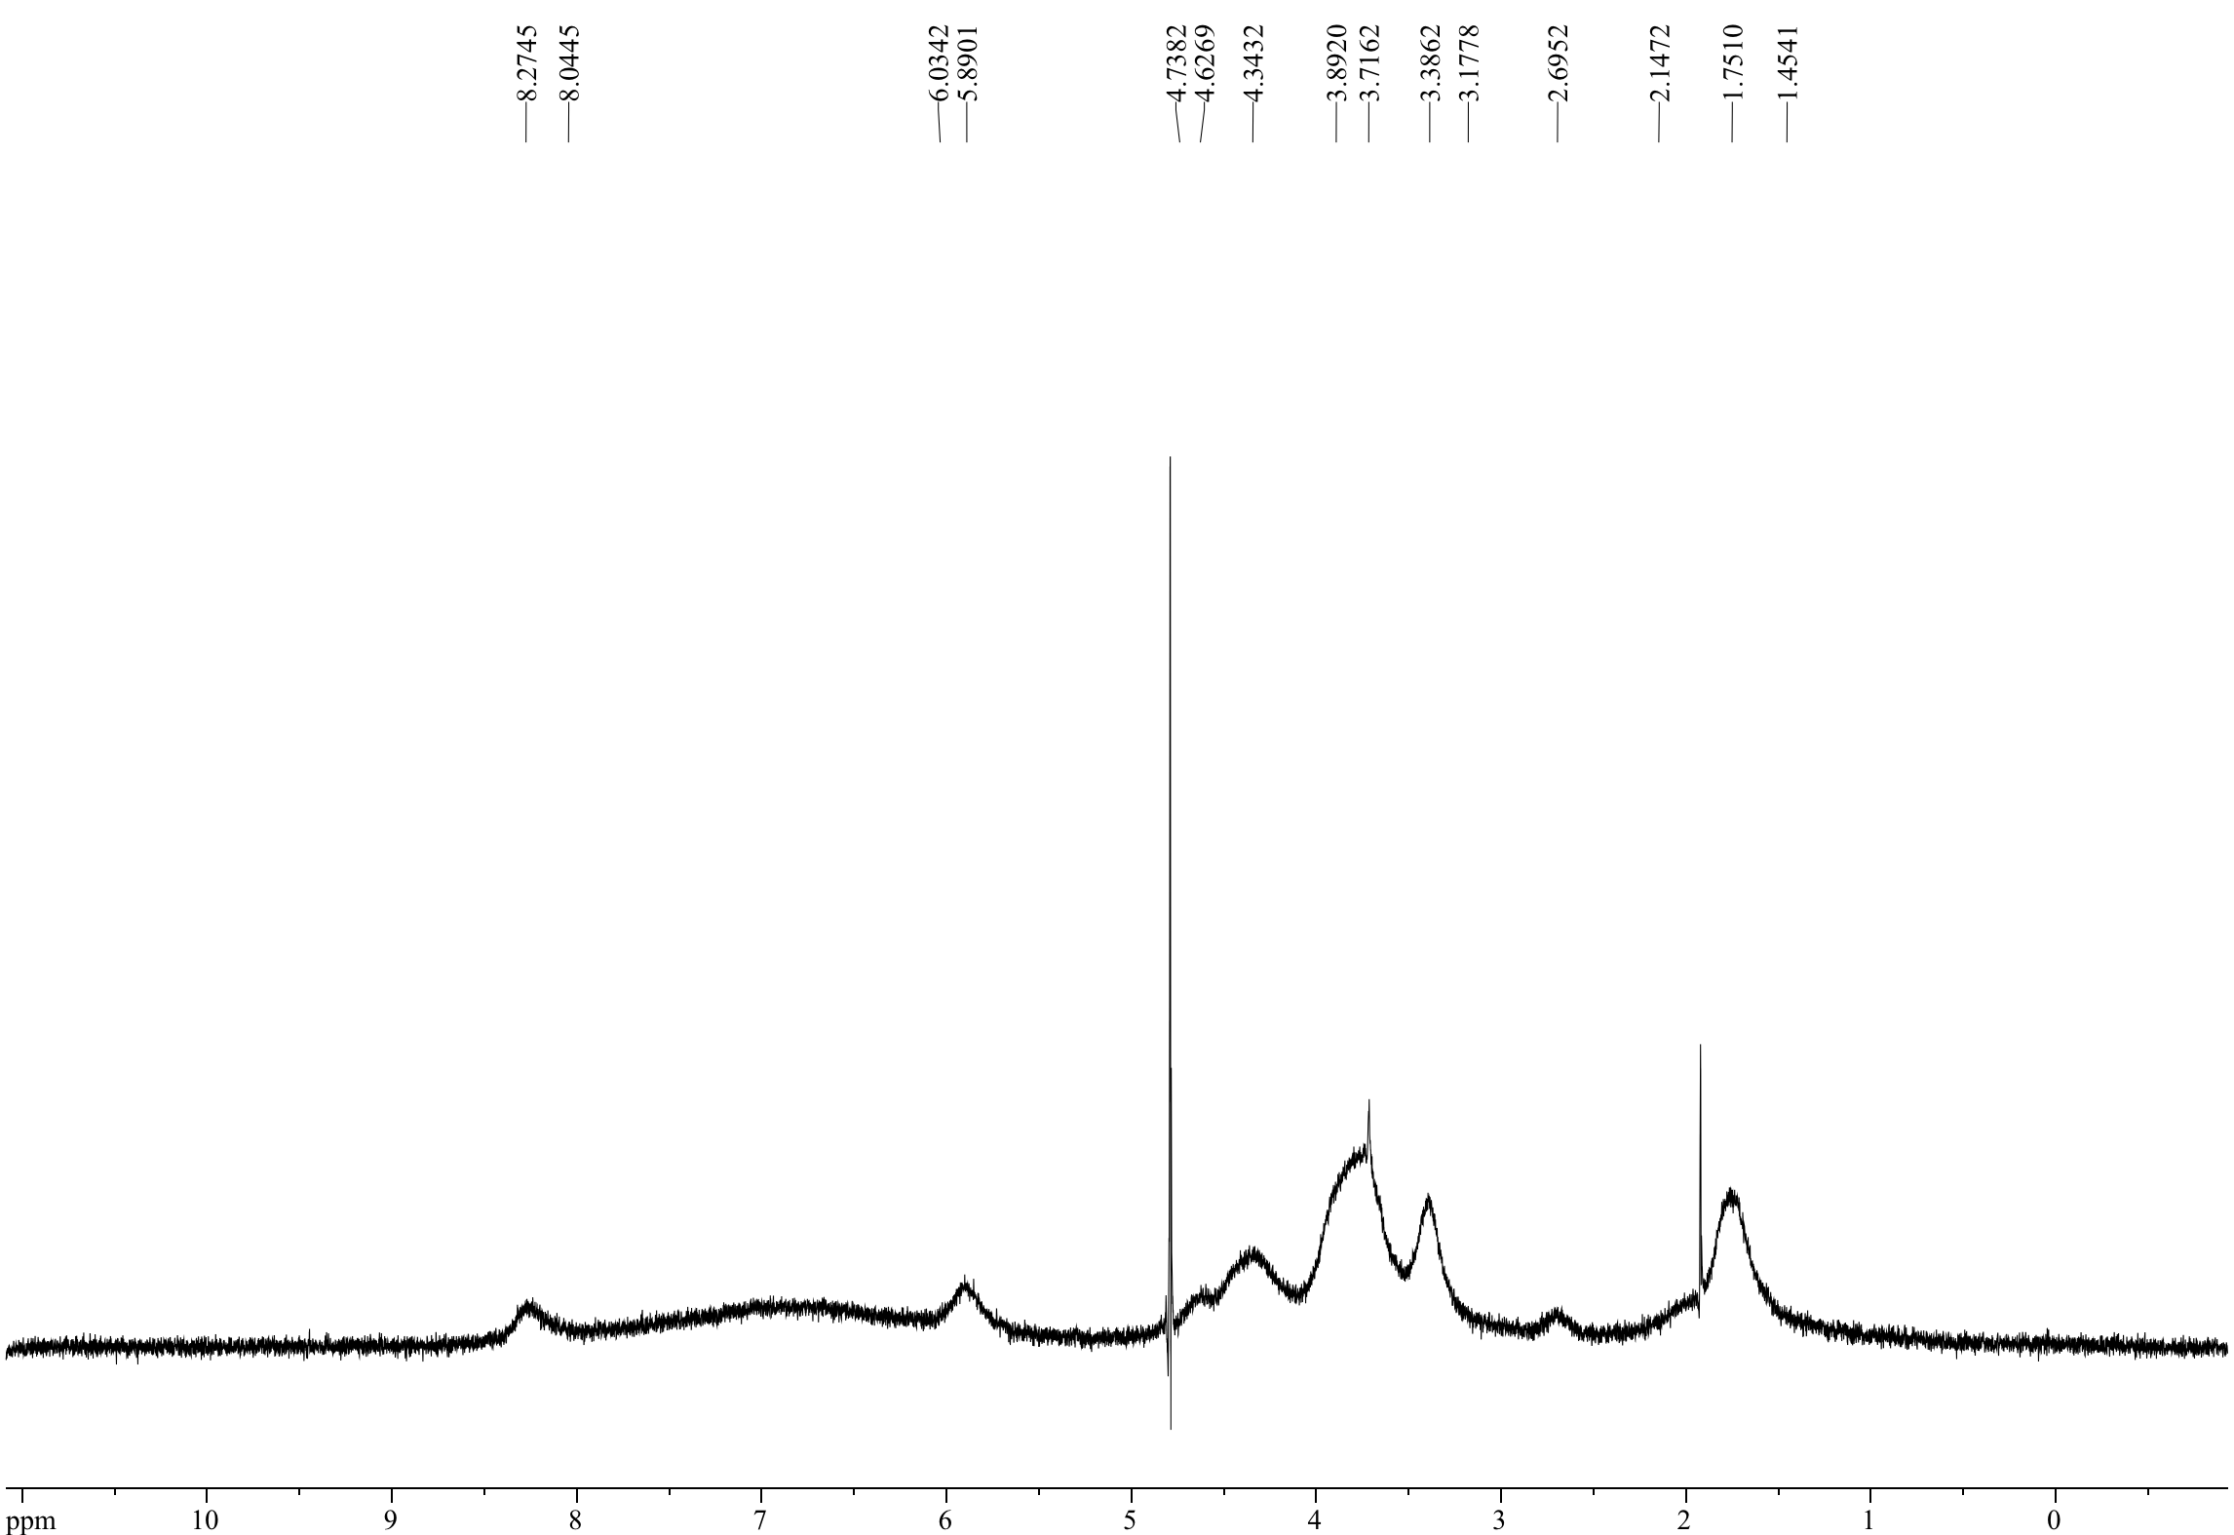

HSQC NMR spectrum of Compound 13 (500 MHz; D₂O)

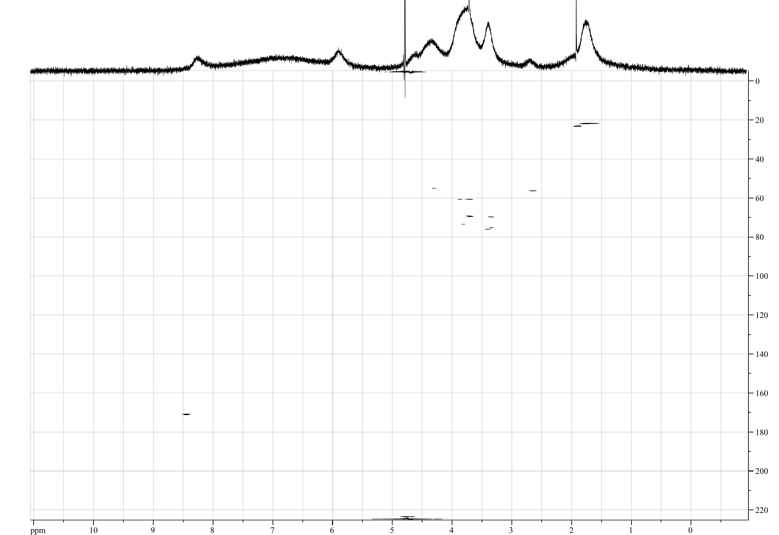
¹H NMR spectrum of Compound 14 (500 MHz; D₂O; water suppressed)

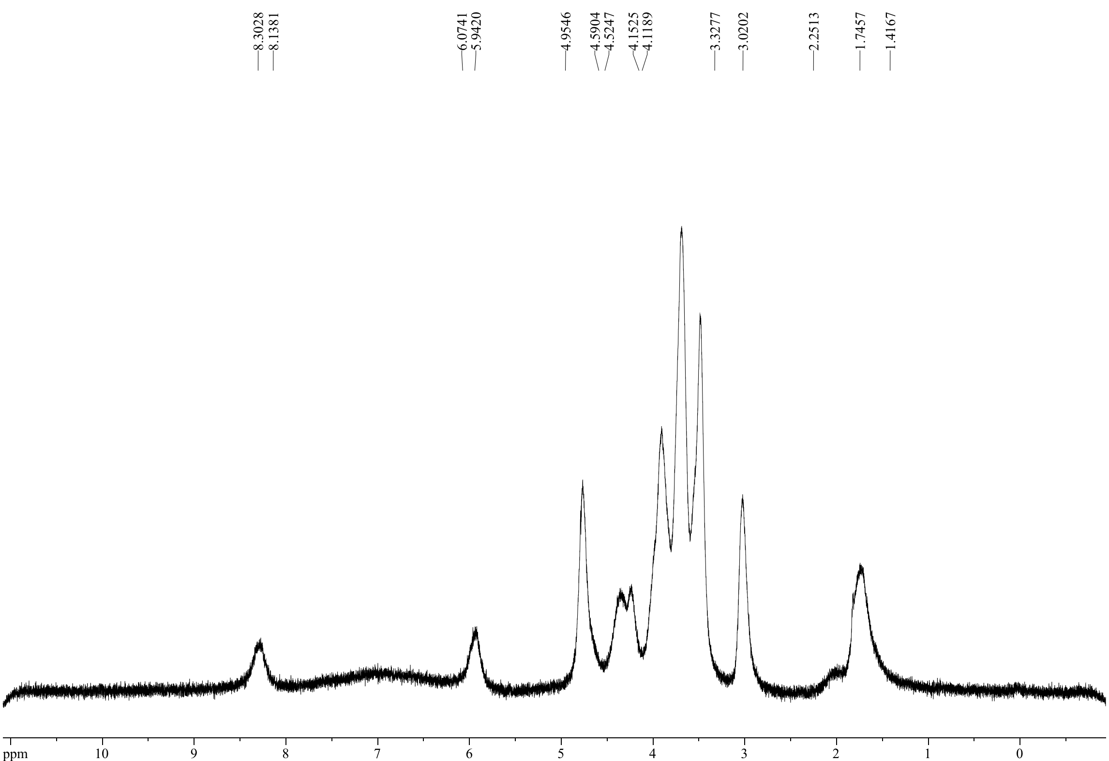

HSQC NMR spectrum of Compound 14 (500 MHz; D₂O)

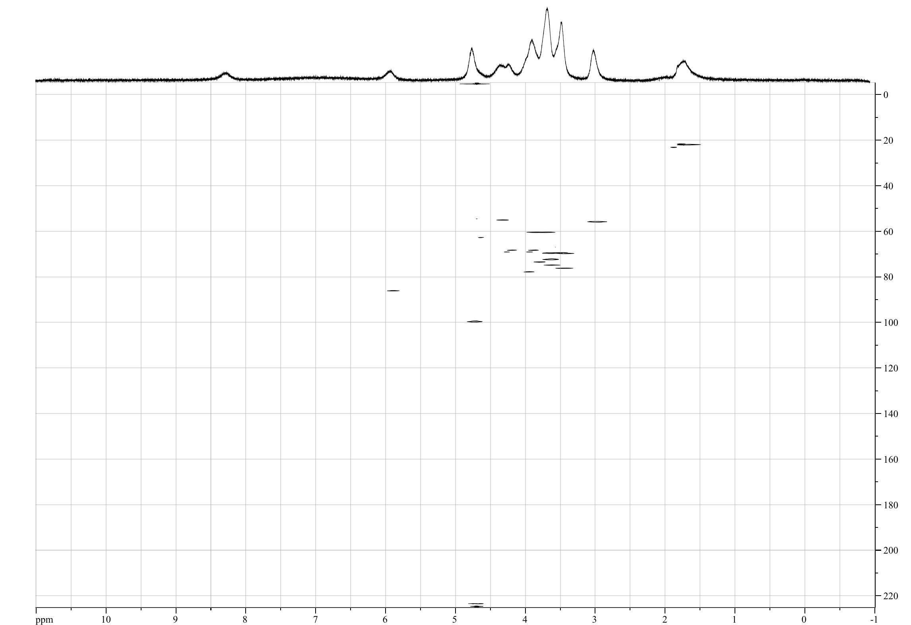
¹H NMR spectrum of Compound 15 (500 MHz; D₂O; water suppressed)
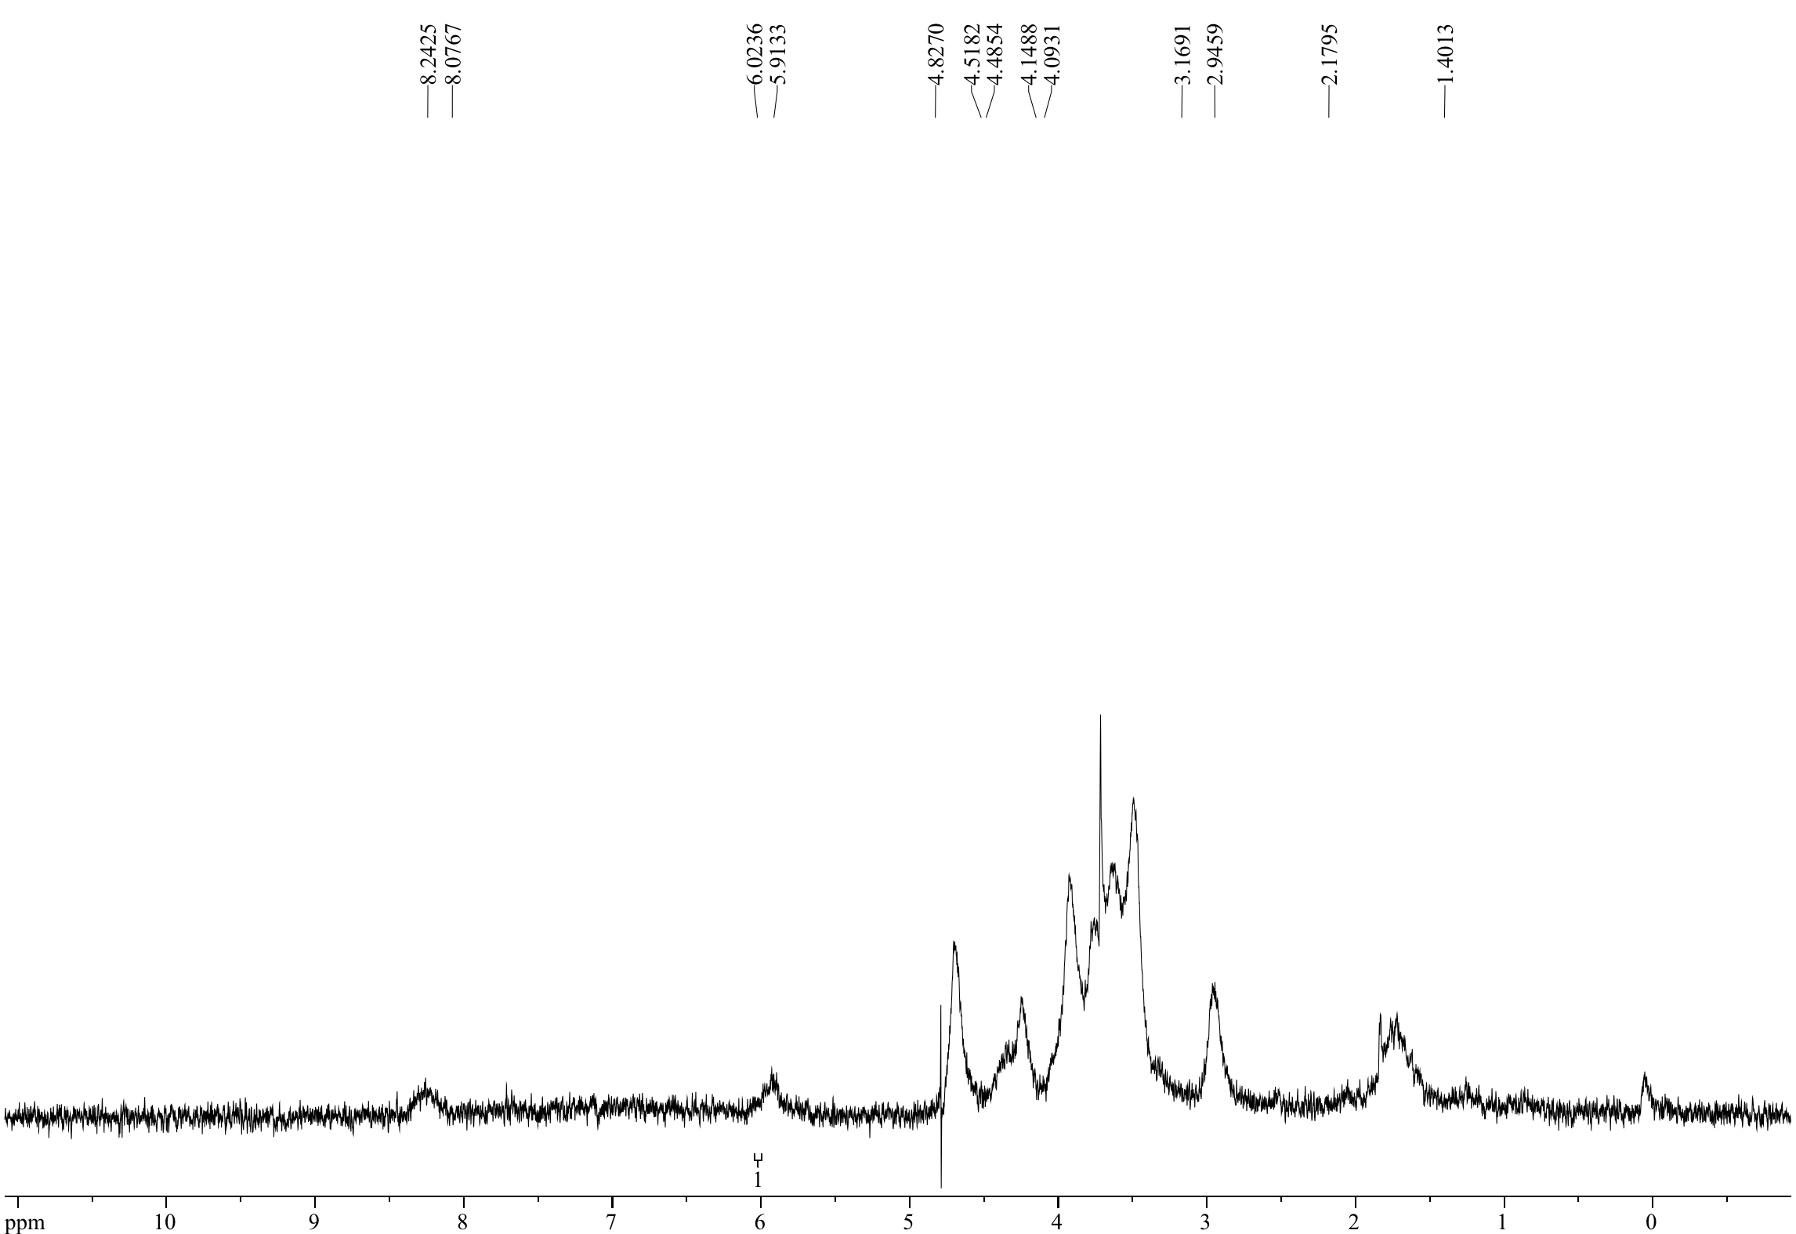

HSQC NMR spectrum of Compound 15 (500 MHz; D₂O)

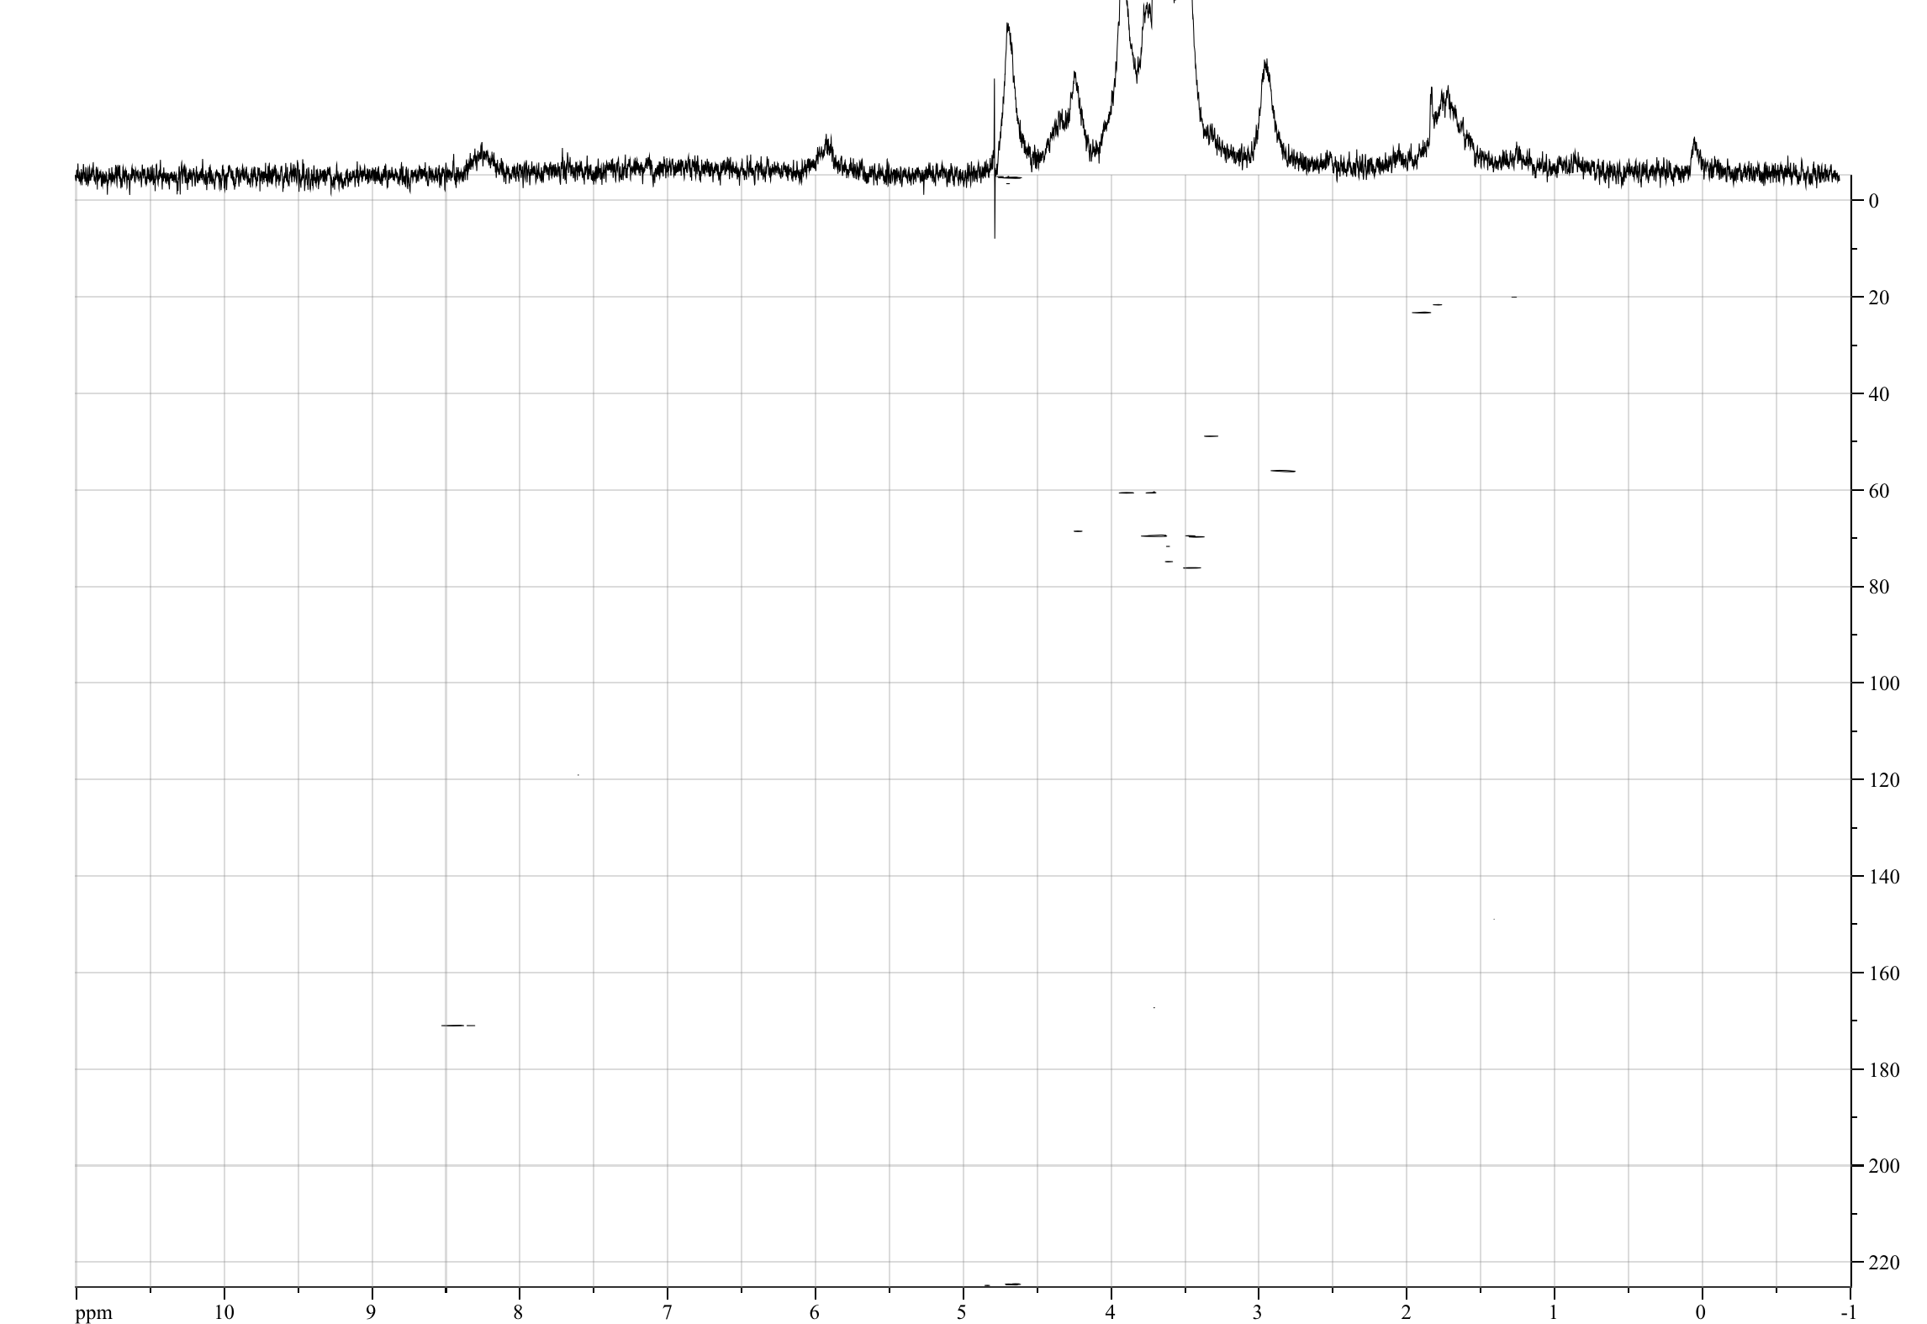
Normalised UV-Visible absorption spectra for compounds 3, 13, 14, and 15

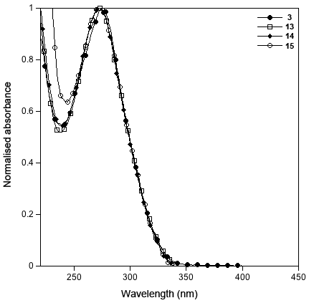

Table S1 UV-Visible absorption spectroscopy data for compounds 3, 13, 14, and 15 and calculated molar extinction coefficients.

Name | Solvent | λ_{abs}/nm | log ε/M⁻¹cm⁻¹
3 | THF | 275 | 5.53
13 | H₂O | 272 | 5.34
14 | H₂O | 272 | 5.33
15 | H₂O | 272 | 5.46

