Addition and correction for Chemical Science

Driving selective aerobic oxidation of alkyl aromatics by sunlight on alcohol grafted metal hydroxides

Sarina Sarina, Huaiyong Zhu, Zhanfeng Zheng, Steven Bottle, Jin Chang, Xuebin Ke, Jin-Cai Zhao,Yining Huang, Andre Sutrisno, Mathew Willans and Guoran Li

Chem. Sci., 2012, 3, 2138−2146 (DOI: 10.1039/c2sc20114c)

Fig. 1 and Scheme 1 are incorrect in the manuscript. The corrected versions are shown below.

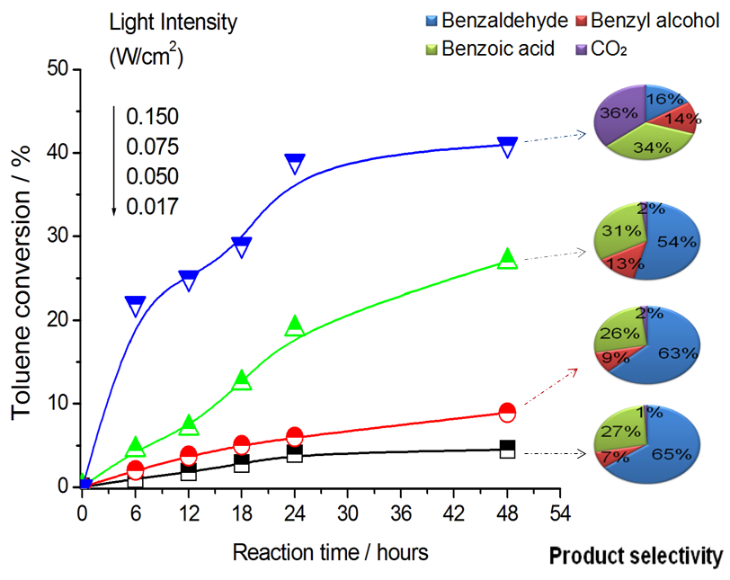

Fig. 1 Oxidation of toluene under UV light irradiation of various intensities.

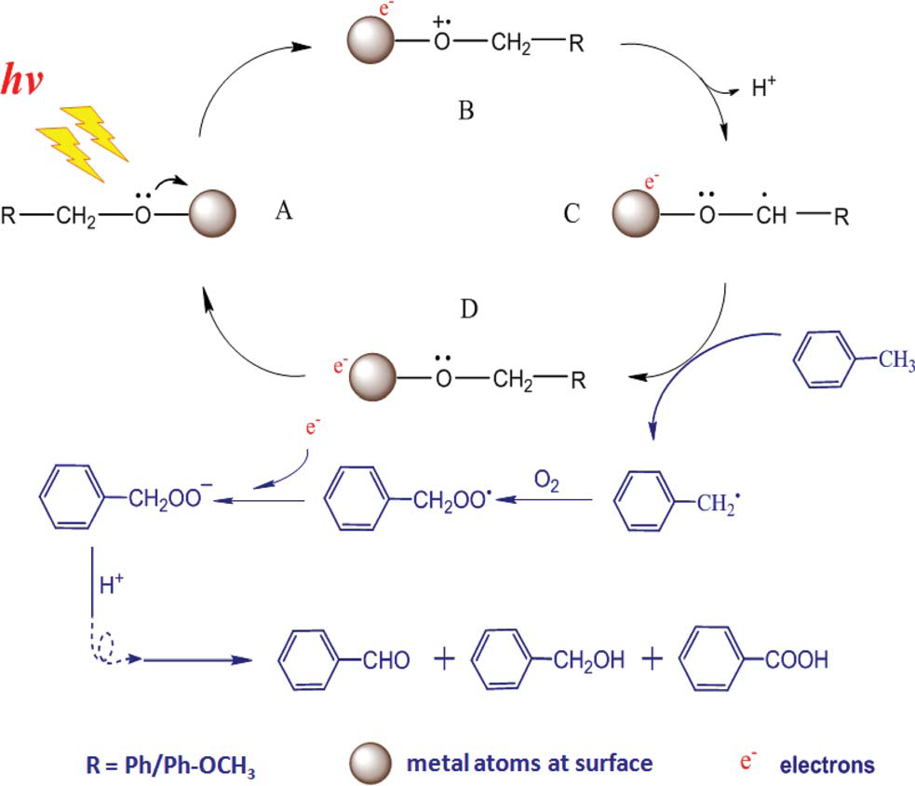
Scheme 1 Proposed pathways of the reaction mechanism. Ph–CH₃ as a reactant example.

The Royal Society of Chemistry apologises for this error and any consequent inconvenience to authors and readers.

Additions and corrections can be viewed online by accessing the original article to which they apply.

