Supporting Information

A New Metal-Organic Hybrid Material with Intrinsic Resistance-Based Bistability: Monitoring In Situ Room Temperature Switching Behavior

Zhongyue Zhang, Hanhua Zhao, Michio M. Matsushida, Kunio Awaga and Kim R. Dunbar*

Table of Contents

1, Crystallographic data for Ag(TCNQCl₂) (1) and Ag(TCNQBr₂) (2).

2, The voltage sweeping experiment.

3, The charge transfer saturation under current in the case of Ag(TCNQCl₂)

4, Experimental Section
1, Crystallographic data for Ag(TCNQCl₂) (1) and Ag(TCNQBr₂) (2).
The CIF files are available from the CCDC database, under the numbers 924677 and 924678.

Table S1. Pertinent crystallographic parameters and data for compounds 1 and 2.
Compound | 1 | 2
Formula | C₁₂H₂N₄Cl₂Ag | C₁₂H₂N₄Br₂Ag
F_{w} [g mol⁻¹] | 380.95 | 469.87
Crystal size [ mm³] | 0.02 x 0.008 x 0.005 | 0.04x 0.02 x 0.01
Crystal system | Monoclinic | Triclinic
Space group | P2/c | P-1
a [Å] | 6.7867(14) | 7.2540(15)
b [Å] | 3.5336(7) | 7.7900(16)
c [Å] | 22.719(4) | 11.640(2)
α [°] | 90 | 84.02(3)
β [°] | 90.69(3) | 74.69(3)
γ [°] | 90 | 65.01(3)
V [Å³] | 544.80(18) | 575.0(2)
Z | 2 | 2
ρ_{calc} [g cm⁻³] | 2.322 | 2.714
μ (Synchrotron) [mm⁻¹] | 0.413 | 0.413
Reflections collected | 8855 | 5294
Unique reflections | 811 | 5294
Reflections with I >2σ(I) | 980 | 3467
Parameters | 47 | 173
R(int) | 0.0497 | 0.0358 (based on data of the twinning domain that is used for structure resolution and refinement)
R1^{[a]} | 0.0392 | 0.0643
wR2^{[b]} | 0.0906 | 0.1502
GOF | 1.396 | 1.024
[a] R1 = Σ||F_{o}| -|F_{c}||Σ|F_{o}|. [b] wR2 = [Σ[w(F_{o}² - F_{c}²)²]/Σ[w(F_{o}²)²]]^{1/2}.

2, The voltage sweeping experiment.
There are two strategies for determining non-linear I-V behavior; these are current-variable sweeping and voltage-variable sweeping. We also performed the voltage variable method on compound 1 (Figure S1).
(a)
(b)
Figure S1. Voltage sweep I-V curve for Ag(TCNQCl₂): (a) -50V to 50V, five segments and (b) 0 to 70V, one segment.

Non-linear behavior for 1 was observed in the voltage sweep experiment but it is more challenging to control the current and protect the sample with the voltage sweep method. As a result, it is difficult to observe hysteresis. The sample exhibits a sharp increase in conductivity with an applied voltage of ~60 V, but then decomposes. The distinctive orange-yellow color of neutral TCNQCl₂ was observed by inspection of the sample under a microscope. (Figure S2).
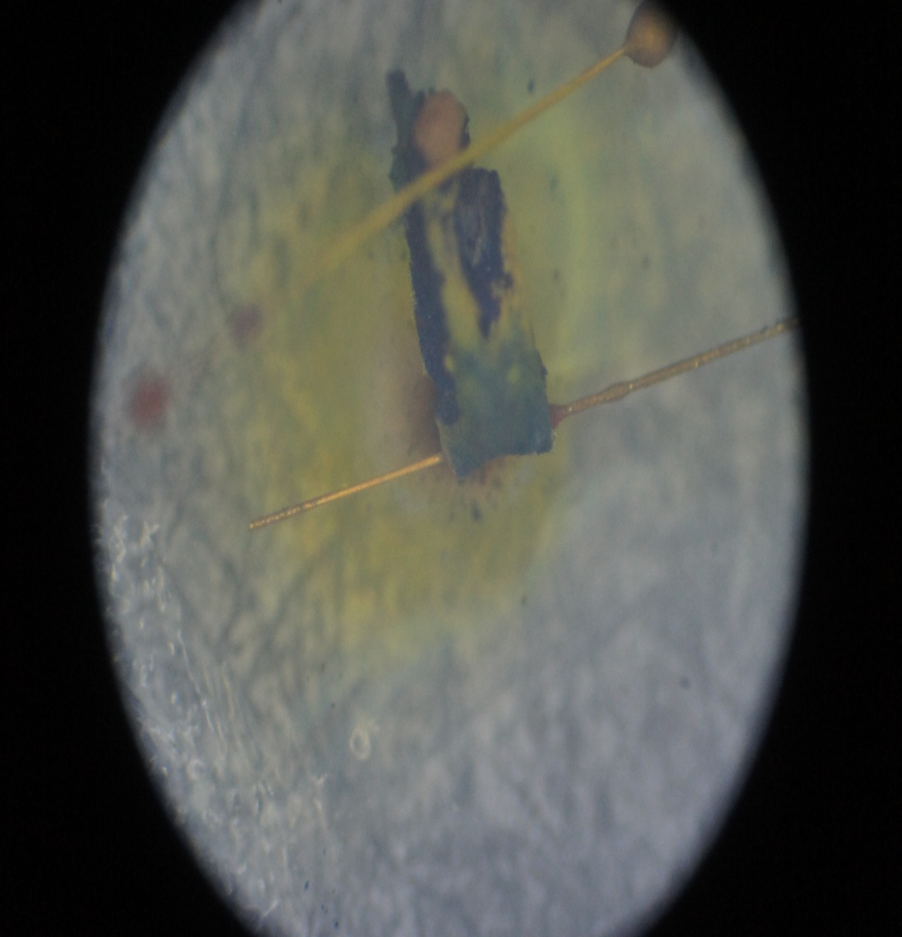

Figure S2. The decomposition of AgTCNQCl₂. Yellow areas are neutral TCNQCl whereas the dark regions indicate the presence of the radical form.

This observation is in excellent accord with the mechanism of switching being charge transfer from TCNQCl₂⁻ radicals to Ag(I) cations. When the applied voltage is increased, the sample undergoes full-electron transfer and decomposes to Ag(0) and neutral TCNQCl₂.

3, The charge transfer saturation under current in the case of Ag(TCNQCl₂)

Theoretical studies of Cu(TCNQ) and Ag(TCNQ) led to the hypothesis that the highly conducting states have contributions from 4s and 5s orbitals respectively. With the linear response between the g-factor and the logarithm value of alternating current, a charge transfer model was derived.
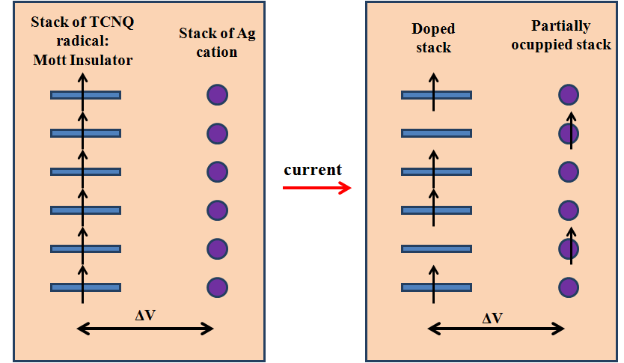

Figure S3. A structural scheme of current induced charge transfer model in Ag(TCNQCl₂).

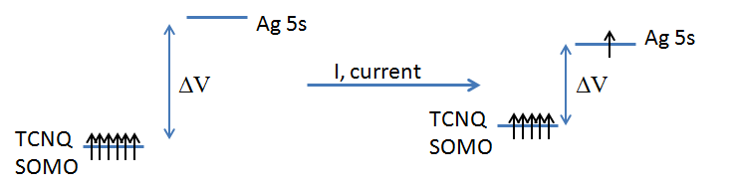

Figure S4. An energy scheme for the current induced charge transfer model in Ag(TCNQCl₂). With the charge transfer, the gap between Ag 5s orbital and TCNQ SOMO are smaller.

The ideal column of TCNQ radicals can be treated as a stack of all singly ocuppied radicals which is known as an intrinsic Mott-insulator type semiconductor. In this case the Ag 5s orbital is empty. The potential gap between the stack of TCNQ radicals and Ag(I) cations is attributed to the difference in their electrochemical potential, which is positive, given that the reaction between Ag(0) and TCNQCl₂ is spontaneous. In this case, the electrons will prefer to reside in the stack of TCNQ radicals. Under an applied current, partial charge transfer occurs, which converts the TCNQ radical stack into a dopped p-type semiconducting stack, which leads to an increase in conductivity. From the orbital energy scheme, it is obvious that the voltage difference between the SOMO of TCNQ and the Ag 5s orbital is proportional to their energy difference, which is also proportional to the occupancy of the 5s orbital and the degree of charge transfer. This voltage regulated distribution is similar to the law of diodes:

I = I_{s}(exp(ΔV/V_{T}) -1) (Equation S1.)

In which I is the applied current, I_{s} refers to the saturation current, ΔV is the voltage across the diode (in this case the voltage difference), and V_{T} = k_{B}T/q, is the thermal voltage which is a constant at a given temperature. As a result, log(I) is proportional to ΔV, and, consequently, proprotional to the charge transfer degree.

From the experimental data, the logarithm value of current is proportional to the shift of the g-factor. The g-factor of the reference compound Li(TCNQCl₂) is 1.99669, which is smaller than the zero-current g-factor for Ag(TCNQCl₂) (2.00478), from which it can be concluded that the hybridization between the Ag 5s orbital and HOMO of TCNQCl₂ will lead to a larger g⊥ value. The increase in the g⊥ value is expected to be proportional to the degree of hybridization. Since the hybridization interaction must communicate through the CN-Ag coordination bond, the ligand metal charge transfer (LMCT) induced by current will lead to elongation and dissociation of CN-Ag bonds, thereby generating Ag(0) in the structure and decreasing the hybridization degree. (Figure S5) This suggests that the charge transfer degree is also proportional to the g⊥ value shift. The relationship can be discribed as below:

g = g_{a}χ_{a}/(χ_{a}+χ_{b}) + g_{b}χ_{b}/(χ_{a}+χ_{b}) (Equation S2)

Here g_{a} is the g-tensor for a coordinated TCNQ radical, and g_{b} is the g-tensor for a free TCNQ molecule. Althought the free TCNQ molecules normally have a closed shell frontier orbital, it will share spin density with other TCNQ radicals as the electrons are highly delocalized as charge carriers in the stacks of TCNQ. The χ_{a}, χ_{b} values are the susceptibility of coordinated and ”free” TCNQ and are proportional to their concentrations in the structure. As a result, the g-tensor shift is proportional to the charge transfer degree.

Given the fact that the logarithmic value of current is proportional to the shift of g-factor, it is suggested that the logarithm value of current is proportional to the charge transfer degree, which corresponds to the model mentioned above.
Figure S5. The hybridization-decomposition model of g-value shifting.

It should be pointed out that the phenomenon is not restricted to one direction in these compounds, as the symmetry of the crystal structures allows for interactions between multiple stacks of TCNQ radicals and metal cation stacks.

From the combined results of this study, we conclude that the hypothesized mechanism of LMCT which leads to the generation of Cu(0) or Ag(0) is correct and that it can be observed in real time. The electron density on the s orbitals of the metals leads to a doping of the purely Mott insulating state of evenly spaced TCNQ radicals in stacks, with the result being a decrease in the on-site Coulomb repulsion and an increase in conductivity.

4, Experimental Section
The ligands TCNQCl₂ and TCNQBr₂ were synthesized by a procedure that is similar to the preparation of TCNQCF₃.^{S3} The starting materials, 1,4-dichloro-2,5- diiodobenzene and 1,4-dibromo-2,5-diiodobenzene were obtained from the iodination of benzene.

Synthesis of Ag(TCNQCl₂), (1): An electrocrystallization cell was equipped with a silver electrode as the anode and an inert-platinum electrode as the cathode in two compartments separated by a medium porosity frit. The anode side was filled with 5 mL of CH₃CN and 2.5 mL of CH₃OH and the cathode side was filled with 7.5 mL of CH₃CN and 54 mg (0.2mmol) of TCNQCl₂ which settled out as a suspension. The applyied current was set in the range of 2.5 μA to 3.0 μA to obtain a product of the best crystallinity. After 2 days, a dark greenish crystalline film was observed to be present on both electrodes. Elemental Analysis: Calc%: C, 37.83, H, 0.53, N, 14.71, Cl, 18.61. Anal%: C, 37.94, H, 0.43, N, 14.70, Cl, 18.33.

Synthesis of Ag(TCNQBr₂), (2): The electrocrystallization set-up is the same as fort he aforementioned case. The anode side was filled with 5 mL of CH₃CN and 2.5 mL of CH₃OH, and the cathode side was filled with 7.5 mL of CH₃CN with a suspension of 72 mg (0.2mmol) of TCNQBr₂. The applied current was adjusted from 1.5μA to 2.3μA to obtain the best crystallinity. After 2 days dark purple crystalline film was found to be present on the surfaces of both electrodes. Elemental Analysis: Calc%: C, 30.68, H, 0.43, N, 11.92,. Anal%: C, 31.14 H, 0.30, N, 11.83.

Thin film preparation of Ag(TCNQX₂)(X =Cl, Br): A piece of Ag foil with a 1 cm² area was pre-cleaned by soaking in 1M HNO₃ for 30 minutes and then rinsed with water followed by ethanol and dried in vacuo. The foil was immersed in 20 mL of a 0.05 mmol CH₃CN solution of TCNQX₂ which led to the instantaneous formation of a dark purple film. After immersion for 30 minutes the foil was removed from the solution, rinsed with acetonitrile and dried in vacuo.

Single crystal data collection: Single crystal diffraction data were collected at 110K at the ChemMatCars beamline 15-ID-B at the Advanced Photon Source (APS), Argonne National Lab. The data collection strategy consisted of obtaining two ω-scans with one full-sphere and one half-sphere for a total 1080 frames with a 0.5º width. Integration was performed with the Bruker-APEXII software package, and the absorption correction (SADABS) was based on fitting a function to the empirical transmission surface as sampled by multiple equivalent measurements. A large correction was adopted considering the presence of the heavy atoms Br and Ag. Solution and refinement of the crystal structure was performed with the SHELX programs ^{S4} and the graphical interface X-SEED. All non-hydrogen atoms were assigned in the difference Fourier maps after several rounds of least square refinements. The hydrogen atoms were placed in calculated positions. Crystallographic details have been deposited as supplementary information (Table S1.)

Conductivity data collection: Temperature dependent conductivity measurements were performed by securing two gold wires (15 μm diameter) to each side of a piece of a rectangular shaped crystalline film obtained from electrocrystallization. This film piece was estimated to be composed of 4-5 domains of single crystals by X-ray diffraction and, as such, is better than a pressed pellet for ascertaining the intrinsic conductivity properties. The size and thickness of film was measured by the length marks attached to the ocular glass of the microscope. A Quantum Design model MPMS SQUID magnetometer equipped with a voltammeter and a current source was used to collect the voltage changes with temperature. A square-wave current of 1.0 μA was applied for the measurement to avoid the non-linear current response and thermal resistance from the contact between the gold wire and film, a set of 6 data points were collected at certain temperature, and the average value of conductivity and temperature was taken to represent the behavior. The direction of applied current is along the longest direction of the film the ensure that the major contribution of conductivity emanates from the stacks of TCNQ radicals.

EPR measurements: EPR data were obtained on a JOEL JES-FA200 X-band EPR instrument. A pressed powder pellet of 1 was used to avoid complications caused by by the twinning of the crystals. The pellet was placed parallel to the direction of the magnetic field and a DC current source was used. A 30 second measurement interval was adopted to avoid heating effects with the application of current. Given that the final result suggested that the biggest g-value shift occured with the applied current of only 1nA, and rapidly decreased with the increasing of applied current, apparently current-induced heat is not the major factor and therefore is ignored. Current-induced field was also neglected as there was no report of significant magnetoresistance behavior for any metal-TCNQ material.

References:
S1 T. Mori, T. Kawamoto, Annu. Rep. Prog. Chem., Sect. C, 2007, 103, 134–172.
S2 Z. Gu, H. Wu, Y. Wei and J. Liu, J. Phys. Chem. 1993, 97, 2543-2545.
S3 H. Ikegami, C. Chong, H. Yamochi and G. Saito, Mol. Cryst. Liq. Cryst. 2002, 382, 21-35.
S4 G.M.Sheldrick, Acta Cryst., 2008, A64, 112-122.

